* **Introduction**

The Project deals with the automation of the reservation and enquiry of the railway reservation system. It maintains all information starting from reservation to cancellation of tickets. It also acts as an enquiry system about the different trains available. This project aimed at the job simplification and reducing the manual work and hereby saving the time of physical visiting the railway stations.

The main objective of the project is to manage the details of train, ticket booking, view the details of the passengers, available seats for the passengers, available trains for the particular route. It will track all the details about the booking, passengers and the train schedules.

* **System Analysis (Research):**

This system is basically concerned with the reservation and cancellation of the railway tickets to the passengers. The need of the system arise because as is the known fact that the India has the largest railway network in the whole of the world and to handle it manually is quite tough job. By computerizing it we will be able to overcome many of its limitations and will be able to handle it more efficiently. The handling of such records and data for such system is a very complex task if it is done manually but it can be made much easier if the system is computerized.

* **System Features:**
* System will allow the user to login in their respective account.
* Admin can edit the details of the trains.
* User will be able to book the tickets according to their needs.
* Tracks the information about train, bookings, passengers.
* Display the details of the booking.
* Print the booked tickets.
* User can cancel the booking.
* **Benefits:**

It will save the operating cost, reduction in paperwork and manual handling of the data, errors that can arises by doing the booking manually will also reduce and the better utilization of the human resources.

* **Defining the system**
* **System Functions:**
  + **Login Module:**
    - Registered users will logged in into the system with the valid credentials.
  + **Reservation Module:**
    - After checking the available seats the Users can reserve the seats.
  + **Train Details:**
    - The details of specific train will be displayed.
  + **Billing Module:**
    - Charge automatically w.r.t number of seats and train.
  + **Cancellation Module:**
    - If the User wants to cancel the ticket they can easily do it.
* **Block Diagram:**

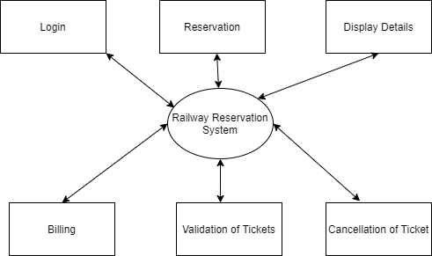

* **SWOT Analysis:**

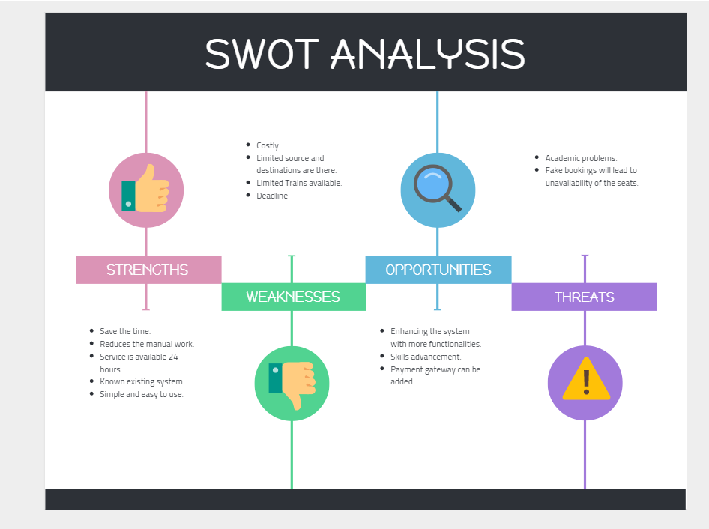

* **5 W’s:**
* **Why:**

To reduce the manual work, along with that to save the time and efforts of Users to personally visit the stations for booking.

* **Who:**

Small and medium size organization can use it.

* **What:**

A simple and easy to use system for the Users to do all the activities related to online train ticket booking system such as reservation, cancellation and all other functions.

* **When:**

As the India has the largest railway network in the whole of the world and to handle it manually is quite tough job thus it is required now to design such systems which will help to do this job efficiently.

* **Where:**

This problem is expected all over the India.

* **Detail Requirements:**
  + **High level requirements:**

|  |  |  |
| --- | --- | --- |
| **ID** | **Description** | **Status** |
| HL01 | User Shall be able to login the system. | Done |
| HL02 | User Shall be able to book the ticket. | Done |
| HL03 | User Shall be able to view the available trains. | Done |
| HL04 | User Shall be able to print the ticket. | Done |
| HL05 | User Shall be able to cancel the ticket. | Done |
| HL06 | Data should be saved in case of failure. | Future |
| HL07 | Proper GUI can be implemented for further. | Future |

* + **Low level Requirements**

|  |  |  |
| --- | --- | --- |
| **ID** | **Description** | **Status** |
| LL01 | The user will be able to login successfully with the valid credential. | Done |
| LL02 | If user entered the incorrect login credentials then ‘SORRY !!!! LOGIN IS UNSUCESSFUL’ message should be displayed. | Done |
| LL03 | If user entered the incorrect login credentials for 4 times then ‘Sorry you have entered the wrong username and password for four times!!!’message should be displayed. | Done |
| LL04 | If the wrong choice number is entered then message of ‘Invalid Choice’ should be displayed. | Done |
| LL05 | After providing the required details for the booking the ticket and yes is provided for confirming the booking, the booking should be successful. | Done |
| LL06 | If all the required details for the booking the ticket are not provided then reservation should be unsuccessful. | Done |
| LL07 | If the proper ticket holder name is provided then the ticket should be cancelled successfully. | Done |
| LL08 | If the proper ticket holder name is not provided then the message ‘No record found for this Name’ should be displayed. | Done |
| LL09 | For validating the tickets if the proper ticket holder name is provided then the message ‘Ticket Holder exist check the list to confirm Once’ should be displayed. | Done |
| LL10 | For validating the tickets if the incorrect ticket holder name is provided then the message ‘No Record Found’ should be displayed. | Done |

* **UML Diagrams**

**HLD**

* + **Architectural Design:**

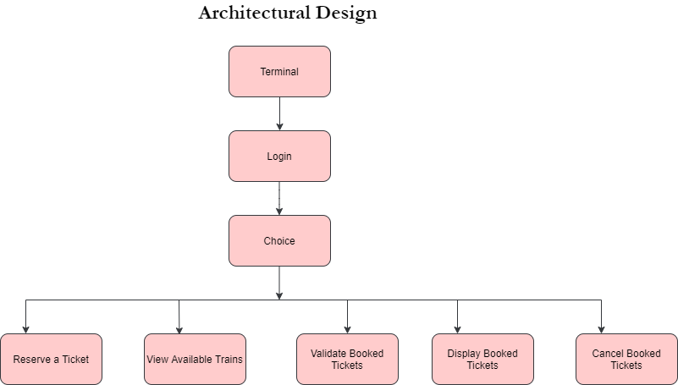

* + **Use case diagram**

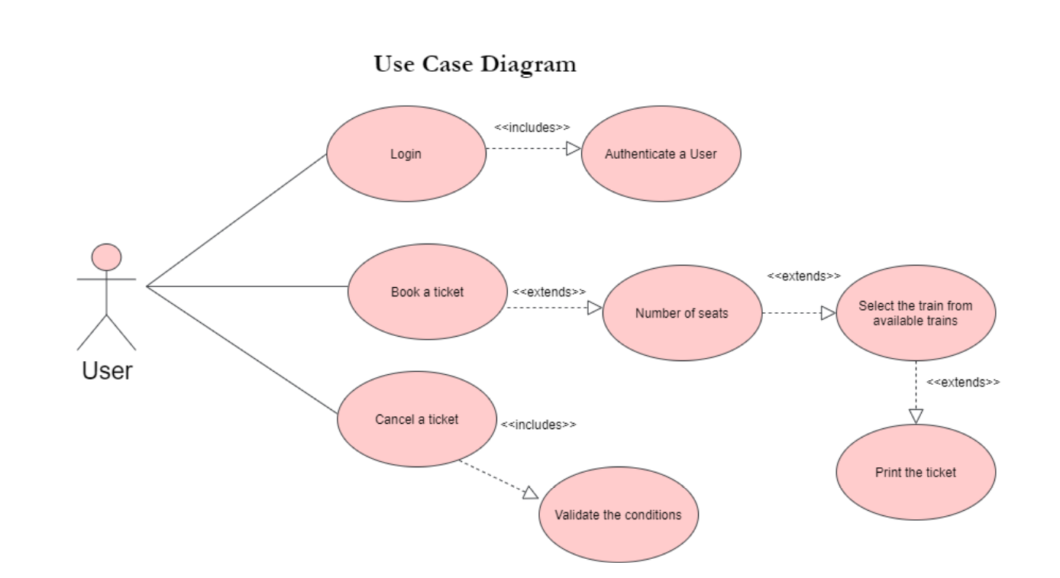

* + **Collaboration Diagram**

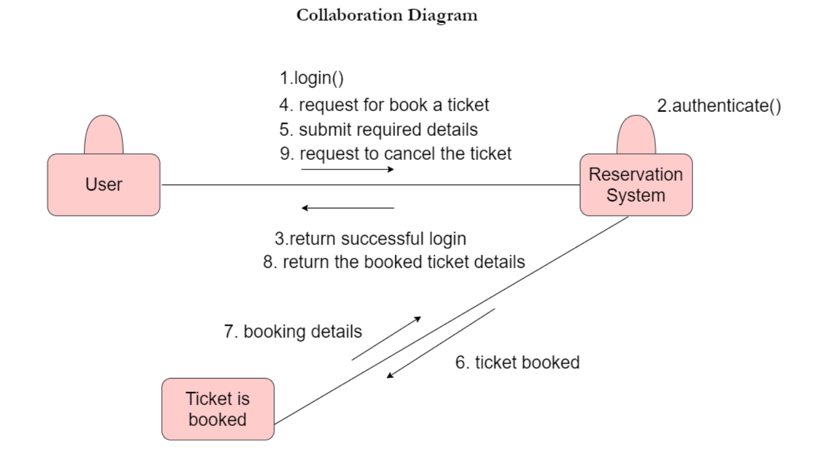

**LLD**

* + **Statechart diagram:**

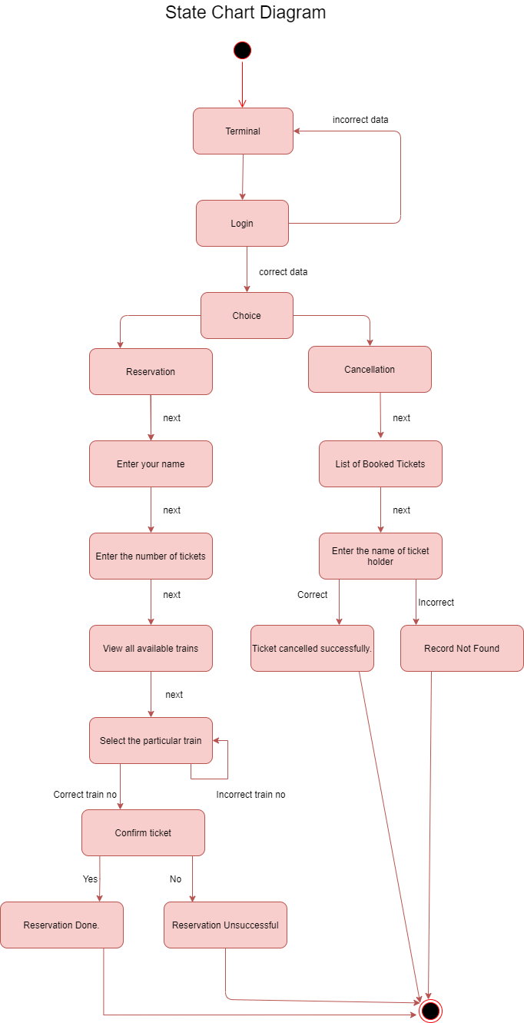

* + **Activity Diagram:**

