**What is Git**

Git is popular version control system that is used to manage project.

Version Control System

**Version Control System (VCS)** is software that helps software developers to work together and maintain a complete history of their work.

Listed below are the functions of a VCS −

* Allows developers to work simultaneously.
* Does not allow overwriting each other’s changes.
* Maintains a history of every version.

**There are two types of VCS:**

**1) Centralized version control system(CVCS)**

**2) Distributed version control system(DVCS)**

Centralized VCS:

In CVCS, the central server stores all the data. It enables team collaboration. It just contains a single repository, and each user gets their working copy. We need to commit, so the changes get reflected in the repository. Others can check our changes by updating their local copy.

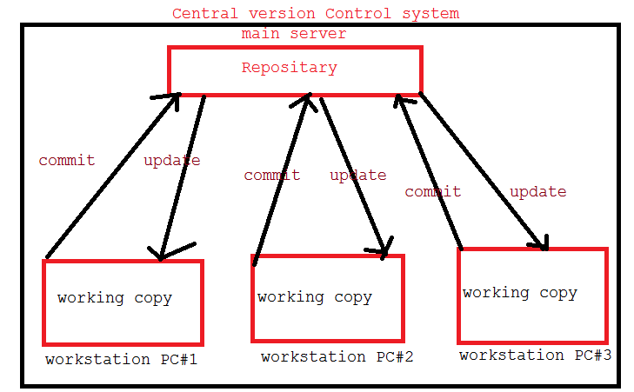

* It is not locally available, which means we must connect to the network to perform operations.
* During the operations, if the central server gets crashed, there is a high chance of losing the data.
* For every command, CVCS connects the central server which impacts speed of operation

​ The Distributed Version Control System is developed to overcome all these issues.

**Distributed Version Control System (DVCS) :**

In DVCS, there is no need to store the entire data on our local repository. Instead, we can have a clone of the remote repository to the local. We can also have a full snapshot of the project history.

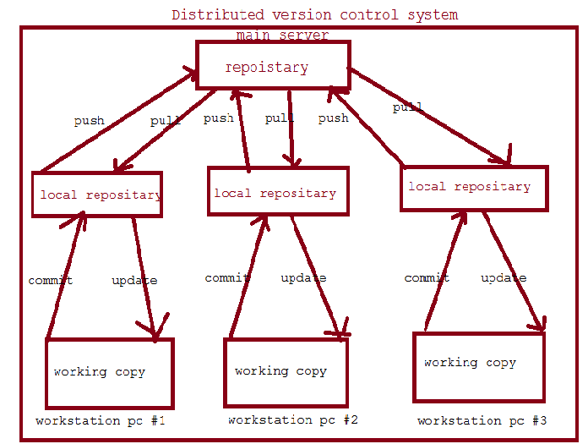

The User needs to update for the changes to be reflected in the local repository. Then the user can push the changes to the central repository. If other users want to check the changes, they will pull the updated central repository to their local repository, and then they update in their local copy.

Repository is a storage where all the developer code will be stored

Repositary is the storage to integrate the code.

Once development completed the every developer should push the code to repositary.

Repositary will track all the changes happening to files

**What is difference between git and github**

|  | **Git** | **GitHub** |
| --- | --- | --- |
| 1. | Git is a software. | GitHub is a service. |
| 2. | Git is a command-line tool | GitHub is a graphical user interface |
| 3. | Git is installed locally on the system | GitHub is hosted on the web |
| 4. | Git is maintained by linux. | GitHub is maintained by Microsoft. |
| 5. | Git is focused on version control and code sharing. | GitHub is focused on centralized source code hosting. |
| 6. | Git is a version control system to manage source code history. | GitHub is a hosting service for Git repositories. |
| 7. | Git was first released in 2005. | GitHub was launched in 2008. |

## 

## Environment setup:

## Step1)Create Account in github site

## [www.github.com](http://www.github.com)

## step2) download and install git client software

## it is used to perform git commond operation with git repo

## git bash we will execute git command

## go to any folder ->right click on mouse->select git bash here ->open

## <https://git-scm.com/downloads>

## Git for Windows stand-alone installer

Download the latest **Git** for Windows installer.

When you've successfully started the installer, you should see the Git Setup wizard screen. Follow

the Next and Finish prompts to complete the installation. The default options are pretty sensible for most users.

## After installing git client,go to any folder and right click on mouse then it should display Git GUI here and Git BASH here

## Click on GITBASH here

Run the following commands to configure your Git username and email using the following commands, replacing Emma's name with your own. These details will be associated with any commits that you create:

$ git config --global user.name " abc"

$ git config --global user.email [abc@gmail.com](mailto:abc@gmail.com)

**Command** :

**git init**:-

🡪 git command are used for initializing git folder

**git remote add origin ‘repo-url’:**

gitremote command is used to configure git central repo url.

**Ex:**

**git pull origin master :-**

**pull command is used to taking the latest changes from central repo to local repo.**

**git status** :-

current branch and changed files and updated files and new files

**git add**:-

git add command are used for adding files to staging area.

1. to add only one file provide specific path

2. to add all changes for commit provide (.)

git add abc.txt (for adding a single file)

git add . ( to add all changes for commit)

**git commit –m ‘msg’ :-**

Commit is used for committing files to local repository.

**git push -u origin :-**

push command is used to push files from local repo to central repo.

git push origin (branchname) for push the branch and changes

**Git clone:**

**Git clone means taking whole project from central repo to local repo.**

**git checkout .**

git checkout -b (branchname) to create new branch

git checkout (branchname) to change branch

**git merge**  <barnchName> :

The git merge command is used to merge the branches.

**git log**:

log command used to display commit history.

**Create Account in github.com**

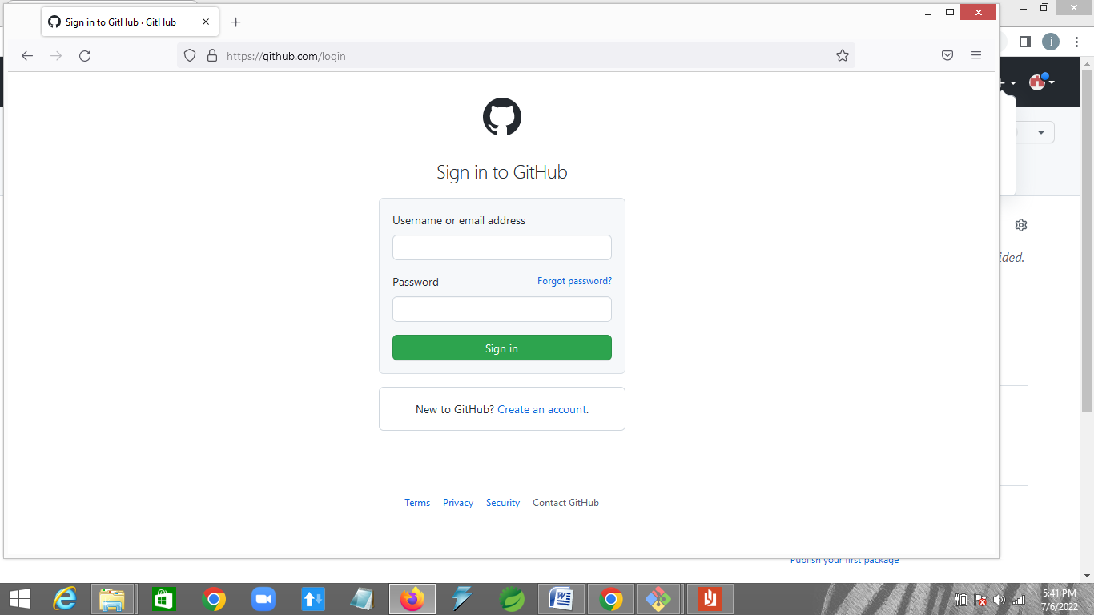

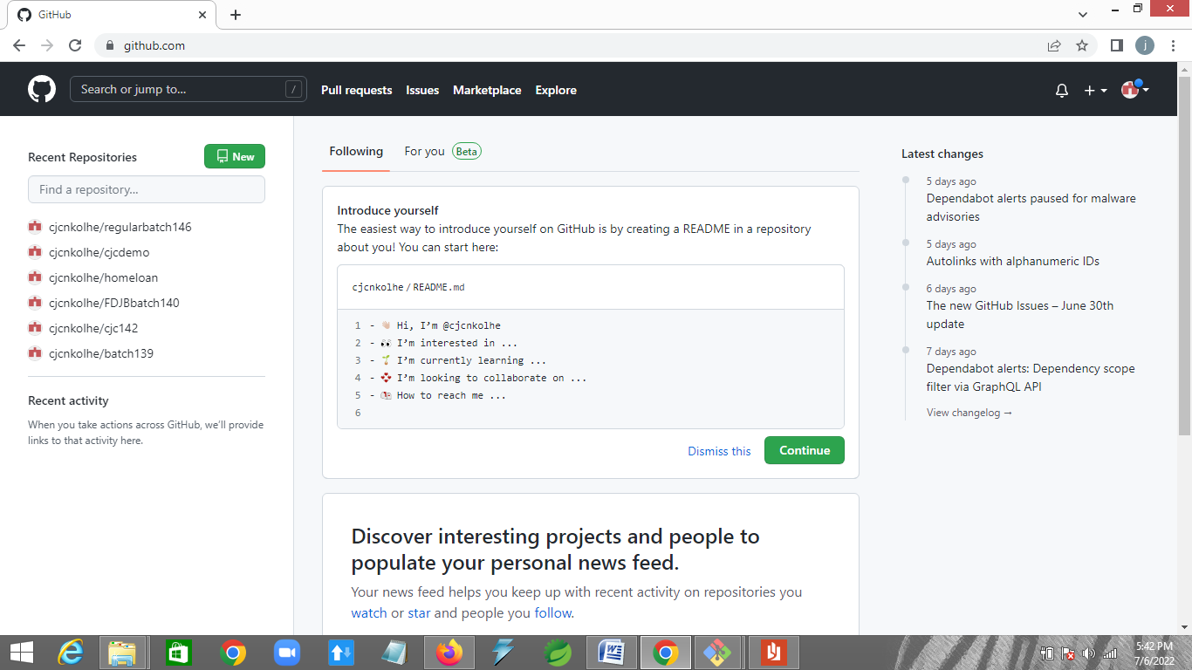

**Step 1: create git repositary**

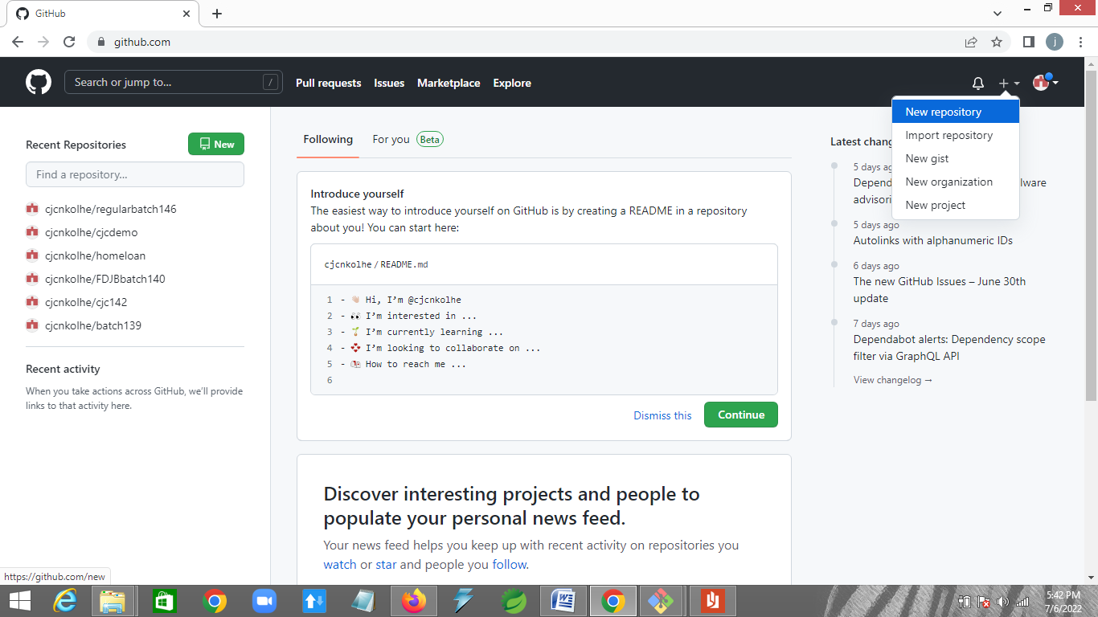

**Step 2: write repositary name**

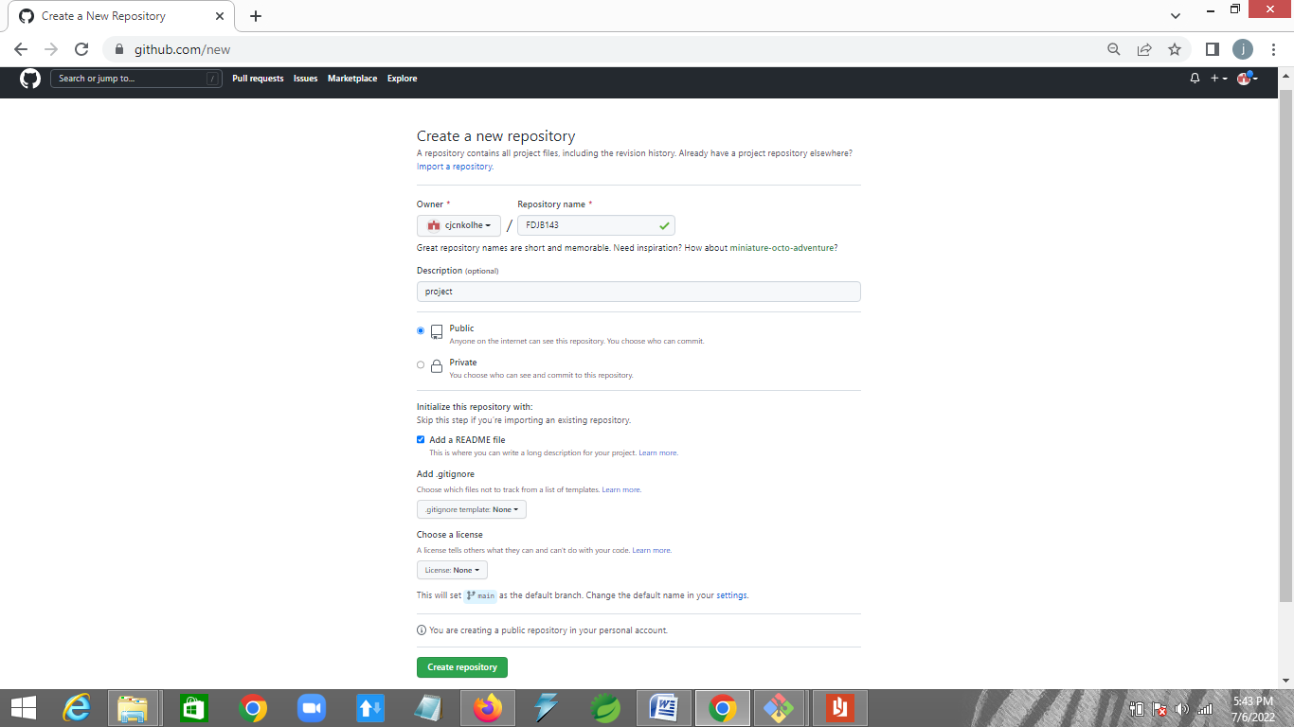

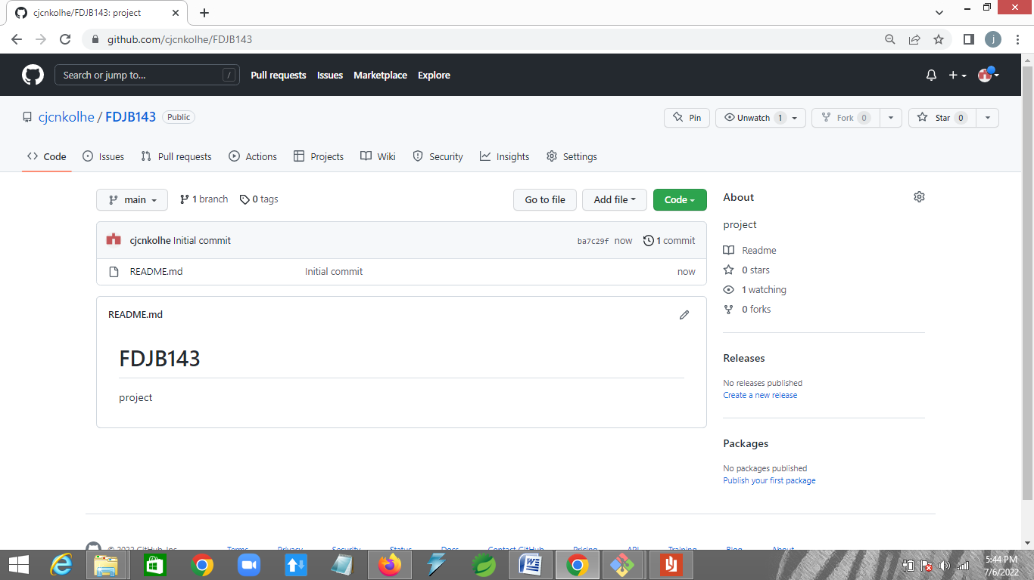

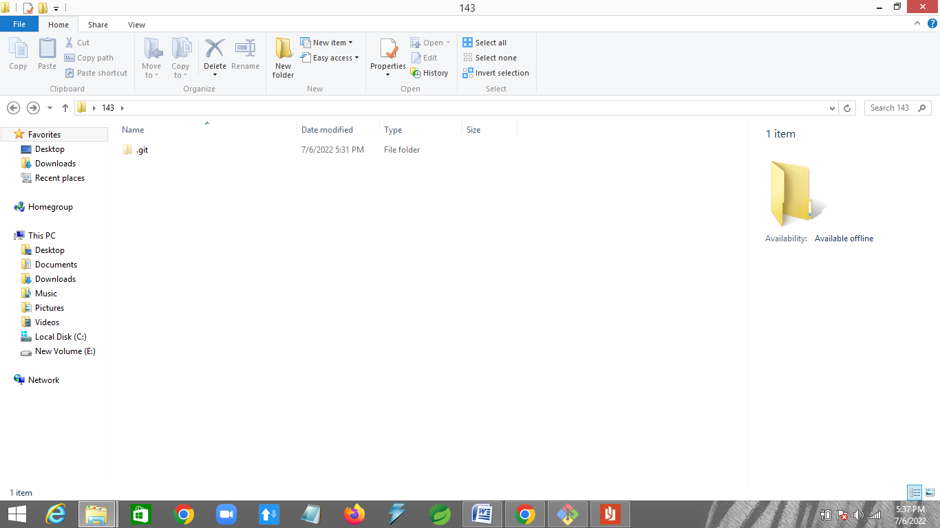

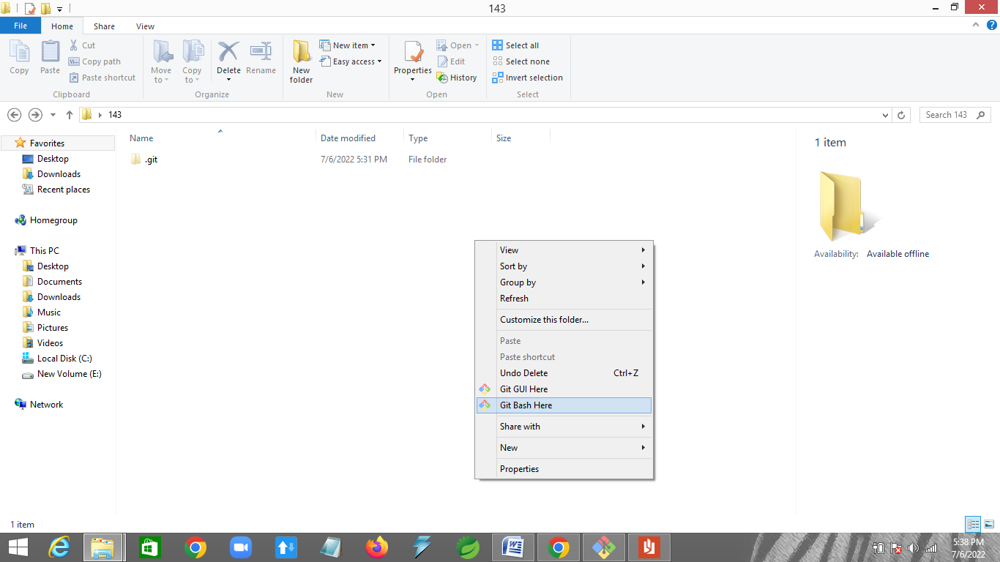

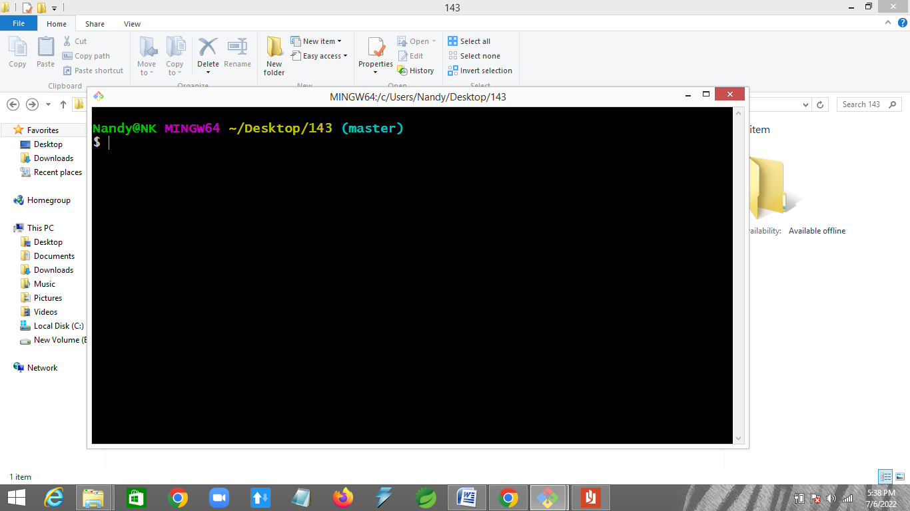

**Commands:**

Nandy@NK MINGW64 ~/Desktop/143

$ git init

Initialized empty Git repository in C:/Users/Nandy/Desktop/143/.git/

Nandy@NK MINGW64 ~/Desktop/143 (master)

$ git remote add origin "https://github.com/cjcnkolhe/regularbatch146.git"

Nandy@NK MINGW64 ~/Desktop/143 (master)

$ git pull origin master

remote: Enumerating objects: 9, done.

remote: Counting objects: 100% (9/9), done.

remote: Compressing objects: 100% (5/5), done.

remote: Total 9 (delta 0), reused 6 (delta 0), pack-reused 0

Unpacking objects: 100% (9/9), done.

From https://github.com/cjcnkolhe/regularbatch146

* branch master -> FETCH_HEAD

* [new branch] master -> origin/master

Nandy@NK MINGW64 ~/Desktop/143 (master)

$ git add c.txt

Nandy@NK MINGW64 ~/Desktop/143 (master)

$ git commit -m "first commit"

[master 6a89d40] first commit

1 file changed, 1 insertion(+)

create mode 100644 c.txt

Nandy@NK MINGW64 ~/Desktop/143 (master)

$ git push origin master

Enumerating objects: 4, done.

Counting objects: 100% (4/4), done.

Delta compression using up to 4 threads

Compressing objects: 100% (2/2), done.

Writing objects: 100% (3/3), 261 bytes | 87.00 KiB/s, done.

Total 3 (delta 1), reused 0 (delta 0)

remote: Resolving deltas: 100% (1/1), completed with 1 local object.

To https://github.com/cjcnkolhe/regularbatch146.git

e37c0d8..6a89d40 master -> master

Nandy@NK MINGW64 ~/Desktop/143 (master)

$ git status

On branch master

Untracked files:

(use "git add <file>..." to include in what will be committed)

d.txt

nothing added to commit but untracked files present (use "git add" to track)

Nandy@NK MINGW64 ~/Desktop/143 (master)

$ git add d.txt

Nandy@NK MINGW64 ~/Desktop/143 (master)

$ git status

On branch master

Changes to be committed:

(use "git restore --staged <file>..." to unstage)

new file: d.txt

Nandy@NK MINGW64 ~/Desktop/143 (master)

$ git commit -m "second commit"

[master b0cdb90] second commit

1 file changed, 1 insertion(+)

create mode 100644 d.txt

Nandy@NK MINGW64 ~/Desktop/143 (master)

$ git status

On branch master

nothing to commit, working tree clean

Nandy@NK MINGW64 ~/Desktop/143 (master)

$ git push origin master

Enumerating objects: 4, done.

Counting objects: 100% (4/4), done.

Delta compression using up to 4 threads

Compressing objects: 100% (2/2), done.

Writing objects: 100% (3/3), 265 bytes | 132.00 KiB/s, done.

Total 3 (delta 1), reused 0 (delta 0)

remote: Resolving deltas: 100% (1/1), completed with 1 local object.

To https://github.com/cjcnkolhe/regularbatch146.git

6a89d40..b0cdb90 master -> master

Nandy@NK MINGW64 ~/Desktop/143 (master)

$ git checkout -b team1

Switched to a new branch 'team1'

Nandy@NK MINGW64 ~/Desktop/143 (team1)

$ git add re

Nandy@NK MINGW64 ~/Desktop/143 (team1)

$ git commit -m "second branch commit"

[team1 6b93948] second branch commit

1 file changed, 1 insertion(+)

create mode 100644 re/c.txt

Nandy@NK MINGW64 ~/Desktop/143 (team1)

$ git push origin team1

Enumerating objects: 4, done.

Counting objects: 100% (4/4), done.

Delta compression using up to 4 threads

Compressing objects: 100% (2/2), done.

Writing objects: 100% (3/3), 293 bytes | 97.00 KiB/s, done.

Total 3 (delta 1), reused 0 (delta 0)

remote: Resolving deltas: 100% (1/1), completed with 1 local object.

remote:

remote: Create a pull request for 'team1' on GitHub by visiting:

remote: https://github.com/cjcnkolhe/regularbatch146/pull/new/team1

remote:

To https://github.com/cjcnkolhe/regularbatch146.git

* [new branch] team1 -> team1

Nandy@NK MINGW64 ~/Desktop/143 (team1)

$ git checkout master

Switched to branch 'master'

Nandy@NK MINGW64 ~/Desktop/143 (master)

$ git checkout team1

Switched to branch 'team1'

Nandy@NK MINGW64 ~/Desktop/143 (team1)

$ git checkout master

Switched to branch 'master'

Nandy@NK MINGW64 ~/Desktop/143 (master)

$ git checkout -b team2

Switched to a new branch 'team2'

Nandy@NK MINGW64 ~/Desktop/143 (team2)

$ git add oe

Nandy@NK MINGW64 ~/Desktop/143 (team2)

$ git commit -m "3rd brach commit"

[team2 1f8c1fd] 3rd brach commit

1 file changed, 1 insertion(+)

create mode 100644 oe/d.txt

Nandy@NK MINGW64 ~/Desktop/143 (team2)

$ git push origin team2

Enumerating objects: 4, done.

Counting objects: 100% (4/4), done.

Delta compression using up to 4 threads

Compressing objects: 100% (2/2), done.

Writing objects: 100% (3/3), 291 bytes | 97.00 KiB/s, done.

Total 3 (delta 1), reused 0 (delta 0)

remote: Resolving deltas: 100% (1/1), completed with 1 local object.

remote:

remote: Create a pull request for 'team2' on GitHub by visiting:

remote: https://github.com/cjcnkolhe/regularbatch146/pull/new/team2

remote:

To https://github.com/cjcnkolhe/regularbatch146.git

* [new branch] team2 -> team2

Nandy@NK MINGW64 ~/Desktop/143 (team2)

$ git checkout master

Switched to branch 'master'

Nandy@NK MINGW64 ~/Desktop/143 (master)

$ git merge team2 -m "merge team2"

Updating b0cdb90..1f8c1fd

Fast-forward (no commit created; -m option ignored)

oe/d.txt | 1 +

1 file changed, 1 insertion(+)

create mode 100644 oe/d.txt

Nandy@NK MINGW64 ~/Desktop/143 (master)

$ git push origin master

Total 0 (delta 0), reused 0 (delta 0)

To https://github.com/cjcnkolhe/regularbatch146.git

b0cdb90..1f8c1fd master -> master

Nandy@NK MINGW64 ~/Desktop/143 (master)

$ git clone "https://github.com/cjcnkolhe/regularbatch146.git"

Cloning into 'regularbatch146'...

remote: Enumerating objects: 21, done.

remote: Counting objects: 100% (21/21), done.

remote: Compressing objects: 100% (11/11), done.

remote: Total 21 (delta 5), reused 15 (delta 2), pack-reused 0

Unpacking objects: 100% (21/21), done.