Hive Outputs

--viewing few records from the departments table

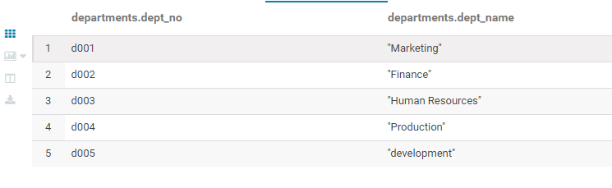

--viewing few records from the dept_emp table

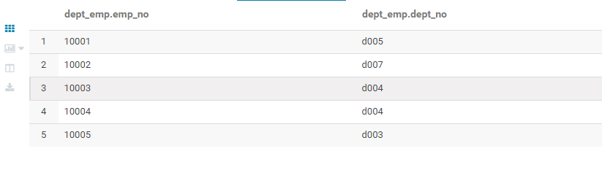

--viewing few records from the dept_manager table

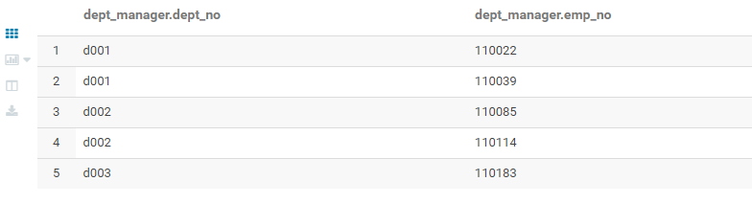

--viewing few records from the employees table

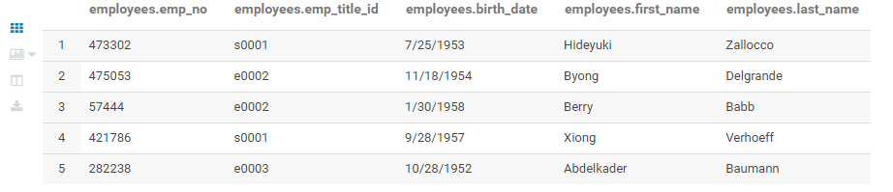

--viewing few records from the salaries table

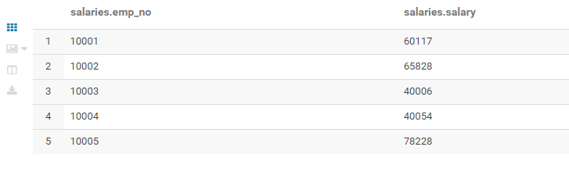

--viewing few records from the titles table

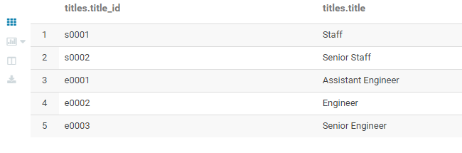

EDA

--A list showing employee number, last name, first name, sex, and salary for each employee1.

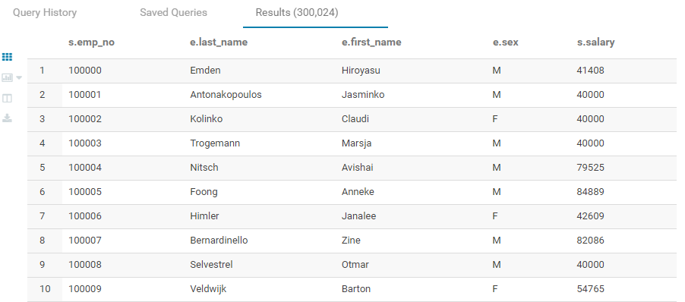

--List employees who were hired in 1986

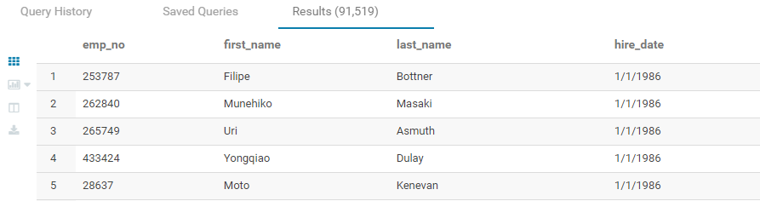

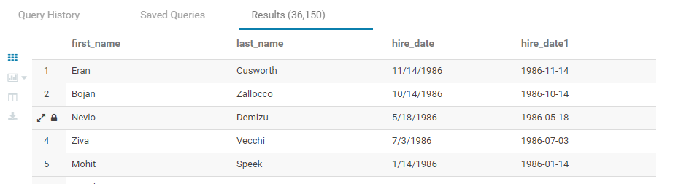

--List the manager of each department with the following information: department number, department name, the manager's employee number, last name, first name.

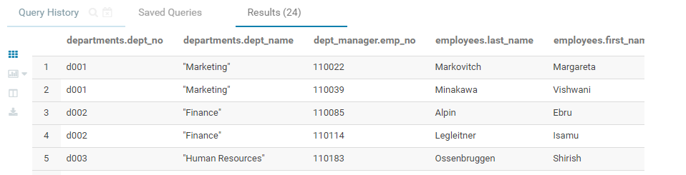

-- List the department of each employee with the following information: employee number, last name, first name, and department name.

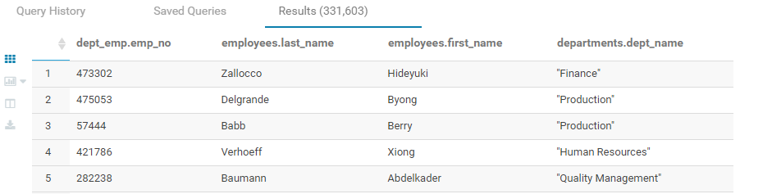

-- List first name, last name, and sex for employees whose first name is "Hercules" and last names begin with "B."

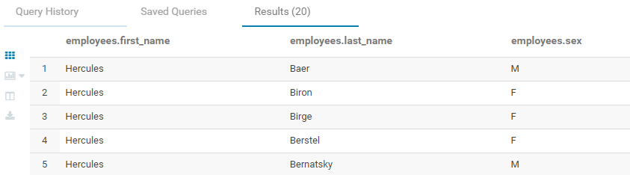

--List all employees in the Sales and Development departments, including their employee number, last name, first name, and department name.

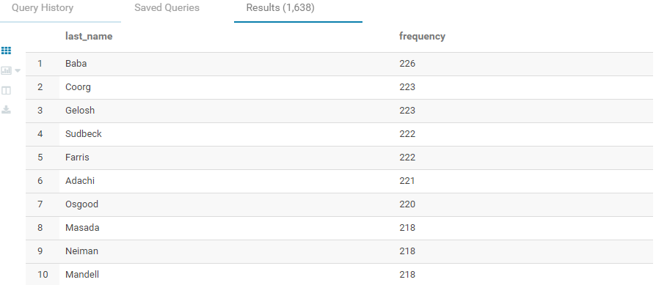

--Histogram to show the salary distribution among the employees

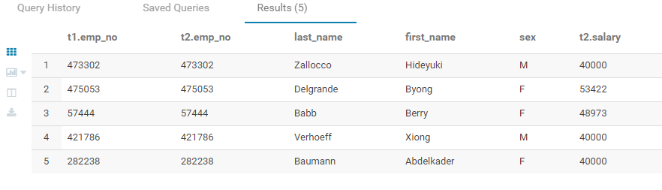

--Bar graph to show the average salary per title with respect to designation

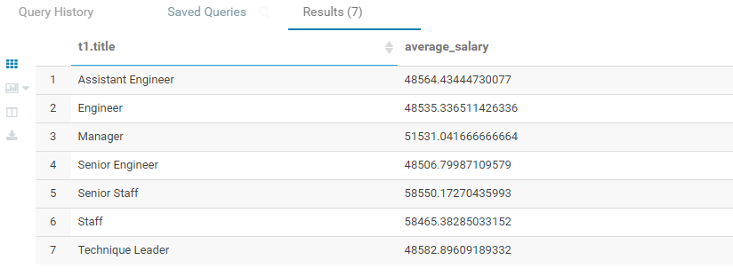

Average salary of employees based on gender.

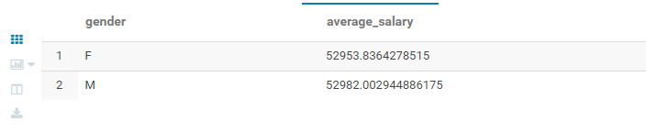

Number of employees according to desingnation.

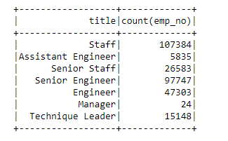

Gender distribution of employees

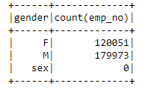

Bar graph to show the average salary per title with respect to designation

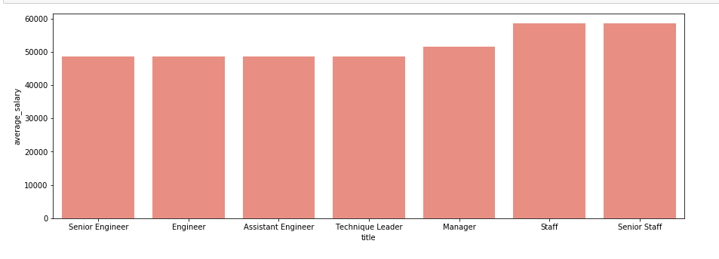

Histogram to show the salary distribution among the employees

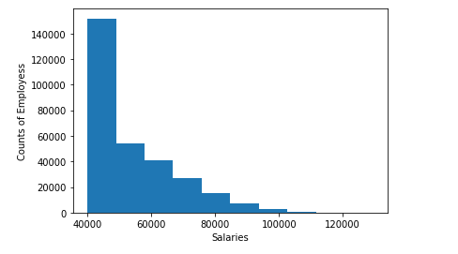

Count of employees based on their performance rating.

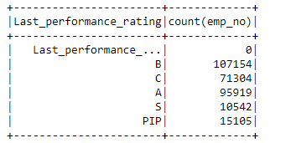

Highest paid employees in the organization.

