**Annuity Bene Services**

Annuities Bene Services Track:. It is a team that tries to find out who is the beneficiary for the particular policy. The payment will either be released to the beneficiary or the details will be passed on to the other team which handles unclaimed amounts. Bene is a short form for Beneficiary

More details about this transition: This is a new transition that we had pitched for last year. Due diligence has been conducted.It comprises of 4 processes

**4 processes:**

1. **Follow up letters**
2. **APO-abandoned property operations**
3. **RSA Validation**
4. **Lumpsum**
5. **Follow-up letters:** is for those policy holders whom we have to make payments. The policy holders are usually the beneficiary.
6. **APO:** If you are not able to find out who the fund is, then u will transfer the property to operations team. This is an internal team.

**3.RSA Validation:** is a report. Every month Prudential send out a report to us. It contains information about who have bereaved. This file is received with a monthly frequency, The work in this process is to check each entry whether payment is applicable or not. If there is death benefit payable then only the payment is made. Out of the four process RSA validation is the simplest one.

**4.Lumpsum:** is a process where you disperse the payment. These are the requests where the team will receive in their system called TEP. Lumpsum means all the amount in one go. Lumpsum is one way where we can disburse the payment in one go. Here the team checks if there is already a claim for the existing policy. There will also be a good order checklist to know if everything is verified or not by operations team. If the payment is not to be made then a letter will be sent out to the policy holder that we cannot make the payment.

LAM -lead Assistant Manager-Ranjan Bannerjee

**How to update the stakeholders on a daily basis?**

We send them trackers on a daily basis.

**ABS Transition Tracker:**

Is a tracker that is shared on a daily basis. The following are the tabs in the tracker.

* **KT Schedule & Status:** is shared on a daily basis. The contents in this tab is also there in Weekly tracker.
* **Attendance tracker:** is where we capture the attendance for the batch.
* **Systems logging:** is done in the beginning of the batch. This is done to check if accesses are working. Even the systems accesses are tracked on a regular basis. It could be possible that one or two of them can struggle with accesses. Even this is tracked.
* **KT Assessment:** Here in this tab we track the scores on a regular basis.
* Risks: If there are any risks those should be listed(Can Suhel give certain examples of Risks)
* Issues: Go through issues
* **BGC & Drug test**: is the back ground checks that are to be done. Depending upon the process that you are joining back gorund check items will be shared by recruitment team(Back ground checks)
* If there are additional checks to be done this will be clearly defined in Statement of work. If there are five category of checks as defined by Prudential than only those checks to be done.

From whom did Suhail get these details from to update in tracker Suhel said he will share the latest implementation plan

**Statement of work:**

This is document what we need for every transition. If it is existing client then we will have to use it. Jagan might have it.

Details mentioned are :

* What are the processes,
* How many FTEs,
* Working hours(Indian holidays we will have to discuss with client & then take holiday)
* Business holidays
* Key mile stones
* When is Ramp start when is Steady state,
* Scope & out of scope
* Ramp Plan
* List of applications
* Bpromt: application is the one that tracks the time of production hours logged in by operations team.
* Name of stakeholders (check with Suhail)
* Billing amount of transition manager is mentioned USD 1200 Per week
* The X denotes it is FTE based as per below screen shot. Prudential is FTE based billing.

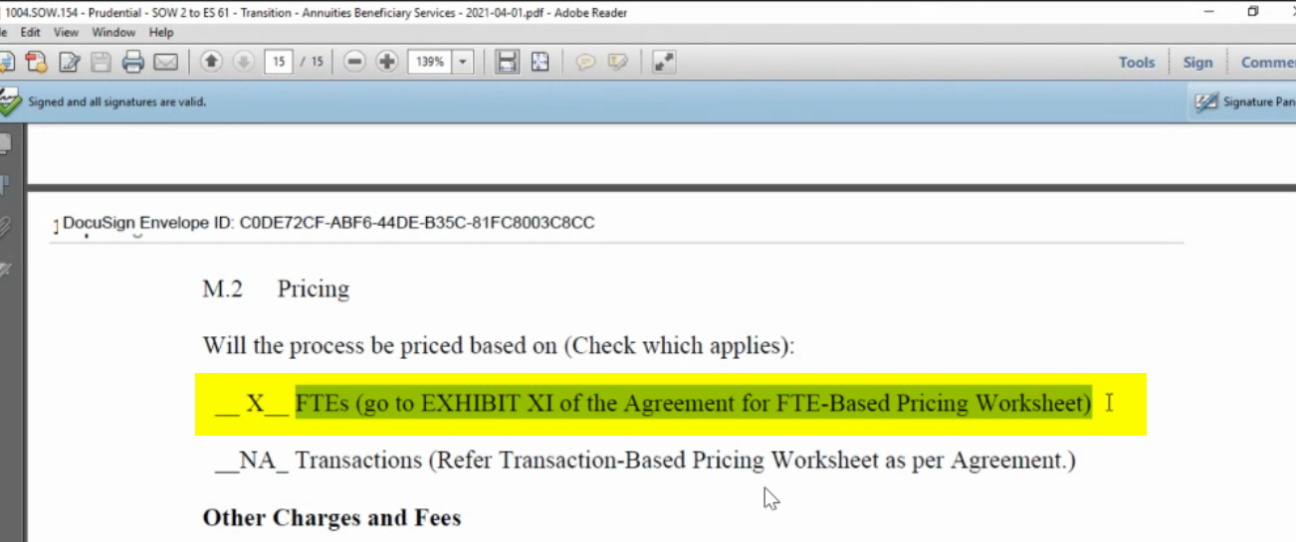

The SOW will figure in Engagement schedule which we don’t have to work on time & time again. We only have to work on Statement of Work

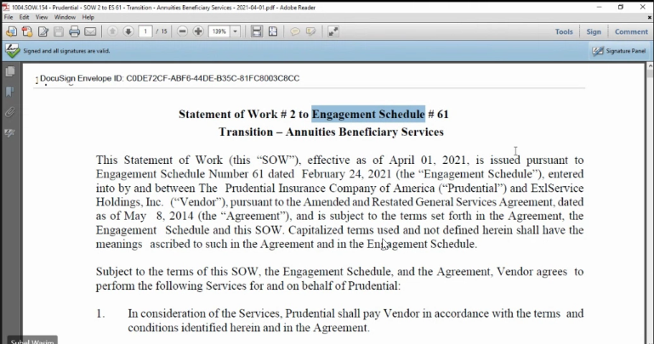

**Due Diligence**

**When is due diligence done?**

It is done after signing of Letter of Intent, MSA & SOW

As is Analysis report: Here in this report we are trying to ascertain how the process is, do they have SOPs, do they have any training reports,

It has details like:

* Number of processes
* How the work is allocated among these processes
* How does the reporting happen, what are the reports, what is the frequency of this report.
* Systems & applications:
* : Quality framework: As is quality methodology:
* Z`: Here the client provides what is the AHT the client is mentioning as on today. What is their target of the work to be done,
* Training framework: is a standard slide
* Migration level assessment : is a kind of calculator we have, we just put in the information.

QTS: is the system that Prudential uses to asses to load all sort of details relating to quality.

BPC :is one of the systems that Operations team works on in Prudential.

Make note of stake holders

LAM -lead Assistant Manager-Ranjan Bannerjee

Due diligence To be report:

**DUE DILIGENCE TO BE REPORT:**

How the process should be is what is mentioned in the report.

Sheet 2: Scope, approaches & deliverables

Process understanding for each process to be mentioned & what is the complexity of each process based on levels

What is the FTE estimation?

What is the KT model to be chosen, here in Prudential it is Remote train the team is the approach

What is the proposed implementation options to the client?

What is proposed ramps for each of the processes for few weeks along with targets

What is the support required from Prudential

Production work flow & quality work flow process maps

Sheet 3: Process Understanding : is what we think the process is . Anything that stands out for example 1200 cases at a time in Process overview is mentioned explicitely.

Sheet 7: Executive Summary

Delivery location details

**Weekly Tracker:**

* Process training update
* Issues and risks if any
* Training updates

1. List of documents that Suhel has taken me through

* 1 Statement of work
* Due Diligence As is & to be
* Weekly report
* Daily report
* MRA Lumpsum payments
* ABS

What is Annuities?

An annuity is a plan that helps you to get a regular payment for life after making a lump sum investment. The life insurance company invests the money of the investor and pays back the returns generated from it.