**Introduction**

**Transitions Walkthrough Session 1 Date 28/07/2021**

**Annuities Bene Services Track:** Bene is a short form for Beneficiary. It is a team that tries to find out who is the beneficiary for the particular policy. Then they release the payment to the beneficiary or pass on the details to the other team which handles unclaimed amounts.

**More details about this transition:** This is a new transition that we had pitched for last year. Then a due diligence was conducted & that is how you got this process. It comprises of 4 processes. Rest details to be shared by Suhel at a later stage.

Suhel has been involved in the process form the due diligence stage. That is the time we do more interaction about the process & do the documentation.

The transition had started in April. But the actual training & hiring started at a later date(did not say the month).

**Transition Walkthrough:**

The methodology that we follow is Smart X.

It was firstly called as MOST then Smart and finally to Smart X.

MOST was based on Six sigma.

SMART was based on agile principles.

**Smart X methodology** it is more connected to system, tools, governance. There are several tools involved in Smart X such as Smart Track, Smart solve.

**Smart Track** is a tool that can provided to client from access perspective. This tool can also send out reminders etc.

Smart Solve : is a new tool (need more details here)

**TcoE**: is a team . The expansion for abbreviation is Transition Center for Excellence. It is a team that ensures we have a robust mechanism in reviewing everything that is done. Right from due diligence , execution stage ,ramp stage etc they are involved. There is checklist that needs to be completed which needs to verified.

**SnagIT** is a tool used to capture screen shots. No need to have access as it has to be used to documentation team.

Note: Go live phase is called as Steady state. Pilot phase is called as Ramp. SOP Transition team never works.

**Smart X sheet3:**

Smart stands for Systematic Methodology Approach & Rigor to Transition Excellence

X stands for Excellence

It is suitable across platforms such as Operation, Analystics & Platform businesses

1. Operations:

a) New client / Geography Program set up

b) Process transitions

c)Reverse transitions

2. Analytics set up

3.Platform set up

What does P1 stands for

What does A1 stands for

3 Phases of Smart X methodology:

1. Discover & Design
2. Transition
3. Service delivery
4. Discover & Design: is where we do our own due diligence. We see the process, process maps are created, .So discover is what the client is doing & based on that we design the solution. This also involves validating what the client would have provided.
5. Transition: is just the solution being implemented which was initially pitched in to the client.
6. Service delivery: is the phase where everything goes well.

**Smart X: involves 10 main project areas:**

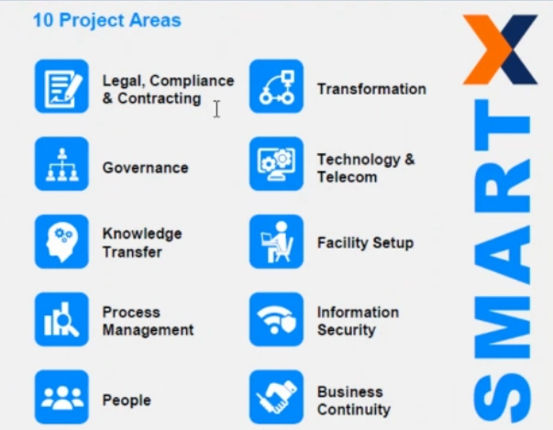

1. **Legal, Compliance & contracting:** we have to do the contracting.Send these documents to legal team. Before we do any work for the client. For Prudential contracting is there. In contracting we usually work on Statement of work & Engagement schedules. Under MSA we have an engagement schedule.

**Note:** All the 10 areas we manage as a transition.

1. **In governance:** we as Transition managers we are working end to end. But we are just overseeing it & check if every thing is on track. For example, for Bene services the following aspects we do, set up an internal meeting, external meeting, check where we are, setting up discussions with technology team. On people front you will be working with HR team to check if recruitment has happened. Just following up with people, making sure if everything is ready. For meeting minutes, we just send out in an email.

**Tasks involved in all project areas for Transition manager:**

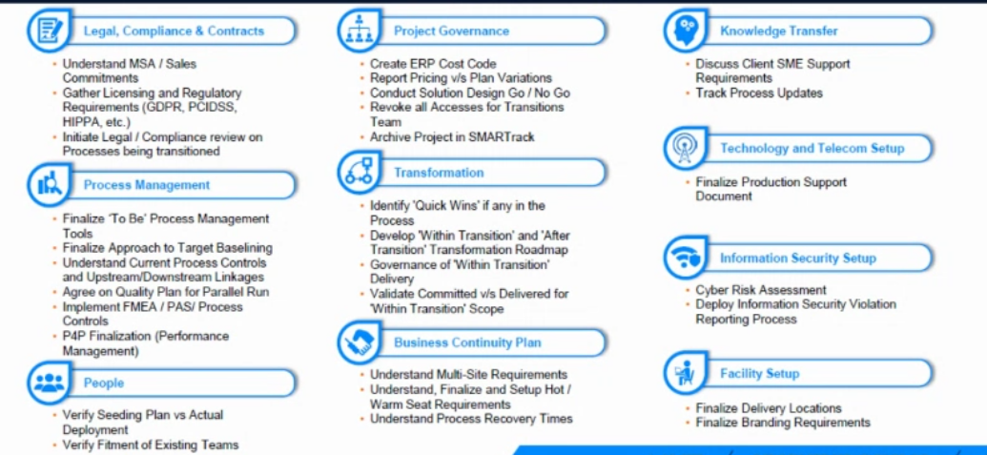

Ask questions after reviewing these tasks.

Is there a chronological order or step by step approach

Note: HIPAA is the regulation in US for health care.

FMEA: We have a quality team who prepare it, we run it through operations & share it to the client.

Identify quick wins: While doing the transitions there is an element of transformation being done. some check if anything can be automated or any suggestions can be given. We only do this once the business is in steady phase.

**Go No go check lists:**

We have 128 check points to review as part of our work. The file provided by Suhel is the check list go through them.

Each tab has a phase as check list

Other questions:

This checklist Go no Go checklist do u keep sending it to some one as an update on a regular basis or is it that I keep this updated till end of transitions & save it finally in the system. If yes then what is intervals that u send.

**Clarifications:**

Smart Solve: Even Suhel has not used. It is new tool.

Go No go checklist: The steps are usually in chronological order.

Go Gono checklist:Whom is it sent: It is only for our internal review. TCOE is the team which reviews the Go no Go checklist . Whenever there is a review u will update the check list & also the link for each documents in Smart Track. No matter which phase u r in, this gO no go checklist serves as a bible. There is a tab called as A1 Shadow Readiness Tollgate which is not used. There is a tab Project Closure Toll gate which is not related to Transition team. Probably it might

In Pdf P4P finalisation : is related to incentives for which which we are not responsible. If there is then we will have to work with operations team. The budget is from operations only.

Under project governance….create ERP post code: Here we just have to send out an email to a SPOC for a particular process. For Prudential it is Sheila Adhikari. You will need a project code or a cost code when it is in Transition. It is used internally & Shiela Adhikari is the person who will get this details.

Under BCP>>>>>What is understand process recovery times>>Process recovery is the process fo how quickly we can set up the process in some other site.

Project Governance: What is report pricing vs plan variations>Pricing work in most of the cases when we are doing a remote transition will not apply. Pricing will usually remain constant. Pricing will vary if we have our remote trainers travel onsite. We ill inform about Per diem, inform two or more people will be travelling. Now if the travel comes up at the last month when the booking must be done in last minute so it varies higher. So what we do is that there is list of standard items which will be mentioned & we will compare as to what are the actuals & mentioned the same.

**Explanation**

**Smart X methodologies file:**

Analytics & Platform we are not working as of now.

1. **In Program Set up:**

It is split into two phases of transition

1. Discover & Design
2. Transition & Service delivery

What ever comes in Discover & Design is mentioned below under different headers.

For example, In discover & design phase, in the heading Program governance all topics that come under it are 2.1 to 2.14.

**Meaning of certain topics:**

New program set up:

Knowledge Transfer:

Assess as is documentation: Here we are ascertaining how the client is placed today. Do they have the SOP, training guides. With Prudential we have noticed that they have all manuals & SOP. Assess as is documentation means that whether the client has details to conduct the training.

1. Process Transition: It is also divided into three phases:

a) Discover & Design

b) Transition

c)Service delivery

Reverse transition: is something not in common. There is not much reverse transition in place.

Responsibility Matrix tab: It tells what are the various things that we are suppose to do. Each function has its own responsibilities.

Go no go checklist: is not needed for analytics & platform set up

Suhel has never used the templates from shared drive. The templates provided smart x methodologies

Note: For Prudential we have noticed that the client has most of the documentations

**Responsibility Transition**