HT16K33 0.56" 4-Digit 7-Segment Display Module

Technical Datasheet & Developer Guide
Document Format: A4
Revision: 1.0 Date: 23 July 2026

Cover Page
HT16K33 0.56" 4-Digit 7-Segment Display Module Technical Datasheet & Developer Guide
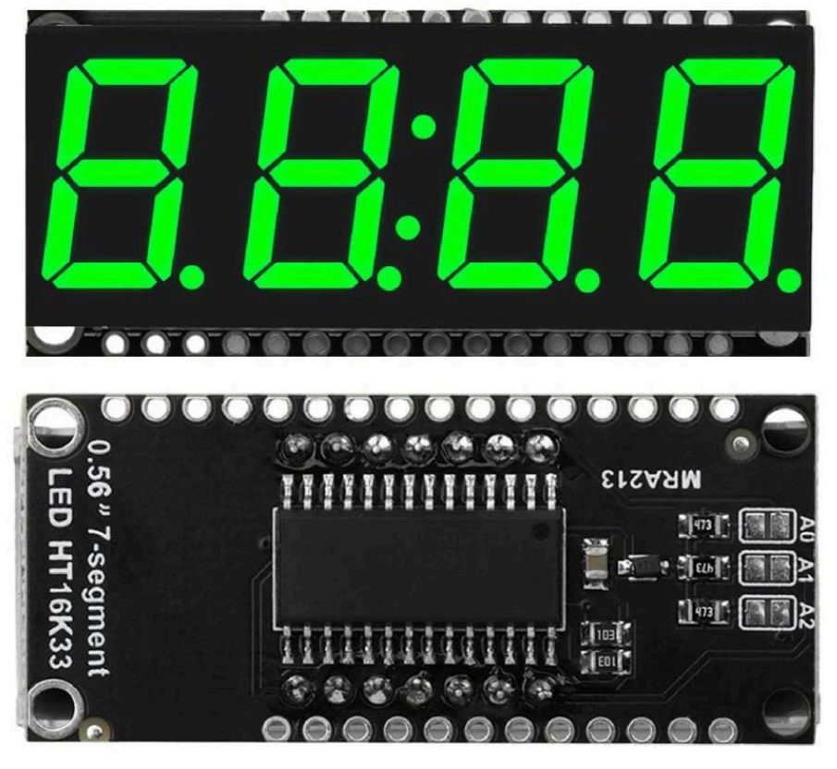

Table of Contents
- Overview
- Features
- Applications
- Electrical Specifications
- Pinout
- HT16K33 Driver Architecture
- Segment Mapping
- Physical Characteristics
- Wiring Guide
- Example Code (Arduino, ESP32, Raspberry Pi)
- Developer Notes
- Revision History

1. Overview
The HT16K33 0.56" 4-Digit 7-Segment Display Module is a compact, I²C-controlled numeric display suitable for clocks, counters, timers, and embedded instrumentation. It integrates a bright 4-digit 7-segment LED display with a central colon indicator and an HT16K33 LED driver.
The PCB marking MRA213 is a manufacturer board identifier and not the part number.

2. Features
- 4 × 7-segment digits (0.56" height)
- Central colon indicator
- HT16K33 LED driver (Holtek)
- I²C interface (up to 400 kHz)
- Adjustable brightness (16 levels)
- 8 selectable I²C addresses (0x70–0x77)
- On-board current-limit resistors
- 3 address-select pins (A0, A1, A2)
- 3.3 V or 5 V operation
- Low power consumption
- Compact PCB footprint

3. Applications
- Digital clocks
- Timers
- Counters
- Frequency displays
- Embedded control panels
- Microcontroller projects (Arduino, ESP32, Raspberry Pi, STM32)

4. Electrical Specifications

4.1 Power
Parameter | Value
Operating Voltage | 3.3–5.0 V
Typical Current | 5–20 mA (depends on brightness & segments lit)
LED Forward Voltage | ~2.0 V (green)
HT16K33 Supply Current | ~1 mA

4.2 I²C Interface
Parameter | Value
Protocol | I²C
Max Clock | 400 kHz
Default Address | 0x70
Address Range | 0x70–0x77
Address pins:
- A0 → +1
- A1 → +2
- A2 → +4
Example: A0=HIGH, A2=HIGH → 0x70 + 1 + 4 = 0x75

5. Pinout
Pin | Function
VCC | Power input (3.3–5 V)
GND | Ground
SDA | I²C data
SCL | I²C clock
A0 | Address select
A1 | Address select
A2 | Address select

6. HT16K33 Driver Architecture
The HT16K33 is a RAM-mapped LED driver with:
- 128 bytes of display RAM
- 16 brightness levels
- Built-in oscillator
- Optional key-scan matrix (unused on this module)

6.1 Display RAM
Each digit uses 2 bytes. Colon is controlled via register 0x04 bit 0.

6.2 Brightness Control
Brightness command:
Code
0xE0 | brightness
Where brightness = 0–15.

7. Segment Mapping
Digit positions (left to right):
Digit | RAM Address
D0 | 0x00–0x01
D1 | 0x02–0x03
Colon | 0x04 bit 0
D2 | 0x06–0x07
D3 | 0x08–0x09
Segment layout:
Code
--A--
| |
F B
| |
--G--
| |
E C
| |
--D--

8. Physical Characteristics
Parameter | Value
Digit Height | 0.56"
PCB Size | ~50 mm × 25 mm
Mounting | 4-pin header + 3 address pins
LED Colour | Green

9. Wiring Guide

Microcontroller → Module
MCU Pin | Module Pin
3.3/5 V | VCC
GND | GND
SDA | SDA
SCL | SCL
Pull-ups (4.7 kΩ) are typically included on the module.

10. Example Code

Arduino
cpp
#include <Wire.h>
#include "HT16K33.h"

HT16K33 display;

void setup() {
Wire.begin();
display.begin(0x70); // Default address
display.setBrightness(10);
}

void loop() {
display.print("1234");
display.setColon(true);
delay(1000);
}

ESP32 (MicroPython)
python
from ht16k33 import HT16K33
from machine import I2C, Pin
import time

i2c = I2C(0, scl=Pin(22), sda=Pin(21))
disp = HT16K33(i2c)

disp.brightness(10)
disp.print("4321")
disp.colon(True)
time.sleep(1)

Raspberry Pi (Python)
python
from ht16k33 import HT16K33
import smbus
import time

bus = smbus.SMBus(1)
disp = HT16K33(bus)

disp.set_brightness(8)
disp.print("9999")
disp.set_colon(True)
time.sleep(1)

11. Developer Notes
- The module is functionally identical to Adafruit’s HT16K33 backpacks.
- The PCB marking MRA213 is not a part number.
- The HT16K33 can drive up to 128 LEDs; this module uses only a subset.
- Colon control is independent of digit control.
- Brightness changes do not affect power stability.

12. Revision History
Revision | Description
1.0 | Initial release of combined datasheet + developer guide

