# Model Experimentation

## Screenshot of MLflow UI

### Screenshot of all the experiments

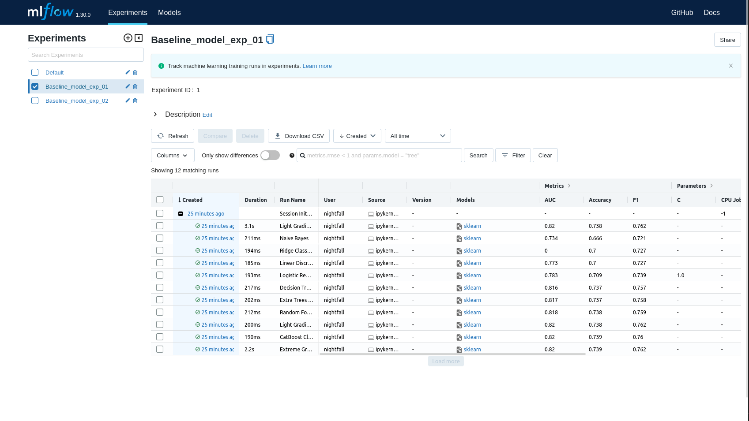

### Screenshot of one experiment with all the artifacts visible

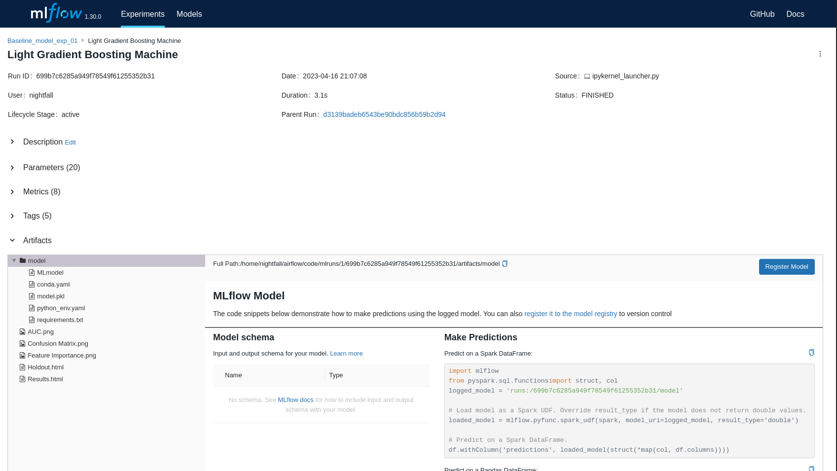

## Screenshot of MLflow UI after dropping features

### Screenshot of all the experiments

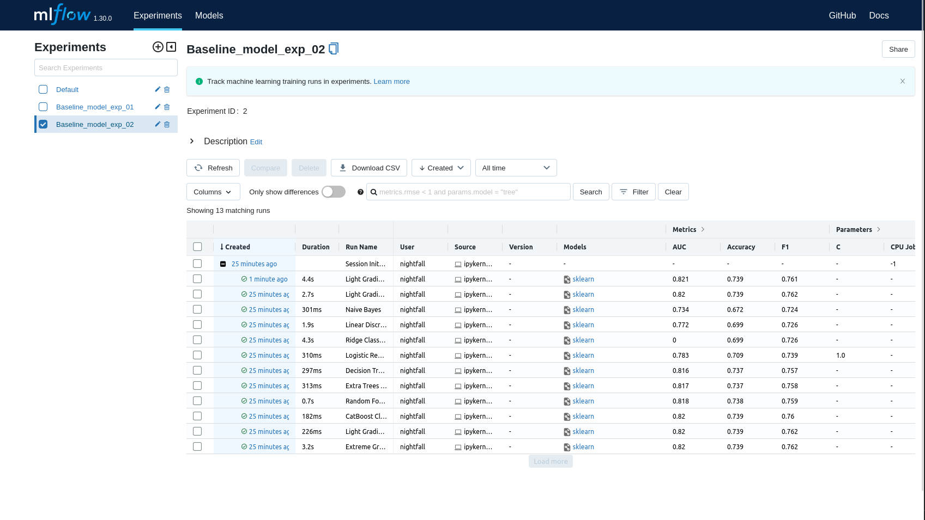

### Screenshot of one experiment with all the artifacts visible

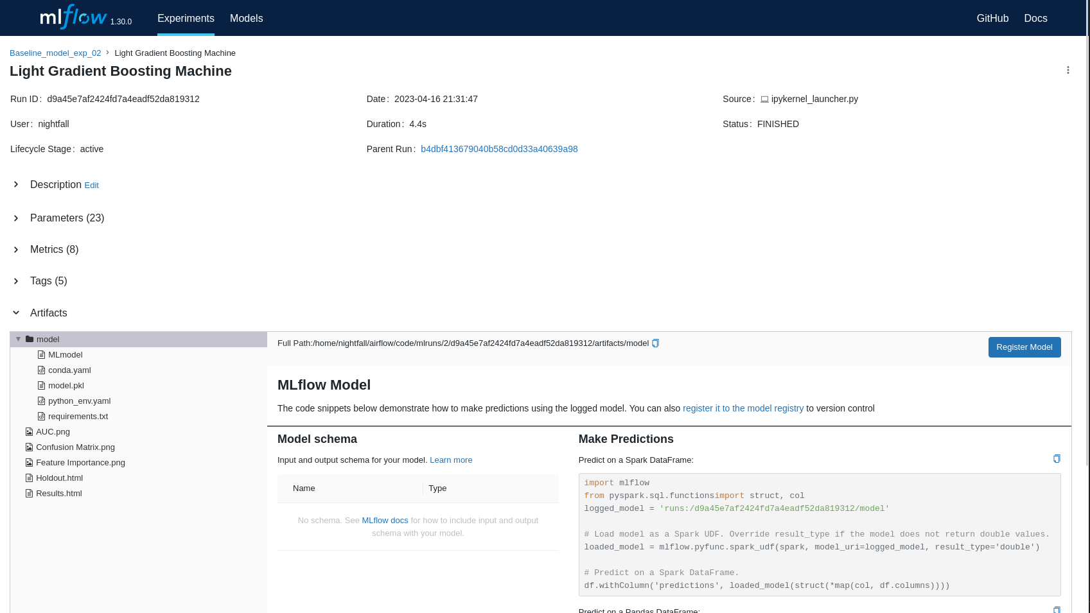

# Data Pipeline

## Screenshot of successful execution Airflow DAG in graph

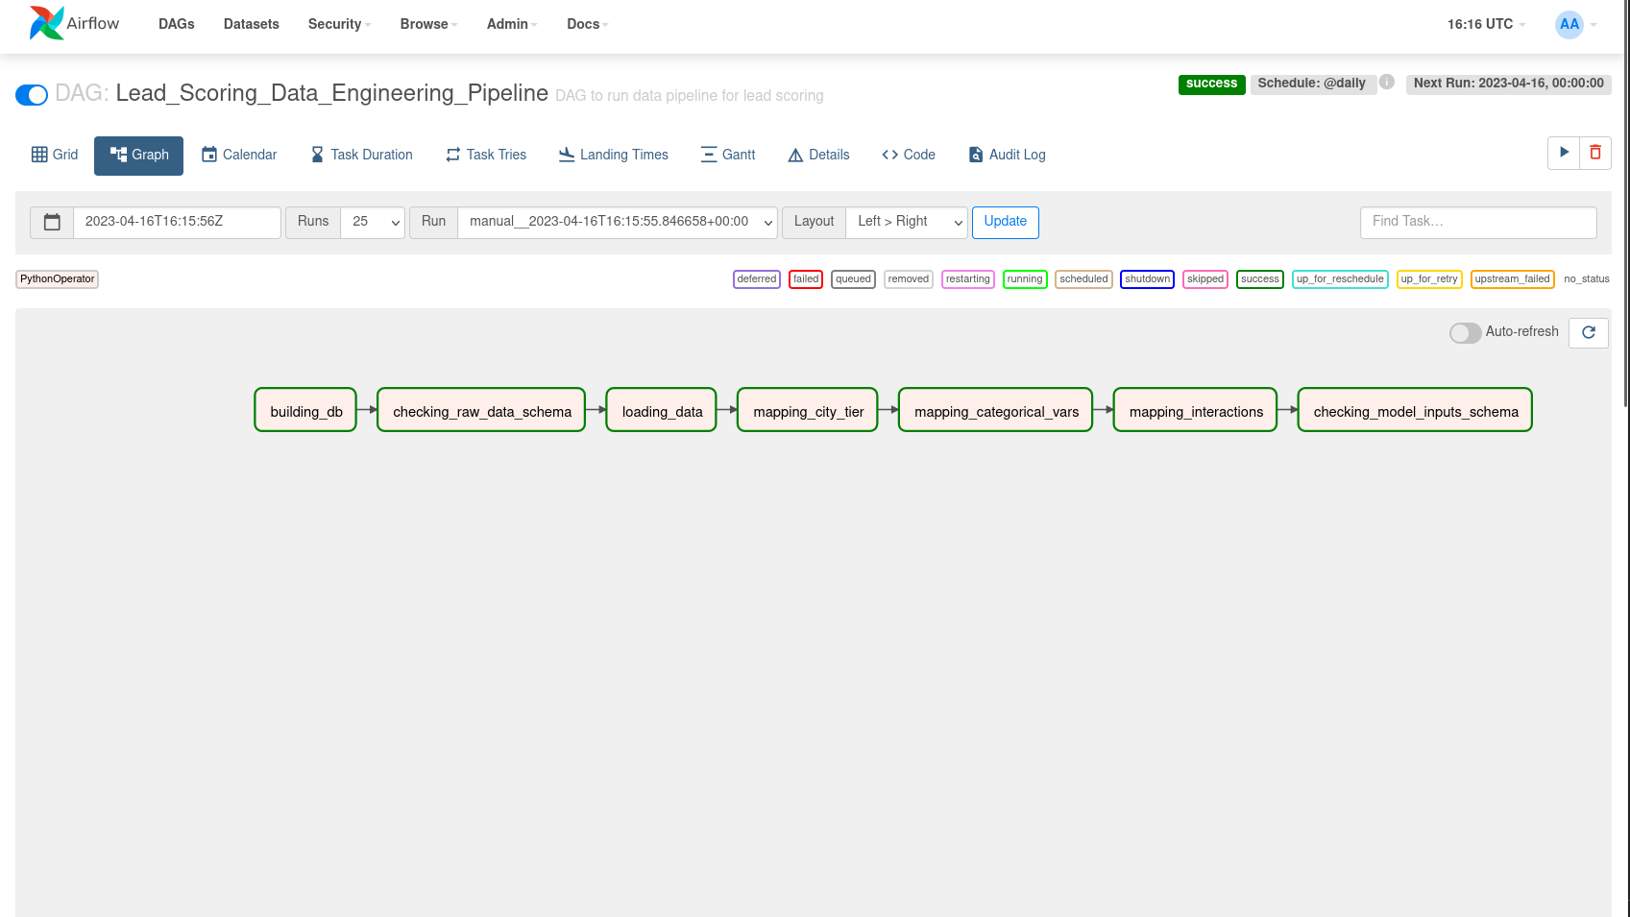

## Screenshot of Airflow UI grid

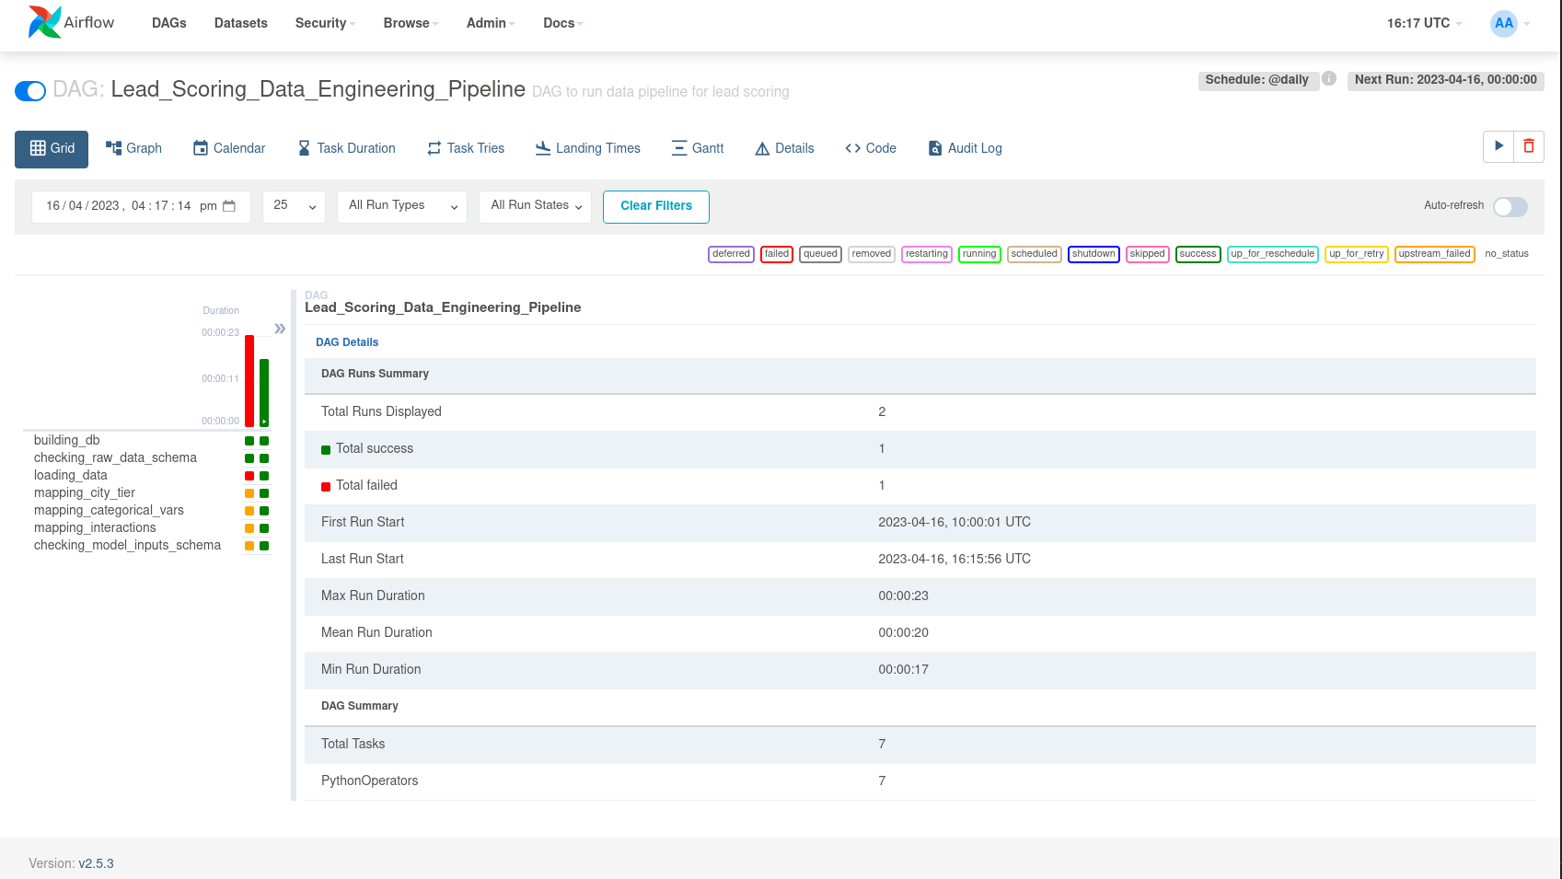

# Training pipeline

## Screenshot of successful execution Airflow DAG in graph

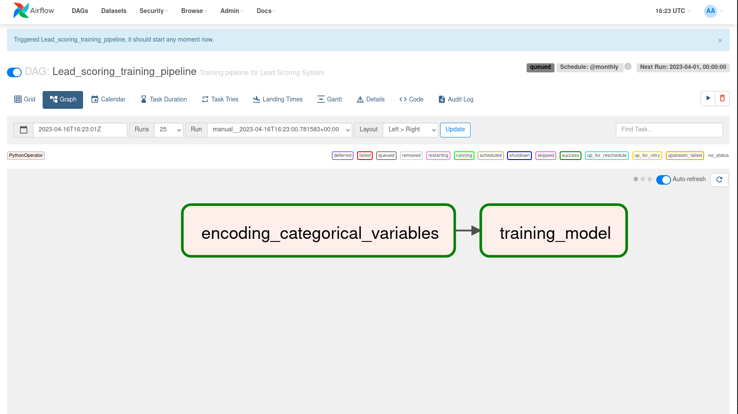

## Screenshot of Airflow UI grid

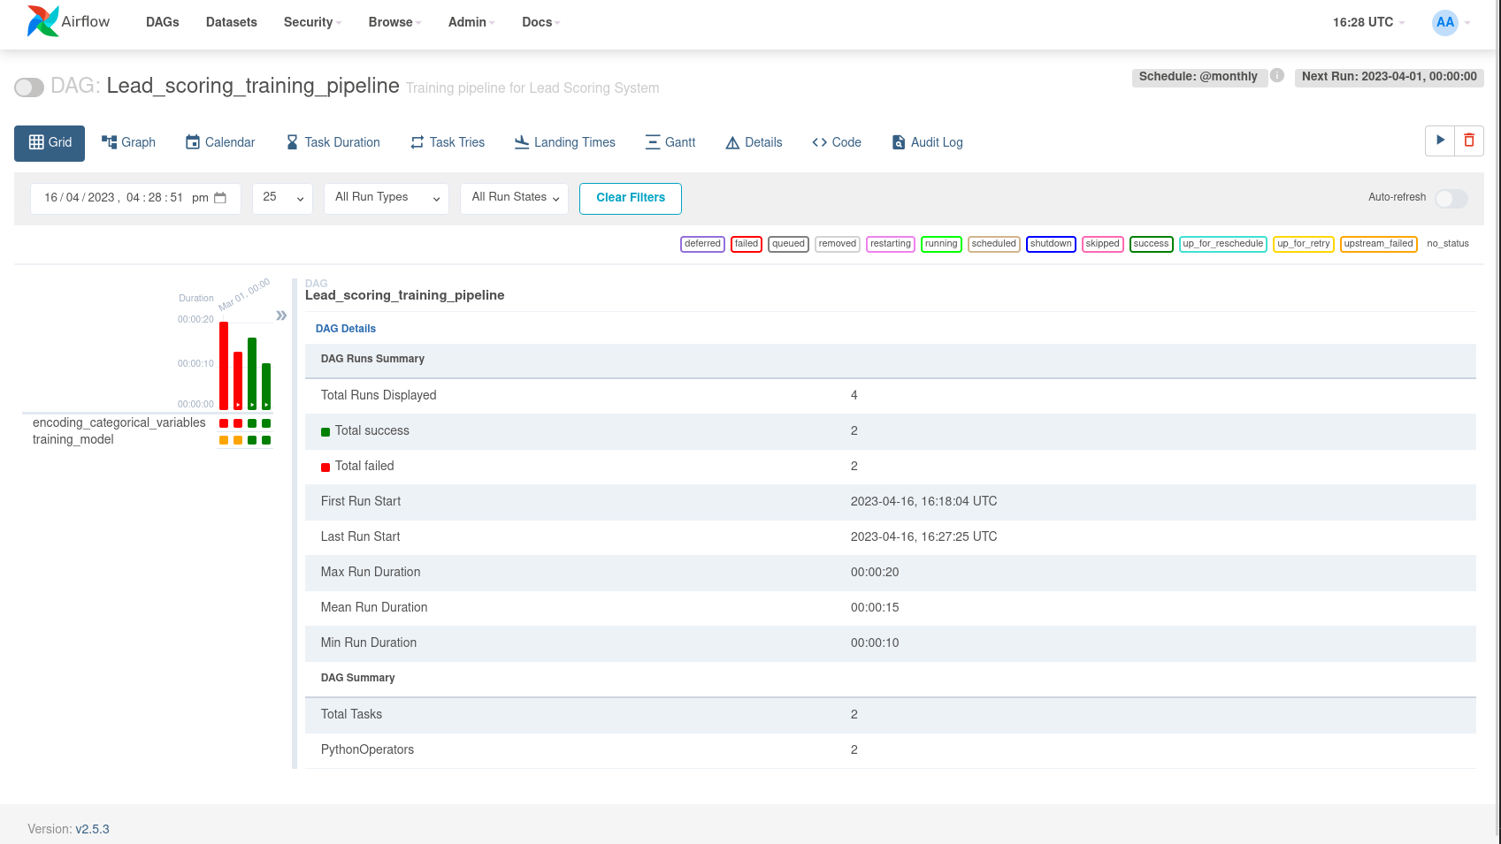

## ML artifacts for training pipeline

### Screenshot of experiments with all the artifacts visible

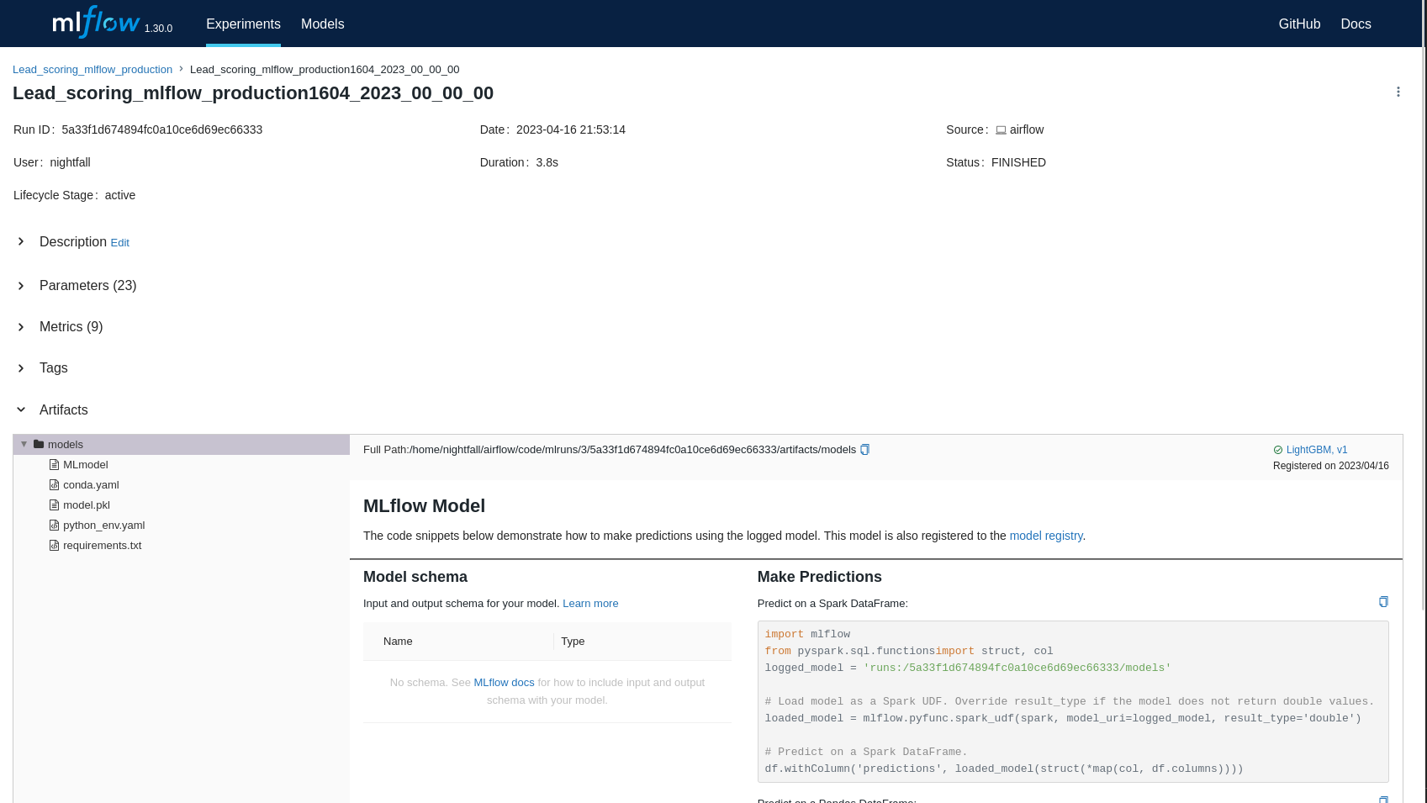

### Screenshot of model registry with model name and stage as 'production'

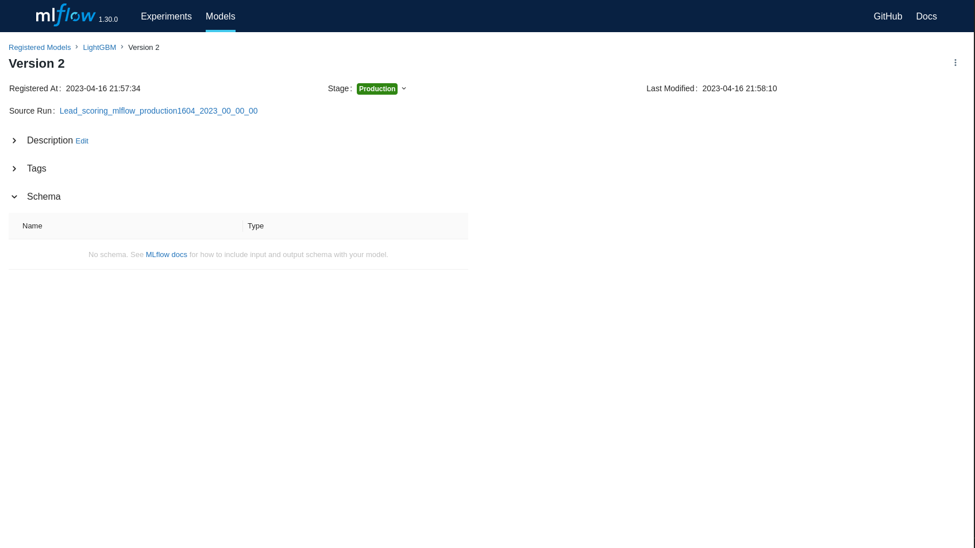

# Inference Pipeline

## Screenshot of successful execution Airflow DAG in graph

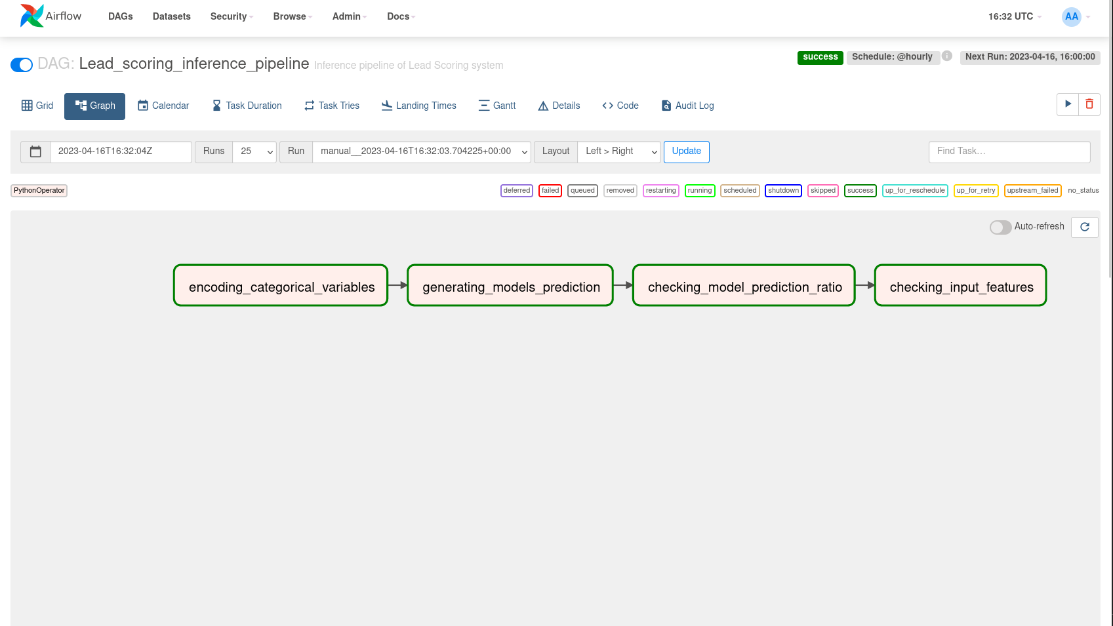

## Screenshot of Airflow UI grid

