CS 6350
ASSIGNMENT 3

Names of students in your group:

Swayam Arora (sxa220196)
Ashraful Islam (axi220026)

Number of free late days used:0
Note: You are allowed a total of 4 free late days for the entire semester. You can use at most 2 for each assignment. After that, there will be a penalty of 10% for each late day.

Please list clearly all the sources/references that you have used in this assignment.
Claude Code
https://www.elastic.co/downloads
https://www.elastic.co/docs/get-started
https://www.elastic.co/kibana
https://newsapi.org/
https://www.elastic.co/blog/getting-started-elasticsearch-query-language
https://www.knowi.com/blog/what-is-elasticsearch-used-for/

Question 1
News Data Source & Results:

We used NewsAPI as the real-time source, querying the get_everything endpoint with rotating keywords (technology, politics, economy, sports, science, health, climate, AI, war, election, and more) every 60 seconds to ensure a continuous stream of fresh, deduplicated articles. We extracted fields from each article: title, description, content, source, url, publishedAt, and a fetched_at timestamp, and wrote each article as a JSON record to Kafka topic news-raw. A PySpark Structured Streaming job consumed news-raw, applied spaCy NER (using the en_core_web_sm model) to each article's combined text field, and maintained running counts of all detected named entities across micro-batches using a stateful groupBy aggregation in complete output mode. Every 30 seconds, the aggregated entity counts were flushed to a second Kafka topic ner-counts, which Logstash forwarded to Elasticsearch (index: ner-entity-counts) using upsert semantics so each document always reflects the latest running count.
Finally, Kibana was used to display a horizontal bar chart of the top 10 most frequent named entities over time, with the dashboard set to auto-refresh every 30 seconds to reflect live updates from the streaming pipeline.called test as the listener
15 minutes:
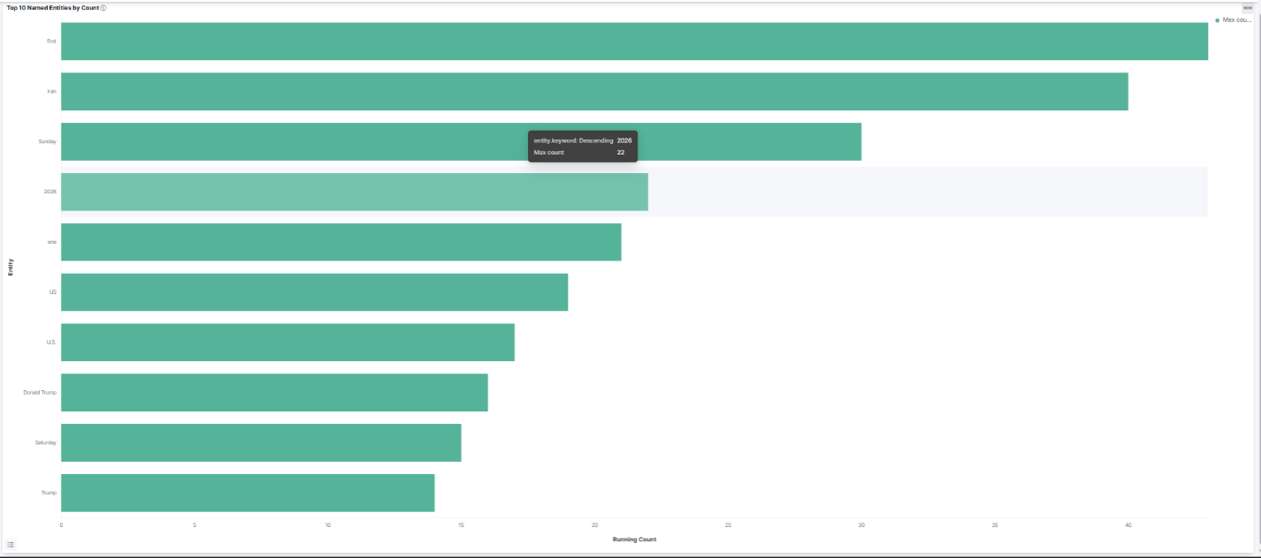

30 minutes:
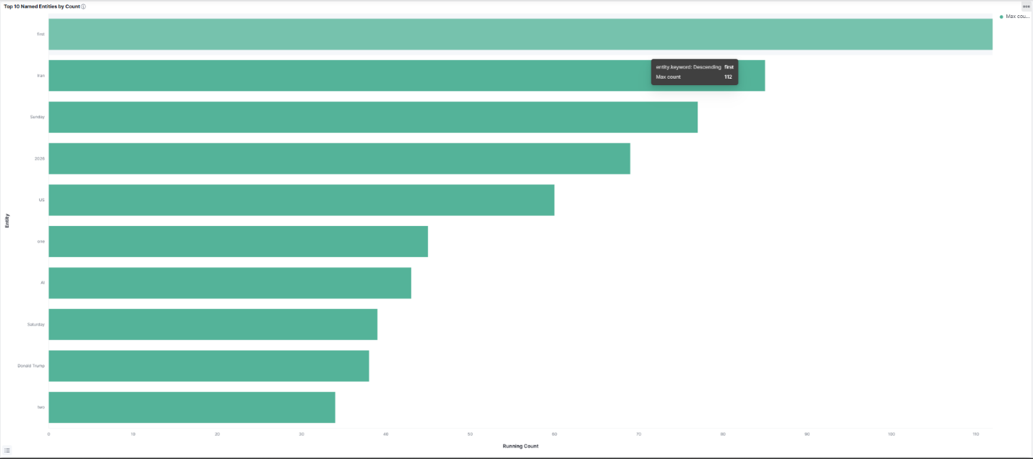

45 minutes:
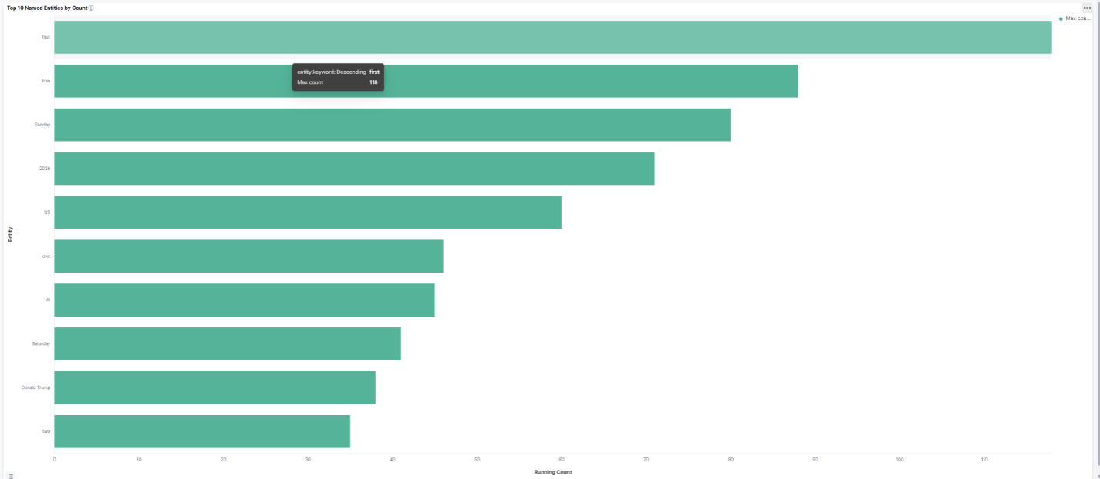
60 minutes:
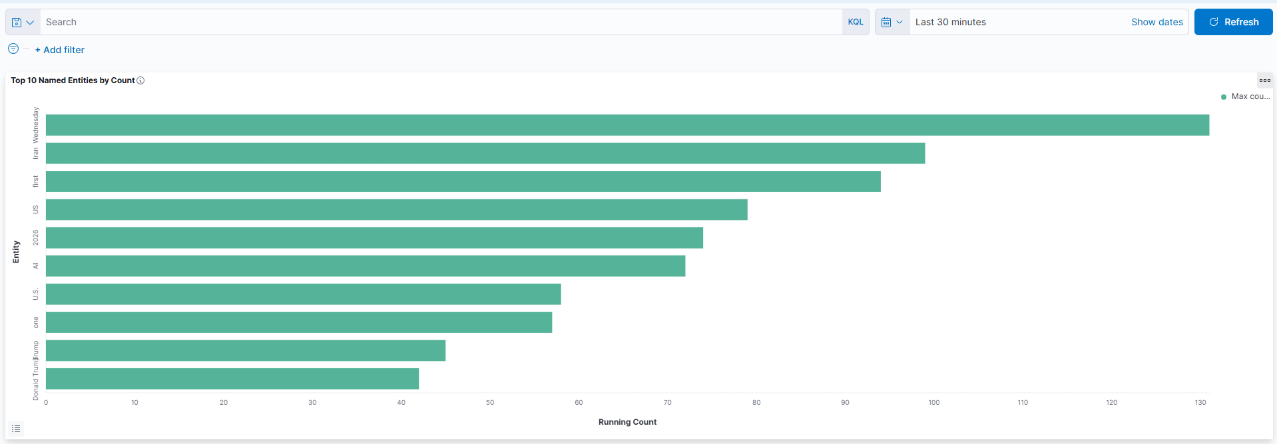

Question 2
Musae-Github Network Analysis:

We used analyzed the **musae-github** social network from SNAP with Spark GraphFrames.

- Dataset page: https://snap.stanford.edu/data/github-social.html
- Archive (downloaded automatically at runtime): https://snap.stanford.edu/data/git_web_ml.zip
- ~37,700 GitHub developers, ~289,003 mutual-follower edges (undirected),
each doubled into two directed edges per the assignment spec.
- Tested with Ubuntu on WSL2. Any Spark 3.5 + Python 3.10+ environment works.

2.3a Top 5 nodes by outdegree (outgoing edges)
==============================================
id | name | outDegree
------+-------------------+----------
31890 | dalinhuang99 | 9458
27803 | nfultz | 7085
35773 | addyosmani | 3324
19222 | Bunlong | 2958
13638 | gabrielpconceicao | 2468

>> Very simple count of the number of accounts these users follow a.k.a. the outdegree in this case. This lists the top 5 users with most outgoing connections. From this we can also infer they are active users, part of a large community on GitHub.

2.3b Top 5 nodes by indegree (incoming edges)
=============================================
id | name | inDegree
------+-------------------+---------
31890 | dalinhuang99 | 9458
27803 | nfultz | 7085
35773 | addyosmani | 3324
19222 | Bunlong | 2958
13638 | gabrielpconceicao | 2468

>> Very simple count of the number of followers each has a.k.a. the indegree in this case. These the are most popular users in terms of follower count or well-known and well-connected users.

2.3c Top 5 nodes by PageRank (resetProbability=0.15, maxIter=10)
================================================================
id | name | pagerank
------+-------------------+-------------------
31890 | dalinhuang99 | 634.0502986779188
27803 | nfultz | 433.4045041751695
35773 | addyosmani | 190.0493832173293
19222 | Bunlong | 178.00658569996676
13638 | gabrielpconceicao | 147.84127656784105

>> Ran the PageRank algorithm to determine the most well-known/popular/influential GitHub users based on their connections (follows/following vs followers). Here we are not just worried about the count of their connections but their value or influence as well. High scores indicate a well connect user that is also well connected to other influential users. In other words, these users are part of a very popular group or highly influential and close-knit/well-known community of GitHub like an upper echelon of its users by account.

2.3d Top 5 connected components by vertex count
===============================================
component | num_vertices
----------+-------------
0 | 37700

>> The number of components is 1 since all users are connection each other at least once in this graph and can be reachable from each other. Connected components are parts or subgraphs that have a connection between all its nodes regardless of the length of the paths to reach each. If a subgraph doesn’t have any connection to another subgraph, they are separate components. However, in our case, the GitHub community seems to be all connected overall.

2.3e Top 5 vertices by triangle count (ties broken randomly)
============================================================
id | name | triangle_count
------+-------------------+---------------
27803 | nfultz | 80286
31890 | dalinhuang99 | 63205
19222 | Bunlong | 27873
35773 | addyosmani | 22758
13638 | gabrielpconceicao | 19762

>> Triangle counts are counts of 3 mutually connected individual GitHub accounts. (ex: A, B, C have connections A B, A C, & B C). These users have the most triangle count connections or, in other words, have tight community connections to fellow GitHub users and not just a lot of followers.

