Reality Probe: Verifying Physical Edits in Video-Reconstructed Worlds
Swayam Singal
Abstract
A video-reconstructed world can carry physical parameters such as stiffness, damping, or gravity that are later changed by an optimizer or authoring operation. A candidate edit may fit recorded motion better and still make the world respond less faithfully to a new physical interaction. Reality Probe treats that edit as provisional: after the candidate is fixed, a physical observation or intervention withheld from proposal generation is evaluated against both the current and proposed models. The result is SUPPORT, VETO, or UNRESOLVED, so weak evidence cannot silently overwrite persistent physical state.
The experiments show that the usefulness of this gate depends on the information in the physical test. Controlled studies contain edits that improve ordinary held-out fit while worsening an untouched physical target, and several numerically stable probes remain too weak to distinguish the competing models. On ten previously unopened videos from the IRIS pendulum benchmark, a finite-amplitude period test reaches 90/110 correct decisions (81.8%), compared with 40/110 (36.4%) for the common small-angle period approximation; all ten placebo cases remain UNRESOLVED. A separately predefined free-fall transfer protocol then fails untouched validation, so its final split remains unopened. Reality Probe therefore provides an evidence-gated commit transaction rather than a universal verifier: fit proposes the edit, a reserved physical test judges it, and unsupported changes remain uncommitted.

Introduction
A reconstructed scene may outlive the capture session that created it. An animation or authoring system may change material stiffness; a digital twin may recalibrate damping; a robotics world model may update contact or compliance. In each case the scene already contains persistent physical state, and a new parameter value is a proposed state transition rather than merely another number produced by an optimizer.
Consider a cloth reconstructed from video. An optimizer proposes a new stiffness because it reduces trajectory error on ordinary held-out frames. Committing that value immediately would assume that better observational fit means better future physical behaviour. The proposal could instead respond worse when the cloth is pulled, struck, or loaded outside the fitting sequence. This paper addresses that gap between proposing a physical edit and accepting it.
By a video-reconstructed world, we mean a scene recovered from observations that stores geometry or appearance together with simulator-facing state or parameters. Physics-aware radiance fields, Gaussian representations, and differentiable simulators increasingly combine reconstruction, parameter estimation, and interaction synthesis (Xuan Li et al. 2023; Xie et al. 2024; Zhang et al. 2024; Liu et al. 2025; Rho et al. 2026; Wada et al. 2026; Hu et al. 2019, 2020). A physical edit can therefore come from an optimizer, a scripted calibration step, an authoring interface, or a learned estimator. Reality Probe is agnostic to that proposal mechanism. It begins only after the current model $M_{0}$ and candidate $M_{1}$ are fixed.
Inverse physics asks which parameters explain observations used for estimation. Identifiability asks whether those observations can determine the parameters, and experiment design asks which measurements best separate alternatives (Y. Wang et al. 2026; Asadi and Laksari 2025). Verification and validation ask whether a computational model is credible for an intended use (Oberkampf, Pilch, and Trucano 2007; Laudy 2026). Reality Probe uses ideas from these traditions at a narrower systems boundary: should one already-proposed physical edit be allowed to replace persistent scene state?
Figure [fig:overview] shows the transaction. Proposal data may produce $M_{1}$, but the reserved physical test is not opened until that proposal is fixed. The same reserved observation or intervention $Y$ is then evaluated under $M_{0}$ and $M_{1}$, and the difference is scaled by measurement, repeat, and numerical uncertainty. SUPPORT allows the candidate to be committed; VETO preserves the current model because the reserved test contradicts the edit; UNRESOLVED also preserves the current model, but because the experiment cannot distinguish the two states strongly enough.
The failure this gate is meant to catch is concrete. Figure 1 shows one controlled case in which the proposed state lowers ordinary held-out error by 14.93% while worsening an untouched physical target by 9.03%. The example is illustrative rather than statistically special: it shows why the metric that proposes an edit and the evidence that accepts it should not be assumed to measure the same thing.
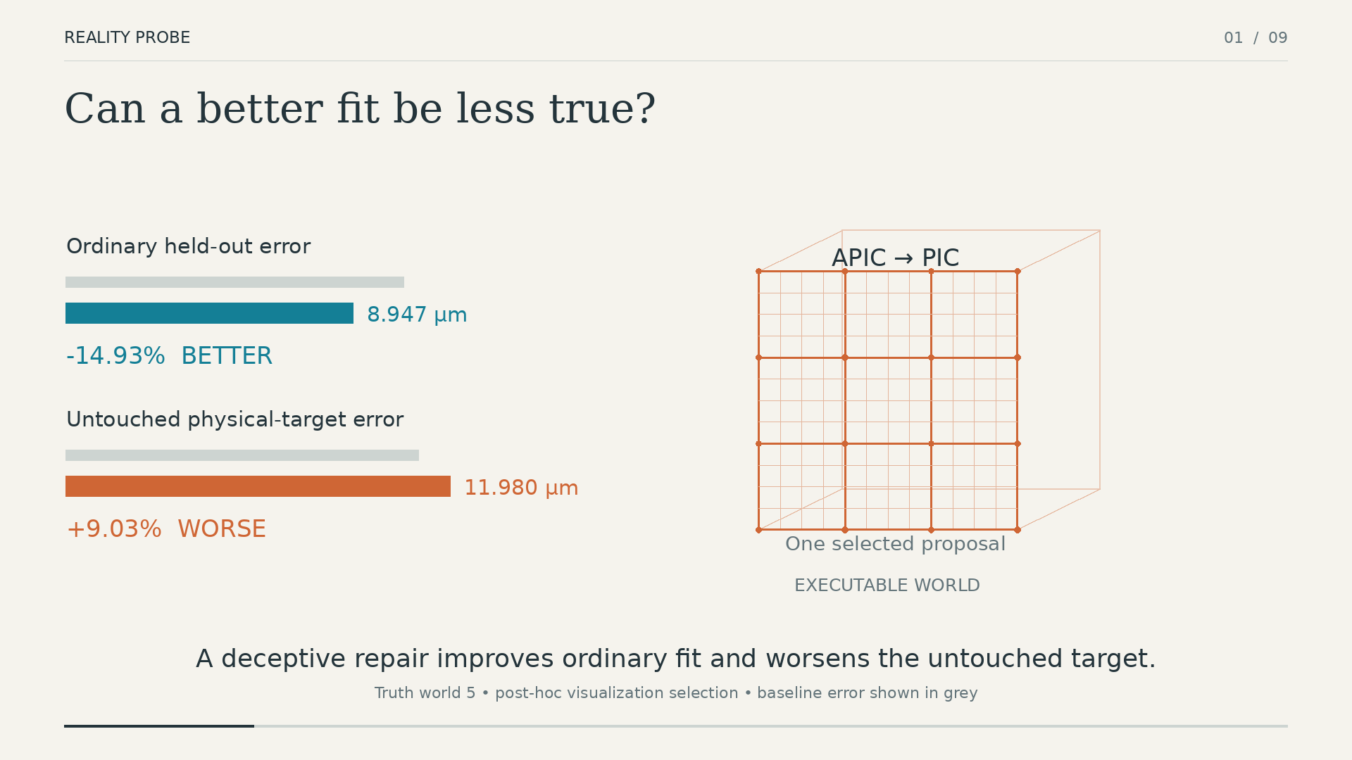
One fit-improving physical regression from the controlled synthetic population. Ordinary held-out error decreases by 14.93%, so the proposal looks better to the fitting criterion, while error on an untouched physical target increases by 9.03%. The case motivates a separate acceptance test; it is not used to choose any threshold.
The paper tests the hypothesis that verification quality is limited by the information in the reserved physical question. A signed-intervention probe can be numerically correct and still carry too little discriminating signal. A known-force response asks a different question. A finite-amplitude pendulum period test matches the dynamics present in the measured video. A separately predefined free-fall transfer test fails untouched validation and is stopped. Preserving both successful and failed channels is important because Reality Probe is intended to expose when a test is uninformative, not to guarantee that every physical edit can be verified.
The resulting architectural change is simple: physically editable reconstructed worlds should use fit, test, then commit rather than fit-and-commit.
The paper makes three contributions:
- An evidence-gated state transition for physical edits. Reality Probe separates proposal evidence from acceptance evidence and records SUPPORT, VETO, or UNRESOLVED before a candidate physical state can replace the current one.
- A controlled study of what makes a verification test informative. Across synthetic and measured settings, we distinguish numerical correctness from physical separability and show that changing the physical interrogation can matter more than refining a weak one.
- A measured finding with an explicit transfer failure. On ten previously unopened IRIS pendulum videos, the finite-amplitude period test reaches 90/110 correct decisions versus 40/110 for the common small-angle approximation, while a separately predefined free-fall protocol fails untouched validation and leaves its final split unopened. The result therefore supports evidence-matched verification rather than universal physical certification.
The rest of the paper asks a single question: what evidence justifies committing a physical edit to a persistent reconstructed world?

Related Work

Physics-aware scene reconstruction and inverse physics
PAC-NeRF couples continuum simulation to a neural radiance field so that physical parameters can be estimated from multi-view video (Xuan Li et al. 2023). PhysGaussian brings Material Point Method dynamics to 3D Gaussian primitives (Xie et al. 2024). PhysDreamer, PhysFlow, MonoPhysics, and M-PhyGs extend physically parameterized visual representations toward interaction synthesis, material estimation, and monocular or multi-material dynamics (Zhang et al. 2024; Liu et al. 2025; Rho et al. 2026; Wada et al. 2026). Differentiable simulators such as ChainQueen and DiffTaichi provide optimization machinery for physical parameters (Hu et al. 2019, 2020).
These systems motivate our setting: a scene model can carry physical state that is estimated from observations and later changed. Reality Probe addresses the next operation in that lifecycle. Given a baseline model and a proposed physical edit, should the persistent scene accept the new state?

Identifiability and informative experiments
Parameter recovery is limited by the information present in the observations. Structural identifiability formalizes whether the model parameters are uniquely recoverable, and recent work studies these conditions directly from video (Y. Wang et al. 2026). IRIS evaluates physical parameter recovery, identifiability, extrapolation, and governing-equation recovery on controlled real video (Khanbayov et al. 2026). Optimal experiment design uses sensitivity or information measures to choose loading conditions that distinguish competing material models (Asadi and Laksari 2025).
Reality Probe uses the same information principle for a different decision. The proposal already exists. The question is whether a reserved experiment separates it from the current model strongly enough to justify changing persistent state. An unresolved outcome therefore says something about the experiment: the evidence available for acceptance is insufficient, even if parameter fitting itself converged.

Model credibility, physical fidelity, and abstention
Verification, validation, and uncertainty quantification separate numerical correctness from model credibility for a stated use (Oberkampf, Pilch, and Trucano 2007). Digital-twin research similarly asks how simulated counterfactuals should be validated (Laudy 2026). GAUGE grounds physical-fidelity comparisons in measured motion across several mechanical task families (S. Wang et al. 2026). These lines of work establish that fit alone is not enough to establish physical credibility.
The three-way decision also has clear prior art. Reject-option analysis studies the error–rejection tradeoff (Chow 1970), and selective prediction learns mechanisms that abstain when a prediction is not sufficiently reliable (Geifman and El-Yaniv 2019). We do not claim abstention as a new decision primitive. The contribution is where it is placed: UNRESOLVED is a first-class state of a physical-edit transaction, so an uninformative experiment prevents a proposed model from silently replacing the current one.

Positioning of the contribution.
Reality Probe does not claim new mathematics for finite differences, moment cancellation, uncertainty standardization, abstention, inverse physics, or verification and validation. Its contribution is the captured-world state-transition boundary that combines these established ideas: the proposal must be fixed before acceptance evidence is opened; the acceptance test compares the current and proposed physical states under an explicit uncertainty model; and insufficient evidence has an operational consequence—the persistent world is not overwritten. The evaluation then asks when that transaction is informative and deliberately retains channels that fail.

Problem Formulation
Let $M_{0}$ be the current physical model stored in a video-reconstructed world and $M_{1}$ a proposed edit. An edit is any change to persistent simulator-facing state—for example a material parameter, damping coefficient, gravity estimate, contact parameter, or another quantity used by the scene’s dynamics. The proposal may be produced automatically or authored manually; the acceptance logic does not depend on its source. We separate observations into three roles:
- fitting evidence, which may change model parameters or generate $M_{1}$;
- ordinary held-out evidence, which measures generalization within the same observation family used for fitting; and
- reserved physical evidence, which is withheld from proposal selection and used only to decide whether $M_{1}$ should replace $M_{0}$.
Let $L_{obs}\left(M\right)$ denote ordinary held-out error and $L_{phys}\left(M\right)$ error on an untouched physical target, with lower values preferred. A fit-improving physical regression occurs when
$$L_{obs}\left(M_{1}\right)<L_{obs}\left(M_{0}\right) \text{but} L_{phys}\left(M_{1}\right)>L_{phys}\left(M_{0}\right).$$
This definition is intentionally agnostic to cause. Parameter compensation, model-form error, boundary assumptions, numerical approximations, and weakly informative observations can all produce the same evidence pattern.
For acceptance, let $Y$ be the reserved physical evidence and $e\left(M,Y\right)$ the error of model $M$ on that evidence. We compare the proposed and current models using
$$z=\frac{e\left(M_{0},Y\right)−e\left(M_{1},Y\right)}{σ},$$
where $σ$ is the uncertainty scale of the comparison. Positive $z$ favors the proposal; negative $z$ favors the current model. Dividing by $σ$ asks whether the observed difference is large relative to measurement, repeat, and numerical uncertainty. We use $z$ as a standardized evidence score, not as a Gaussian hypothesis-test statistic.
The experiments use the repository-frozen decision rule
$$\begin{matrix}z≥2 & ⇒SUPPORT, \\ z≤−2 & ⇒VETO, \\ \left|z\right|<2 & ⇒UNRESOLVED.\end{matrix}$$
The magnitude 2 is an operational threshold for this study, not a universal physical-credibility constant. Keeping it fixed after data access is what makes a negative result meaningful: weak evidence remains weak instead of becoming a decision through threshold relaxation.

Reality Probe

From proposal to commit
Reality Probe is a commit gate around an existing physical-model update process. The optimizer is free to use its fitting objective to produce $M_{1}$. Once the proposal is fixed, the acceptance stage evaluates a reserved physical test against both $M_{0}$ and $M_{1}$. The resulting evidence score and uncertainty are stored with provenance before any state change occurs.
SUPPORT means $M_{1}$ clears the positive evidence margin and may replace the baseline. VETO means the reserved experiment favors $M_{0}$ strongly enough to reject the proposal. UNRESOLVED means the experiment does not separate them; the system therefore preserves $M_{0}$ without pretending that $M_{1}$ has been disproved. This distinction matters operationally because contradiction and lack of information should not be recorded as the same event.
The separation is causal as well as organizational. If the reserved measurement is consulted while choosing $M_{1}$, it stops being acceptance evidence and becomes another fitting signal. Reality Probe therefore treats proposal generation and acceptance as sequential transactions with separate provenance.

A mechanism-selective probe: DCS
Dark-Field Counterfactual Spectroscopy is one way to construct reserved evidence when several controlled interventions are available. For physical model $M$ and intervention $u$, let $F_{M}\left(u\right)$ be the measured response. DCS forms a signed combination
DμFM=i​wiFMui,
with weights chosen so that low-order response terms cancel:
rα=i​wiuiα≈0, α<k.
Here $α$ indexes a monomial in the intervention coordinates and $k$ is the requested cancellation order. The purpose is not to invent a new finite-difference construction; it is to suppress response shared by competing models so that disagreement in higher-order behavior becomes easier to observe.
For intuition, the one-dimensional second-order contrast
$$F\left(+a\right)+F\left(−a\right)−2F\left(0\right)$$
removes the constant term and cancels a response that is linear in intervention amplitude $a$. The reported experiments synthesize the actual order-2 comparator on a $3×3$ intervention lattice instead of using Eq. [eq:second] directly.
The implementation also evaluates the Boolean-lattice Möbius contrast
κS=T⊆S​−1S−TFT,
which removes contributions attributable to lower-order subsets of intervention factors. We use it as an interaction statistic; the underlying inclusion–exclusion construction is classical.

Uncertainty and the acceptance score
The acceptance score is only useful if the uncertainty denominator refers to the same physical quantity as the numerator. We therefore track measurement uncertainty, variation across repeated observations, and numerical sensitivity to solver resolution. Signed DCS combinations propagate independent measurement and repeat variance through the squared weight gain i​wi2. Numerical error can be correlated across intervention points, so the refinement experiments measure the same witness at nominal and finer solver resolution instead of assuming independence.
For witness selection, active DCS synthesis searches the nullspace of the lower-moment constraints and evaluates deterministic projected directions. The resulting maximin search is non-convex, so we treat the selected witness as a reproducible heuristic and make no global-optimality claim.
The important systems property is independent of the particular probe: the same acceptance interface can consume a DCS witness, a force-compliance response, a pendulum period residual, or another reserved physical measurement. What changes is the information carried by $Y$, not the semantics of SUPPORT, VETO, and UNRESOLVED.

Evaluation Design
The evaluation is organized by the question each study answers, not by the order in which the experiments were developed. Table [tab:stages] maps each study to the claim it can support. We distinguish constructed controls, frozen validation, retrospective diagnosis, locked final tests, and post-final stress tests because those evidence classes support different claims.
Study | Evidence class | Question
Synthetic contrast study (D1–D4V) | controlled, frozen synthetic | Can a mechanism-selective probe detect a fit-improving physical regression, and does numerical refinement make it decision-useful?
DOT C2 (Xinyuan Li et al. 2025) | measured engineering check | Does the full capture–fit–edit–verify–rollback path operate on measured deformable motion?
GAUGE (S. Wang et al. 2026) | retrospective + frozen measured validation | Can ordinary and mechanism-sensitive channels disagree, and does the frozen witness resolve new measured cases?
Known-force compliance | fresh synthetic | Does changing the physical question increase separability under the same decision rule?
IRIS pendulum (Khanbayov et al. 2026) | locked measured final | Can a dynamics-matched test verify proposed edits on fresh video?
IRIS free-fall (Khanbayov et al. 2026) | frozen measured validation | Does the approach transfer to a second equation family without retuning?

Controlled study of probe informativeness
The synthetic study begins with a deliberately strong positive control (D1): 64 parameter changes improve the ordinary fitting criterion while degrading an untouched physical target. This stage tests the DCS implementation, not generalization.
The next two stages freeze the selected probe and move to unseen truth worlds. D2 tests whether the signed witness reaches the fixed decision margin on 16 new worlds. D3 repeats the comparison on six fresh worlds while evaluating the same witness at finer numerical resolution, allowing us to distinguish weak physical separation from simple solver error.
The final synthetic verification stage (D4V) starts from 36 edits that all improve ordinary held-out fit. Their untouched physical behavior separates them into 14 regressive edits and 22 beneficial edits. The separate force-study population contains 12 regressive and 24 beneficial ordinary-improving edits; Table 1 keeps the two populations distinct. DCS is compared with raw-bundle, pair-specific raw, Fisher/Jacobian, and maximum-motion alternatives under the same $\left|z\right|≥2$ decision rule.
Ordinary-improving synthetic proposal populations. The two populations are separate and are not pooled.
Population | Regressive | Beneficial | Resolved
D4V | 14 | 22 | 0/36
Fresh force study | 12 | 24 | 0/36

Measured-system checks
DOT C2 is used as an engineering check for the complete measured-data path. The sequence supplies 3D correspondences, so the system can ingest measured trajectories, fit on one partition, replay held-out motion, propose a local material edit, evaluate it, and roll back when the acceptance test fails. Table 2 reports the measured-path quantities, and Figure 2 shows held-out measured correspondences against model predictions at true residual scale. Because DOT does not provide the stress-free state, loads, thickness, mass, or constitutive ground truth, its fitted material values are reported only as effective parameters of the chosen model.
DOT C2 engineering check. These values validate the pipeline; they are not constitutive ground truth.
Quantity | Result
Measured correspondence points
Trajectory observations (fit / held-out) | (585 / 90)
Effective $E,ν$ | kPa, 0.45
Dynamic RMS (fit / held-out) | / 4.417 mm
Acceptance outcome | rollback
Held-out DOT C2 measured-versus-predicted geometry at $t=0.167$ s. Circles are measured correspondences, crosses are predictions, and connecting segments are true-scale residuals.
Figure [fig:dot-c2-render] complements the correspondence plot with the actual rendered system output. It is a pipeline/visualization check rather than constitutive ground truth: DOT does not provide the physical quantities needed to interpret the fitted material values as uniquely identified properties.
GAUGE contributes two different measured evidence classes. GAUGE is retrospective in the foam-shearing study, where we ask whether ordinary marker error and a mechanism-sensitive longitudinal channel can prefer different models. A separate frozen validation study uses previously untouched stretching and compression repeats 5–7, with SUPPORT, VETO, and placebo cases declared before evaluation. Final repeats 8–10 remain unopened after that validation fails.

Changing the physical question
The force-compliance study holds proposal generation fixed and changes only the physical test. Fresh prospective force evidence is synthetic in this paper; no measured force-sensor claim is made. Six APIC truth worlds span three Young’s moduli and two Poisson ratios. Each proposal is evaluated under four known load directions ($+x$, $−x$, $+y$, and $+z$); the response records top-layer and interior displacement.
The same decision magnitude $τ=2$ is used for DCS and force compliance. Numerical uncertainty is measured by repeating the proposed-model response at half timestep, while measurement and repeat scales are fixed before execution. The purpose of this study is not to rescue DCS with a different threshold. It asks whether a physically different experiment makes the current and proposed models easier to distinguish.
Figure [fig:force-worked-example] makes one controlled edit concrete. The candidate is not judged by an abstract score alone: the same known load is applied to both states, their deformations are compared in model space, and the resulting response bundle is converted into the reserved evidence used by the gate.
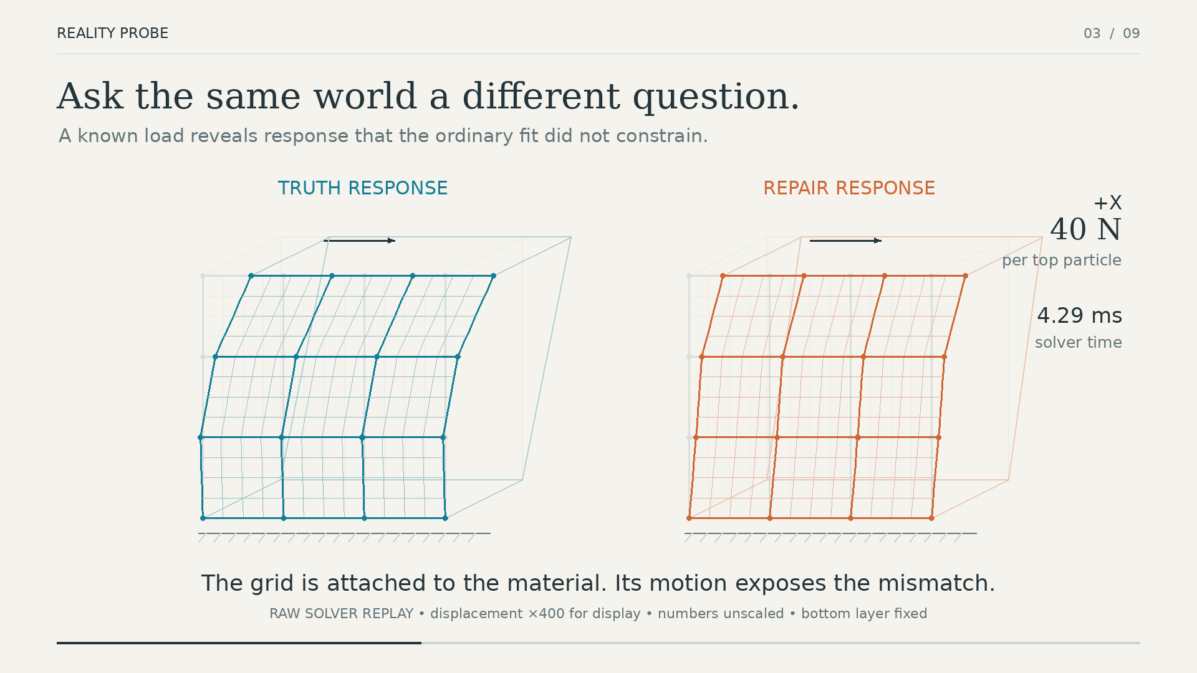 | 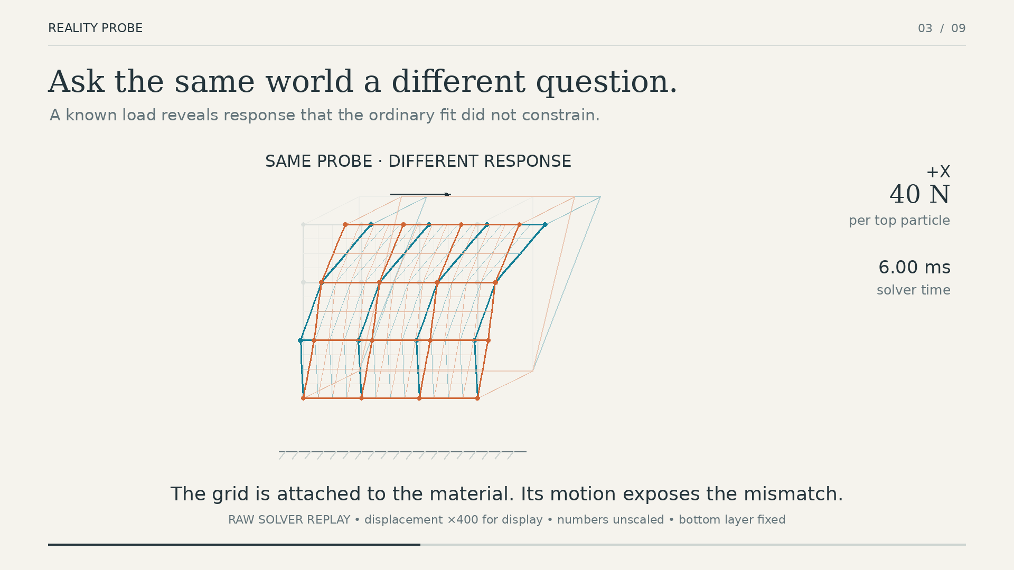
(a) Same known load on current/truth and proposed states | (b) Overlaid responses under the reserved intervention
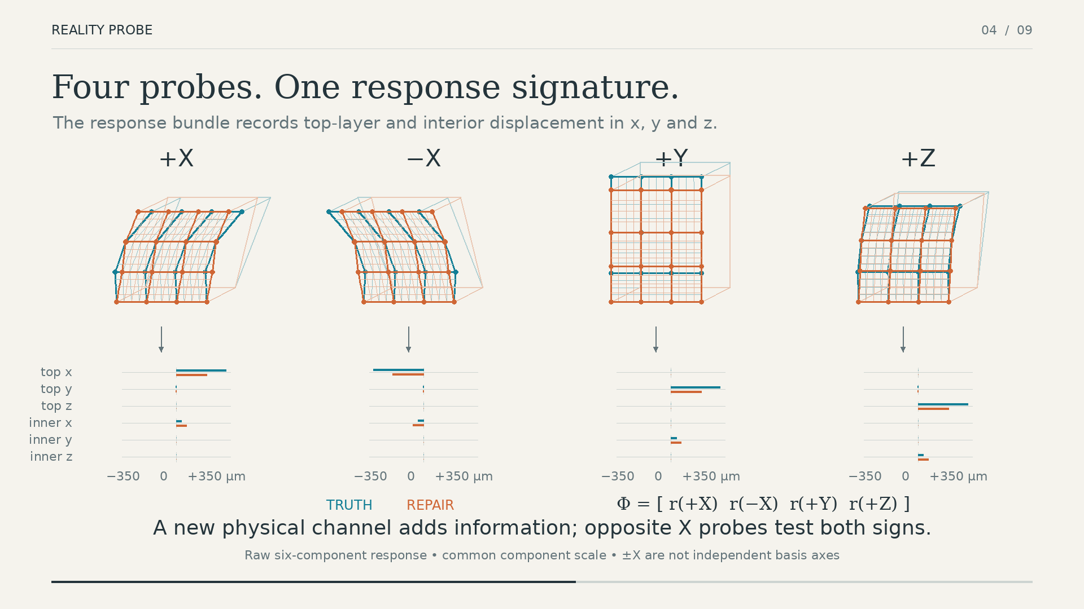 | 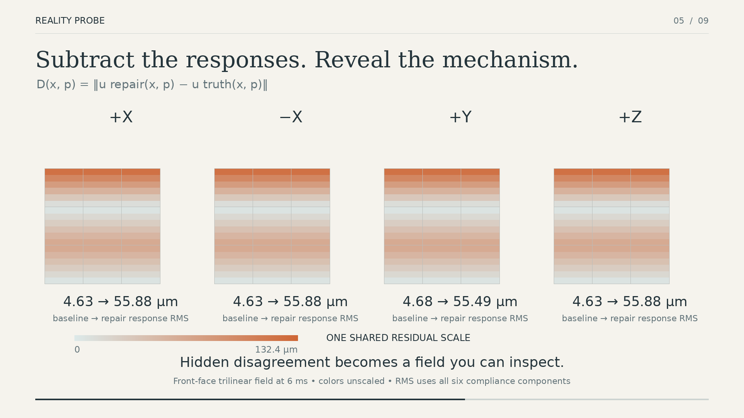
(c) Four-direction response fingerprint | (d) Spatial disagreement field

Locked real-video evaluation
The positive measured test uses the IRIS pendulum_90 setting. Before the ten final videos are opened, the tracker, proposal schedule, physical probe, and decision rule are frozen. The primary test uses the finite-amplitude pendulum period relation, which accounts for the measured swing amplitude; the diagnostic baseline uses the common small-angle period approximation, which assumes sufficiently small oscillations. Each physical video produces 11 controlled SUPPORT/VETO/UNRESOLVED cases, giving 110 nested case rows across ten videos.
A separate free-fall protocol tests transfer to another equation family. Development uses drop_50/06..10; validation uses untouched drop_100/06..10. The designated final set drop_150/02..10 is opened only if validation passes. Thresholds, tracker logic, proposal selection, and scene membership are frozen before validation.
Post-final pendulum analyses are kept separate from the locked result. They cluster by physical video, compare additional residual models, generate proposals without ground-truth access, vary proposal/probe overlap, propagate rope-length uncertainty, and stress the video pipeline under corruption and temporal downsampling.

Results

Better fit is not a physical acceptance test
Fit-improving physical regressions occur in both controlled proposal populations. Fourteen of 36 D4V edits and 12 of 36 fresh force-study edits improve ordinary held-out error while worsening an untouched physical target. These fractions describe the constructed test populations; they are not prevalence estimates.
The consequence is more important than the count. A pipeline that commits an edit because held-out trajectory error improved would accept physically worse states in these examples. Figure 1 shows one such edit, and Figure 3 shows the same mismatch across the full fresh proposal population.
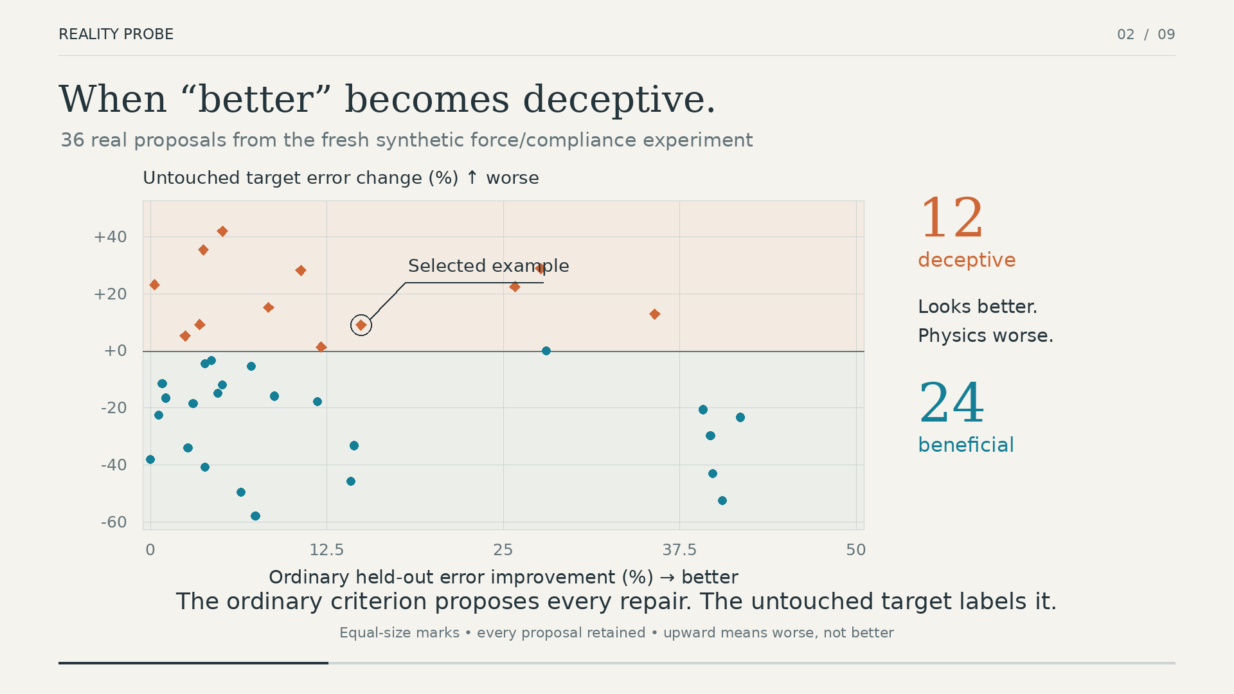
Ordinary held-out improvement does not determine physical improvement in the fresh proposal population. The scatter makes the acceptance problem visible at population scale: some edits move the fitting metric in the desired direction while moving the untouched physical target in the wrong direction.

Probe sophistication cannot compensate for an uninformative experiment
DCS passes the constructed control: all 64 deliberately regressive parameter changes are rejected. That result verifies the implementation and confirms that signed intervention contrasts can expose a strong difference when one is present.
The frozen synthetic evaluations tell a different story. On unseen truth worlds, DCS remains far below the acceptance margin. Numerical refinement reduces solver discrepancy but does not materially increase separation. In the D4V proposal population, DCS, raw bundles, pair-specific raw responses, Fisher/Jacobian selection, and maximum-motion selection all resolve 0/36 proposals at $\left|z\right|≥2$. DCS is therefore neither uniquely failing nor uniquely superior: the kinematic experiment itself does not provide enough evidence for the acceptance decision.
GAUGE shows the same distinction on measured data. In the retrospective shearing study, ordinary marker error prefers the finite-overlap model, while the longitudinal mechanism channel prefers the endpoint model in 9/10 held-out repeats. In the separately frozen validation study, the raw truth direction is correct but the witness signal is tiny relative to repeat and numerical variability; directional SUPPORT/VETO coverage is 0/24, while all 12 placebo cases correctly remain UNRESOLVED.
Changing the physical question has a much larger effect. Known-force compliance raises median standardized evidence magnitude from 0.0488 to 0.5586 relative to fresh DCS, an 11.46$×$ increase, although no proposal crosses the frozen decision boundary. Table 3 summarizes the result.
Fresh synthetic comparison under the same frozen decision rule. A different physical interrogation increases separability substantially but still does not justify a commit.
Quantity | DCS | Force compliance
Median $\left|z\right|$ | 0.0488 | 0.5586
Maximum $\left|z\right|$ | 0.1728 | 1.3191
Resolved proposals | 0/36 | 0/36
Figure [fig:evidence-strength] visualizes both parts of that result: the changed physical question produces substantially stronger evidence, yet the entire proposal set remains below the fixed acceptance boundary.
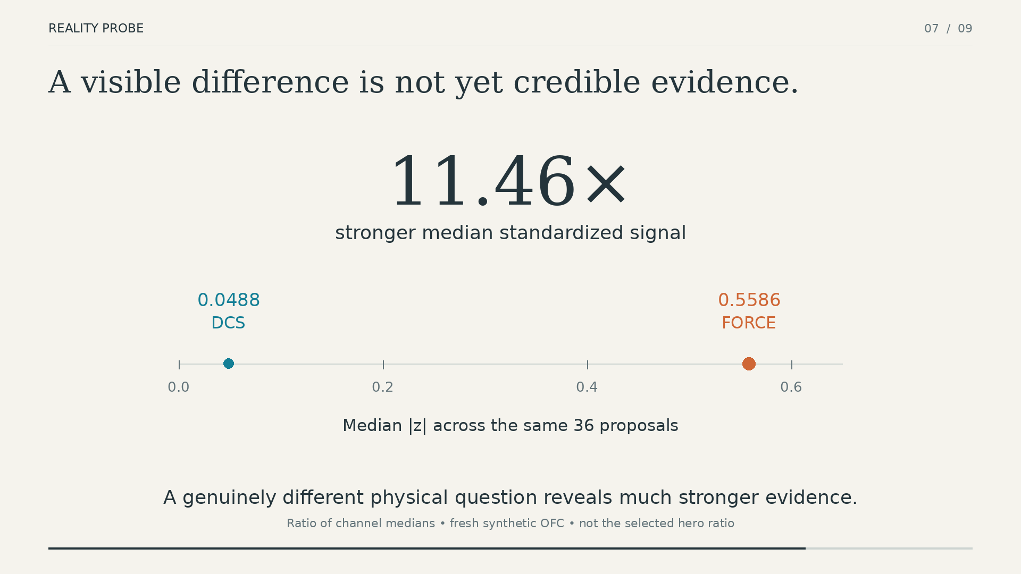 | 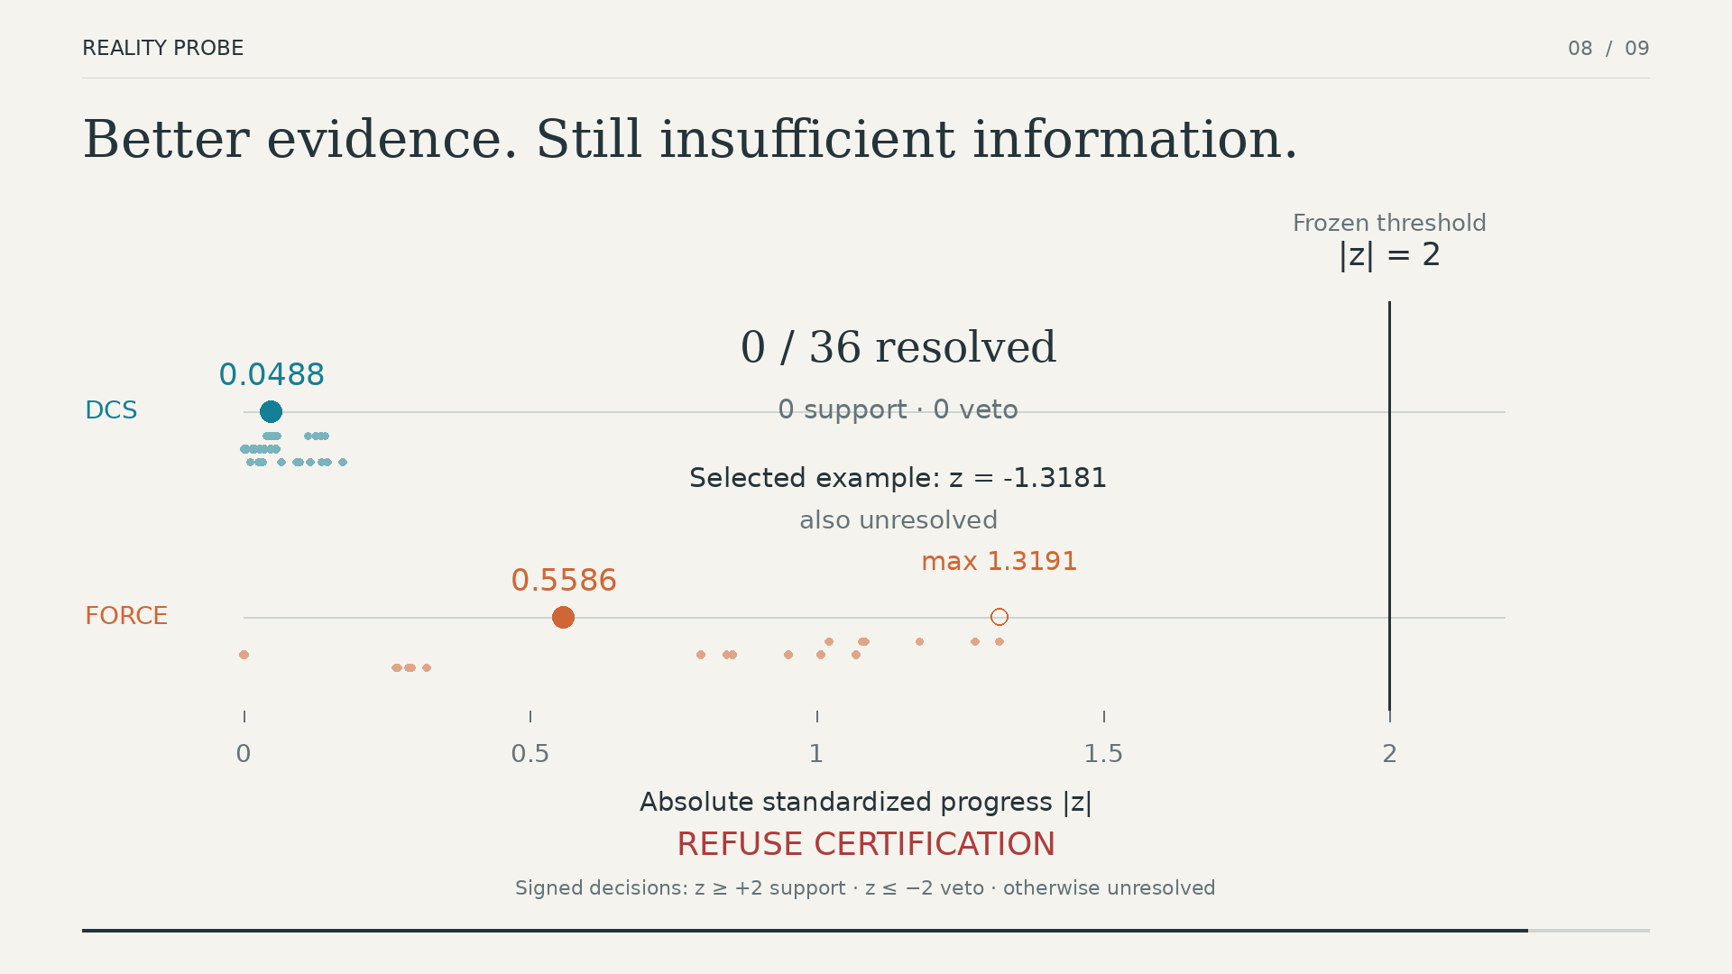
(a) Median standardized evidence increases 11.46$×$ | (b) The strongest proposal still remains below the fixed boundary
Together, these studies isolate the core issue: when competing models produce nearly the same measured physical response, a more elaborate statistic cannot create missing information. The experiment must change.

A dynamics-matched test works on fresh pendulum video
All ten previously unopened pendulum_90 videos pass quality control. The finite-amplitude period test reaches 81.82% strict decision accuracy, compared with 36.36% for the small-angle approximation. Table 4 separates SUPPORT, VETO, and placebo-UNRESOLVED outcomes so the source of the improvement is visible rather than hidden inside one accuracy number.
Locked IRIS pendulum result. Primary denotes the finite-amplitude probe; case rows are nested within ten physical videos.
Outcome | Primary | Small-angle
Overall correct | 90/110 | 40/110
SUPPORT correct | 40/50 | 0/50
VETO correct | 40/50 | 30/50
UNRESOLVED placebo | 10/10 | 10/10
The physical video, not the case row, is the independent unit. The primary probe beats the baseline on all ten videos; an exact two-sided sign test over those ten paired video outcomes gives $p=0.001953125$. Two stronger post-final residual baselines also remain below the locked primary result.
The success is not an artifact of manually scheduled parameter factors. In a post-final GT-hidden test, proposals are generated from an early video segment and committed to a hash before ground truth is joined; all ten ordinary-improving proposals are then classified correctly on reserved evidence. The decision also remains stable when proposal and probe windows are varied from disjoint to fully overlapping, although both windows still come from the same sensor stream.
Robustness tests identify a concrete acquisition boundary. Noise, blur, modest frame duplication/drop, central occlusion, and crop perturbations preserve the locked 81.82% accuracy in the tested ranges. Temporal downsampling does not: accuracy falls to 63.64% at 30 fps and 45.45% at 15 fps. The verifier therefore depends on preserving the temporal information required by the pendulum observable.

Transfer to free-fall fails, so the claim stays conditional
The free-fall protocol passes development before untouched validation is opened. On drop_50, four of five videos pass quality and the median acceleration relative error is 8.05%.
The same frozen logic fails on drop_100/06..10. All five videos pass low-level quality checks, yet median acceleration relative error rises to 111.7%. The selected intervals are consistent with a locally ballistic partial trajectory rather than the full known-height fall. Post-validation diagnostics explore scaling, endpoint anchors, track stitching, resolution, association, ranking, and bidirectional reconstruction, but none yields a robust target-free correction across the spent development and validation evidence.
The protocol therefore stops. drop_100 becomes retrospective evidence, drop_150/02..10 remains unopened, and the paper does not convert this failure into a second positive result. The implication is direct: Reality Probe does not remove the need to design a valid physical test. It makes a failed test visible before that evidence is used to approve a model change.

Discussion

From fit-and-commit to test-and-commit
The systems consequence is a change in where acceptance happens. A fitting loop may be tempted to accept new parameters as soon as ordinary held-out loss decreases. Reality Probe keeps those parameters provisional and opens a separate physical question only after the proposal is fixed. The state changes only when that reserved evidence supports it.
This matters for any application that keeps a physically parameterized scene alive after reconstruction. A graphics authoring system may update material behavior; a simulation-backed digital twin may recalibrate a parameter; a robotics world model may refine contact or compliance. The paper does not claim deployment validation for all of these domains. The architectural lesson is narrower and transferable: persistent physical state should not be overwritten solely because the fitting objective improved.
The three-way decision also changes failure handling. VETO means the reserved test contradicts the proposed state. UNRESOLVED means the experiment is not informative enough to decide. Keeping these states separate prevents an evidence-poor test from masquerading as either success or failure.

Verification is also an experiment-design problem
The contrast between DCS, force compliance, pendulum, and free-fall connects the acceptance problem to identifiability and experiment design (Y. Wang et al. 2026; Asadi and Laksari 2025). The same two physical models can be almost indistinguishable under one observation and easy to separate under another. In our experiments, numerical refinement changes the evidence less than changing the physical channel.
This suggests a practical design loop for future systems. When the verifier returns UNRESOLVED, the next action should not automatically be a lower threshold or a stronger optimizer. The system should ask which intervention, sensor, or time scale is most likely to separate the competing physical states. Reality Probe provides the transaction boundary; informative experiment selection determines whether that boundary can be crossed.

Scope and limitations
The strongest measured positive result covers one IRIS pendulum regime and ten physical videos. The 110 controlled rows are nested within those ten videos, so the physical sample size is ten. The post-final clustered analysis respects that structure, but broader claims require different pendulum lengths, cameras, amplitudes, and capture conditions.
The force-compliance result is synthetic. It establishes that a different physical question can increase separability under controlled ground truth; it does not establish measured force-sensor verification. GAUGE provides measured evidence but its frozen directional validation remains unresolved.
Temporal resolution is a concrete acquisition limit. The pendulum decision degrades sharply under downsampling. A deployment using this observable would therefore need an acquisition rate that preserves the relevant period information.
The free-fall failure bounds cross-domain generality. The development result does not survive untouched validation, and the final split remains unopened. Reality Probe cannot compensate for an event definition that does not correspond to the physical quantity used by the estimator.
The synthetic mechanics experiments also cover a limited family of MPM configurations. DCS witness selection is deterministic but heuristic, and the decision magnitude of 2 is a frozen operational rule for this study and has no claim to universal validity.
Finally, proposal and verification windows in the pendulum study come from the same video stream. Their temporal overlap can be changed, but they are not independent sensor modalities. A stronger future test would reserve a separately instrumented physical channel.

Implications for future physically editable scene systems
The most useful next experiment is not another threshold sweep. It is a measured intervention whose information content is chosen before final data access: a calibrated external force, modal excitation, or another sensor-backed response that targets the physical parameter being edited. The proposal-generation pipeline should remain blind to that reserved channel.
At the system level, the acceptance record should persist with the model state: which proposal was made, which measurement was withheld from fitting, what uncertainty was assigned, what decision was reached, and which version was committed or preserved. This turns physical editing into an auditable state transition instead of an opaque optimizer update.

Reproducibility and Implementation Notes
The repository records each frozen experiment with code revision, dataset revision, protocol files, machine-readable result ledgers, and SHA-256 manifests. The core synthetic study, locked pendulum final test, and failed free-fall validation are tied to separate commits so that later analysis cannot silently redefine an earlier gate. Full immutable identifiers and exact commands remain in the result ledgers, keeping the manuscript readable without weakening provenance.
The C++20 implementation includes nonlinear MPM replay, APIC/PIC transfer variants, finite-difference and adjoint influence paths, DCS moment checks, uncertainty propagation, witness synthesis, numerical refinement, and commit/rollback bookkeeping. Experiment drivers are kept separate from the core implementation, allowing a validation failure to remain frozen while later diagnostic code evolves.
The locked pendulum result was also replayed on Ubuntu with current dependencies. All discrete final decisions reproduce exactly, including the primary/baseline correctness counts and paired outcomes. The median period-inferred length error changes by about 0.10% relative between the locked Mac/Metal run and Ubuntu. We therefore claim decision-level cross-platform reproduction, not bitwise numerical identity.
Paper figures are generated from committed trajectories or result ledgers. Display magnification is disclosed where used and never changes the reported numerical values. The Stanford Bunny is a visualization carrier, not benchmark geometry.

Conclusion
A physically editable scene has two separate problems: estimating a better model and deciding whether that model should replace the one already stored. This paper focuses on the second problem. Reality Probe places a reserved physical test between proposal and commit, so a proposal can be accepted, rejected, or left pending when the experiment is not informative enough.
The experiments show why that separation matters. Better held-out fit can coincide with worse physical behavior. Numerically correct probes can still fail because the chosen observation does not distinguish the competing models. Changing the experiment can increase separability far more than refining the same estimator. A dynamics-matched pendulum test succeeds on fresh measured video, while a separately frozen free-fall protocol fails validation and is stopped; the validation set is not recycled into development.
The practical implication is a change in system architecture. Video-reconstructed worlds that carry persistent physical state should not let optimization overwrite that state automatically. They should treat a physical edit as provisional until reserved evidence supports it, preserve the previous model when evidence is weak, and record why the transition was or was not committed. Reality Probe provides that acceptance boundary; designing informative physical tests determines how often the system can cross it.

Declarations

Ethics Statement.
N/A. This work reports software, simulation, rendering, and analysis of public research datasets. It does not recruit human participants or collect personal data from research participants.

Data Availability Statement.
The public datasets used in this study remain available from their cited original providers. The implementation, experiment scripts, frozen protocols, machine-readable result ledgers, figure-generation code, and derived evidence supporting the reported results are available in the project repository at https://github.com/swayam8624/Vulkax. Third-party datasets and videos are not redistributed.

Funding Statement.
This research received no specific grant from any funding agency in the public, commercial, or not-for-profit sectors.

Conflict of Interest.
The author declares no conflict of interest.

Permissions Statement.
All figures and tables in this manuscript were created by the author from project-generated simulations, diagrams, measurements, or derived analyses. No third-party copyrighted figure or table is reproduced; upstream datasets remain subject to their original terms.

Generative AI Use Disclosure.
OpenAI ChatGPT was used during September–October 2026 as an assistive research and writing tool for code drafting and debugging, experiment orchestration, analysis scripts, visualization and manuscript tooling, and drafting or language revision. AI output was not treated as empirical evidence. Reported numerical results were produced by the project software and frozen experiment artifacts, and the author checked claims, citations, figures, tables, and manuscript text against those sources before submission. No confidential human-subject or personally identifying research data were supplied to the tool. The author remains responsible for the code, analyses, claims, conclusions, and final text.
Asadi, Amirreza, and Kaveh Laksari. 2025. “Optimal Experimental Design for Repeatable Hyperelastic Material Characterization.” Journal of the Mechanical Behavior of Biomedical Materials 170: 107104. https://doi.org/10.1016/j.jmbbm.2025.107104.
Chow, C. K. 1970. “On Optimum Recognition Error and Reject Tradeoff.” IEEE Transactions on Information Theory 16 (1): 41–46. https://doi.org/10.1109/TIT.1970.1054406.
Geifman, Yonatan, and Ran El-Yaniv. 2019. “SelectiveNet: A Deep Neural Network with an Integrated Reject Option.” In Proceedings of the 36th International Conference on Machine Learning, 97:2151–59. Proceedings of Machine Learning Research.
Hu, Yuanming, Luke Anderson, Tzu-Mao Li, Qi Sun, Nathan Carr, Jonathan Ragan-Kelley, and Frédo Durand. 2020. “DiffTaichi: Differentiable Programming for Physical Simulation.” In International Conference on Learning Representations.
Hu, Yuanming, Jiancheng Liu, Andrew Spielberg, Joshua B. Tenenbaum, William T. Freeman, Jiajun Wu, Daniela Rus, and Wojciech Matusik. 2019. “ChainQueen: A Real-Time Differentiable Physical Simulator for Soft Robotics.” In IEEE International Conference on Robotics and Automation (ICRA), 6265–71. https://doi.org/10.1109/ICRA.2019.8794333.
Khanbayov, Rasul, Mohamed Rayan Barhdadi, Erchin Serpedin, and Hasan Kurban. 2026. “IRIS: A Real-World Benchmark for Inverse Recovery and Identification of Physical Dynamic Systems from Monocular Video.” In European Conference on Computer Vision (ECCV), 366–83. https://arxiv.org/abs/2603.16432.
Laudy, Olav. 2026. “The Digital Twin Counterfactual Framework: A Validation Architecture for Simulated Potential Outcomes.” https://arxiv.org/abs/2604.01325.
Li, Xinyuan, Yu Guo, Yubei Tu, Yu Ji, Yanchen Liu, Jinwei Ye, and Changxi Zheng. 2025. “Textureless Deformable Object Tracking with Invisible Markers.” IEEE Transactions on Pattern Analysis and Machine Intelligence 47 (9): 7243–54. https://doi.org/10.1109/TPAMI.2024.3463422.
Li, Xuan, Yi-Ling Qiao, Peter Yichen Chen, Krishna Murthy Jatavallabhula, Ming C. Lin, Chenfanfu Jiang, and Chuang Gan. 2023. “PAC-NeRF: Physics Augmented Continuum Neural Radiance Fields for Geometry-Agnostic System Identification.” In International Conference on Learning Representations. https://arxiv.org/abs/2303.05512.
Liu, Zhuoman, Weicai Ye, Yan Luximon, Pengfei Wan, and Di Zhang. 2025. “Unleashing the Potential of Multi-Modal Foundation Models and Video Diffusion for 4D Dynamic Physical Scene Simulation.” In Proceedings of the IEEE/CVF Conference on Computer Vision and Pattern Recognition (CVPR), 11016–25.
Oberkampf, William L., Martin Pilch, and Timothy G. Trucano. 2007. “Predictive Capability Maturity Model for Computational Modeling and Simulation.” SAND2007-5948. Sandia National Laboratories. https://doi.org/10.2172/976951.
Rho, Daniel, Jun Myeong Choi, Matthew Thornton, Biswadip Dey, and Roni Sengupta. 2026. “MonoPhysics: Estimating Geometry, Appearance, and Physical Parameters from Monocular Videos.” https://arxiv.org/abs/2605.30320.
Wada, Norika, Kohei Yamashita, Ryo Kawahara, and Ko Nishino. 2026. “M-PhyGs: Multi-Material Object Dynamics from Video.” In Proceedings of the IEEE/CVF Conference on Computer Vision and Pattern Recognition (CVPR). https://arxiv.org/abs/2512.16885.
Wang, Shuai, Yaxin Feng, Xuekun Jiang, Shihan Tian, Ningyu Yan, Xing Shen, Chaoyang Lyu, et al. 2026. “GAUGE: A Measurement-Grounded Benchmark for Physical Fidelity in Simulation Engines and Video World Models.” https://arxiv.org/abs/2608.05948.
Wang, Yuanyuan, Wenjie Wang, Kun Zhang, and Mingming Gong. 2026. “Physics from Video: Identifiability of Time-Invariant Second-Order ODEs Under Minimal Trajectory Conditions.” https://arxiv.org/abs/2606.00115.
Xie, Tianyi, Zeshun Zong, Yuxing Qiu, Xuan Li, Yutao Feng, Yin Yang, and Chenfanfu Jiang. 2024. “PhysGaussian: Physics-Integrated 3D Gaussians for Generative Dynamics.” In Proceedings of the IEEE/CVF Conference on Computer Vision and Pattern Recognition (CVPR), 4389–98.
Zhang, Tianyuan, Hong-Xing Yu, Rundi Wu, Brandon Y. Feng, Changxi Zheng, Noah Snavely, Jiajun Wu, and William T. Freeman. 2024. “PhysDreamer: Physics-Based Interaction with 3D Objects via Video Generation.” In European Conference on Computer Vision (ECCV), 388–406. https://doi.org/10.1007/978-3-031-72627-9_22.

