**INTRODUCTION**

The COVID-19 pandemic, also known as the coronavirus pandemic, is an ongoing global pandemic of coronavirus disease 2019 caused by severe acute respiratory syndrome coronavirus 2. The virus was first identified in December 2019 in Wuhan, China. The World Health Organization declared a Public Health Emergency of International Concern regarding COVID-19 on 30 January 2020, and later declared a pandemic on 11 March 2020. As of 20 April 2021, more than 141 million cases have been confirmed, with more than 3.02 million deaths attributed to COVID-19, making it one of the deadliest pandemics in history. Symptoms of COVID-19 are highly variable, ranging from none to life-threatening illness. The virus spreads mainly through the air when people are near each other. It leaves an infected person as they breathe, cough, sneeze, or speak and enters another person via their mouth, nose, or eyes. It may also spread via contaminated surfaces.

regarding this situation there are many national-international programs and protocols are undertaken. India alongside with few countries had begun the vaccination drives for the covid19. as we are moving forward, the authorities are still facing many issues like keeping track of the data. because data is the only source through which they can track records, it is important to keep tracking record

by concerning this issue, I believe this project will work in many aspects regarding keeping the correct information in concerned manner.

**SCOPE OF PROJECT:**

1. A data entry for patients

2. A data entry about many hospitals

3. A data entry for covid-19 vaccines

4. A data entry for managing supply of vaccines to hospitals

5. Generates registration reports for vaccinations

6. To either print or view the same.

7. The system is fast in working and accurate in getting information.

8. Various reports generated by the system are designed according to the hospital needs.

9. Quick reports are generated as and when required.

10. Accuracy is maintained.

11. Privacy of data is maintained.

12. This document defined the need and requirement of the Covid-19 Tracker and the

different area of application where it could be implemented.

13. For the development of project Visual Basic 6.0 & MS Access are used.

**PROPOSE SYSTEM:**

The existing non computerized system requires maintenance of a large number of big registers including information about patient’s details.

-The main objective of proposed system is to reduce the manual work. Following are the objective of the proposed system-

- The system removes the possibility of any erroneous reading to occur as it first validates the data fed to it

- All are unnecessary tedious paperwork is removed

- The user is given the facility to view the test, observations that were carried out earlier.

- Security checks are carried out whenever access to private information changes of sensitive data is requested.

- To provide fast access and past data backup facility is provided.

**SYSTEM ANALYSIS**

**SOFTWARE REQUIREMENTS**

Windows 7, 8, 10

Visual Basic 6.0

Microsoft Access

**HARDWARE REQUIREMENTS**

Ram-512 MB

Processor Pentium 4 or above

HDD - 20 GB

**SYSTEM DESIGN:**

ENTITY RELATIONSHIP DIAGRAM:

The overall logical structure of a database can be expressed graphically by an E_R DIAGRAM. The entity relationship diagram enables a software engineer to fully specify the data object that are input from a system, the

Attribute that define the properties of thee objects and the

Relationships between these objects. The E-R data model is one of the several semantic data models, the semantic aspect of the model lies in the attempt to represent the meaning of the data. The E-R MODEL is extremely useful in mapping the meaning and interaction of real-world enterprises into a conceptual schema.

Please note that the concept of E-R diagram is totally different from DFD.

To draw E-R diagram we use following symbol-

|  |  |  |
| --- | --- | --- |
| SR. NO | SYMBOL | MEANING |
| 1 |  | FLOW LINES  DIRECTIONAL FLOW |
| 2 |  | RECTANGLE  TO REPRESENT ENTITY |
| 3 |  | DIAMOND BOX  TO REPRESENT RELATIONSHIP |
| 4 |  | ELLIPSE  TO REPRESENT ATTRIBUTE |

**ENTITY RELATIONSHIP DIAGRAM:**



**DATA FLOW DIAGRAM:**

A data flow diagram is a graphical technique that depicts information flow and the transforms that are applies as data moves from input to output. The data flow diagram is also known as Data Flow Graph or Bubble Chart.

The processes in data flow diagram are shown by named circles or bubble and data flow is represented by named arrows entering or leaving the bubbles.

A rectangle represents by a source or sinks and is a net originator or consumer of data.

In DFD, there are four symbols as-

|  |  |  |
| --- | --- | --- |
| SR NO. | SYMBOL | MEANING |
| 1 |  | A procedural or consumer or Information that exit outside. The system is represented by External entity. |
| 2 |  | A transformer of information that exit within the system is represented by process. |
| 3 |  | Arrow head indicate the flow of data from entity to process or process to entity. |
| 4 |  | Storage of date that is to be used by one or more Processes is represented by Data store. |

**CONTEXT LEVEL DFD:**

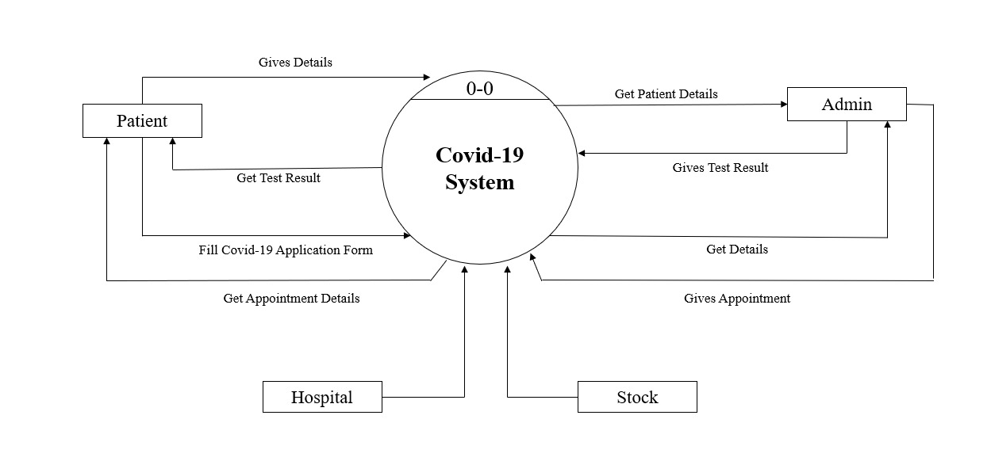

**FIRST LEVEL DFD:**

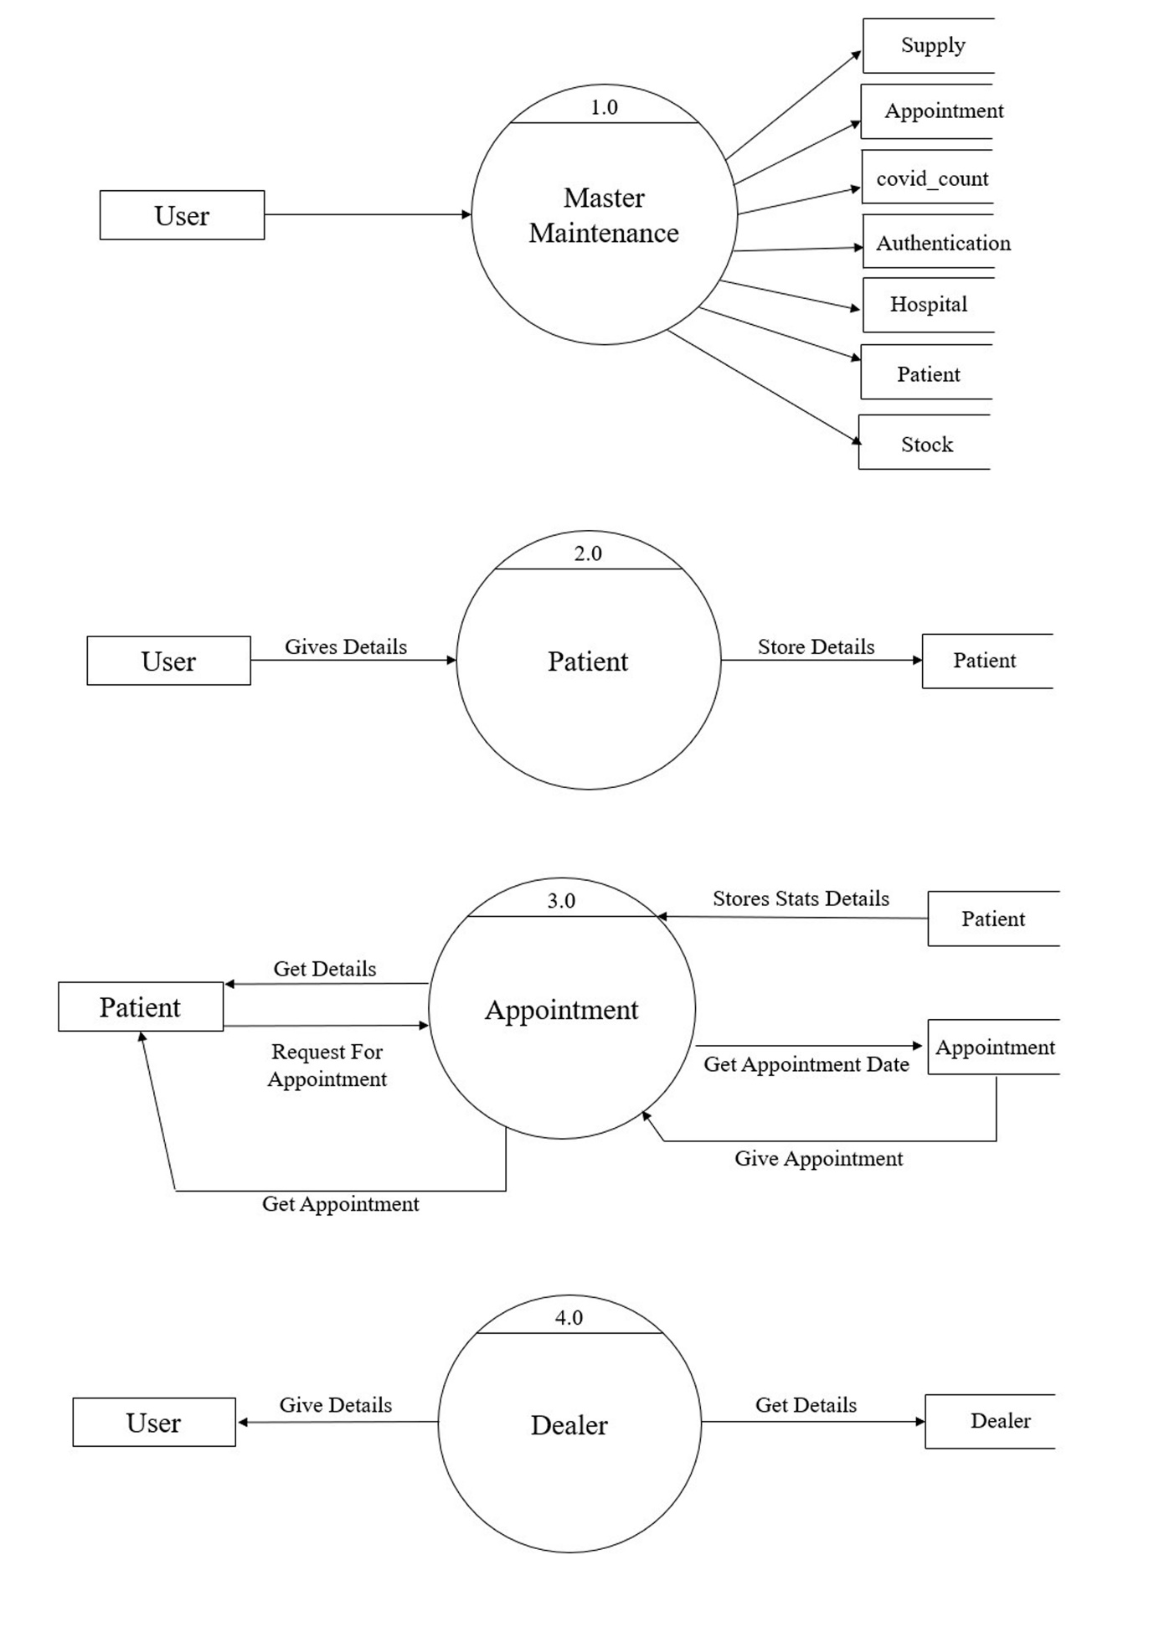

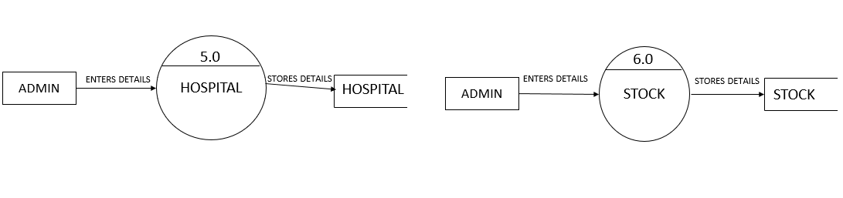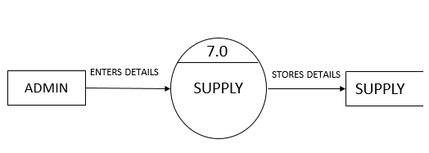

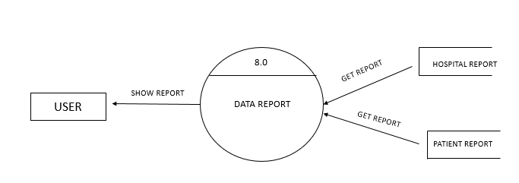

**FILE DESIGN**

**TABLE DESIGN**

The database is design for this system is as follows:

|  |  |  |
| --- | --- | --- |
| SR NO. | TABLE NAME | PURPOSE |
| 1 | AUTHENTICATION | To add and Authenticate the login of the admin or user |
| 2 | COVID_COUNT | To keep record of total, active, recovered and death cases due to COVID-19. |
| 3 | DEALER | To add Dealer’s details from which the vaccines are being taken |
| 4 | HOSPITAL | Details of Hospital which are COVID-19 centers |
| 5 | PATIENT | Details of Patients are stored |
| 6 | STOCK | To keep the record of vaccine stock |
| 7 | SUPPLY | To supply the stock in Hospitals and to keep track of stock available in each hospital. |
| 8 | APPOINTMENT | To give appointment to the patient as per the Beds, Vaccine availability of the Hospital |

1. **TABLE NAME: - AUTHENTICATION**

|  |  |
| --- | --- |
| FIELDS | DATATYPE |
| USERNAME | STRING |
| PASSWORD | STRING |

1. **TABLE NAME: - COVID COUNT**

|  |  |
| --- | --- |
| FIELDS | DATATYPE |
| CITY NAME | STRING |
| TOTAL COUNT | NUMBER |
| ACTIVE COUNT | NUMBER |
| DEATH COUNT | NUMBER |
| RECOVER COUNT | NUMBER |

1. **TABLE NAME: - DEALER**

|  |  |
| --- | --- |
| FIELDS | DATATYPE |
| ID | NUMBER |
| COMP_NAME | STRING |
| BRAND_NAME | STRING |
| PLOT | STRING |
| STREET | STRING |
| CITY | STRING |
| STATE | STRING |
| PIN | NUMBER |
| PHONE NUMBER | NUMBER |
| EMAIL | STRING |

1. **TABLE NAME: - HOSPITAL**

|  |  |
| --- | --- |
| FIELDS | DATATYPE |
| HOSPITAL ID | NUMBER |
| HOSPITAL NAME | STRING |
| PLOT | STRING |
| STREET | STRING |
| CITY | STRING |
| STATE | STRING |
| HOSPITAL EMAIL | STRING |
| HOSPITAL CONTACT | NUMBER |
| HOSPITAL BEDS | NUMBER |

1. **TABLE NAME: - PATIENT**

|  |  |
| --- | --- |
| FIELDS | DATATYPE |
| ID | NUMBER |
| FIRST NAME | STRING |
| MIDDLE NAME | STRING |
| LAST NAME | STRING |
| GENDER | STRING |
| MARTIAL STATUS | STRING |
| BLOOD GROUP | STRING |
| DOB | DATE |
| KIN NAME | STRING |
| KIN RELATION | STRING |
| KIN PHONE | NUMBER |
| KIN EMAIL | STRING |
| HOUSE NO | STRING |
| STREET | STRING |
| CITY | STRING |
| PIN | NUMBER |
| PHONE NO | NUMBER |
| EMAIL | STRING |
| ALTERNATE PHONE NO | NUMBER |
| PHOTO | MEMO |

1. **TABLE NAME: - STOCK**

|  |  |
| --- | --- |
| FIELDS | DATATYPE |
| ID | NUMBER |
| DEALER ID | NUMBER |
| VACCINE NAME | STRING |
| QUANTITY | NUMBER |
| PURCHASE DATE | DATE |

1. **TABLE NAME: - SUPPLY**

|  |  |
| --- | --- |
| FIELDS | DATATYPE |
| ID | NUMBER |
| HOSPITAL ID | NUMBER |
| HOSPITAL NAME | STRING |
| SUPPLY BRAND | STRING |
| SUPPLY QUANTITY | NUMBER |
| SUPPLY DATE | DATE |

1. **TABLE NAME: - APPOINTMENT**

|  |  |
| --- | --- |
| FIELDS | DATATYPE |
| ID | NUMBER |
| HOSPITAL ID | NUMBER |
| PATIENT ID | NUMBER |
| PATIENT NAME | STRING |
| APPOINTMENT DESCRIPTION | STRING |
| APPOINTMENT DATE | DATE |
| STATUS | STRING |
| COVID RESULT | STRING |

**FORM DESIGN**

**USER INTERFACE**

1. **LOGIN PAGE**

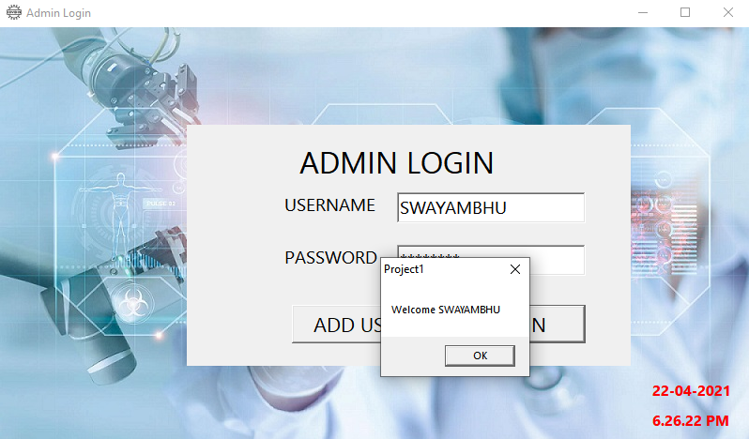

1. **DASHBOARD**

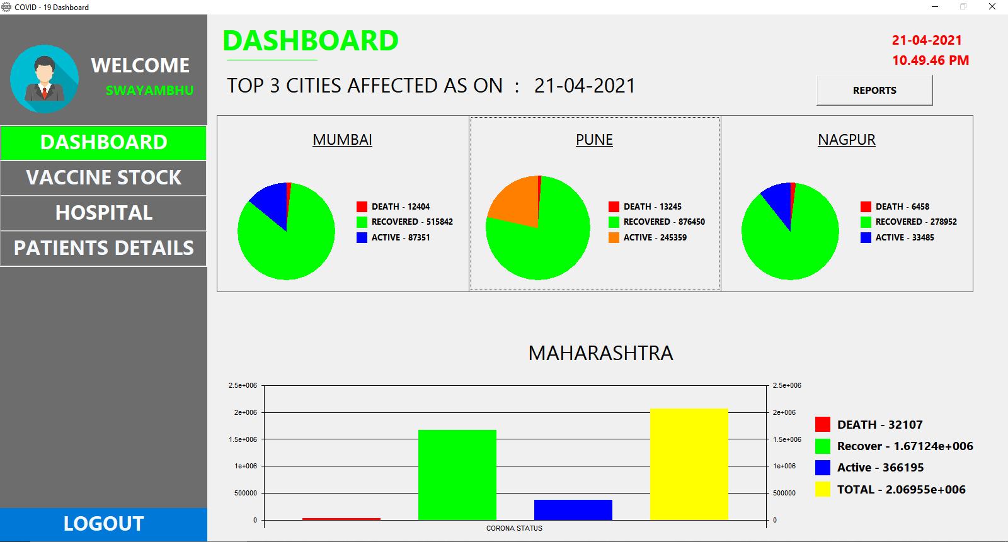

1. **VACCINE STOCK – ADD STOCK**

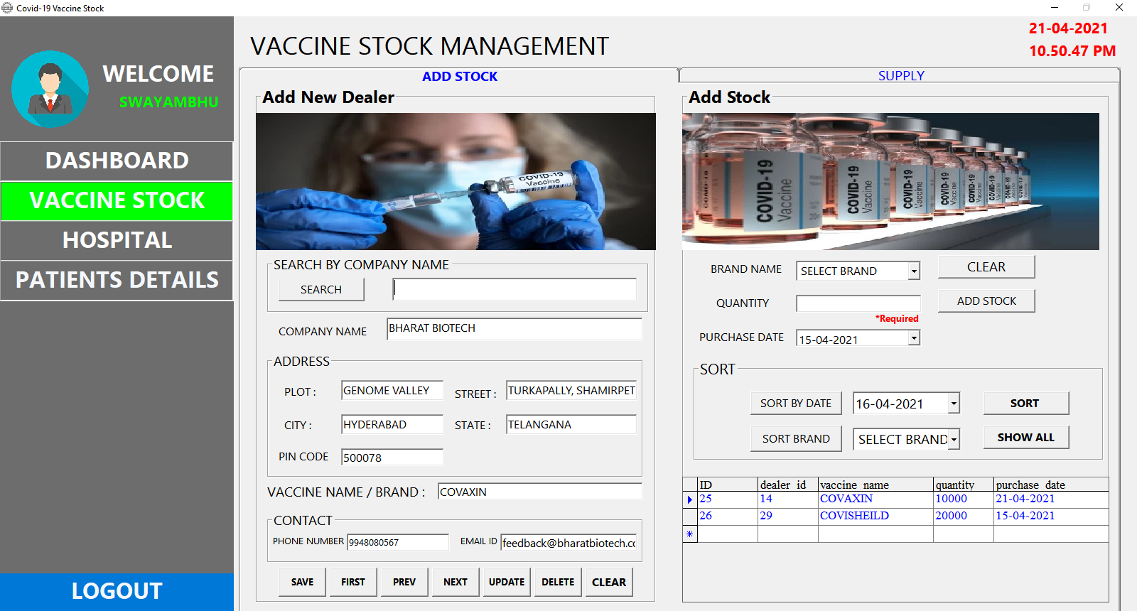

1. **VACCINE STOCK – SUPPLY STOCK**

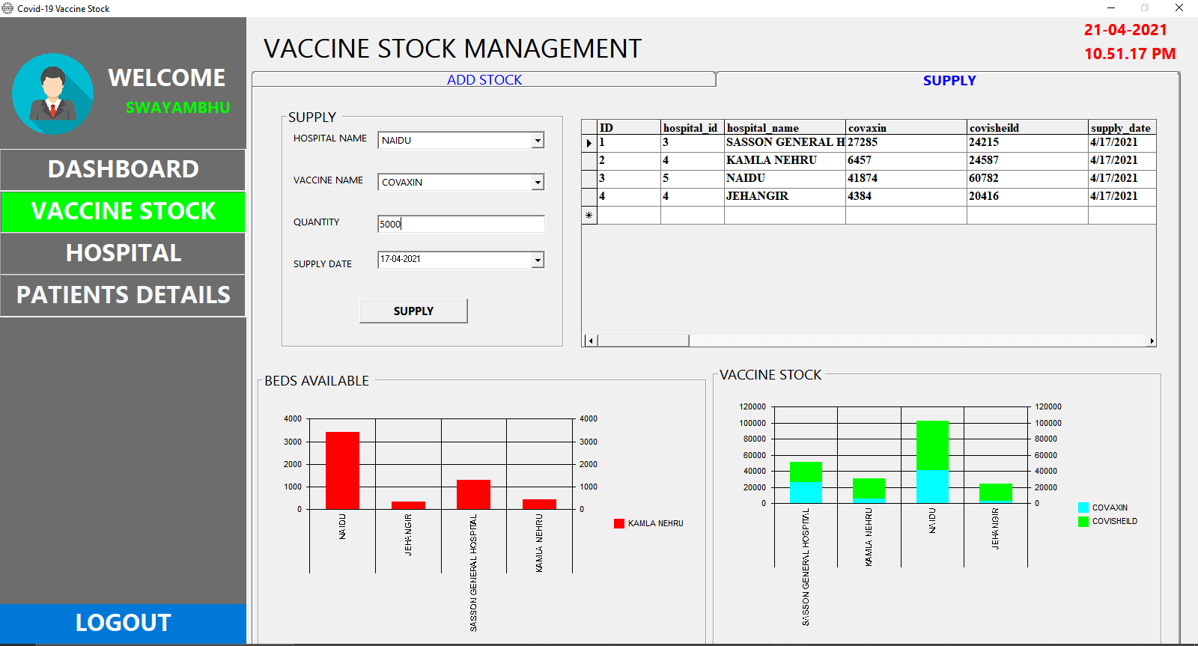

1. **HOSPITAL**

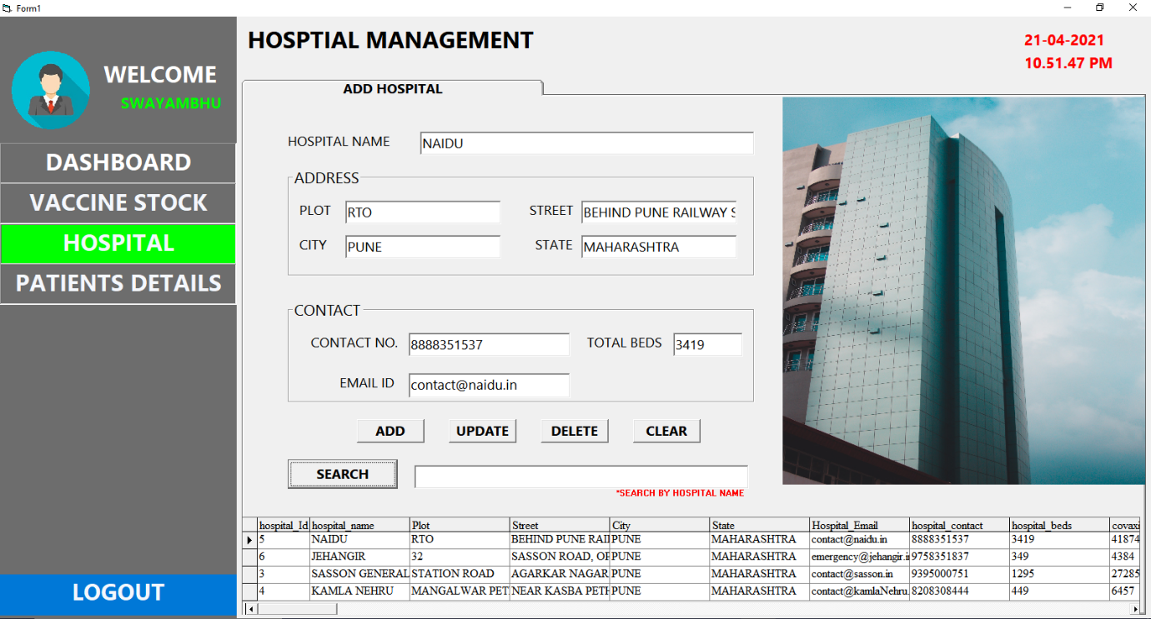

1. **PATIENT – REGISTRATION**

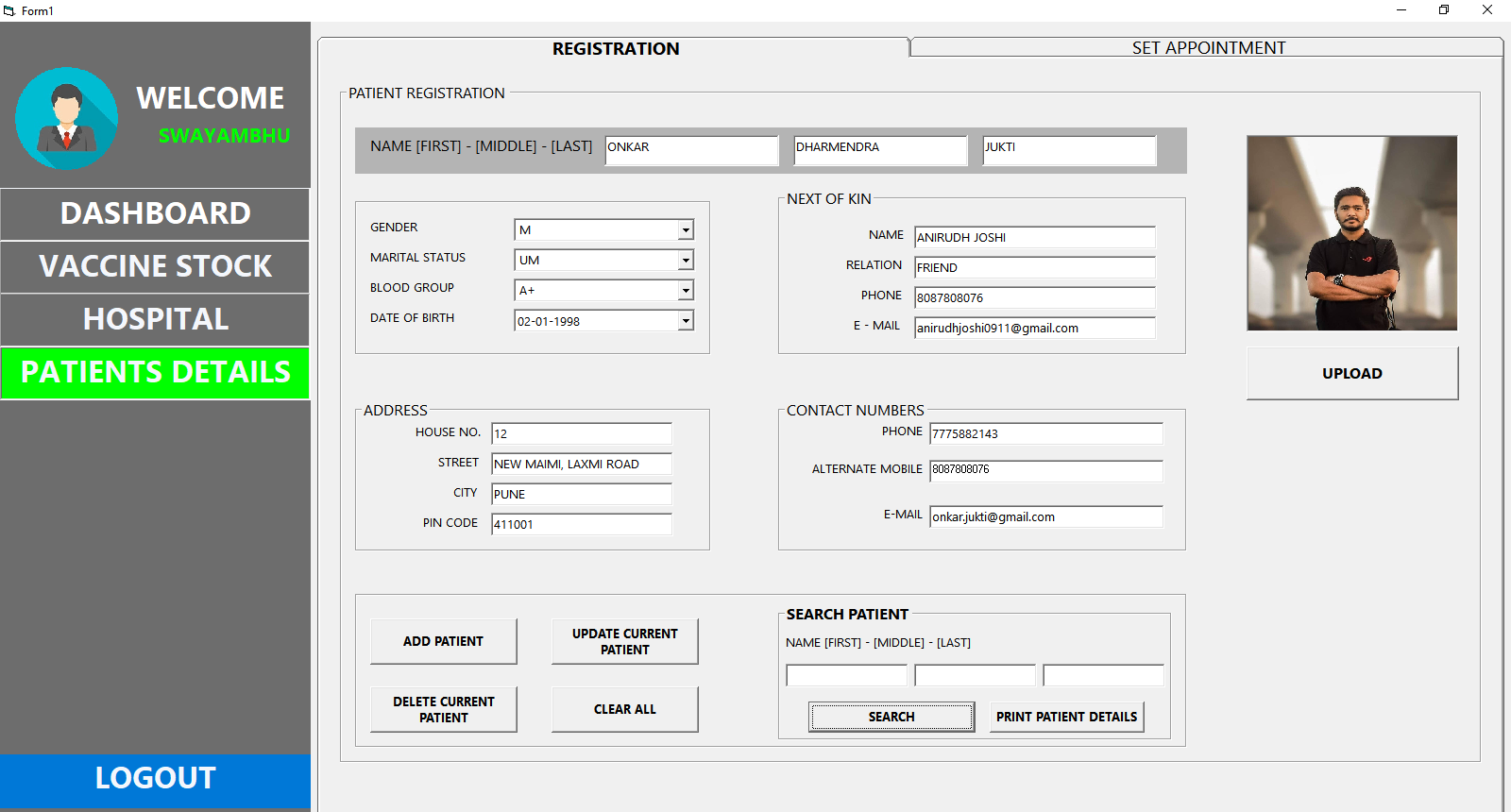

1. **PATIENT – SET APPOINTMENT**

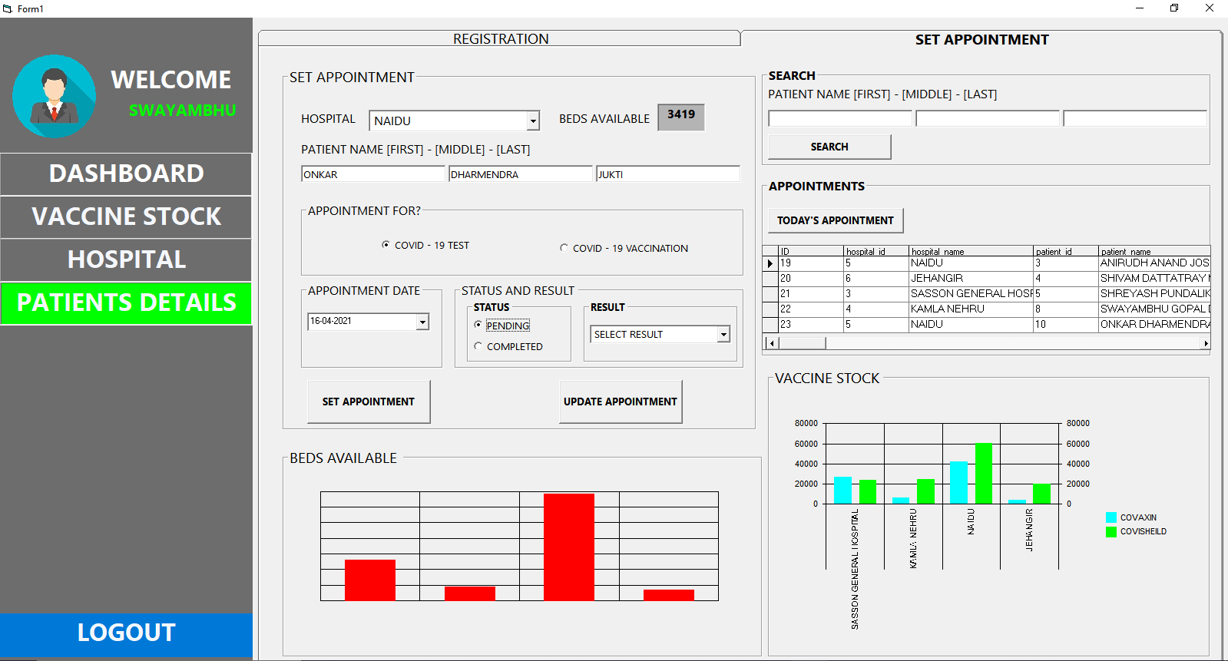

**DATA REPORT**

1. **PATIENT APPOINTMENTS**

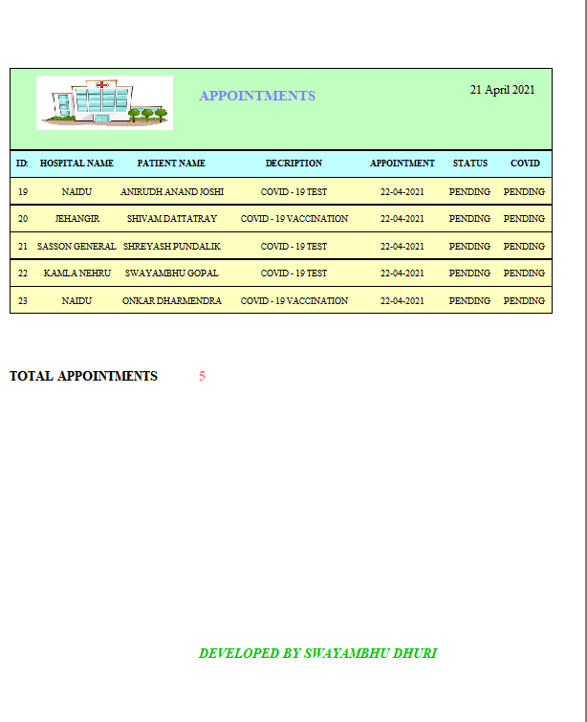

1. **HOSPITAL REPORT**

