CS691 - Computer Science, Spring 2023
Project Initiation Document
ParkEZ

Project: ParkEZ
Project Manager: Krunal Bhavsar
Start Date : 01/24/2023
Completion Date :

Table of Contents
Document Purpose 4
Background to the Proposed Work 4
Vision 4
Project Objectives 5
Project Scope 5
Business Case 6
Assumptions 10
Constraints 10
Risk Management Strategy 11
Deliverables 13
Stakeholders 14
Project Team 14
Project Plan 17
Milestones 17
Project Controls 18
Communication Plan 19

Document Details
Version | Modifications | Author | Date
1.0 | Initial PID Document | Krunal Bhavsar | 02/05/2023

Approvals
This document requires the following approvals:
Name | Role | Signature | Date | Version
Prof. Yuri | Approver |  | 02/05/2023 | 1.0

Distribution
This document has been distributed to:
Name | Role | Date of Issue | Version
Krunal Bhavsar | Project Manager
Swayambhu Gopal Dhuri | Lead Developer
Srija Reddy | Product Owner
Ruchi Sharma | Lead Business Analyst
Tom Alex | DBA
Tom Cookson | QA
Suruchi Patil | Software Developer
Shubham Mittal | Software Developer
Chetan Basnet | Software Tester

Document Purpose (assigned to Krunal)
The fundamental data required to manage the project has been captured in this document. The document will outline the "ParkEZ" website's scope, objectives, tasks, roles, and duties, costs, and deliverables.
- Details of the approach to be adopted for the implementation of the “ParkEZ” Project.
- Details of the roles and responsibilities.
- Description of functions and activities.
- Explanation of the processes.
- Details of the communication plan between team members and with the stakeholders.
- Quality records, risks, project controls and exceptions.

This document's sections are dynamic and may evolve throughout the course of the project. The PID document will have a record of the modifications. Every time a significant project-related decision is made, the PID will be consulted. Also, the PID document will be used at the end of the project to measure whether the project was managed successfully or not and weather all deliverables were produced in timely manner or not.

Background to the Proposed Work (assigned to Ruchi Sharma)
Parking customers benefit from ParkEZ because it shows customers how full parking lots are before they leave and may even recommend optimal parking spots.
Business owners benefit from ParkEZ because they have a limited amount of parking in their parking lot and they need as many parking lot spaces free as possible so customers can get to their business. ParkEZ helps business owners monitor their parking lot by calculating how full the parking lot is throughout the week and notifying the business owner if noncustomers are parked for extended periods of time. ParkEZ also saves recordings for a period, so if a recording is needed from a camera for a specific time for the business owner or the authorities it can easily be retrieved.
The project's goal is to reduce the stress that drivers face while parking. The drivers who use this application will be informed of the parking options in the location they wish to visit. This will lessen the stress and ambiguity involved in finding a suitable parking space close to the target location.
This application ensures parking safety, but its major contribution to traffic congestion are the factors of making the parking experience faster, more convenient, and hassle-free.

Vision (Assigned to Chetna and Tom Alex)
We believe parking should be easily accessible and guaranteed for every individual for a more efficient work or shopping experience. We offer parking space availability info and automated monitoring of camera feeds to our customers. As such, they can streamline finding spaces by inputting the location and in turn will receive a recommended spot that best suits their needs. Our product will not only solve the problem of parking congestion and security but create a more productive and simpler lifestyle for everyone.

Project Objectives (assigned to Chetan and Tom Alex)

- To create a hassle-free parking solution website/app for buyers in high traffic marketplace.
- To register users based on login id and password, credentials will determine type of access to website and app (Business operators/property managers vs. customers).
- To partner with marketplaces and parking lot properties to provide subscription services and ad placements which generate profit.
- To create a friendly, intuitive, and responsive UX/UI for the customers and business operators/property owners.
- To save time for store customers/residents to find parking.
- To increase business sales by managing the flow of customers.
- To promote safety in parking lot and provide notification for parking lot violations.
- To generate additional profit through advertising local businesses on the customer facing interfaces.

Project Scope (assigned to Shubham and Tom Cookson)
Our website helps people find parking spaces and reduces non-patron parkers that will be towed by the business owners/property managers. The features include:
- A means of providing customers with data about parking availability.
- Provide basic automated monitoring of the parking lot that can inform business owners/property managers of some violations.
- Providing data about parking lot usage and analytics.
- Providing access to archived camera footage, up to a certain date, available for business owners/property managers and outside organization to access if requested.
- Subscription based services will be provided for parking customers.
- Advertising will be offered to local businesses for the customer facing websites.
For the team, we will
- Provides a friendly, intuitive, and responsive UX/UI for the customers and business operators/property owners.
- Setting up a staging and production environment for development.
- To set up development, staging and production environments
- Ensuring all team members have skillsets that match their respective roles.
- A reliable and responsive database will be created.
- Teamwork will be incorporated into the development of the application.
- All software and hardware requirements will be met before commencing software development.

Business Case (assigned to Shubham and Tom Cookson)
Application Name | ParkEZ
Type of business model | Subscription: Retail or private/public property owners will pay monthly premiums to better facilitate customer parking and tow removals.  Advertising: Local businesses, such as malls, shopping centers, car rental companies, and stores near the parking lot, will be able to place advertising on our customer facing website and app. When a customer uses ParkEZ to check parking availability, they will see nearby businesses who advertise with us on their webpage or app.
Target audience of external users  (Customer Segments) | For whom are we creating value?  Businesses, property owners, customers/patrons of the stores and businesses who choose to advertise with us.  Who are our most important customers?  Busy businesses and property locations such as malls that get a lot of foot traffic and require parking spaces for customers.
Groups of internal stakeholders, business users | Indicate who will be using the system in your organization, i.e., internal users.  The development group, the customer support team, the advertising team and an administrator.  Do we need a product development group?  Yes, to build an application/platform for the businesses. To address reported issues, monitor the platform for bugs and ensure it is working correctly.  Do we need a sales group?  Yes, a sales group will be needed for initial exposure to the market in attracting businesses to the platform. From there, we will rely on referrals since in many cases property owners manage other properties as well.  Do we need a finance group (accounts payable, receivable)?  Yes, in order to keep track of our funds and ensure we remain profitable our costs must remain below our revenue.  Do we need a customer support team?  Yes, as we have a diverse set of areas to implement our application ranging from mall strips to parking garages, we will need a team that can assist with resolving issues that may arise with different lighting conditions, areas of car traffic and parking lot striping.  The customer support team can also help advertisers with ad management.  Do we need an advertising management group?  Yes, ads will be sold for local businesses (e.g., stores in malls) and appear on the website and apps customer facing parking availability pages. The advertising management group will sell and maintain ads.
Value propositions | What value do we deliver to the customer?  We will help increase business revenue by finding people parking spaces and reducing non-patron parkers that will be towed by the business owners/property managers.  We also connect local businesses with potential customers through advertising.  Which one of our customer’s problems are we helping to solve?  We are increasing the efficiency of and revenue from parking lots.  Loss of revenue occurs due to customer frustration from parking lot congestion. Increasing revenue through foot traffic by facilitating parking for store customer. Also, helping find illegal parking instances to facilitate tows that can also lead to increased revenue for the business/property owner.  What bundles of products and services are we offering to each Customer Segment?  Property Owners/Store Operators/Malls: An easy way to track illegal parkers and reduce the number of non-patrons in their parking lots.  Customers of Businesses: A one stop solution for all their parking needs for the businesses they love to patronize at no cost to them.  Advertising Customers: An opportunity to find local customers by advertising on ParkEZ.  Which customer needs are we satisfying?  - Need to maximize revenue for business operators/property owners from possible patrons by facilitating finding parking spaces.  - Need to reduce illegal parking by non-patrons.  - Need to reduce crime by automating camera footage monitoring.  - Provides customers an easy way to check traffic nearby their favorite spots to shop.  - Increase business for advertising customers.
Key resources | What Key Resources do our Value Propositions require?  - Team of developers to create the customer facing interface and the software that monitors the parking lot.  - Customer support team to act as an intermediary between the app and the property owners.  - Access to security camera feed from business owners or property managers.  Our Distribution Channels?  - Cellphone app stores, website, signage on property with application information  Customer Relationships?  - The nature of customer relationships is of a self-service character for individuals parking their cars.  - For businesses using our app to assist in managing their parking, our customer support team will act as an intermediary. Property managers also have access to some self-service features through their own web portal.  Revenue Streams?  - Subscriptions.  - Selling advertisements.
How the system is used | What is the main system use scenarios for the External Customers?  - Parking customer will go to the app, type in the store name and will see how many parking spaces are available.  - For example, a person may want to go to a popular downtown restaurant with limited parking. They can check parking availability via ParkEZ before leaving to decide whether to park in the parking lot or use other nearby parking.  - Business owners and security operators will have a web portal to sign in and view parking lot availability and any infraction instances that are liable for tow removal.  - For example, a local Thrift Store owner with free parking may notice that a car has been parked in the parking lot for over 24 hours. He will see this on his web portal and know to call the towing company or issue a warning.  - Advertising users will have a simple portal where they can upload advertisements (images matching specifications and URLs they go to), select frequency and time length of ads, and select which parking locations their ads will appear in.  - You may have a small restaurant outside of a mall with a parking garage. Paying for advertising on the ParkEZ app may help more customers parking in the mall find your restaurant.  What is the main system use scenarios for the Internal Users?  - Customer support team members will have an administrative portal where information is available about all the parking lots being monitored.  - A customer support team member may need this feature if a business says the system isn’t working correctly registering a parking space. The internal user can login and confirm if the customers bug is a technical issue that needs addressing.  - Customer support team members will be able to query all available information to assist law enforcement if required.  - Law enforcement calls to ask if a stolen cars’ license plate has been seen in the records.  - Internal users will have a simple dashboard interface where they can see metrics about how different advertisements are performing, total income from advertisements, and what advertisements are currently approved for what timeslots
External Interfaces (data feeds) | Does the system exchange data with external systems?  Yes, it does:  - In case of any accidents or emergency data is shared with police and first responders.  - Feed from cameras in parking lots.  - Credit card payment interface for payments from advertisers and subscribers.
Revenue generation, Revenue streams | Monthly Subscription Premium, Advertisement Fees
Key Partners/Suppliers (Stakeholders) | Parking lot operators, investors, customers who bought advertisements, police, and security
Expected Benefits to the Customer | - Maximize business revenue.  - Minimize crime or illegal parking.  - Ease burden on security operators/property management overseeing parking use through security camera monitoring.
Known Prototypes | Reference some known portals on the Internet that are similar to your business case. You will use these prototypes for developing business, user requirements.  - parquery.com  - parkingdetection.com

Assumptions (Assigned to Shubham)

Assumption | Validated by | Status | Comments
Meetings | Product Manager | In Process | Meetings will be scheduled every week by Product Manager
Work Assignment | Product Manager | In Process | All work will be assigned by Product Manager according to the roles.
Development Stage | All Members | In Process | Every member of the corporate over the development work
Technologies | Development Team | In Process | Development Team will suggest technologies for development.
Customer Review | Business Analyst | In Process | Business Analyst will provide analytics about pre-customer review/feedback
Resources | All members | In Process | Resources required to reach development stage will be set up by all members.
Business Tie-ups | Business Analyst & DBA Developer | In Process | Business Tie-ups will be looked by BA and DBA Developer to incorporate in the application

Constraints (assigned to Suruchi)
The things that need to be taken into consideration during the delivery of this project are
- Time: As this is a team project, there are multiple people with different schedules and different levels of time available. In addition, as a team, we have to work around everyone's calendar to find a time to meet that works for everyone. Each person must plan within their own schedule to find time to complete individual work for this project.
- Missing Group Member: In such a case, to be able to fill in for absent team members, all members should get familiar with each other's duties.
- Deadlines: Despite limited time as stated above, the deadlines for each deliverable must be met.
- Requirements: We must make sure that the application that we develop fulfills the requirements that have been set for this project.

Risk Management Strategy (assigned to Ruchi Sharma)
Risk management planning is the process of identifying, assessing, and prioritizing risks that could impact an organization's ability to achieve its objectives. The goal of risk management planning is to minimize the negative impact of risks on an organization and maximize the potential positive outcomes. The process typically involves the following steps:
The objective of risk management planning is to create a structured approach to addressing uncertainty and to ensure that an organization has the resources and contingency plans in place to manage potential risks.
Some potential risks in this business model with mitigation methods include:

Risk | Risk Description | Probability | Impact | Mitigation Method
Customer Acquisition | Attracting and retaining subscribers, especially retail or property owners, can be challenging and requires significant marketing and customer acquisition efforts. | Medium | High | To mitigate the risk of attracting and retaining subscribers, the company could focus on building strong relationships with its target audience through marketing and customer engagement activities, such as providing excellent customer service, conducting market research, and offering incentives and rewards to retain customers. The company could also explore partnerships with other organizations that serve the same customer base to reach more potential subscribers
Technical Challenges | There may be technical challenges in developing and maintaining the customer-facing website and app, which could result in decreased customer satisfaction and increased costs. | Medium | High | To mitigate the risk of technical challenges, the company could invest in developing a robust and secure technical infrastructure, regularly testing, and updating its systems, and engaging with technical experts to address any issues that arise. Additionally, the company could invest in training and development programs for its technical staff to ensure that they have the necessary skills and knowledge to maintain the customer-facing website and app.
Advertising Revenues | Relying on advertising revenues from local businesses is uncertain and could be impacted by changes in local market conditions or the businesses' marketing budgets. | High | High | To mitigate the risk of relying on advertising revenues, the company could diversify its revenue streams by exploring other sources of income, such as subscription-based services or offering premium features for a fee. The company could also build strong relationships with its advertising partners to ensure that their budgets remain stable, even during periods of market uncertainty.
Regulations | ParkEZ may face regulations related to customer parking and tow removal, which could result in increased costs and decreased efficiency | Medium | High | To mitigate the risk of facing regulations, the company could stay informed about the relevant regulations and standards, engage with legal and regulatory experts, and ensure that its operations comply with all applicable laws and regulations. The company could also work proactively with regulatory agencies to understand their requirements and develop strategies to ensure compliance.

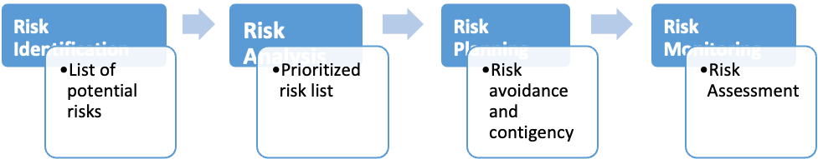Figure- Risk Management stages

Deliverables (Assigned to Krunal)
The deliverables of the project for phase 1 are:
No | Artifact Name | Responsible Party
1 | Project Plan | PM
2 | PID document | PM
3 | BRM Diagram | Product Owner
4 | Context Diagram | Lead BA
5 | Architecture Diagrams (2) | Lead Dev/DBA
6 | User Requirements | Product Owner
7 | RCT (includes functions, decompositions, supplementary requirements) | Lead BA
8 | Use-Case Diagram (UML) | Lead BA
9 | Activity Diagram (UML) | Lead BA
10 | Data-flow Diagram | Lead BA
11 | Functional Requirements (user stories) | Lead BA
12 | Class Diagram (UML) | Lead Dev
13 | Sequence Diagram (UML) | Lead Dev
14 | ER Diagrams (conceptual, logical) | DBA
15 | Table Specs | DBA
16 | Source code sample (part of Application Demo) | Lead Dev
17 | Test Plan document | Lead QA
18 | Application Demo | All

Stakeholders (assigned to Srija)

Stakeholders | Interests
Parking lot operators | Increased security in parking lots, increased availability of spaces
Investors | Maximized return on investment
Security and police | Available footage of crime that has occurred, alerts about cars overstaying legal parking limits
Customers who bought advertisements | Increased exposure to nearby consumers

Project Team (assigned to Swayambhu Dhuri)
The project team includes the following roles
- Project Manager
- Product Owner
- Lead Software Developer
- Software Developer
- Business Analyst
- QA Lead
- Tester
- DBA

 |  | Project Roles
Process Area | Project Tasks | Project Manager | Product Owner | Dev Lead | Business Analyst | Test Manager | DBA
Project Management | Develop a project plan | A,R | C | C | C | C | I
Project Management | Provide cost estimate | A,R | C | C | C | C | I
Project Management | Hire resources | A,R | C | C | C | C | I
Project Management | Establish a project portal on SharePoint | A,R | R | I | I | I | I
Project Management | Maintain a project risk and issue log | A,R | R | C | C | C | I
Project Management | Provide project status reports | A,R | R | C | C | C | C
Requirements | Perform requirements analysts | A | R | C | R | I | I
Requirements | Gather business requirements | R | I | C | R | I | I
Requirements | Produce functional requirements | A | I | C | R | C | I
Design | Produce high-level design specs | A | I | R | C | I | C
Design | Produce data model | A | I | C | C | I | R
Design | Produce detailed design specs | A | I | R | C | I | R
Coding | Establish a code repository | A | I | R | I | I | I
Coding | Develop component code | A | I | R | I | I | I
Testing | Develop a test plan | A | I | C | C | R | C
Testing | Establish a test repository | A | I | C | I | R | I
Testing | Develop test specifications | A | I | C | I | R | I
Testing | Execute testing, report defects | A | I | I | I | R | I
Testing | Conduct defect review calls | A | I | C | R | R | C
Testing | Produce, deliver defect metrics | A | I | C | R | R | I
Testing | Support test environments | A | I | R | C | C | R
Deployment | Produce a deployment plan | A | I | R | I | I | R
Deployment | Produce deployment procedures | A | I | R | I | I | R
Deployment | Deploy software into production | A | I | R | C | C | R

Project Plan (assigned to Shubham Mittal, Swayambhu Dhuri, Suruchi, and Tom Cookson)
This semester (Project I), the project will follow the Waterfall model comprised on the phases shown below. The implementation phase is scheduled for 2 weeks where the project team will implement the Home page and login features, laying grounds for the next semester.
The project plan includes 5 milestones defined below.

Milestones (Assigned to Krunal)
MS1: Initial Project Plan (02/14/2023)
This is the first stage of project where we discussed about the tow different ideas in the group where we have selected the idea which was more suitable and efficient for the business purpose. In this stage we are going to make project initiation document where we have mentioned the details of the project including project plan, RACI table, Risk management etc.
MS2: Requirements Completed (03/07/2023)
In the second stage of project we are going to complete the requirements of the project including functional (user stories)-non-functional (business) & various diagrams such as UML analysis, fishbone, data-gram. We are going to complete the system modelling and develop the home page demo.
MS3: Design Completed (03/28/2023)
Stage three incudes making ER diagrams, data flow diagrams, database & reference data specifications.
MS4: Coding Completed (04/18/2018)
In the fourth stage we are going to design and implement the project using the database, softwares and git hub.
MS5: Testing Completed (04/25/2023)
In the testing stage we are going test the design that we have developed and going to resolves the flaws that we face in testing stage. We are going to test the code that we have developed for the web applications.

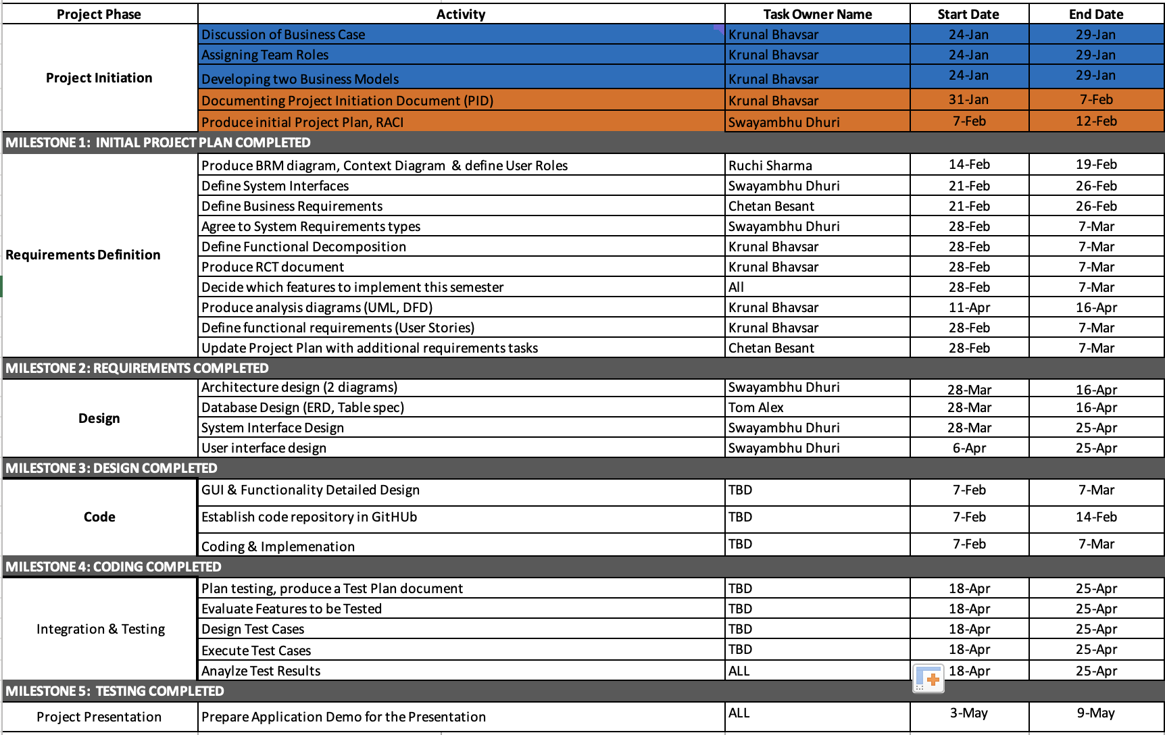

Project Controls (Assigned to Krunal)

- Official language of the project will be English. Official meetings will be held in English. All project documentation and presentations will also be written in English.
- Project manager will be organizing two weekly meetings. All the team members are allotted their work that has to be completed before each week.
- In case any member cannot make for the meeting, manager should reschedule a meeting or held it online through zoom. Most of the asynchronous communication will be done on slack for Business.
- Important points and topics will be discussed in the meetings. Final decisions will be made by the end of the meetings taking everyone’s opinion in the consideration.
- Weekly meeting minutes will be maintained by the project manager which will also include the progress of the project phases. Manager will also keep a track of the deadlines and ensure that everyone plays their role accurately.
- Slack, WhatsApp, and Google drive will be used to update all the team members with the important information by the manager and for sharing all the files.

Communication Plan (assigned to Srija)
This section will include how stakeholders will be communicated with during the project and how frequently. This should include a note on where to find the communications plan if you have one.
Stakeholder | Frequency | Type | Purpose
Project Manager | Daily | Email, Zoom, personal meetings, Slack, phone | To discuss working progress, estimates, requirements prioritization, role and responsibilities within the team. To discuss any issues related to communication between team members or issues related to team members.
Professor | At every Stage  -Regarding the  progress and  deliverable  drafts | Email, Slack,  Classroom | To approve  project  implementation  and direction.  Advise if there  are any potential  issues.
Development  Team | At key stages | Email, Slack,  meetings | To determine  any loopholes or  find any bugs in  the program and create the software.
Investors | In regular intervals | Meetings, Email | To verify the progress of the system and to validate its future scope
Project Team | Daily | Email, personal meetings, social media, Slack | Maintain progress and ensure that the team is meeting the requirements
Customer End users | Acquire feedback about App performance during testing and periodically after deployment. | Feedback on customer facing interface | Feedback
Parking Lot operators | Daily | CCTV footage, phone | To verify and validate application functionality.

