

Project Report | VITyarthi Course
By: Swayam Shree Das | Registration No.: 26BCE11238
Program: B.Tech CSE Core | Semester: 1st Semester
Course: Introduction to Problem Solving and  Programming | Faculty: Jitendra Pratap Singh Mathur

Introduction
The Shopping List Manager is a menu-driven Python program for tracking items a user plans to buy. It supports item
entry and management and calculates estimated shopping costs. The project demonstrates introductory programming
concepts through a practical command-line application

Problem Statement
A shopper may forget planned purchases or find it difficult to estimate costs when quantities and prices are recorded
informally. This program provides a simple terminal-based list to organize item names, quantities, prices, and
purchase status.

Objectives
- Practise Python lists, dictionaries, functions, loops, conditions, and input handling.
- Add, view, search, update, purchase, and remove shopping items.
- Calculate the total, purchased, and pending item values.
- Organize the implementation into small modules and validate it with unit tests

Scope and Target Users
The intended users are students or individuals who want a basic shopping checklist in a terminal. One list is held in
memory during a single run. Data is cleared when the program exits; file or database storage is outside this version’s scope.

Functional Requirements
FR1 | Add an item with a name, positive quantity, and non-negative  price. | Details / confirmation
FR2 | Display all items and their status. | List / item rows
FR3 | Update the quantity of a selected item | Number and quantity / confirmation
FR4 | Mark a selected item as purchased | Item number / confirmation
FR5 | Remove a selected item | Item number / confirmation
FR6 | Search item names without case sensitivity. | Word / matches or no-match
FR7 | Calculate total, purchased, and pending values. | Current list / amounts
FR8 | Exit the menu loop. | Choice / goodbye message

Non-functional Requirements

- Usability: The numbered menu uses short, clear action names.
- Reliability: Invalid numeric input and item numbers are reported to the user.
- Maintainability:Related responsibilities are placed in separate modules.
- Performance: Local list operations are appropriate for a personal shopping list.
- Resource use: The program uses the Python standard library and stores only the current list in memory
System Architecture
The program follows a simple modular structure. The main module controls the menu, input helpers validate values,
item_entry collects new item details, display prints menus and data, and shopping_list carries out operations. The
shared list of dictionaries is the in-memory data store.
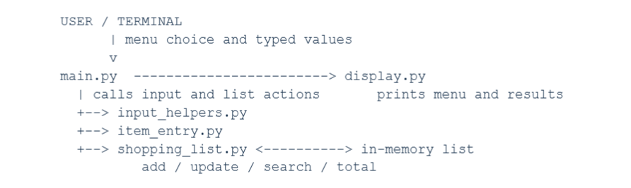
Design Diagrams
Use Case Diagram
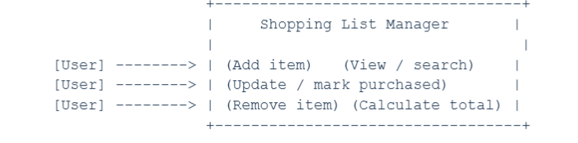
Workflow Diagram
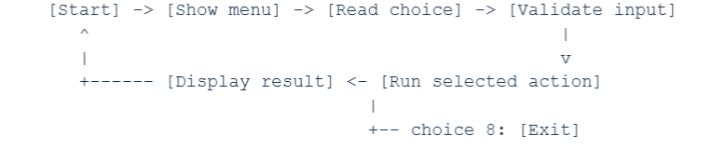
Sequence Diagram: Add Item
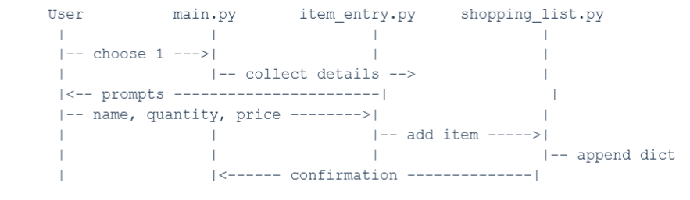
Component Diagram
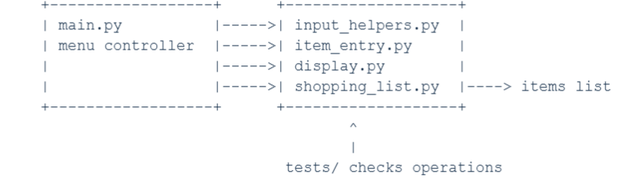
Storage Design
Each item is a dictionary with name (text), quantity (integer), price (number), and purchased (Boolean). A list stores
zero or more item dictionaries. Since this version has no persistent storage, an ER diagram is not applicable.
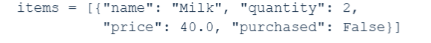

Design Decisions and Rationale
A list of dictionaries keeps each item’s related details together and is suitable for an introductory project. Menu item
numbers start at 1 for users; the program subtracts 1 to access Python list positions. In-memory storage keeps the
implementation simple. Separate modules make input, display, and list operations easier to locate and maintain.
Implementation Details
The program uses Python 3 and built-in language features. The shopping_list module adds, updates, searches,
marks, removes, and calculates costs. The search converts names and search terms to lowercase. Cost calculations multiply each quantity by its price and add the values to the total and appropriate purchased or pending total.

File | Purpose
main.py | Menu loop and action routing
shopping_list.py | Shopping-list operations and cost calculations
display.py | Menu and list display
input_helpers.py | Numeric and item-number checks
item_entry.py | Prompts for new item details
README.md | Project overview, setup, run, and test instructions
statement.md | Problem, scope, users, and high-level features

Screenshots / Results
Sample terminal output (illustrative; actual values depend on user input):

Adding an item to the list:
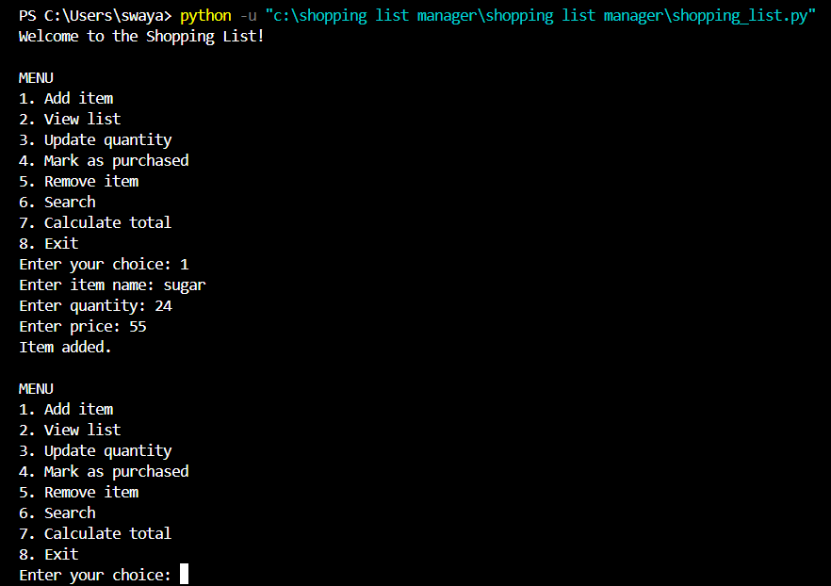
Showing the current list
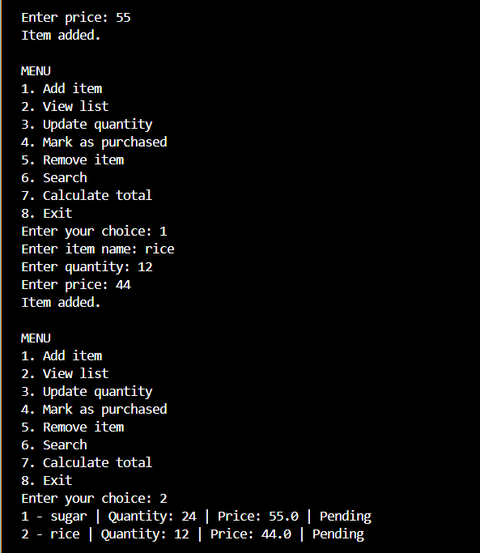
Marking an item as purchased
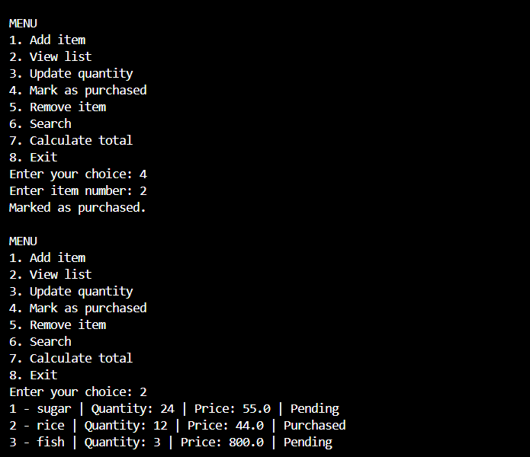

Testing Approach
The built-in unittest framework checks adding an item, updating quantity, marking it purchased, removing it, searching without case sensitivity, and calculating totals. The test suite was run while preparing this report: 6 tests passed
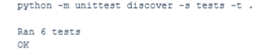
Manual checks should also cover empty lists, blank item names, invalid numeric input, invalid menu choices, and
out-of-range item numbers.

Challenges Faced
The user-facing item number begins at 1, while Python list positions begin at 0. The program converts between these
by subtracting 1. Numeric conversion and item selection also require validation so invalid input does not cause an
unhandled error.

Learnings and Key Takeaways
The project provides practice in breaking a problem into functions, selecting a suitable data structure, using conditions
and loops, validating user input, and testing individual operations. Modular files also help keep a small program
organized.

Future Enhancements
- Save and load the list from a file.
- Allow editing item names and prices.
- Add categories, budget limits, or sorting.
- Add more tests for invalid input and menu interaction.

References
~ VITyarthi claases and modules.
~ Offline classes learning

