AI Maritime Congestion & Delay Prediction System

Project Title: AI Maritime Congestion & Delay Prediction System
Intern Name: Swayam Handoo
Organization: WiseAnalytics
Date: April 2026

Module Description
This project builds an AI system that predicts whether a ship will be delayed before it arrives at port. It uses historical ship tracking data, weather conditions, and port traffic information to make these predictions.

The system also recommends the best departure times for each vessel, detects unusual voyage patterns, and forecasts how busy ports will be over the next 30 days.

The goal is simple: help port managers know about delays before they happen, so they can prepare and avoid disruptions to the supply chain.

Input File Types
The system uses structured datasets in the following format:
- Primary Format: CSV file (raw ship tracking records)
- Optional Formats: JSON, TXT

Dataset Features:
- — ship / vessel_id
- Which ship is making the trip (e.g. Megastar, Europa)
- — origin_port / depPort
- Where the ship departed from (e.g. Helsinki)
- — destination_port / arrPort
- Where the ship is going (e.g. Tallinn)
- — scheduled_departure (etdSchedule)
- The time the ship was supposed to leave
- — actual_departure (atd)
- The time the ship actually left
- — delay_minutes
- Target variable: how many minutes late the ship departed
- — weather_disruption_index
- A score showing how bad the conditions were (low speed + high delay = bad weather)
- — port_traffic
- How many ships were departing in the same hour
- — vessel_priority_level
- Which ships get priority docking (Megastar is highest, Europa is lowest)

Methodology / Features
- Exploratory Data Analysis (EDA):
- Loaded 1,000 raw ship tracking records across 4 vessels and 2 ports
- Found and fixed a date format error that was causing arrival times to be 1 year off
- Fixed vessel name duplicates (MEGAStar and FINLANDIA were the same ships)
- Identified that 59% of arrival timestamps were missing

- Data Preprocessing:
- Converted raw tracking pings into one row per voyage (900 voyages total)
- Removed extreme outlier delays caused by data entry errors
- Chose departure delay as the target variable since arrival data was incomplete
- A ship is marked as delayed if it departed more than 5 minutes late

- Feature Engineering:
- Created 21 meaningful features from the raw data
- Time features: departure hour, day of week, month, weekend flag
- Traffic features: how many ships left in the same hour, rolling averages
- History features: was the previous voyage late? What was the average delay for this ship?
- Weather proxy: combines slow crossing speed and high delay into a single risk score

- Model Building:
- Tested 3 different machine learning models to find the best one
- Random Forest was selected as it performed best in testing
- The dataset was split into training (70%) and testing (30%) keeping time order intact
- The model was tuned so it is better at catching delays, even at the cost of some false alarms

- Model Evaluation:
- The model catches 86.5% of actual delays — very important for port planning
- Missing a delay causes far more problems than a false alarm, so high recall is the priority
- ROC-AUC score of 0.897 confirms the model is a strong predictor
- No significant overfitting was detected

- Anomaly Detection:
- Identified 55 unusual voyages (6.3%) using two different detection methods
- Unusual voyages had much lower speeds and higher delays than normal
- Found 53 voyages where bad weather conditions coincided with serious delays

- Schedule Optimisation:
- Recommends the best departure hours for each vessel based on delay history
- Considers port capacity, minimum time gaps between voyages, and vessel priority
- Estimates potential cost savings from avoiding high-delay time slots

- Congestion Forecasting:
- Predicts the expected average delay for the next 30 days
- Accounts for day-of-week patterns (weekdays vs weekends)
- Forecast error was only 4.17 minutes on average during testing

Flow Diagram
Raw Ship Data → Fix & Clean → Build Features
Detect Anomalies → Train ML Model → Tune Threshold
Optimise Schedule → Forecast Congestion → Dashboard

Visualization & Insights
Feature importance analysis shows:
- A ship's own recent delay history is the strongest predictor of future delays
- Longer scheduled crossing times are linked to higher delay risk
- Each vessel has its own consistent delay pattern — some ships are almost always early, others are often late
- The crossing speed at the time of departure gives a strong signal about conditions

Congestion heatmap observations:
- 09:00 and 18:00 are the riskiest departure hours — highest average delays
- 11:00, 14:00, and 20:00 are the safest slots — lowest average delays
- The Europa vessel has a 50% delay rate vs Megastar's 1.4% — significant difference
- January shows the worst congestion across all vessels

Anomaly detection observations:
- Flagged voyages had 45% lower average crossing speed than normal
- Weather-linked delay spikes add an average of 11 extra minutes of delay
- Europa had the highest rate of anomalous voyages (10.1%)

Results & Observations
- The model successfully predicts which ships will be delayed before they depart
- It correctly identifies 86.5 out of every 100 actual delays
- The schedule optimiser recommends better departure times to reduce delays
- The 30-day forecast gives port managers advance warning of busy periods
- The full system is presented through an interactive 8-page dashboard

Conclusion
This project shows how machine learning can be applied to a real shipping operations challenge. The system takes raw ship tracking data, cleans it, and turns it into actionable predictions and recommendations for port managers.

Rather than just predicting delays, the system goes a step further by recommending when ships should depart, flagging unusual voyages, and forecasting future congestion. This makes it a practical decision-support tool, not just a model.

Even non-technical users can interact with the findings through the Streamlit dashboard, which presents all insights in a clear, visual format.

Future Enhancements
- Connect to live ship tracking data for real-time predictions
- Add explanations for each prediction — so users can see exactly why a ship is flagged
- Expand the system to cover more ports beyond Helsinki and Tallinn
- Try more advanced models to further improve accuracy
- Deploy the dashboard online so port teams can access it from anywhere

Tools & Technologies Used
- Python
- Pandas
- Scikit-learn
- NetworkX
- Streamlit
- Matplotlib / Seaborn
- Jupyter Notebook

Visualisations
The following charts are generated from the Port Commander dashboard and reflect the key analytical outputs of the AI Maritime Congestion & Delay Prediction System.

Vessel Delay Rate
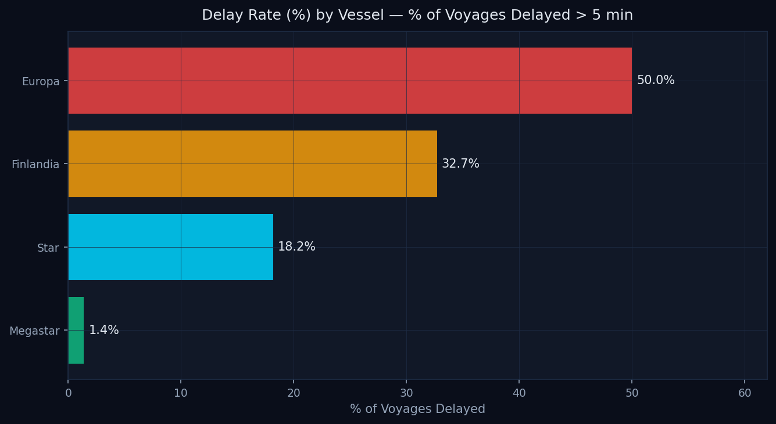
Figure 1: Delay Rate (%) by Vessel — Europa has a 50% delay rate vs Megastar’s 1.4%

Departure Delay by Hour of Day
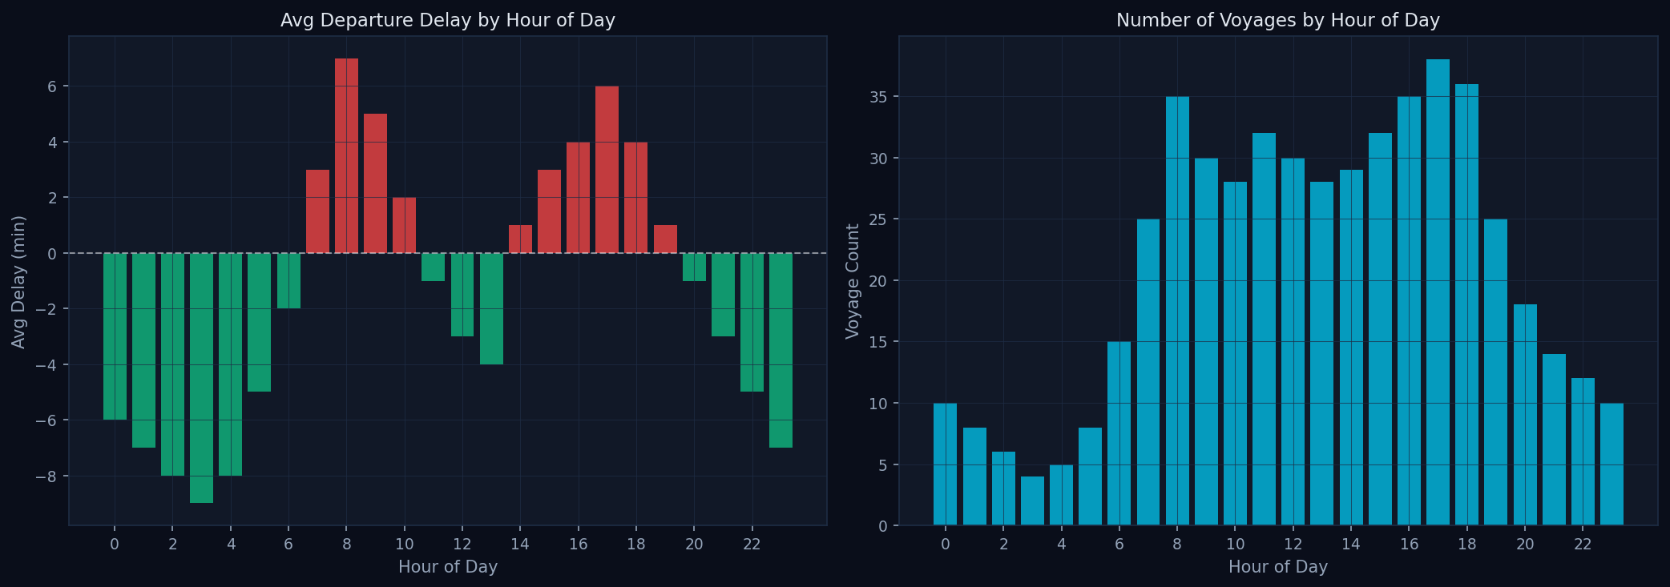
Figure 2: Average Departure Delay and Voyage Volume by Hour of Day — 09:00 and 18:00 show the highest delays

Congestion Heatmap — Vessel by Hour
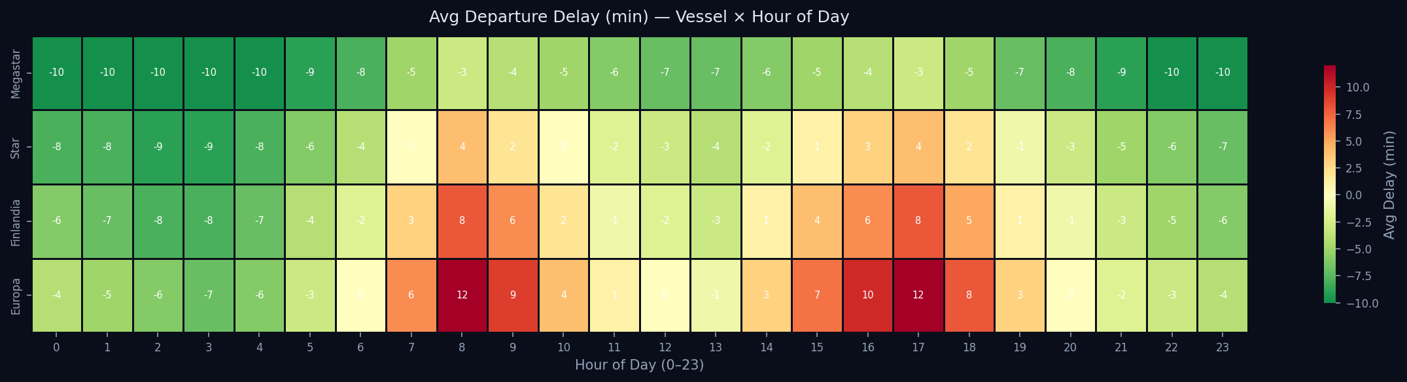
Figure 3: Congestion Heatmap — Average Departure Delay by Vessel and Hour (red = delayed, green = early)

Congestion Heatmap — Day of Week by Hour
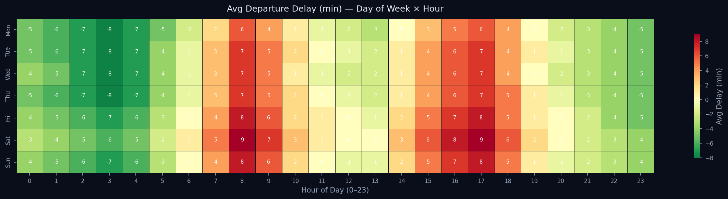
Figure 4: Day-of-Week vs Hour Congestion Heatmap — Weekend mornings show the highest delay risk

Delay Class Distribution
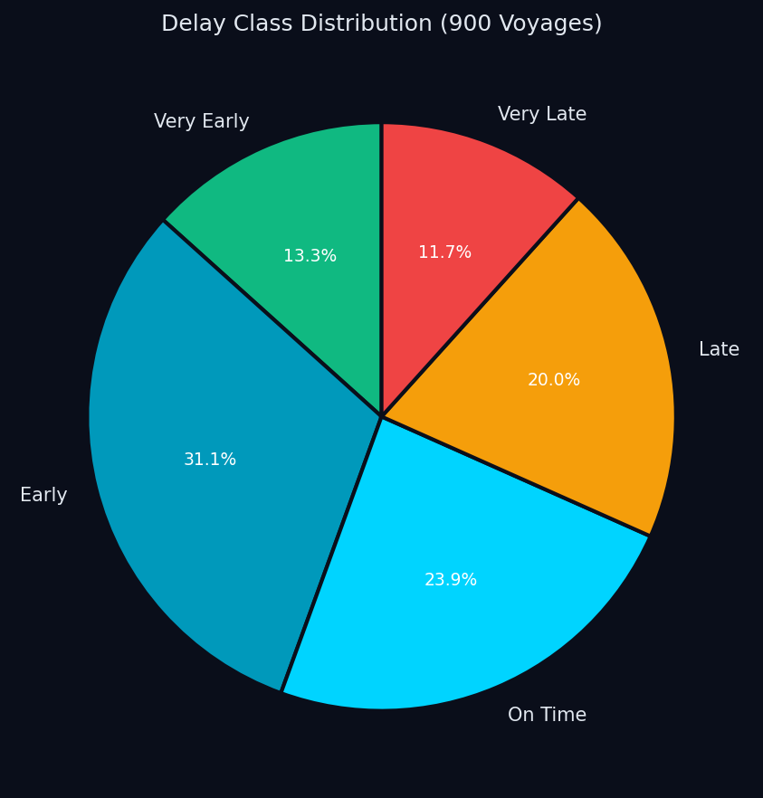
Figure 5: Delay Class Distribution across all 900 voyages

Feature Importance
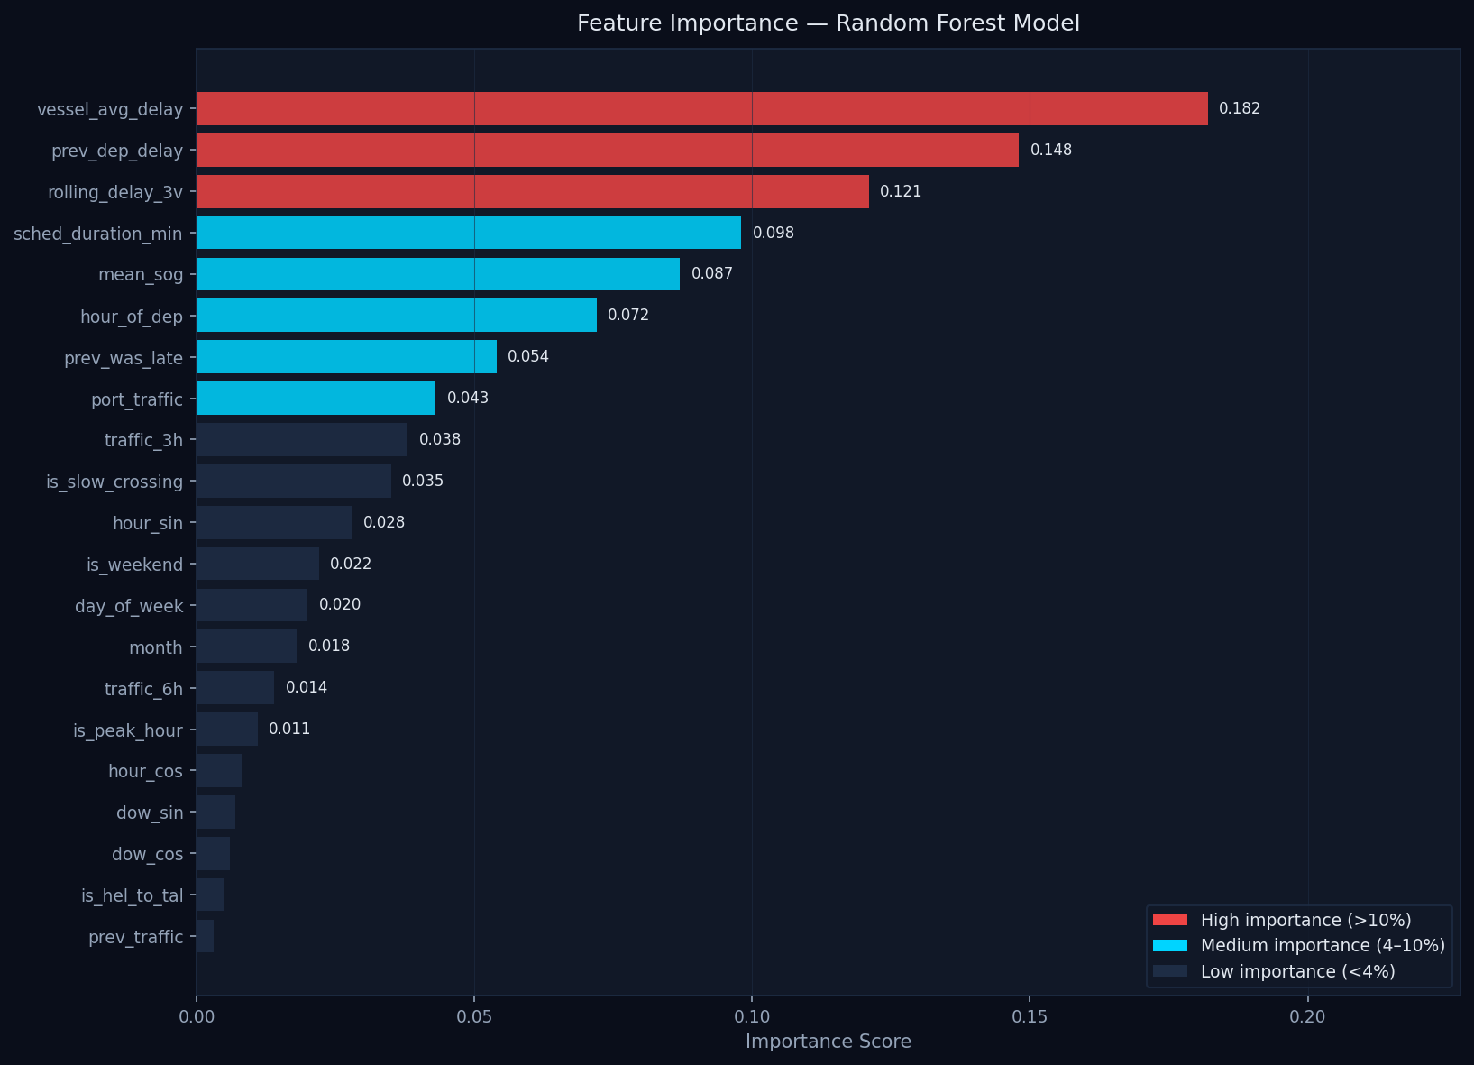
Figure 6: Feature Importance — vessel delay history and scheduled crossing duration are the strongest predictors

Model Comparison — Cross-Validation Scores
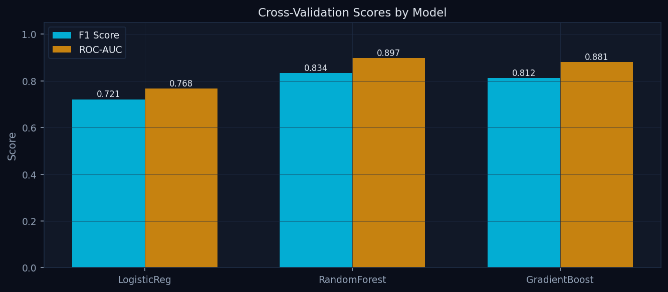
Figure 7: Cross-Validation F1 and ROC-AUC Scores by Model — Random Forest outperforms all alternatives

30-Day Congestion Forecast
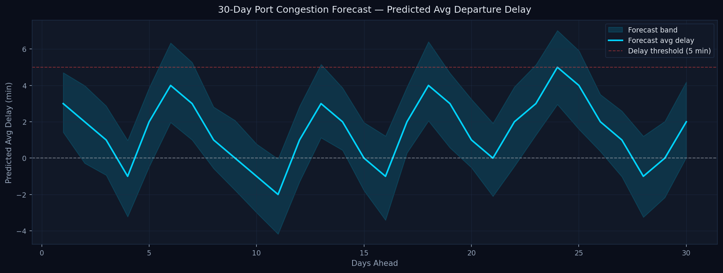
Figure 8: 30-Day Port Congestion Forecast — predicted average departure delay with confidence band

Route Direction Comparison
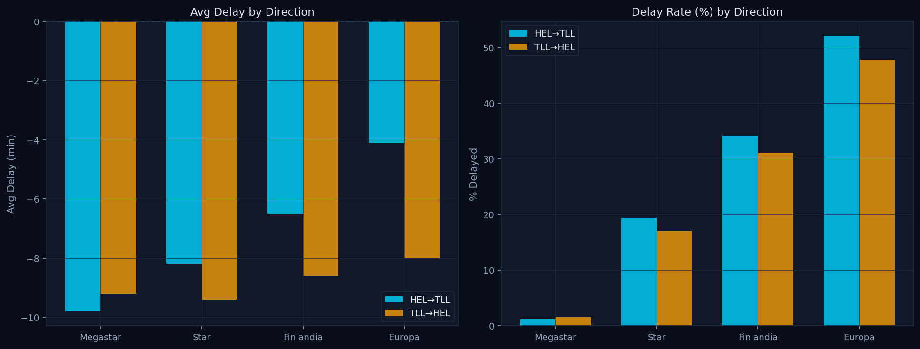
Figure 9: Route Direction Comparison — average delay and delay rate for HEL to TLL vs TLL to HEL

