Worksheet No. - 1.1

Student Name: Swayam UID: 25CA20015
Branch: MCA Section/Group: MCA/1-A
Semester: 2nd Date of Performance: 6 jan 2026
Subject Name: Technical training Subject Code:25CAP-652

Aim/Overview of the practical: To design and implement a sample database system using DDL, DML, and DCL commands, including database creation, data manipulation, schema modification, and role-based access control to ensure data integrity and secure, read-only access for authorized users.

Objective: To gain practical experience in implementing Data Definition Language (DDL), Data Manipulation Language (DML), and Data Control Language (DCL) operations in a real database environment. This will also include implementing role-based privileges to secure data.

S/W Requirement: Oracle Database Express Edition and pgAdmin

Requirements:
- Database Design

  - Create multiple tables such as Department, Employee, and Project.

  - Define appropriate PRIMARY KEY and FOREIGN KEY constraints.

  - Enforce NOT NULL, UNIQUE, and CHECK constraints where necessary.

Data Manipulation

  - Insert sample records into all tables.

  - Perform UPDATE operations to modify existing records.

  - Perform DELETE operations while maintaining referential integrity.

Access Control & Security

  - Create a role/user for a reporting staff member.

  - Grant ONLY SELECT privilege on required tables to this role/user.

  - Explicitly REVOKE CREATE privilege so that the user cannot create any database objects.

  - Ensure the user has read-only access to the database.

Schema Modification

  - Use ALTER TABLE to add or modify a column.

  - Drop a table that is no longer required using DROP TABLE.

Procedure/Code:
1
CREATE TABLE Department ( dpt_id INT PRIMARY KEY,
dpt_name VARCHAR(30) UNIQUE NOT NULL
);

CREATE TABLE Employee ( emp_id INT PRIMARY KEY,
emp_name VARCHAR(30) NOT NULL,

salary INT CHECK (salary > 0), dpt_id INT,
CONSTRAINT fk_dpt FOREIGN KEY (dpt_id) REFERENCES
Department(dpt_id)
);

CREATE TABLE Project ( project_id INT PRIMARY KEY,
project_name VARCHAR(30) NOT NULL, dpt_id INT,
CONSTRAINT fk_project_dpt FOREIGN KEY (dpt_id) REFERENCES Department(dpt_id)
);

-- 2
INSERT INTO Department VALUES (1, 'HR'),
(2, 'IT'),
(3, 'Sales'),
(4, 'Finance');

INSERT INTO Employee VALUES (101, 'Roshan', 50000, 2),
(102, 'Sanchit', 45000, 1),
(103, 'Riya', 55000, 3),

(104, 'Swayam', 60000, 4);

INSERT INTO Project VALUES
(201, 'Payroll System', 2),
(202, 'Web Application', 2);

UPDATE Employee SET salary = 55000 WHERE emp_id = 101;

DELETE FROM Project WHERE project_id = 202;

--3
SELECT CURRENT_USER;

CREATE ROLE report_staff
WITH LOGIN PASSWORD 'staff1';

SELECT CURRENT_USER;

GRANT SELECT ON Department TO report_staff; GRANT SELECT ON Employee TO report_staff; GRANT SELECT ON Project TO report_staff;

REVOKE CREATE ON SCHEMA public FROM report_staff;

REVOKE INSERT, UPDATE, DELETE ON Department FROM report_staff; REVOKE INSERT, UPDATE, DELETE ON Employee FROM report_staff; REVOKE INSERT, UPDATE, DELETE ON Project FROM report_staff;

--4
ALTER TABLE Employee
ALTER COLUMN emp_name TYPE VARCHAR(50);
DROP TABLE Project;

Output:
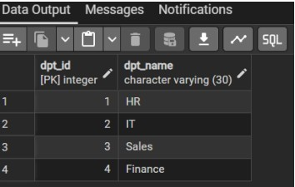

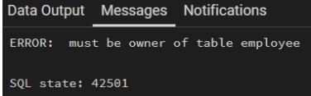

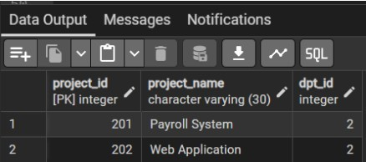
Learning outcomes (What I have learnt):

- Design relational database tables using appropriate data types, PRIMARY KEY, and FOREIGN KEY constraints.
- Apply data integrity rules using NOT NULL, UNIQUE, and CHECK constraints.
- Insert, update, and delete records from tables using SQL DML commands.
- Maintain referential integrity between related tables using FOREIGN KEY constraints.

