ANNUAL REPORT
2024-2025
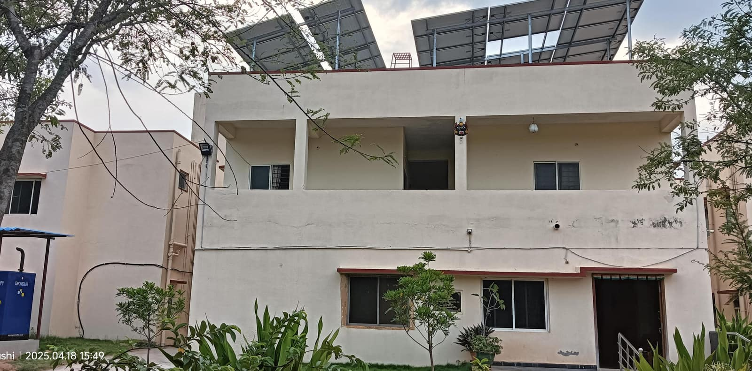

SWAYAMKRUSHI
SURVEY NO 687,688
JAWAHARNAGAR VILLAGE, CHENNAPUR, SHAMIRPET MANDAL,
MEDCHAL DISTRICT NEAR BALAJI NAGAR,
YAPRAL, HYDERABAD, TELANGANA
PIN CODE: 500087
E-Mail:- swayamkrushimk@gmail.com.
www.swayamkrushi.org.in.

SWAYAMKRUSHI

1. About the organization:
Swayamkrushi is a voluntary organization established in 1991 and is located in Secunderabad, Andhra Pradesh. It was the only institution of its kind in the country and has been spear heading the movement to increase the awareness about and inclusion of adults with developmental challenges into the society / community. It is dedicated to the rehabilitation, education and integration of adults with developmental / intellectual disabilities. The aim is to build and develop a symbiotic relationship between the disabled individuals and their immediate community. This has helped in bridging the existing social and emotional chasms between the community and the disabled individuals. This has proved to be a grand success.
Recognizing its contribution to the cause of mainstreaming persons with Intellectual Disability, Swayamkrushi has been made the State Nodal Agency Centre (SNAC) for the National Trust (Ministry of Social Justice & Empowerment). The National Trust was established by an Act of Parliament in 1999 for the Welfare of persons with Autism, Cerebral Palsy, Intellectual Disability and Multiple Disabilities. National Trust works towards providing opportunities for capacity development of persons with disability and their families with an aim of facilitating them, promoting the creation of an enabling environment and an inclusive society and thus fulfilling their rights.

VISION STATEMENT
To build a society in which the less fortunate persons live with dignity, pride and as productive members of the society.
MISSION STATEMENT

To house and train intellectually challenged adults before facilitating their employment and independent living within the community

SWAYAMKRUSHI’S CURRICULUM FOR INDEPENMDENT LIVING (I.L)
The curriculum that we follow makes them independent
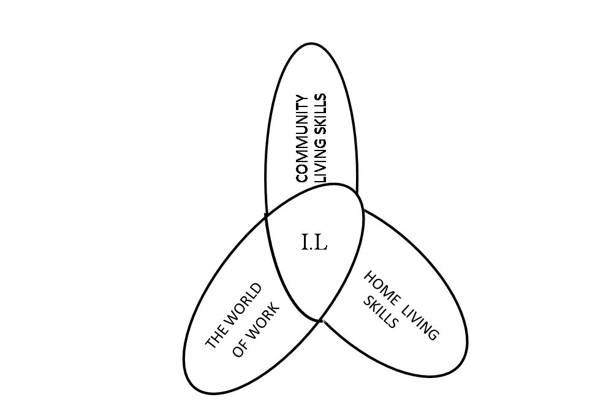
Preparation for Community living skills
Life at home 1. Mobility
Life at Community 2. Stores & Services
The world of work 3. Restaurants
Transition from School 4. Recreation

OBJECTIVES:

Rehabilitation of Intellectually Challenged
The core idea consists of placing the challenged individuals in ‘Group Homes’ while providing them supervision and training. Each home has eight trainees and is managed by a resident staff member. The model aims at:-
- Providing family life for the young people with intellectual disabilities.
- Provide opportunities to people with intellectual disabilities to undergo normal developmental experiences.
- Give experience to people with intellectual disabilities in the management of household work independently.
- Ease people with intellectual disabilities into the idea of living in one place and work at another place just like other normal persons of the society.
- Facilitate the integration of the intellectually challenged persons into the community.

2. Projects at glance:
a. MR School cum Vocational Centre for intellectual disabilities gets grant in aid from Deen Dayal Rehabilitation Scheme, Ministry for Social Justice & Empowerment, New Delhi for their Special School and Vocational Centre for intellectual disabilities. It has a residential set up as well as day scholars. There are 60 members in our residential set up and 100 members come as day scholars. Out of the 160 members 90 are Female and 70 are Male. They are trained in Special Education, various vocations and life time survival skills
b. Gharaunda is another life long stay scheme of National Trust which is run by Swayamkrushi. The set up is only for women and there are 26 members. 19 members are orphans and are from BPL families & LIG families. 7 members are paying for their stay. They are being trained for open employment and sheltered workshops. This Centre is supported by The National Trust, New Delhi
3. Activities: Important activities and celebrations:

May 13th 2024:- Swayamkrushi students participated in the Lok Sabha Elections on May 13th, 2024, and cast their votes.
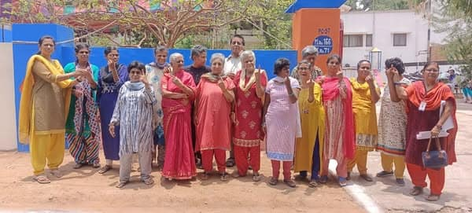

June 4rth 2024:- Empowering Women with Knowledge and Care
The dedicated Swayamkrushi team, including teachers, staff, and B.Ed Special Education students, conducted a vital menstrual hygiene awareness program for the women of Vikalangula Colony on 29.05.2024. Together, we distributed sanitary pads and shared essential health information. Proud to support our community and foster better health and well-being!

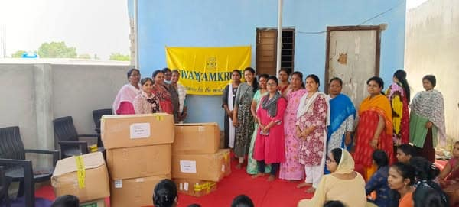

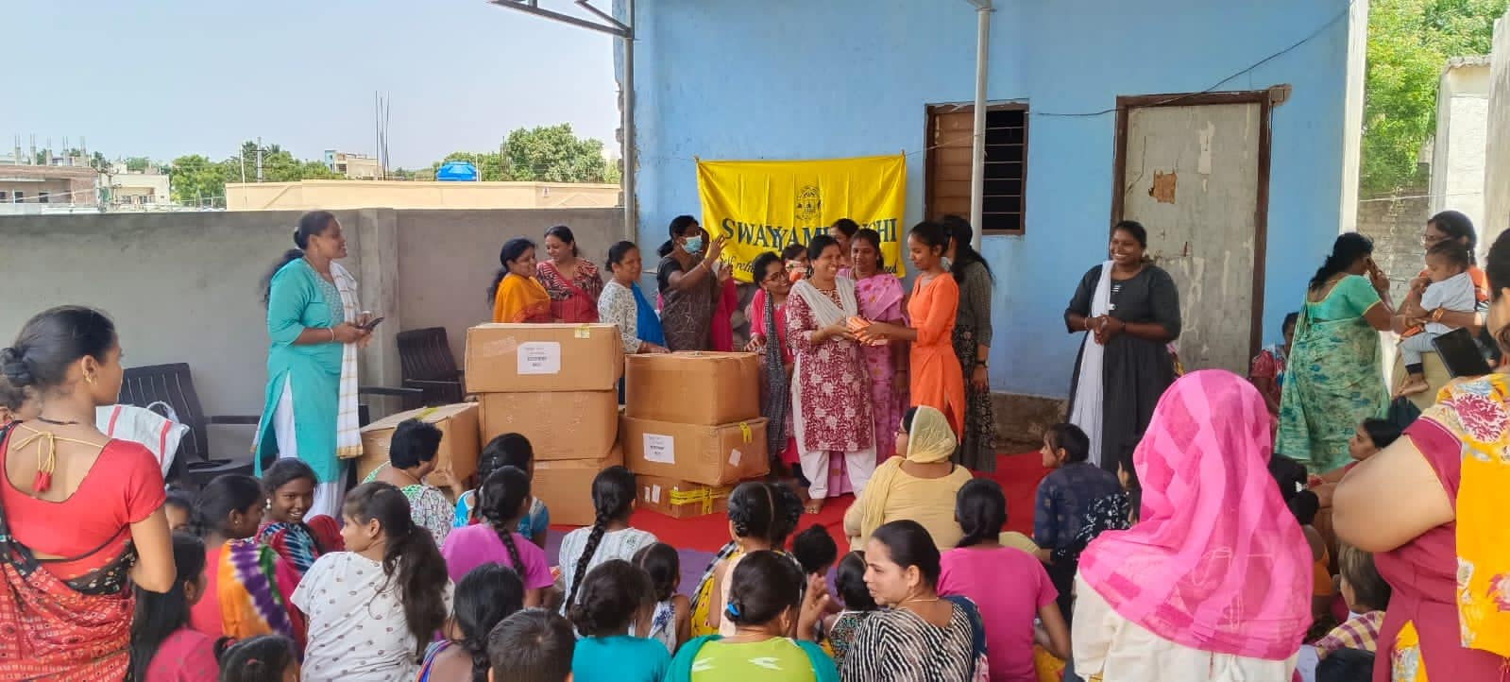

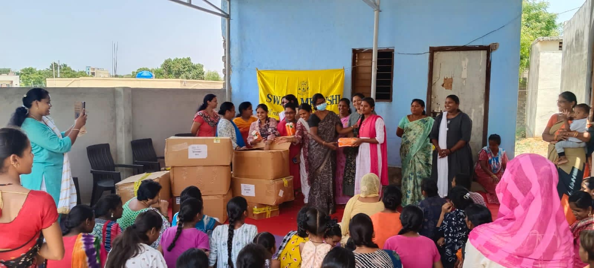

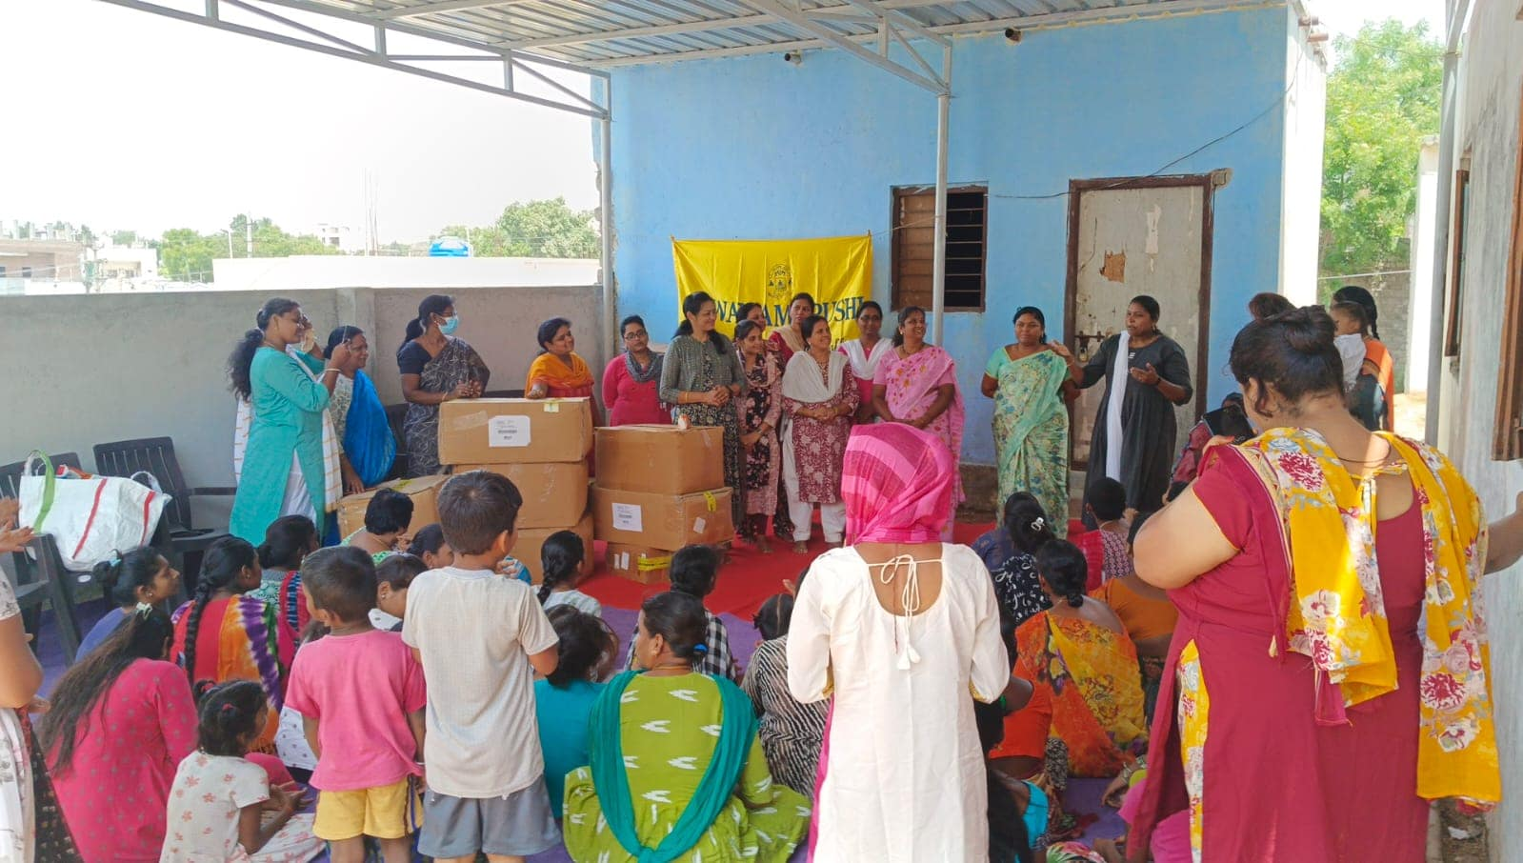

June 10th 2024:- Magical Day at the Bombay Circus!
The children of Swayamkrushi were taken to the Bombay Circus and enjoyed an unforgettable day filled with wonder and excitement! Their smiles and laughter lit up the tent.

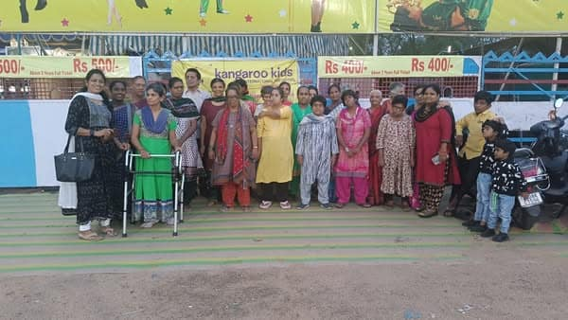

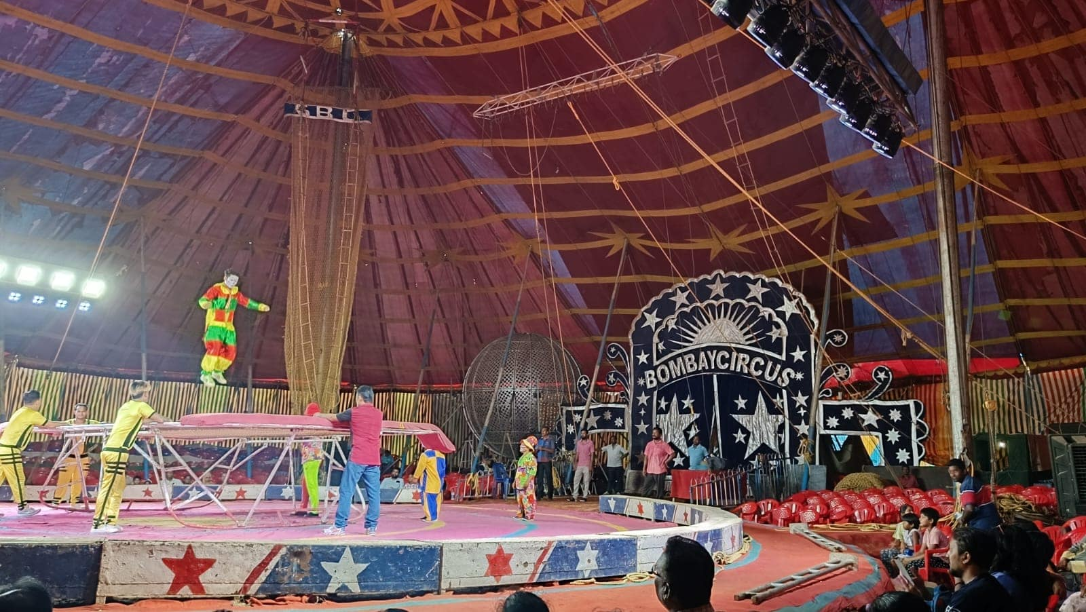

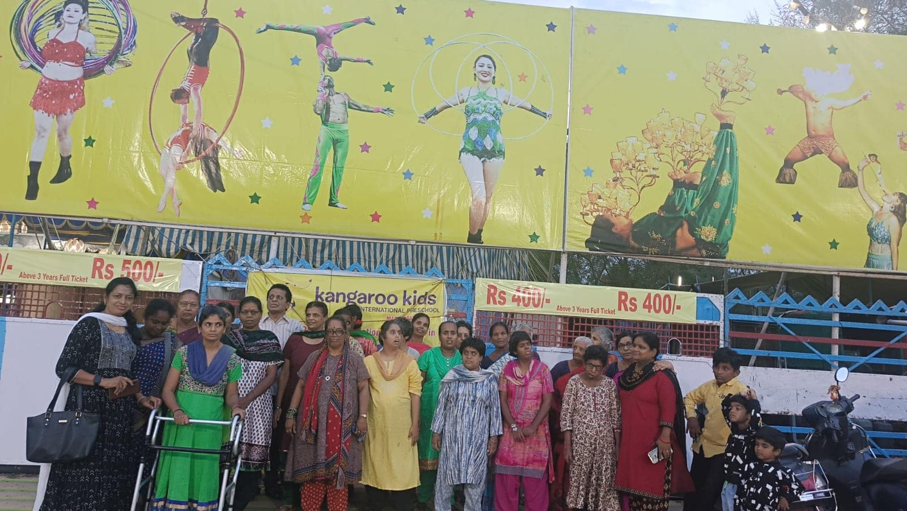

June 10th 2024:- The incredible children of Swayamkrushi participated in the International Yoga Day event organized by the National Institute for the Empowerment of persons with Intellectual Disabilities (DIVYANGJAN). Their enthusiasm and commitment are truly inspiring!

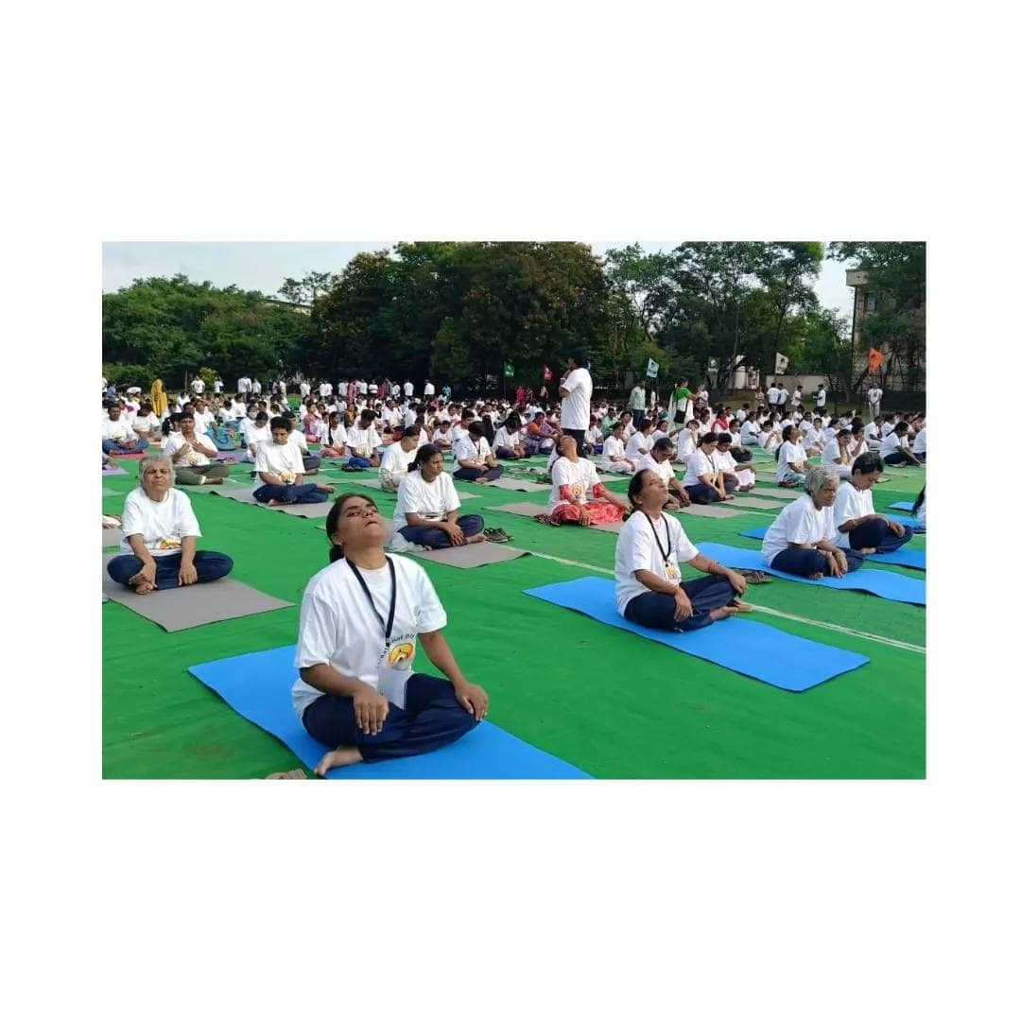

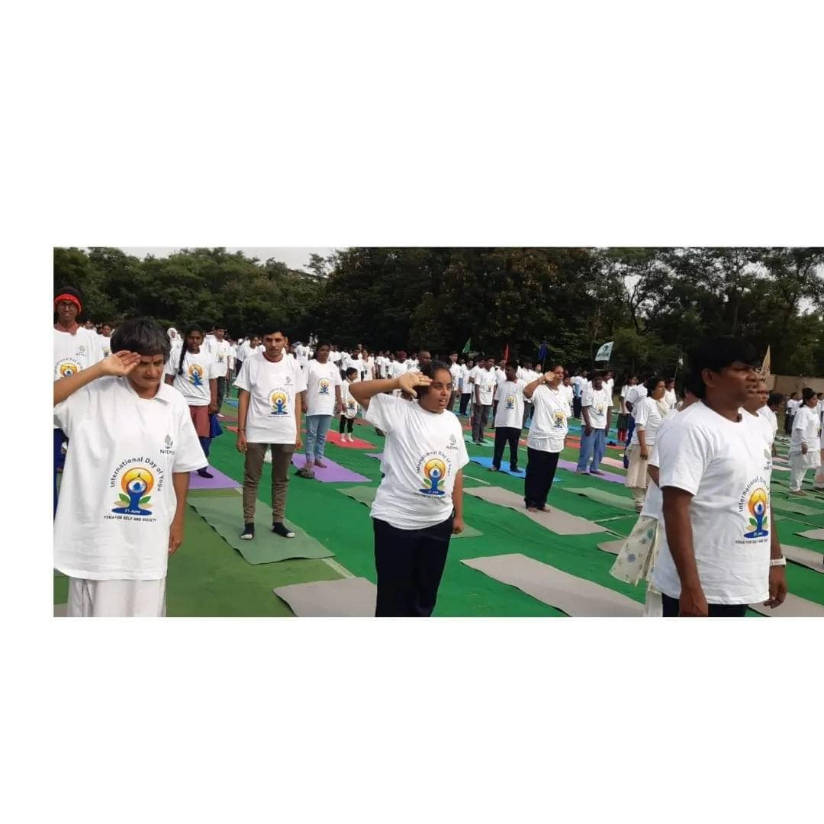

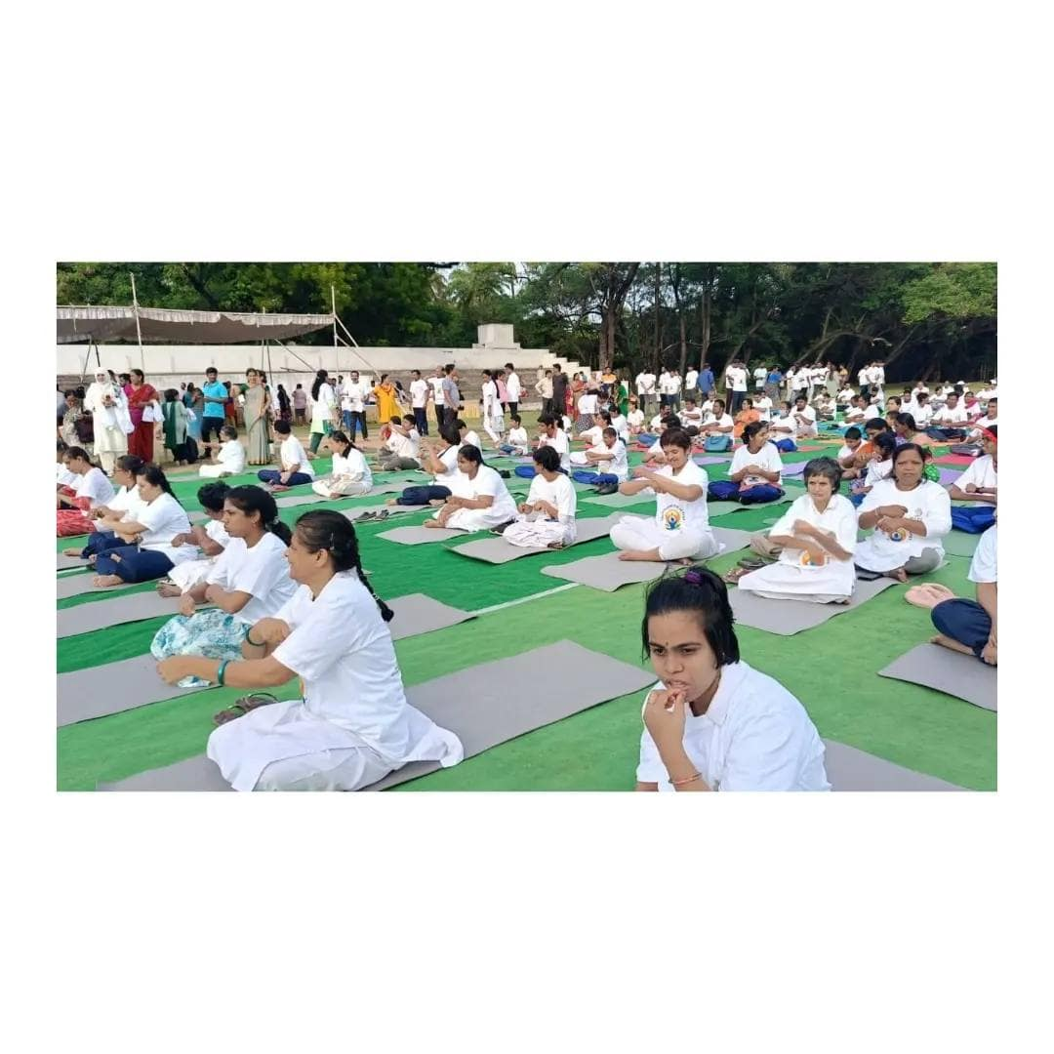

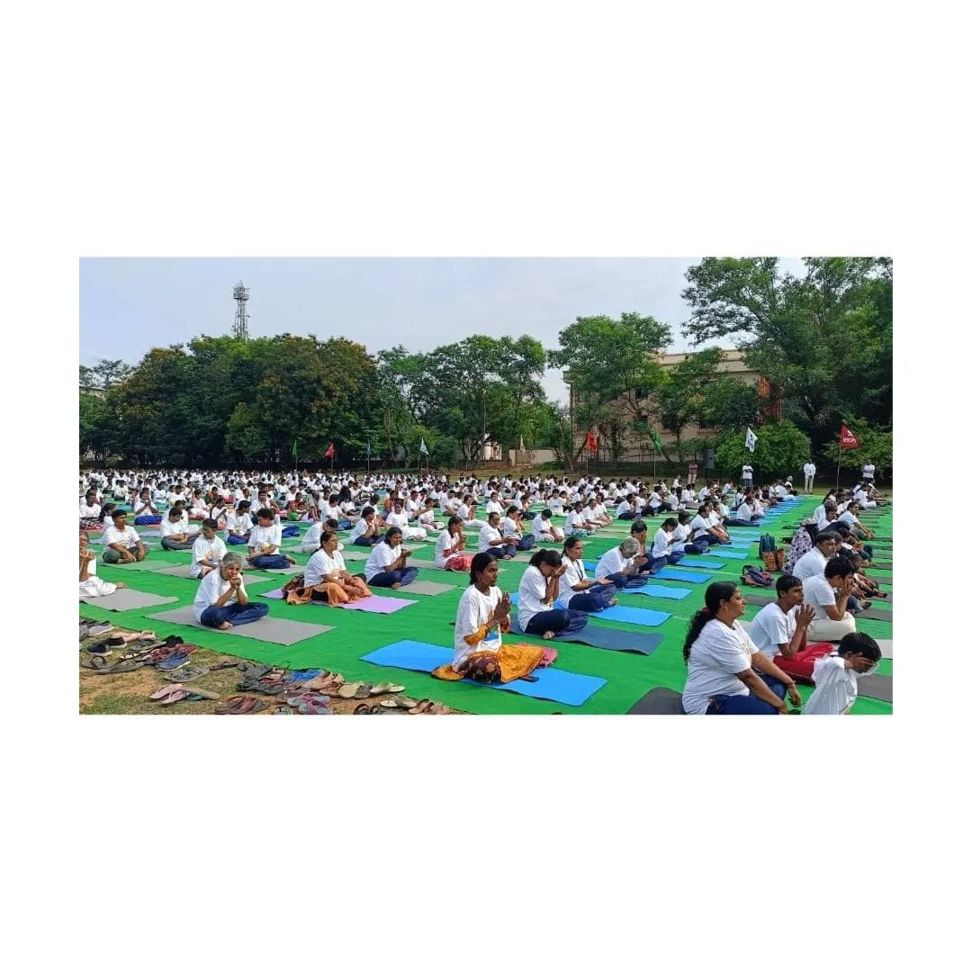

July 27th 2024:- Celebrating the incredible journey of Swayamkrushi on our Founder’s Day! On 27th July, we honored the birthday of our visionary founder, Dr. Manjula Kalyan, whose unwavering dedication continues to inspire us. A heartwarming moment as Manjula madam received blessings from her elder sister, symbolizing the love and support that drives our mission forward.

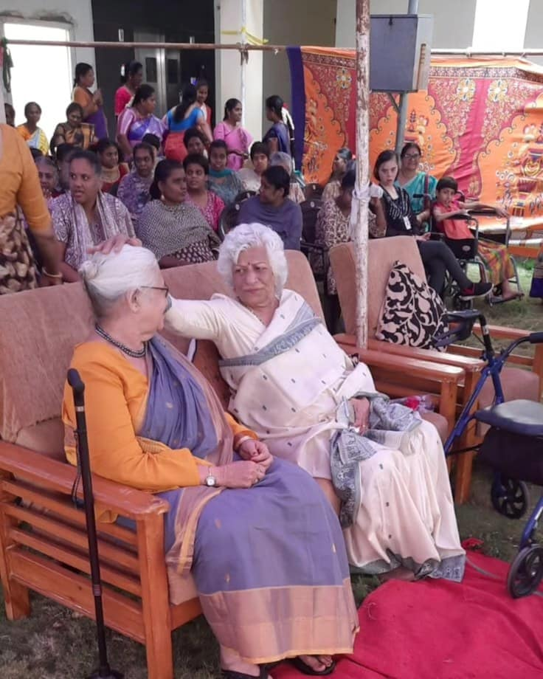

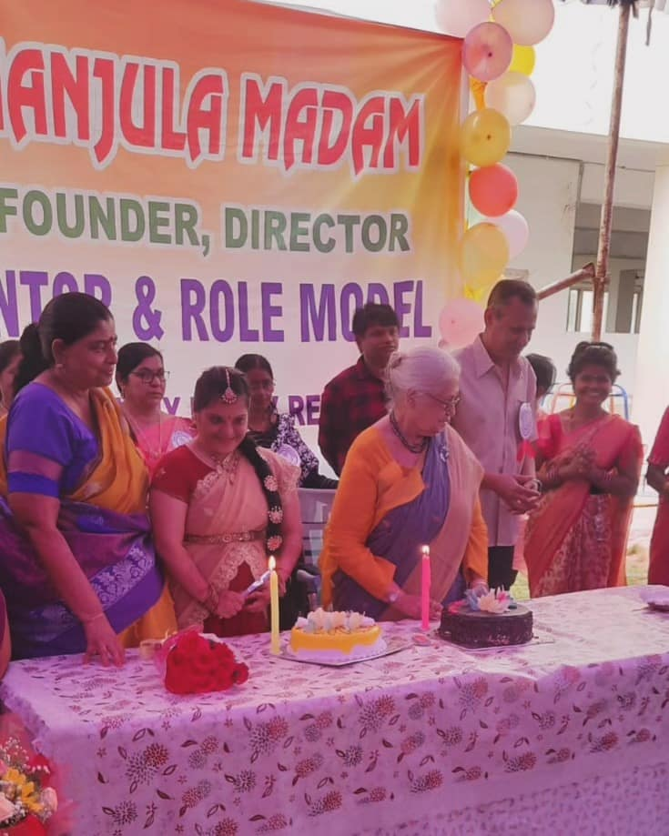

August 12th 2024:- Celebrating our beloved Principal, Dr. V. Kanaka Durga, on her grand birthday on 12th August! Her leadership and passion shine brightly in every aspect of Swayamkrushi, guiding us toward a brighter future. Here’s to many more years of making a difference together!

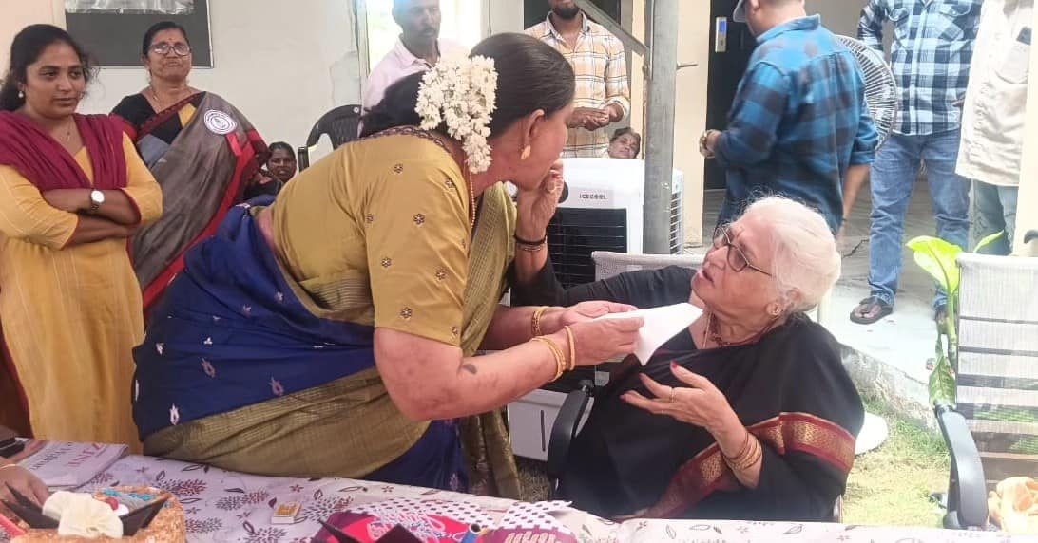

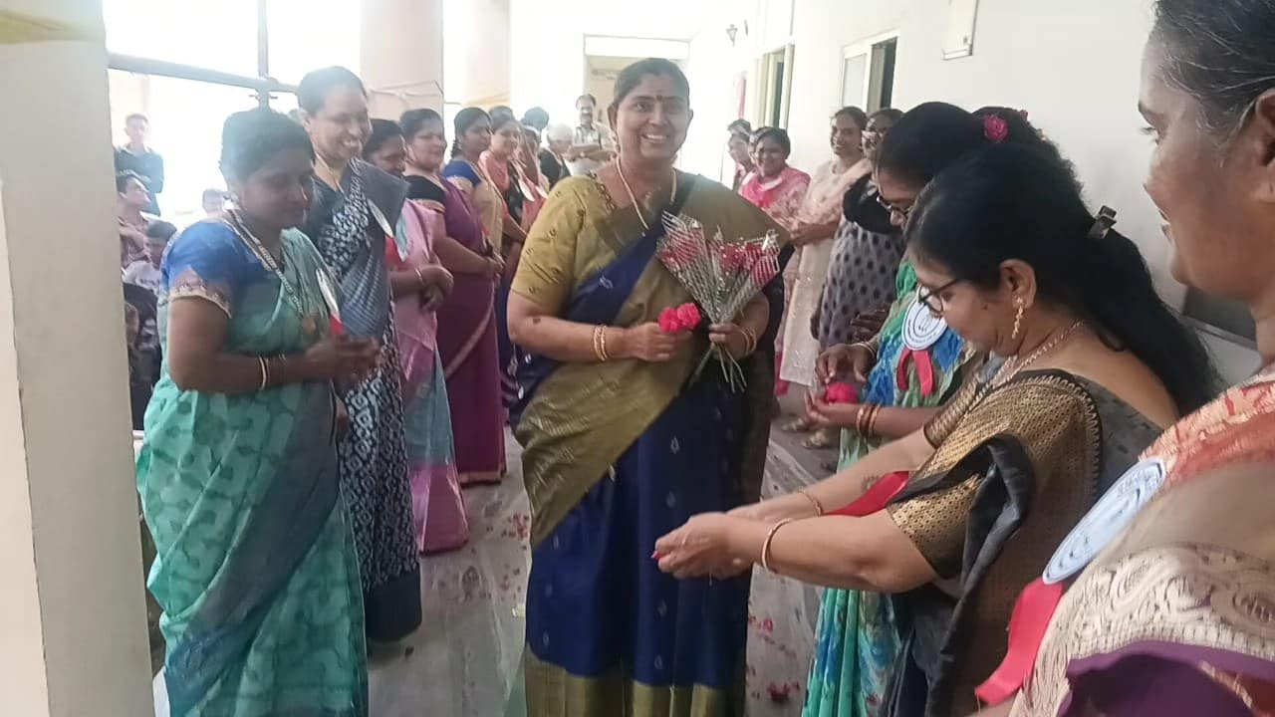

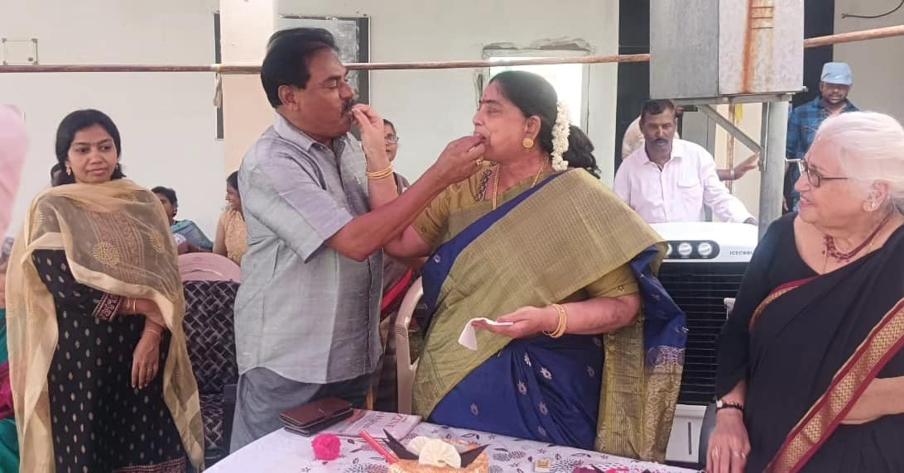

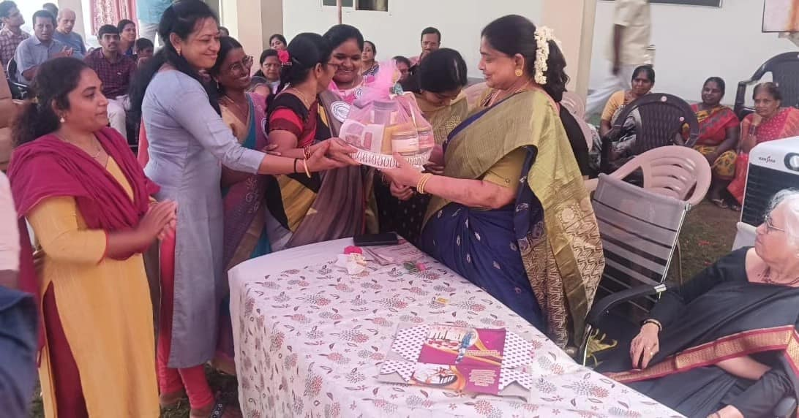

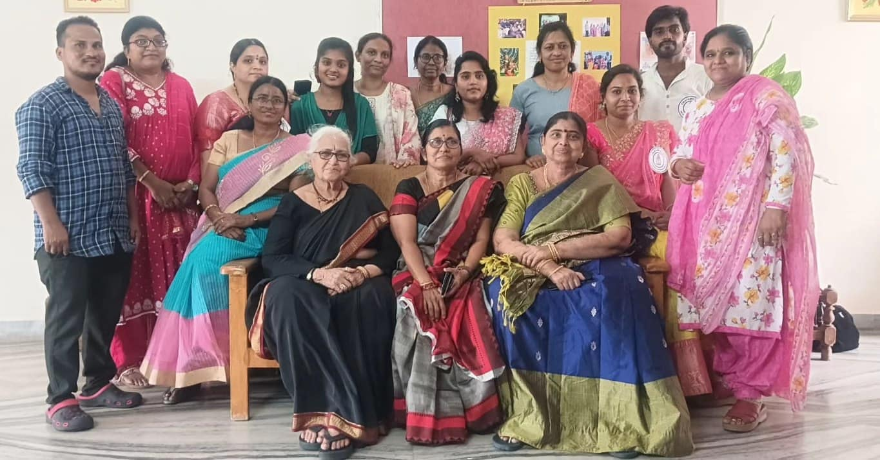

20 August 2024:- Celebrating the spirit of freedom and inclusion at Swayamkrushi this Independence Day! Air Marshal Sri Harpal Singh, along with our esteemed Director Dr. Manjula Kalyan, Group Capt. Suresh Garu, Principal Dr. V. Kanaka Durga, and other Air Force members, hoisted the national flag, marking a day of unity and pride. Our amazing Swayamkrushi participants showcased their talents through vibrant performances, filling the day with joy and energy. Air Marshal Sri Harpal Singh also planted a sapling, symbolizing growth, hope, and a brighter future for all.
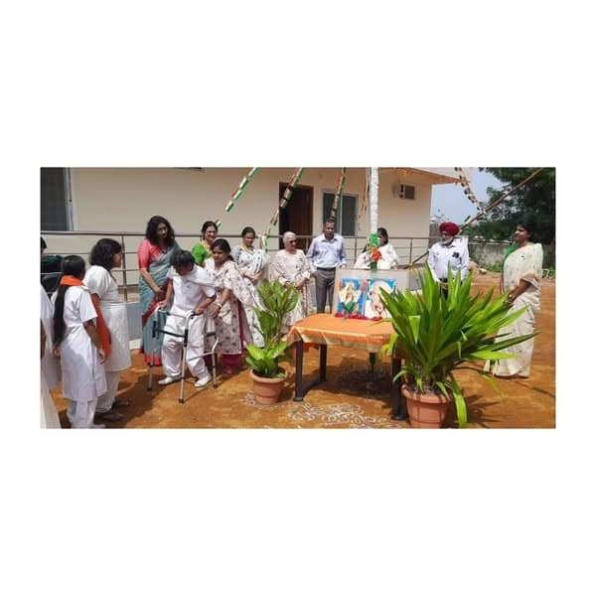

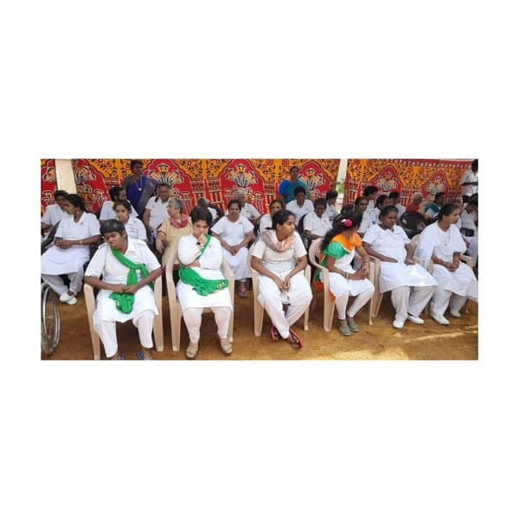

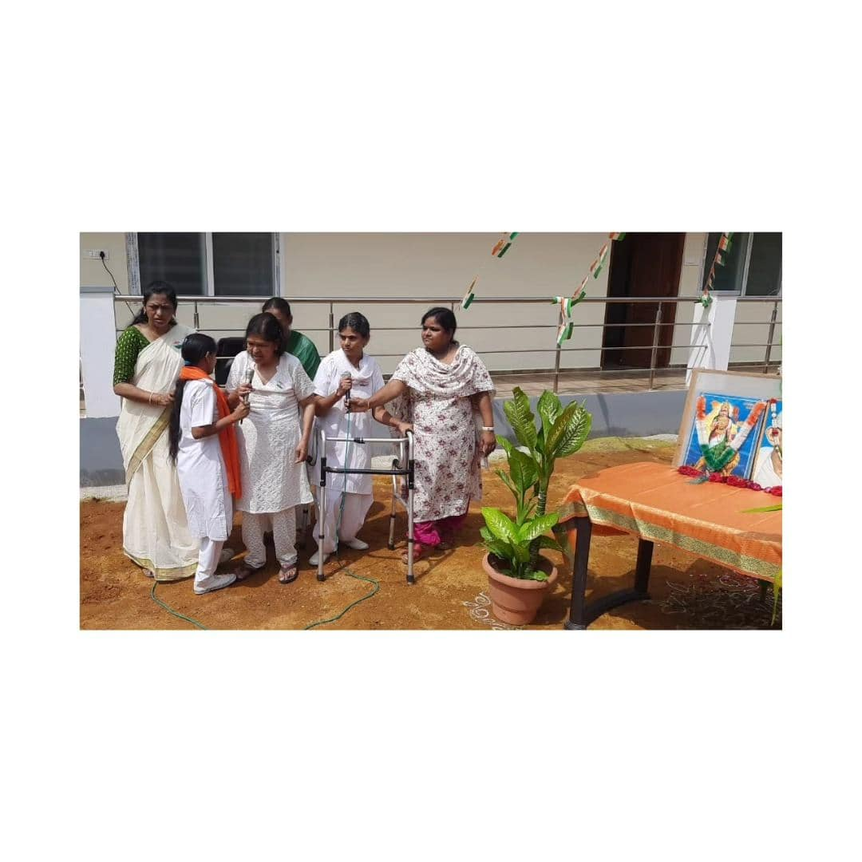

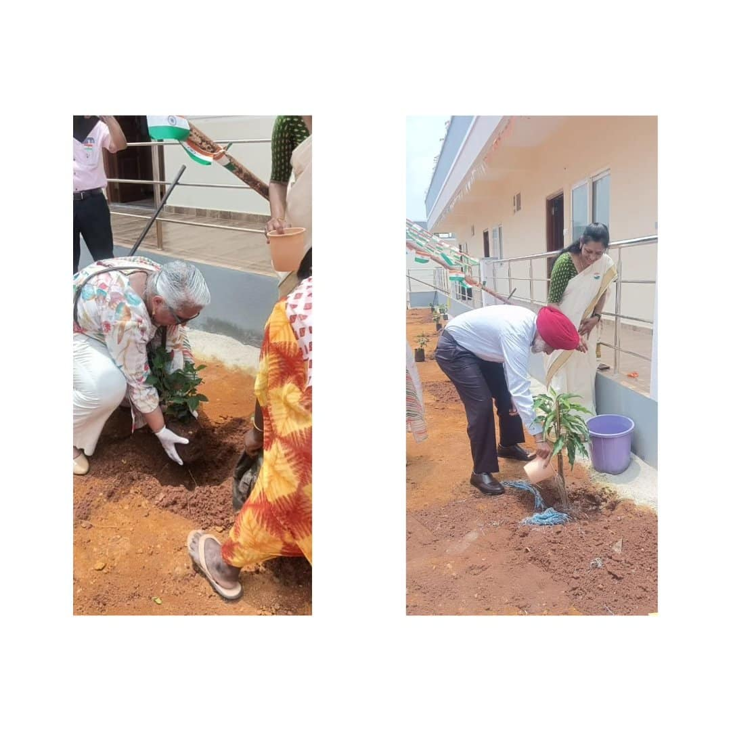

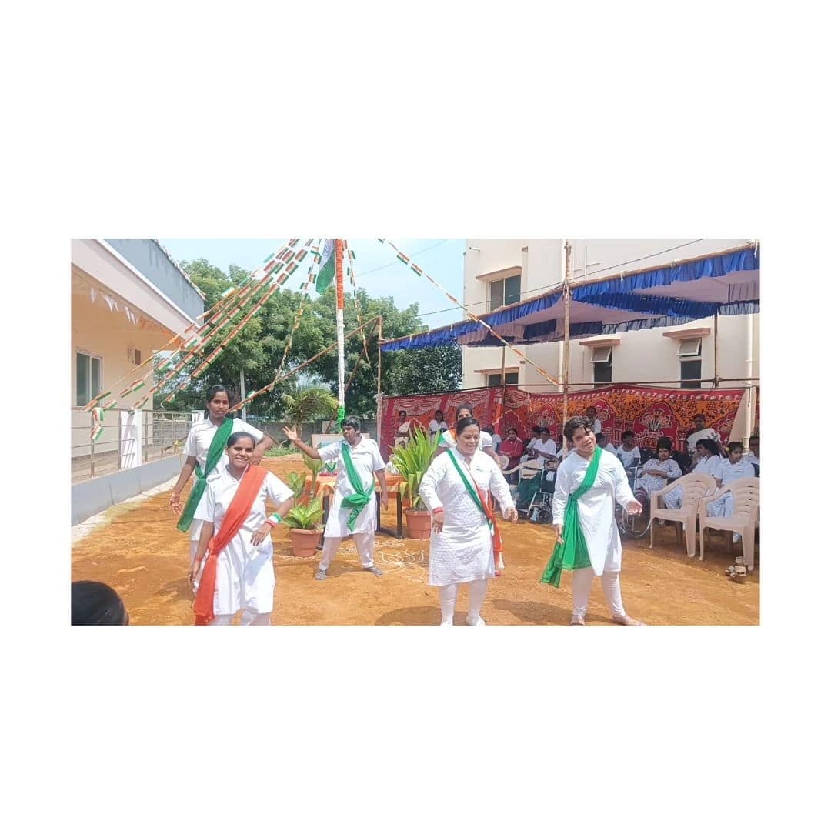

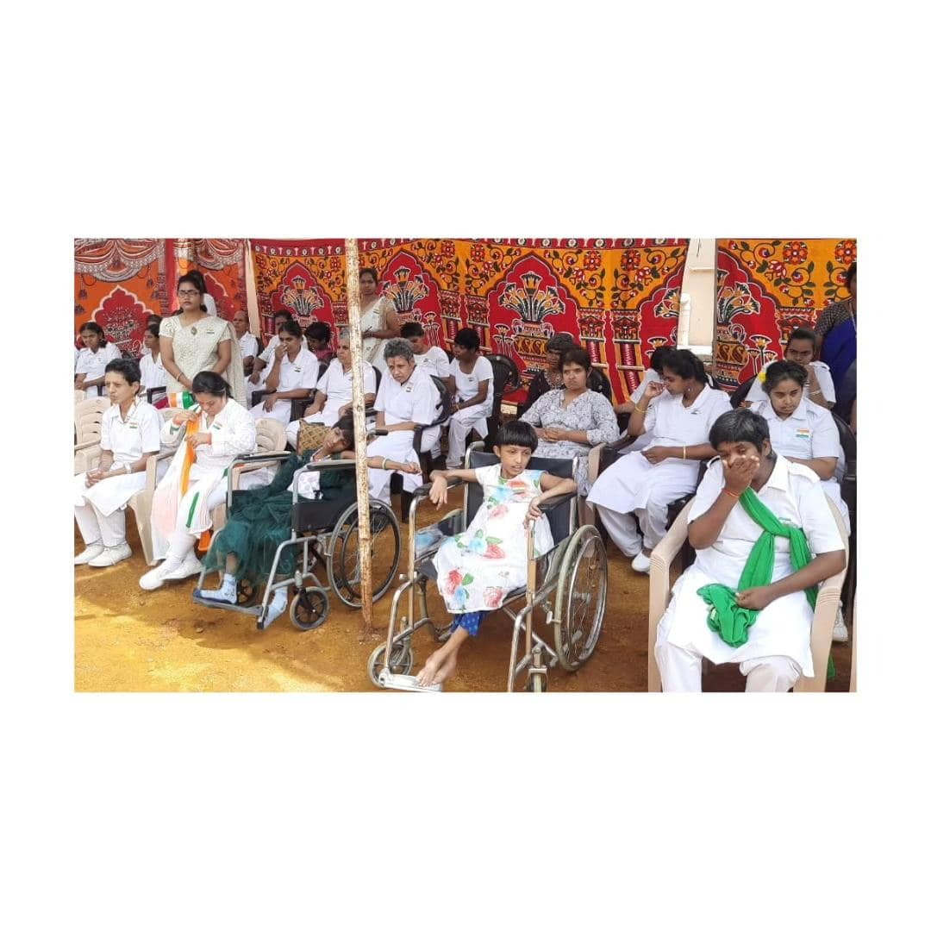

5th Sept 2024:- All teachers were honored on September 5th, 2024 on the occasion of Teachers Day.

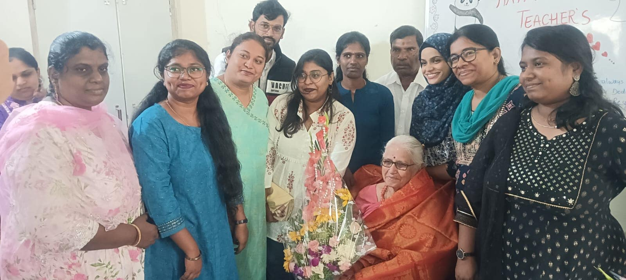

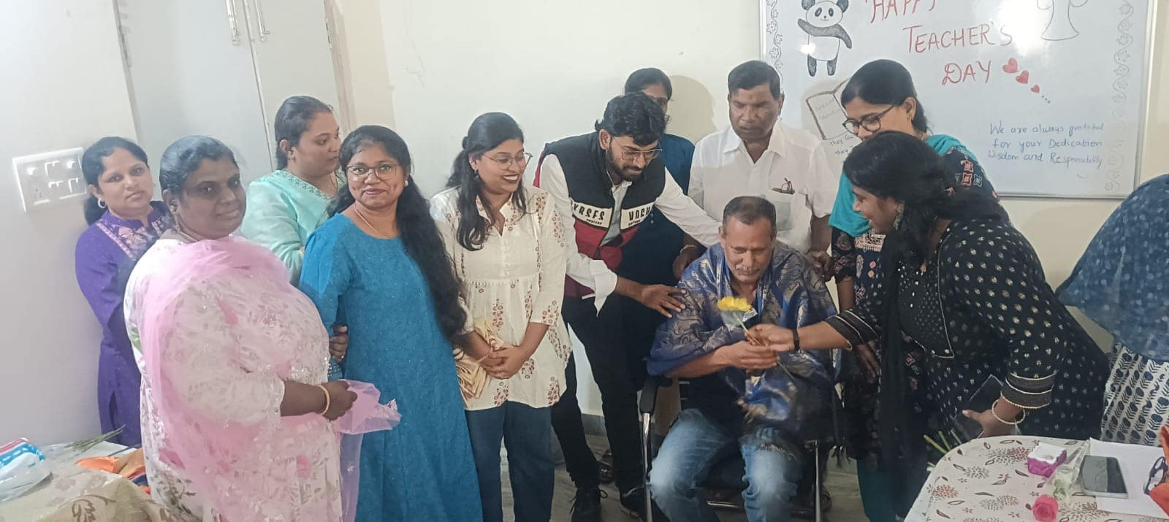

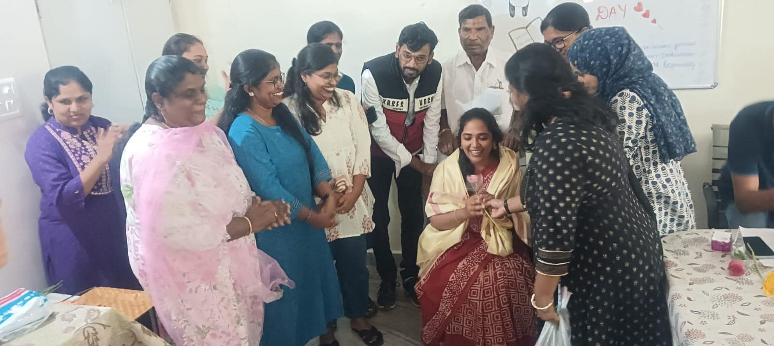

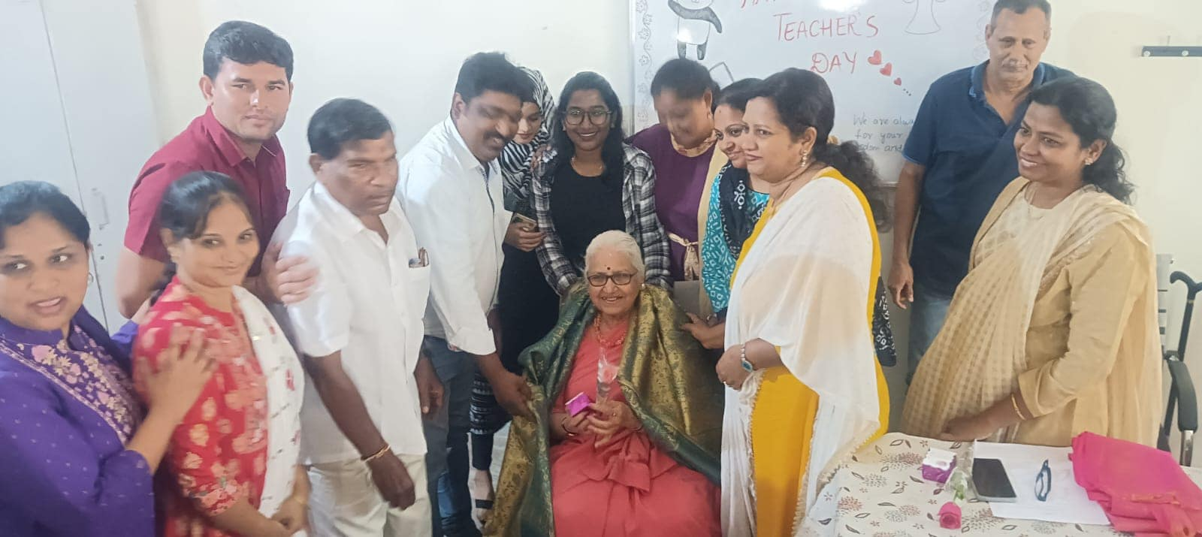

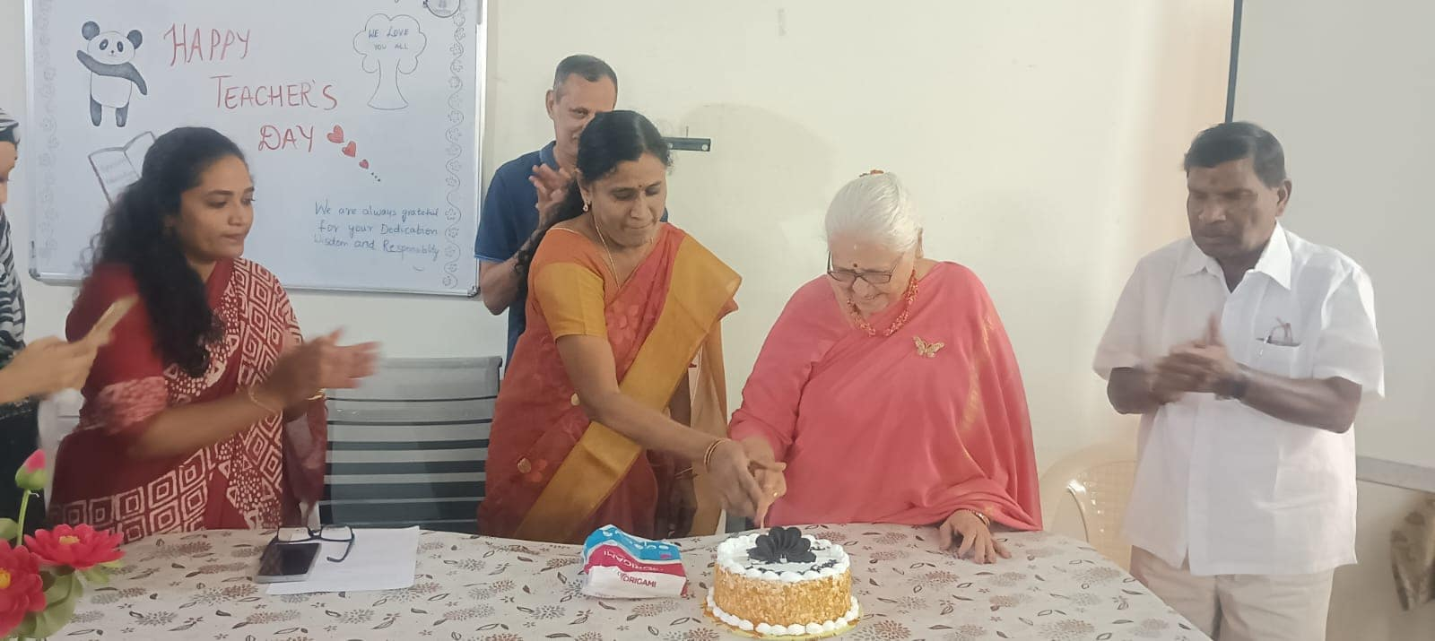

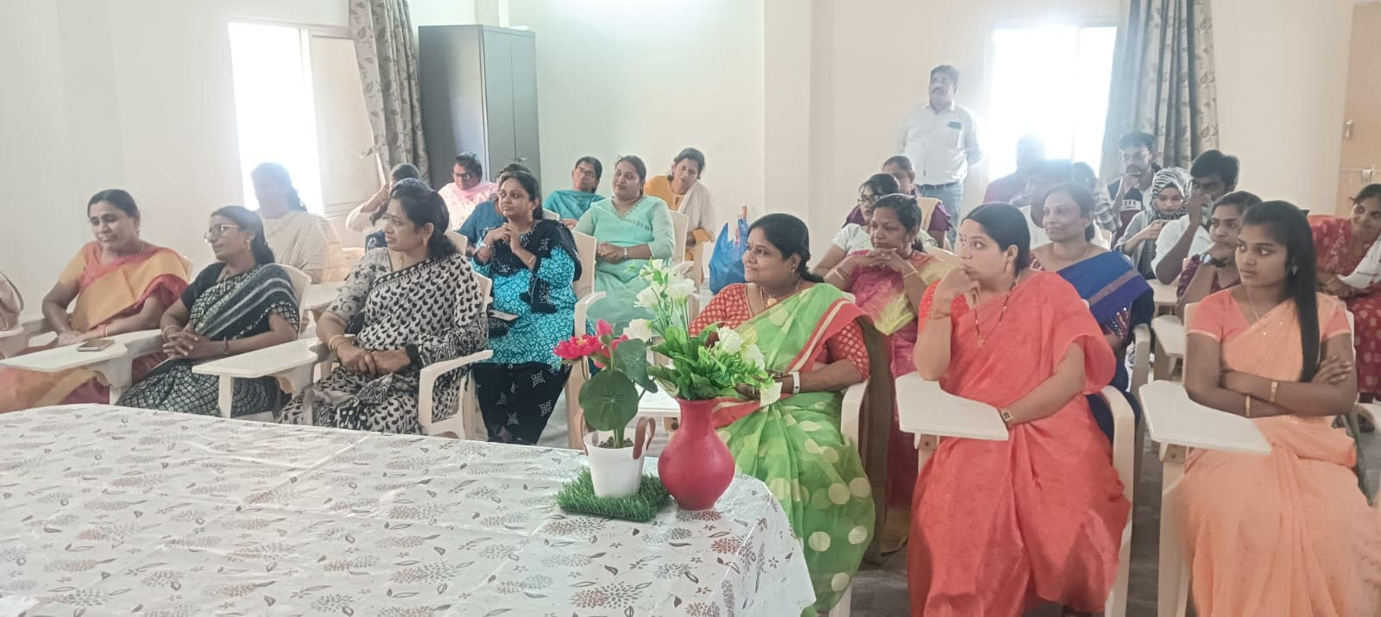

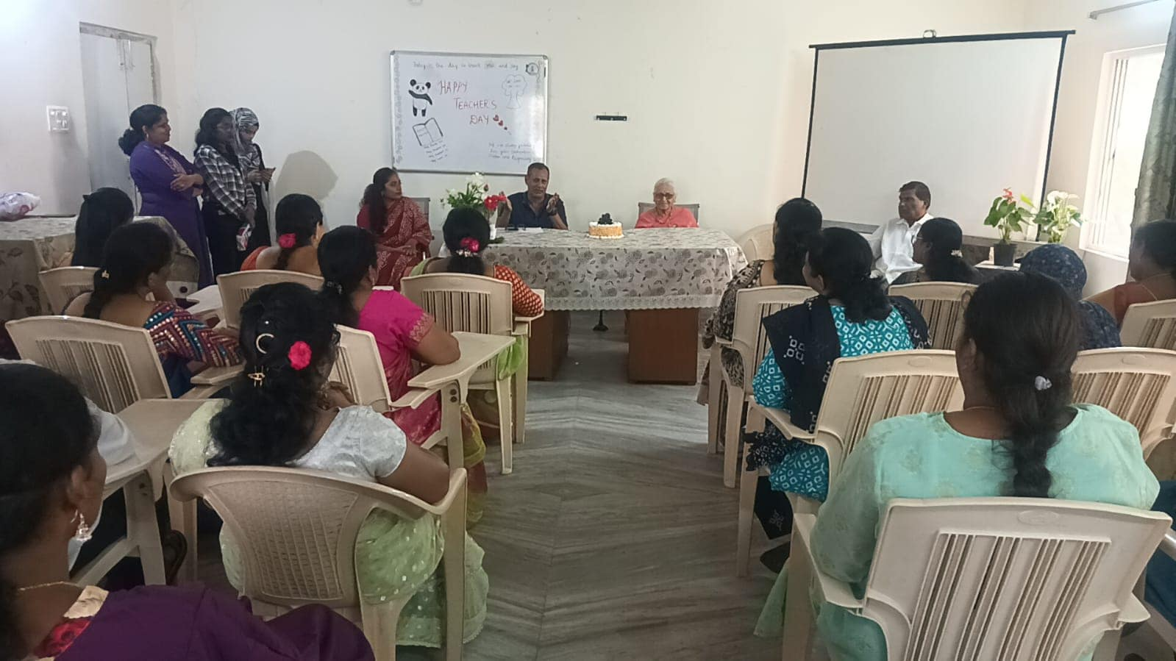

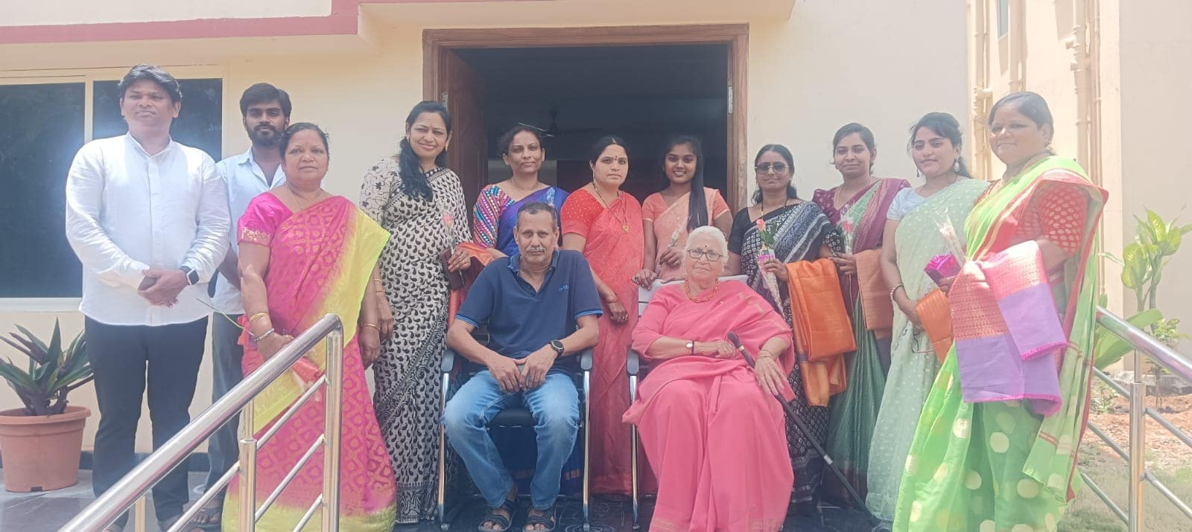

7th Sept 2024:- Swayamkrushi celebrated Ganesh Chaturdhi on 7th Sept 2024.

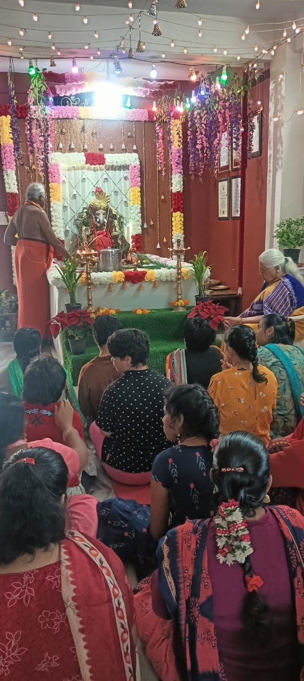
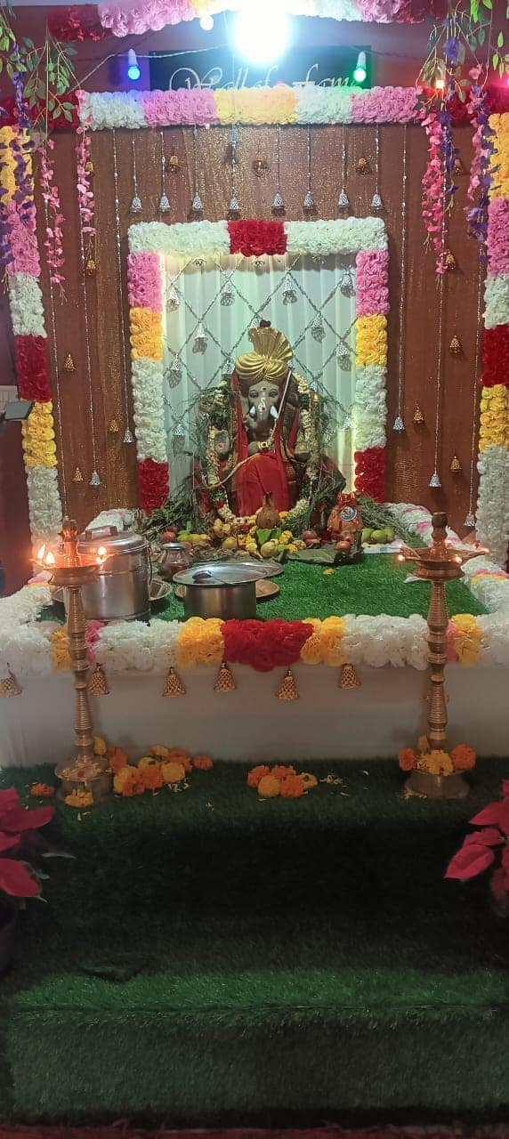

16th Sept 2024:- Students and staff of Swayamkrushi participated in the Ganesh Idol immersion at Swayamkrushi on 16-09-2024.

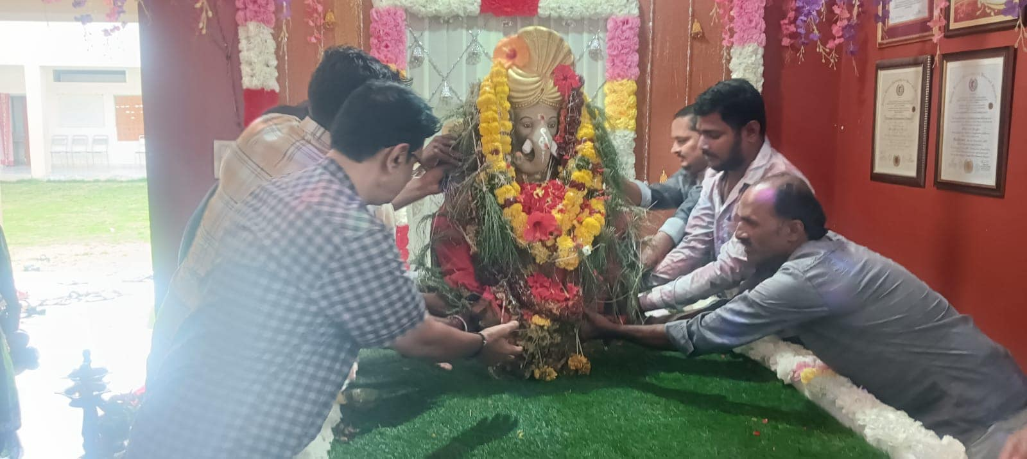

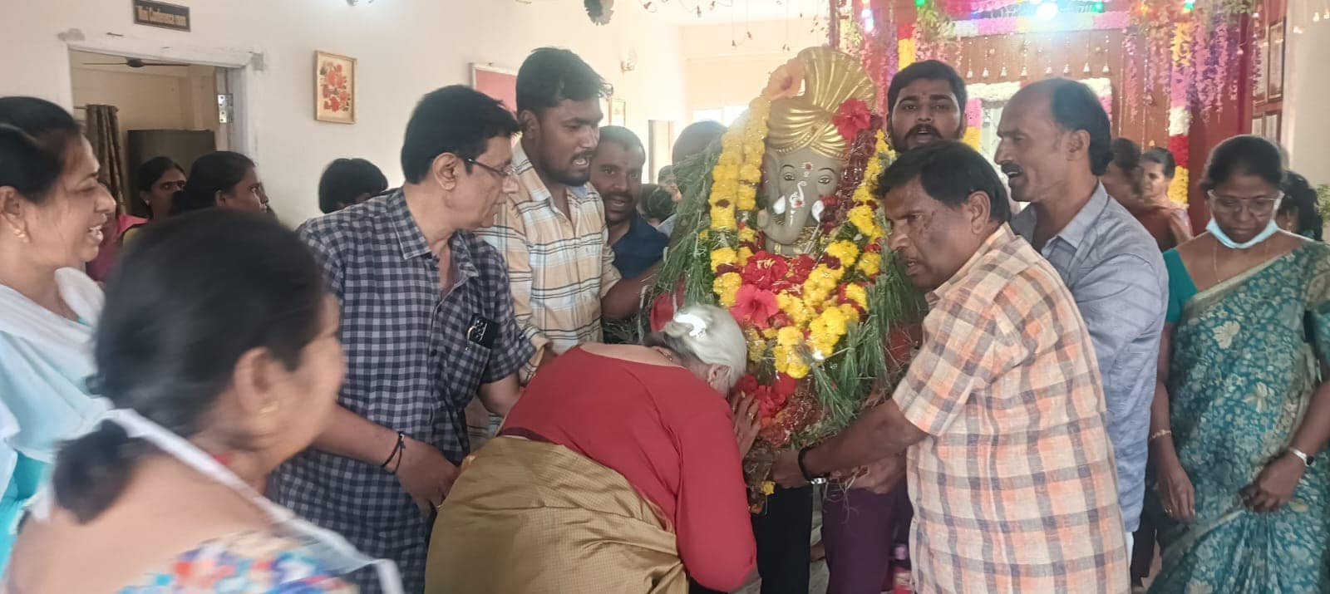

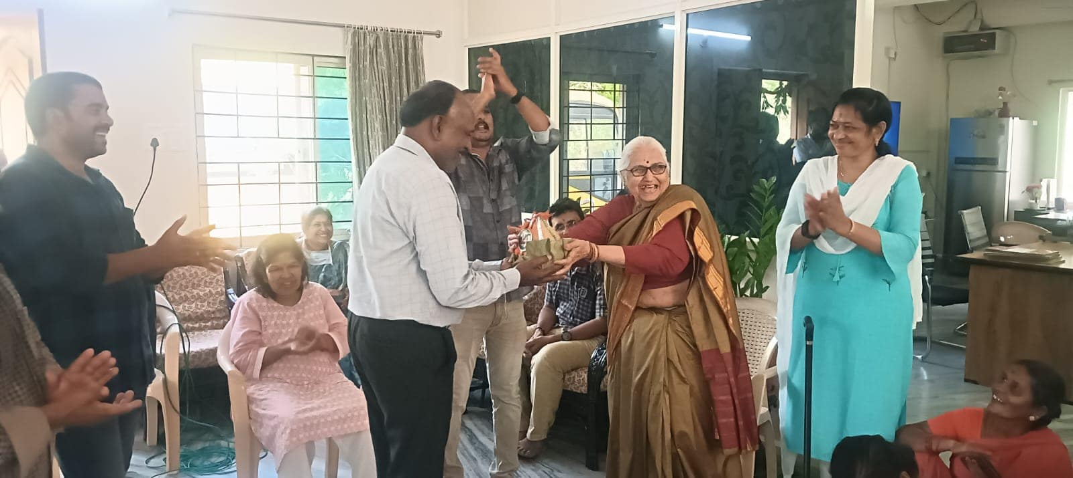

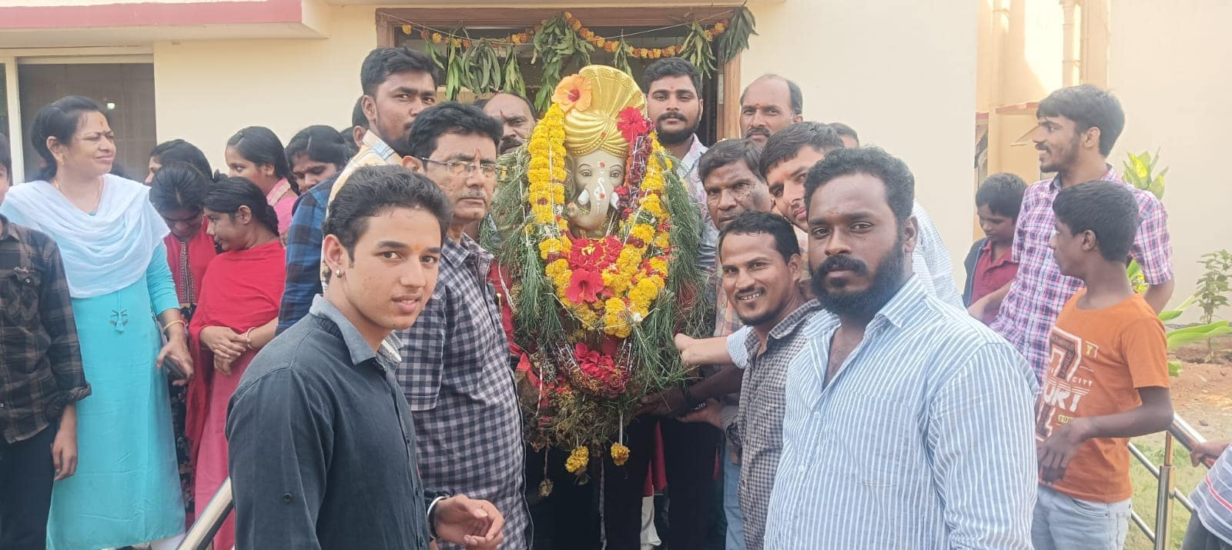

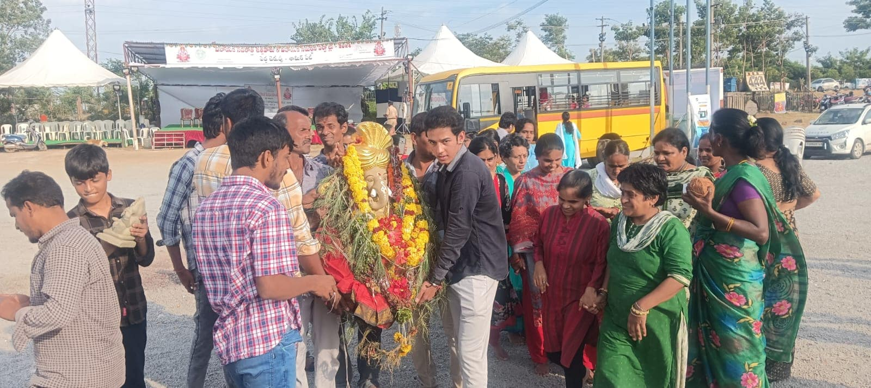

21st ^{Sept} 2024:- The shining light of Swayamkrushi is no more. The large hearted spokesperson of Swayamkrushi has gone silent.
Durga Maam as she was fondly called by one and all will be sorely missed. She was excellent in interacting and dealing with people of all ages, with exceptional wit and humor. With this ability she made people feel ease and made people to instantly like her.
All members of past and present will surely miss her and her place in all our hearts cannot be replaced by any one.

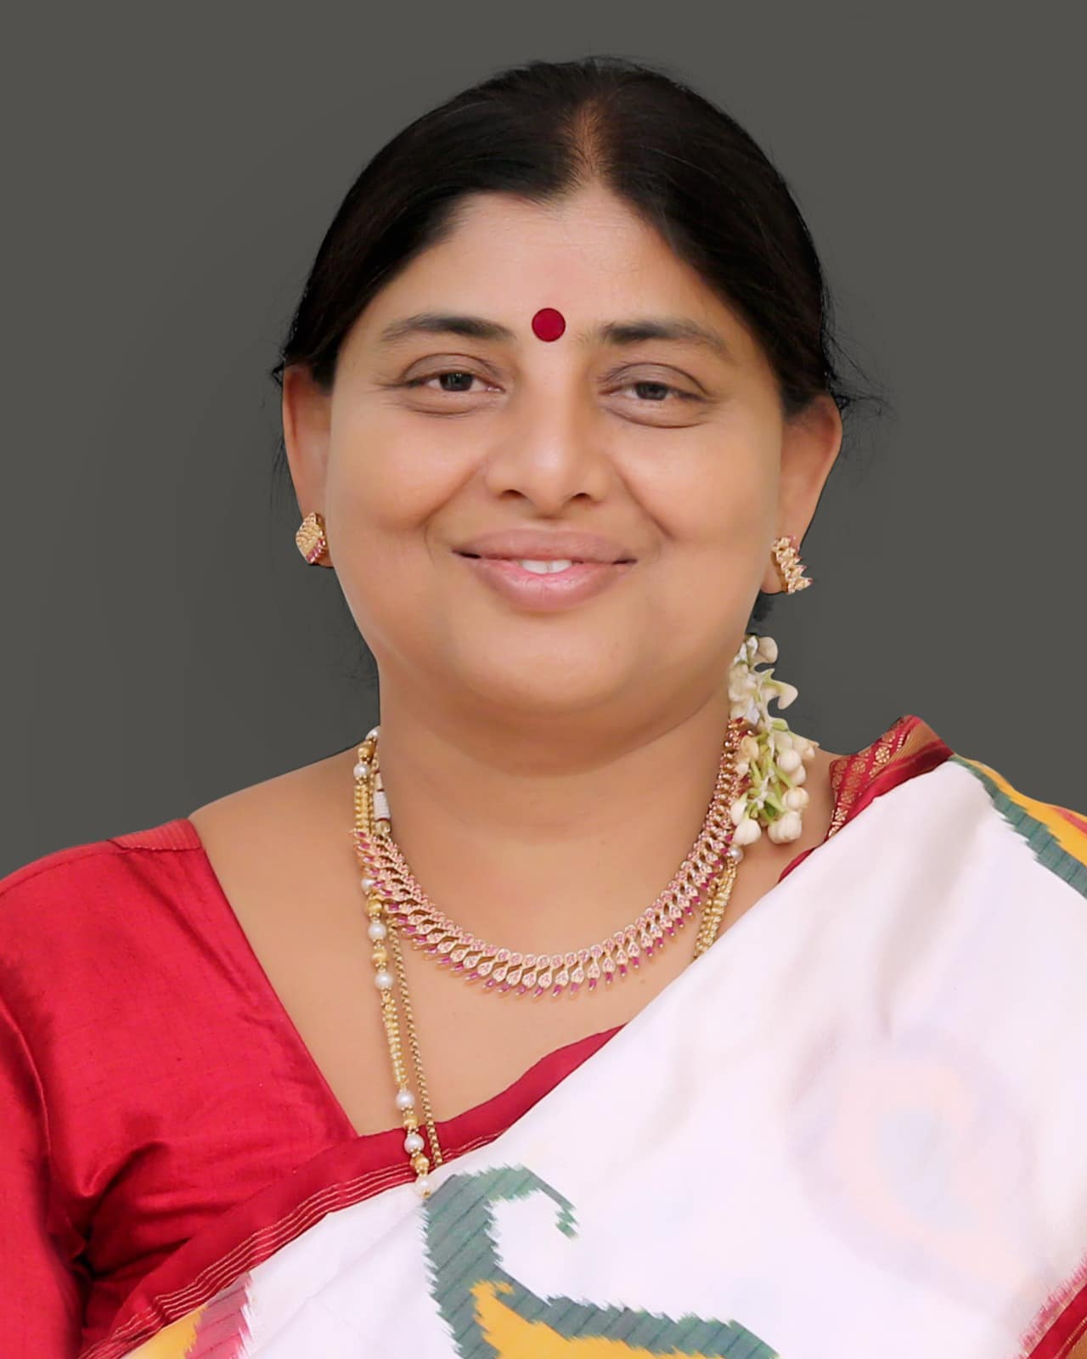

7th Oct 2024:- A project for providing single bedroom apartments for parents who have intellectually challenged children was conceived by Mrs Manjula Kalyan. Seven such apartments were built on the campus of Swayamkrushi. On completion of the construction all the apartments were handed over to the parents by
Smt.Sunanda Joint Director (Women Development and Child Welfare Dept), Sri M. Krishna Reddy (Women, Children’s, Disabled & Senior Citizen Officer of Medchal Malkajgiri), and Dr. Prashanna Gogoi ( Sangeet Natak Akademi Awardee & Director, North East Zone NEZCC, Ministry of Culture, Government of India.
1.Vasundara Devi kanuga
2.Doctor Ramanjanyulu Bandaru, Doctor Mallishwari Bandaru
3.Laxman Prasad
4.Seshachalam garu
5.Purushotham garu

on 07/10/2024. Before handing over the apartments a wonderful cultural programme was put up by the children of Swayamkrushi. The keys to the apartments were handed over by
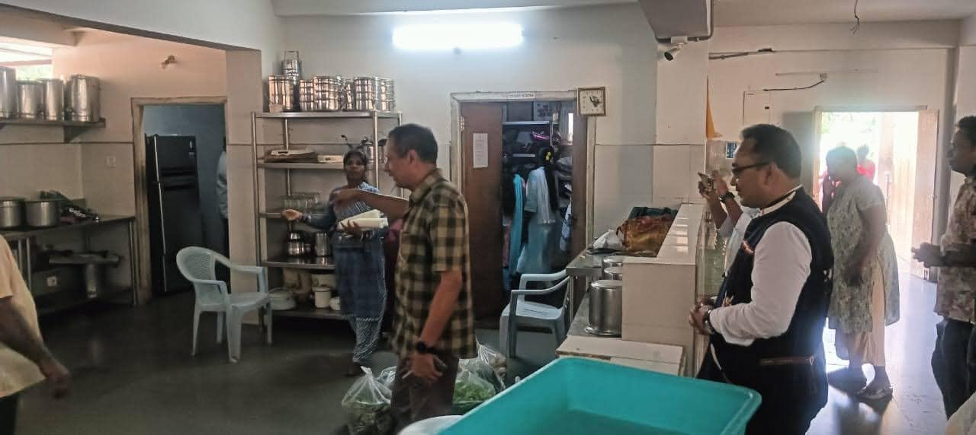
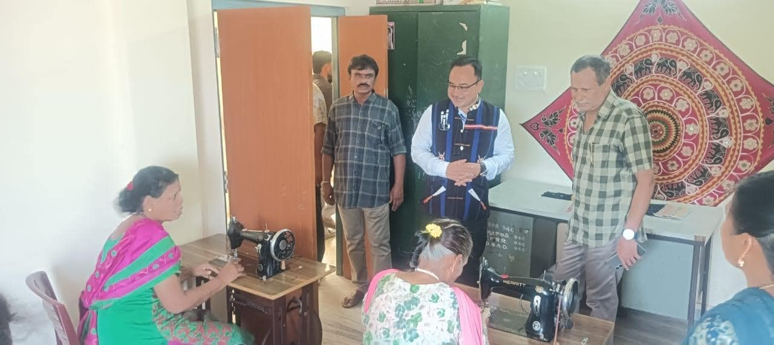

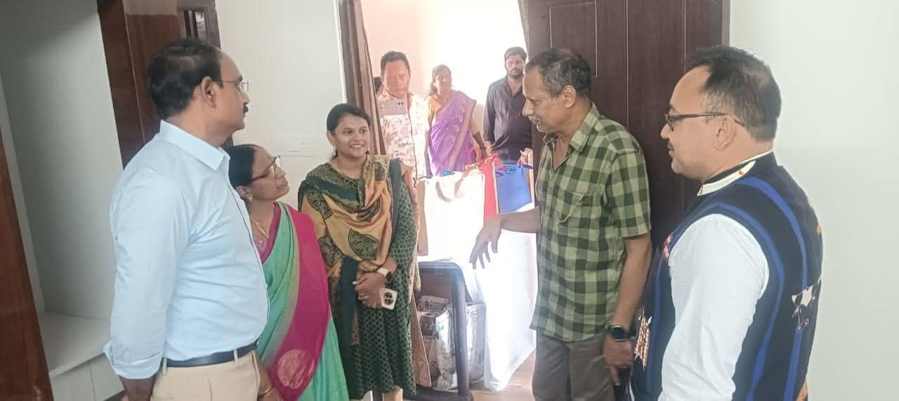
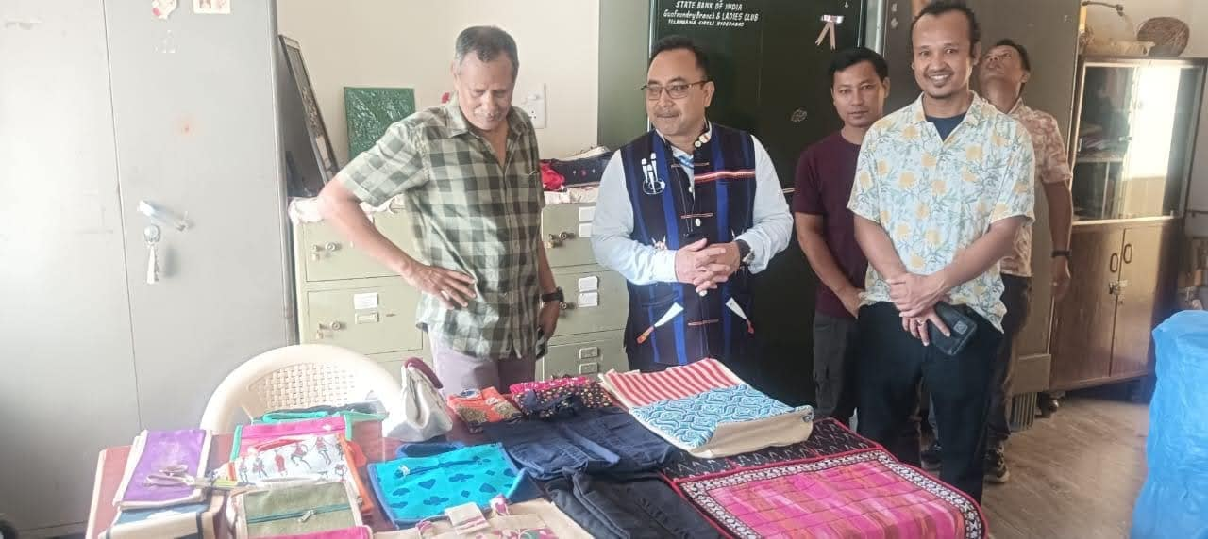

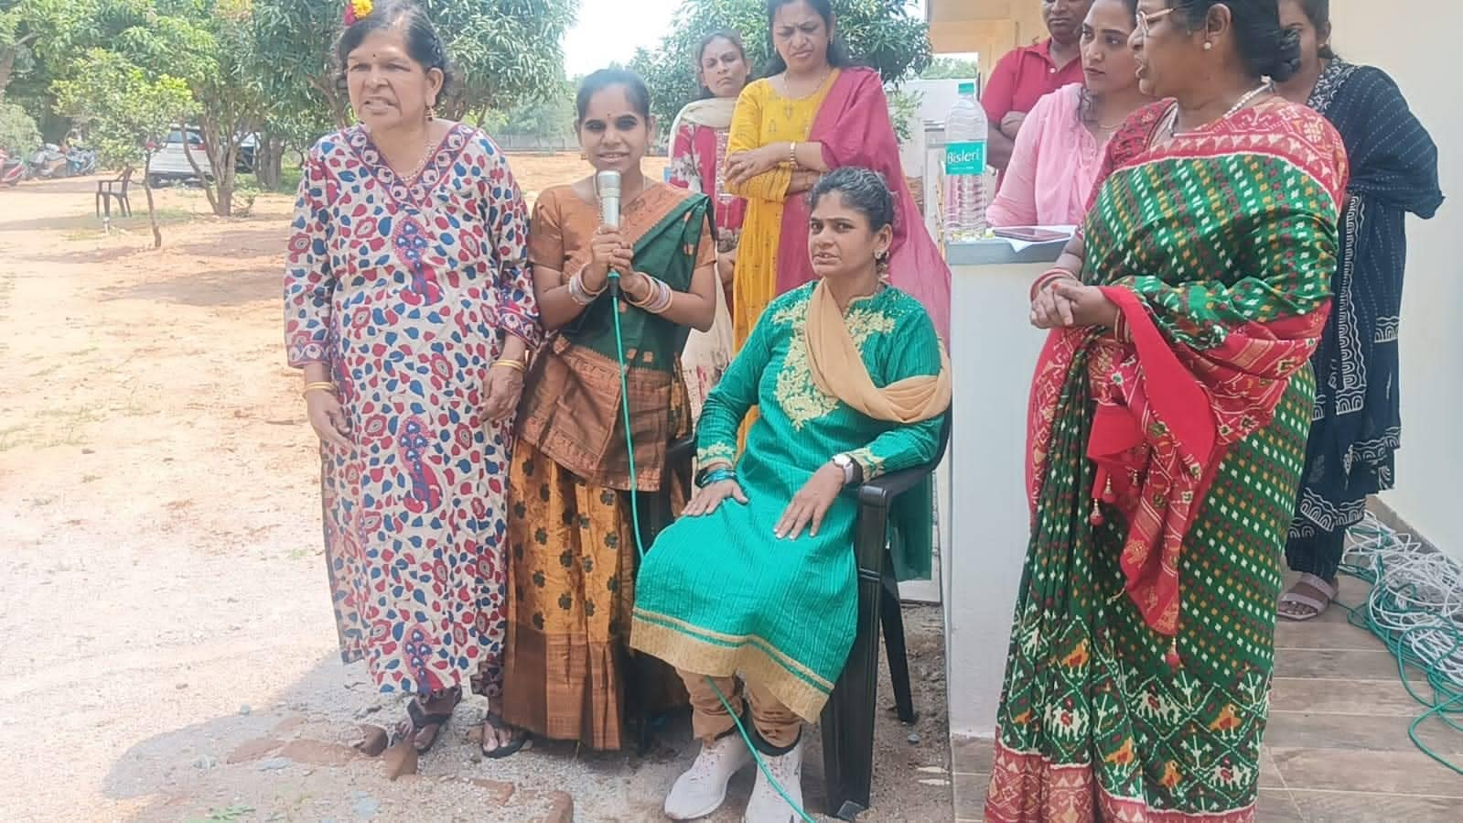
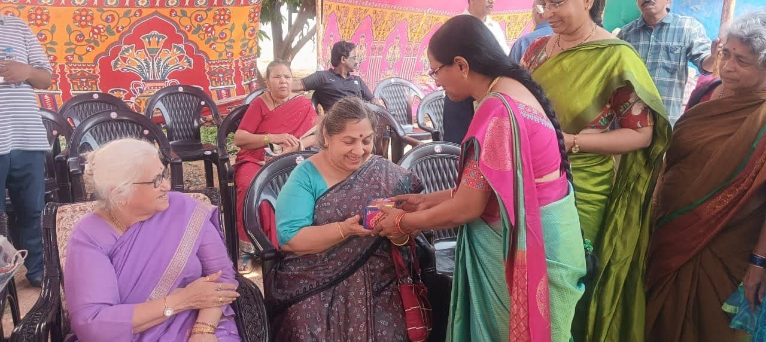

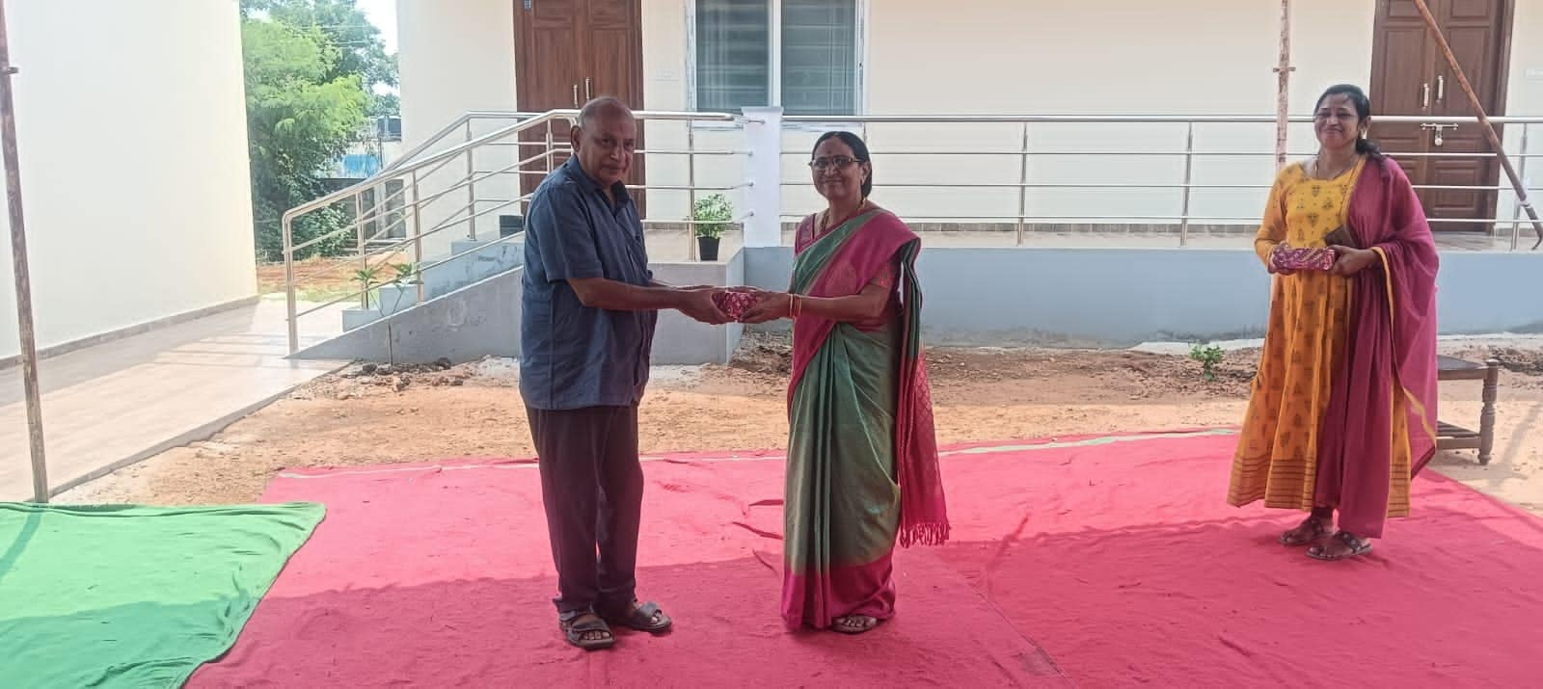
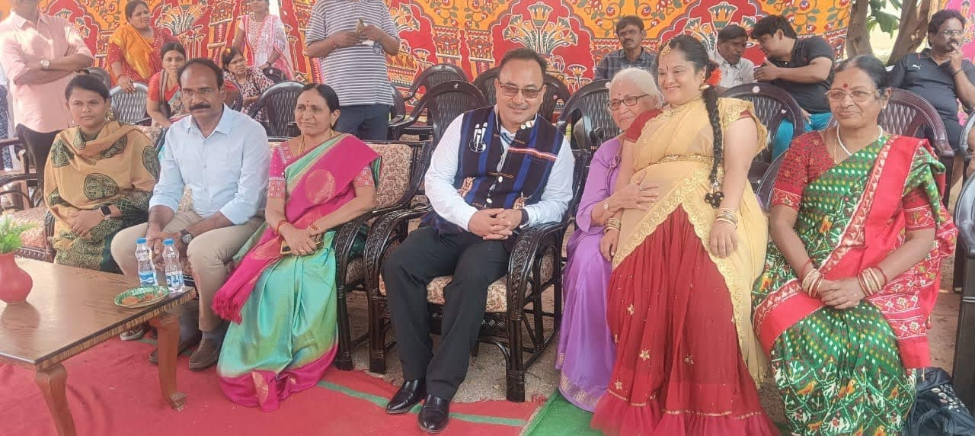

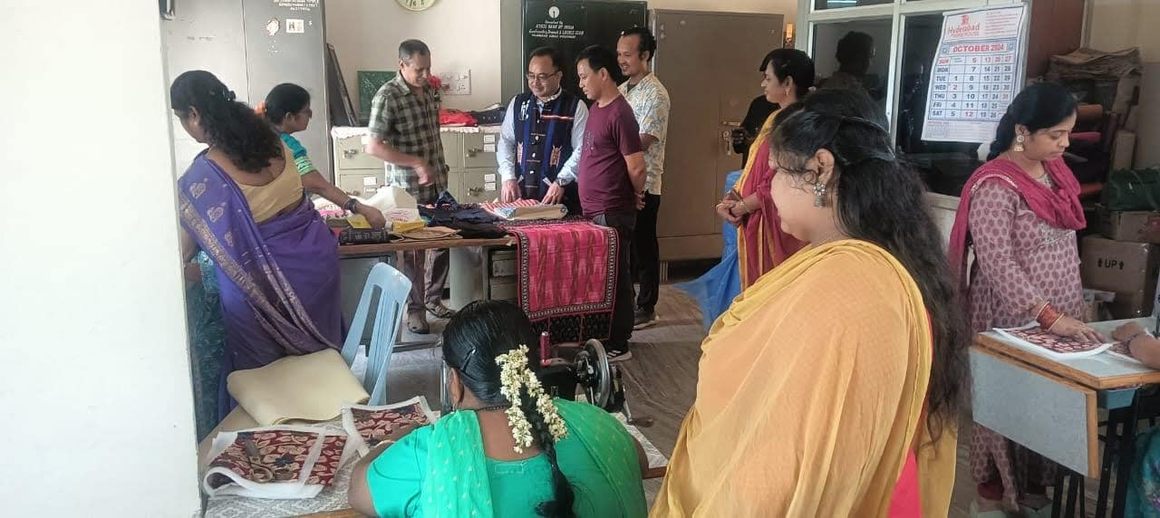

29th Oct 2024:- Bringing smiles and care to Swayamkrushi! Grateful to the dedicated team of Doctors from Army College of Dental Sciences visited on 29-10-2024 and conducted a dental check-up camp for our inmates. Ensuring healthy smiles and well-being for all.
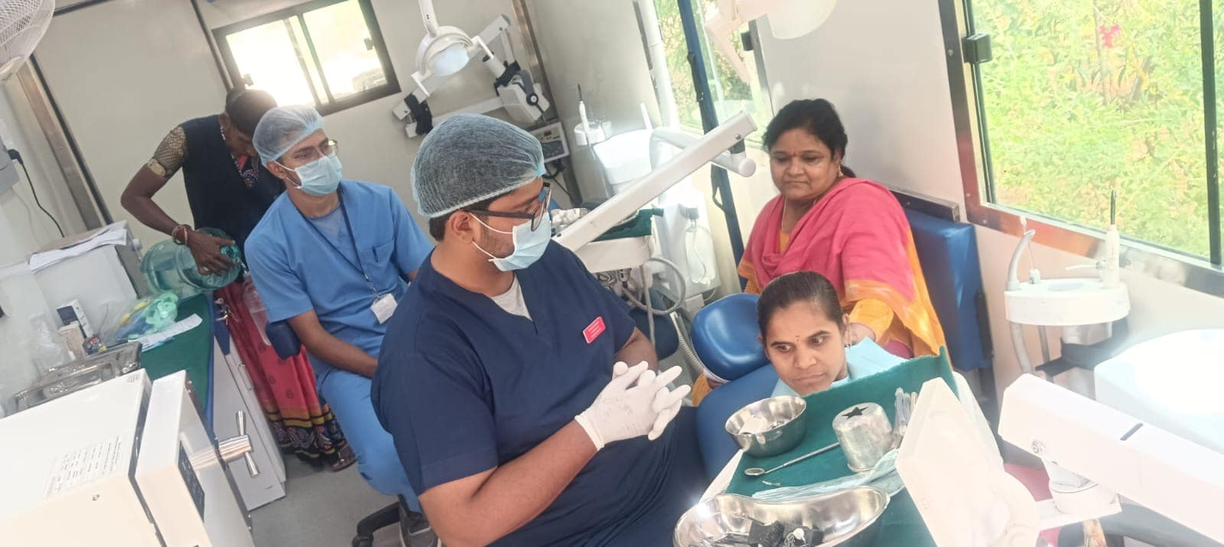

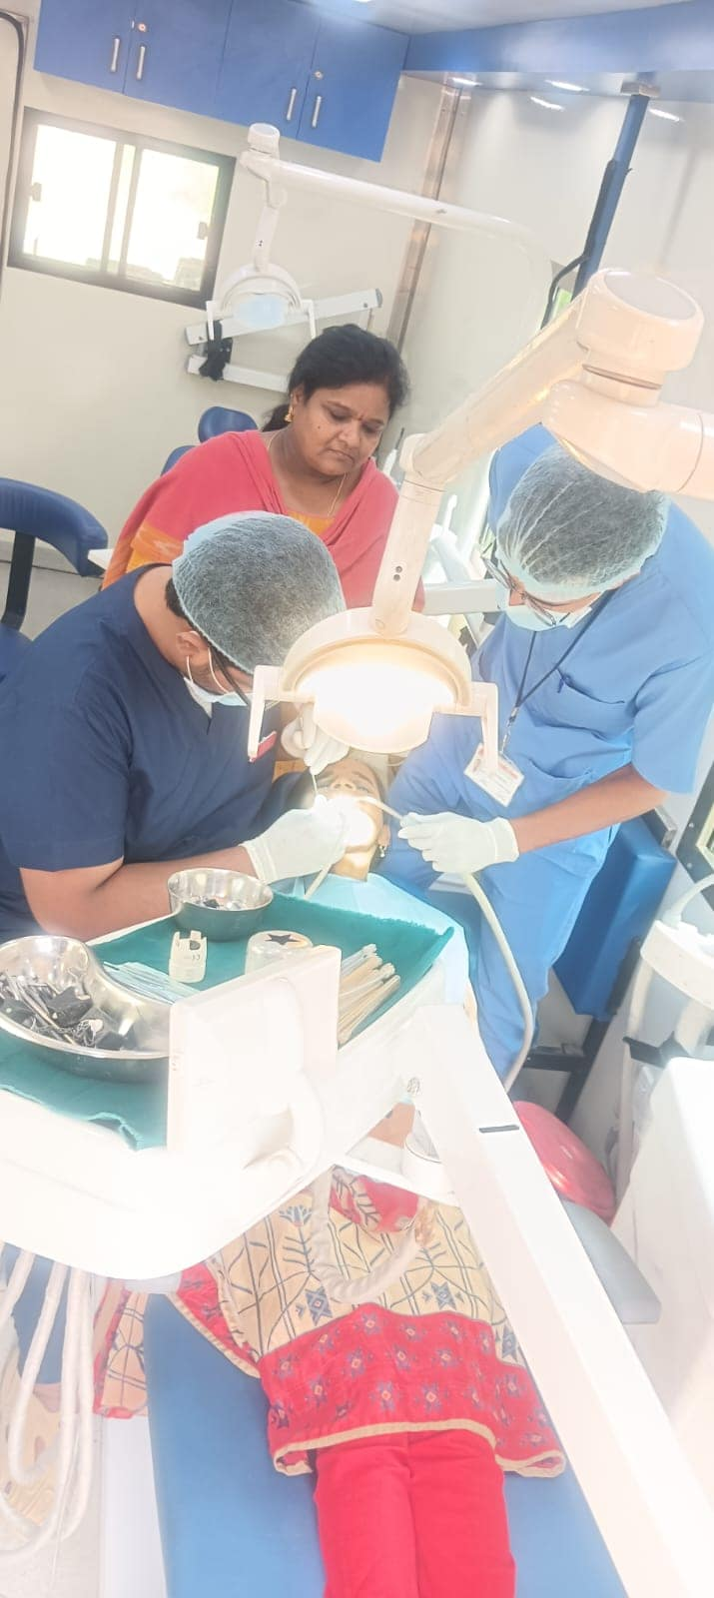

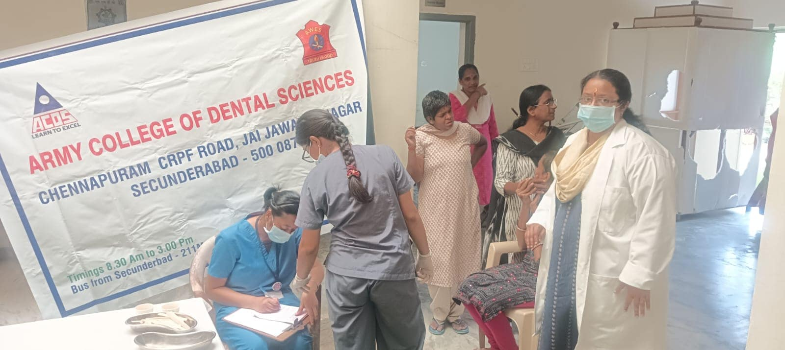
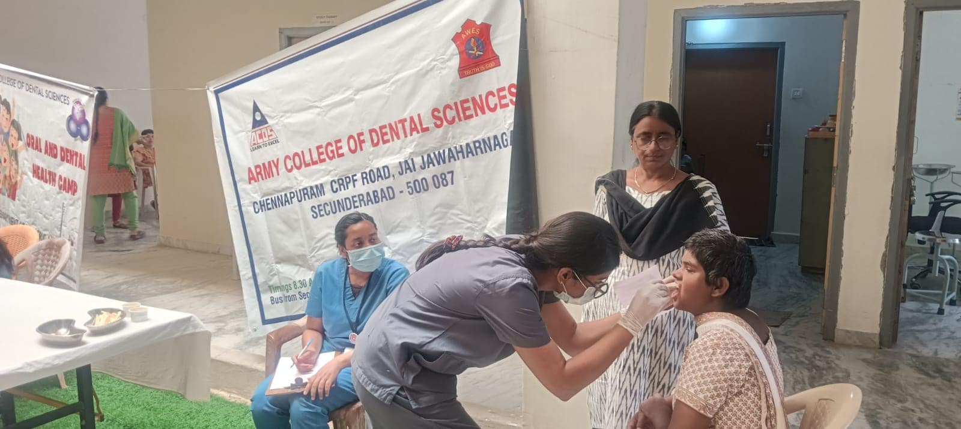

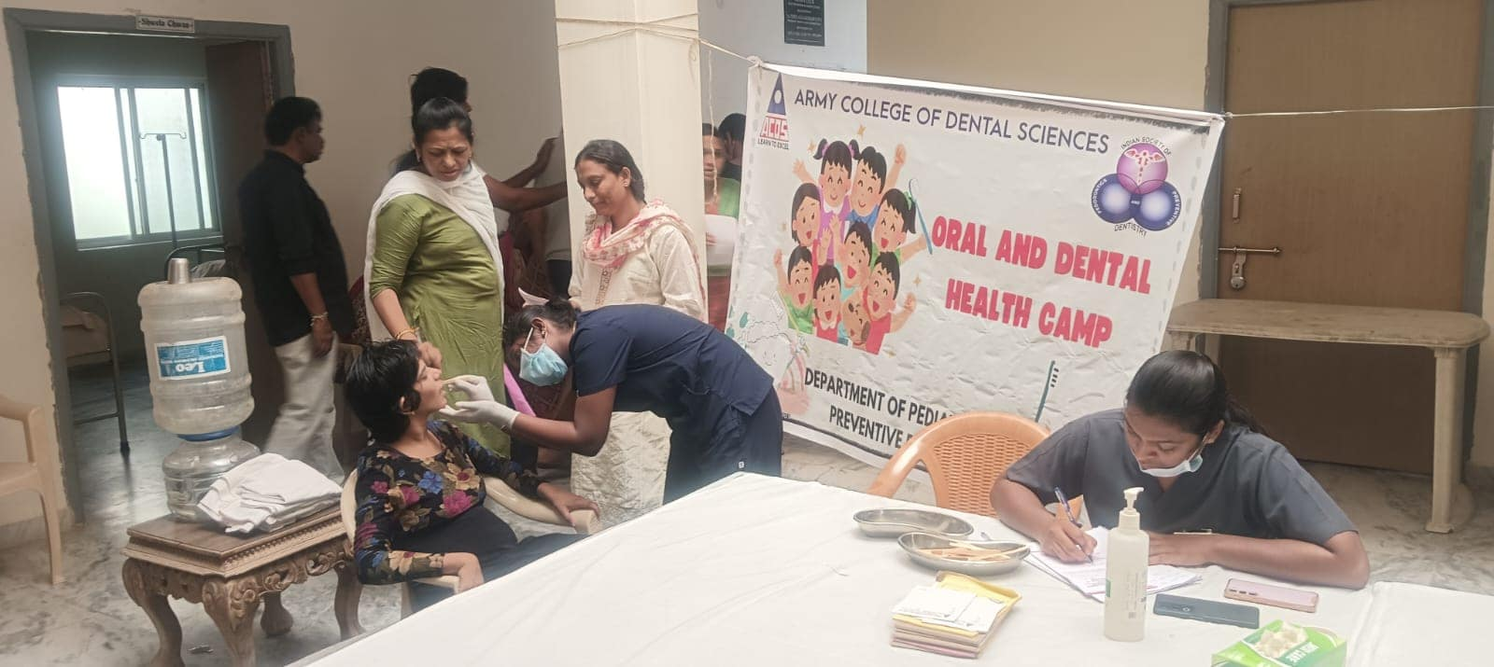

30th Oct 2024:- The Freshers' Party for the batch 2024-26 was held on 28th October 2024 at SwayamKrushi campus. The senior batches of 2022-24 and 2023-25 warmly welcomed the newcomers. Dr. Manjulaa Kalyan, Director, graciously welcomed the freshers and offered valuable suggestions for their upcoming academic endeavors. Additionally, Mrs. Jayalaxmi, Ms. Priyanka, and Ms. Sujatha participated in the event, wishing the students success in their academic journey. Swayamkrushi also expressed heartfelt gratitude to the senior batches for their contributions to making the event a success.

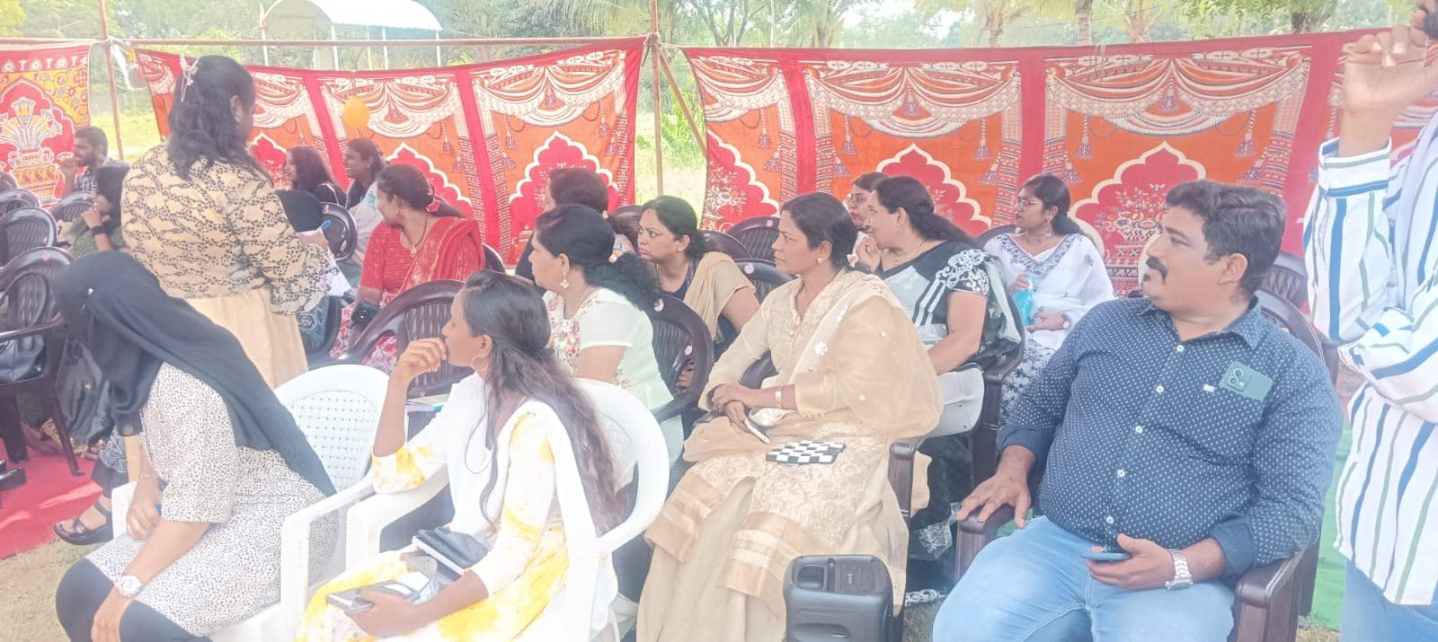
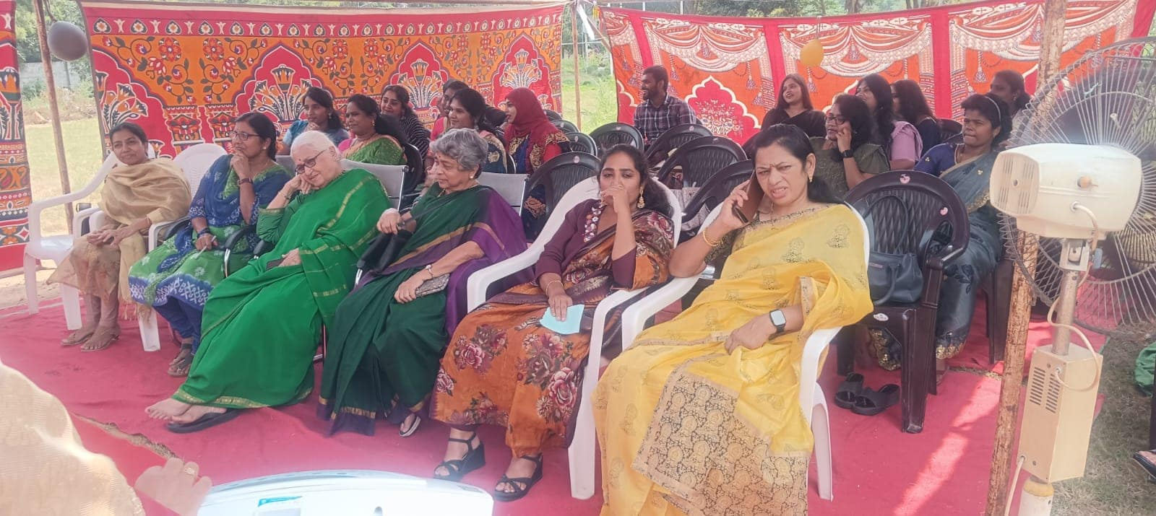

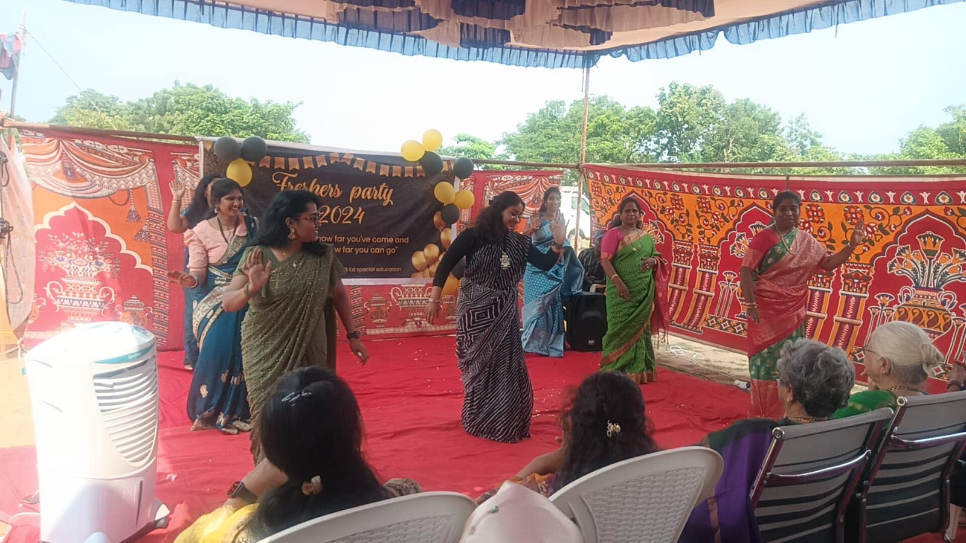
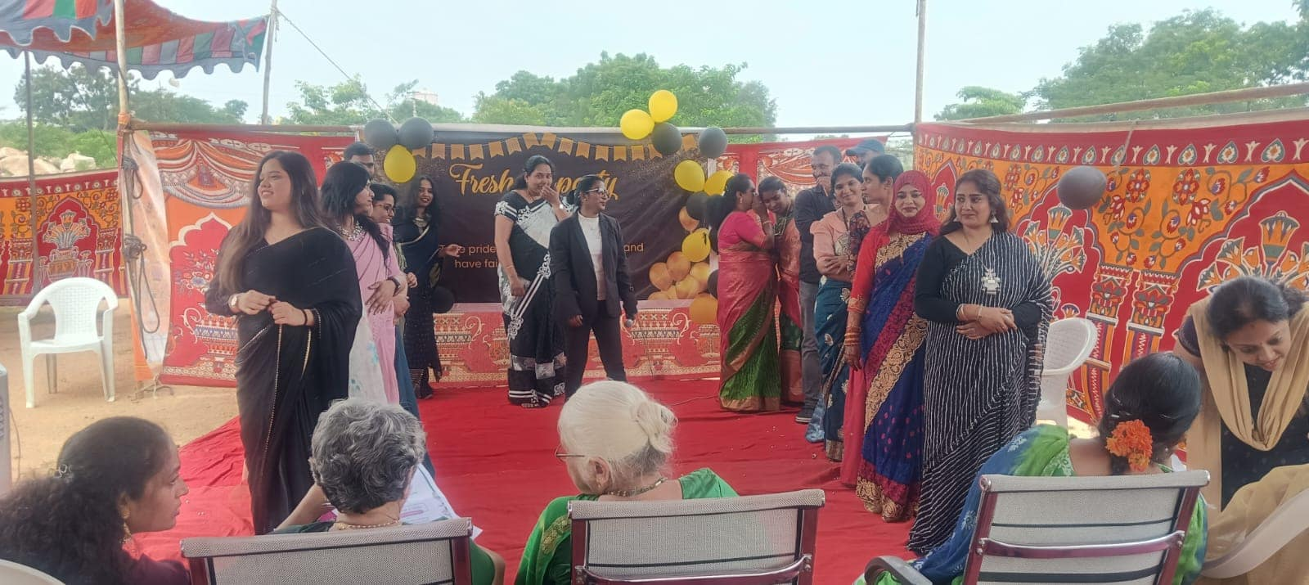

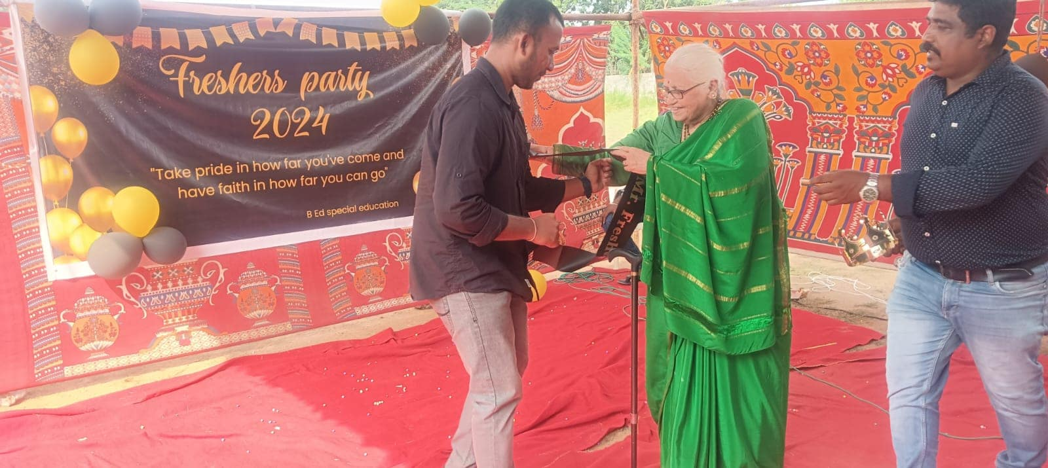
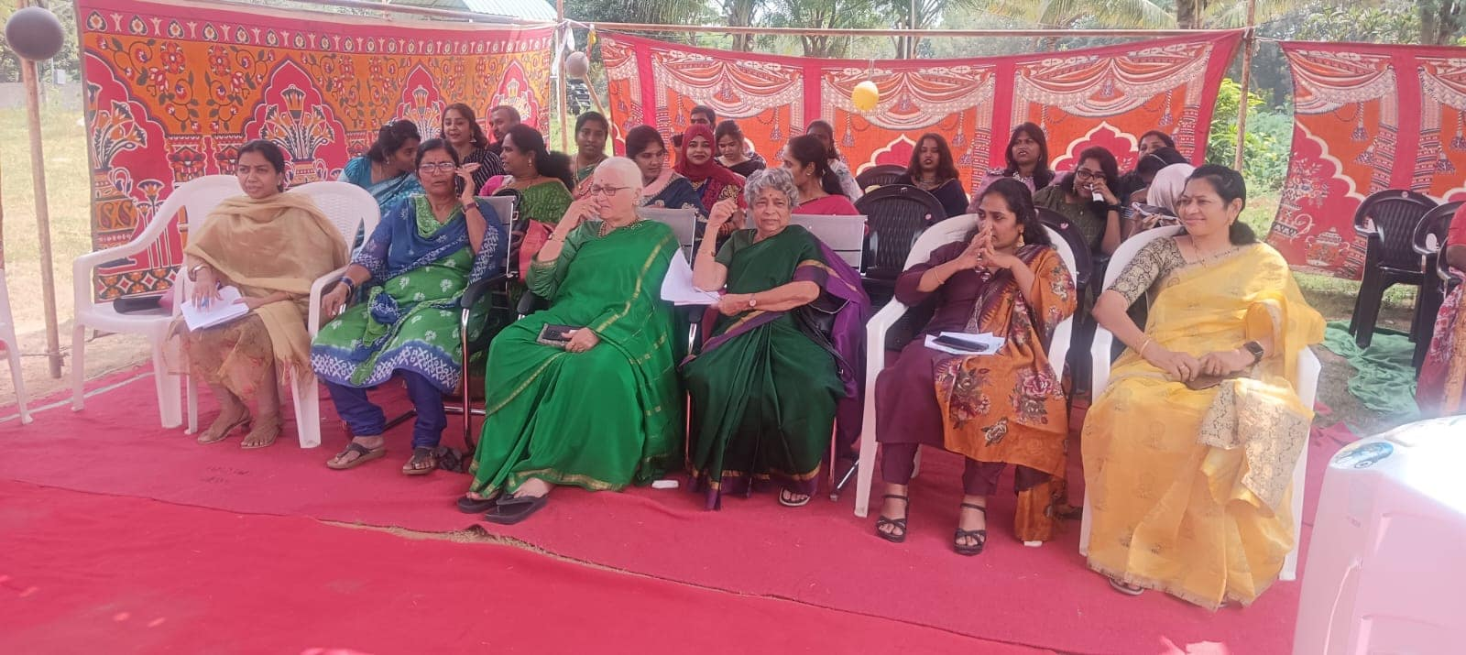

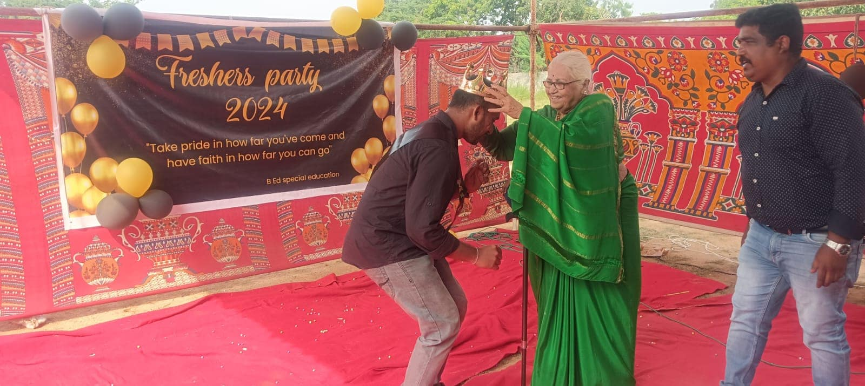

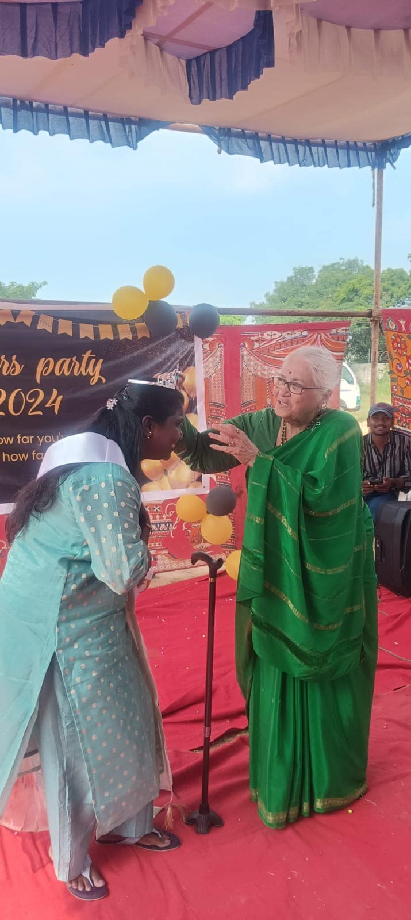

15th Nov 2024:- Members of Ruva Foundation Bangalore visited on 15-11-2024 and donated 6 Wheelchairs for Swayamkrushi.
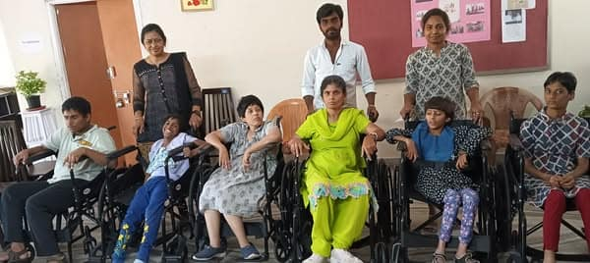
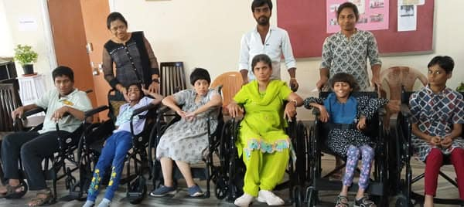
15th Nov 2024:-

19th Nov 2024:- Students and Teachers from Gitanjali Devshala School Balamrai Secunderabad visited Swayamkrushi on 19-11-2024 and donated Sholapur Bed-Sheets. Students of Gitanjali School interacted with the Director of Swayamakrushi Dr. Manjulaa Kalyan.
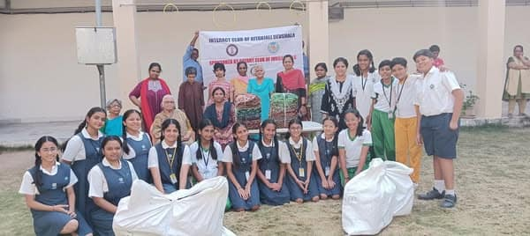
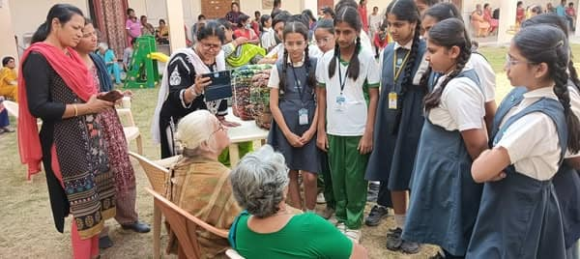

22nd Nov 2024:- Swayamkrushi staff participated in Karthika Masa Vana Bhojanam at new campus.
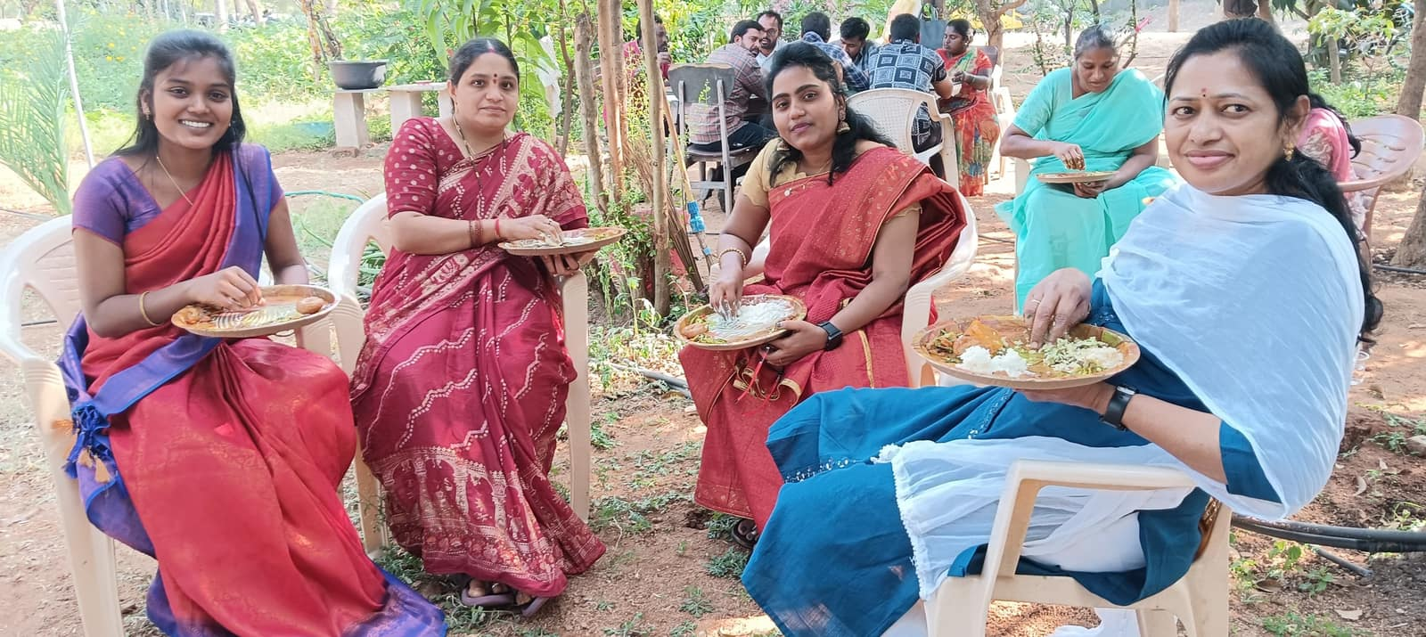
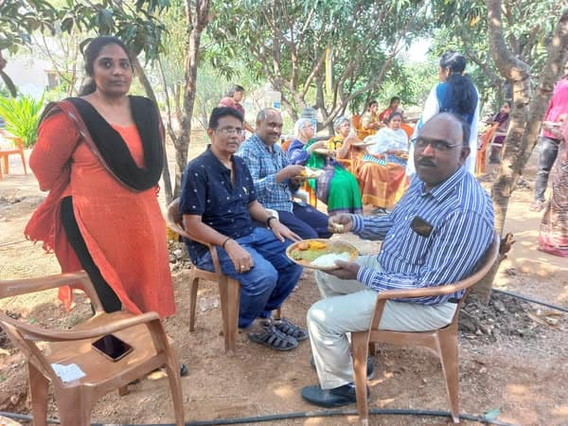
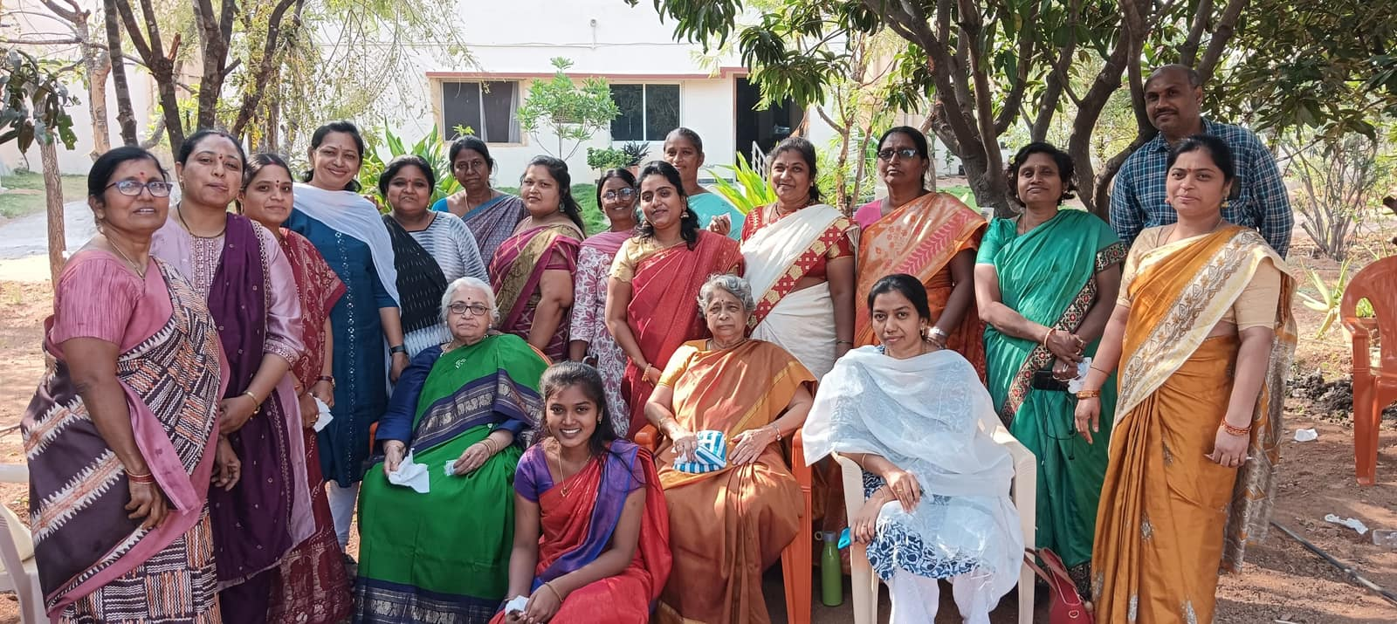

3rd Dec 2024:- Swayamkrushi celebrated the World Disability day on 3rd Dec 2024. A grand cultural programme was held which was provided over by Shri Chenna Sarath Babu (M.A L..L..M ..(PhD.).

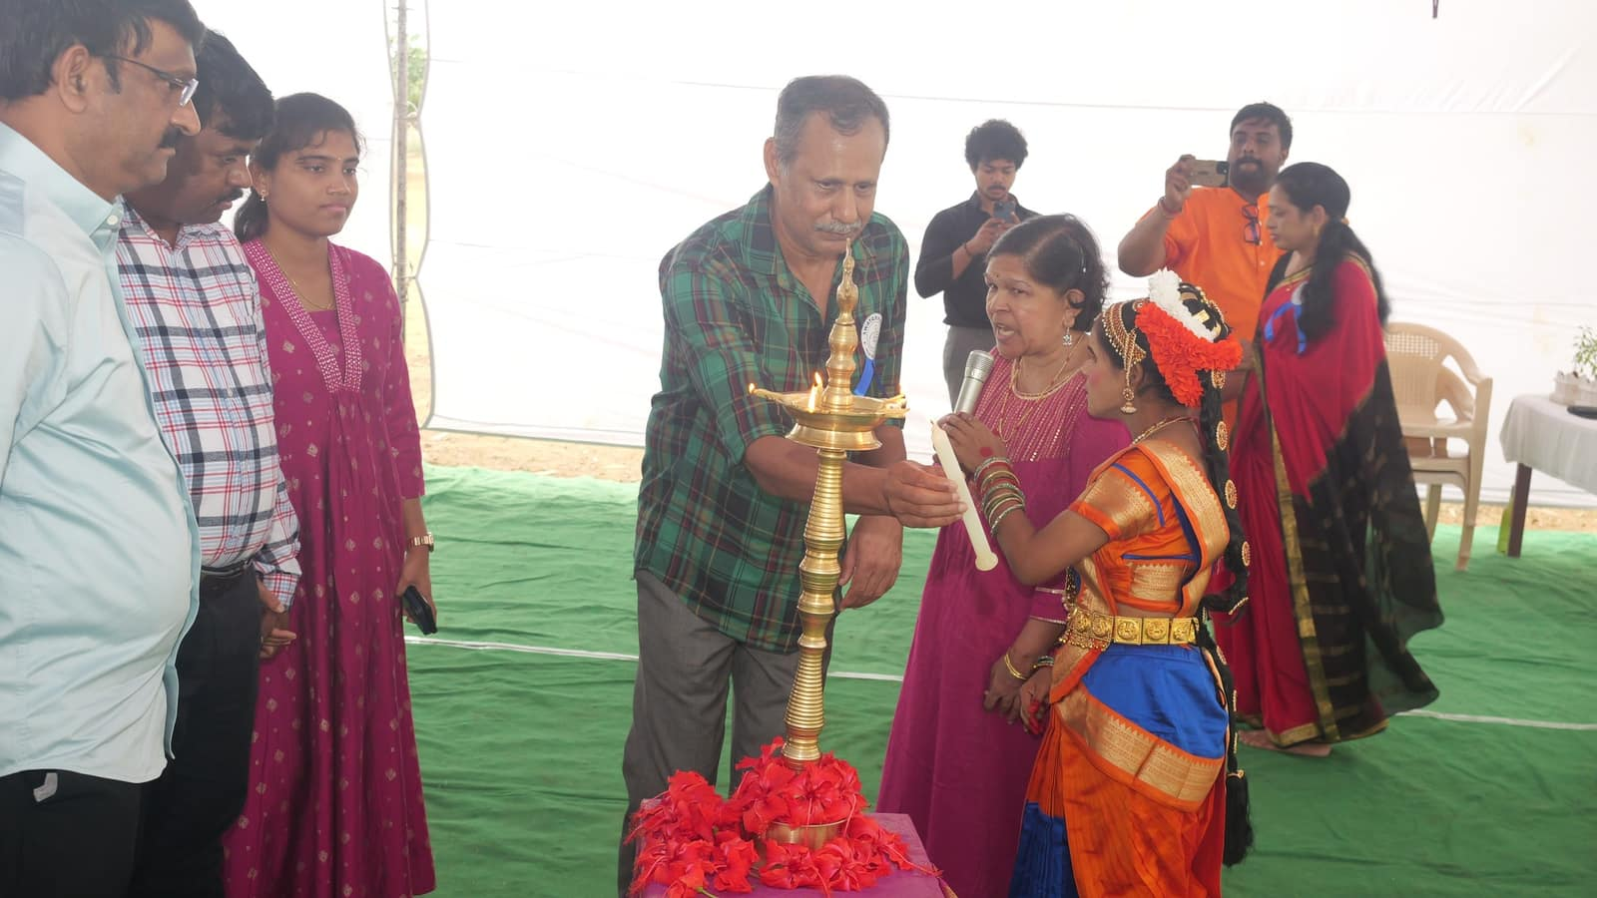
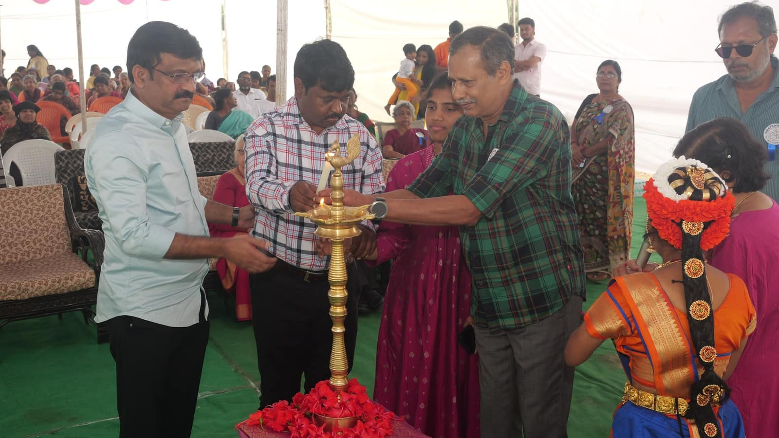

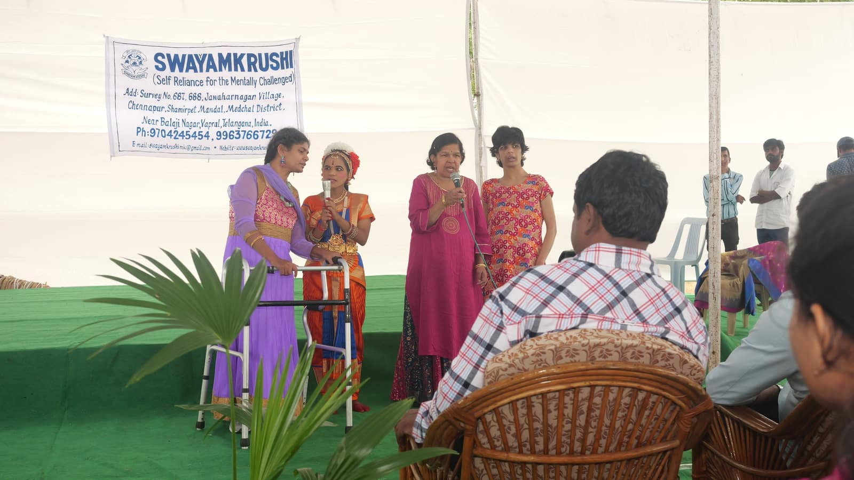
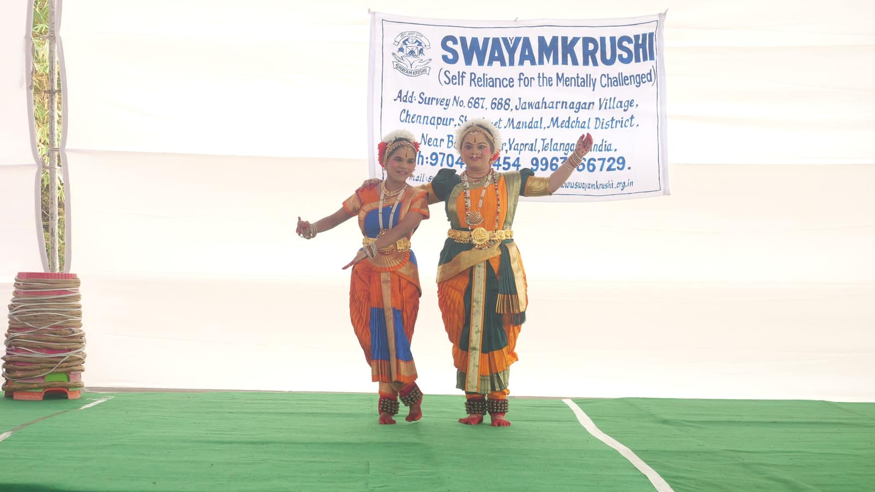

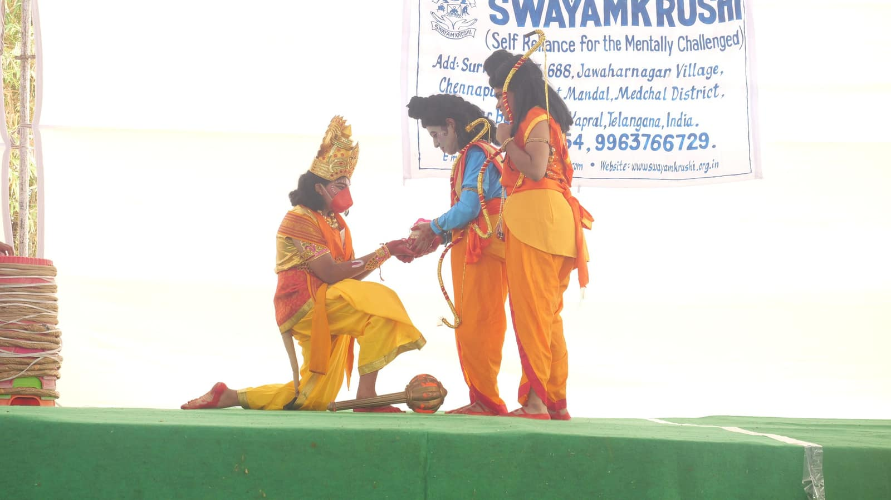
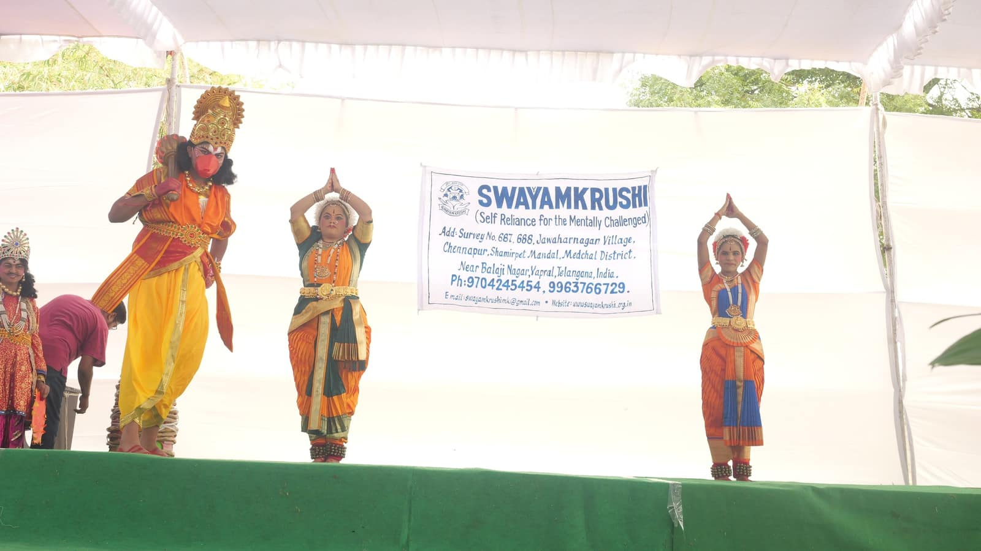

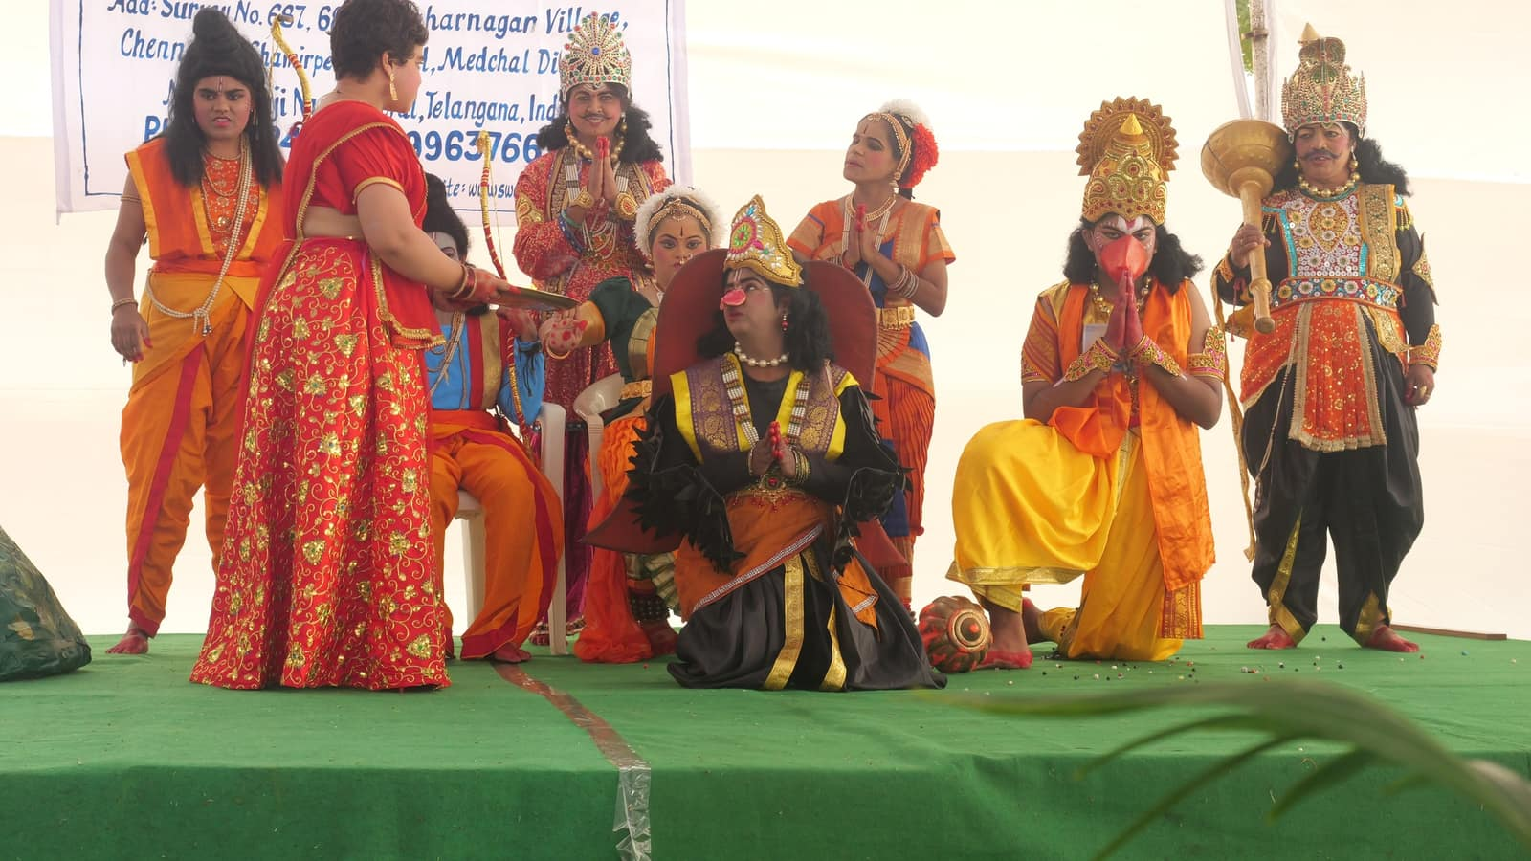
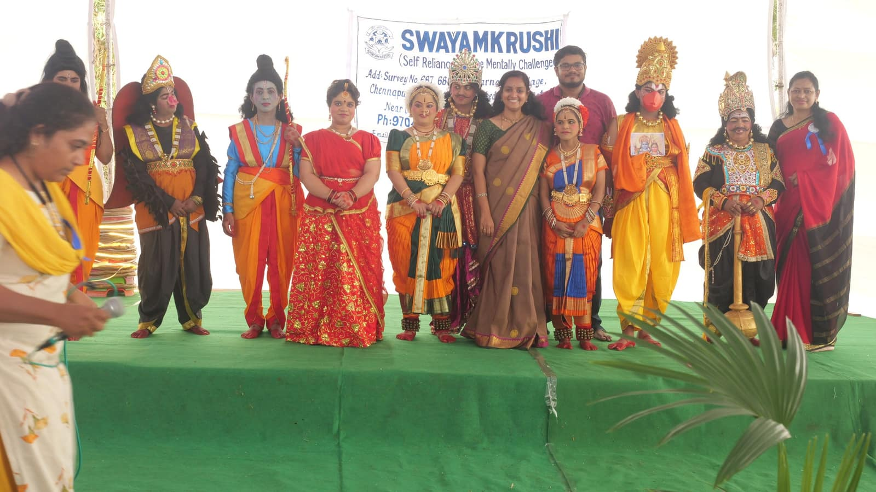

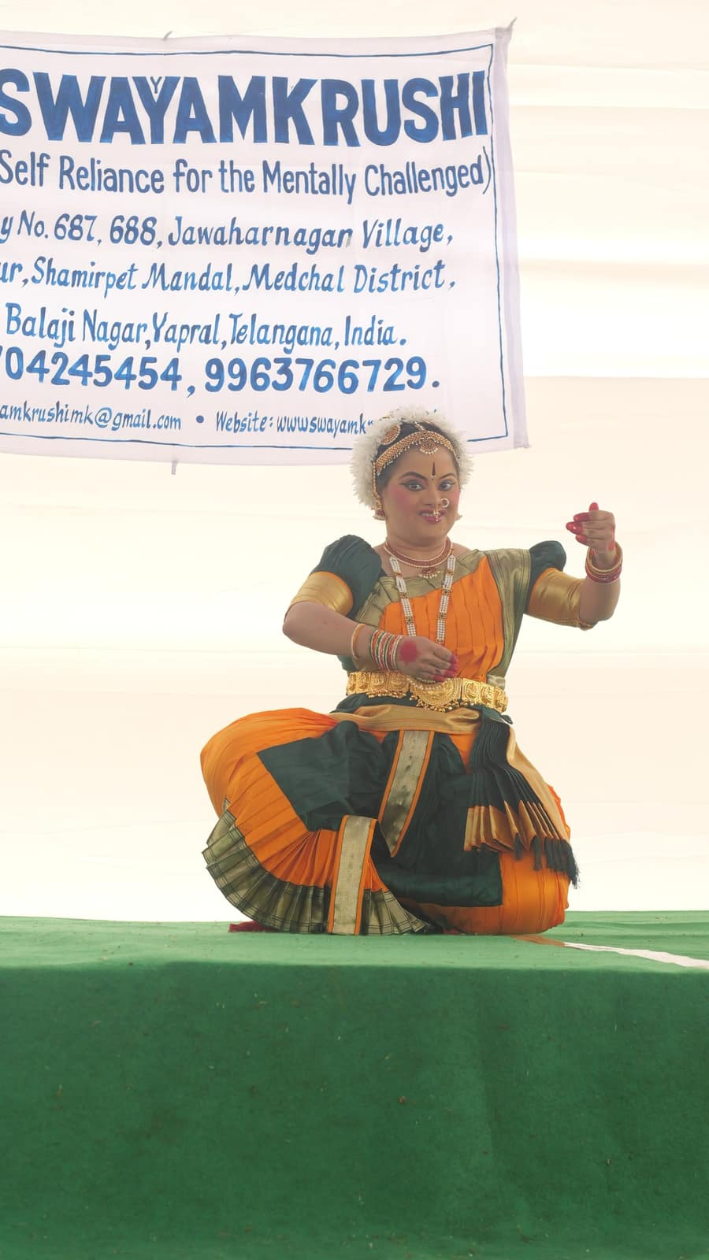
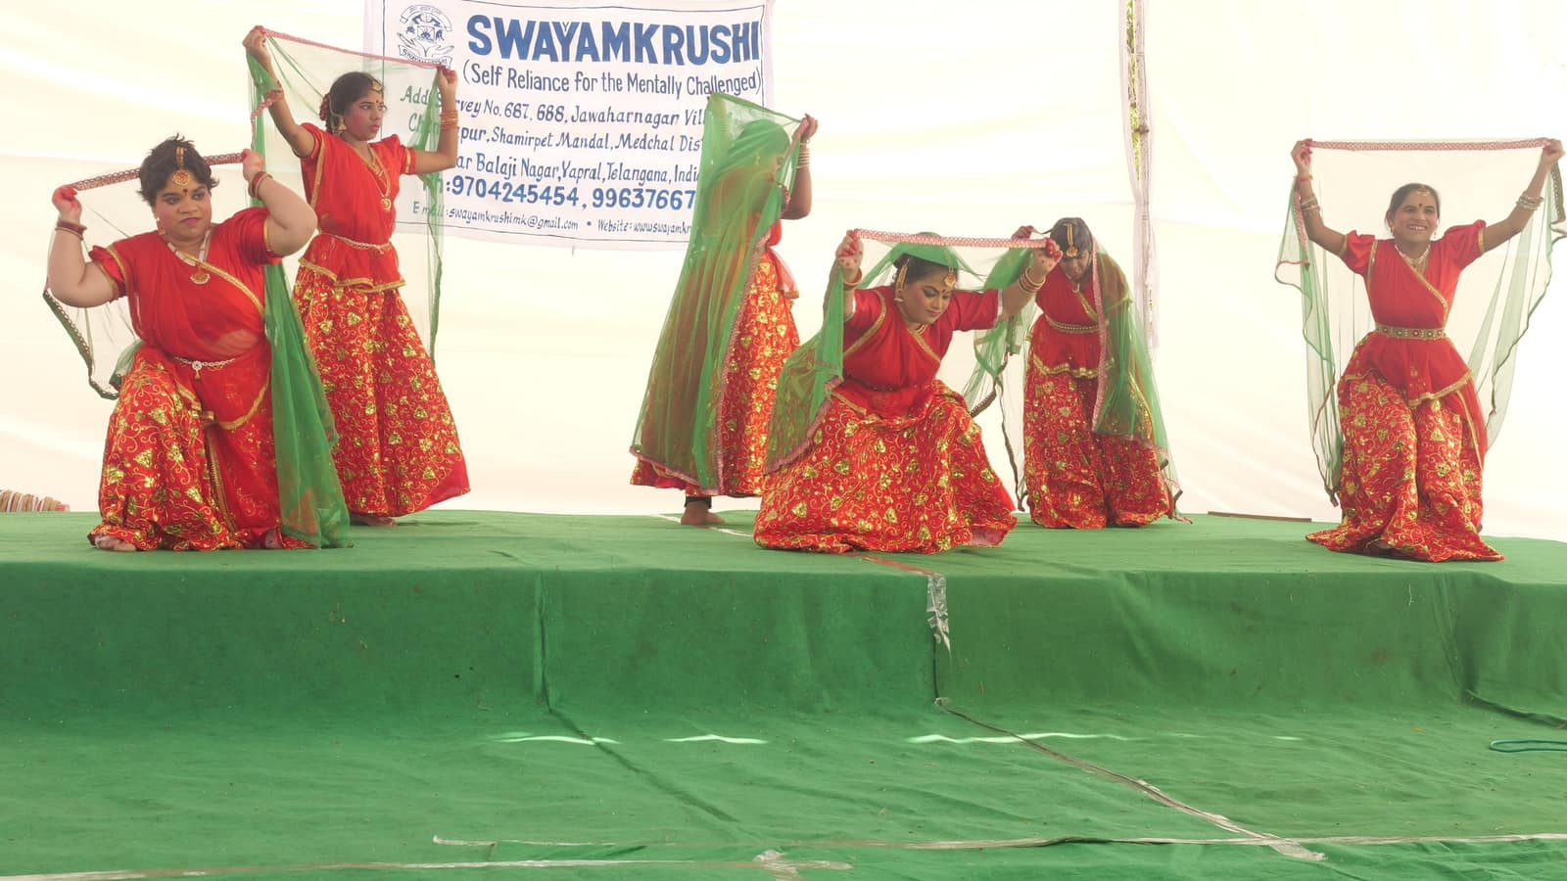

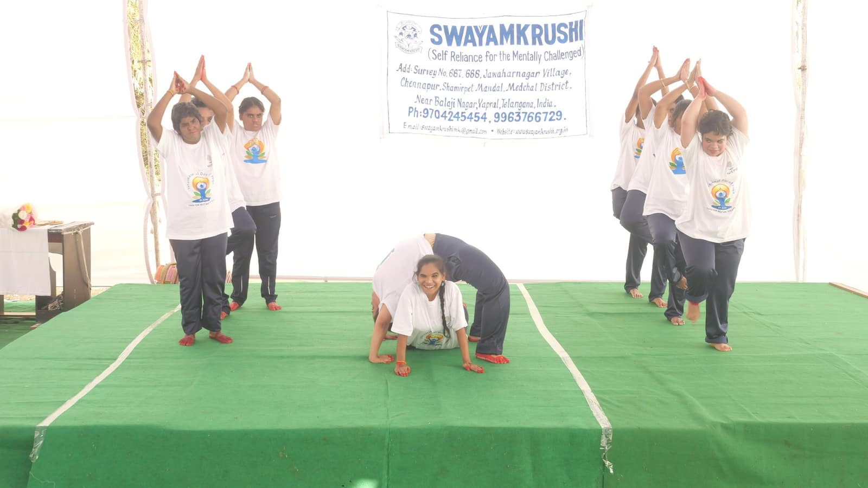
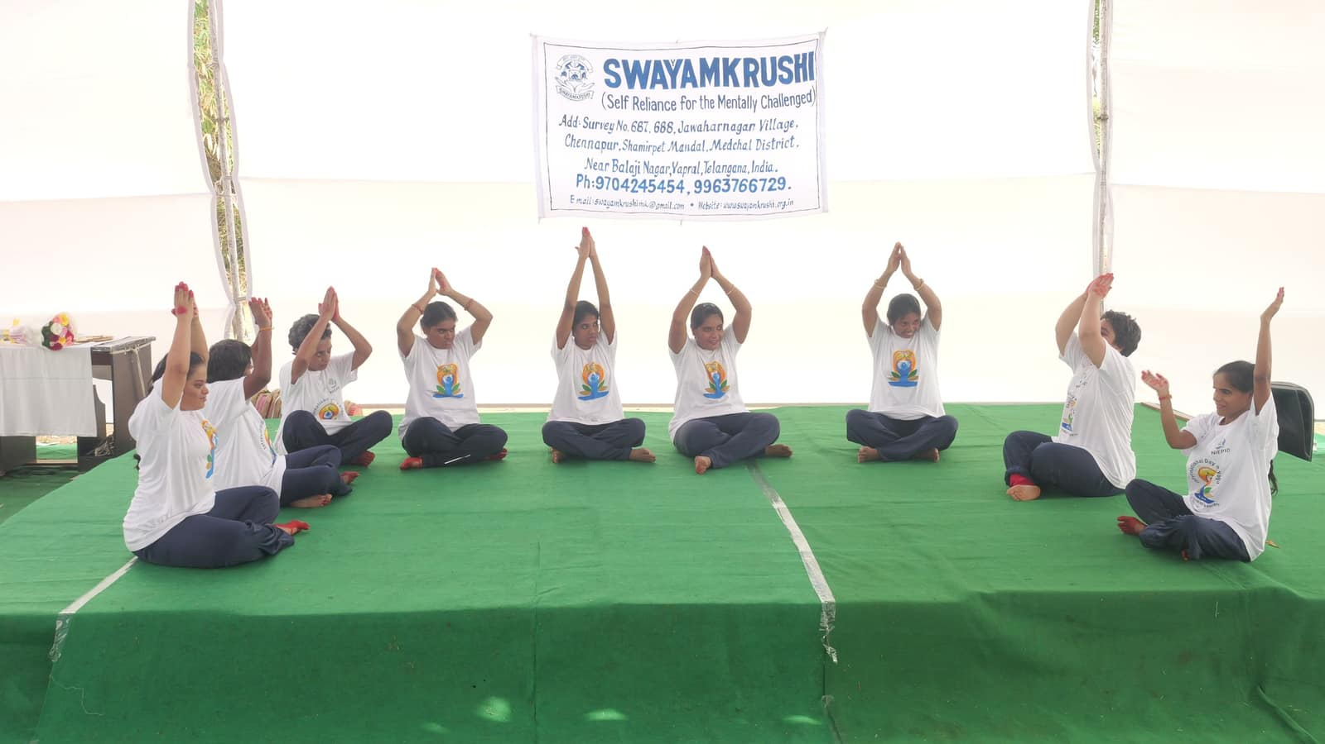

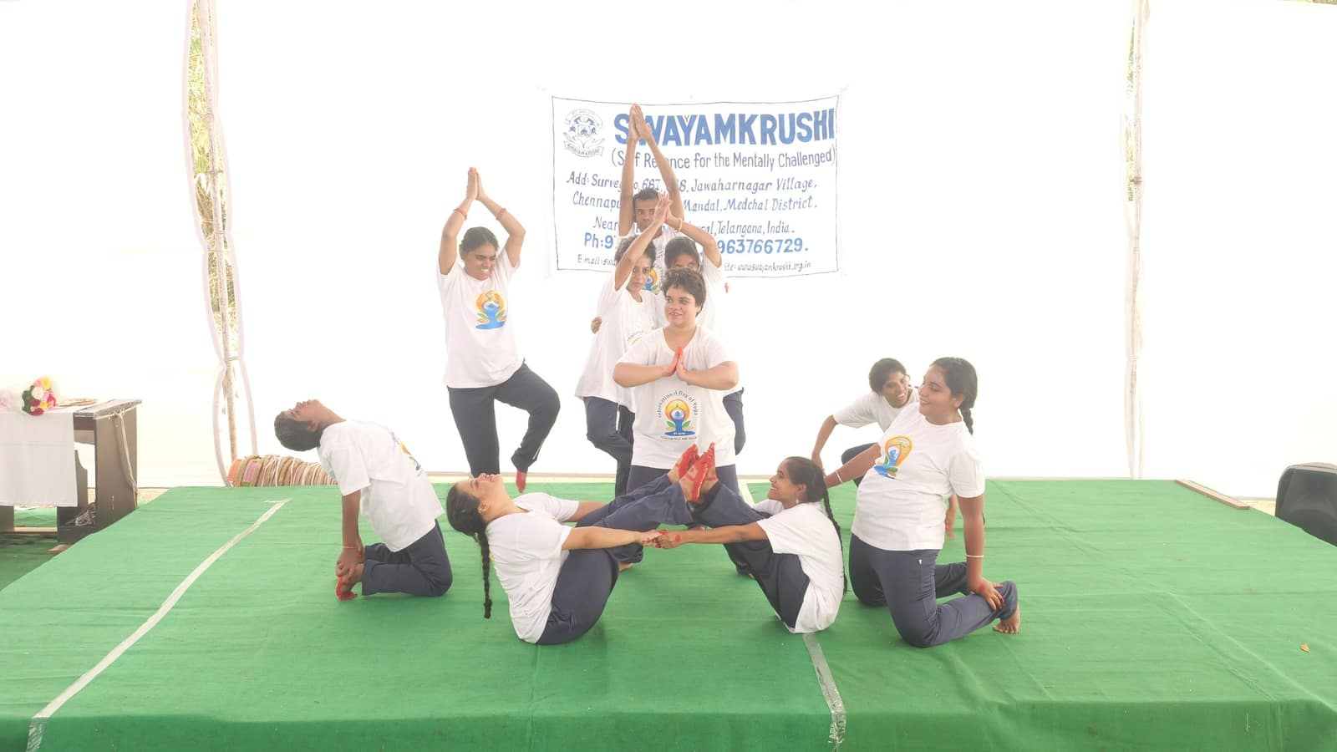
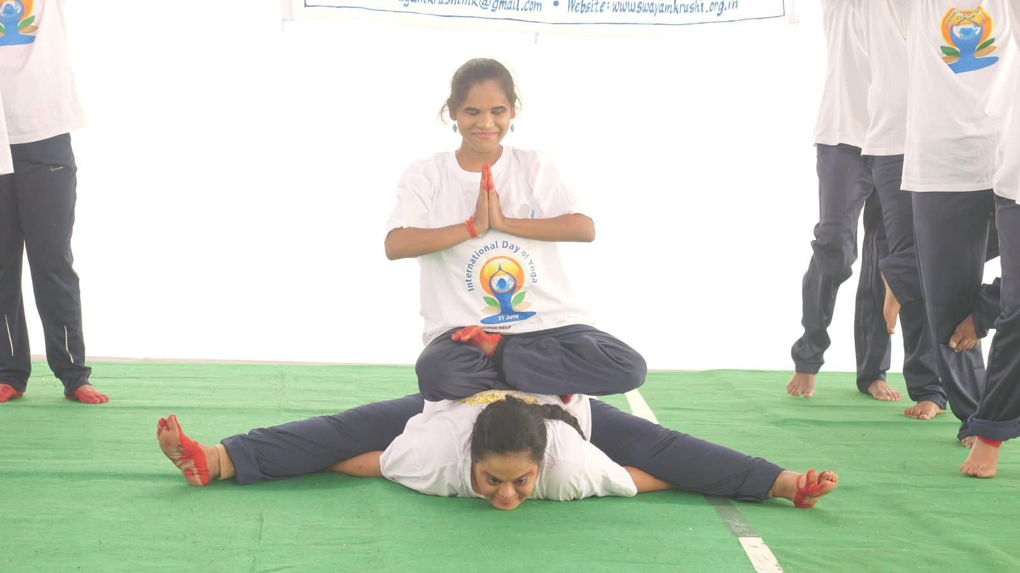

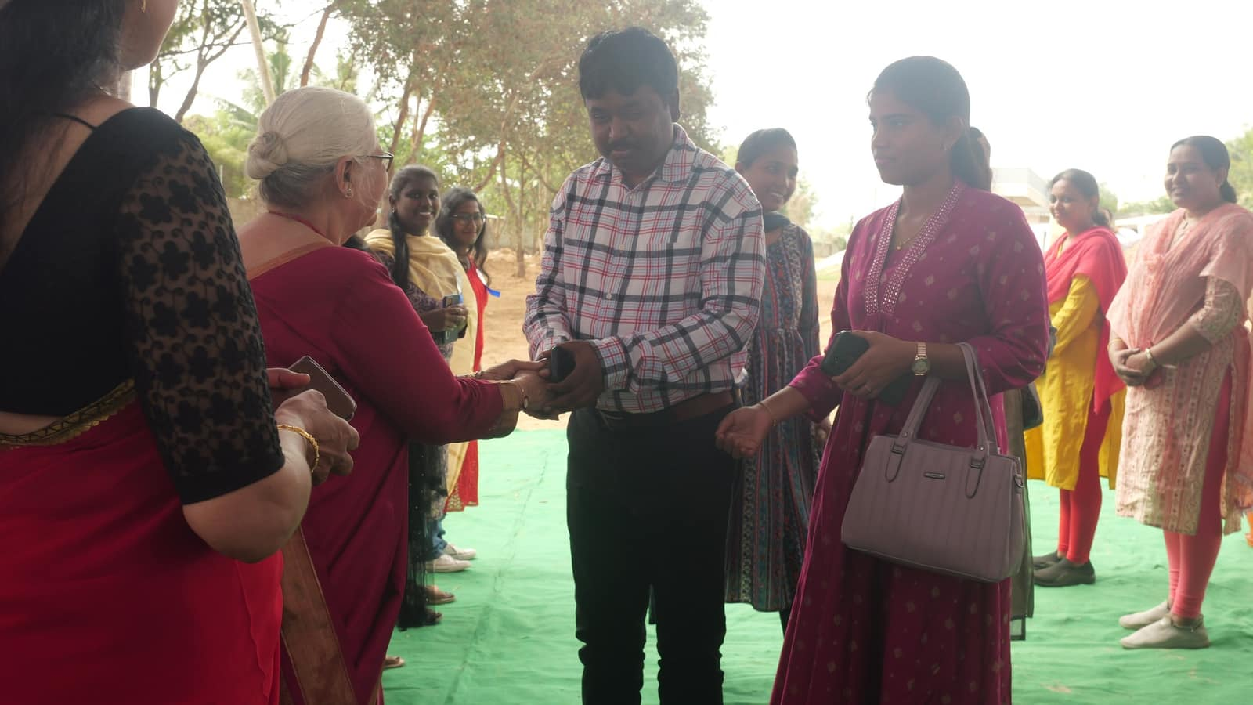
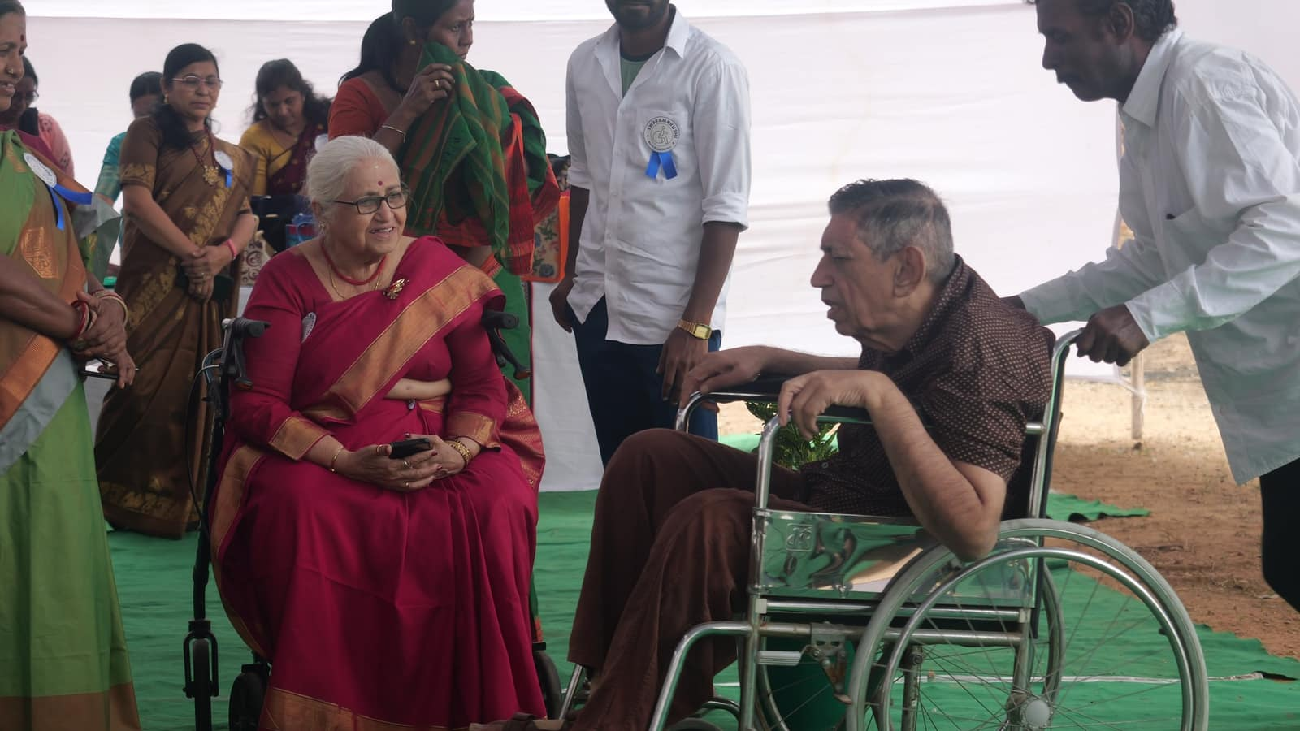

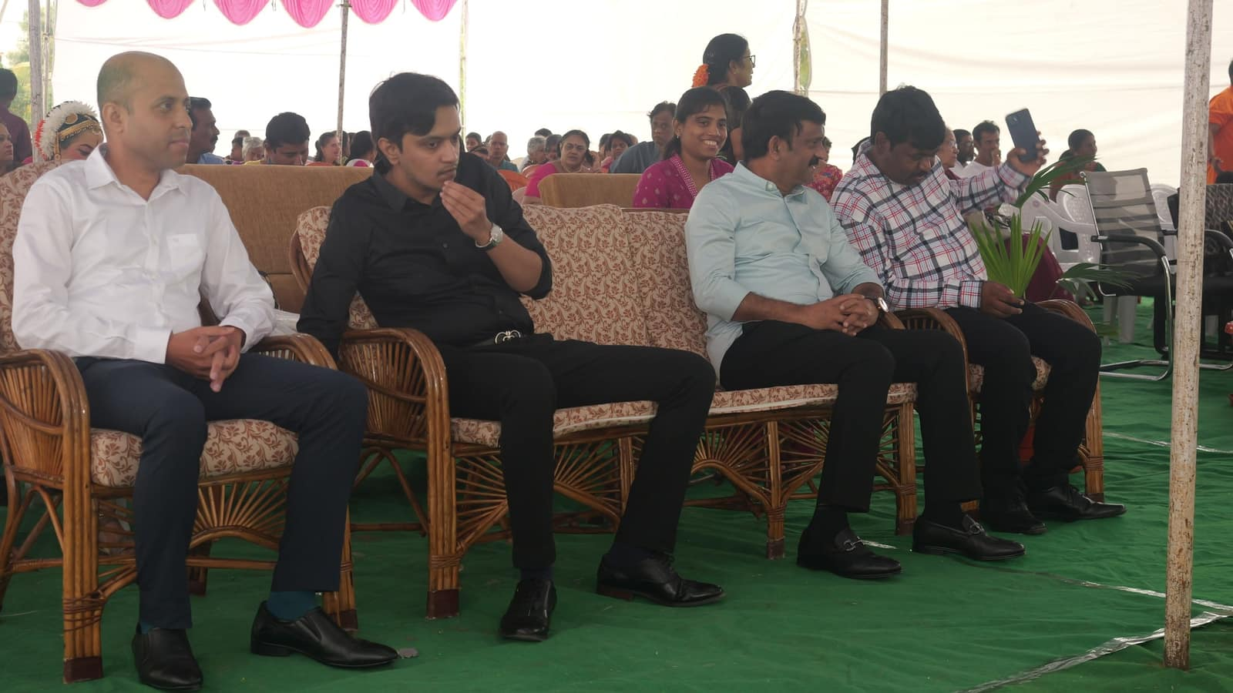

3rd Dec 2024:-

Jan 09-01-2025:- At our Harvest Festival, we were honored to have Gummadi Venella garu as our esteemed host. Her speech on supporting women with disabilities was truly inspiring. She pledged her continued support for the cause, emphasizing the importance of empowerment and inclusion.
In addition to her heartfelt words, Venella garu delighted the audience with a beautiful song dedicated to women. She also shared touching memories of her father, adding a personal and emotional dimension to the event. Her presence and participation greatly enriched the festival, leaving a lasting impression on all attendees.

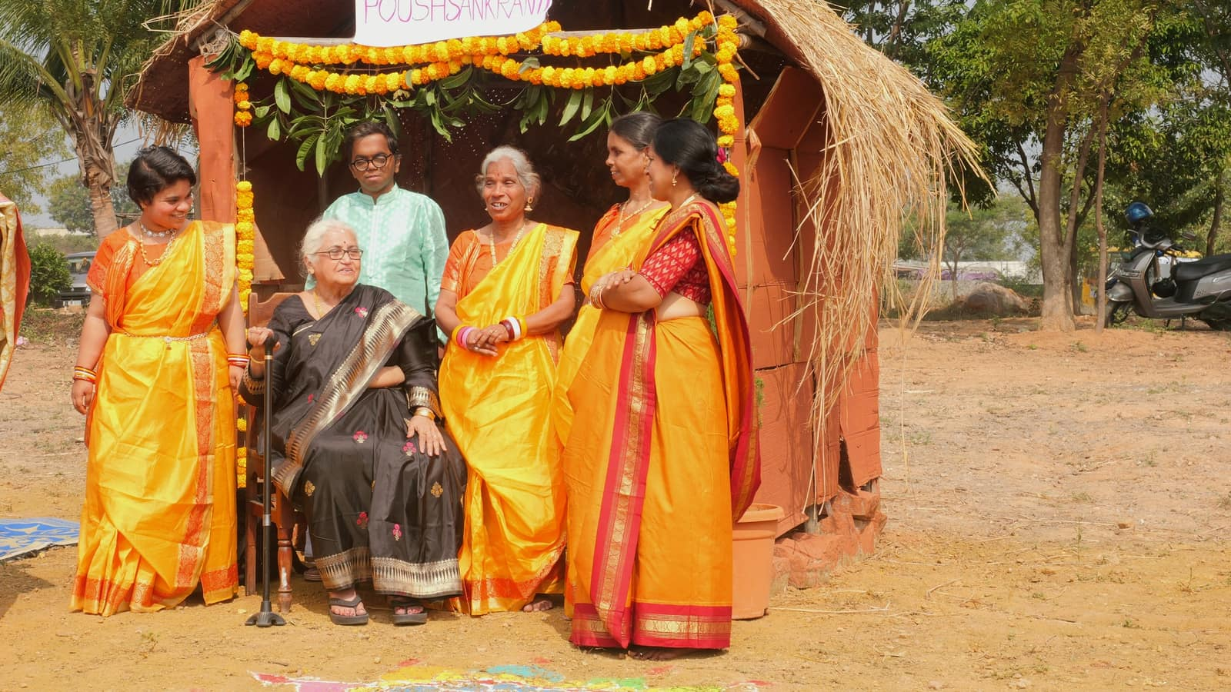
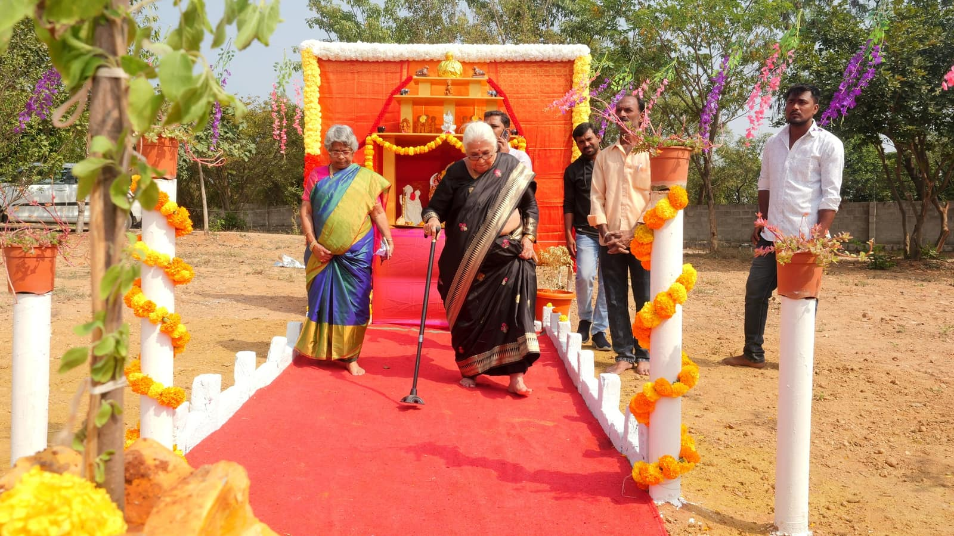

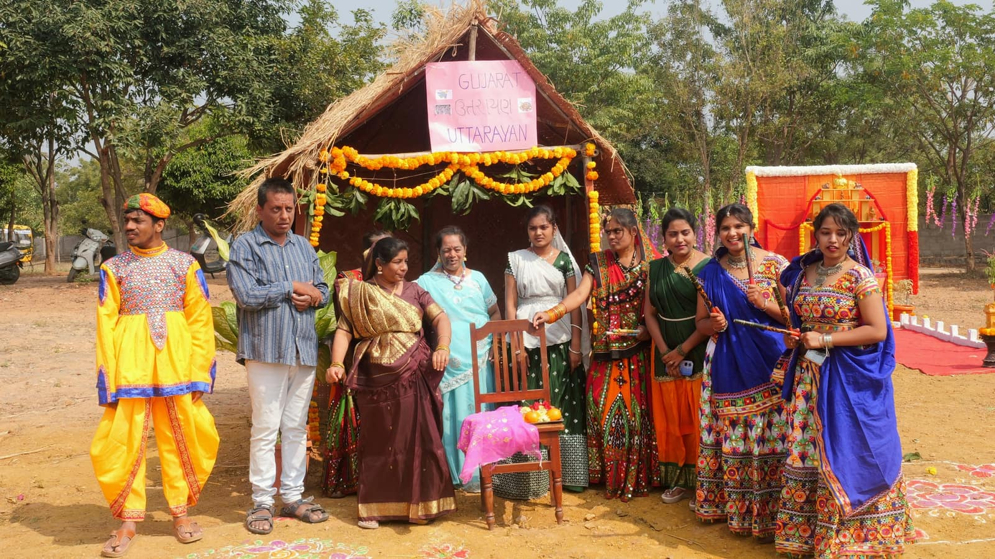
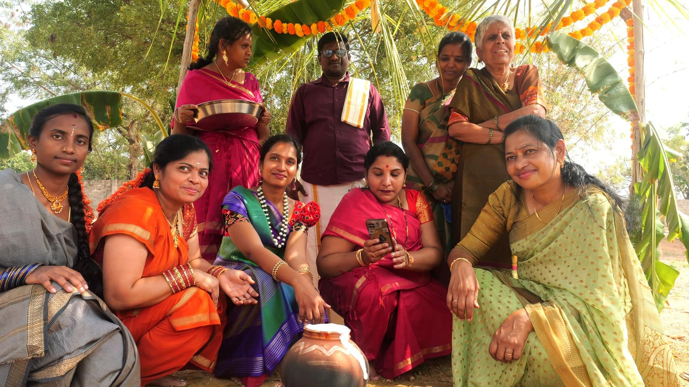

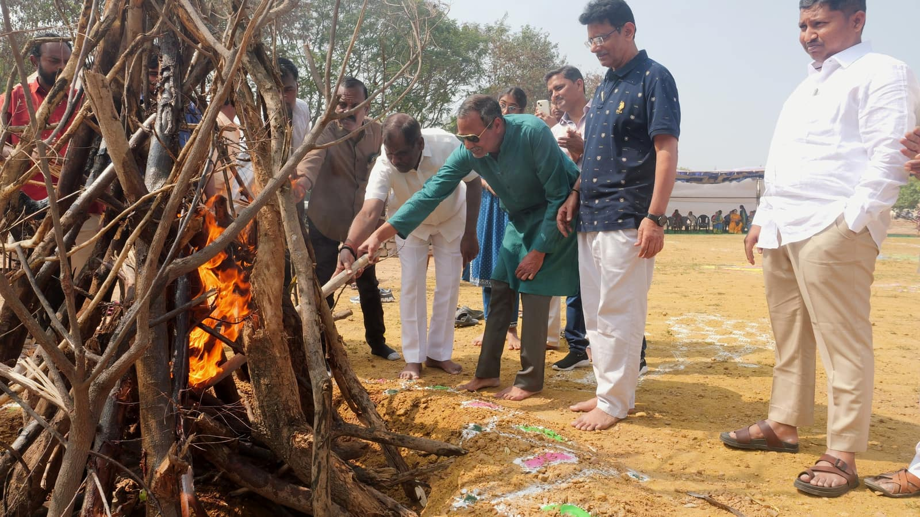
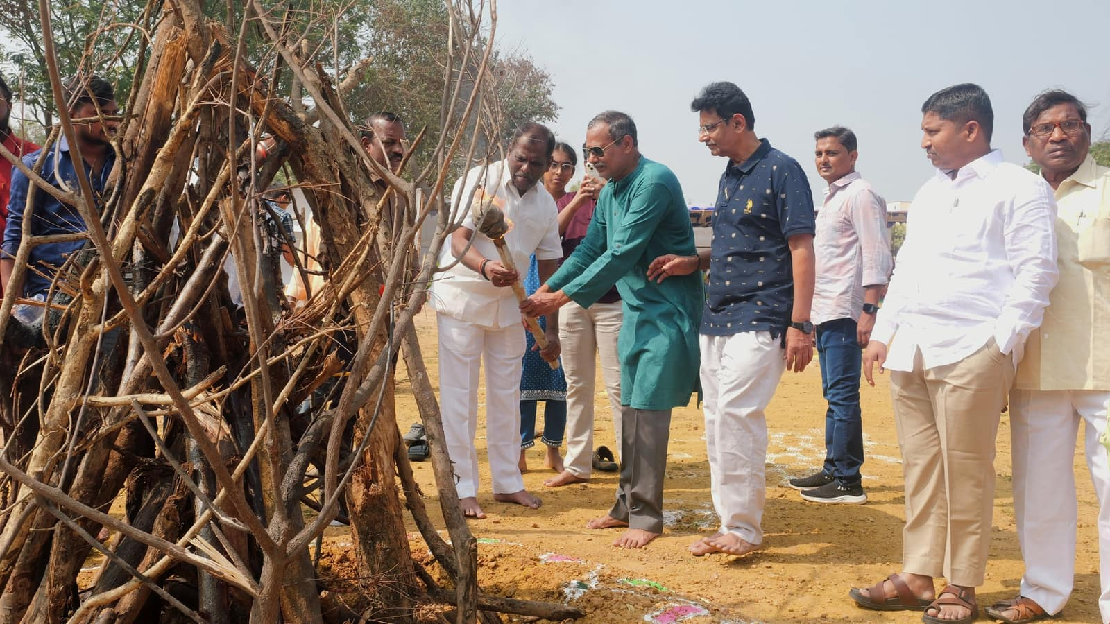

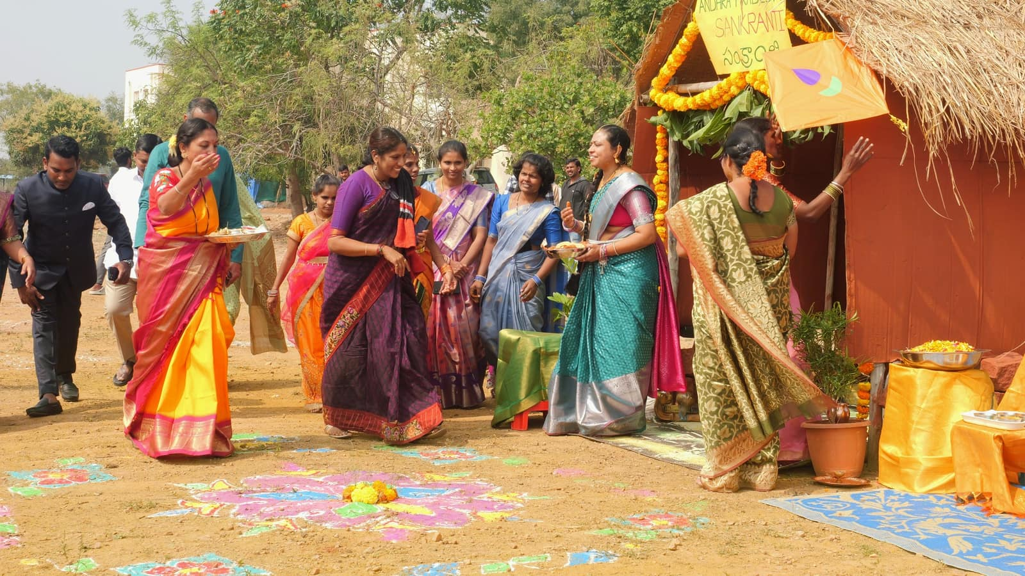
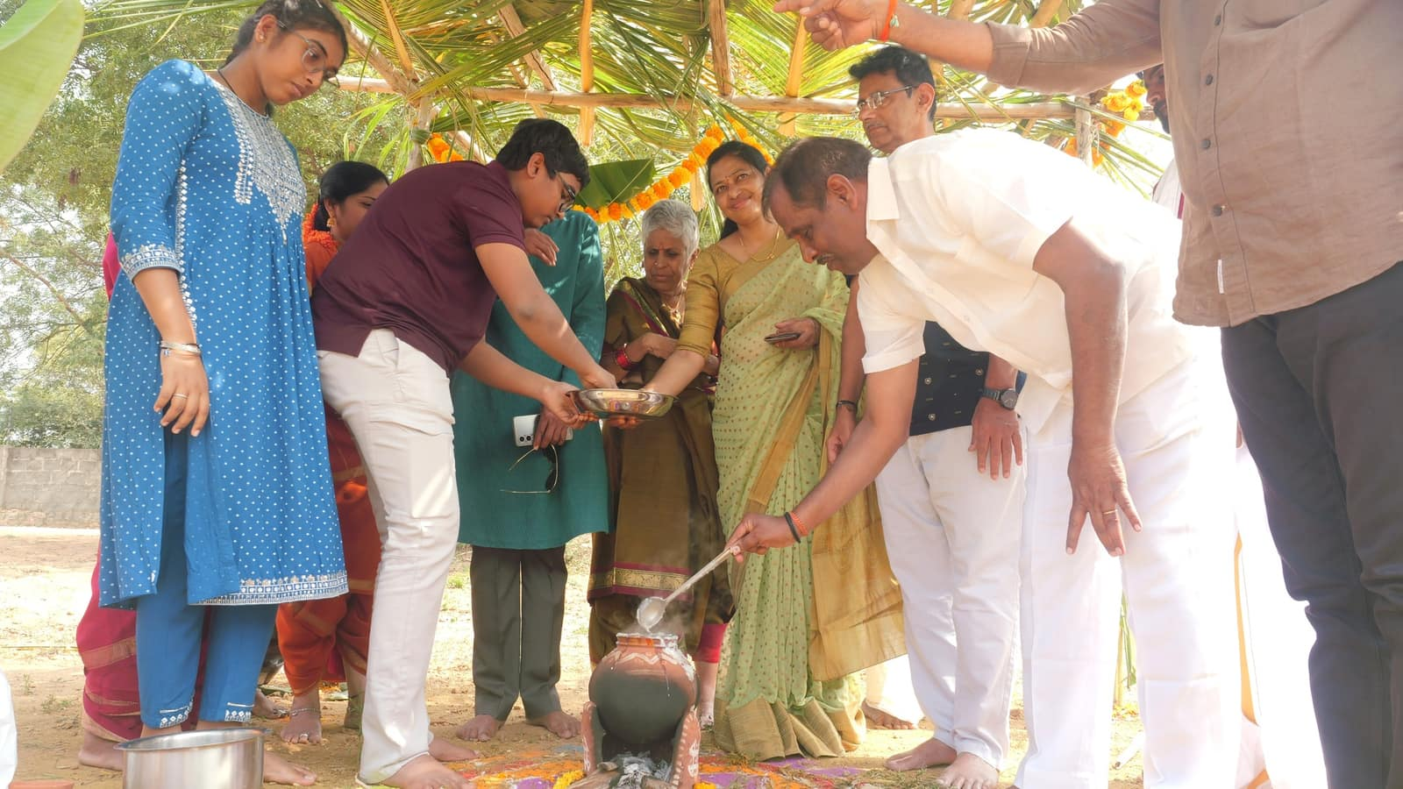

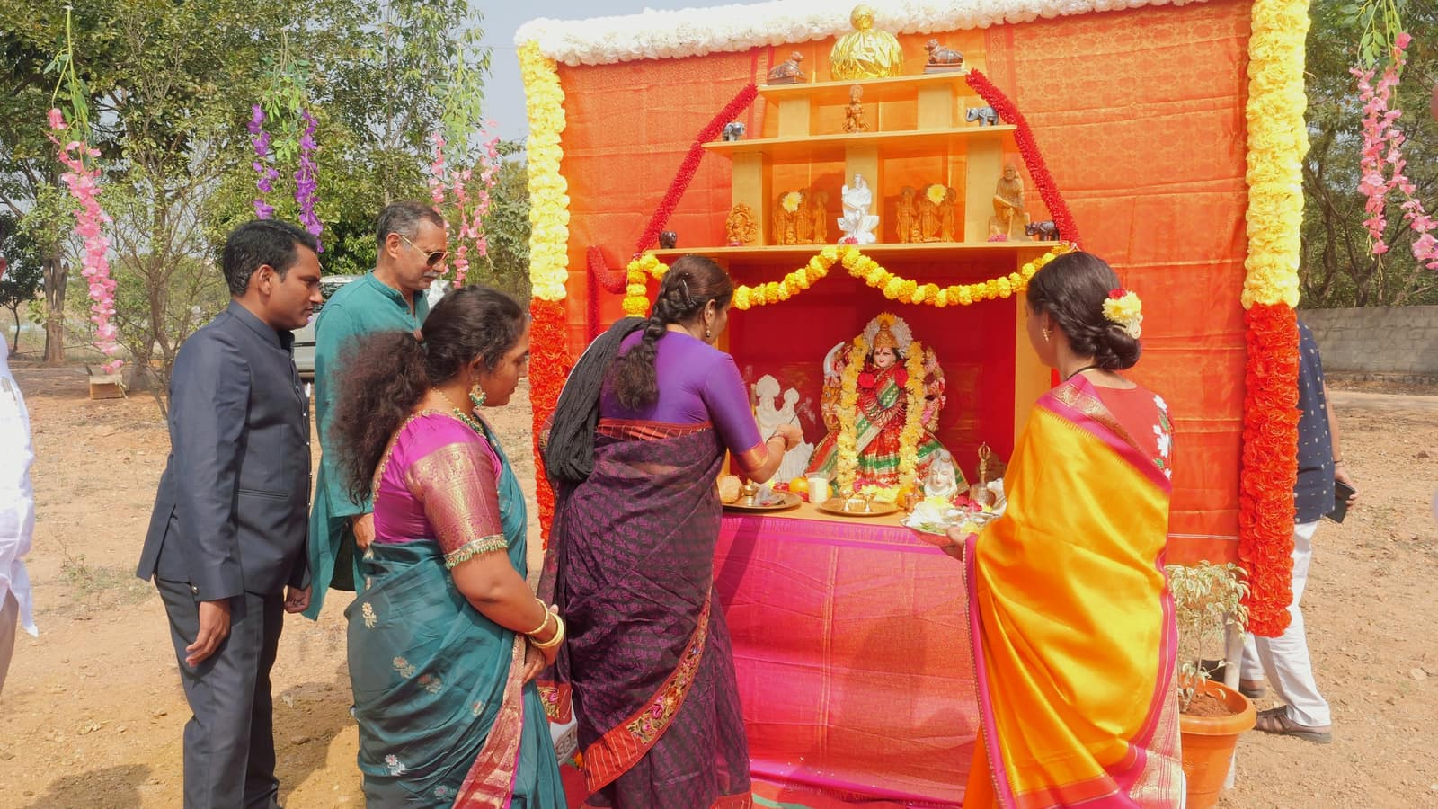
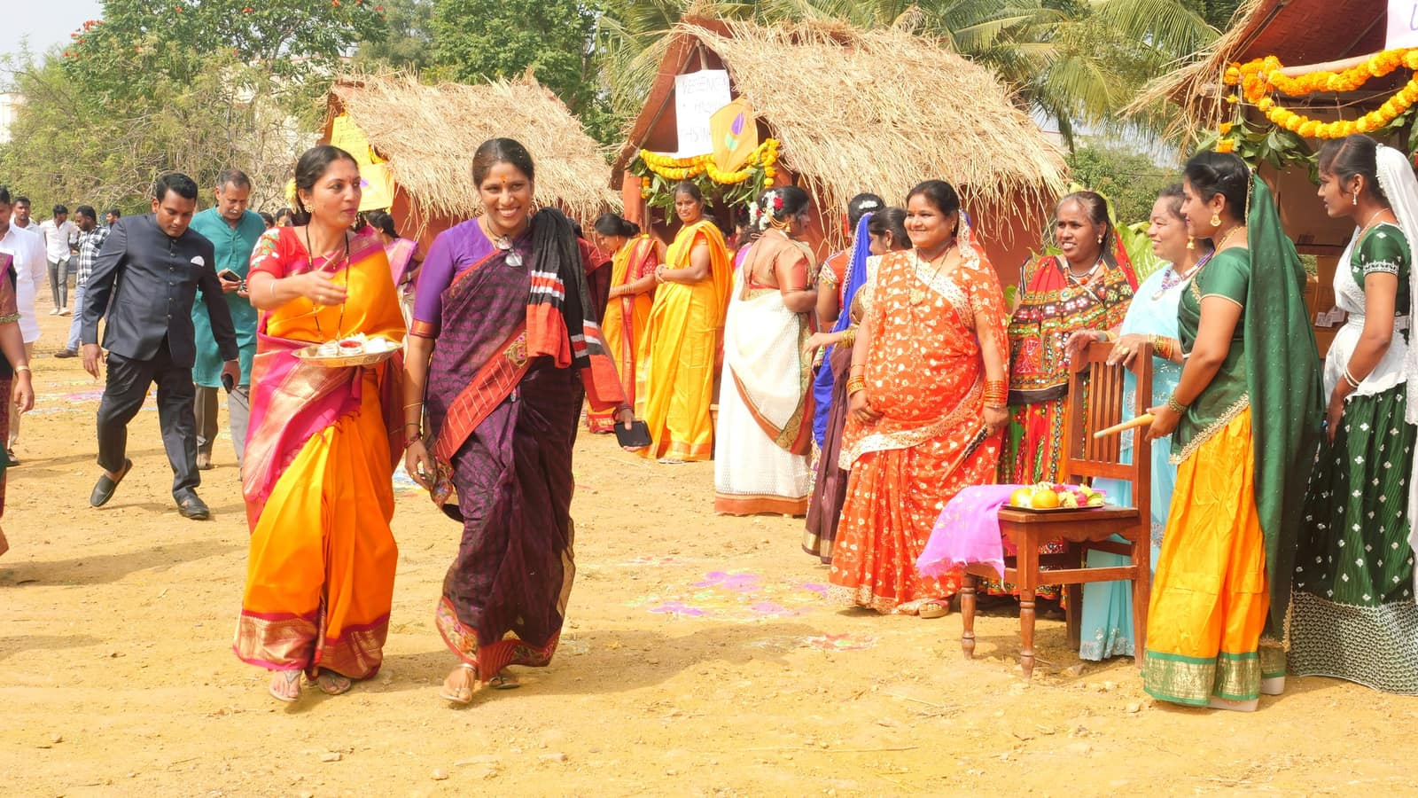

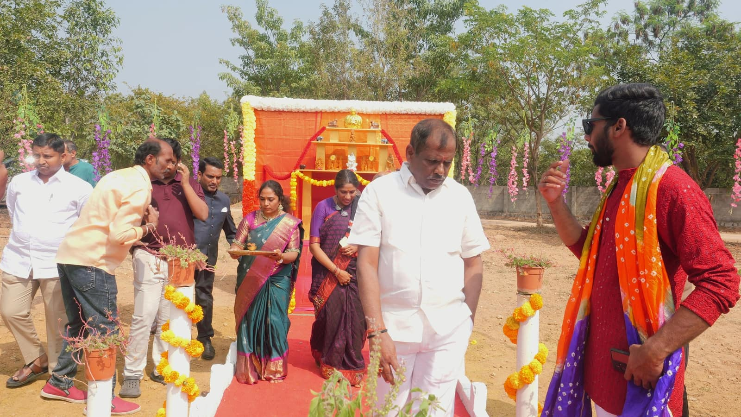
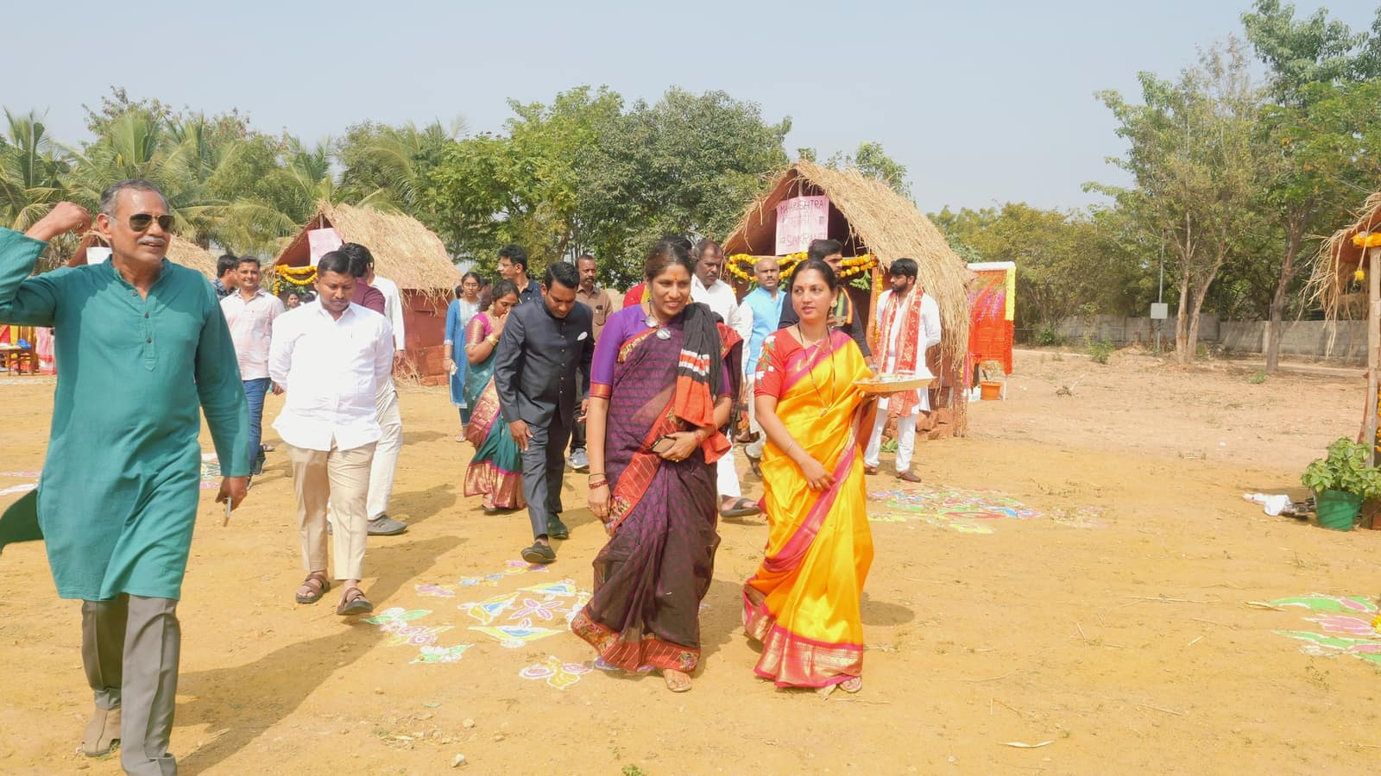

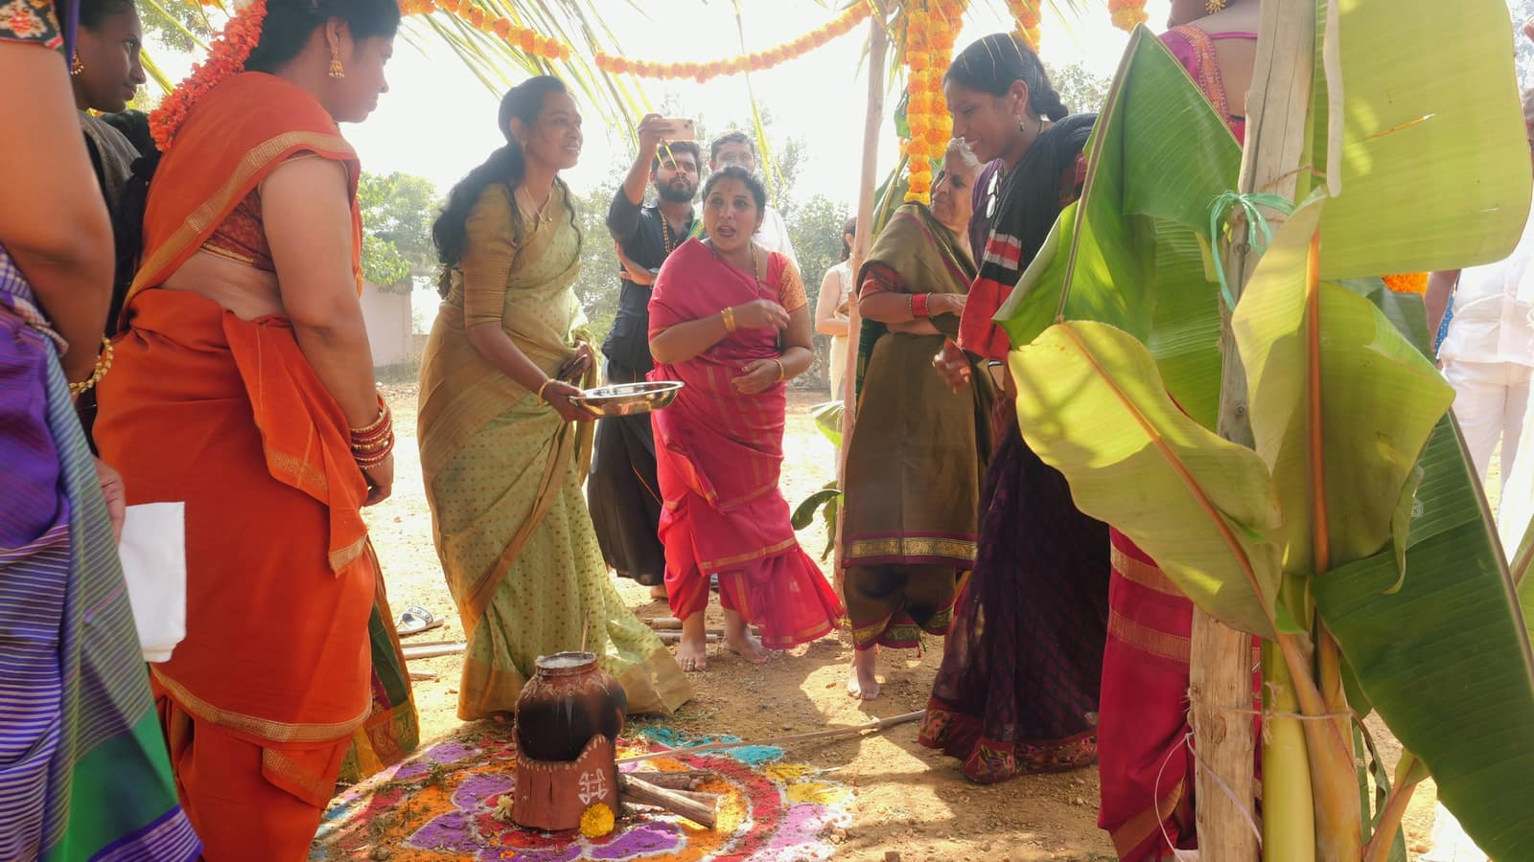
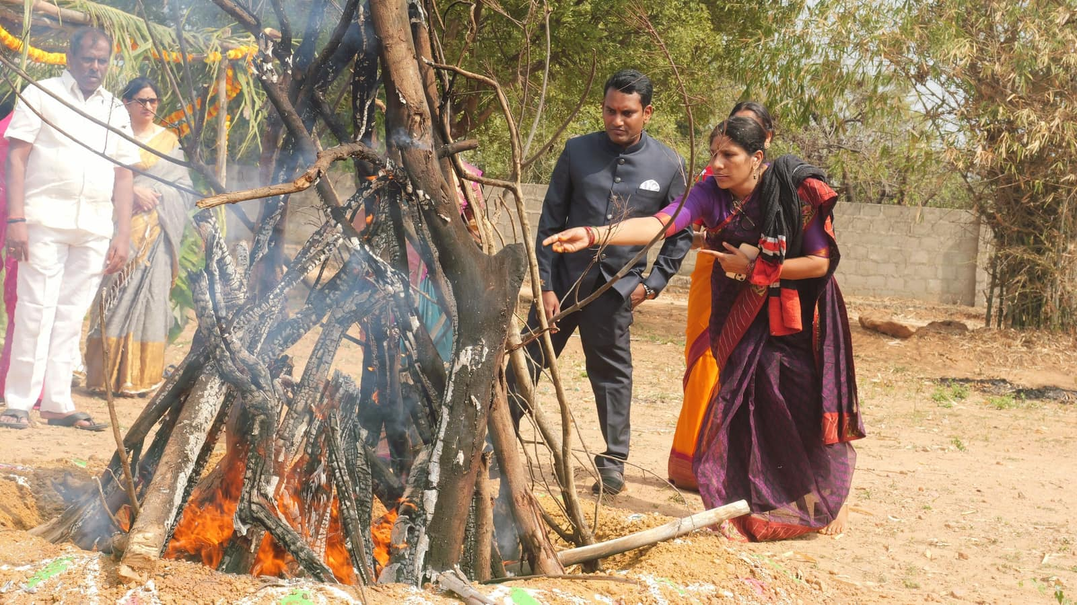

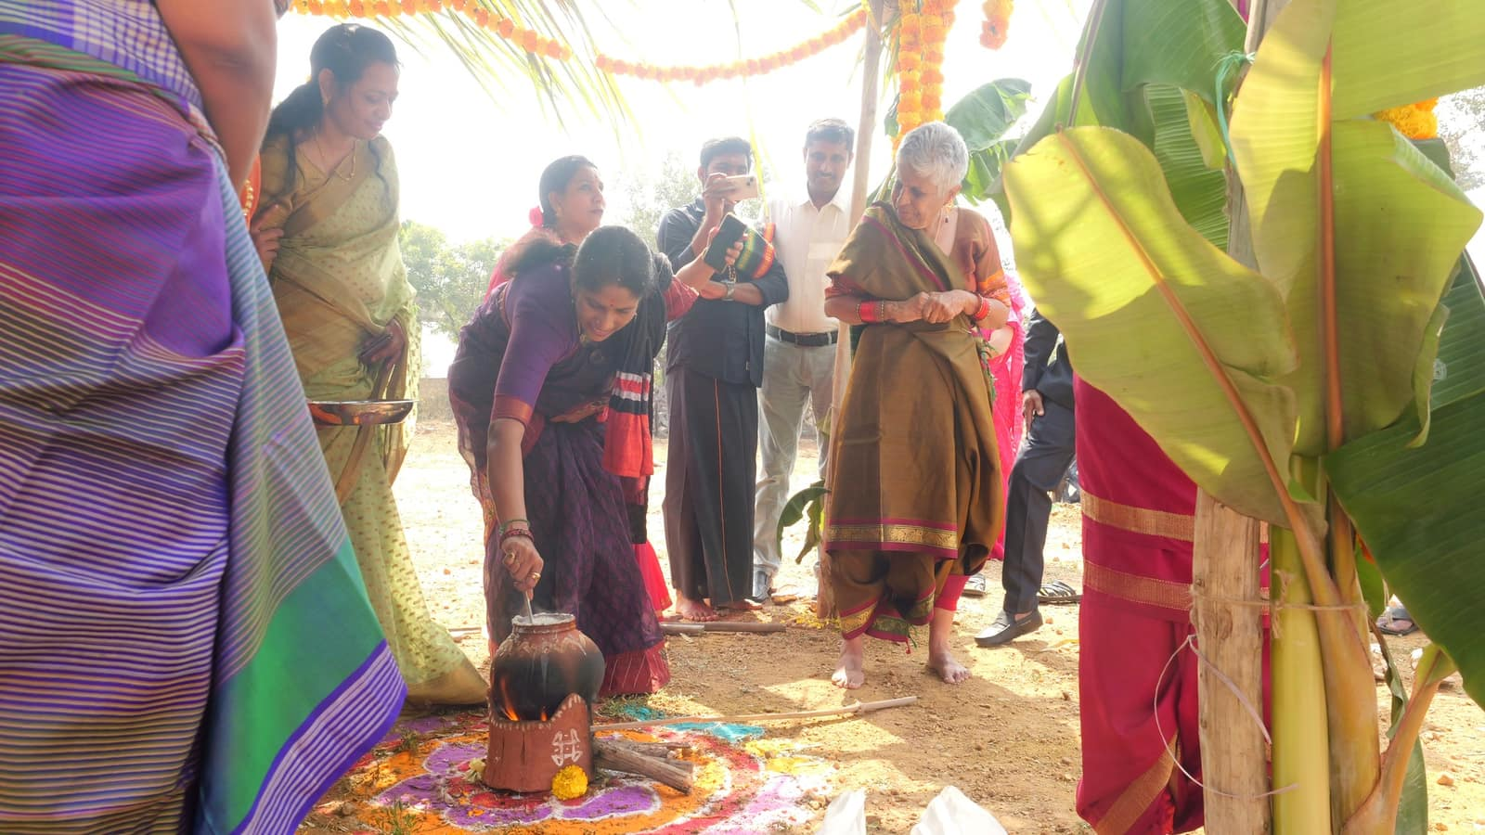
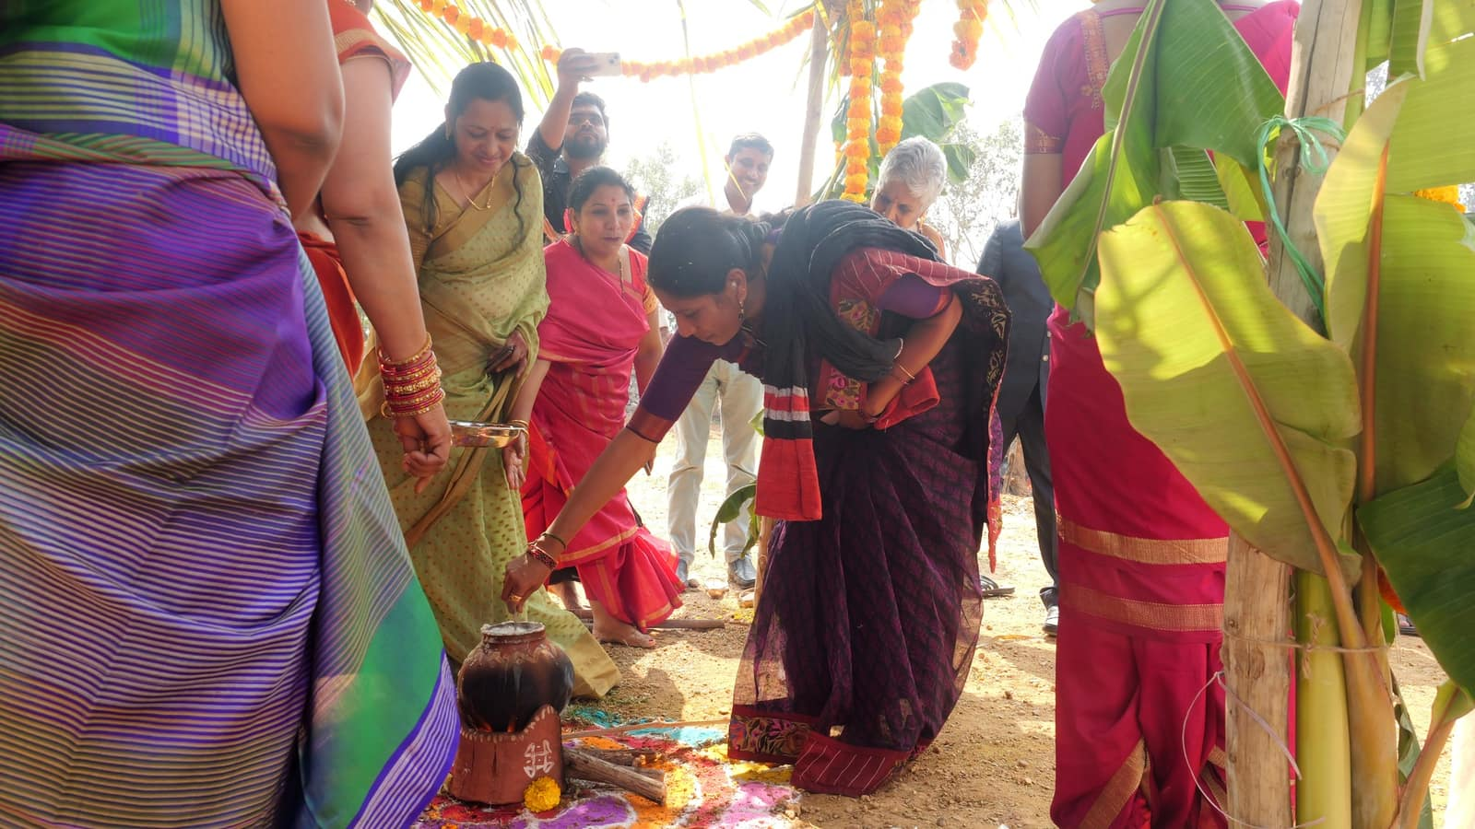

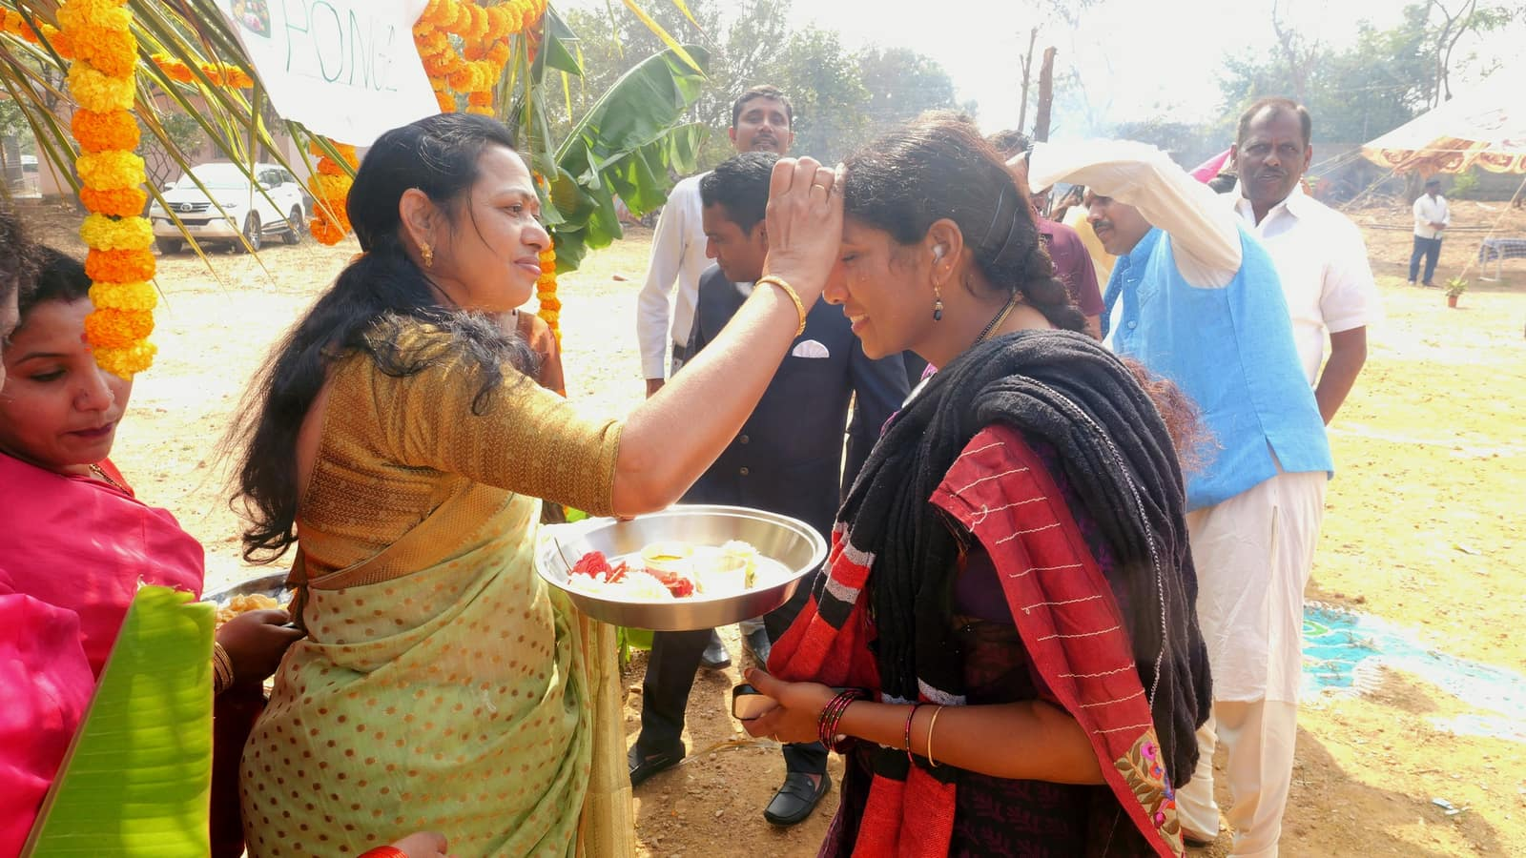
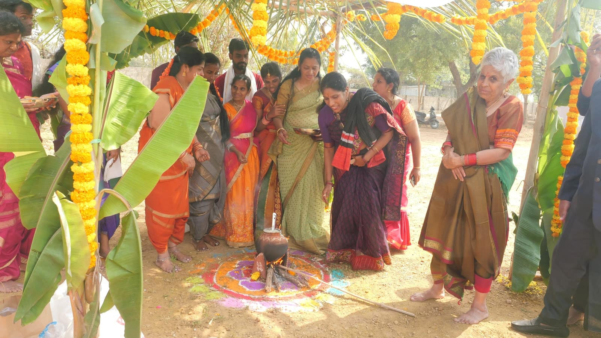
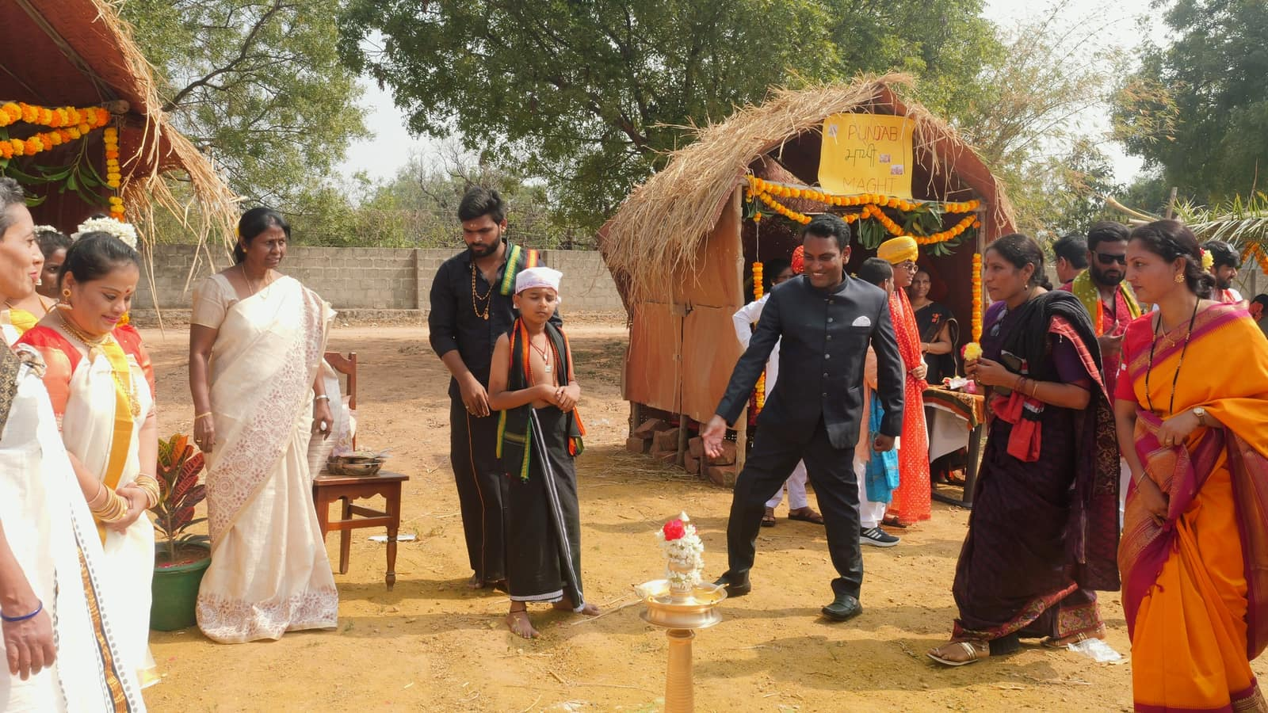

Jan 26th 2025:- Empowering minds, embracing unity! Swayamkrushi celebrates Republic Day 2025 with fervor and patriotism. Honored by the presence of Chief Guest Air Vice- Marshal, Sri Sattaru Bhanoji Rao. Witness the joy as our empowered women dance, sing, and hoist the tricolor high!

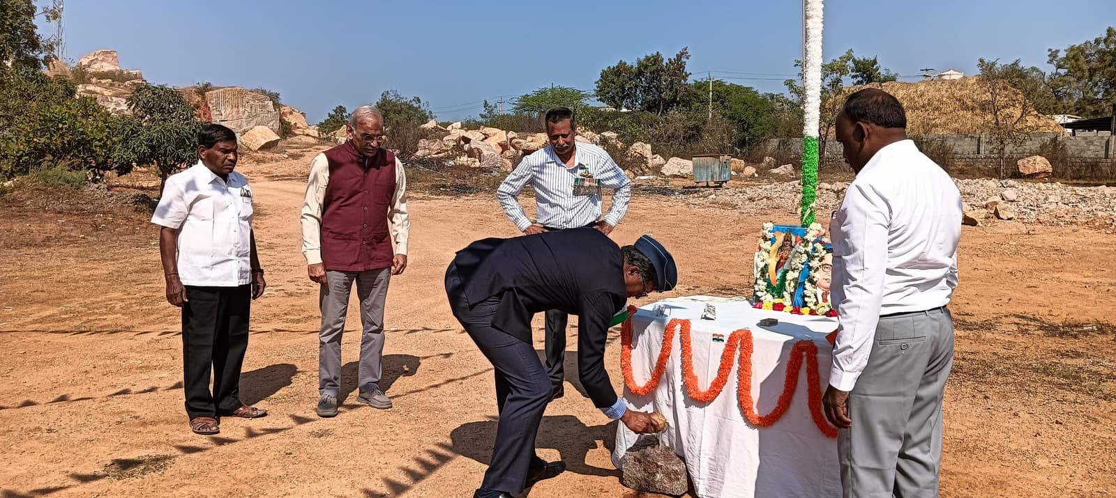
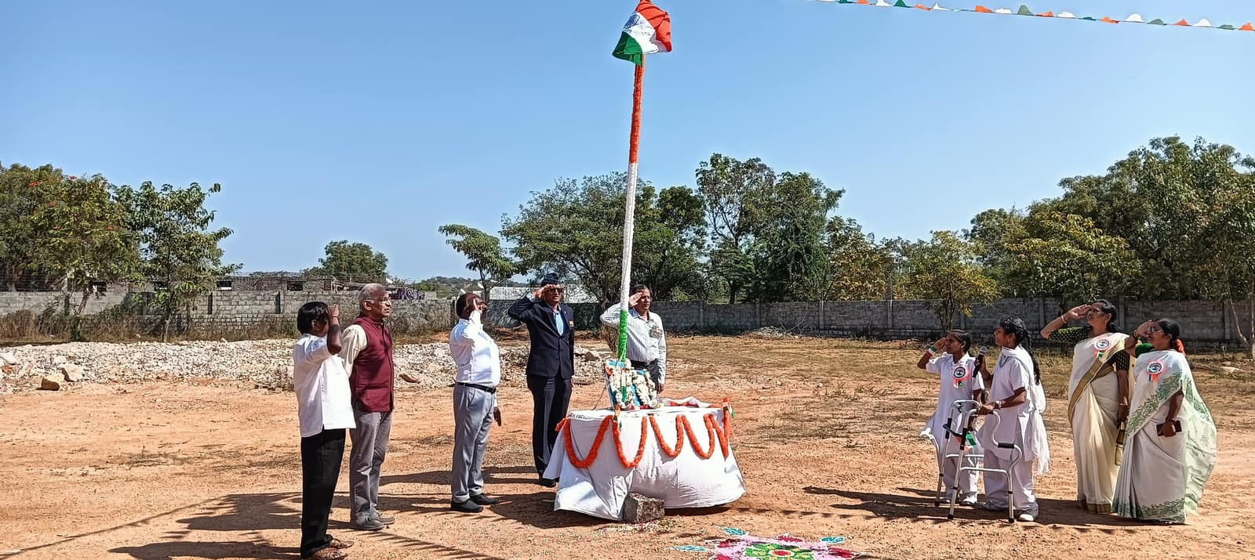

Feb 5th 2025:- Swayamkrushi Celebrated Graduation day on Feb 2025 B.Ed Spl Edn (ID) batch 2022-24.
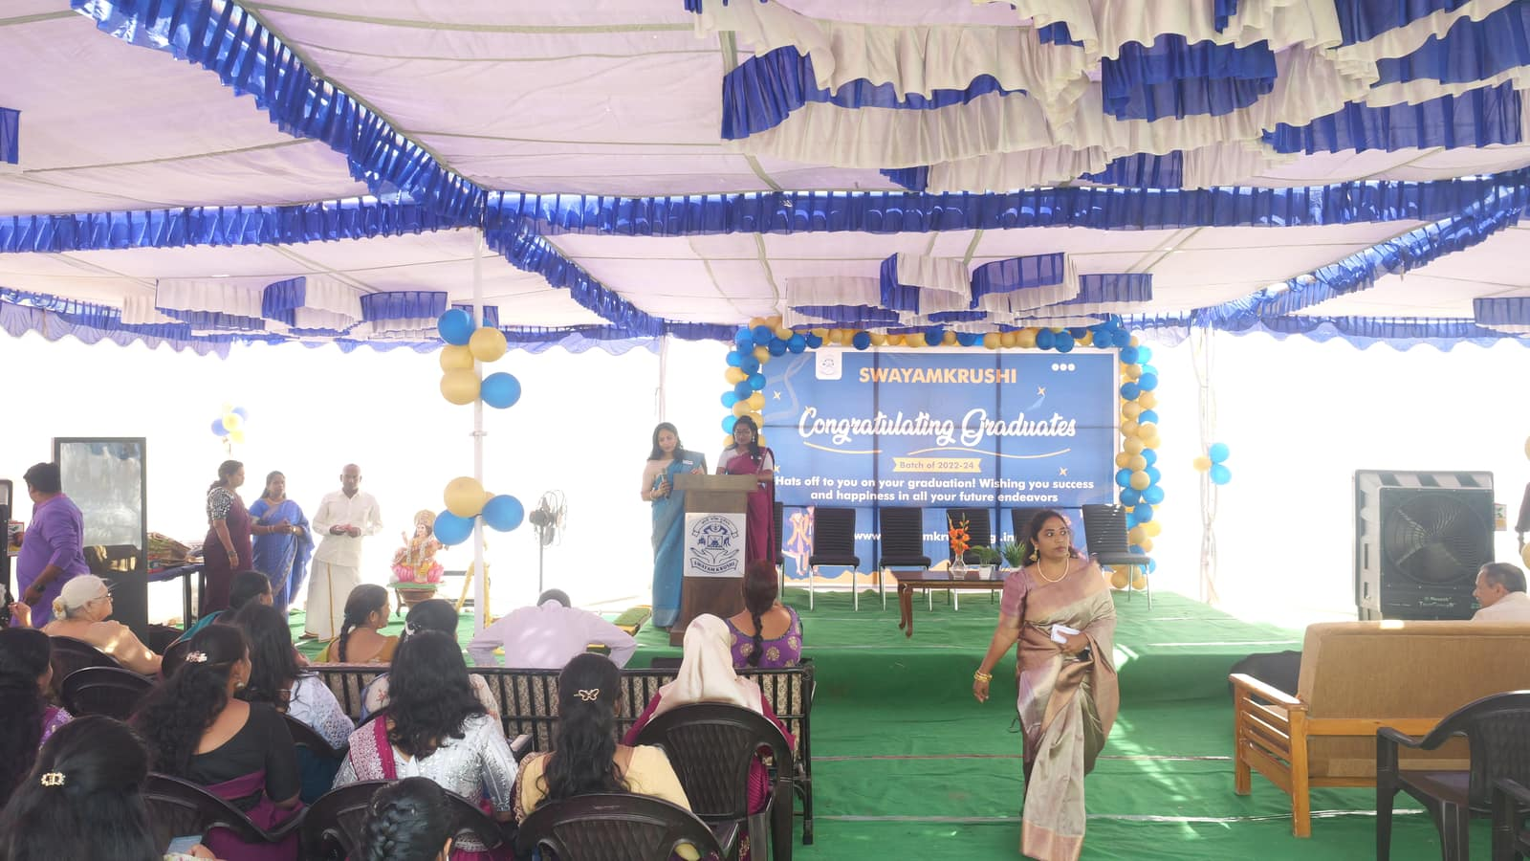
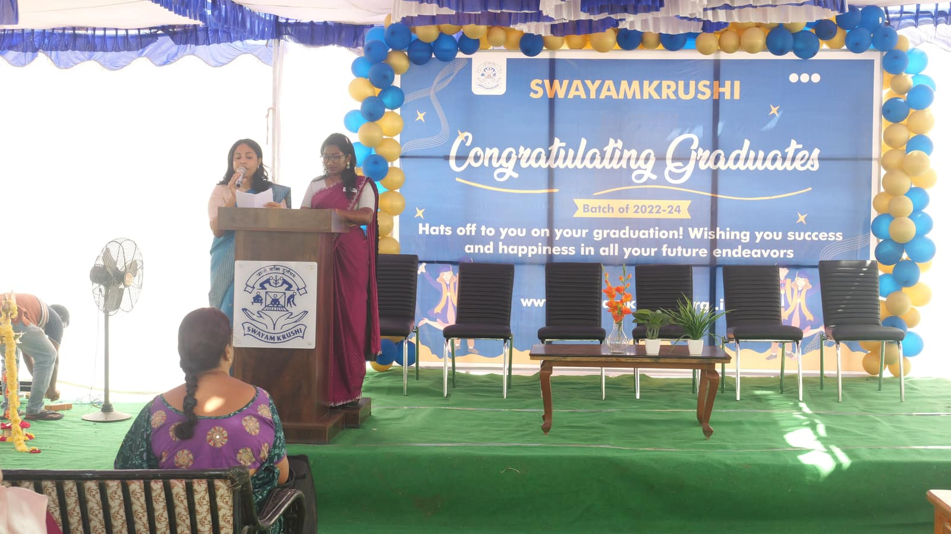

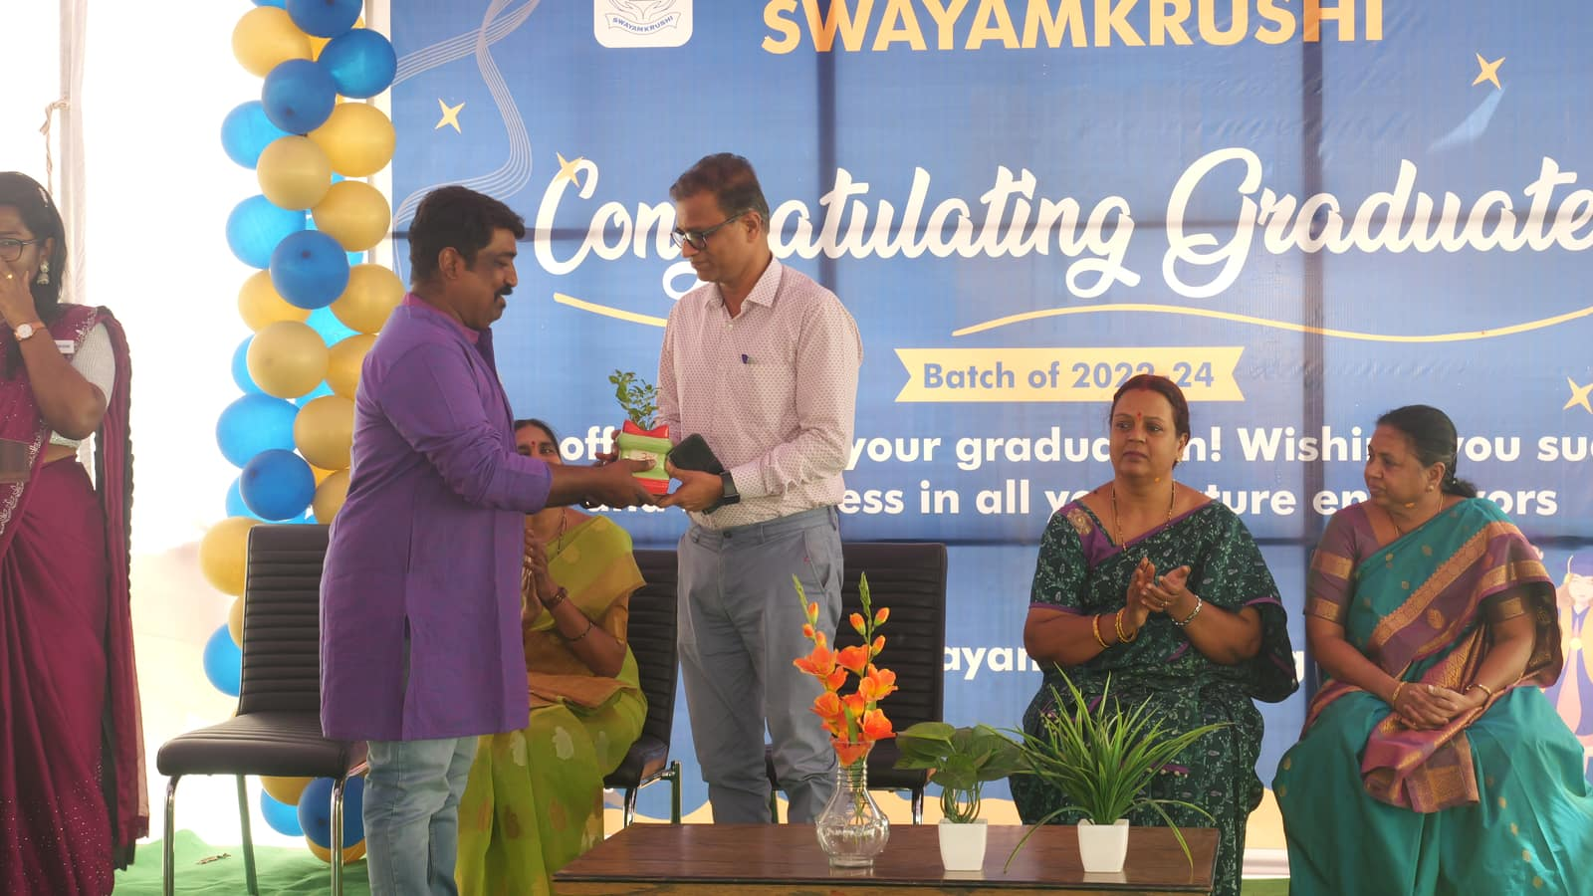
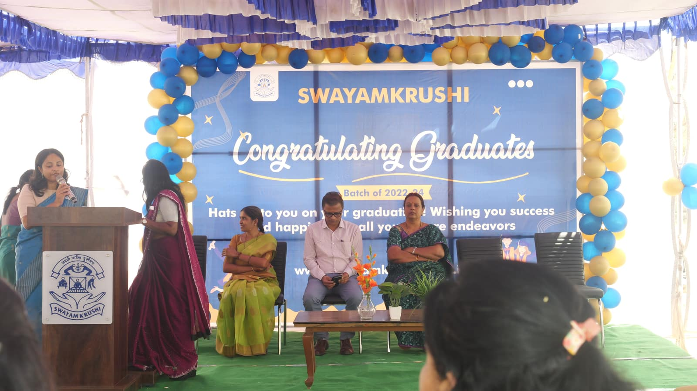

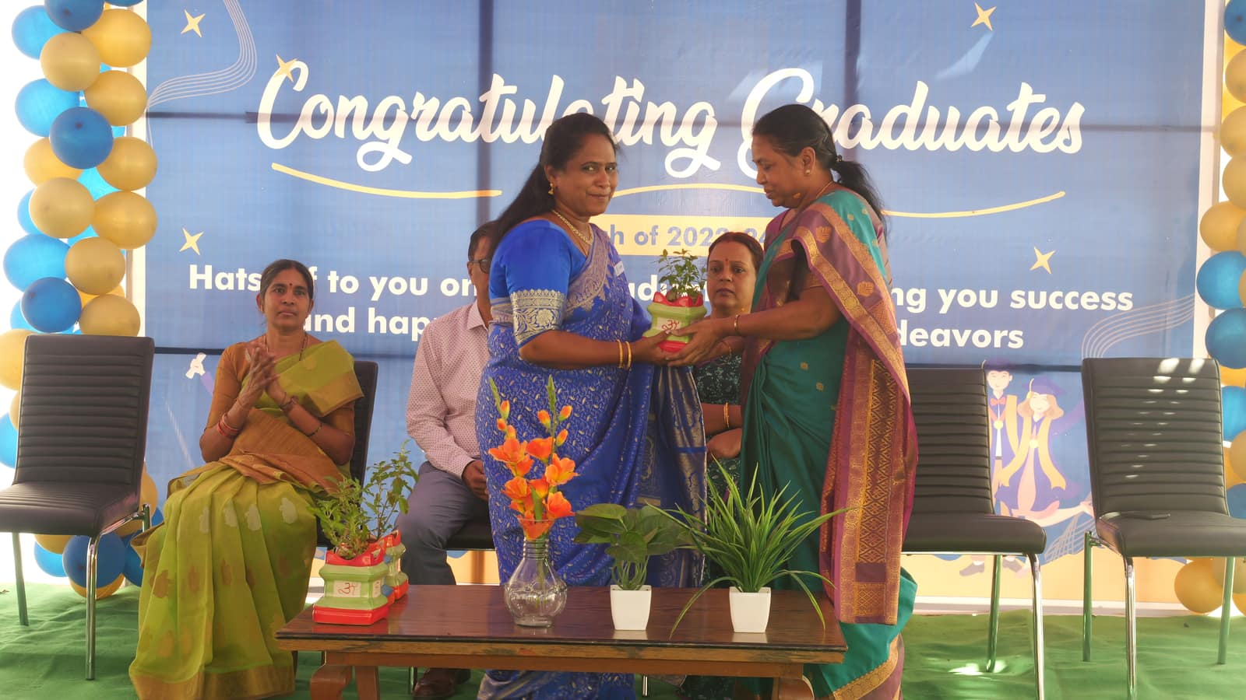
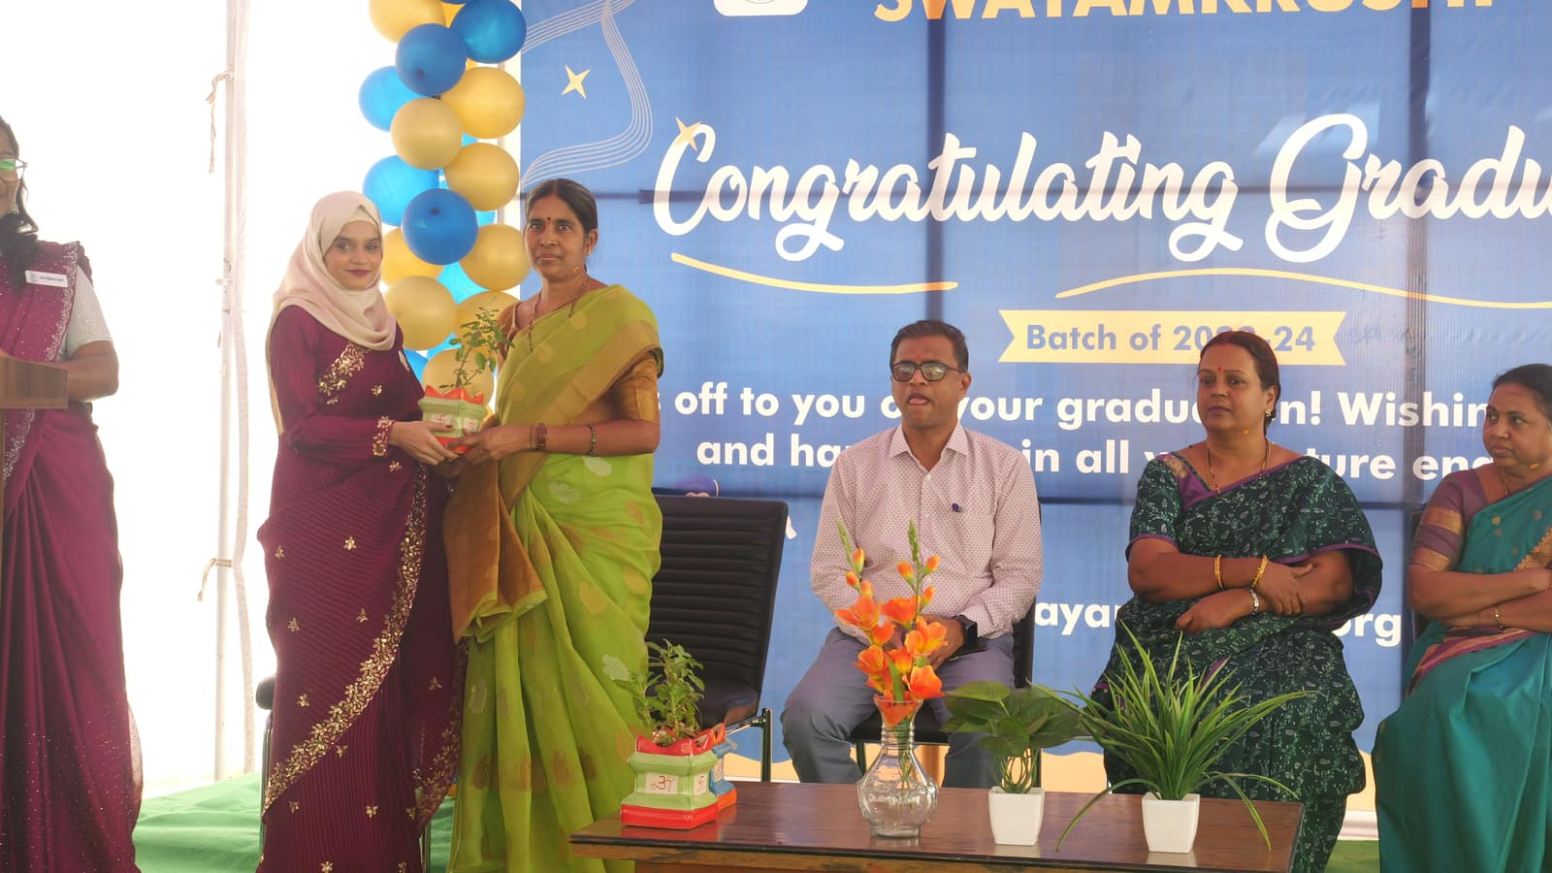
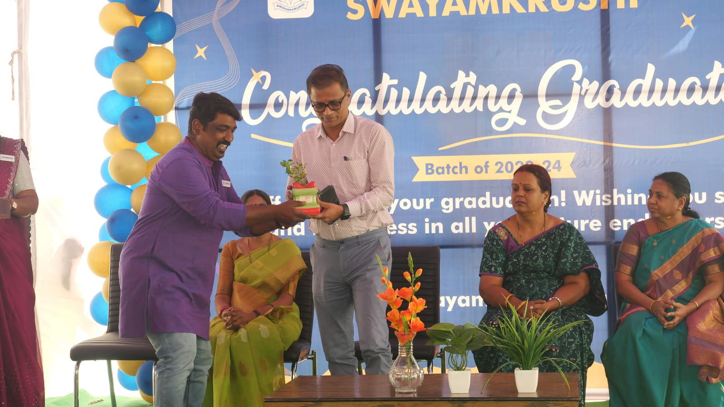
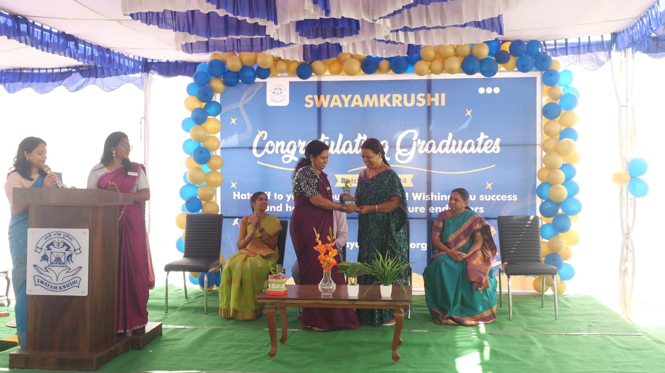

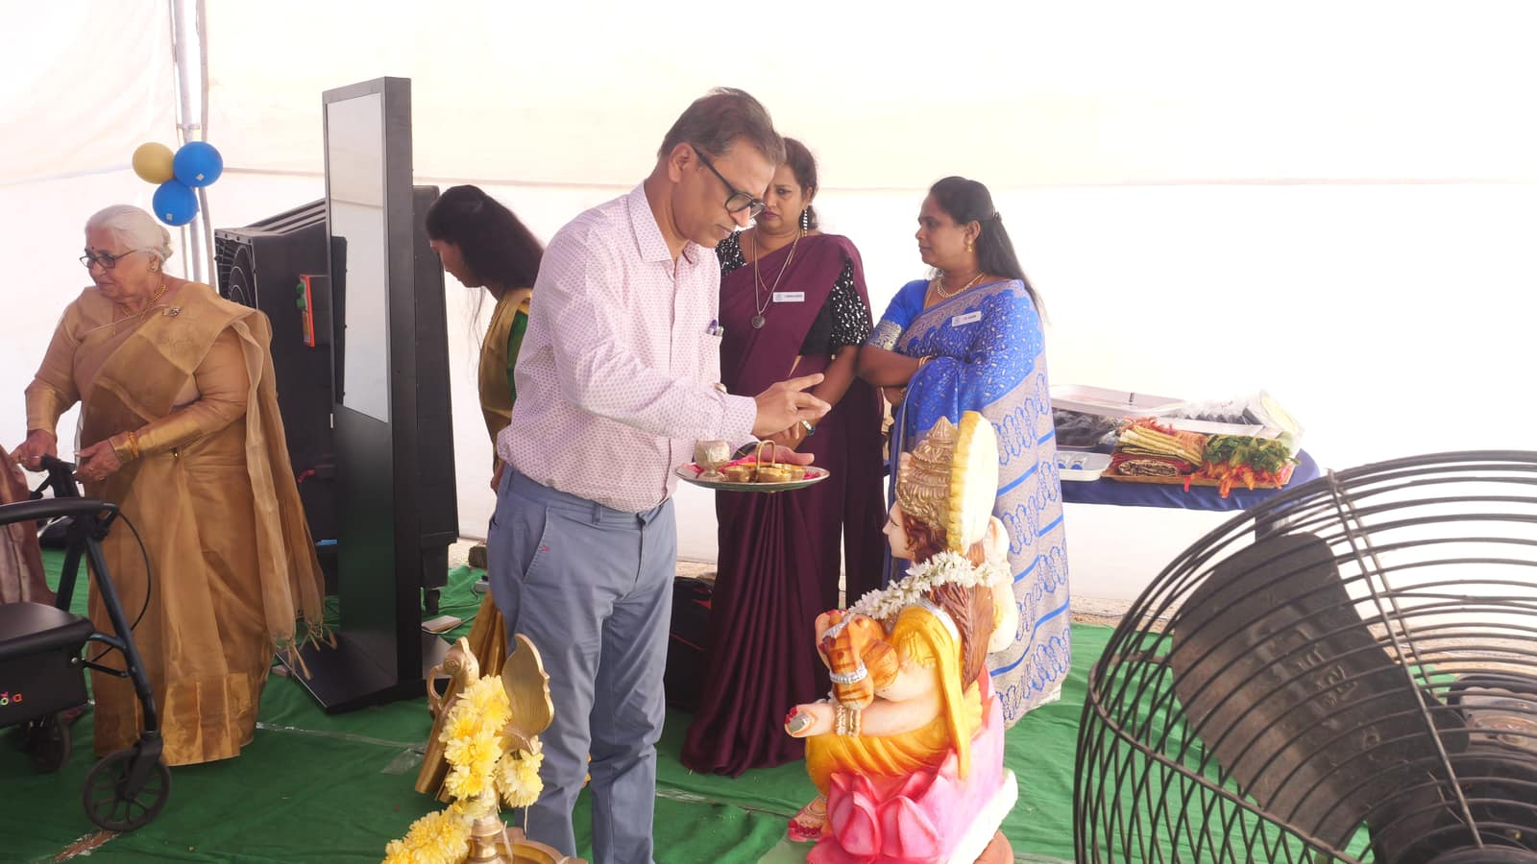
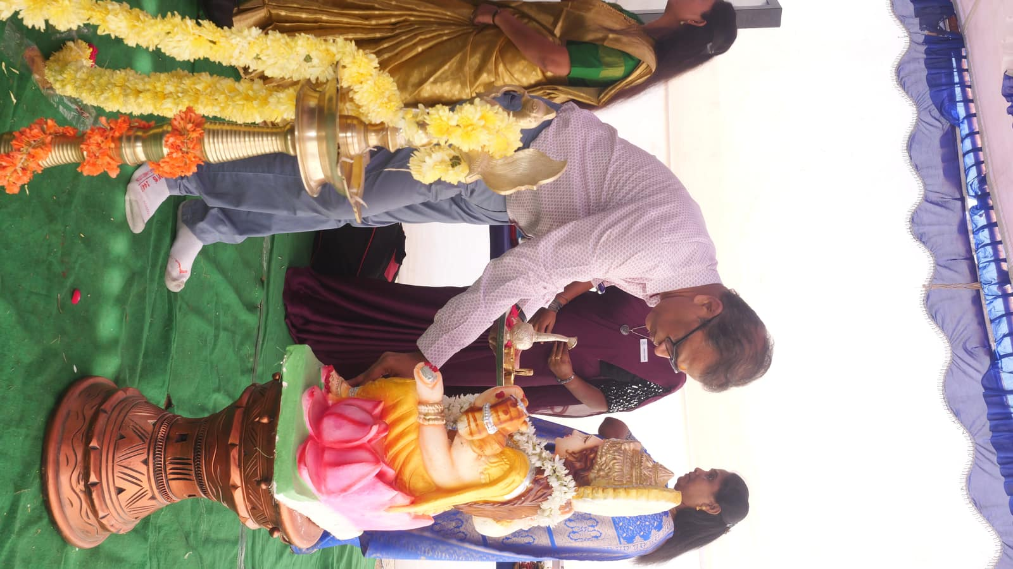

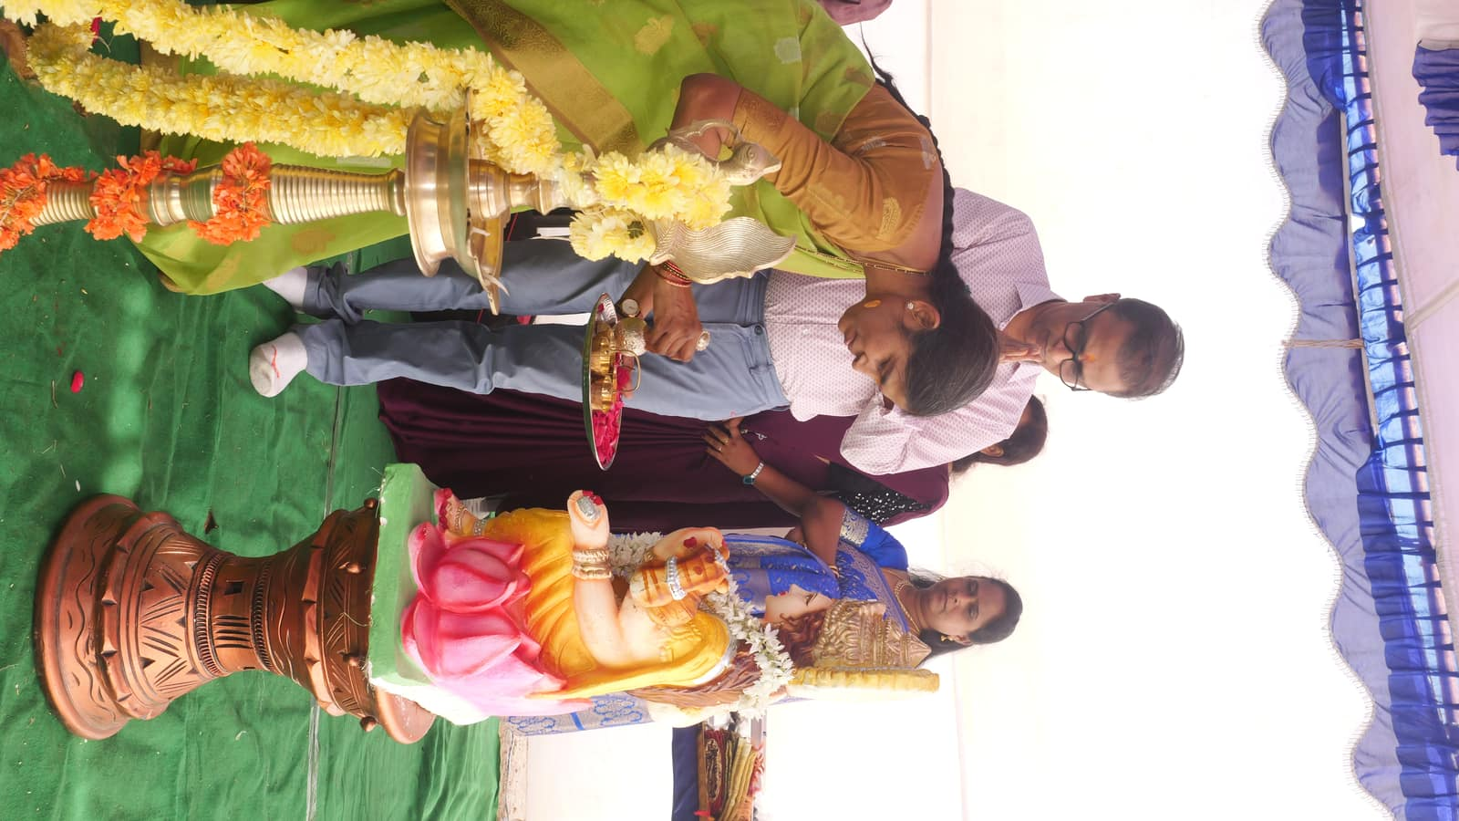
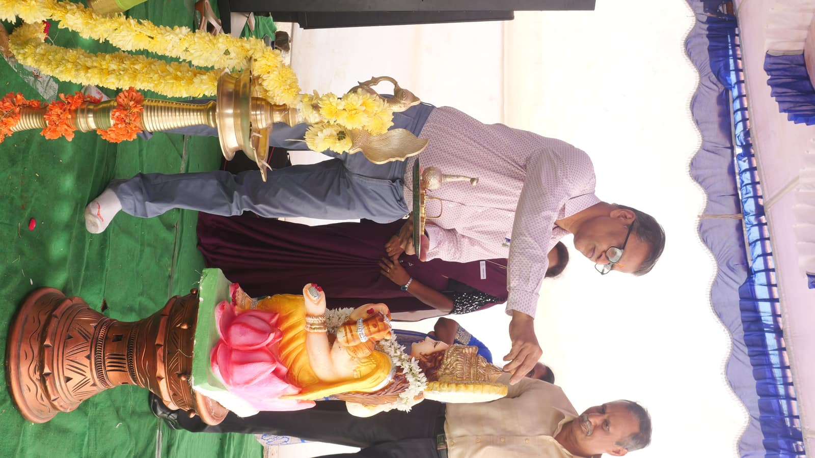

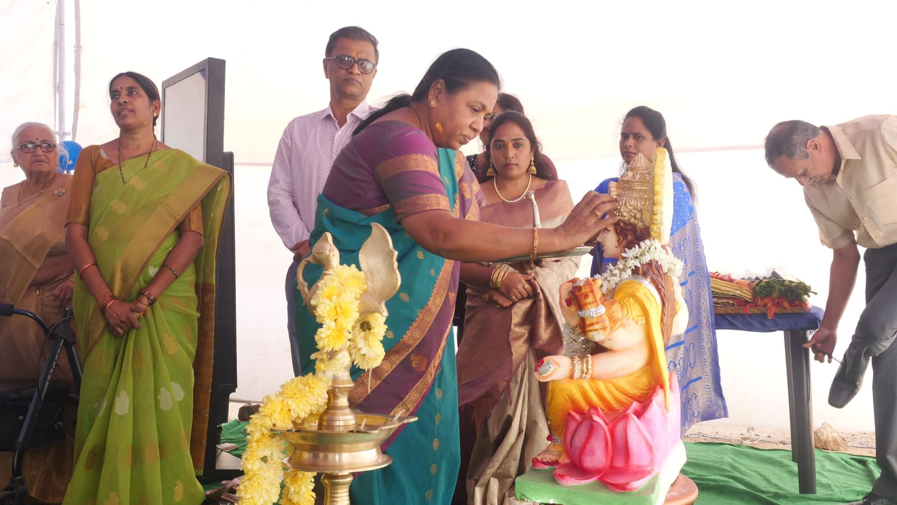
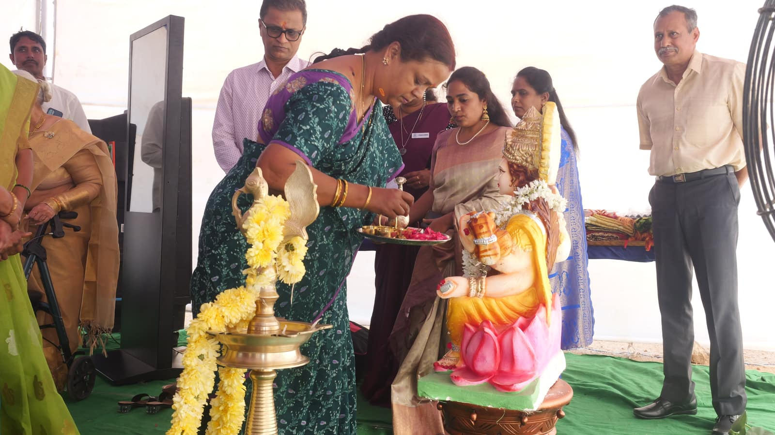

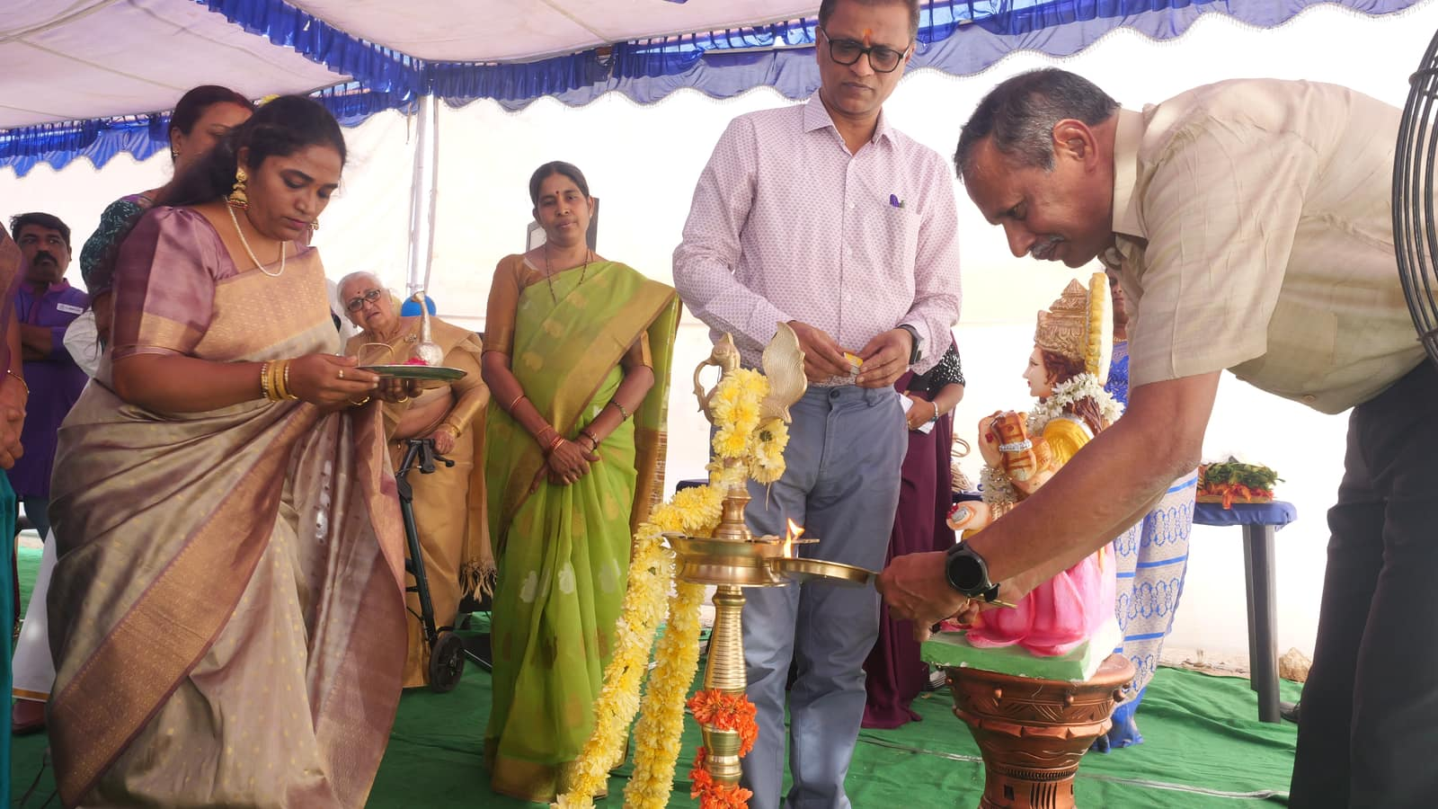
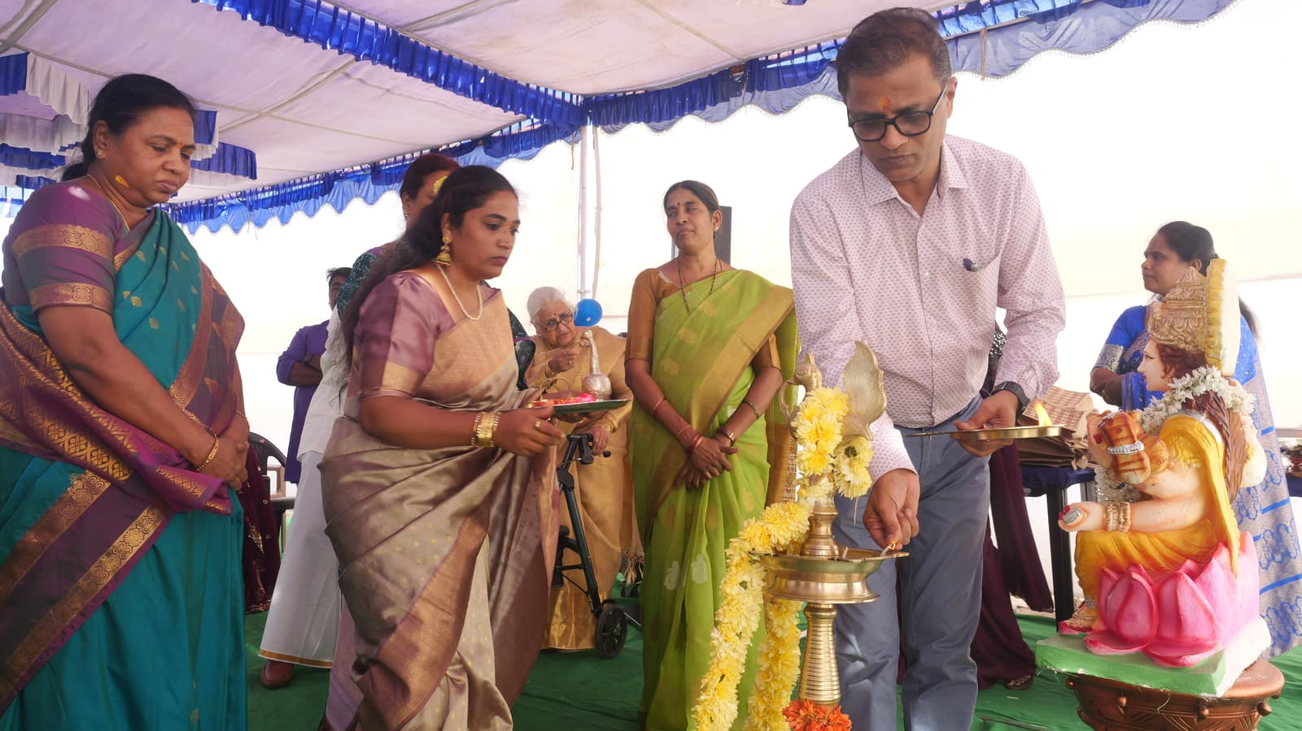

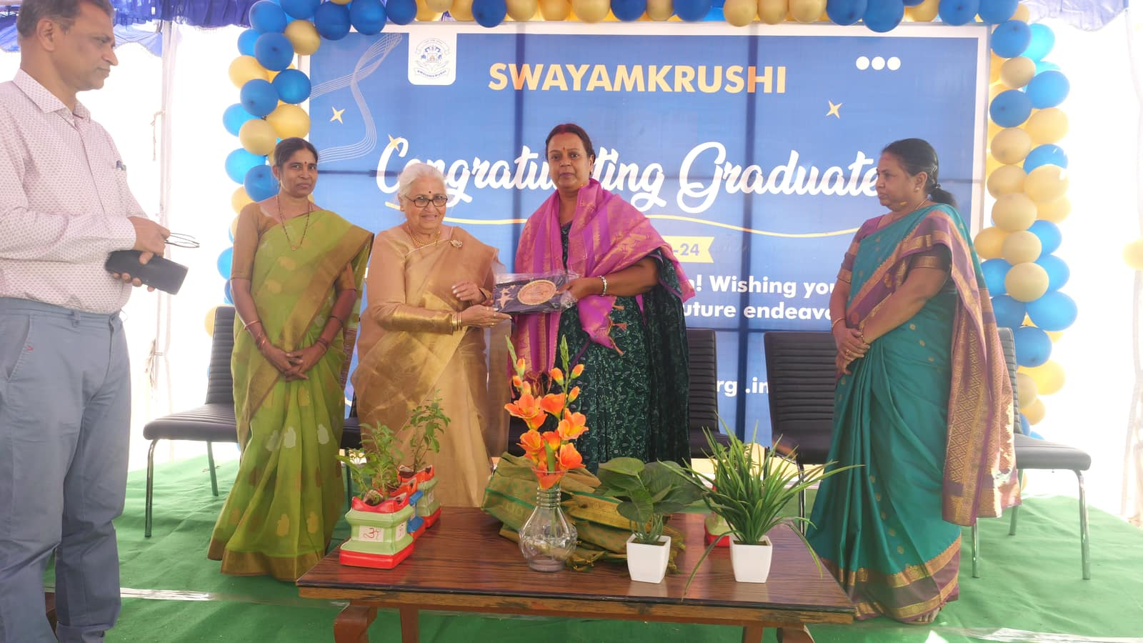
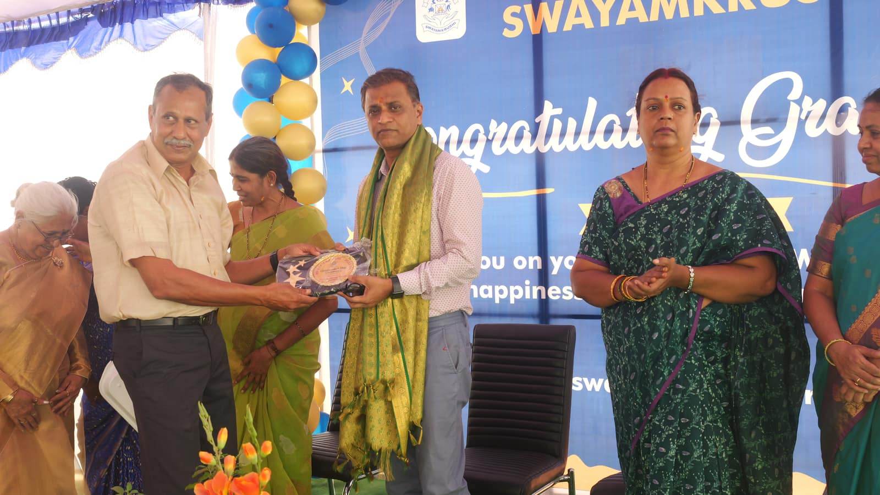

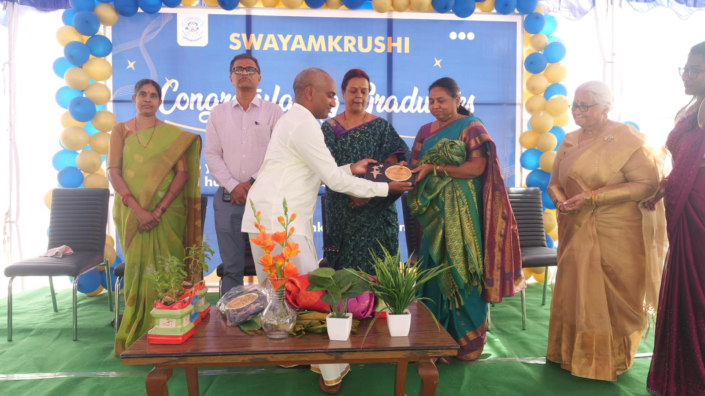
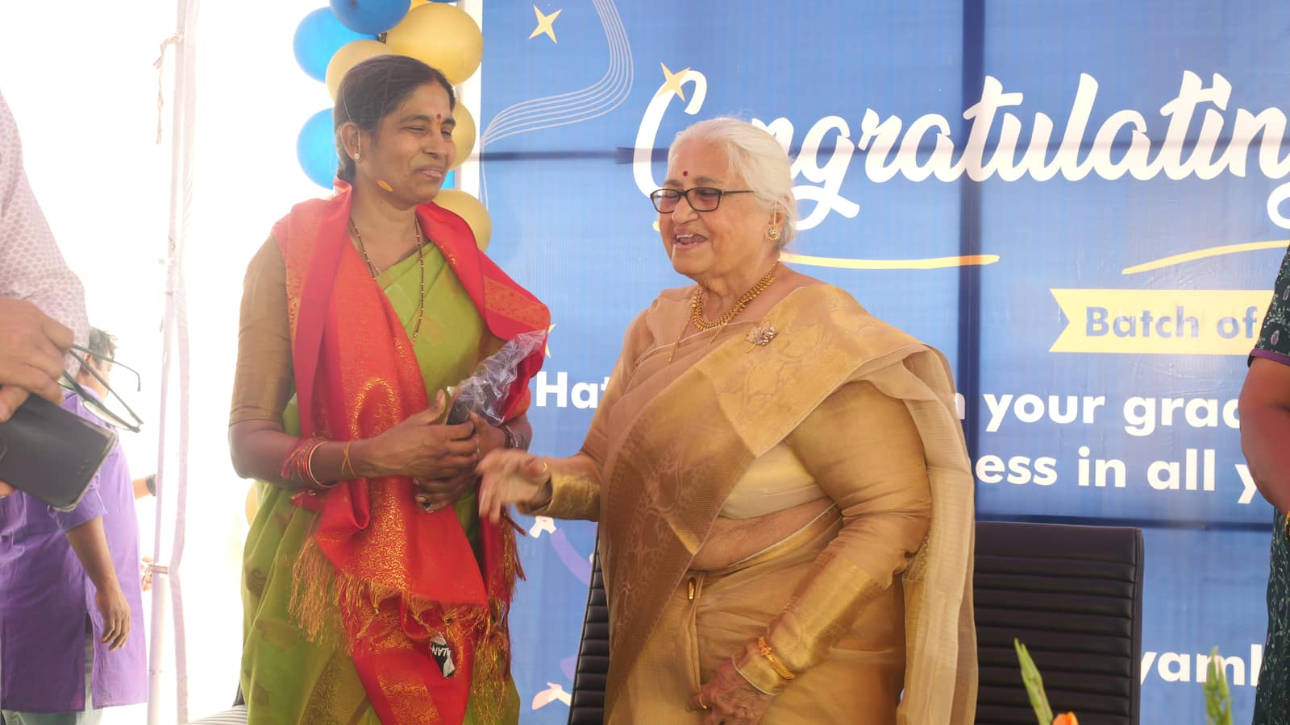
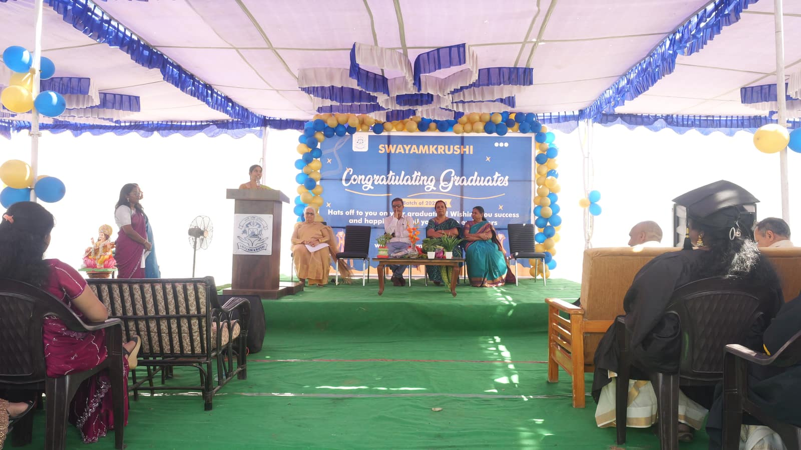

March 15-03-2025:-

Today, our B.Ed first-year and second-year students along with dedicated school teachers from Swayamkrushi Self reliance for the mentally challenged led by Dr.Manjulaa Kalyan founder and director, an inspiring Swachh Bharat program, rallying together in Balaji Nagar, Chennapur Village, Jawahar Nagar. With spirited slogans and enthusiastic participation, we celebrated the power of collective action in building a cleaner, healthier community.
Every small act counts—let's continues to push boundaries and make our surroundings shine. Together, we march toward a Swachh Bharat!

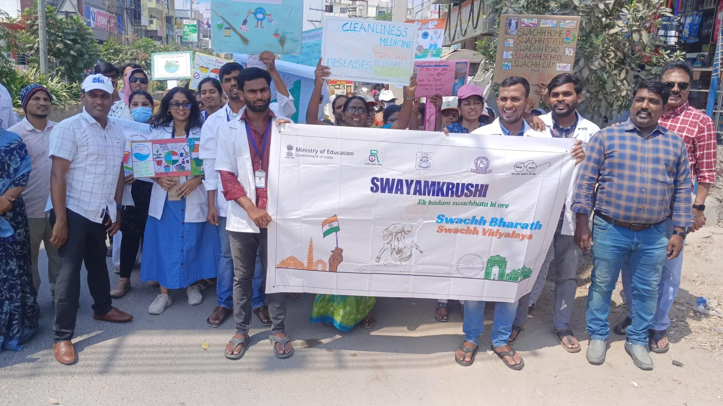
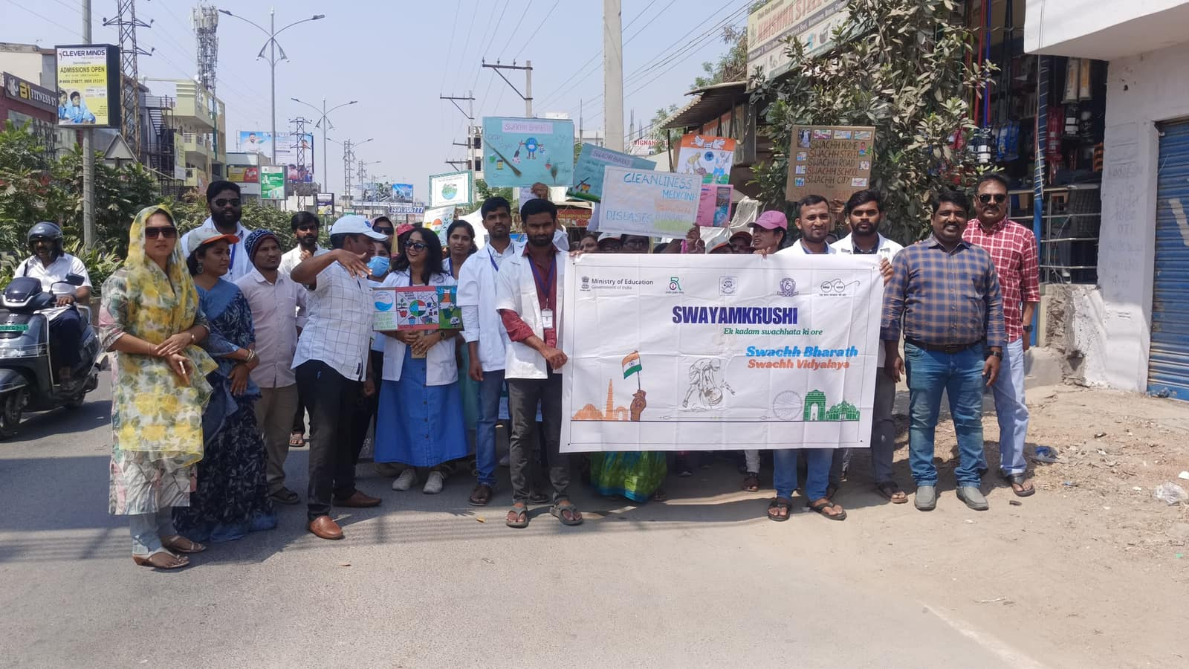

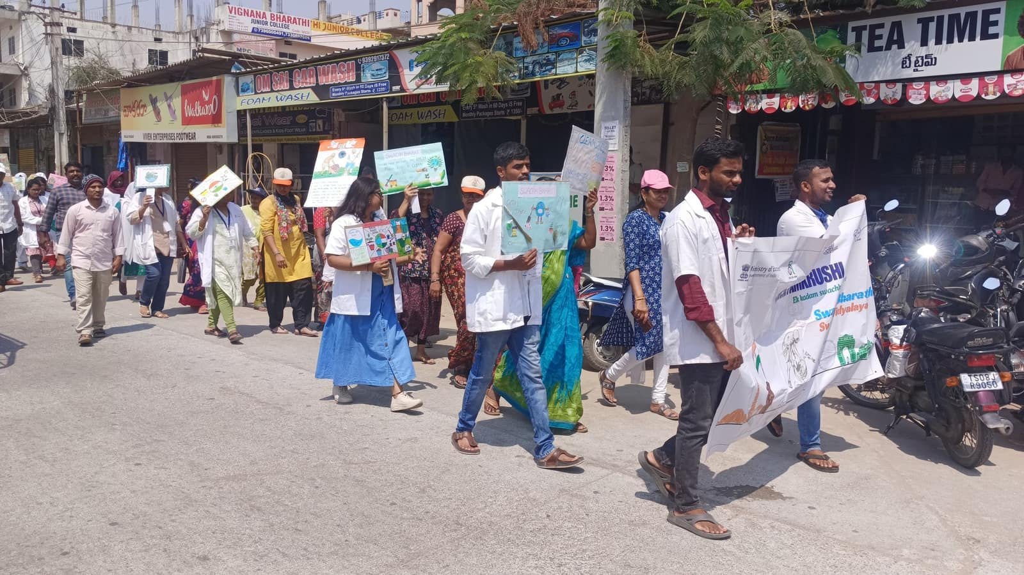
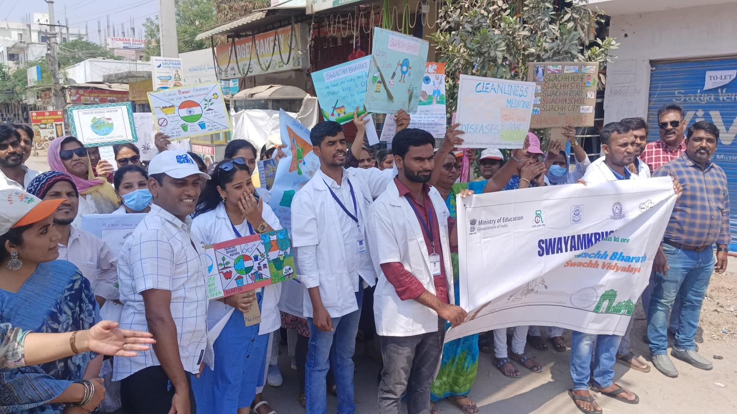

March 17-03-2025:-

On Feb 15th 2025, our B.Ed first-year and second-year students along with dedicated school teachers from Swayamkrushi Self reliance for the mentally challenged led by Dr.Manjulaa Kalyan founder and director, an inspiring Swachh Bharat program, rallying together in Balaji Nagar, chennapur village, jawahar nagar. With spirited slogans and enthusiastic participation, we celebrated the power of collective action in building a cleaner, healthier community.
Every small act counts—let's continue to push boundaries and make our surroundings shine. Together, we march toward a Swachh Bharat!
