ASSIGNMENT - 1

DDL COMMANDS (Create, Alter, Drop)
1) Create Command - CREATE command is used to define the structure of an object before storing data in it.
CREATE TABLE Library(
Book_ID INT,
Book_Title VARCHAR(50),
Author_Name VARCHAR(100),
Genre VARCHAR(100)
);

INSERT INTO Library VALUES
(101, 'The Alchemist', 'Paulo Coelho', 'Fiction'),
(102, 'Sapiens', 'Yuval Noah Harari', 'Non-Fiction'),
(103, 'Clean Code', 'Robert Martin', 'Technology'),
(104, 'Wings of Fire', 'A.P.J. Abdul Kalam', 'Biography'),
(105, 'The Hobbit', 'J.R.R. Tolkien', 'Fantasy'),
(106, 'Atomic Habits', 'James Clear', 'Self-Help');

SELECT * FROM Library;
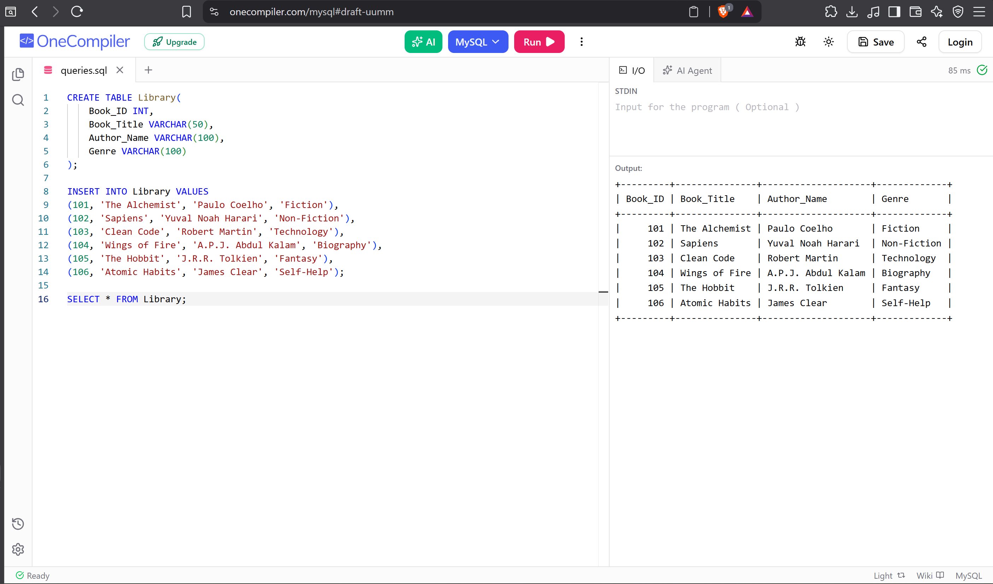
2) Alter Command - Used to modify the structure of an existing table without deleting it.
ALTER TABLE Library
ADD Price INT;

SELECT * FROM Library;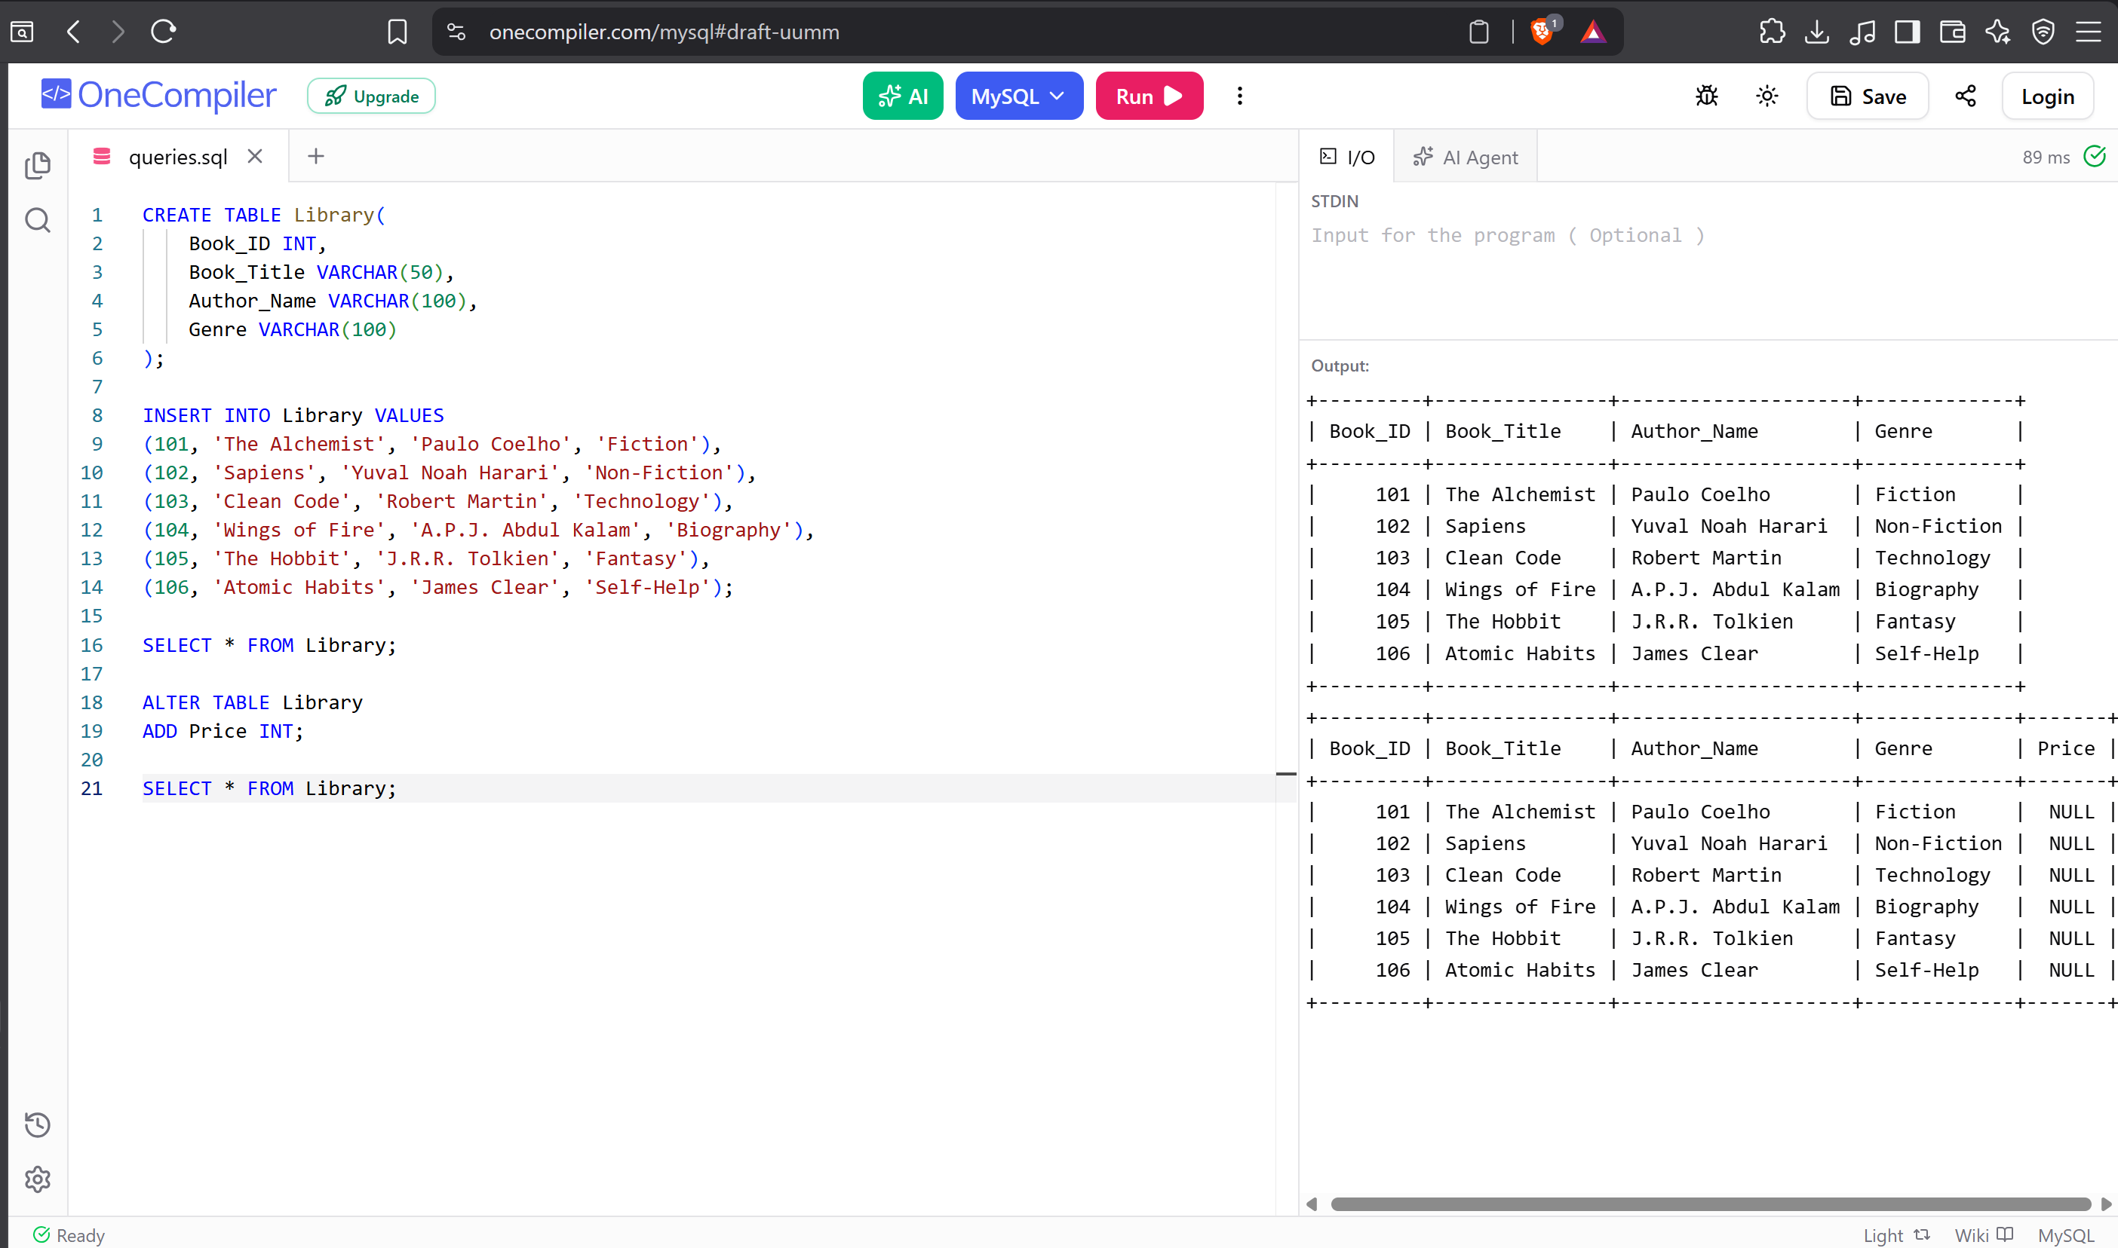

3) Drop Command - Command used to permanently delete a database object such as a table, database, or column.
ALTER TABLE Library
DROP COLUMN Price;

SELECT * FROM Library;
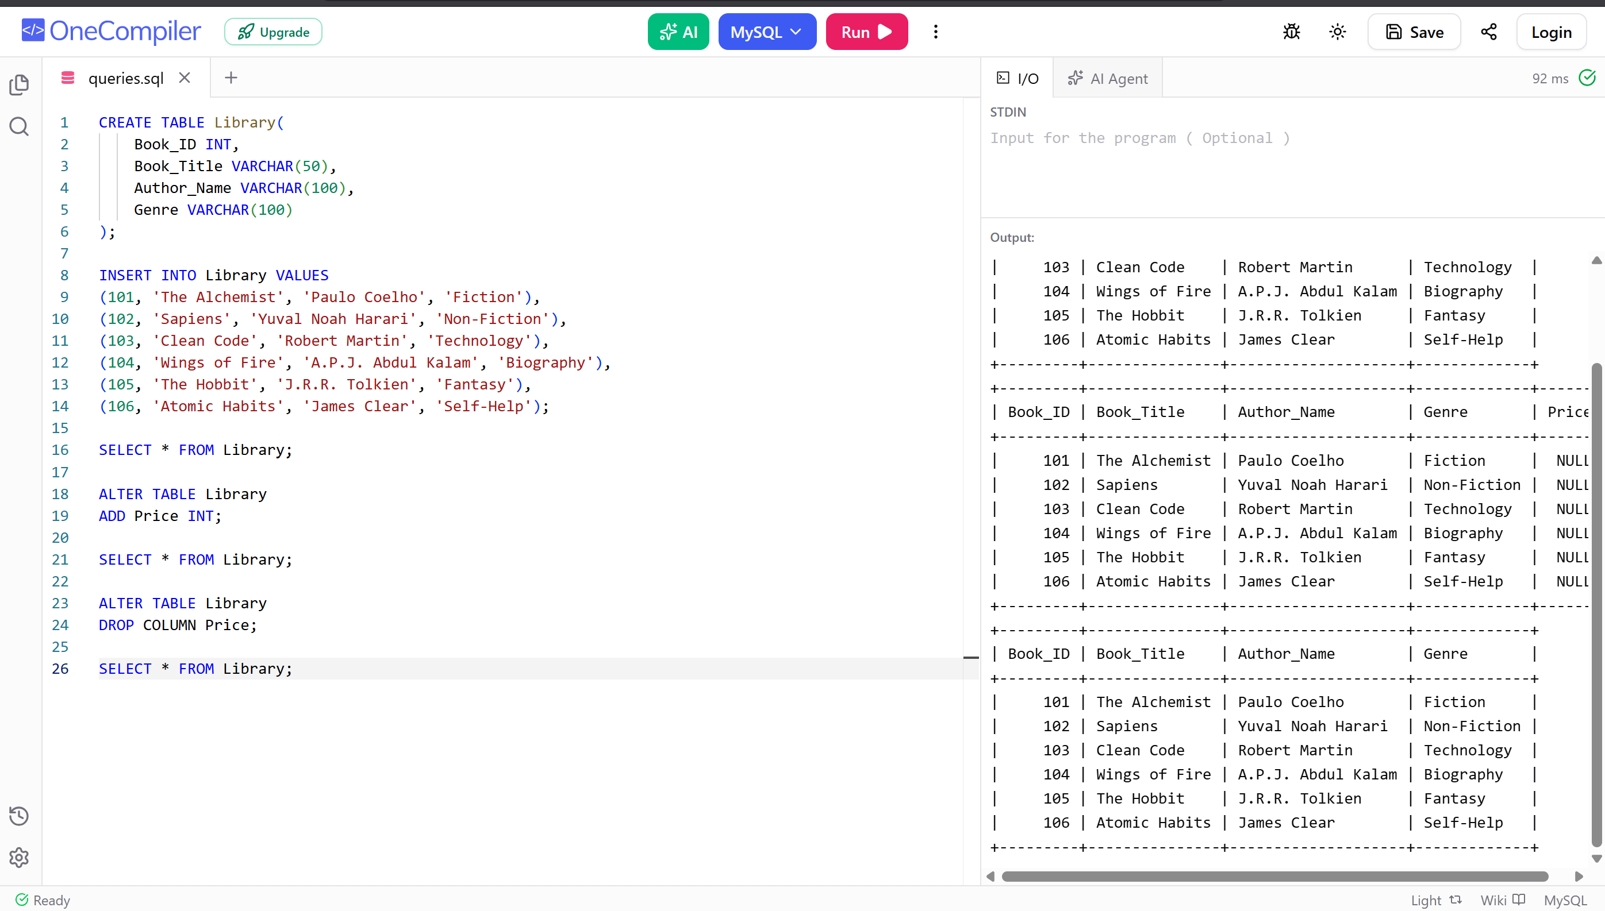
https://github.com/swayammannan/DBMS-LAB.git

