**NAME - SWAYAM RAUT  
DIV - D15B  
ROLL NO - 51  
ADV.DEVOPS EXP 2**

ELASTIC BEANSTALK ENVIRONMENT:-

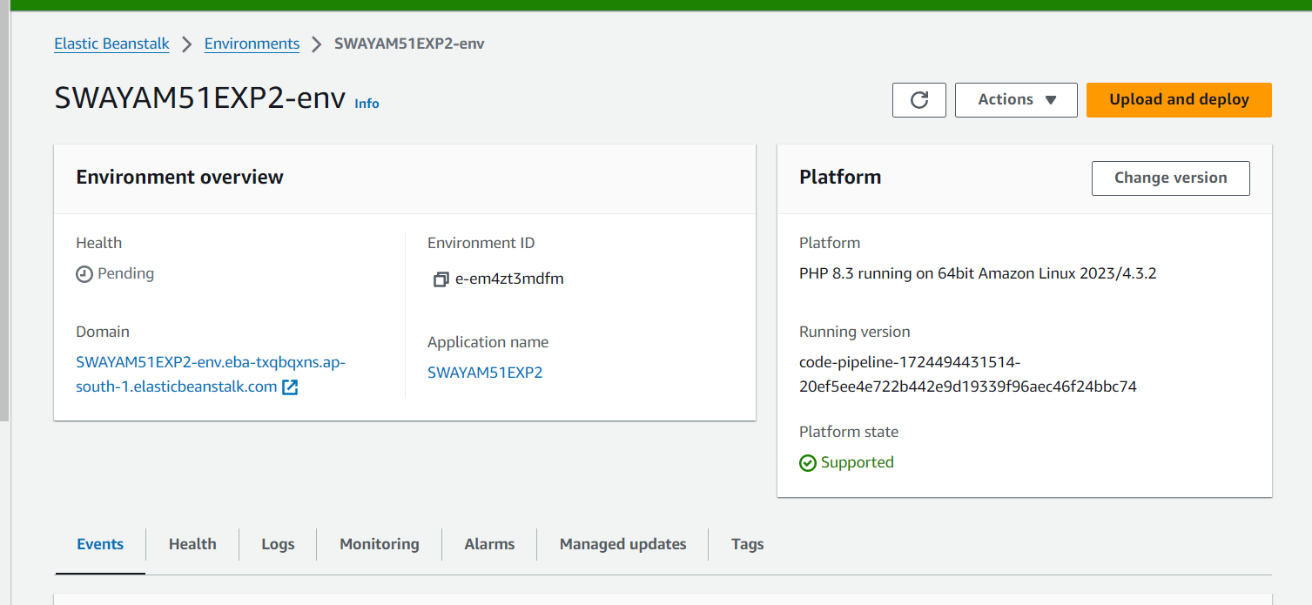

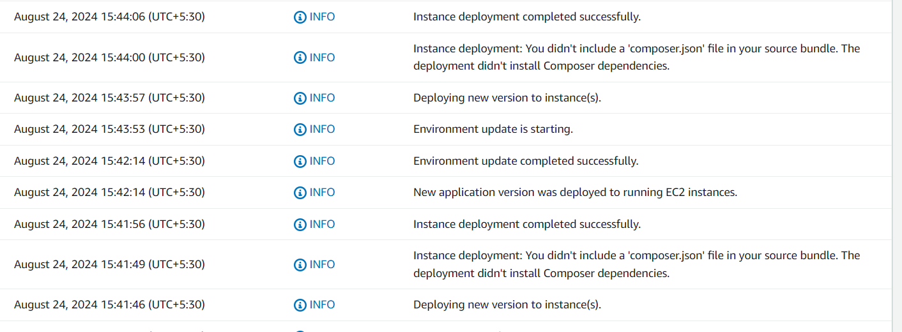

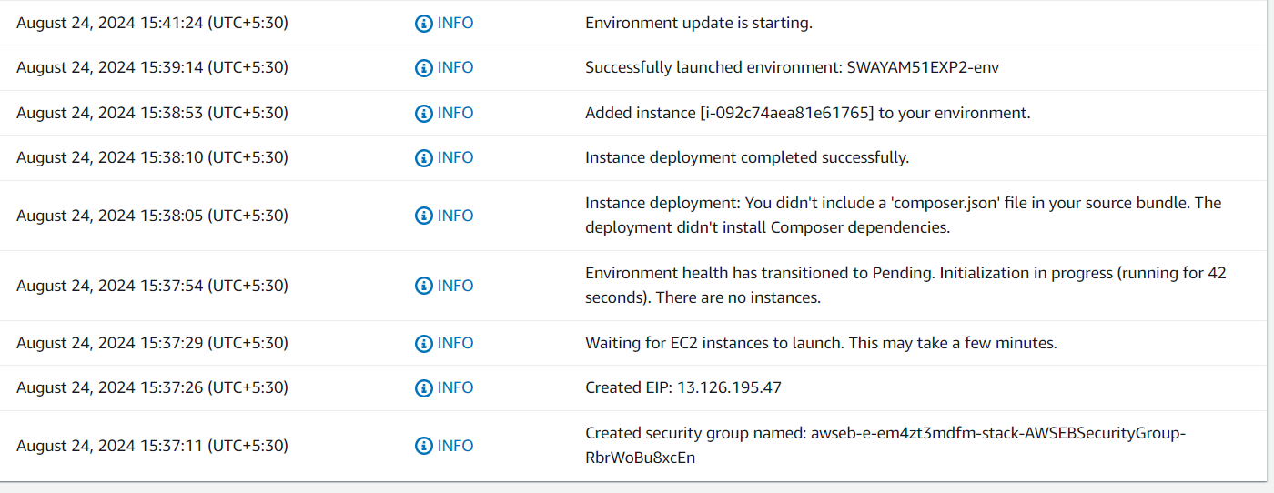

CODE PIPELINE

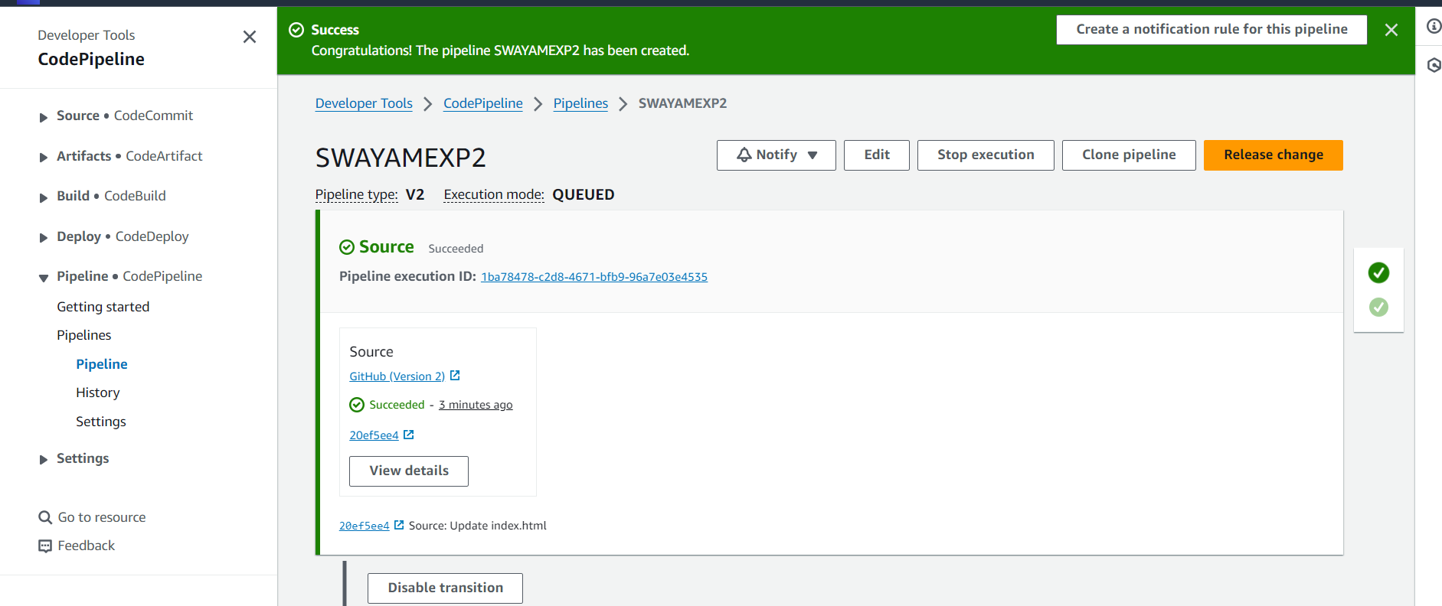

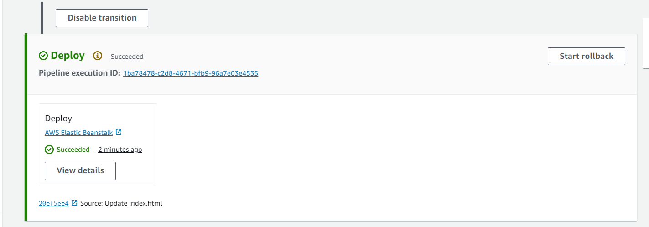

BEFORE UPDATING:-

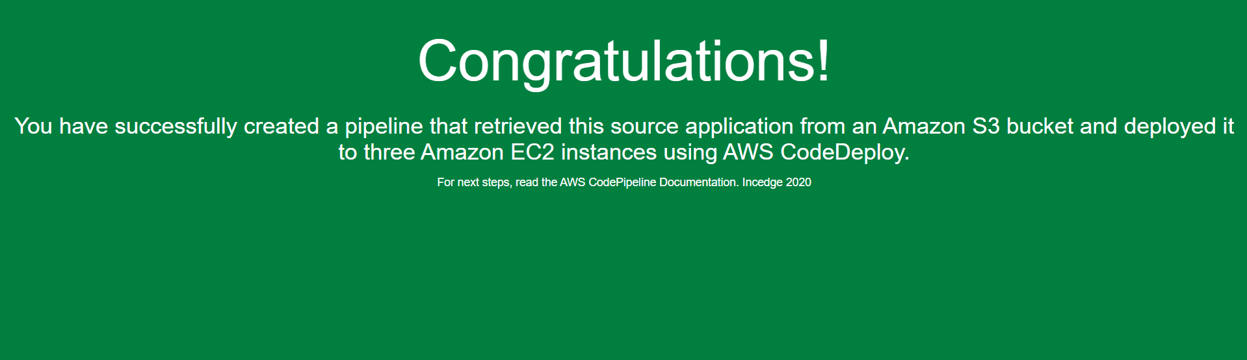

AFTER UPDATING:-

