**Steps:**

1. Create 3 EC2 Ubuntu Instances on AWS.

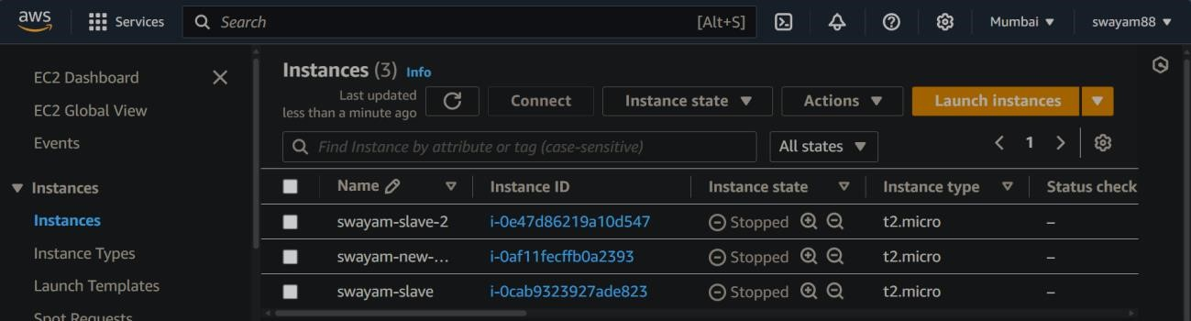

Installing Docker

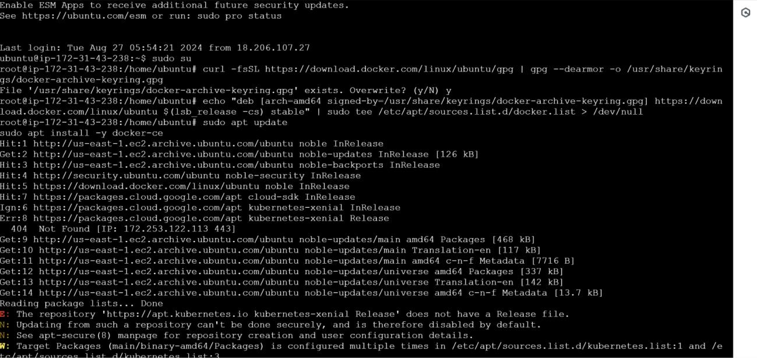

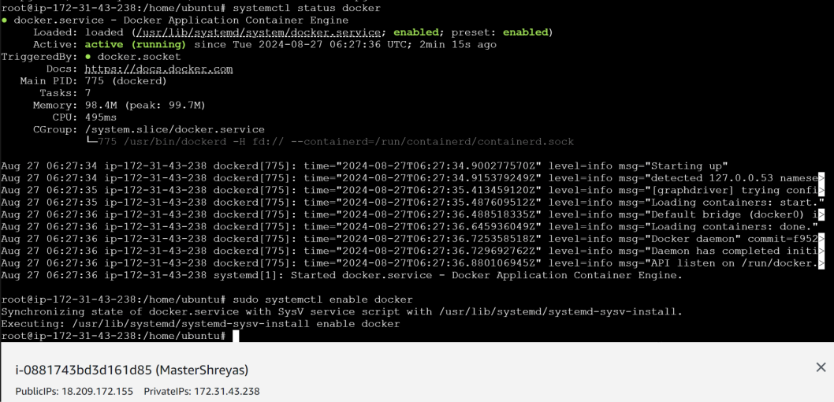

Install Kubernetes on all 3 machines

* curl -fsSL https://download.kubernetes.com/linux/ubuntu/gpg | gpg --dearmor -o

/usr/share/keyrings/kubernetes-archive-keyring.gpg

* echo "deb [arch=amd64 signed-by=/usr/share/keyrings/kubernetes-archive-keyring.gpg] https://download.kubernetes.com/linux/ubuntu $(lsb_release -cs) stable" | sudo tee

/etc/apt/sources.list.d/kubernetes.list



* sudo apt update
* sudo apt install -y kubectl kubelet kubeadm

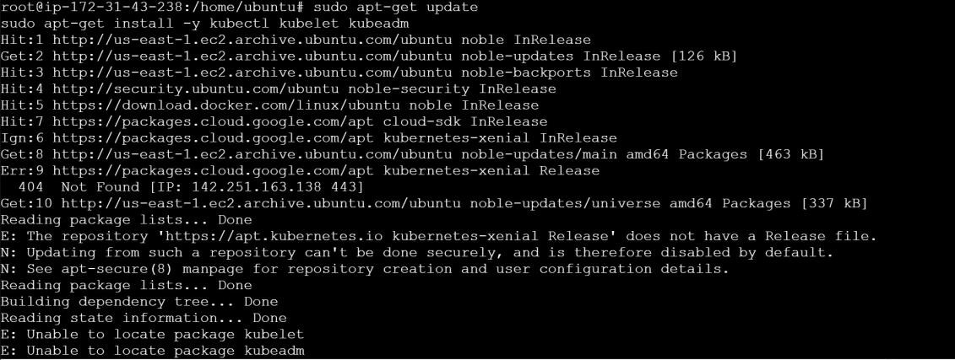

* Snap install kubectl –classic



* Snap install kubelet –classic



* Snap install kubeadm –classic



* sudo swapoff -a
* echo "net.bridge.bridge-nf-call-iptables=1" | sudo tee -a /etc/sysctl.conf
* sudo sysctl -p

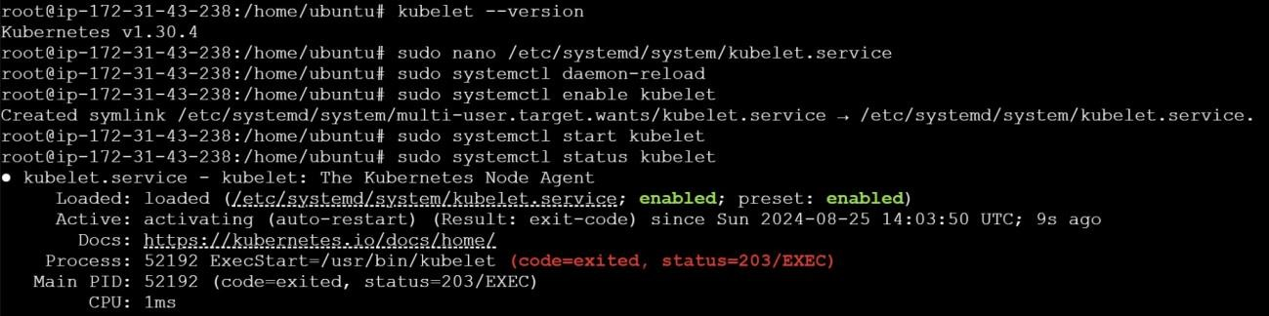

* sudo nano /etc/systemd/system/kubelet. service

Manually add content to file

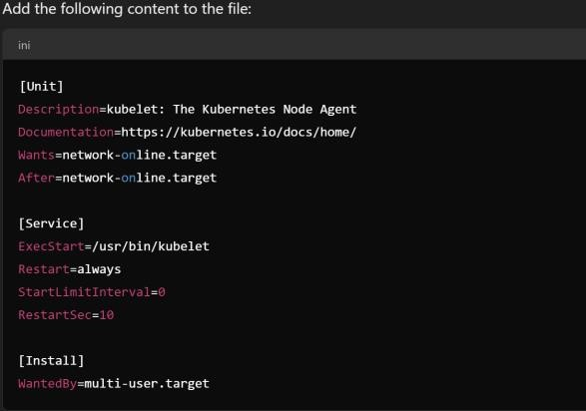

* sudo systemctl daemon-reload
* sudo systemctl enable kubelet
* sudo systemctl start kubelet
* sudo kubeadm init --pod-network-cidr=10.244.0.0/16

**--ignore-preflight-errors=all**

