Aim: To design a flutter app by including basic widgets.

**main.dart (File that contains the UI Layout)**

import 'package:flutter/material.dart';

void main() {

runApp(MyApp());

}

class MyApp extends StatelessWidget {

@override

Widget build(BuildContext context) {

return MaterialApp(

home: FormScreen(),

);

}

}

class FormScreen extends StatefulWidget {

@override

_FormScreenState createState() => _FormScreenState();

}

class _FormScreenState extends State<FormScreen> {

// State variables

String _nameText = '';

String _passwordText = '';

bool _notificationsEnabled = false;

double _volumeValue = 0.0;

String _selectedCountry = 'Select a country';

bool _agreedToTerms = false;

// List of countries for dropdown

final List<String> _countries = ['USA', 'India', 'Germany', 'Japan'];

@override

Widget build(BuildContext context) {

return Scaffold(

body: SingleChildScrollView(

child: Padding(

padding: const EdgeInsets.all(16.0),

child: Column(

crossAxisAlignment: CrossAxisAlignment.center,

children: [

// Image

Image.asset(

'assets/sample.png',

width: 280,

height: 280,

fit: BoxFit.contain,

),

SizedBox(height: 16),

// Name TextField

TextField(

decoration: InputDecoration(

labelText: 'Enter your name',

border: OutlineInputBorder(),

),

onChanged: (value) {

setState(() {

_nameText = value;

});

},

),

SizedBox(height: 16),

// Password TextField

TextField(

obscureText: true,

decoration: InputDecoration(

labelText: 'Enter your password',

border: OutlineInputBorder(),

),

onChanged: (value) {

setState(() {

_passwordText = value;

});

},

),

SizedBox(height: 16),

// Notifications Switch

Row(

mainAxisAlignment: MainAxisAlignment.center,

children: [

Text('Enable Notifications'),

Switch(

value: _notificationsEnabled,

onChanged: (bool value) {

setState(() {

_notificationsEnabled = value;

});

},

),

],

),

SizedBox(height: 16),

// Volume Slider

Column(

children: [

Text('Volume: ${_volumeValue.toInt()}'),

Slider(

value: _volumeValue,

min: 0,

max: 100,

onChanged: (double value) {

setState(() {

_volumeValue = value;

});

},

),

],

),

SizedBox(height: 16),

// Country Dropdown

Column(

children: [

Text(

_selectedCountry,

style: TextStyle(fontSize: 16, color: Colors.black),

),

ElevatedButton(

onPressed: () {

_showCountryDialog();

},

child: Text('Choose Country'),

),

],

),

SizedBox(height: 16),

// Terms Checkbox

Row(

mainAxisAlignment: MainAxisAlignment.center,

children: [

Checkbox(

value: _agreedToTerms,

onChanged: (bool? value) {

setState(() {

_agreedToTerms = value ?? false;

});

},

),

Text('Agree to Terms & Conditions'),

],

),

SizedBox(height: 16),

// Submit Button

ElevatedButton(

onPressed: () {

// TODO: Implement submit logic

},

child: Text('Submit'),

),

],

),

),

),

);

}

// Custom method to show country selection dialog

void _showCountryDialog() {

showDialog(

context: context,

builder: (BuildContext context) {

return AlertDialog(

title: Text('Select a Country'),

content: Column(

mainAxisSize: MainAxisSize.min,

children: _countries.map((country) {

return ListTile(

title: Text(country),

onTap: () {

setState(() {

_selectedCountry = country;

});

Navigator.of(context).pop();

},

);

}).toList(),

),

);

},

);

}

}

**Output**

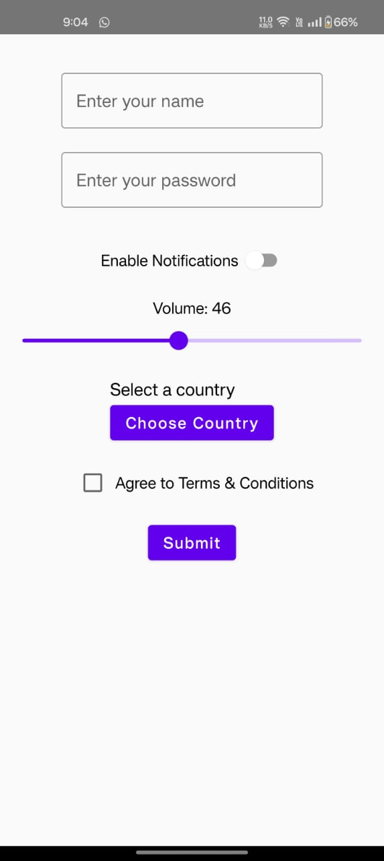

The following custom components have been used:

1. Dropdown
2. Checkbox
3. Notification slider

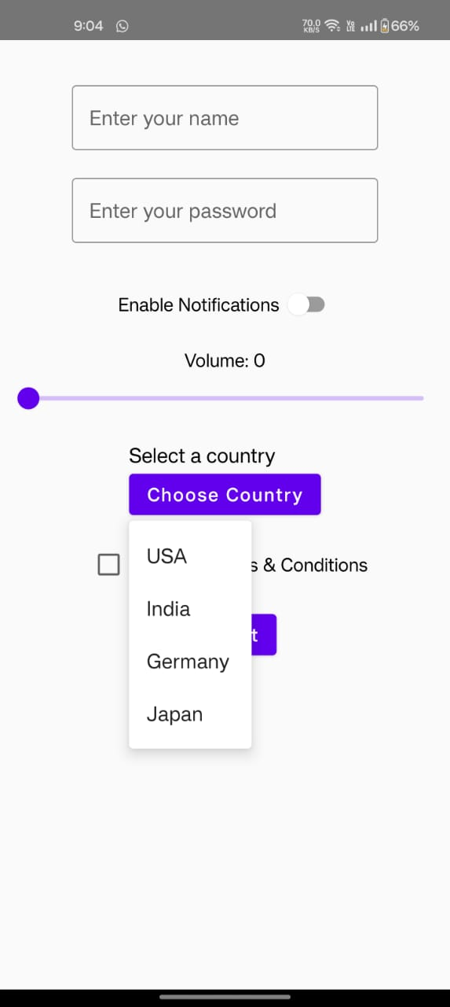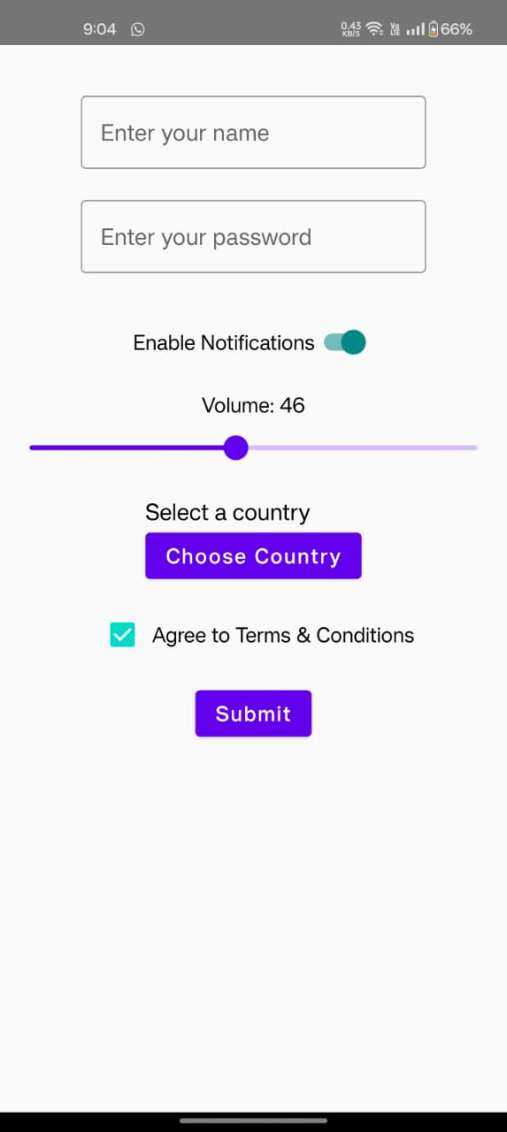



**Conclusion: In this lab experiment, we acquainted ourselves with the fundamental concepts of Dart programming language and learnt to import and position custom UI components using it.**