Aim: To include icons, images, fonts in Flutter app

**main.dart**

import 'package:flutter/material.dart';

import 'package:google_fonts/google_fonts.dart';

void main() {

runApp(MyApp());

}

class MyApp extends StatelessWidget {

@override

Widget build(BuildContext context) {

return MaterialApp(

home: FormScreen(),

);

}

}

class FormScreen extends StatefulWidget {

@override

_FormScreenState createState() => _FormScreenState();

}

class _FormScreenState extends State<FormScreen> {

String _nameText = '';

String _passwordText = '';

bool _notificationsEnabled = false;

double _ageValue = 18.0;

String _selectedCountry = 'Select a country';

bool _agreedToTerms = false;

final List<String> _countries = ['USA', 'India', 'Germany', 'Japan'];

@override

Widget build(BuildContext context) {

return Scaffold(

body: SingleChildScrollView(

child: Padding(

padding: const EdgeInsets.all(16.0),

child: Column(

crossAxisAlignment: CrossAxisAlignment.center,

children: [

// Image

Image.asset(

'assets/sample.png',

width: 280,

height: 280,

fit: BoxFit.contain,

),

SizedBox(height: 16),

// Name TextField with Icon

TextField(

decoration: InputDecoration(

labelText: 'Enter your name',

labelStyle: GoogleFonts.hack(),

prefixIcon: Icon(Icons.person),

border: OutlineInputBorder(),

),

onChanged: (value) {

setState(() {

_nameText = value;

});

},

),

SizedBox(height: 16),

// Password TextField with Icon

TextField(

obscureText: true,

decoration: InputDecoration(

labelText: 'Enter your password',

labelStyle: GoogleFonts.hack(),

prefixIcon: Icon(Icons.lock),

border: OutlineInputBorder(),

),

onChanged: (value) {

setState(() {

_passwordText = value;

});

},

),

SizedBox(height: 16),

// Notifications Switch with Icon

Row(

mainAxisAlignment: MainAxisAlignment.center,

children: [

Icon(Icons.notifications),

Text('Enable Notifications', style: GoogleFonts.hack()),

Switch(

value: _notificationsEnabled,

onChanged: (bool value) {

setState(() {

_notificationsEnabled = value;

});

},

),

],

),

SizedBox(height: 16),

// Age Slider

Column(

children: [

Text(

'Select your age: ${_ageValue.toInt()}',

style: GoogleFonts.hack(),

),

Slider(

value: _ageValue,

min: 18,

max: 100,

onChanged: (double value) {

setState(() {

_ageValue = value;

});

},

),

],

),

SizedBox(height: 16),

// Country Dropdown

Column(

children: [

Text(

_selectedCountry,

style: GoogleFonts.hack(fontSize: 16, color: Colors.black),

),

ElevatedButton(

onPressed: () {

_showCountryDialog();

},

child: Text('Choose Country', style: GoogleFonts.hack()),

),

],

),

SizedBox(height: 16),

// Terms Checkbox

Row(

mainAxisAlignment: MainAxisAlignment.center,

children: [

Checkbox(

value: _agreedToTerms,

onChanged: (bool? value) {

setState(() {

_agreedToTerms = value ?? false;

});

},

),

Text('Agree to Terms & Conditions', style: GoogleFonts.hack()),

],

),

SizedBox(height: 16),

// Submit Button with Icon

ElevatedButton.icon(

onPressed: () {

// TODO: Implement login logic

},

icon: Icon(Icons.check),

label: Text('Login', style: GoogleFonts.hack()),

),

],

),

),

),

);

}

void _showCountryDialog() {

showDialog(

context: context,

builder: (BuildContext context) {

return AlertDialog(

title: Text('Select a Country', style: GoogleFonts.hack()),

content: Column(

mainAxisSize: MainAxisSize.min,

children: _countries.map((country) {

return ListTile(

title: Text(country, style: GoogleFonts.hack()),

onTap: () {

setState(() {

_selectedCountry = country;

});

Navigator.of(context).pop();

},

);

}).toList(), ), );},);}}

**Output:**

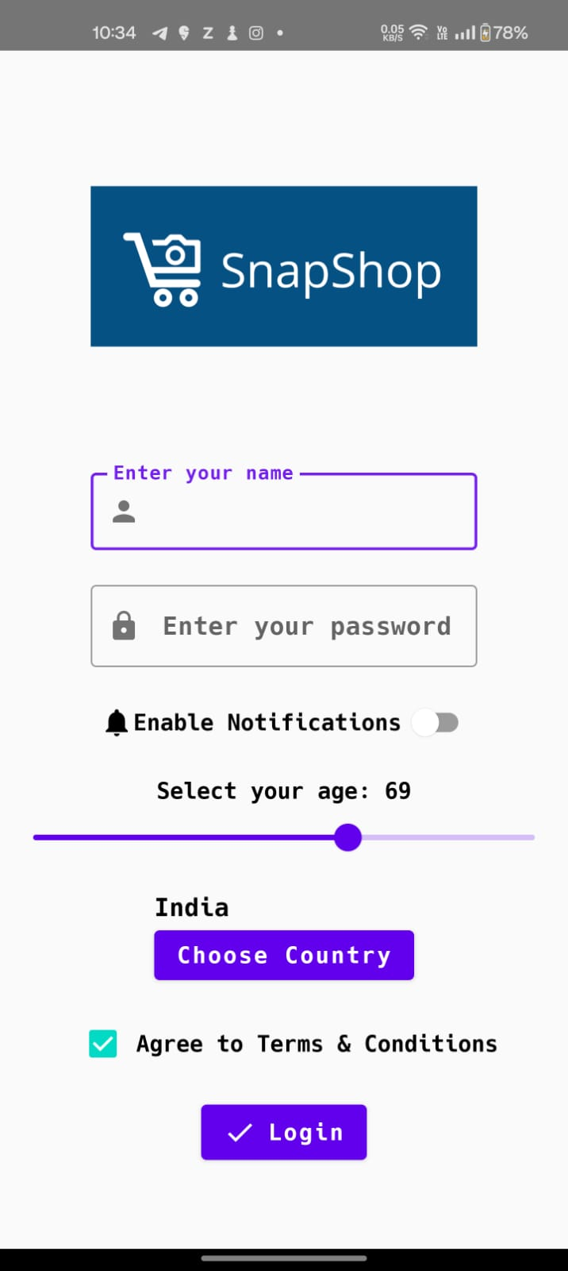

Here, we imported a custom font called hack.tff

Additionally, we also relied on external components for MaterialUI library

We also added an image as a widget.



