Aim: Add to your home screen feature on a web application.

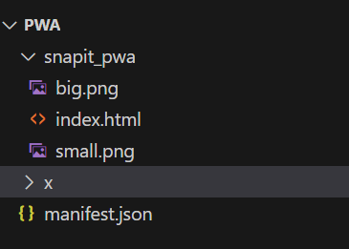

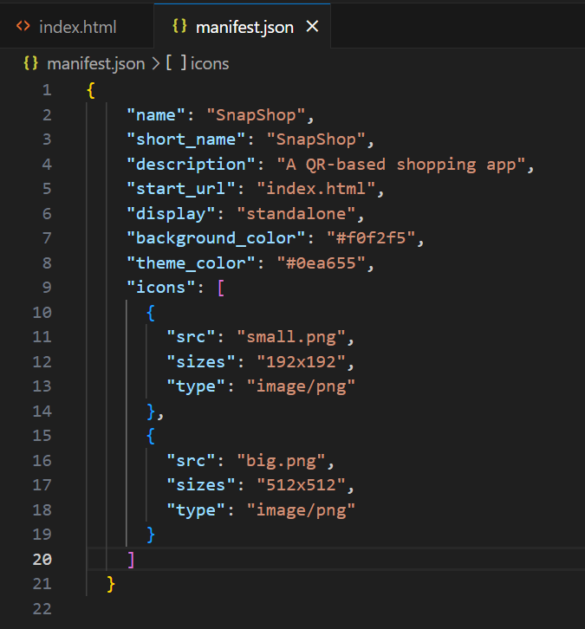

On adding Icon images and manifest.json file to the file structure, we could see the option to install the website as if it were an application.

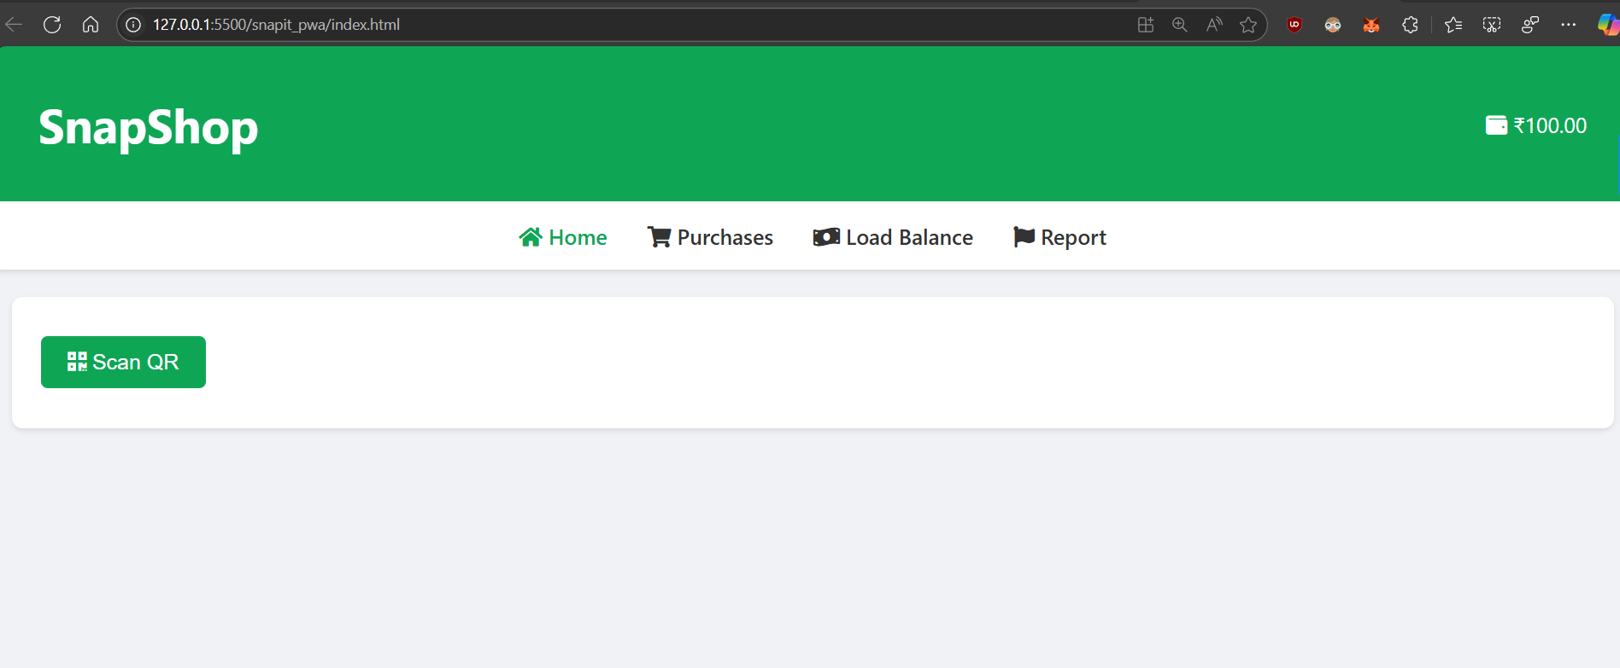

On clicking install, the web application could be accessible from the desktop. Clicking it would create an isolated instance of that web app through which only the features of that particular web app would be accessible.

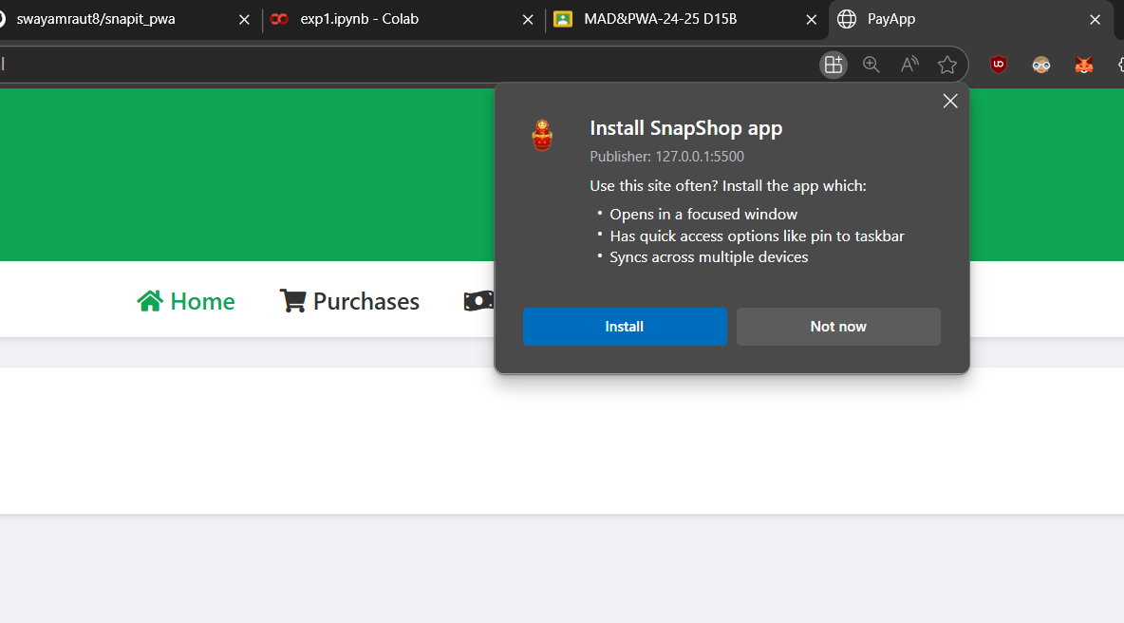

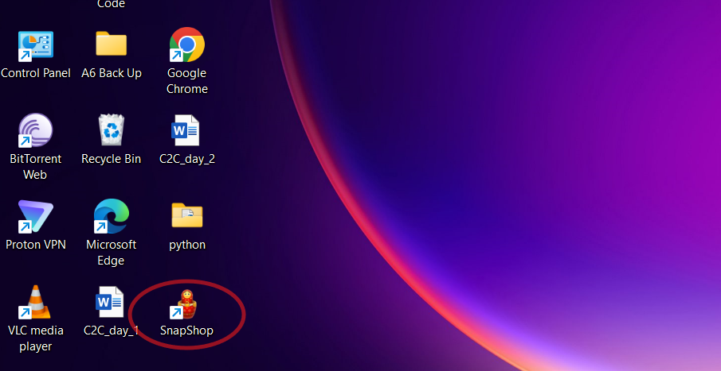

Conclusion: Through this experiment we learnt to add the ‘add to my webpage’ feature to our web application. This is the most fundamental step to be performed while building progressive web applications.