**Aim**: To code and register a service worker, and complete the install and activation process for a new service worker for the E-commerce PWA.

Create service-worker.js

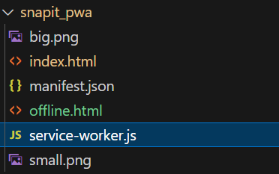

Create a cacheable file called offline.html to be displayed in the absence of an internet connection.

