**Aim**: To implement Service worker events like fetch, sync and push for E-commerce PWA.

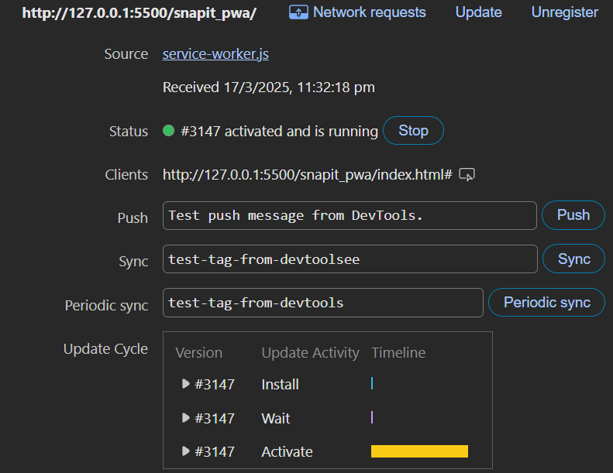

Make the following changes to the service-worker.js

// Install Event: Cache assets

// Activate Event: Cleanup old caches

// Fetch Event: Supports both Cache-First & Network-First

// Sync Event: Retry sending data when online

// Function to send pending screenshots to the server

// Push Event: Display push notifications

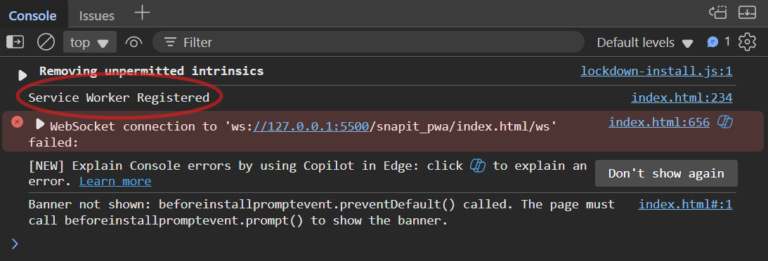

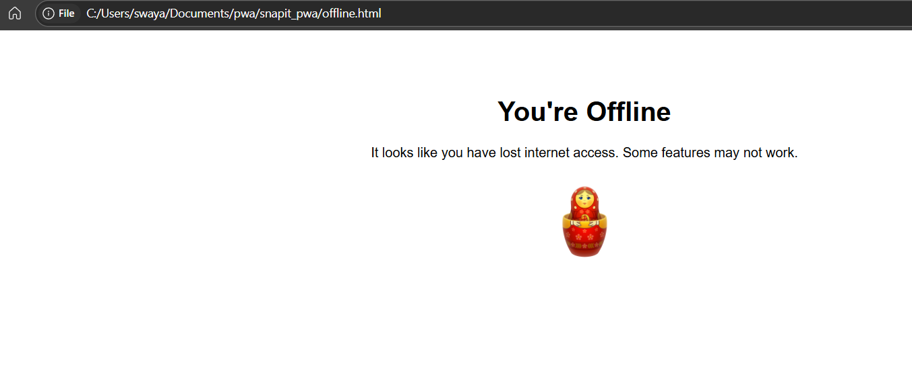

Conclusion: We implemented the functionality of offline web cache capture so that in the absence of a stable internet connection, the app would display a generic waiting page.