## G H RAISONI COLLEGE OF ENGINEERING & MANAGEMENT, WAGHOLI, PUNE

**(An Autonomous Institute under UGC Act 1956 & Affiliated to Savitribai Phule Pune University)**

**EXPERIMENT NO. 1**

# AIM OF EXPERIMENT: Apply pivot table of Excel to perform data analysis

**Date of Performance:** 13/03/2020 **Sign of Teacher:**

**Name: Swayam Terode Roll No. : C70**

**Division: C**

# AIM: Apply pivot table of Excel to perform data analysis

**What is Pivot Table**?

A **Pivot Table** is **used** to summarise, sort, reorganise, group, count, total or average data stored in a **table**. It allows us to transform columns into rows and rows into columns. It allows grouping by any field (column), and using advanced calculations on them. Descriptive Analysis Tool

**Uses of Pivot Table:**

A **Pivot Table** is **used** to summarise, sort, reorganise, group, count, total or average data stored in a **table**. It allows us to transform columns into rows and rows into columns. It allows grouping by any field (column), and using advanced calculations on them.

**PRODECEDURE:**

**What are the steps to creating a pivot table?**

**Step1**: First download any excel file having numeric and other data **INPUT**

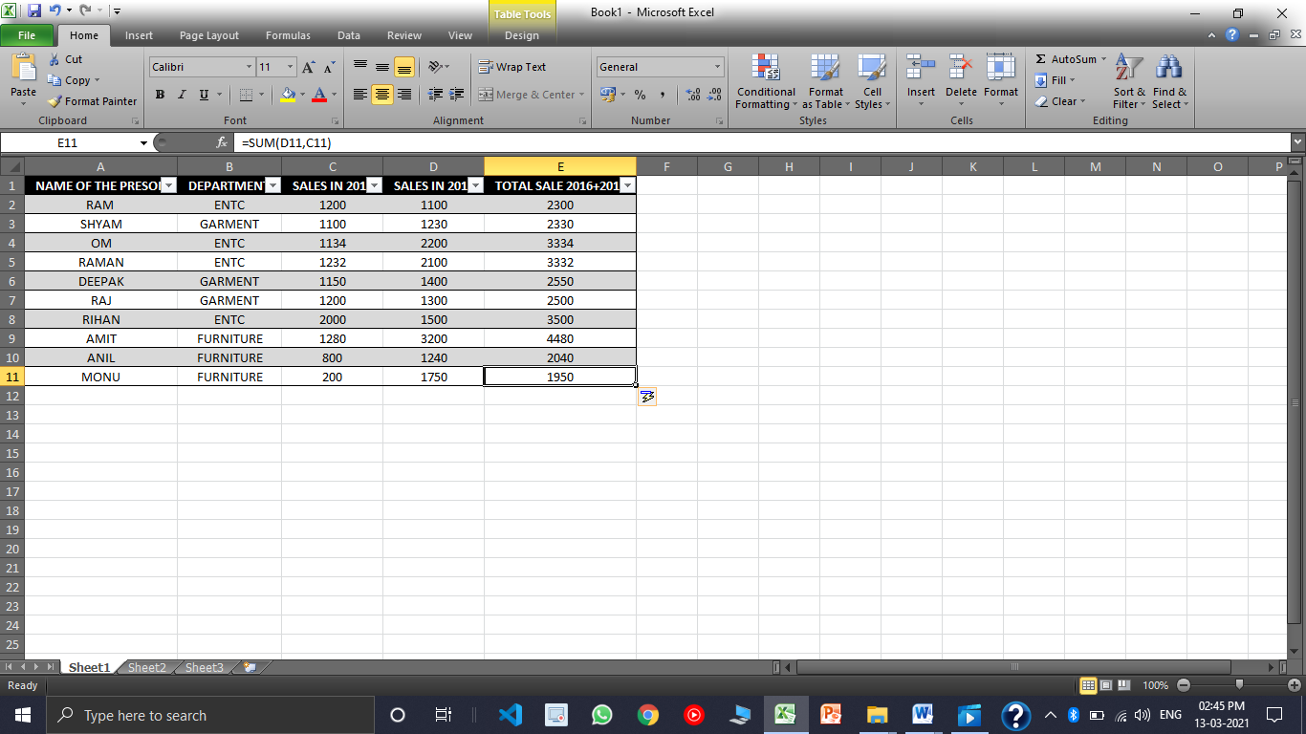

**Step 2:** Rows and column should not be empty.

**Step3:** Before running pivot table select first cell at least.

**Step4**: Insert pivot table

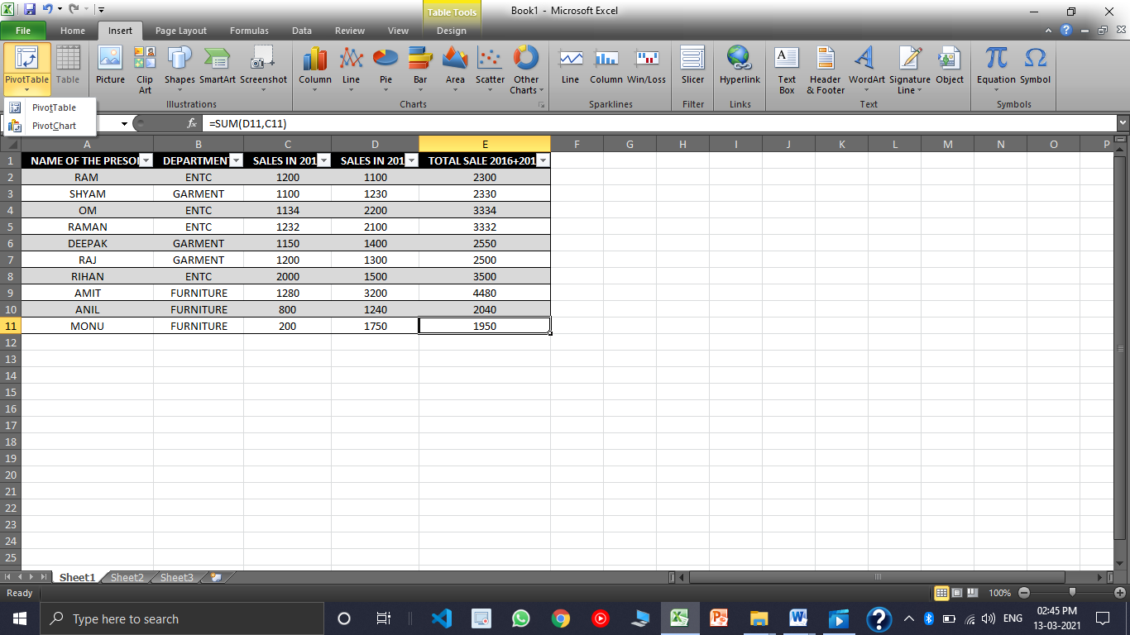

**Step 5:** Range must be specified

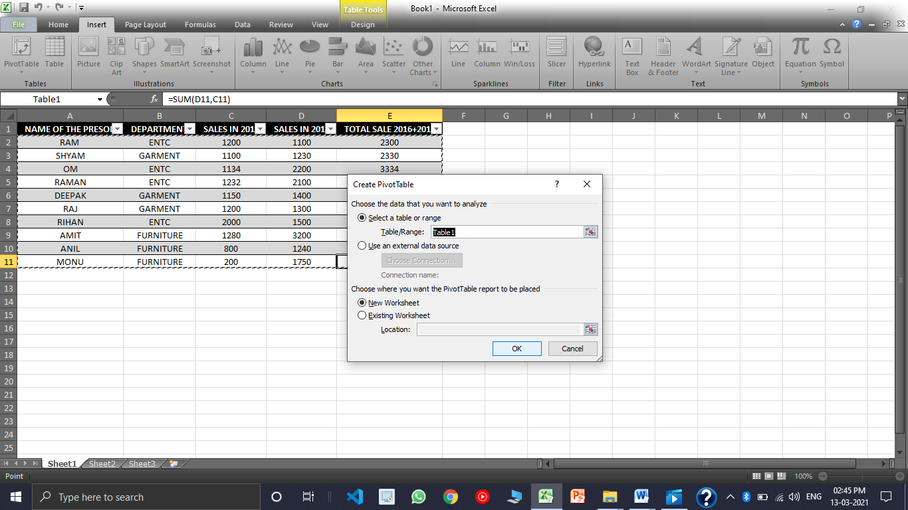

**RESULT:**

**Step 6:** Select field which ever you want to summarize.

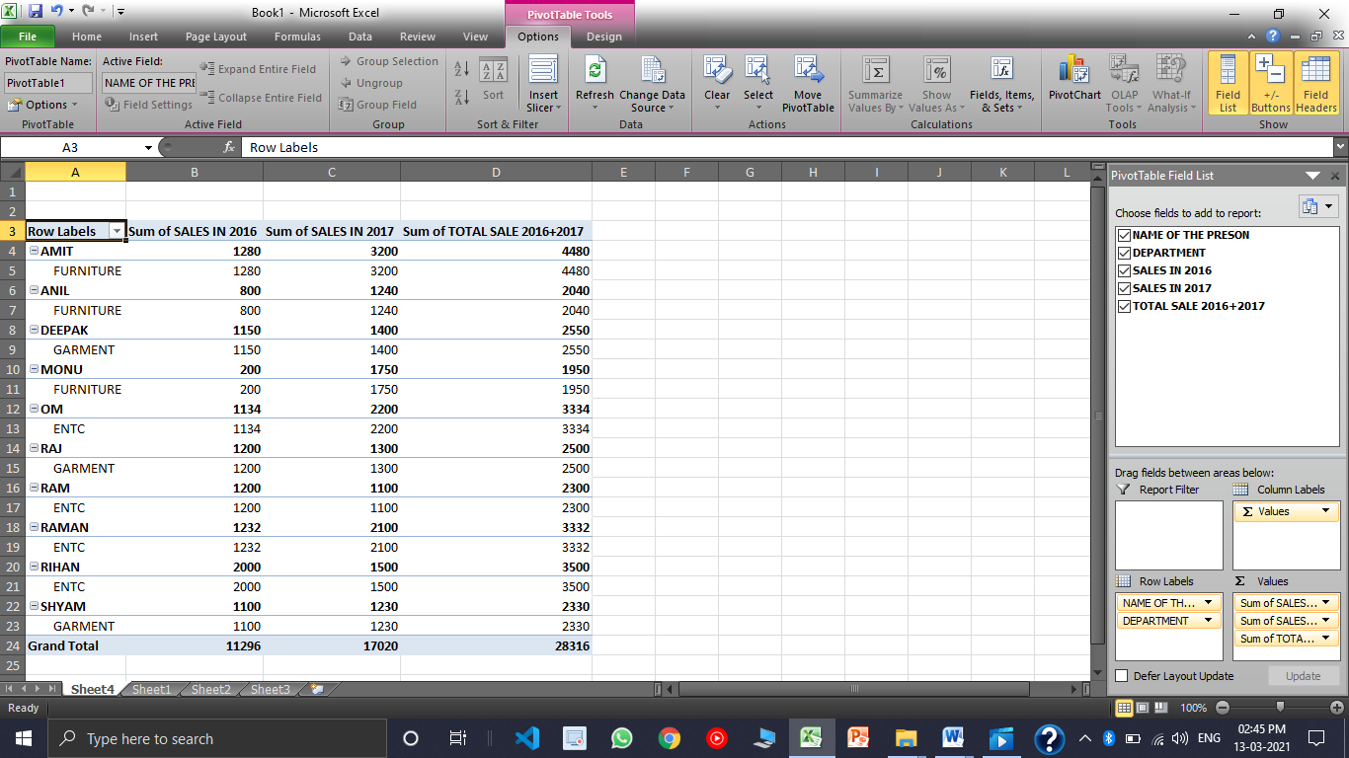

**Step 7:** Select the Field Accordingly

