## G H RAISONI COLLEGE OF ENGINEERING & MANAGEMENT, WAGHOLI, PUNE

**(An Autonomous Institute under UGC Act 1956 & Affiliated to Savitribai Phule Pune University)**

# EXPERIMENT NO. 2

# Perform Descriptive statistics on given data set using descriptive statistics toolbox of excel

# AIM OF EXPERIMENT: Perform Descriptive statistics on given data set using descriptive statistics toolbox of excel

**Date of Performance:** 13/03/2020 **Sign of Teacher:**

**Name: Swayam Terode Roll No. : C70**

**Division: C**

# AIM: Perform Descriptive statistics on given data set using descriptive statistics toolbox of excel

# Descriptive Statistics

Descriptive statistics are used to describe the basic features of the data in a study. They provide simple summaries about the sample and the measures. Together with simple graphics analysis, they form the basis of virtually every quantitative analysis of data.

# Descriptive Statistics Tools

The type of **statistical** methods used for this purpose is called **descriptive statistics**. They include both numerical (e.g. mean, mode, variance…) and graphical **tools** (e.g. histogram, boxplot…) which allow summarizing a set of data and extracting important information such as central tendencies and dispersion.

**PRODECEDURE:**

This performed practical is helpful for understanding Descriptive statistics on given data set using descriptive statistics toolbox of excel.

1. 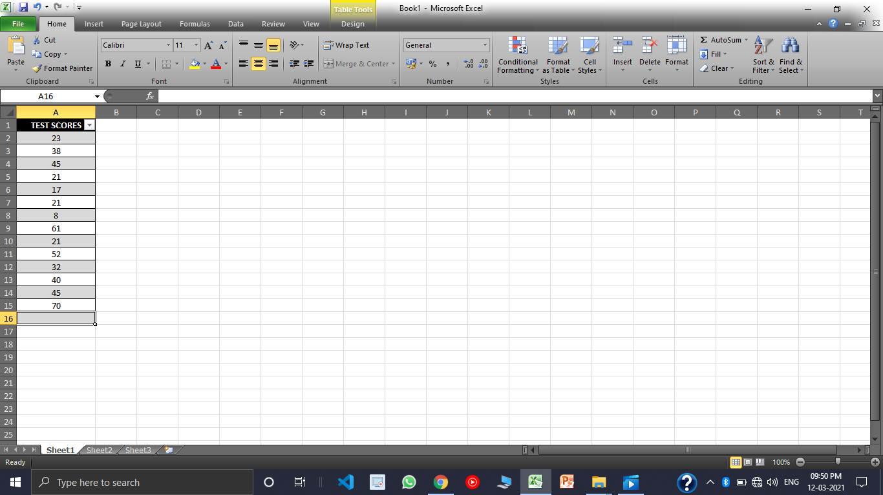**Enter the data in excel sheet**, I have considered it As TEST SCORES. The data exists from C2:C15
2. Click on **Data tab** and then click on **Data Analysis.**

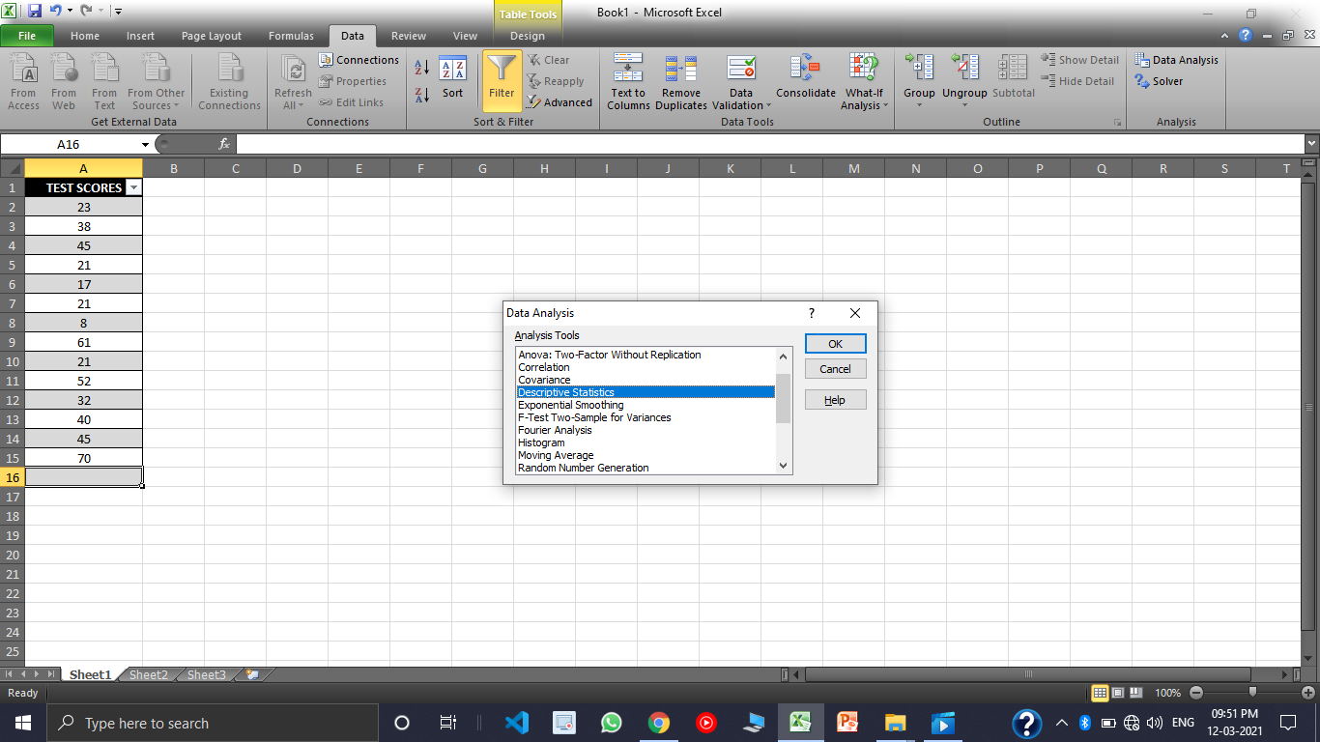

1. Clicking on this **Data Analysis** this dialogue box would select **Descriptive Statistics** and click on **ok.**



1. Select the range A2:A16, which should be grouped by Columns.

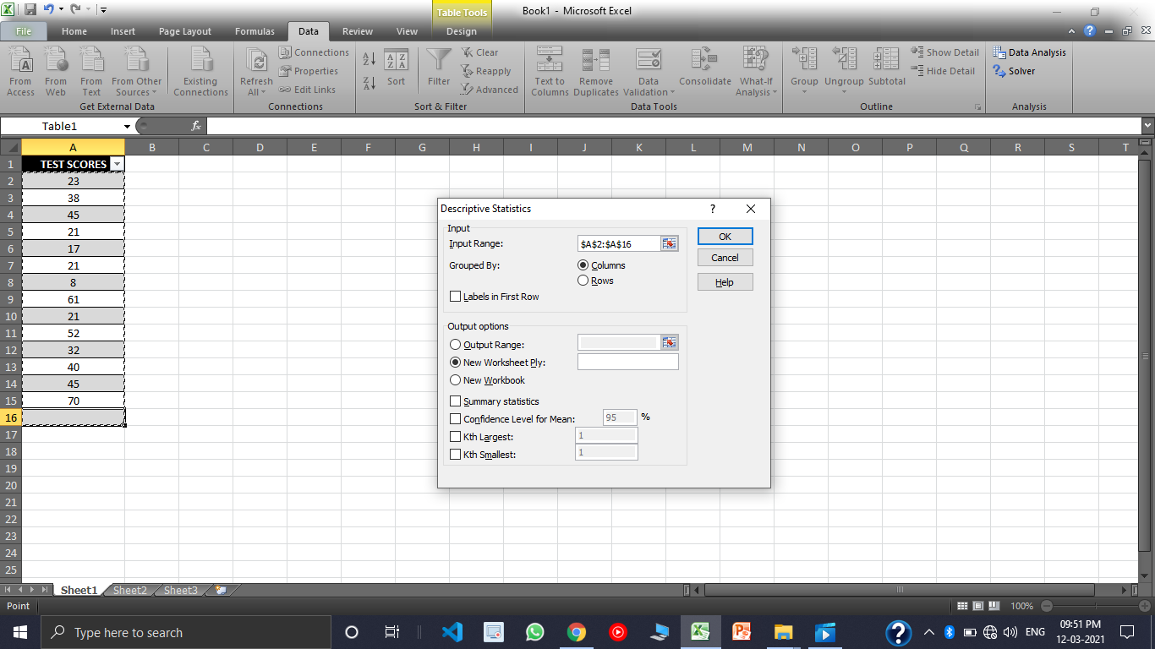

1. Then select the Output Range as its **C1** in my case.

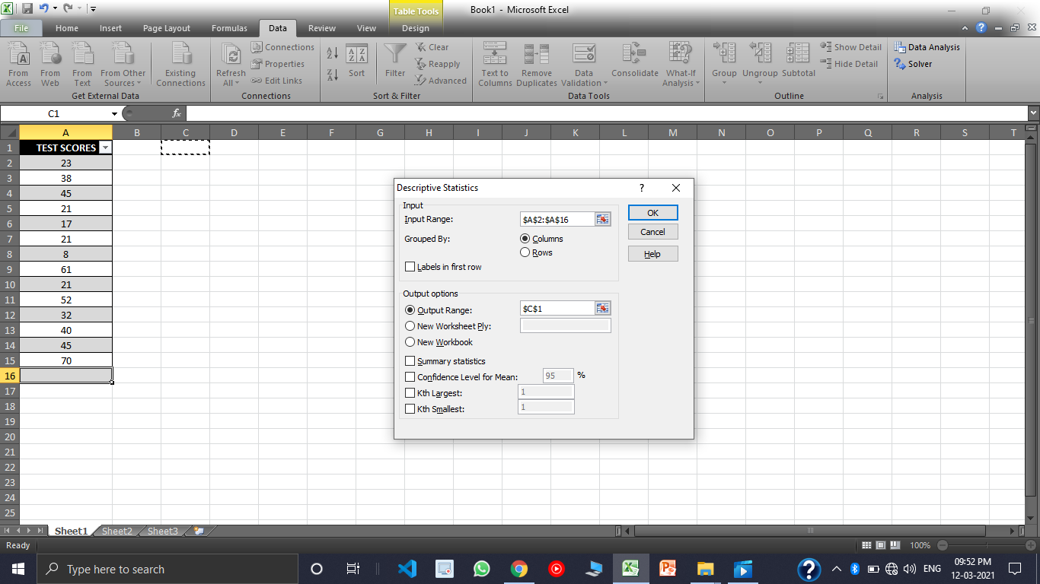

1. Then click on **Summary Statistics Checkbox** and also on the **Confidence Level for Mean** then clickon **OK**

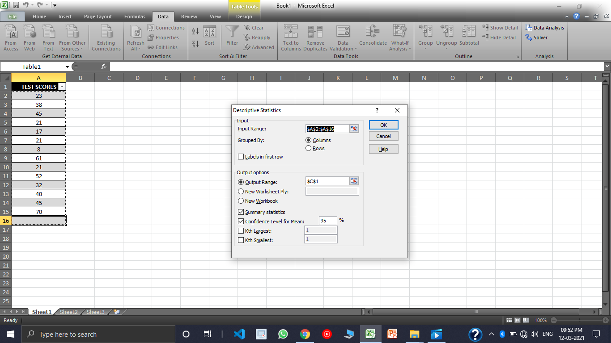

1. **RESULT :**

After clicking on **OK** the below dialogue box would open. This is our desired Output.

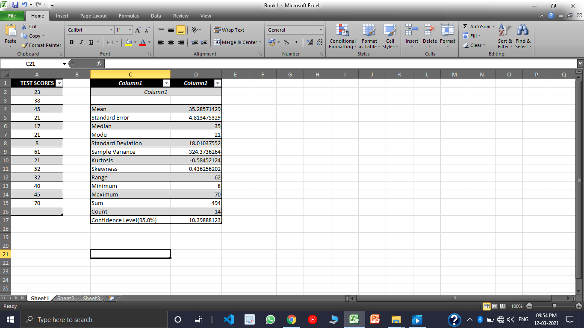

1. The below ***Pie Chart*** Shows the **Descriptive Analysis** of the given data set.

