## G H RAISONI COLLEGE OF ENGINEERING & MANAGEMENT, WAGHOLI, PUNE

**(An Autonomous Institute under UGC Act 1956 & Affiliated to Savitribai Phule Pune University)**

**EXPERIMENT NO. 5**

# AIM OF EXPERIMENT: Perform Multiple Linear Regression using Data Analysis Toolbox of Excel.

**Date of Performance:** **27/03/2020** **Sign of Teacher:**

**Name: Swayam Terode Roll No. : C70**

**Division: C**

# AIM: Perform Multiple Linear Regression using Data Analysis Toolbox of Excel.

# Theory:

## What Is Multiple Linear Regressions (MLR)?

Multiple linear regression (MLR), also known simply as multiple regression, is a statistical technique that uses several explanatory variables to predict the outcome of a response variable. The goal of multiple linear regressions (MLR) is to model the linear relationship between the explanatory (independent) variables and response (dependent) variable.

In essence, multiple regressions are the extension of ordinary least-squares (OLS) regression because it involves more than one explanatory variable.

**KEY TAKEAWAYS**

* Multiple linear regression (MLR), also known simply as multiple regression, is a statistical technique that uses several explanatory variables to predict the outcome of a response variable.
* Multiple regressions are an extension of linear (OLS) regression that uses just one explanatory variable.
* MLR is used extensively in econometrics and financial inference.

## Formula and Calculation of Multiple Linear Regression

## *yi*​ = *β*0​ + *β*1​*xi*1​ + *β*2​*xi*2​ +...+ *βp*​*xip*​+ *ϵ*

## *where, for i=n observations*

## *yi*​=dependent variable

## *xi*​=explanatory variables

## *β*0​=y-intercept (constant term)

## *βp*=slope coefficients for each explanatory variable

## *ϵ*=the model’s error term (also known as the residuals)​

## PRODECEDURE:

**What are the steps to creating a pivot table?**

**Step1**: First download any excel file having numeric and other data **INPUT.**

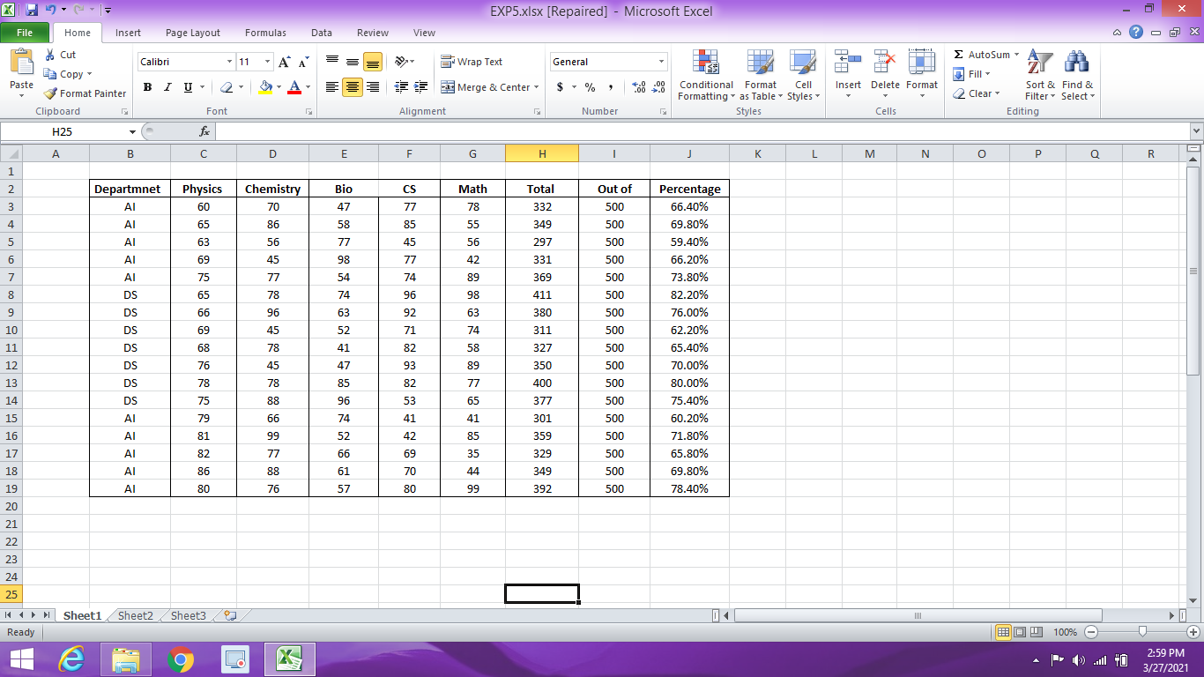

**Step 2:** Rows and column should not be empty.

**Step3:** Then click on **data** tab and then on the **Data analysis** tab then select the Regression and then on **OK**.

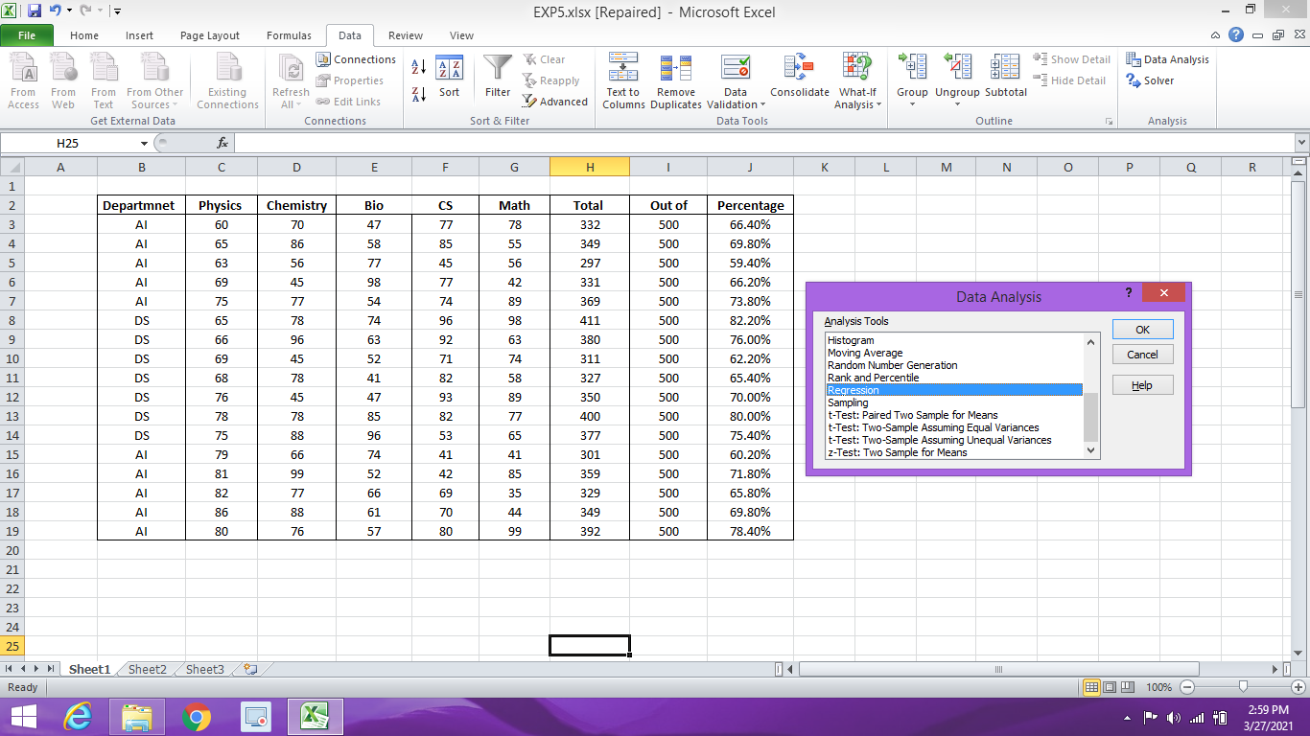

**Step4**: Input the Y range as TOTAL and Input X Range as Marks of all Subjects.

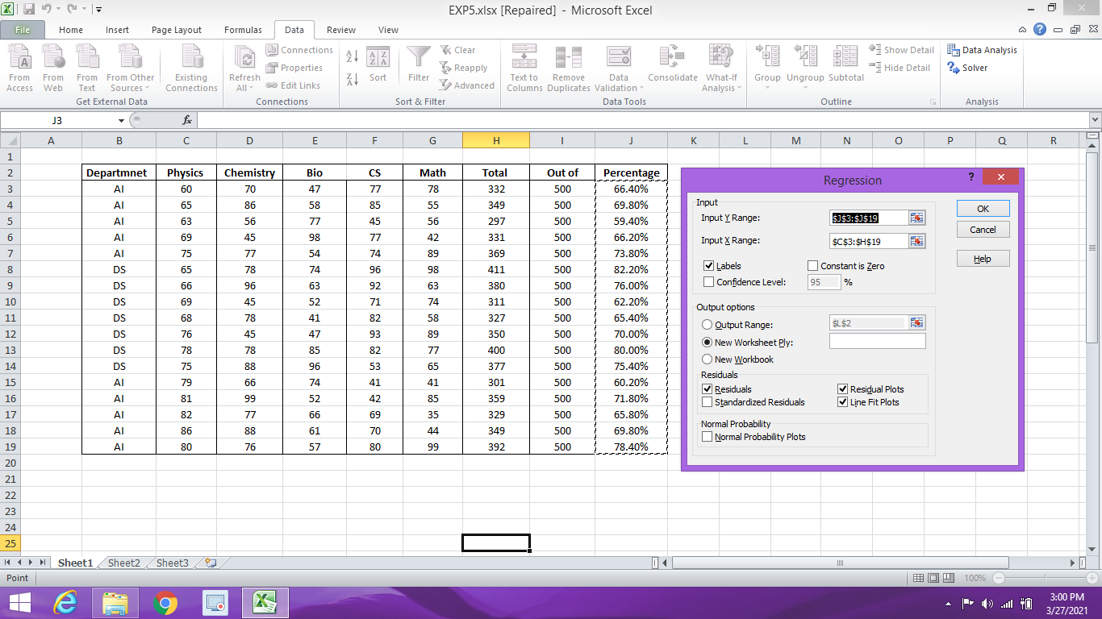

**Step 5:** Select the checkbox of Labels**, Residuals, Residual Plots** and **Line Fit Plot.**



**RESULT:**

**The below are the result of the following.**

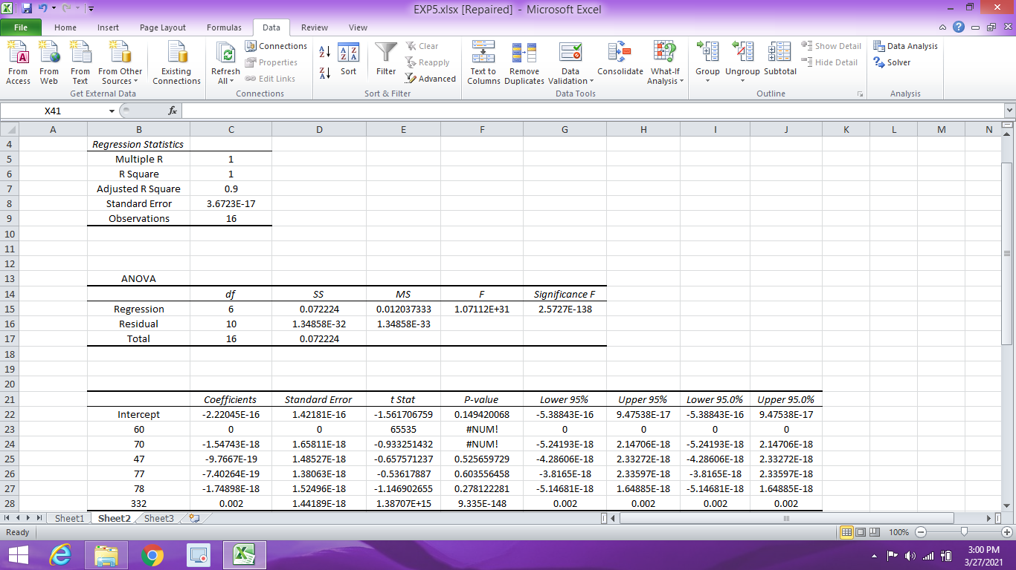





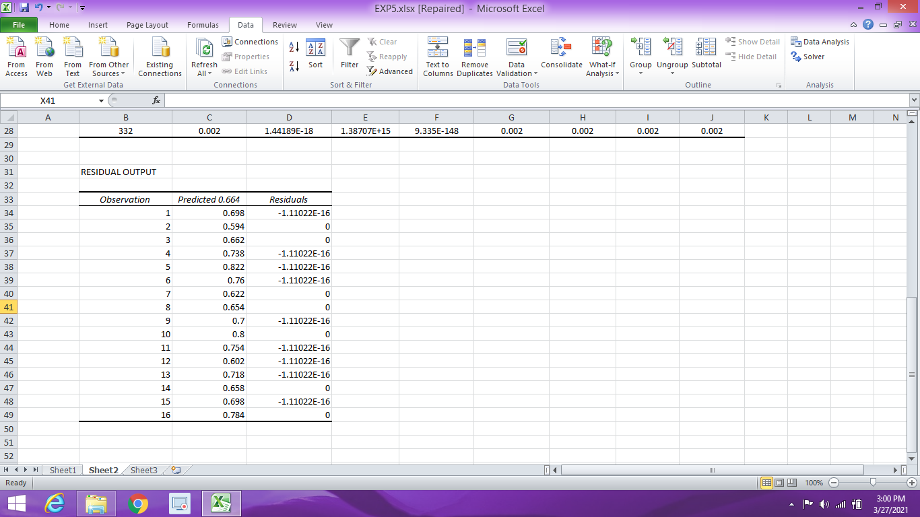

**The GRAPHS**

