**EXPERIMENT No.: 6**

**NAME OF EXPERIMENT:** Perform the Logistic Regression and given dataset and Interpret the regression table

**Name –Swayam Terode**  **Roll No.: C70 Division : C**

**Date of Performance:** ______________ **Sign of Teacher:**

**AIM:** Perform the Logistic Regression and given dataset and Interpret the regression table

**Theory:**

RUNNING XLSTAT THE FIRST TIME (EXCEL 2007, 2010, 2013, 2016)

## Making sure Microsoft Excel macros are enabled

Whatever your Excel or XLSTAT version, it is necessary that the Macros security level is set to Medium so that XLSTAT can run.  
  
Here is how to verify that Macros are properly enabled:

1. Click the **Office** button on the upper left corner of the Excel window to open the **Office Menu** (Excel 2007) or click the **File** tab (Excel 2010, 2013, 2016).
2. Click on the **Excel Options** button on the bottom of the Office menu window (Excel 2007) or choose **Excel Options** in the **File** menu (Excel 2010, 2013, 2016).
3. The **Excel Options** window will appear.
4. Select **Trust Center** in the middle of the menu bar on the left.
5. Click on the **Trust Center Settings...** button on the right of the window.
6. The **Trust Center** window will appear.
7. Select **Macro Settings** in the middle of the menu bar on the left
8. Select the 2nd option for the **Macro Settings**
9. Activate the option **Trust access to the VBA project object model**
10. Click **OK** to close the **Trust center** window
11. Click **OK** to close the **Excel options** window

## Ensuring your OS and Excel version are supported by XLSTAT

It is also recommended that you make sure your Operating system and your Microsoft Office version are compatible with your XLSTAT version. To check the list of supported systems for XLSTAT, follow this [tutorial](https://help.xlstat.com/s/article/supported-systems-for-xlstat?language=en_US).

## Running XLSTAT

To run XLSTAT for the first time, you can choose one of these options:

* choose the option 'launch XLSTAT' at the end of the installation procedure,
* use the Windows Start / Programs / Addinsoft / XLSTAT command,
* use the XLSTAT shortcut on your desktop

The XLSTAT tab is also added (see image below). Both XLSTAT toolbar and the XLSTAT tab can be used to access the XLSTAT functions. By clicking on an item of the menu, you activate the dialog box corresponding to the selected function.

Input:

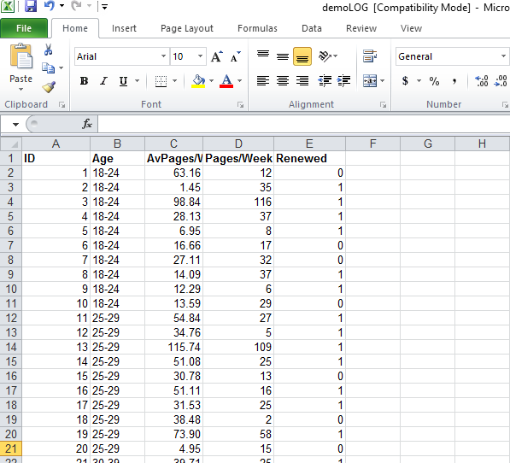

**OUTPUT:**

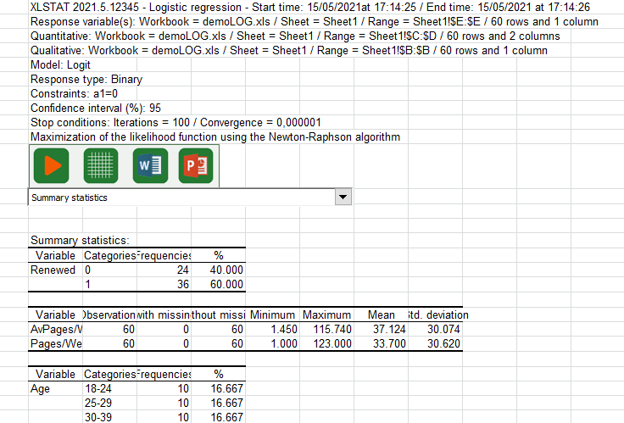

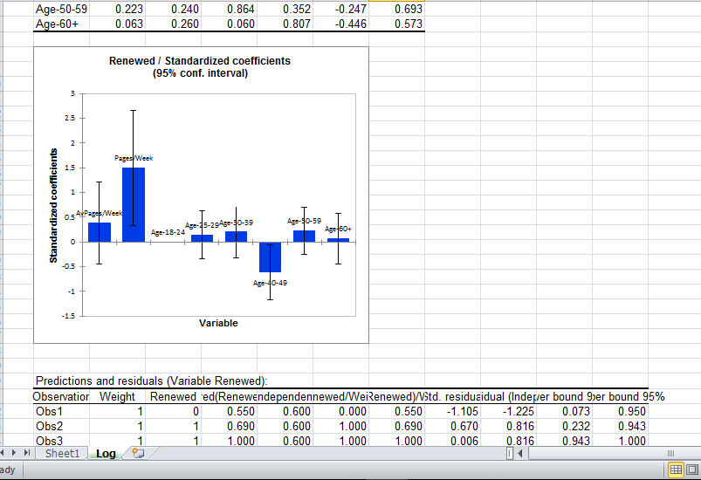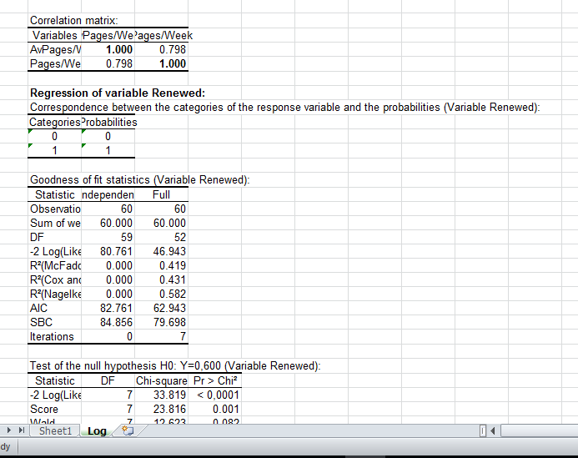

**EXPERIMENT NO.: 7**

**NAME OF EXPERIMENT:** Install Tableau, Understand User Interface, Dimensions, Measures, Pages, Filters, Marks and Show Me, Dataset Connections and create visualization.

**Name –Swayam Terode**  **Roll No.: C70 Division : C**

**Date of Performance:** ______________ **Sign of Teacher:**

**AIM:** Install Tableau, Understand User Interface, Dimensions, Measures, Pages, Filters, Marks and Show Me, Dataset Connections and create visualization

### Theory:

### 1 What do you need to know before using Tableau?

You don’t need to know much to use Tableau, but still, a basic awareness of all the types of graphs such as bar graph, line charts, histograms, etc. is preferred.

Along with that, it will be beneficial if you possessed some basic understanding of database management (data types, joins, drill down, drill up, etc.) too.

### 2. Installation:

To work on Tableau, you **need** Tableau, right?

Out of the five above mentioned products, Tableau Desktop, Public and Online offer Data Visual Creation.

**Tableau Desktop**

It is available in the following three formats:

1. [Free trial for 14 days](https://www.tableau.com/products/trial)
2. If you are a student or a teacher, you get free access to the [Desktop](https://www.tableau.com/academic) for a full year.
3. [Purchase Tableau](https://buy.tableau.com/)
4. **Tableau Public**
5. [Tableau Public](https://public.tableau.com/s/download) is purely free of all costs and does not require any license. But it comes with a limitation that all of your data and workbooks are made public to all Tableau users.
6. **Tableau Online**
7. [Tableau Online](https://sso.online.tableau.com/public/idp/SSO) is the best option for you, if you wish to make your Workbooks on the Cloud and be able to access them from anywhere.

## 3. Getting Started

Now that you have the suitable product installed and set up,

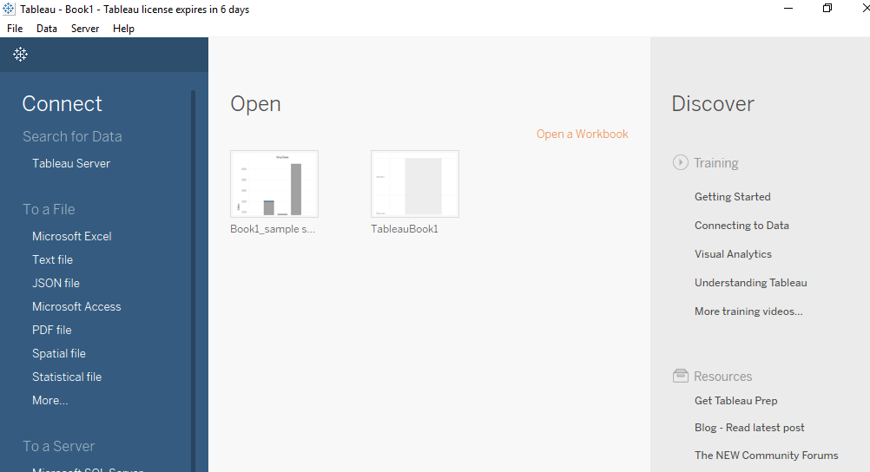

The first thing that you will obviously need to do is import the data onto Tableau. So quickly follow the below steps:

1. Since the data is in an Excel File, click on **Excel** and choose the Sample – Superstore.xls file to get :
2. You can see three sheets on the screen, but we are only going to be dealing with Orders here, so go ahead and drag the same on Drag sheets here :

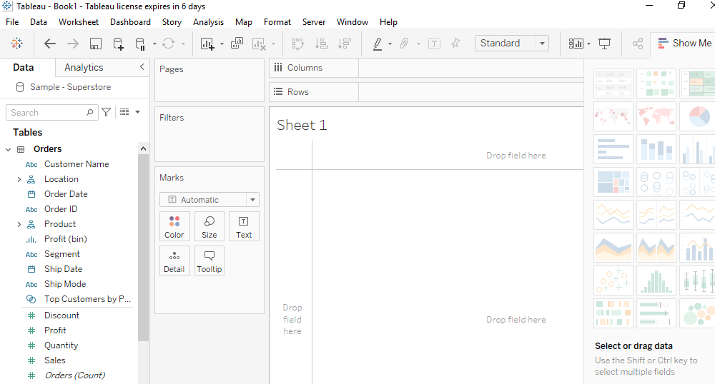

After drag and drop fields to columns and row you can view data in different modes.

**EXPERIMENT No.: 8**

**NAME OF EXPERIMENT:** Various graphs in Tableau, Integration of Map and geo-locations, Creating Interactive Dashboard and Publishing your Dashboard to Tableau Public Site.

**Name –Swayam Terode**  **Roll No.: C70 Division : C**

**Date of Performance:** ______________ **Sign of Teacher:**

# Build a Simple Map

You can build several different types of maps for your geographic analysis in Tableau. If you're new to maps, or simply want to take advantage of the built in mapping capabilities that Tableau provides, you can create a simple point or filled (polygon) map similar to the examples below.

**Prerequisites**: To build a simple map, your data source must contain location data (location names, or latitude and longitude coordinates).

**INPUT:** sample axles file which has country name and latitude and longitude coordinates

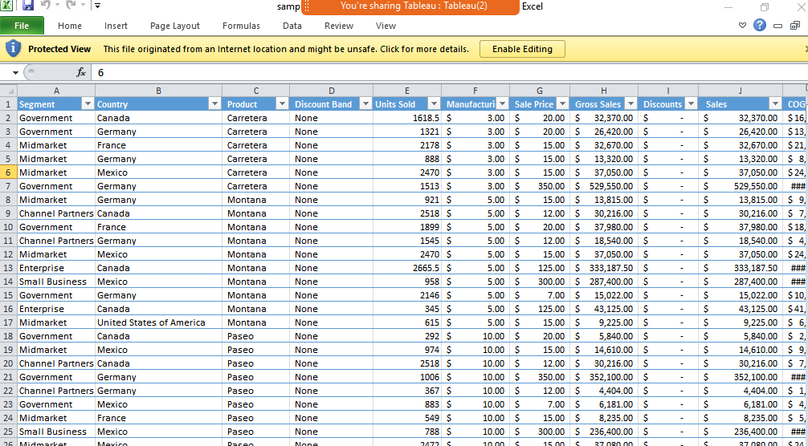

**OUTPUT:**

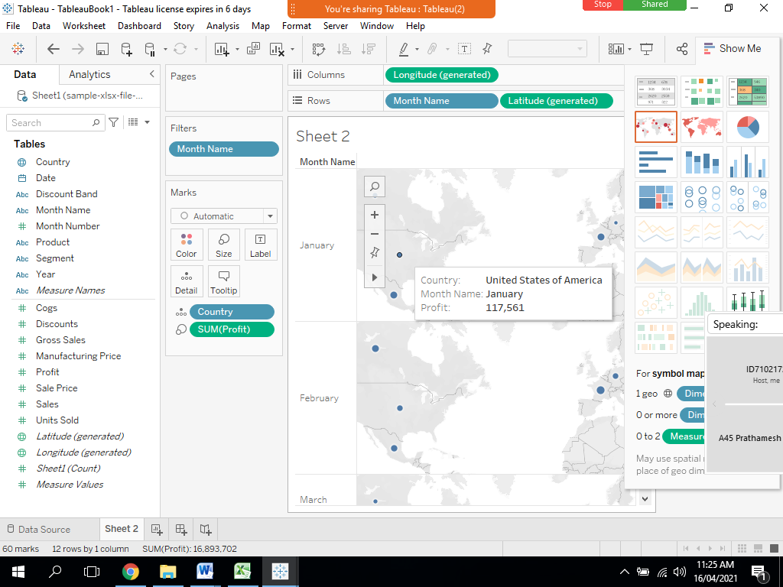

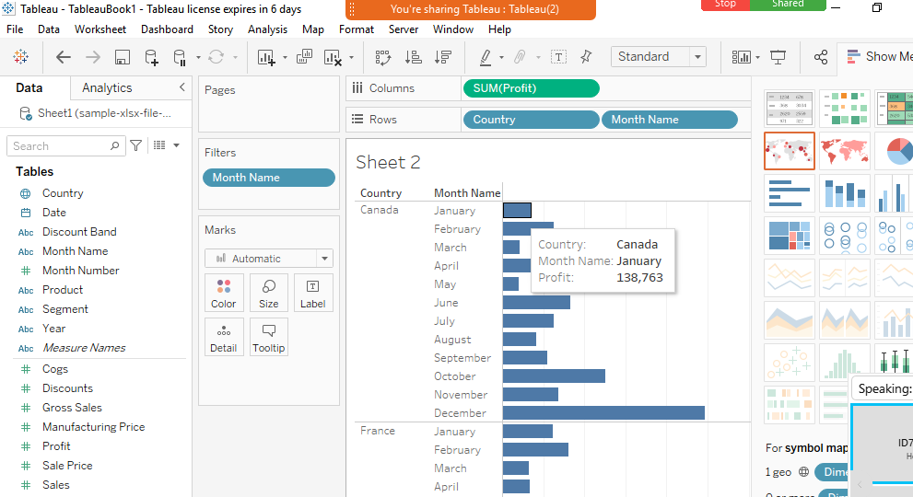

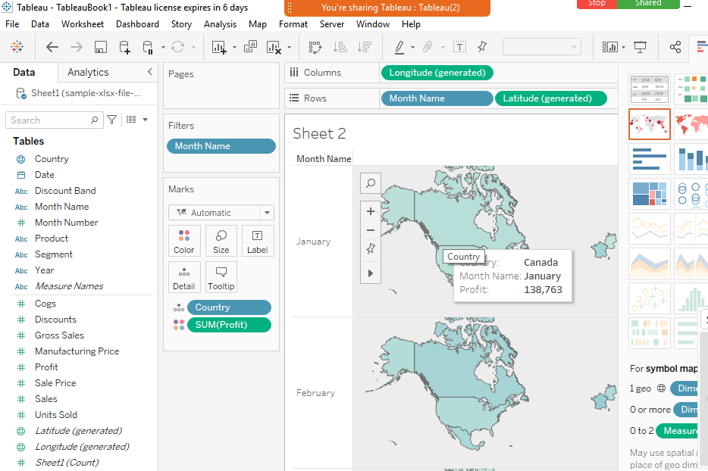

**EXPERIMENT No.: 9**

**NAME OF EXPERIMENT:**  Scatter Plots, Data Highlighter, Pages and Cards, Annotations Creating Story and publishing on Tableau Public.

**Name –Swayam Terode**  **Roll No.: C70 Division : C**

**Date of Performance:** ______________ **Sign of Teacher:**

**AIM:** Scatter Plots, Data Highlighter, Pages and Cards, Annotations Creating Story and publishing on Tableau Public.

**Theory:**

**What is Scatter Plot?**

A scatter plot (aka scatter chart, scatter graph) uses dots to represent values for two different numeric variables. The position of each dot on the horizontal and vertical axis indicates values for an individual data point. Scatter plots are used to observe relationships between variables.

Example:

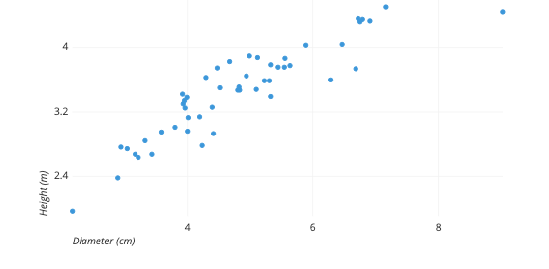

The example scatter plot above shows the diameters and heights for a sample of fictional trees. Each dot represents a single tree; each point’s horizontal position indicates that tree’s diameter (in centimeters) and the vertical position indicates that tree’s height (in meters). From the plot, we can see a generally tight positive correlation between a tree’s diameter and its height. We can also observe an outlier point, a tree that has a much larger diameter than the others. This tree appears fairly short for its girth, which might warrant further investigation.

Use scatter plots to visualize relationships between numerical variables.

In Tableau, you create a scatter plot by placing at least one measure on the **Columns** shelf and at least one measure on the **Rows** shelf. If these shelves contain both dimensions and measures, Tableau places the measures as the innermost fields, which means that measures are always to the right of any dimensions that you have also placed on these shelves. The word "innermost" in this case refers to the table structure.

|  |  |
| --- | --- |
| **Creates Simple Scatter Plot** | **Creates Matrix of Scatter Plots** |
| https://help.tableau.com/current/pro/desktop/en-us/Img/dataview_examples_scatter1a.png | https://help.tableau.com/current/pro/desktop/en-us/Img/dataview_examples_scatter1b.png |
|  |  |

A scatter plot can use several mark types. By default, Tableau uses the shape mark type. Depending on your data, you might want to use another mark type, such as a circle or a square. For more information, see [Change the Type of Mark in the View](https://help.tableau.com/current/pro/desktop/en-us/viewparts_marks_marktypes.htm).

To use scatter plots and trend lines to compare sales to profit, follow these steps:

1. Open the **Sample - Superstore** data source.
2. Drag the **Profit** measure to **Columns**.

Tableau aggregates the measure as a sum and creates a horizontal axis.

1. Drag the **Sales**measure to **Rows**.

Tableau aggregates the measure as a sum and creates a vertical axis.

Measures can consist of continuous numerical data. When you plot one number against another, you are comparing two numbers; the resulting chart is analogous to a Cartesian chart, with x and y coordinates.

Now you have a one-mark scatter plot:

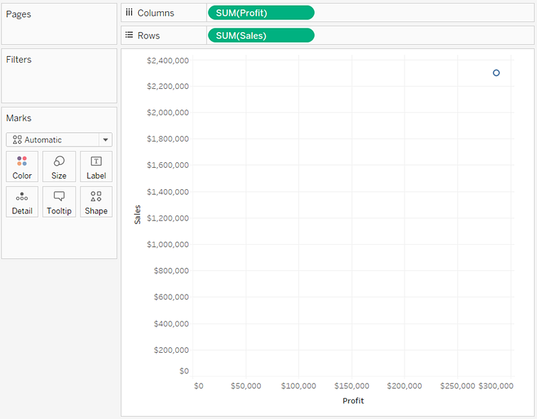

4. Drag the **Category** dimension to **Colour** on the Marks card.

This separates the data into three marks—one for each dimension member—and encodes the marks using colour.

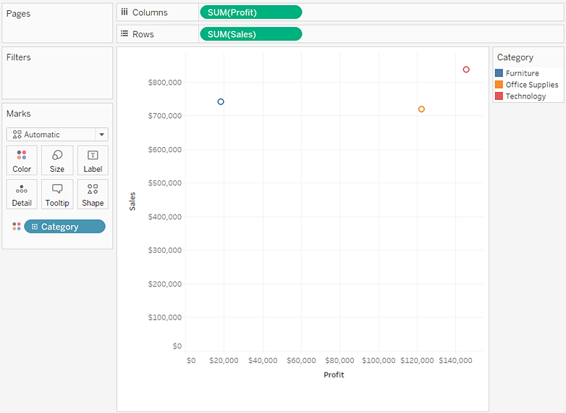

5. Drag the **Region** dimension to **Detail** on the **Marks** card.

Now there are many more marks in the view. The number of marks is equal to the number of distinct regions in the data source multiplied by the number of departments. (If you're curious, use the **Undo** button on the toolbar to see what would have happened if you'd dropped the **Region** dimension on **Shape** instead of **Detail**.)

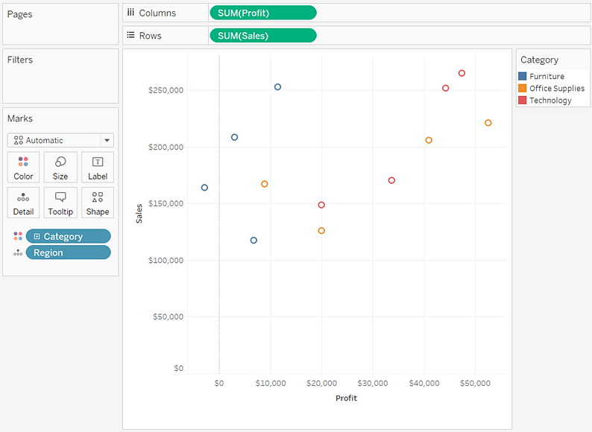

To add trend lines, from the **Analytics** pane, drag the **Trend Line** model to the view, and then drop it on the model type

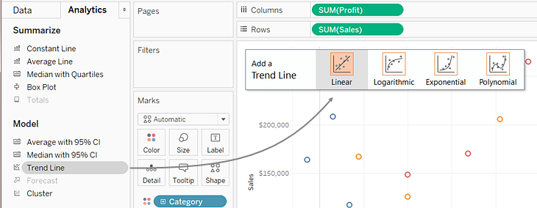

A trend line can provide a statistical definition of the relationship between two numerical values. To add trend lines to a view, both axes must contain a field that can be interpreted as a number—by definition, that is always the case with a scatter plot.

Tableau adds three linear trend lines—one for each colour that you are using to distinguish the three categories.

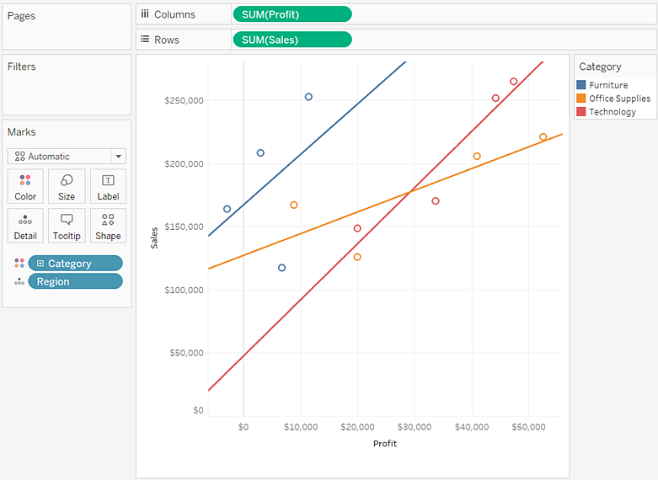

However the cursor over the trend lines to see statistical information about the model that was used to create the line:

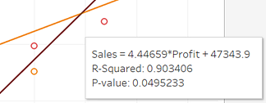

For more information, see [Assess Trend Line Significance](https://help.tableau.com/current/pro/desktop/en-us/trendlines_add.htm#significance). You can also customize the trend line to use a different model type or to include confidence bands. For more information, see [Add Trend Lines to Visualization](https://help.tableau.com/current/pro/desktop/en-us/trendlines_add.htm).

### 