**[What is thermal runaway in a transistor?](https://www.quora.com/What-is-thermal-runaway-in-a-transistor?no_redirect=1" \t "_top)**

1. In a grounded emitter bipolar transistor, the base forward conduction voltage decreases with increasing temperature. If you bias this transistor from a fixed bias voltage through a fixed resistance, you will get some base current and therefore for collector current and power dissipation in the transistor.

If that power dissipation heats the transistor it will make the base voltage decrease. With a fixed bias voltage and resistance this leads to higher base current and higher collector current. Depending on load, this may cause higher power dissipation which causes even higher device temperature and even lower base voltage.

This is thermal runaway and can lead to high enough device temperature to lead to device destruction. It can be avoided by techniques like temperature compensating the bias circuit or by loading the collector such that increased current does not increase power.

1. Thermal runaway is considered to be a condition where increasing temperature affects operating parameters so that more heat is created, which in turn causes more of the same, increasing temperature more. Eventually heat exceeds the maximum and goes insanely high and causes meltdown and failures.

IN a transistor, it may be leakage that goes up with temperature, that increase the power dissipation causing more leakage. Thermal equilibrium cannot be met and the device literally melts down.

1. Transistor is a semiconductor device used for switching electrical signals or power. Thermal runaway is a kind of uncontrolled positive feedback. Thermal runaway occurs in situations where the increase in temperature changes the conditions in a way that causes further increase in temperature leads to a destructive result(feedback).

As the collector current increases, power dissipated increases which in turn increases the collector base junction temperature. This results in destruction of the transistor. This is called thermal runaway in transistors.

1. Thermal runaway is caused by improper biasing and/or insufficient heatsinking of a transistor. In a BJT, the inherent base-emitter voltage decreases with increasing temperature by about 2mV per degree C. In addition, the beta (or Hfe) may increase.

In a common emitter configuration, if you supply a fixed voltage to the base with no negative feedback, as the junction temperature increases, the collector current will increase, causing the temperature will increase further. If the heatsink is inadequate, the temperature will continue to increase until the transistor fails.

Thermal stability requires negative feedback, usually with an emitter resistor or collector to base feedback. It also may help to use temperature compensation in the base biasing, for instance with a forward biased diode.

What is DC Load Line Analysis and Its Significance?

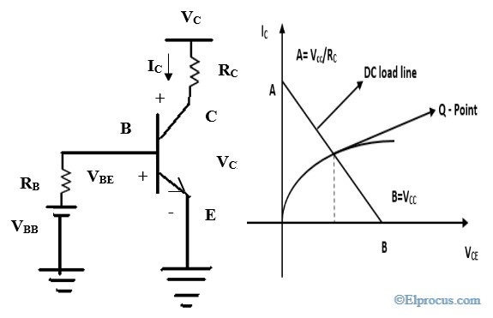

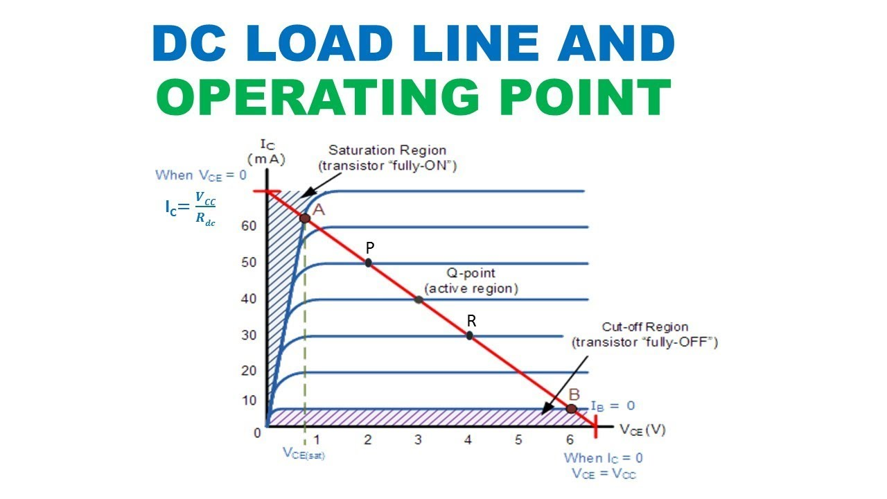

**Definition:** The DC (Direct Current) load line is a graph that has all possible volumes of output current (Ic) and output voltage (VCE) for a given amplifier. In the case of the [amplifier,](https://www.elprocus.com/classification-of-amplifiers-classes-its-applications/)it has two inputs they are AC input and DC input. If we analyze the circuit for DC input, then it is called a DC analysis. Similarly, if we have only AC input while analyzing then it is called AC analysis. If there are multiple sources available in the circuit you can treat one source at a time by using the superposition theorem.

The transistor consists of the collector, emitter, and bias. The circuit diagram of the dc load line using a transistor is shown below. As shown in the figure, the DC [battery](https://www.elprocus.com/batteries-types-working/) VBBis applied at the base and the collector terminals of the transistor. The voltage between collector and emitter is called V­­CE and voltage between bias and emitter is called V­BE. To get the dc load line, we need to apply Kirchhoff’s Voltage Law to the output.

**Case 1:** If we put IC= 0, then will get VCE = VCC

**Case 2:** If we put VCE = 0, then IC becomes VCC/ RC

By using the above two cases we can easily draw the dc load line for output characteristics. The dc load line is a graph of all values of IC and VCE. For [common emitter configuration](https://www.elprocus.com/common-emitter-amplifier-circuit-working/), the IC and VCE will be on output characteristics that’s why dc load line is drawn at output characteristics. If we plot using the above two cases, we will get the slope line and that line is called the dc load line.

The operating point ‘Q’ is defined as a point for a particular value of IC and the corresponding value of VCE. We have to select the Q point exactly in the middle of the load line. When output characteristics intersect dc load line we can get different Q points.

