Amazon Sales Data Analysis Project

SQL + Power BI Project Report

Submitted By: Vipin Prakash
Course: Data Analytics
Tools Used: SQL, Power BI
Date: 2026
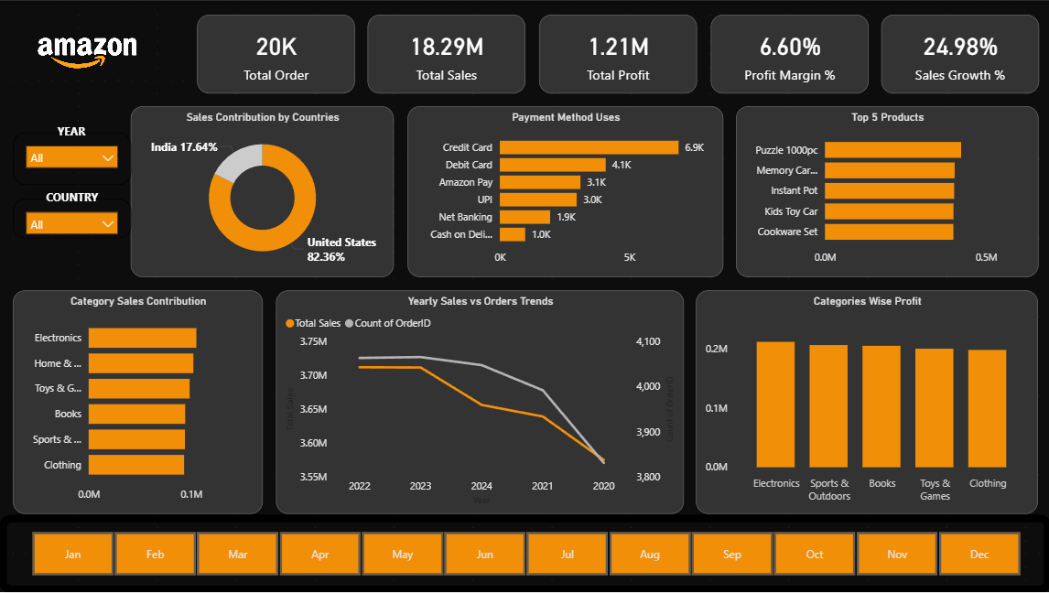

Project Overview
This project analyzes Amazon sales data using SQL and Power BI.
It focuses on cleaning raw data, performing analysis, and generating insights.
The goal is to simulate a real-world e-commerce analytics scenario.

Tools & Technologies
SQL (MySQL) – Data cleaning and analysis
Power BI – Dashboard and visualization
Excel/CSV – Data source

Key Analysis Performed
Sales and profit analysis
Country-wise sales contribution
Payment method usage
Top products analysis
Category-wise performance
Yearly and monthly trends

Dashboard Explanation
KPI Cards: Show total orders, sales, profit, and growth
Sales by Country: Highlights US vs India contribution
Payment Methods: Displays customer preferences
Top Products: Identifies best-selling items
Category Analysis: Shows sales and profit distribution
Trend Chart: Displays yearly performance

Key Insights
US contributes majority of sales (~82%)
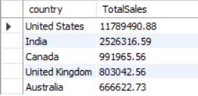
Credit Card is most used payment method
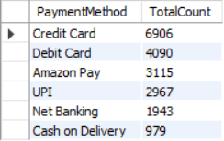
Electronics is top-performing category
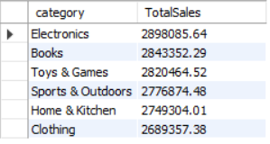
Profit margin is around 6.6%
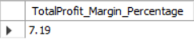
Sales show fluctuations over years
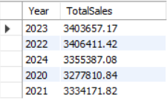
Top Brands and their category by their total sales in each country
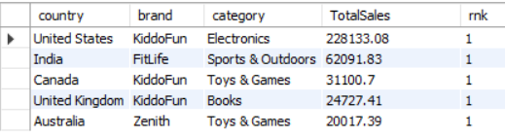
Order Status Ratio
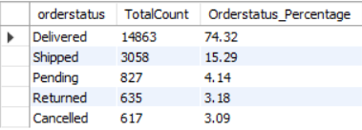

Business Recommendations
Expand to other countries
Improve profit margins
Focus on top categories
Optimize payment experience
Promote best-selling products

Conclusion
This project demonstrates SQL and BI skills.
It provides insights for business decision-making.
Helps understand real-world data analytics workflow.

