MICROPROJECT REPORT (Phase 1) ON
SMART WASTE CLASSIFICATION USING COMPUTER VISION

Course Name: Deep Learning (ADCOR1PC301)

Submitted by:
Name: Tanmay Badhe
Roll No.: 33
PRN: 124BTAI1026

Name: Swayam Netke
Roll No.: 33
PRN: 124BTAI1066

Class: TYAIDS-03

Submitted to:
Department of Artificial Intelligence and Data Science
College Name: Shah and Anchor Kutchhi Engineering College, Chembur - 400088
Academic Year: 2026-27

ABSTRACT
Waste management has become one of the major environmental challenges due to the rapid increase in municipal and industrial waste. Improper segregation of waste leads to reduced recycling efficiency, increased landfill usage, and environmental pollution. Manual waste classification is labor-intensive, time-consuming, and often inaccurate. Recent advances in Artificial Intelligence (AI) and Deep Learning provide an opportunity to automate this process using computer vision techniques.
This microproject focuses on designing a Smart Waste Classification System using Computer Vision to automatically identify different types of waste materials from images. The proposed solution will utilize deep learning models trained on publicly available waste image datasets such as TrashNet or Garbage Classification Dataset. Images will undergo preprocessing techniques including resizing, normalization, and data augmentation to improve model performance. Transfer learning architectures such as MobileNetV2 or EfficientNetB0 will be explored due to their lightweight nature and high classification accuracy. The proposed model will be compared with a baseline Convolutional Neural Network (CNN) to evaluate improvements in classification performance.
The system will be evaluated using metrics such as Accuracy, Precision, Recall, F1-score, and Confusion Matrix. In addition, deployment challenges, ethical considerations, and practical applications in smart cities, recycling plants, and automated waste management systems will be discussed. The proposed solution aims to support Sustainable Development Goal (SDG) 12 – Responsible Consumption and Production by promoting efficient waste segregation and encouraging sustainable recycling practices.

1. INTRODUCTION
The rapid growth of urbanization and industrialization has significantly increased the amount of waste generated worldwide. According to environmental studies, improper waste disposal contributes to pollution, greenhouse gas emissions, and inefficient recycling processes. One of the major reasons for poor recycling efficiency is the lack of proper waste segregation at the source. Traditional waste segregation relies heavily on manual labor, which is time-consuming, costly, and prone to human errors. As a result, recyclable materials often become contaminated, reducing their reuse potential.
Recent advancements in Artificial Intelligence (AI), Machine Learning (ML), and Deep Learning (DL) have enabled intelligent automation in many real-world applications. Among these technologies, Computer Vision allows machines to interpret and classify images with high accuracy. Convolutional Neural Networks (CNNs), along with modern transfer learning architectures such as MobileNetV2 and EfficientNet, have demonstrated outstanding performance in image classification tasks by automatically learning meaningful visual features without manual feature extraction.
The proposed microproject focuses on developing a Smart Waste Classification System using Computer Vision that automatically identifies waste categories such as plastic, paper, cardboard, glass, metal, and organic waste from images. The classified waste can then be directed towards appropriate recycling or disposal processes. Such a system can reduce manual effort, improve recycling efficiency, and support smart city initiatives.
A literature review indicates that recent studies have achieved promising results using deep learning techniques. MobileNetV2 has shown improved classification accuracy while remaining computationally efficient for embedded systems. Edge-based architectures such as WasteNet demonstrate that real-time waste classification is feasible on low-power hardware. Comparative studies also show that transfer learning significantly outperforms traditional CNN models when trained on limited datasets. These findings motivate the selection of lightweight transfer learning models for the proposed system.
The proposed work directly contributes to United Nations Sustainable Development Goal (SDG) 12 – Responsible Consumption and Production by encouraging responsible waste management and promoting sustainable recycling practices through intelligent automation.

Objectives
- To understand the environmental challenges associated with improper waste segregation.
- To study recent deep learning techniques used for image-based waste classification.
- To collect and preprocess an appropriate waste image dataset.
- To implement a deep learning model using TensorFlow or PyTorch for waste classification.
- To compare the performance of a baseline CNN with a transfer learning model such as MobileNetV2.
- To evaluate the model using Accuracy, Precision, Recall, F1-score, and Confusion Matrix.
- To analyze deployment challenges, ethical considerations, and real-world applications.

Scope
The scope of this microproject is limited to image-based waste classification using deep learning techniques. The system will classify waste into categories such as plastic, paper, glass, metal, cardboard, and organic waste using publicly available datasets. The project includes dataset preprocessing, model training, validation, and performance evaluation. The proposed solution can be extended for deployment in smart dustbins, recycling plants, educational institutions, and municipal waste management systems to improve waste segregation efficiency.

2. METHODOLOGY
The proposed methodology consists of multiple stages that systematically develop an intelligent waste classification system. The overall workflow is shown in Figure 1.
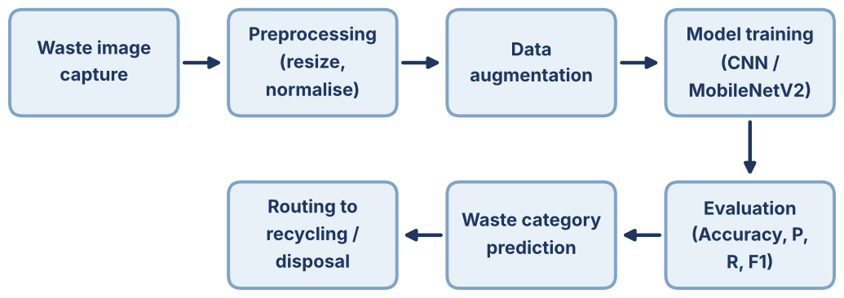
Figure 1. Proposed pipeline of the Smart Waste Classification System.

Step 1: Domain Analysis and Literature Review
Initially, the waste management problem is studied by reviewing research papers related to computer vision and deep learning-based waste classification. Existing approaches, datasets, and deep learning architectures are analyzed to identify suitable techniques for the proposed solution. The review indicates that lightweight transfer learning models such as MobileNetV2 provide high classification accuracy while requiring relatively low computational resources.

Step 2: Dataset Collection
A publicly available dataset such as TrashNet or the Garbage Classification Dataset will be selected. The dataset contains labeled images of different waste categories including:
- Plastic
- Paper
- Cardboard
- Glass
- Metal
- Organic Waste
The dataset will be divided into Training, Validation, and Testing sets using an approximate ratio of 70:15:15.

Step 3: Data Preprocessing
Image preprocessing improves the quality and consistency of input data before model training.
The preprocessing steps include:
- Image resizing to 224 × 224 pixels
- Pixel value normalization
- Removal of duplicate or corrupted images
- Data augmentation techniques such as:
  - Random Rotation
  - Horizontal Flip
  - Zoom
  - Brightness Adjustment
These techniques help reduce overfitting and improve model generalization.

Step 4: Model Selection
Two models will be considered.

Baseline Model
A standard Convolutional Neural Network (CNN) will be implemented to establish baseline performance.

Proposed Model
A transfer learning model based on MobileNetV2 will be implemented because:
- It provides high classification accuracy.
- It requires fewer parameters.
- It is suitable for deployment on embedded devices and smart waste bins.
- It offers faster inference compared to larger architectures.

Step 5: Model Training
The model will be trained using TensorFlow/Keras with the following configuration:
- Framework: TensorFlow/Keras
- Optimizer: Adam
- Loss Function: Categorical Crossentropy
- Learning Rate: 0.001
- Batch Size: 32
- Number of Epochs: 25–30
Training and validation accuracy and loss will be monitored to prevent overfitting.

Step 6: Performance Evaluation
The trained model will be evaluated using:
- Accuracy
- Precision
- Recall
- F1-score
- Confusion Matrix
- ROC-AUC (if applicable)
The results will be compared with the baseline CNN model to justify the effectiveness of the proposed transfer learning approach.

Step 7: Deployment Challenges and Applications
Possible deployment challenges include:
- Similar appearance of different waste materials.
- Poor lighting conditions.
- Occluded or damaged waste objects.
- Limited availability of labeled datasets.
- Computational constraints on embedded hardware.
Potential real-world applications include:
- Smart Dustbins
- Recycling Plants
- Municipal Waste Management
- Smart Cities
- Educational Demonstration Systems

3. REFERENCES

Research Papers
[1] M. R. Salami et al., "Application of MobileNetV2 to Waste Classification," PLOS ONE, vol. 18, no. 3, 2023.
[2] M. Mittal et al., "WasteNet: Waste Classification at the Edge for Smart Bins," arXiv preprint arXiv:2006.05873, 2020.
[3] M. Abdelhamid et al., "Classification of Waste Materials with a Smart Garbage System for Efficient Waste Management," Frontiers in Environmental Science, vol. 11, 2023.
[4] M. M. Islam et al., "Artificial Intelligence-Based Automated Waste Classification: A Systematic Review," Sustainability, 2025.

Documentation
[5] TensorFlow Documentation – https://www.tensorflow.org
[6] PyTorch Documentation – https://pytorch.org

