1. **Average search time for LSH and linear search.**

Runtime comparison between linear search and LSH based search of top 10 nearest neigh-bors.

The LSH based search is much **faster than the linear search** which is bit strange as I thought Linear search will faster but it took 12.48 for single iteration where as LSH took 11.05

1. **Plots for error value vs. L and error value vs. K, and brief comments for each plot**

**(*for my understanding I have taken L values from 10 to 24)***

**error value vs. L Inferences are:**

1. Here error is decreasing with increasing hash table L value
2. Reason: Actual nearest neighbor is falling with increasing query point so error is decreasing

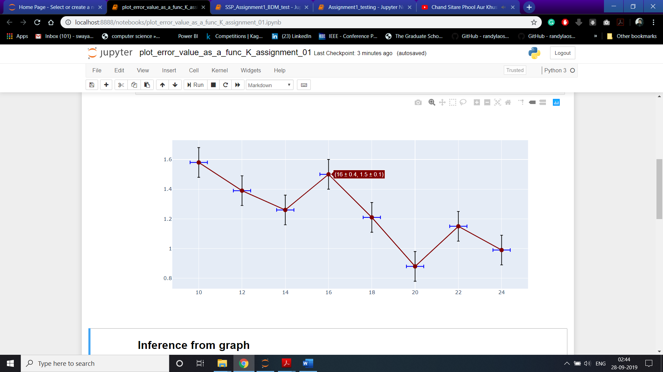

Fig 1. Error value vs L

**error value vs. K**

I have taken K values from 14 to 24 with 2 point increment for better visualization and pattern finding.

Inference:

1. 1. While increasing K value with 2points total number of buckets increases
2. 2. Chances of falling all True neighbours in a bucket decreases as query point is also decreases.
3. 3. Due to the above reasons the error may be increasing

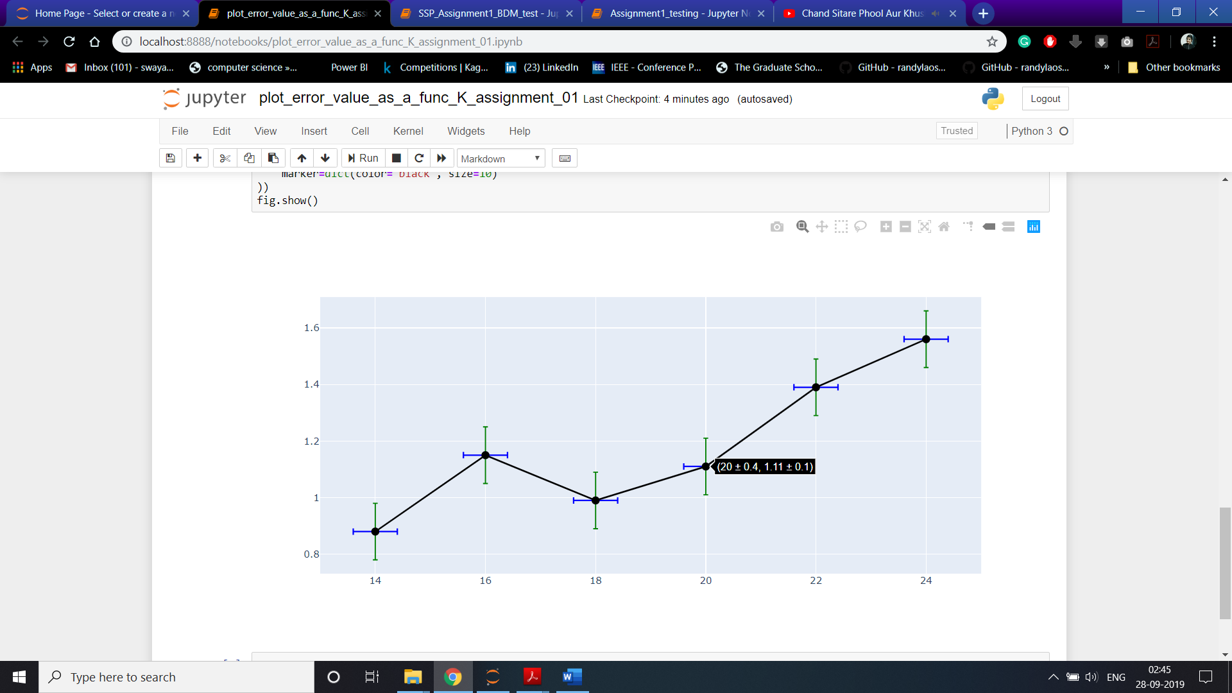

Fig 2. Error value vs K

1. **Plot of 10 nearest neighbors found by the two methods (also include the original image) and brief visual comparison**

**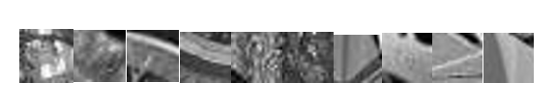**

**Actual nearest neighbor**

**top10_images-1top10_images-2top10_images-4top10_images-3top10_images-5top10_images-6top10_images-7top10_images-10top10_images-8top10_images-9**

**Based on neural net**

**Comparison of Both methods actual top 10 and neighbours obtained by LSH**

∑1= 1 0

0 1

∑2= 1.2 0.9

0.9 1.2