Time Series is generally data which is collected over time and is dependent on it.
Here we see that the count of cars is independent of time, hence it is not a time series. While the CO2 level increases with respect to time, hence it is a time series.
Let us now look at the formal definition of Time Series.
A series of data points collected in time order is known as a time series. Most of business houses work on time series data to analyze sales number for the next year, website traffic, count of traffic, number of calls received, etc. Data of a time series can be used for forecasting.
Not every data collected with respect to time represents a time series.
Some of the examples of time series are:
Stock Price :
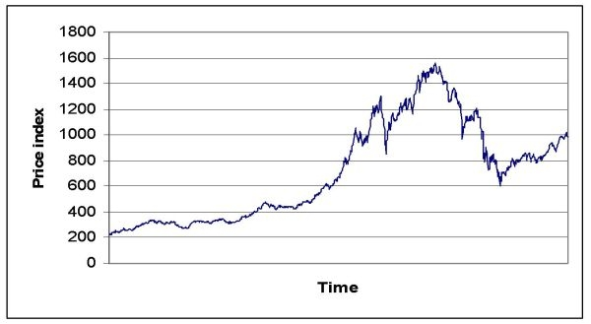
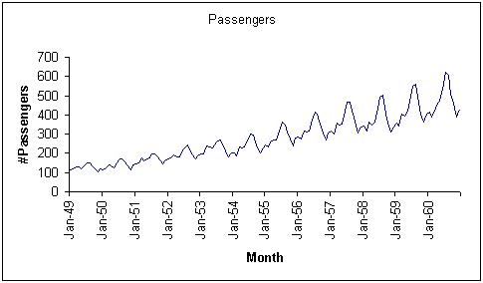
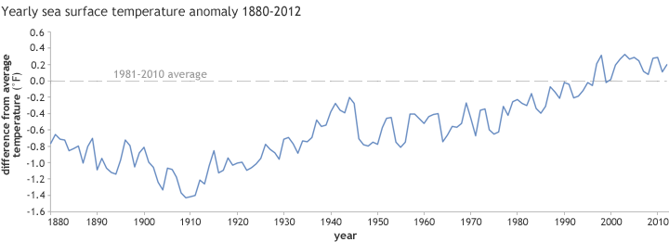
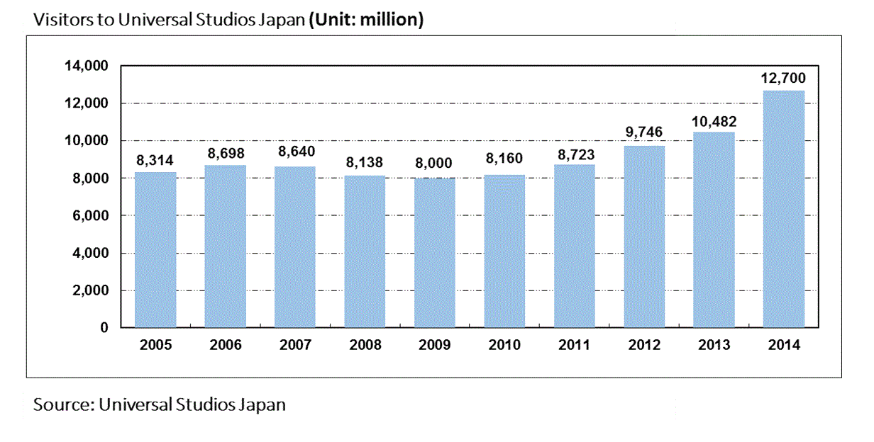

Components of a Time Series
- Trend : Trend is a general direction in which something is developing or changing. So we see an increasing trend in this time series. We can see that the passenger count is increasing with the number of years. Let’s visualize the trend of a time series:
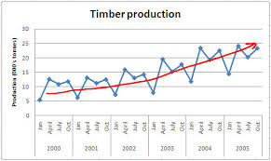
Example
Here the red line represents an increasing trend of the time series.
- Seasonality : Another clear pattern can also be seen in the above time series, i.e., the pattern is repeating at regular time interval which is known as the seasonality. Any predictable change or pattern in a time series that recurs or repeats over a specific time period can be said to be seasonality. Let’s visualize the seasonality of the time series:
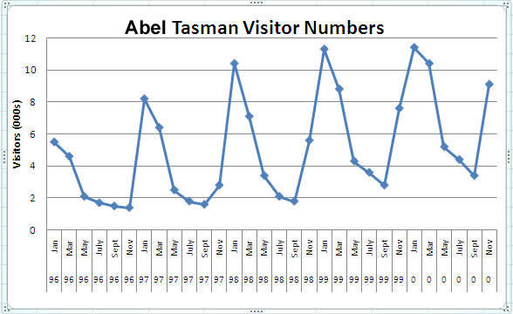
Example
We can see that the time series is repeating its pattern after every 12 months i.e there is a peak every year during the month of january and a trough every year in the month of september, hence this time series has a seasonality of 12 months.
Difference between a time series and regression problem
Here you might think that as the target variable is numerical it can be predicted using regression techniques, but a time series problem is different from a regression problem in following ways:
- The main difference is that a time series is time dependent. So the basic assumption of a linear regression model that the observations are independent doesn’t hold in this case.
- Along with an increasing or decreasing trend, most Time Series have some form of seasonality trends,i.e. variations specific to a particular time frame.
So, predicting a time series using regression techniques is not a good approach.
Time series analysis comprises methods for analyzing time series data in order to extract meaningful statistics and other characteristics of the data. Time series forecasting is the use of a model to predict future values based on previously observed values.

Understanding Data:

1) Hypothesis Generation

2) Getting the system ready and loading the data

3) Dataset Structure and Content

4) Feature Extraction

5) Exploratory Analysis

b) Forecasting using Multiple Modeling Techniques:

1) Splitting the data into training and validation part

2) Modeling techniques

3) Holt’s Linear Trend Model on daily time series

4) Holt Winter’s Model on daily time series

5) Introduction to ARIMA model

6) Parameter tuning for ARIMA model

7) SARIMAX model on daily time series

