Sean W. Barton

Art History Section 02

Visual Analysis Paper

12/13/15

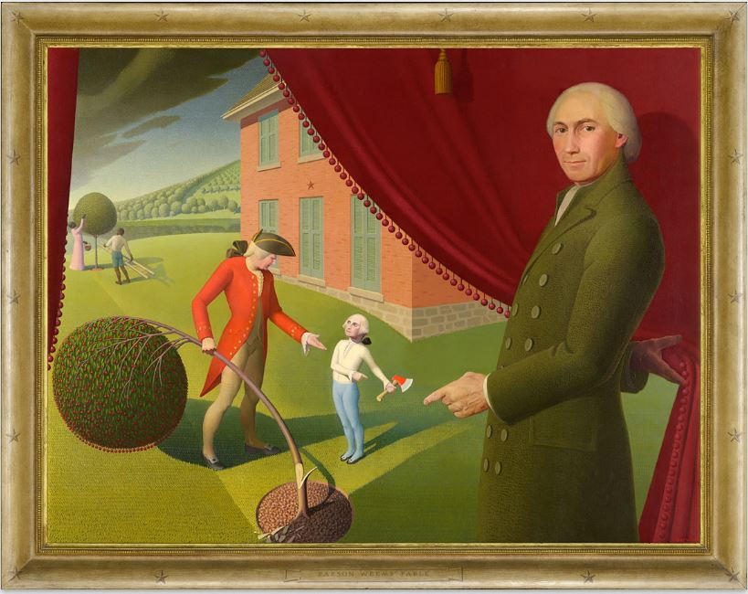

I chose ‘*Parson Weems’ Fable*’ by the artist, Grant Wood, as my first piece of art to analyze. This piece was drawn in the modern art era in 1939; the medium chosen was oil on canvas and the size was 127.3W x 97.5H cm. The subject of the drawing depicts George Washington as a child using a hatchet to cut down a cherry tree. I remember hearing this story as a child as this is a big part of my choice of this work of art. George Washington is questioned by his father who cut down the tree and George Washington, not being able to tell a lie, informs his father that he is the culprit. This was an epiphany as a child to attempt to always tell the truth, even though we, as adults, can’t always manage that. Woods’ elements of color and space really shine in this. He uses a lot of green and a lot of red but they are very unique and stand out. The element of space can be depicted by the curtain that is drawn. His choices of design and composition appear to be balance and proportion. The balance ties in really well using the color choices and the proportion with the curtain similar to the space element.

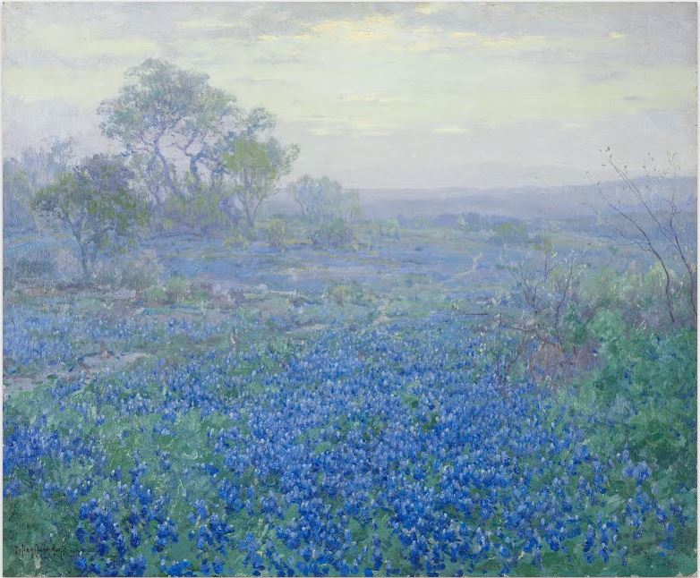

The second piece of art that I chose is Julian Onderdonk’s ‘*A Cloudy Day, Bluebonnets near San Antonio, Texas*’ created in 1918. Onderdonk’s piece was drawn with oil on a 76.5W x 63.8H cm canvas. I chose this piece of art because this is something that I see every spring living in the state of Texas. The subject depicts a field of bluebonnet flowers near San Antonio. The drawing looks beautiful and seeing them in person is even more fascinating. They sprout a lot along the sides of Texas roads and in large open fields. You’ll see people pulled over just to get out of their vehicles and take photos with the freshly budded flowers. The bluebonnet is the state flower of Texas. Onderdonk’s choices of elements here are color and texture. The color comes from the large choices of the light and dark blues (perfectly depicts a bluebonnet) and the green and gray background (foggy day) and the texture you can see between with the differences between the blue and green, it almost looks splotchy. His choices of design and composition I would say are emphasis and repetition. Emphasis on the level of detail in each bunch of flowers while at the same time being repetitive.

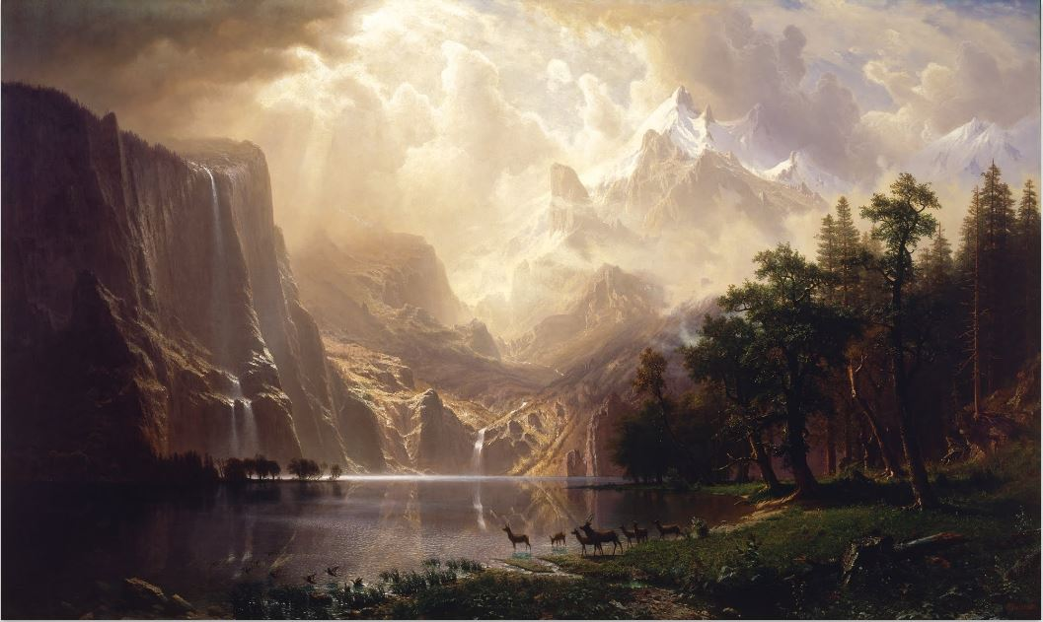

The third piece of work that I chose is ‘*Among the Sierra Nevada, California*’ by Albert Bierstadt. This piece was drawn in 1868 with a medium of oil on canvas measuring the dimensions of 3051.3W x 1828.8H mm. There are little details specified on this painting but I chose it due to the shear level of detail of every aspect of the drawing, whether it be the mountains in the background, the lake, or even the deer. The way the clouds were drawn parting and allowing light down onto the lake and mountains is majestic. I would say Bierstadt’s elements of choice would be surface and space. He took advantage of the use of canvas by looking into the details of the lake you can see the canvas texture and the space you can see by admiring the area of the entire painting. I’d say his principles of design and composition would be emphasis and variety. Every detail of this work of art has been emphasized with great levels of detail and there is so much variety in this painting if you look at everything I’ve previously mentioned. Overall, this piece is absolutely beautiful and my favorite so far. I will definitely look into more of Bierstadt’s works.

**References:**

Parson weems’ fable (Unknown) Retrieved December 13, 2015 from <https://www.google.com/culturalinstitute/u/0/asset-viewer/parson-weems-fable/SwHq47XAgCz28Q?projectId=art-project>

A cloudy day, bluebonnets near san antonio, texas (Unknown) Retrieved December 13, 2015 from <https://www.google.com/culturalinstitute/u/0/asset-viewer/a-cloudy-day-bluebonnets-near-san-antonio-texas/8QH3EBQrgPqotA?projectId=art-project>

Among the sierra nevada, california (Unknown) Retrieved December 13, 2015 from <https://www.google.com/culturalinstitute/u/0/asset-viewer/among-the-sierra-nevada-california/IQE1CY9y_Rfy5A?projectId=art-project>