Philip, Seth, Brandon

Heatmap Viz Project

**Rationale**

Use a heatmap to depict the relationship between home values and temperatures and population density. See if the average temperatures of an area correlates to the average or median home values in that area.

**Datasets**

**Inspiring Visuals**

**Sketch**

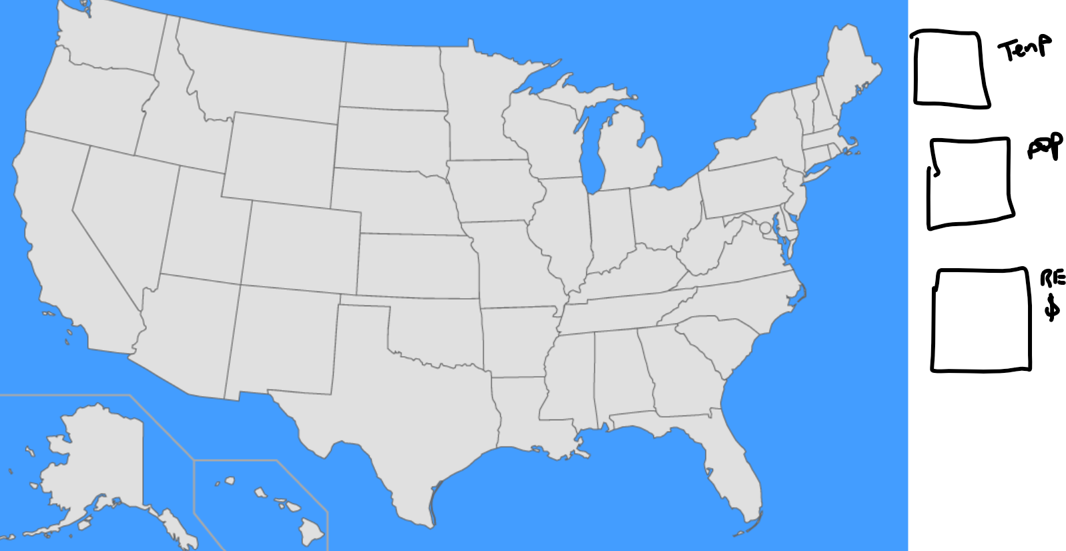

**Github Link**

<https://github.com/swbrummund/Project_HeatmapViz>