Fusing short-pulse voltage waveforms with handcrafted features for rapid state-of-health estimation of lithium iron phosphate batteries: a controlled comparison of encoder pairings
[First Author]ª, [Second Author]ª, [Corresponding Author]^{a,}*
ª [Department, Institution, City Postcode, Country]
Corresponding author: [Name].
Address: [Postal address].
Tel: [ ].
E-mail address: [ ]
Declarations of interest: None
Funding information
[Funding sources and grant numbers to be added.]
Abstract:
Background
Short current pulses offer a rapid diagnostic for the state of health (SOH) of lithium-ion batteries, because a single pulse lasts seconds to minutes and needs only a controlled current step. Whether a learned waveform representation adds information to handcrafted pulse features, and how the encoders of such multi-branch models should be paired, has not been tested under a controlled protocol.
Method
A dual-branch model is built in which a primary branch of handcrafted features and the cumulative cycle count is supplemented by a branch encoding the 101-point pulse-voltage response. All 15 pairings of three handcrafted-feature and five waveform encoders are evaluated on 16,938 pulse records from 64 public lithium iron phosphate (LFP)/graphite cells with five-fold cell-disjoint cross-validation. The model is further tested on an independent nickel–manganese–cobalt (NMC)/graphite dataset, on held-out cycling conditions, under cycle-count errors and sensor noise, and with reduced pulse protocols.
Significant findings
A multilayer perceptron (MLP) handcrafted-feature encoder paired with a patch-based Transformer (PatchTST) waveform encoder attains the lowest cell-level root-mean-square error, 1.377 SOH percentage points (95% CI 1.247–1.513). The waveform branch lowers the error by 8.2% in 58 of 64 cells, most strongly below 80% SOH (17.2%), and the gain is reproduced on the NMC dataset (7.6%, 39 of 44 cells). Encoder rankings depend on the pairing: PatchTST ranks first with the MLP but last with the other two encoders. The model is robust to unseen cycling conditions and ±10% cycle-count errors (at most +3.5%), three charge pulses match the six-pulse protocol, and inference needs only 19,041 parameters. Encoders for pulse-based SOH estimation should therefore be selected as pairings on controlled evidence rather than by architectural complexity.
KEYWORDS Lithium iron phosphate battery; State of health; Short current pulse; Feature fusion; Patch-based Transformer; Cell-disjoint validation

1. Introduction
Lithium-ion batteries (LIBs) in electric vehicles and energy storage systems age throughout their service life. Assessing their state of health (SOH) is essential for estimating available energy and power, planning maintenance and informing decisions on second-life use [1–3]. Capacity-based SOH is defined as the ratio of a battery’s current capacity to its initial capacity, and its direct measurement requires a full charge–discharge test under controlled conditions. Such tests typically take several hours and interrupt normal operation, making frequent field testing impractical [4,5]. SOH must therefore be inferred from signals that can be acquired more rapidly. Data-driven approaches have been built on differential curves, partial charging curves, voltage relaxation, electrochemical impedance spectroscopy (EIS) and short current pulses. Most of them impose demanding operating requirements, such as prolonged data collection, complete controlled cycles or dedicated excitation hardware [1,4,6,8–11]; differential-curve peaks, for example, are further blurred by sensor noise and by the flat voltage plateau of lithium iron phosphate (LFP) cells [7]. These requirements are difficult to meet outside the laboratory. Short current pulses are a notable exception. A current pulse is essentially a time-domain impedance measurement [12], and under suitable test conditions its response can even be used to reconstruct impedance spectra [13]. Degradation modes such as loss of lithium inventory, loss of active material and interfacial film growth alter the pulse response, causing it to evolve with ageing [12,14], and pulse-based characterisation is already standard in battery testing [15]. Whereas a full hybrid pulse power characterisation sequence can exceed 12 h [17], a single pulse lasts only seconds to minutes and requires nothing more than a controlled current step, making pulse testing a rapid and practical route to capacity estimation [16]. For LFP cells, the pulse response is dominated by kinetic overpotentials, so its change with ageing remains measurable even where the equilibrium voltage barely moves.
Data-driven SOH estimation relies on input features extracted from voltage, current, temperature or impedance measurements, and studies adopt diverse forms—voltage curves, incremental-capacity or differential-voltage curves, statistical metrics, frequency-domain indicators or model parameters—depending on battery type, operating condition and model structure. Deployment in battery management systems (BMSs) adds further constraints: inference must run in real time on resource-limited hardware, and black-box behaviour undermines trust in safety-relevant decisions [18,19]. By how they are obtained, the inputs fall into two categories [21,22]. One extracts handcrafted health indicators from voltage, current, temperature or incremental-capacity curves as inputs to regression models [3]. These indicators are physically interpretable but rely on human expertise and transfer poorly across operating conditions [21,22]. The other learns representations directly from raw sequences with deep networks; it avoids manual feature design but offers limited interpretability, and its performance depends heavily on how well the network architecture matches the task [18,22]. Multi-branch models can combine the strengths of both by fusing several input representations [23–25]; however, their encoders are selected at design time, and comparative evaluations focus on baseline models and fusion strategies rather than on systematic comparisons of branch encoders [24,25]. Systematic comparisons under consistent protocols and rigorous cross-validation also remain limited [26], and some benchmarks consider only a single input type [27]. Consequently, there is no consensus on feature extraction, and this fragmentation, together with the lack of standard evaluation protocols, makes it difficult to compare methods on a common basis and to transfer them to new batteries or real BMSs [20].
For SOH estimation from short current pulses, existing studies each use a single input representation: Li et al. [16] and Nowacki et al. [28] use raw pulse responses, whereas Tao et al. [17,29] and Ran et al. [30] regress SOH on features extracted from the responses, and transfer across states of charge has also been examined [31]. These studies confirm that short pulses carry SOH-relevant information, but no consensus has been reached on how features should be extracted or which representation is preferable. Three issues remain unclear. First, the main effect of the encoder in each branch is unknown, including whether a more complex encoder for handcrafted features improves performance. Second, encoder pairing has not been examined: the performance of a waveform encoder may depend on the handcrafted-feature encoder it is paired with, a dependence that comparisons varying only one branch cannot capture. Third, comparability across studies is limited by differences in input information [32–34], data splitting and preprocessing [35,36] and training settings [26], and no common benchmark exists [37]. A systematic comparison is therefore needed in which both encoders are varied and all combinations are evaluated under a unified protocol. The answer also matters for deployment: if more complex encoders bring no benefit, lightweight structures should be preferred for resource-limited BMSs.
Fusing handcrafted features with raw waveforms can improve SOH estimation [23–25,42]. However, previous studies fused signals from different measurements [42,43] or different transforms of one signal [24,25], and few have addressed the fusion of handcrafted features and raw waveforms derived from the same pulse; the design of a supplementary encoder for a single short pulse has received little attention. Handcrafted features as the primary branch are common practice in SOH estimation [3,17,29,30]. They have clear physical meanings and suit lightweight models [21], in line with BMS requirements for interpretability and cost, and context absent from the raw waveform, such as usage history, can be added to them explicitly. However, handcrafted features compress the response: each describes only a predefined property, so coverage of all ageing-related changes across operating conditions cannot be assured [22]. Moreover, most handcrafted features are differences, statistics or frequency-domain quantities computed individually, so joint changes across different parts of the transient are difficult to characterise. A learned encoder can extract such shape information directly from the raw waveform, including information not covered by handcrafted features. Used alone, however, learned encoders offer limited interpretability [18], and raw waveforms carry no information on operating conditions or usage history. A learned waveform encoder is therefore better suited to supplementing handcrafted features than to replacing them.
For the waveform branch, patch-based encoders are a promising candidate. PatchTST encodes contiguous segments as tokens and relates them through self-attention [40], which may complement individually computed features. However, it was designed for long-sequence forecasting [40]. In battery research it has been applied to SOH estimation [44], lifetime prediction [45] and voltage prediction [46], but its adaptation to short-pulse inputs and scalar health estimation remains unexamined.
To address these issues, we construct a complete comparison matrix of waveform and handcrafted-feature encoders under a unified experimental protocol, with identical data splits, preprocessing and training budgets. The matrix includes five waveform encoders with convolutional, fully connected, temporal convolutional [38], point-wise attention [39] and patch-based [40] architectures, and three handcrafted-feature encoders: a multilayer perceptron (MLP), a ResNet and an FT-Transformer [41]. All combinations are compared using cell-disjoint cross-validation. Unlike fusion studies that select branch encoders in advance [23–25] or model comparisons using a single input [27], this design estimates main effects, tests dependence on encoder pairing and attributes error differences to the encoders themselves. Based on the matrix, we develop a dual-branch model consisting of a primary handcrafted-feature branch, encoded by an MLP and incorporating operating context and cumulative cycling information, and a supplementary branch of patch-based waveform representations, for which a concrete adaptation of PatchTST from time-series forecasting to scalar SOH estimation is presented. The two branches are fused at a late stage. To reflect the general decline of capacity with cycling, a soft monotonicity constraint on predicted SOH with respect to the cumulative cycle count is imposed; unlike approaches built on degradation dynamics, mechanistic features or digital twins [47–49], it requires no mechanistic model. Ablation studies and cell-level statistical analysis quantify the contribution of each design factor.
The main contributions of this work are as follows:
- We construct a complete comparison matrix of waveform and handcrafted-feature encoders under a unified experimental protocol, enabling comparable evaluation of their main effects and of their dependence on encoder pairing with identical data splits, preprocessing and training budgets.
- We develop a dual-branch model for SOH estimation from short current pulses, using a primary handcrafted-feature branch supplemented by patch-based waveform representations, with operating context, cumulative cycling information and a concrete adaptation of PatchTST to scalar SOH estimation. Ablation studies and cell-level statistical analyses isolate the contributions of individual design factors and identify the conditions under which the waveform branch helps.
- We examine the generality of the model on held-out cycling conditions, under cycle-count errors and sensor noise, with reduced pulse protocols and on an independent nickel–manganese–cobalt (NMC)/graphite dataset, on which the waveform increment is reproduced, and quantify its attribution and computational cost.

2. Data and unified protocol
All models share one data protocol, so that error differences between encoders can be attributed to architecture: the cleaning rules, cell split, input policy of both branches and the train-fold feature selection and scaling are identical across the 15 encoder pairings and all supplementary experiments (Table 1).

2.1. Dataset, pulse protocol and SOH definition
The public UConn-ISU-ILCC LFP/Gr battery ageing dataset [28] contains 64 LFP/graphite power cells (nominal capacity 1.2 Ah) aged under 11 cycling conditions that differ in constant-current–constant-voltage (CC–CV) charge rate (2C–3.25C), constant-current discharge rate (1.5C or 2C) and depth of discharge (DOD, 60–100%) (Supplementary Table S1). Cycling was interrupted roughly every 100 cycles for a reference performance test (RPT) that measured the remaining capacity and applied short pulses [28,31]. All ageing tests and RPTs were performed by the data publisher; this study reanalyses the data.
Each RPT applies one charge and one discharge pulse at each of three SOCs. A pulse consists of 30 s at 0.2C, 10 s at 1C and a 60 s rest (Fig. 1a) [31]; it lasts 100 s and passes about 0.44% of the nominal capacity. Pulses are triggered at preset voltage cut-offs, so 20%, 50% and 90% are nominal SOCs at beginning of life and the actual SOC drifts as capacity fades [31]. Each RPT therefore yields records for six conditions (three nominal SOCs × two directions). Within the 1 Hz record, the voltage step at each current change mainly reflects ohmic resistance and fast charge transfer, the continued change during constant current adds diffusion, and the slow recovery during rest is dominated by diffusion relaxation [12] (Fig. 1b,c). The voltage difference between the ends of the 0.2C and 1C segments gives the 10-s direct-current internal resistance (DCIR) used in Section 2.3.2.
SOH is normalised by the discharge capacity at the first RPT of the same cell:
$y_{ir}=100×\frac{Q_{ir}}{Q_{i0}}$ (1)
where $Q_{ir}$ is the discharge capacity of cell $i$ at RPT $r$. SOH thus denotes capacity retention relative to the initial measurement rather than to the rated capacity. The capacity comes from the full reference discharge of the RPT, i.e. the hour-long test that pulse diagnostics aim to replace; it serves only as the label, and no quantity derived from it enters the model (Section 2.3.2).
Each record contains 101 voltage samples: sample 0 is the last voltage before current is applied, and the 30, 10 and 60 s segments were resampled to 1 Hz by piecewise cubic Hermite interpolation in the publisher’s processing code [31]. Interpolated points are not treated as independent samples. Each inference uses one pulse record, i.e. one 100-s test. The primary metric averages the six single-record predictions of an RPT, which corresponds to a joint diagnosis at three nominal SOCs whose duration also includes bringing the cell to each SOC; single-condition errors are reported separately (Section 4.3).
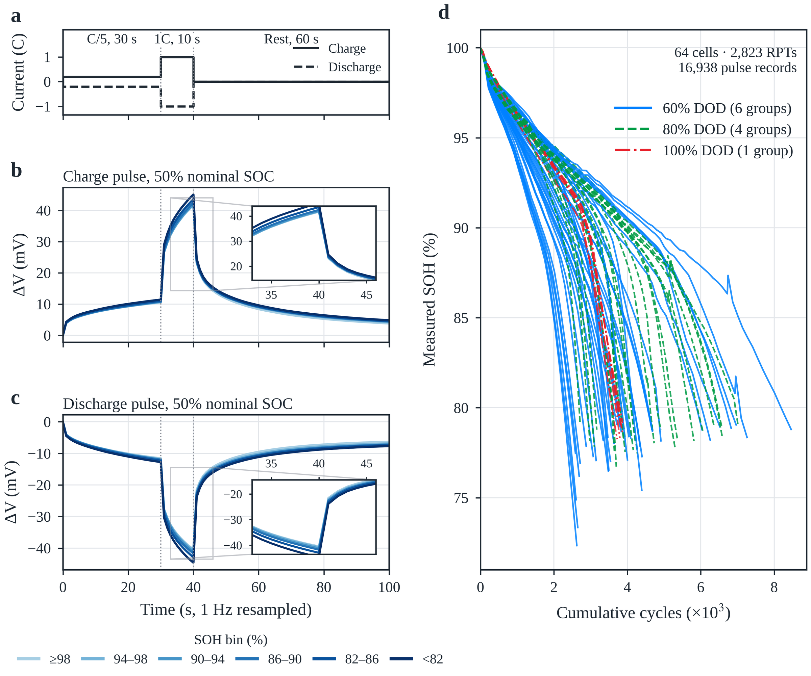
Fig. 1. Dataset and pulse response. (a) Programmed current of the charge (solid) and discharge (dashed) pulses: 30 s at C/5, 10 s at 1C and 60 s rest. (b, c) Mean voltage response ΔV relative to the pre-pulse voltage at 50% nominal SOC, grouped by measured SOH (darker = lower SOH); insets magnify the end of the 1C segment and the onset of relaxation, where the overpotential grows with ageing. (d) Measured SOH of the 64 cells versus cumulative cycle count, coloured by depth of discharge; lines connect measured RPTs without interpolation.

2.2. Data cleaning and cell-disjoint split
Before cleaning, the data contain 17,130 records in 2,855 cell–RPT groups. A record is retained only if it passes all predefined checks:
$A=\left\{\left(V,x,y\right):\begin{matrix} & V_{t}∈\left[2.5,4.5\right] V ∀t; \max_{t}V_{t}−\min_{t}V_{t}∈\left[0.005,0.5\right] V; \max_{t}\left|V_{t+1}−V_{t}\right|≤0.1 V \\ & y∈\left[0,110\right]; q_{miss}≤0.20; \left|G_{i,r}\right|=6; \max_{g∈G_{i,r}}y_{g}−\min_{g∈G_{i,r}}y_{g}≤{10}^{−5}\end{matrix}\right\}$ (2)
where $V_{t}$ is the $t$-th voltage sample, $y$ the SOH in percent, $q_{miss}$ the fraction of missing handcrafted features and $G_{i,r}$ the six condition records of cell $i$ at RPT $r$. All 192 removed records failed because their cycle count was not finite: the publisher’s data lack the cycle count at the 42nd RPT, which affects all 32 cells that reached it (32 complete cell–RPT groups). The remaining 16,938 records form 2,823 complete groups covering all 64 cells, with SOH from 72.34% to 100% (Fig. 1d). Thresholds were fixed in advance and logged, not tuned on test errors.
Five outer test folds were built with split seed 42: the 64 cell identifiers were permuted and divided into five disjoint test sets. Within the non-test cells of each fold, validation cells were drawn with the fold index as offset and a stride of five, and the remaining cells were used for training, giving 40/11/13, 41/10/13, 41/10/13, 41/10/13 and 42/10/12 training/validation/test cells. All RPTs and conditions of a cell are assigned together, because random record-level splits inflate accuracy [36]. The split is identical for all experiments, and the MLP primary branch with the PatchTST supplementary branch serves as the reference configuration R0.
Table 1. Data, inputs and experimental design.
Item | Setting
Data | Public UConn-ISU-ILCC LFP/Gr dataset; 64 cells, 16,938 records, 2,823 cell–RPT groups
Pulse conditions | Nominal SOC 20%, 50%, 90% × charge, discharge; 100 s per pulse
Waveform branch | 101-point ΔV, per-position train-fold standardisation
Primary branch | 50 train-fold-selected features (49 waveform-derived + DCIR) + cumulative cycle count τ
Excluded inputs | Coulomb-counted SOC and its deviation (derived from reference capacity); other records of the same RPT; past capacities; cell identity
Validation | Five cell-disjoint outer folds; initialisation seeds 0, 1, 2
Encoder matrix | 5 waveform × 3 primary-branch encoders × 5 folds × 3 seeds = 225 trainings
Further experiments | 19 neural configurations × 15 = 285 trainings; 30 reproduced reference models (Section 3.5)
Primary metric | Cell-macro RMSE after averaging the six condition predictions of each RPT

2.3. Handcrafted primary branch inputs

2.3.1. Candidate feature families
The handcrafted branch is the primary branch of the model. Of 150 candidate features, 143 are computed from the voltage of a single pulse and 7 describe condition and age (Table 2). Waveform-derived features follow the publisher’s pulse timing and act on the 30-s low-current segment, the 10-s high-current segment, the 60-s rest and the full sequence. They form six families, each feature having a fixed window and formula (Supplementary Note S1). All are computed item by item: transient-boundary features span adjacent segments but compare only predefined sample pairs and do not represent joint shape changes across the transient, which motivates the supplementary waveform branch (Section 2.4).
Table 2. Candidate handcrafted feature families and their selection on the training cells of fold 0.
Family | Candidates | Window | Content | Selected
Segment statistics | 45 | 30 s, 10 s, 60 s segments | Level, dispersion, shape, entropy, linear trend | 9
Global waveform | 24 | Full sequence | Global statistics, end points, quantiles | 7
Difference dynamics | 22 | First and second differences | Rate of voltage change and its change | 14
Transient boundary | 18 | Predefined sample pairs | Steps at current changes, net changes, response times | 2
Frequency and wavelet | 24 | Demeaned, windowed sequence | Spectral amplitudes, band energies, spectral shape, wavelet energies | 16
Nonlinear complexity | 10 | Full sequence | Autocorrelation, Hjorth parameters, entropies, Hurst exponent | 1
Condition and age context | 7 | Record metadata | Nominal and coulomb-counted SOC, deviation, direction, DCIR, cycle count, RPT index | 1ª
Total | 150 |  |  | 50
ª Matched-condition DCIR. Across the five folds, 47 features were selected in every fold and 54 in at least one. Coulomb-counted SOC, SOC deviation, cumulative cycle count and RPT index do not enter selection (Section 2.3.2).

2.3.2. Condition context and cumulative cycle count
A single pulse carries no record of cumulative use, and its starting SOC drifts with ageing. The primary branch therefore considers seven context candidates,
$\left[\frac{SOC_{nom}}{100}, \frac{SOC_{coul}}{100}, \frac{SOC_{coul}−SOC_{nom}}{100}, ±1, {DCIR}_{pulse,SOC}, n_{i,r}, r\right]$ (3)
namely nominal SOC, coulomb-counted SOC, their deviation, pulse direction, matched-condition DCIR, cumulative cycle count and RPT index. The publisher computes the DCIR from the voltage difference between the two current levels of the same pulse, $R=\left|V_{40}−V_{30}\right|/\left(1.2 A−0.24 A\right)$ [31], where $V_{30}$ and $V_{40}$ are the last samples of the 0.2C and 1C segments. It depends only on the pulse, represents the power-related resistance discussed in Section 1, and enters feature selection.
Coulomb-counted SOC and its deviation from the nominal SOC are excluded. The publisher’s code divides the charge accumulated at the pulse start by the capacity measured in the reference discharge of the same RPT [31], which is the numerator of the SOH label in Eq. (1); both quantities are therefore label-derived and unavailable without a full capacity test. Nominal SOC and pulse direction remain candidates, but since every RPT contains all six conditions their rank correlation with SOH is zero and they were never selected; the direction is also evident from the sign of the waveform input.
The cumulative cycle count does not enter selection; it is standardised separately as the input $τ$ (Section 2.5), and the RPT index is removed to avoid duplicating age information. The count $n_{i,r}$ is accumulated from the cycle intervals between successive RPTs. Because the 42nd-RPT interval is missing, the 32 affected cells undercount one interval (67–118 cycles, median 85, i.e. 1.3–2.3% of life) at their 494 subsequent cell–RPT points; Fig. 1d and the model use the same rule. Using $τ$ requires the cell’s cycle record, which defines the application scope of the model.

2.3.3. Train-fold feature selection
Removing cumulative cycle count, RPT index and the two label-derived SOC quantities leaves 146 selectable features. In each fold, the Spearman rank correlation between each feature and SOH is computed on the training records only,
ρj=i​rij−rjriy−ryi​rij−rj2i​riy−ry2 (4)
where $r_{ij}$ and $r_{i}^{y}$ are the ranks of feature $j$ and of the label. Features are taken greedily in descending $\left|ρ_{j}\right|$, skipping any candidate whose absolute rank correlation with an already selected feature reaches 0.98:
$S←S∪\{j\} \text{if and only if} \max_{i∈S}\left|ρ_{ji}^{rank}\right|<0.98 \text{and} \left|S\right|<K$ (5)
If fewer than $K$ features pass, the remaining finite-correlation features are added in descending $\left|ρ_{j}\right|$ without the redundancy constraint. Each fold selected 50 features, 47 of them in all five folds (54 in the union), so the selection is stable across training cells. In fold 0, frequency and wavelet (16) and difference-dynamics features (14) dominate (Table 2), and the DCIR ranks 13th–14th in every fold. The dominant frequency and the 85% spectral roll-off are constant within the training cells of some folds and are skipped, so at most 144 features can be ranked. The choice $K=50$ is justified in Section 4.5.3.

2.4. Supplementary waveform branch input
The waveform branch receives only the voltage sequence of the pulse, without condition or age information. The sequence $V_{0},…,V_{100}$ is referenced to its first sample,
$Δv_{t}=V_{t}−V_{0}, t=0,1,…,100$ (6)
which removes the starting voltage so that the sequence represents the pulse-induced polarisation, the kinetically controlled part that remains measurable on the flat LFP plateau. Each position is then standardised with training-fold statistics,
${\tilde{v}}_{t}=\frac{Δv_{t}−μ_{t}^{w}}{σ_{t}^{w}}$ (7)
so the full 101-point transient is retained for the waveform encoder to learn inter-segment shape information not covered by the handcrafted features.

2.5. Imputation, scaling and input audit
Missing values are imputed by the training-fold median of finite values and then standardised:
$m_{j}=median\{x_{ij}:x_{ij}∈R\}, {\tilde{x}}_{ij}=\left\{\begin{matrix}x_{ij}, & x_{ij}∈R \\ m_{j}, & x_{ij}∉R\end{matrix}\right., z_{ij}=\frac{{\tilde{x}}_{ij}−μ_{j}}{σ_{j}}$ (8)
The cumulative cycle count is standardised and appended to the $K$ selected features,
ni,r=q≤r​Δci,q, τ=ni,r−μnσn, h=z1,…,zK,τT∈RK+1 (9)
giving a 51-dimensional primary-branch input for $K=50$. Labels are divided by 100 and standardised, and predictions are transformed back:
$y^{\text{*}}=\frac{y/100−μ_{y}}{σ_{y}}, \hat{y}=100\left(σ_{y}{\hat{y}}^{\text{*}}+μ_{y}\right)$ (10)
All statistics in Eqs. (4), (5) and (7)–(10) are fitted on the training fold only. Apart from the cycle count, every input is obtained from the single pulse; other condition records of the same RPT, past capacities, cell identity and reference-capacity-derived quantities never enter the model (Supplementary Table S2).

3. Model and experimental design

3.1. Framework
The model consists of a handcrafted primary-branch encoder $E_{h}$, a waveform supplementary-branch encoder $E_{v}$ and a regression head $g$ (Fig. 2). The primary branch receives the 51-dimensional input $h$ of Eq. (9) and the supplementary branch receives $\tilde{v}$ of Eq. (7); both are derived from the same pulse record, and $τ$ additionally needs the cycle record. Each encoder outputs a 32-dimensional embedding, and the concatenation is mapped to the standardised SOH:
${\hat{y}}^{\text{*}}=g\left(\left[E_{v}\left(\tilde{v}\right); E_{h}\left(h\right)\right]\right)$ (11)
The two branches differ in information: the primary branch carries pulse-derived physical descriptors such as the DCIR together with usage information and can estimate SOH on its own, whereas the supplementary branch sees only the shape of the response. The supplementary branch is therefore evaluated by its increment over the primary branch (Section 4.2). In the encoder matrix, three primary-branch and five supplementary-branch candidates are crossed while everything else is held fixed.
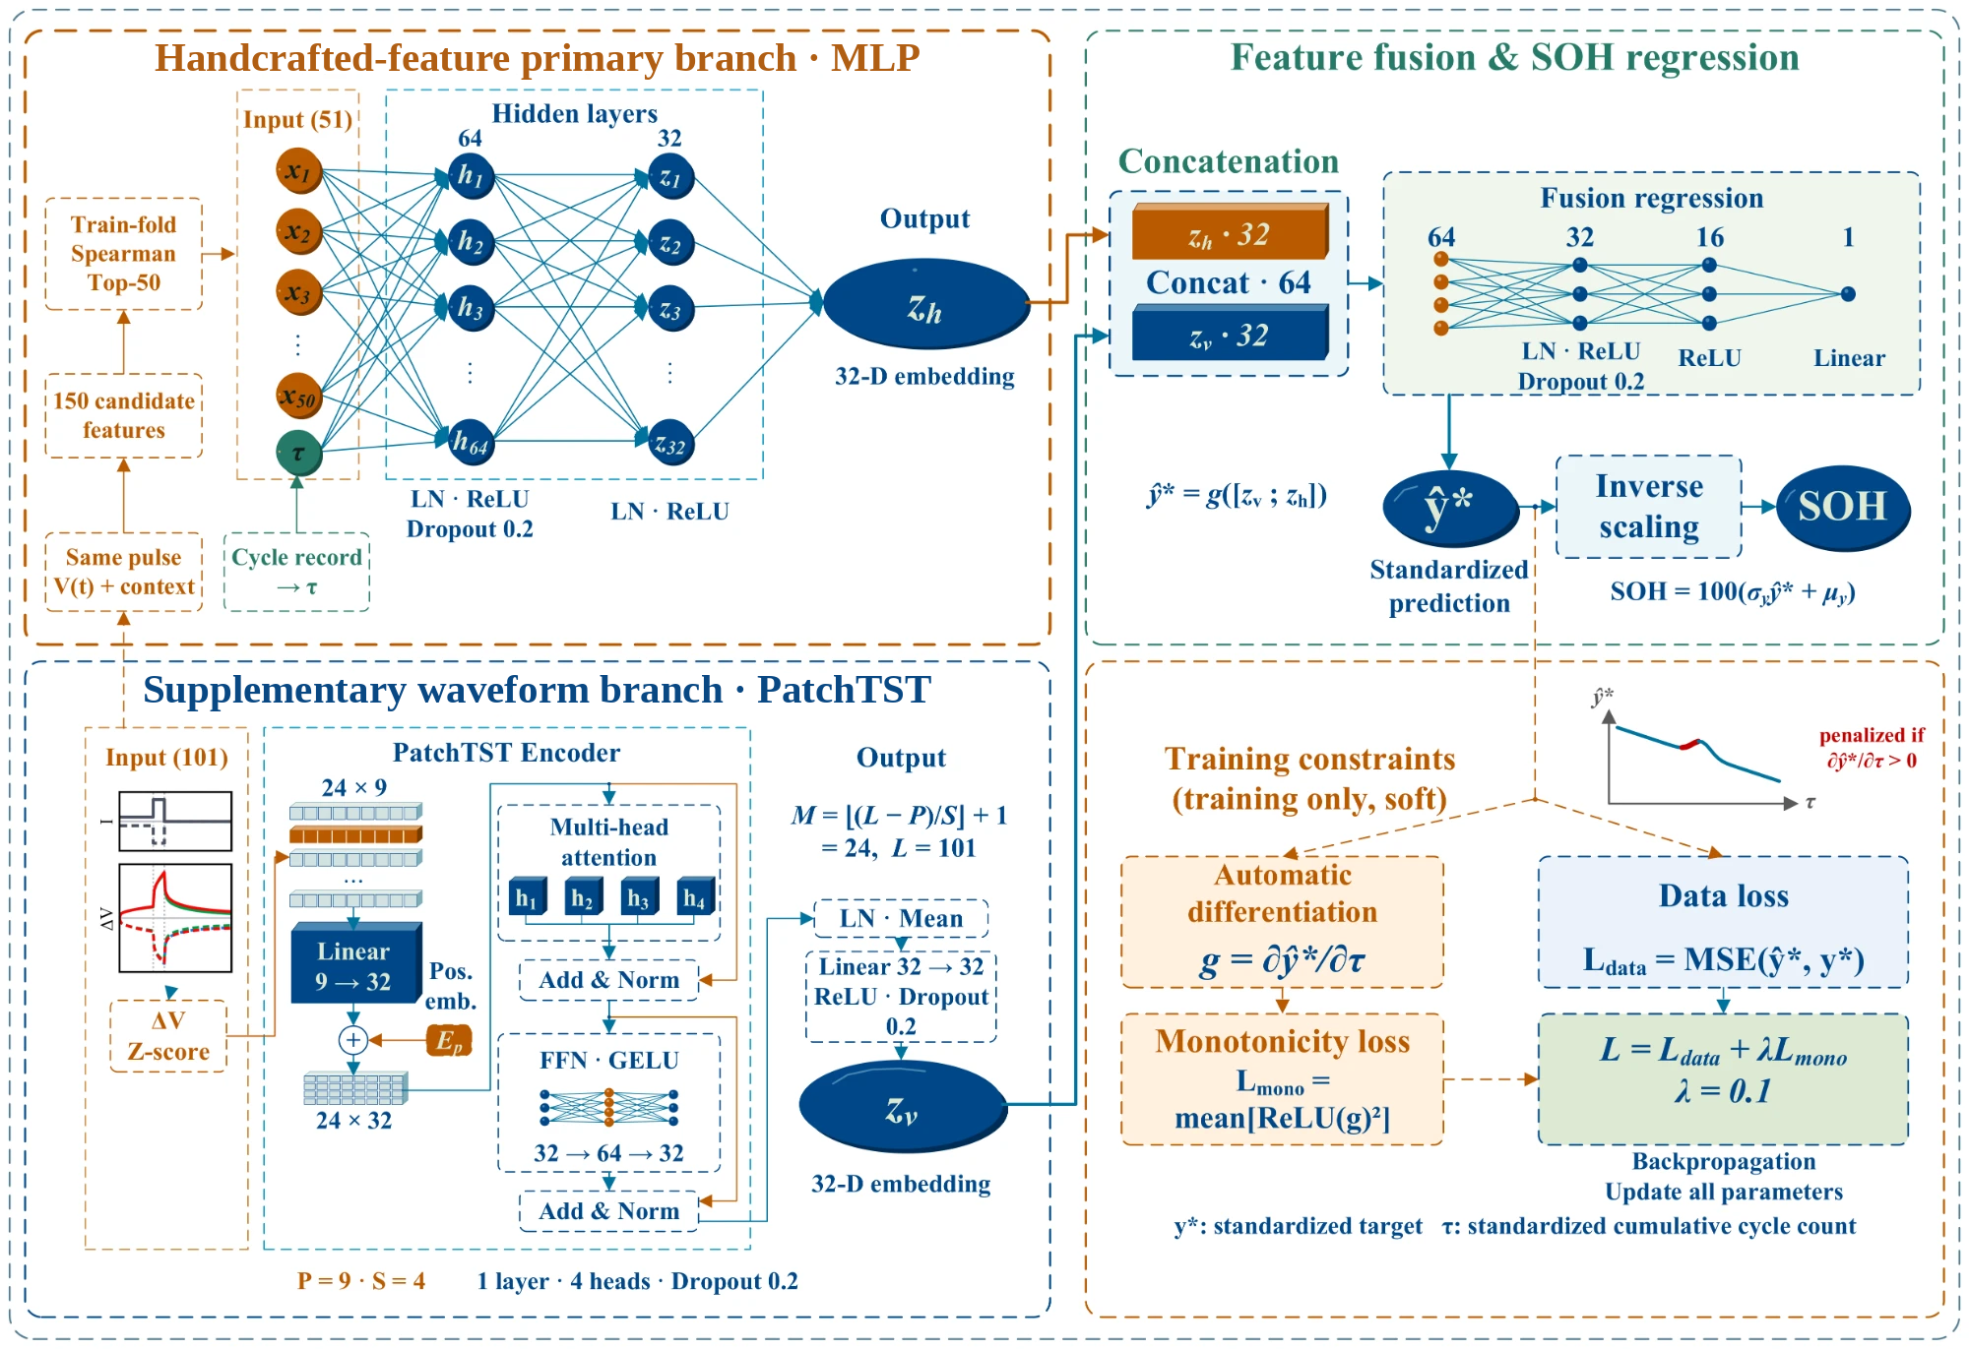
Fig. 2. Dual-branch SOH estimation model (configuration R0). Top left: handcrafted primary branch; 50 train-fold-selected features and the standardised cumulative cycle count τ form a 51-dimensional input encoded by an MLP into a 32-dimensional embedding. Bottom left: supplementary waveform branch; the 101-point pulse response is referenced to its first sample, standardised per position and split into 24 patches (length P = 9, stride S = 4) that a single-layer PatchTST encodes into a 32-dimensional embedding. Right: the concatenated 64-dimensional embedding is regressed to the standardised SOH ŷ* and inverse-transformed. Training minimises the mean squared error plus a penalty on positive ∂ŷ*/∂τ (λ = 0.1); the soft constraint acts only during training.

3.2. Primary-branch encoders
Three primary-branch encoders are compared. The MLP maps the 51 inputs to 64 and then 32 units, each layer followed by layer normalisation and ReLU, with dropout 0.2 after the first layer (5,600 parameters). ResNet and FT-Transformer follow their tabular reference implementations [41], adjusted to a 32-dimensional output at a similar budget: ResNet uses two residual blocks of width 28 (5,800 parameters), and FT-Transformer tokenises each input to width 20 and uses one Transformer block with four heads and a ReGLU feed-forward layer of hidden width 26 (6,124 parameters), both with dropout 0.2. All three receive the same input; $τ$ is passed as a separate tensor and concatenated so that the partial derivative of the prediction with respect to $τ$ can be computed (Section 3.4).

3.3. Waveform encoders and PatchTST adaptation
Five supplementary-branch encoders map the 101-point standardised sequence to a 32-dimensional embedding, each ending with a linear projection, ReLU and dropout 0.2 (Table 3). The convolutional neural network (CNN) has three convolutional layers (channels 1→16→32→64, kernels 7, 5, 3, each with batch normalisation and ReLU, max pooling after the first two) followed by global average pooling; the MLP maps 101→64→48→32; the temporal convolutional network (TCN) [38] has width 24 and three residual blocks with dilations 1, 2 and 4, using symmetric padding over the complete pulse rather than strictly causal convolution; and the point-wise Transformer (PW-Trans.) [39] treats each of the 101 samples as a token (width 24, one layer, four heads) with mean pooling over tokens.
PatchTST was introduced for long-horizon forecasting [40]; here its patching idea is retained. The sequence of length $L=101$ is split into overlapping patches of length $P$ and stride $S$, whose number is
$M=floor\left(\frac{L−P}{S}\right)+1, p_{m}={\left({\tilde{v}}_{\left(m−1\right)S}, {\tilde{v}}_{\left(m−1\right)S+1},…,{\tilde{v}}_{\left(m−1\right)S+P−1}\right)}^{T}∈R^{P}$ (12)
With $P=9$ and $S=4$, $M=24$ and the last patch ends exactly at the 101st sample, so no padding or truncation is needed. Each patch is linearly embedded to $D=32$, a learnable positional embedding is added, and a single post-normalisation Transformer encoder layer with four heads, a GELU feed-forward width of 64 and dropout 0.2 models patch-level dependencies; layer normalisation, mean pooling over tokens and a linear projection give the 32-dimensional embedding (Supplementary Note S2). Patching first represents neighbouring samples jointly within a local window and then relates segments through attention, reducing the token count from 101 to 24; the branch has 10,752 parameters.
Relative to the original PatchTST [40], four changes adapt it to single-value regression from one short pulse. (i) Mean pooling plus a linear projection replaces the flatten head, making the embedding size independent of the patch count; a flatten head would raise the branch to 34,304 parameters (42,593 in total). (ii) Reversible instance normalisation (RevIN) is not used, preserving the response amplitude, which scales with internal resistance and may carry ageing information. (iii) The input is the first-sample-referenced, position-standardised single channel of Section 2.4 rather than the raw voltage. (iv) Only one encoder layer is kept, without the multi-step forecasting head or self-supervised pre-training. Changes (i)–(iii) are tested by reverting each in turn (Section 4.5.2).
Table 3. Architectures and parameter counts of the primary- and supplementary-branch encoders.
Module | Encoder | Main settings | Parameters
Primary branch | MLP | 51→64→32; layer norm, ReLU; dropout 0.2 after layer 1 | 5,600
Primary branch | ResNet | 2 residual blocks; width 28; hidden width 28 | 5,800
Primary branch | FT-Transformer | 1 block; token width 20; 4 heads; ReGLU width 26 | 6,124
Supplementary branch | CNN | Channels 1→16→32→64; kernels 7, 5, 3; pooled projection | 11,232
Supplementary branch | MLP | 101→64→48→32; layer norm, ReLU, dropout | 11,440
Supplementary branch | TCN | Width 24; 3 residual blocks; dilations 1, 2, 4; symmetric padding | 11,744
Supplementary branch | PW-Trans. | 101 tokens; width 24; 4 heads; 1 layer; FFN 48 | 8,192
Supplementary branch | PatchTST | 24 patches; width 32; 4 heads; 1 layer; FFN 64; mean-pooled projection | 10,752
Head | MLP | Concatenated 2 × 32; 64→32→16→1 | 2,689
Total parameters of a pairing are the sum of the primary-branch, supplementary-branch and head parameters: 16,481–20,557 across the 15 pairings and 19,041 for R0.

3.4. Regression head, loss and training
The head maps the 64-dimensional concatenation through 64→32→16→1 fully connected layers, with layer normalisation, ReLU and dropout 0.2 after the first layer and ReLU after the second (2,689 parameters). R0 thus has 5,600 + 10,752 + 2,689 = 19,041 parameters, and the similar budgets of all 15 pairings (16,481–20,557) limit the influence of model size on the comparison. Linear weights use Xavier uniform initialisation with zero biases.
The training objective combines the mean squared error of the standardised SOH with a penalty on positive partial derivatives with respect to $τ$:
$L=MSE\left({\hat{y}}^{\text{*}},y^{\text{*}}\right)+\frac{λ}{B}\sum_{b=1}^{B}{{\left[∂{\hat{y}}_{b}^{\text{*}}/∂τ_{b}\right]}_{\text{+}}^{2}}$ (13)
where $B$ is the mini-batch size, ${\left[x\right]}_{\text{+}}=max\left(0,x\right)$ and $λ=0.1$. The term discourages predictions that rise with $τ$ when other inputs are held fixed, encoding the prior that capacity fades with cycling without a mechanistic degradation model. Because the voltage response and handcrafted features also change with ageing, a non-positive partial derivative does not guarantee monotone predictions along a measured trajectory, so the penalty is a soft constraint whose trajectory-level effect is examined in Section 4.5.1.
All networks use AdamW (learning rate 10⁻³, weight decay 10⁻⁴), batch size 256, at most 100 epochs and gradient-norm clipping at 5. ReduceLROnPlateau (patience 5, factor 0.5), early stopping with patience 15 and best-epoch selection all monitor the cell-macro root-mean-square error (RMSE) on the validation cells. Each configuration is trained on the five outer folds with initialisation seeds 0, 1 and 2; mini-batch shuffling uses a separate generator (seed + 10,000) and deterministic CUDA kernels, so every run is bitwise reproducible. Training used an NVIDIA GeForce RTX 5060 Laptop GPU; the full procedure is given in Supplementary Algorithm S1.

3.5. Ablations and reference models

3.5.1. Ablation and sensitivity configurations of R0
Branch ablations test the necessity of each branch (Supplementary Table S3). A2 keeps only the primary branch (with $τ$ and the monotonicity penalty) and feeds its 32-dimensional embedding to a 32→32→16→1 head (7,265 parameters); it is the direct reference for the waveform increment. A1 keeps only the PatchTST branch and concatenates the DCIR and $τ$ directly to a 34→32→16→1 head (12,481 parameters). Factor ablations remove the penalty ($λ=0$, A3) and additionally remove $τ$ (A4, 50-dimensional primary-branch input). Patch parameters are compared on a 2 × 2 grid: P1 (5, 2), P2 (5, 4), P3 (9, 2) and R0 (9, 4). Adaptation ablations revert one change of Section 3.3 at a time: D1 uses a flatten head, D2 adds RevIN with learnable affine parameters before patching, and D3 uses the raw voltage instead of $Δv$ (keeping position-wise standardisation). Finally, $K$ is varied over {10, 20, 30, 50, 75, 100, 144}, where 144 is the number of rankable candidates.

3.5.2. Reproduction of a published pulse model
The raw-pulse model of Nowacki et al. [28] is reproduced with the defaults of the public code under the present split and metric: the input is the 101-point $Δv$, inputs and targets are standardised with training statistics, and an MLP with five hidden layers of 100 tanh units is trained with Adam (learning rate 0.0015, batch 50, at most 500 epochs, early stopping on training loss with patience 5). One model per pulse direction covers all SOCs, and only the SOH output of the original multi-output model is kept (30 models in total).

3.5.3. Generalisation, robustness and deployment experiments
Five further experiments probe the scope of the model. (i) Unseen cycling conditions: each of the 11 cycling groups is held out in turn (leave-one-group-out), with validation cells drawn from the remaining groups. (ii) Independent chemistry: the UConn-ILCC NMC/Gr dataset [31] (44 cells, 11 cycling conditions) uses the same 100-s pulse protocol; the three nominal SOCs 20%, 50% and 90% are used for parity, giving 8,016 records in 1,336 cell–RPT groups (SOH 41.2–100%), and the identical pipeline of the original implementation is applied with five cell-disjoint folds (seed 42); because the DCIR enters none of the 50 selected features on these data, it is added to the input of A1 separately, as its definition requires. Only the voltage-step and range limits of Eq. (2) are relaxed to 0.3 V and 0.8 V for the higher-resistance NMC cells, which removes no record. (iii) Robustness: the cycle count of the test cells is biased by ±10% with the trained models fixed, and zero-mean Gaussian noise with σ_{noise} = 1 or 2 mV is added to all voltages before feature extraction, with every model retrained on the noisy data (matched sensor noise). (iv) The number of pulses averaged per RPT is varied from one to six over all condition combinations. (v) Integrated gradients [50] attribute R0’s prediction to the waveform samples, and parameters, floating-point operations (FLOPs) and single-thread CPU latency quantify deployment cost. Except for (ii), these experiments were run with an independent CPU re-implementation of the protocol. Under the original five-fold split, the re-implementation gives RMSEs of 1.427 and 1.474 pp for R0 and A2 (versus 1.377 and 1.500 pp), and every comparison in Section 4.6 is made within the re-implementation (Supplementary Note S4).

3.6. Metrics and statistical tests
The six condition records of an RPT share one capacity label and cannot be treated as independent samples. For cell $i$, RPT $r$ and initialisation $s$, the six condition predictions are first averaged to ${\overline{y}}_{irs}$; the RMSE of each cell over its RPTs is then averaged over seeds and cells:
$e_{is}=\sqrt{\frac{1}{R_{i}}\sum_{r=1}^{R_{i}}{{\left({\overline{y}}_{irs}−y_{ir}\right)}^{2}}}, RMSE=\frac{1}{NS}\sum_{i=1}^{N}{\sum_{s=1}^{S}{e_{is}}}$ (14)
where $R_{i}$ is the number of RPTs of cell $i$, $N=64$ and $S=3$. The mean absolute error (MAE) is aggregated in the same way, and errors are expressed in SOH percentage points (pp). Uncertainty is estimated by 5,000 fold-stratified cell bootstrap resamples that preserve the pairing of cells between models. Paired differences are defined as ΔRMSE = RMSE_{candidate} − RMSE_{reference}, so negative values favour the candidate, and p values come from 5,000 two-sided paired sign-flip randomisations. Holm correction is applied within seven prespecified test families at α = 0.05 (Supplementary Note S3); stratified, bias, marginal and post hoc analyses are descriptive. Intervals are conditional on the fixed split and trained models.

4. Results and discussion
Unless stated otherwise, RMSE and MAE follow Eq. (14), intervals are 95% fold-stratified cell bootstrap intervals, and “improved cells” counts cells with lower error in a paired comparison.

4.1. Encoder pairings and their dependence
Among the 15 pairings, R0 (MLP primary branch + PatchTST supplementary branch) attains the lowest RMSE, 1.377 pp (1.247–1.513), with an MAE of 1.141 pp (Table 4, Fig. 3a). Relative to the MLP + CNN pairing it reduces RMSE by 0.131 pp (−0.160 to −0.101; Holm p = 0.003), or 8.7%, improving 51 of 64 cells. The runner-up, ResNet + MLP, reaches 1.397 pp, 0.020 pp above R0; because not all pairs were tested against each other, the lowest observed mean is not claimed to be significantly better than every alternative. R0 also ranks first on the validation cells (1.310 pp), and the top three pairings and their order coincide between validation and test; across the five test folds R0 ranks 8th, 1st, 1st, 1st and 3rd.
At the level of single factors, the FT-Transformer primary branch raises the error by 0.147 pp on average relative to the MLP (0.107–0.191), whereas ResNet and MLP are indistinguishable; the average effects of the waveform encoders are small (−0.041 to −0.011 pp relative to the CNN). The ranking of supplementary-branch encoders, however, depends on the primary branch (Fig. 3b). PatchTST is best with the MLP primary branch but last with ResNet and FT-Transformer, which prefer the MLP and point-wise Transformer supplementary branches, respectively. Taking MLP + CNN as the double reference, all eight difference-in-differences are positive (ResNet 0.061–0.140 pp, FT-Transformer 0.098–0.174 pp; uncorrected p ≤ 0.0022), so the advantage of a supplement over the CNN shrinks or reverses when the primary branch changes.
A sum-of-squares decomposition of the 3 × 5 RMSE table attributes 84.4% of the between-pairing variation to the primary branch, 3.8% to the supplementary branch and 11.8% to their pairing (Fig. 3c). Without the FT-Transformer row the shares become 0.1%, 52.3% and 47.6%, so the apparent primary-branch dominance reflects the higher error of FT-Transformer, while the pairing term is substantial in both cases. Encoders should therefore be selected as pairings on controlled evidence, not by architectural complexity; this agrees with the BMS preference for lightweight, interpretable models [18,27] and supports the choice of an MLP primary branch with a PatchTST supplementary branch.
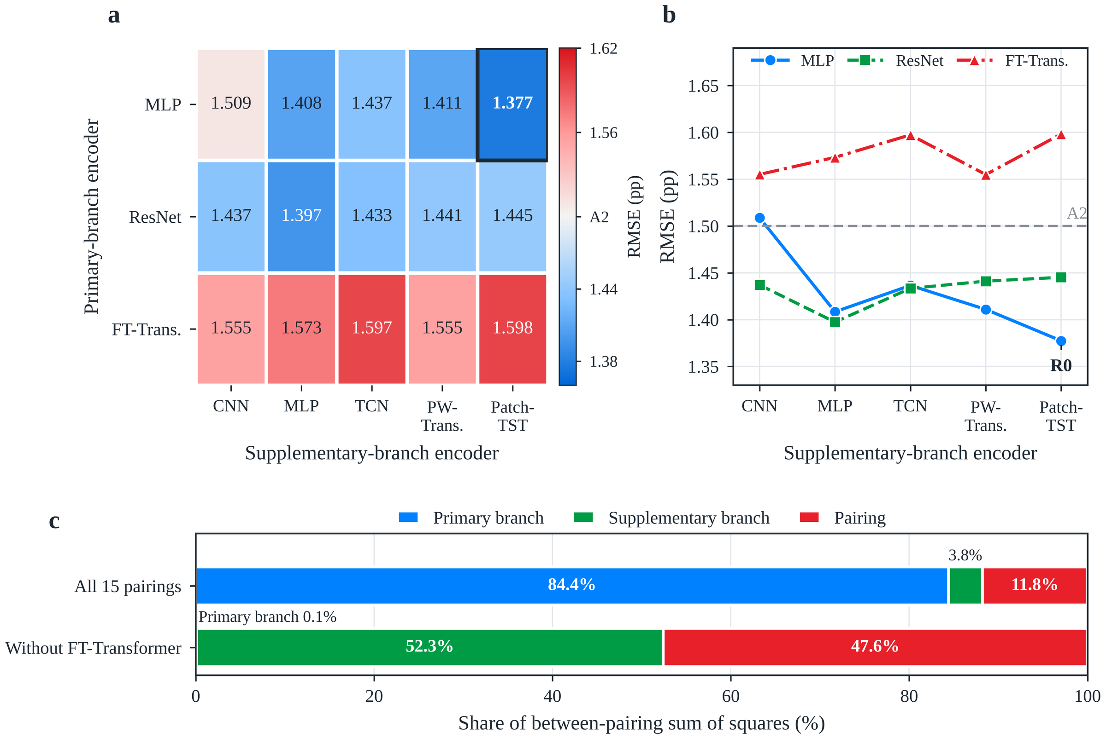
Fig. 3. Main effects and pairing dependence in the encoder matrix. (a) Cell-macro RMSE of the 15 pairings; the diverging scale is centred on the primary-branch-only model A2 (1.500 pp), blue denoting lower and red higher error; the frame marks R0. (b) Interaction plot; non-parallel lines indicate pairing dependence; the dashed line marks A2. (c) Share of the between-pairing sum of squares due to primary branch, supplementary branch and pairing for all 15 pairings (95% intervals: 73.1–90.2%, 1.9–8.1%, 7.3–20.2%) and without FT-Transformer (0.0–4.6%, 40.4–65.0%, 34.1–58.4%), from 5,000 fold-stratified cell bootstraps. Values are seed-averaged cell metrics from 225 trainings.
Table 4. Errors of all 15 encoder pairings (SOH pp).
Primary branch | Complement | Rank | RMSE | 95% CI | MAE | Val. RMSE (rank) | ΔRMSEª | Holm p
MLP | PatchTST | 1 | 1.377 | 1.247–1.513 | 1.141 | 1.310 (1) | −0.131 | 0.003
MLP | MLP | 3 | 1.408 | 1.271–1.553 | 1.154 | 1.321 (3) | −0.100 | 0.003
MLP | PW-Trans. | 4 | 1.411 | 1.276–1.546 | 1.164 | 1.341 (5) | −0.098 | 0.003
MLP | TCN | 6 | 1.437 | 1.294–1.585 | 1.175 | 1.356 (8) | −0.072 | 0.003
MLP | CNN | 10 | 1.509 | 1.368–1.655 | 1.249 | 1.408 (10) | — | —
ResNet | MLP | 2 | 1.397 | 1.258–1.548 | 1.152 | 1.312 (2) | −0.111 | 0.003
ResNet | TCN | 5 | 1.433 | 1.296–1.581 | 1.186 | 1.332 (4) | −0.075 | 0.003
ResNet | CNN | 7 | 1.437 | 1.304–1.578 | 1.200 | 1.367 (9) | −0.072 | 0.003
ResNet | PW-Trans. | 8 | 1.441 | 1.303–1.583 | 1.199 | 1.355 (7) | −0.068 | 0.003
ResNet | PatchTST | 9 | 1.445 | 1.309–1.592 | 1.200 | 1.352 (6) | −0.064 | 0.003
FT-Transformer | PW-Trans. | 11 | 1.555 | 1.406–1.709 | 1.303 | 1.495 (12) | +0.046 | 0.103
FT-Transformer | CNN | 12 | 1.555 | 1.404–1.710 | 1.305 | 1.482 (11) | +0.046 | 0.093
FT-Transformer | MLP | 13 | 1.573 | 1.420–1.731 | 1.315 | 1.495 (13) | +0.065 | 0.038
FT-Transformer | TCN | 14 | 1.597 | 1.448–1.758 | 1.333 | 1.518 (14) | +0.089 | 0.003
FT-Transformer | PatchTST | 15 | 1.598 | 1.446–1.757 | 1.340 | 1.525 (15) | +0.089 | 0.003
ª Pairing minus MLP + CNN; negative values denote lower error. Holm p values refer to the 14 comparisons against MLP + CNN, not to comparisons between pairings. Validation RMSE is the mean best-epoch error on validation cells over 15 runs.

4.2. Waveform increment over the handcrafted primary branch
Adding the PatchTST branch to the MLP primary branch lowers the error on the same test cells (Table 5, Fig. 4a). R0 improves on A2 by 0.123 pp (−0.141 to −0.103; Holm p < 0.001), with 58 of 64 cells improved and a paired effect size d_{z} = −1.55. Relative to A1, which lacks the handcrafted primary branch, R0 improves by 0.117 pp (−0.187 to −0.033; Holm p = 0.002) in 50 of 64 cells, with a larger spread between cells (d_{z} = −0.36, Fig. 4b). A1 and A2 do not differ (−0.006 pp, −0.091 to 0.065; p = 0.91); because A1 still contains the DCIR and $τ$, this is not a pure waveform-versus-feature comparison. The two representations are thus complementary on average.
Table 5. Ablation of the primary branch, supplementary waveform branch, cycle count and monotonicity penalty (SOH pp).
Config. | Inputs and constraint | RMSE | MAE | Contrast | ΔRMSE | 95% CI | Holm p | Improved cells
A2 | Primary branch + τ, λ = 0.1 | 1.500 | 1.244 | — | — | — | — | —
R0 | Primary branch + PatchTST + τ, λ = 0.1 | 1.377 | 1.141 | R0 − A2 | −0.123 | −0.141 to −0.103 | <0.001 | 58/64
A1 | PatchTST + DCIR + τ, λ = 0.1 | 1.494 | 1.259 | R0 − A1 | −0.117 | −0.187 to −0.033 | 0.002 | 50/64
A3 | As R0, λ = 0 | 1.406 | 1.164 | R0 − A3 | −0.028 | −0.038 to −0.018 | <0.001 | 46/64
A4 | As A3, without τ | 1.983 | 1.718 | A3 − A4 | −0.578 | −0.731 to −0.421 | <0.001 | 52/64
ΔRMSE is the first minus the second configuration of each contrast; improved cells are those where the first has the lower error. The four contrasts are prespecified confirmatory tests with Holm correction among them.
Not every waveform encoder delivers this increment (Table 6, Fig. 4c). With the MLP primary branch fixed, PatchTST, MLP, point-wise Transformer and TCN supplementary branches lower RMSE by 0.123, 0.092, 0.089 and 0.063 pp (Holm p < 0.001 for all), whereas the CNN supplementary branch changes it by +0.009 pp (−0.012 to 0.028; Holm p = 0.491). PatchTST gives the largest observed reduction, consistent with its rank in Section 4.1.
Table 6. Increment of each supplementary waveform branch over the MLP primary branch A2 (SOH pp).
Supplementary branch | Dual-branch RMSE | ΔRMSE | 95% CI | Relative change | Holm p | Improved cells | d_{z}
PatchTST | 1.377 | −0.123 | −0.141 to −0.104 | −8.2% | <0.001 | 58/64 | −1.55
MLP | 1.408 | −0.092 | −0.109 to −0.074 | −6.1% | <0.001 | 55/64 | −1.14
PW-Trans. | 1.411 | −0.089 | −0.109 to −0.070 | −5.9% | <0.001 | 54/64 | −0.97
TCN | 1.437 | −0.063 | −0.089 to −0.037 | −4.2% | <0.001 | 45/64 | −0.56
CNN | 1.509 | +0.009 | −0.012 to 0.028 | +0.6% | 0.491 | 28/64 | +0.09
ΔRMSE is the dual-branch model minus A2 (1.500 pp); d_{z} is the mean per-cell difference divided by its standard deviation. Holm correction covers these five comparisons.
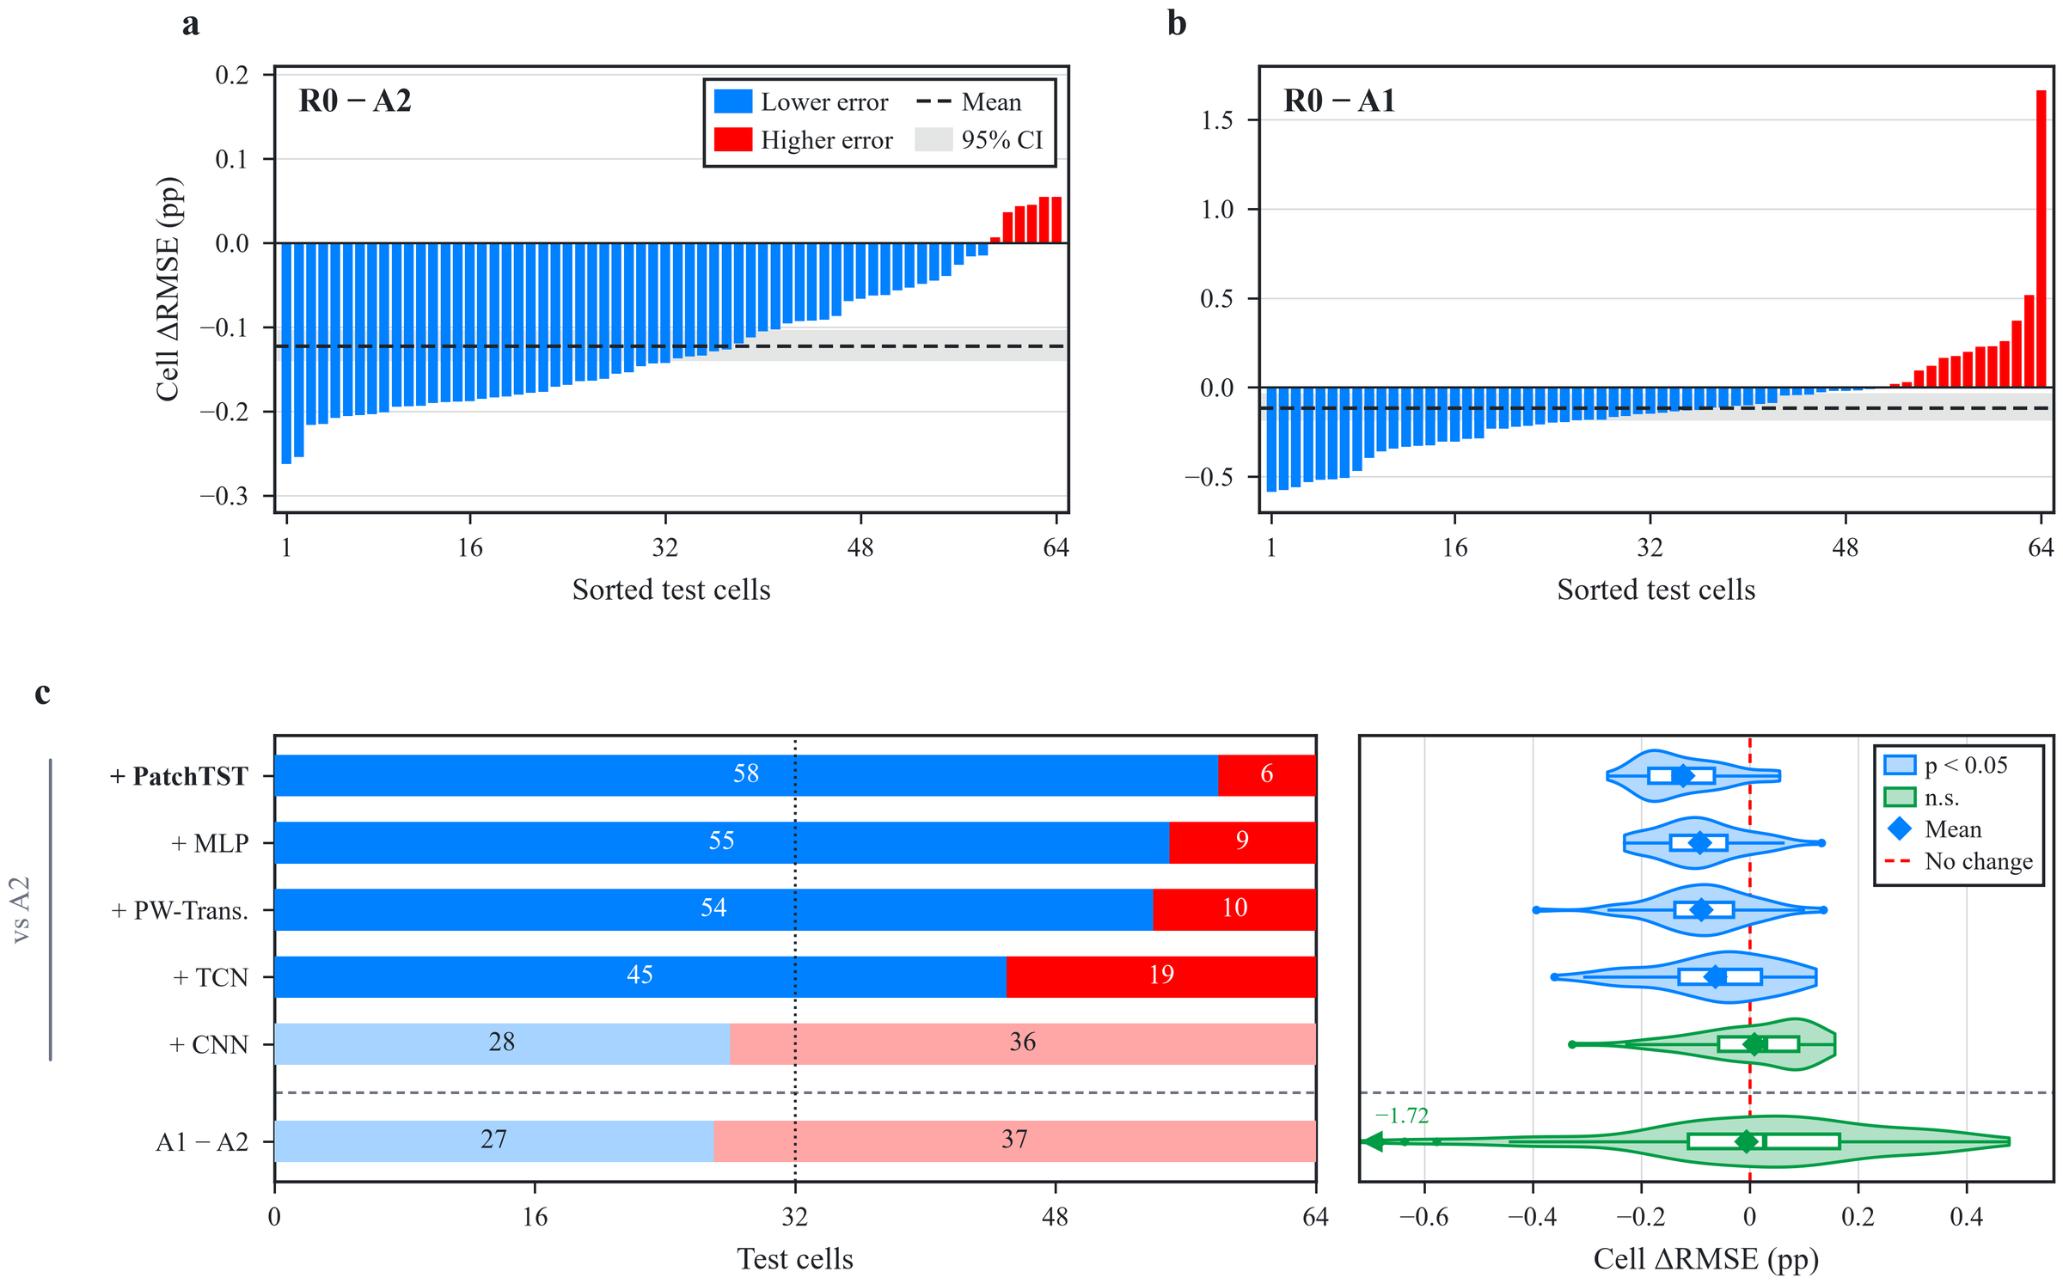
Fig. 4. Effects of the handcrafted primary branch and the supplementary waveform branch. (a) Per-cell RMSE difference R0 − A2 (seed-averaged) for the 64 test cells sorted in ascending order; blue bars denote lower and red bars higher error for R0; the dashed line and grey band show the mean difference and its 95% interval. (b) As (a) for R0 − A1; the rightmost bar is cell 3. (c) Left: numbers of cells with lower (blue) or higher (red) error after adding each supplementary branch to the MLP primary branch, and for A1 versus A2 (below the dashed line); pale colours mark non-significant differences. Right: violin and box plots of the 64 paired differences (box, interquartile range; line, median; whiskers, 1.5 × IQR; diamond, mean); one value outside the axis (A1 − A2, −1.72 pp, cell 3) is marked at the left edge.

4.3. Distribution of the increment and bias correction
The increment varies in size across SOH ranges but has the same sign in all six pulse conditions (Supplementary Table S4, Fig. 5b). Below 80% SOH, R0 lowers the error relative to A2 by 0.413 pp (17.2%, 62/64 cells), and above 95% by 0.148 pp (15.5%, 61/64); the 90–95% range shows the smallest gain (0.027 pp, 36/64). Across the six conditions the reduction ranges from 0.085 to 0.139 pp; 313 of the 384 cell–condition units (81.5%) improve, 29 cells improve in all six conditions, and all 11 cycling groups show negative mean differences (−0.029 to −0.186 pp). Each single pulse condition therefore benefits from the supplementary branch, which matters for deployments that can afford only one pulse.
Binned bias analysis shows that the increment partly corrects a shrinkage bias of the primary branch (Fig. 5a). Over the 2,823 cell–RPT points, A2 overestimates SOH by 3.25 pp below 78% and underestimates it by 1.41 pp at 98–100%; R0 reduces these to 2.74 and 1.16 pp. The change in prediction from A2 to R0 increases with true SOH (slope 0.034 pp per pp, 0.031–0.036) and crosses zero near 92.1%: predictions are lowered at low SOH and raised at high SOH, opposite to the bias of A2. As a result, 68.0% of the points move closer to the measurement, the slope of predicted on true SOH rises from 0.848 to 0.882, and the total squared error falls by 14.4%.
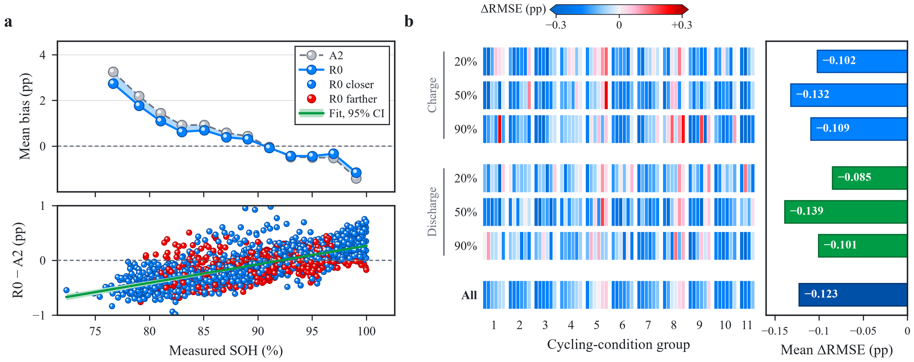
Fig. 5. Bias correction by the supplementary waveform branch and its distribution across conditions and cells. (a) Top: mean bias (prediction minus truth) in 2-pp bins of measured SOH (bins below 78% merged) for A2 (grey) and R0 (blue); the shading marks the corrected bias. Bottom: R0 − A2 prediction change at the 2,823 cell–RPT points (blue, closer to the measurement; red, farther) with the least-squares fit and its 95% bootstrap band. Predictions are averaged over seeds and conditions. (b) Left: per-cell R0 − A2 RMSE difference for the six conditions and all records (cells ordered by cycling group; colours saturate beyond ±0.3 pp). Right: cell-macro mean difference per row; all 95% intervals exclude zero.

4.4. Comparison with a published pulse model
The reproduced raw-pulse model of Nowacki et al. [28] reaches 1.628 pp, and R0 is 0.251 pp lower (Holm p = 0.019) in 47 of 64 cells (Table 7). Because that model uses only the raw pulse without $τ$, the gap reflects both the dual-branch structure and the cycle record; within the present design, the contribution of the waveform branch is isolated by the R0 − A2 comparison of Section 4.2.
Table 7. Inputs and cell-macro errors of the reference methods (SOH pp).
Model | Input | RMSE | 95% CI | ΔRMSE vs. A2 | ΔRMSE vs. R0 | Holm pª | Cells better than R0
R0 (this work) | Features + τ + ΔV | 1.377 | 1.247–1.513 | −0.123 | — | — | —
A2 (primary branch only) | Features + τ | 1.500 | 1.365–1.637 | — | +0.123 | <0.001 | 6/64
Nowacki et al. [28], reproduced | Raw ΔV | 1.628 | 1.454–1.820 | +0.128 | +0.251 | 0.019 | 17/64
ª Versus R0. R0 versus A2 belongs to the prespecified family of Table 5; the comparisons with the reproduced model belong to the extended family of Supplementary Note S3.

4.5. Contribution of design factors

4.5.1. Cumulative cycle information and monotonicity penalty
Among the ablated factors, removing the cycle count increases the error most (Table 5, Fig. 6a–c). Without the monotonicity penalty in either model, A3 (with $τ$) is 0.578 pp below A4 (without $τ$; reduction 0.421–0.731; Holm p < 0.001) in 52 of 64 cells, i.e. removing $τ$ raises the error by about 41%. The cycle record is therefore an important input.
The soft monotonicity penalty yields a small accuracy gain (Fig. 6d–f): R0 is 0.028 pp below A3 (reduction 0.018–0.038; Holm p < 0.001) in 46 of 64 cells. The share of positive partial derivatives with respect to $τ$ (5.39% for A3, 5.61% for R0) and of rising predictions between adjacent RPTs of the same cell and condition (26.88% and 27.03%) remain essentially unchanged, so the penalty acts as a regulariser rather than as a guarantee of monotone trajectories.
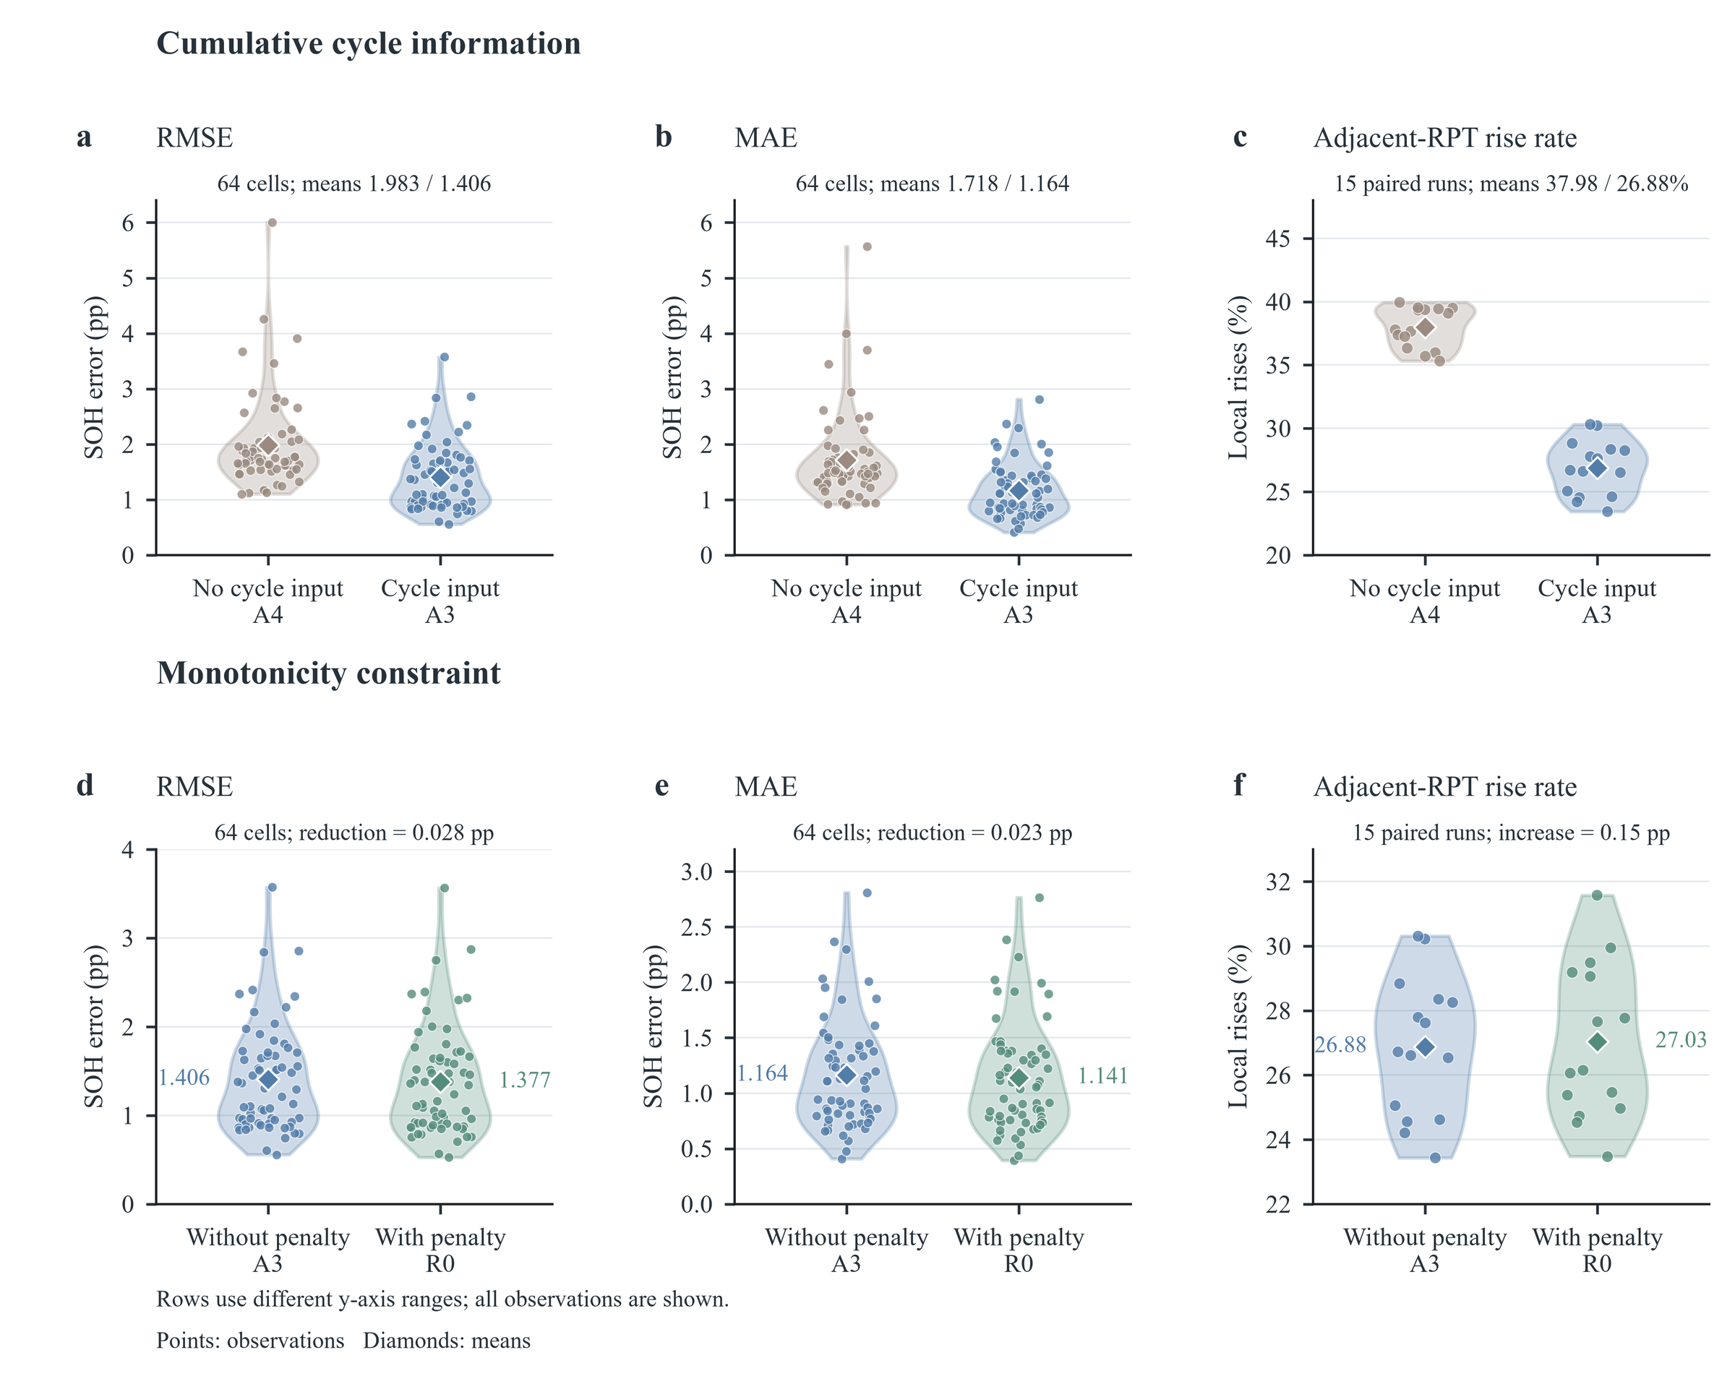
Fig. 6. Effects of cumulative cycle information and the monotonicity penalty. Top row: A4 (no cycle input) versus A3 (cycle input), both without the penalty. Bottom row: A3 (no penalty) versus R0 (penalty). (a, d) RMSE; (b, e) MAE; (c, f) rate of rising predictions between adjacent RPTs. Error distributions contain the 64 test cells (seed-averaged); rise rates are computed within cell, nominal SOC and direction for the 15 runs. Violins are kernel densities limited to the observed range; points are observations and diamonds means. Rows use different y-axis ranges.

4.5.2. Design of the waveform branch
On the 2 × 2 patch grid, R0’s (9, 4) setting gives the lowest error (Table 8; Supplementary Fig. S1). P1 (5, 2), P2 (5, 4) and P3 (9, 2) raise RMSE by 0.072, 0.094 and 0.055 pp (Holm p < 0.001), and length and stride interact: stride 4 is better with length 9 but stride 2 is better with length 5 (difference-in-differences −0.077 pp, −0.100 to −0.054). Of the three adaptations, the mean-pooling head is clearly supported: reverting to a flatten head (D1) raises the error by 0.062 pp (0.036–0.089; Holm p < 0.001) while more than doubling the parameter count (19,041 to 42,593). Adding RevIN (D2, −0.020 pp, −0.049 to 0.005) or using the raw voltage (D3, +0.007 pp, −0.005 to 0.017) makes no detectable difference (Holm p = 0.345 for both). With A2 as the common reference, all six PatchTST variants reduce the error by 0.028–0.143 pp (40–57 of 64 cells improved), so the increment is not tied to a single patch setting.
Table 8. PatchTST patch parameters and adaptation ablations (SOH pp).
Config. | Difference from R0 | RMSE | 95% CI | Params. | ΔRMSE | 95% CI of ΔRMSE | Holm p | R0 better
R0 | Patch (9, 4), mean-pooling head, no RevIN, ΔV input | 1.377 | 1.247–1.513 | 19,041 | — | — | — | —
P1 | Patch (5, 2) | 1.449 | 1.315–1.585 | 19,713 | +0.072 | 0.050–0.094 | <0.001 | 51/64
P2 | Patch (5, 4) | 1.472 | 1.341–1.611 | 18,945 | +0.094 | 0.080–0.109 | <0.001 | 56/64
P3 | Patch (9, 2) | 1.432 | 1.297–1.570 | 19,777 | +0.055 | 0.038–0.071 | <0.001 | 47/64
D1 | Flatten head | 1.440 | 1.304–1.585 | 42,593 | +0.062 | 0.036–0.089 | <0.001 | 46/64
D2 | With RevIN | 1.357 | 1.229–1.491 | 19,043 | −0.020 | −0.049 to 0.005 | 0.345 | 28/64
D3 | Raw voltage input | 1.384 | 1.253–1.518 | 19,041 | +0.007 | −0.005 to 0.017 | 0.345 | 41/64
ΔRMSE is the configuration minus R0; positive values mean the corresponding R0 design is beneficial. Patch (P1–P3) and adaptation (D1–D3) ablations form two families with Holm correction over three comparisons each.

4.5.3. Number of handcrafted features
Within the present candidate set, $K=50$ is supported (Supplementary Table S5, Fig. S2). $K$ = 10, 20 and 30 raise RMSE by 0.139, 0.122 and 0.091 pp (Holm p = 0.001), $K$ = 75 and 100 are slightly worse (+0.037 and +0.041 pp; Holm p = 0.002), and $K=144$ is indistinguishable from $K=50$ (−0.002 pp, −0.019 to 0.015; Holm p = 0.838) while requiring 31.6% more parameters. $K=50$ is therefore a balanced choice between accuracy and input size.

4.6. Generalisation, robustness and deployment
Except for the main NMC/graphite results, which come from the original implementation, the experiments in this section use the CPU re-implementation of Section 3.5.3, which reproduces the cleaning exactly and the reported errors closely, including the sign and significance of the waveform increment (R0 − A2 = −0.046 pp, −0.070 to −0.023; p < 0.001; 42 of 64 cells) and the identity of the best- and worst-estimated cells (cells 12 and 3). All comparisons below are made within this implementation (Table 9, Fig. 7).
Unseen cycling conditions. When each cycling group is held out entirely, the error of the neural models rises only moderately (R0 from 1.427 to 1.560 pp, +9.3%; A2 +8.2%) (Fig. 6a). The waveform increment persists for unseen conditions (R0 − A2 = −0.035 pp, −0.053 to −0.015; p = 0.008; 39 of 64 cells), with lower group-mean errors in seven of the 11 held-out groups.
Independent chemistry. On the NMC/graphite dataset (original implementation, five folds × three seeds), R0 reaches a cell-macro RMSE of 1.968 pp (95% CI 1.728–2.236) against 2.132 pp for A2: R0 − A2 = −0.163 pp (Holm-adjusted p = 0.0004), with 39 of 44 cells improved and a 7.6% error reduction, close to the 8.2% on LFP; the difference is negative in every outer fold and every initialisation seed, and A1, without the handcrafted branch, reaches 2.468 pp. The waveform increment is therefore reproduced on a second electrode chemistry. As on LFP, the waveform branch reduces the low-SOH overestimation: below 60% SOH, the mean bias falls from 4.1 pp for A2 to 3.3 pp for R0.
Information added by the waveform branch. The open-circuit voltage of NMC is sloped, so capacity fade shifts the actual SOC at which pulses are applied and the pre-pulse voltage itself tracks SOH: its absolute Spearman correlation with SOH averages 0.93 over the six conditions, against 0.36 for LFP. The waveform branch receives the first-sample-referenced voltage ΔV, which excludes this absolute level, and supplies the dynamic response during the pulse. When the handcrafted features include absolute-level quantities such as the pre-pulse voltage or voltage quantiles, the two sources partly overlap: in the re-implementation, the NMC waveform increment vanishes when such features enter the primary branch (+0.004 pp) and returns to −0.158 pp (−0.205 to −0.112; p < 0.001; 36 of 44 cells) when they are removed from the candidates, matching the original implementation (Supplementary Note S4). The waveform branch thus contributes dynamic information beyond the absolute voltage level rather than repeating what the handcrafted features already encode.
Cycle-count errors and sensor noise. A systematic ±10% error in the cycle count raises R0’s error by only 1.5–3.5% (1.449 and 1.477 pp), and leaves the waveform increment intact (−0.048 and −0.041 pp; p ≤ 0.002) (Fig. 7b). With matched sensor noise in training and test data, accuracy degrades gracefully: at σ_{noise} = 1 and 2 mV, R0 reaches 1.620 and 1.715 pp (+13.5% and +20.2%), and the waveform increment is maintained (−0.058 pp in 50 of 64 cells and −0.045 pp in 46 of 64 cells; p ≤ 0.002).
Number of pulses. With a single pulse per RPT, R0 reaches 1.549 pp on average over the six conditions (1.490–1.582 pp); two and three pulses give 1.477 and 1.453 pp, against 1.427 pp for all six (Fig. 7c), and R0 stays below A2 for every pulse count. The three charge pulses alone reach 1.432 pp, within 0.005 pp of the full protocol, so the diagnostic time can be halved, and the pulses can be applied during charging as proposed for vehicles [16].
Attribution. Integrated gradients spread R0’s waveform attribution almost evenly over the response: the mean absolute attribution per sample is 0.0132, 0.0138 and 0.0135 pp in the C/5, 1C and rest segments, with the same profile for all six conditions (Fig. 7d). The supplementary branch therefore draws on the shape of the whole transient rather than on one segment that a single handcrafted descriptor could isolate, in line with its intended role of capturing inter-segment information.
Computational cost. R0 has 19,041 parameters (74 kB in 32-bit floating point) and needs 0.42 MFLOPs per pulse, most of them in the waveform branch (A2: 13.7 kFLOPs). On a single CPU thread, one inference takes 0.52 ms in PyTorch and the reference Python implementation of all 143 waveform features takes 6.5 ms, both negligible against the 100-s pulse. This footprint is of the order targeted by embedded SOH estimators [19].
Table 9. Generalisation and robustness in the re-implementation (cell-macro RMSE, SOH pp).
Scenario | R0 | A2 | R0 − A2 | 95% CI | p | Improved cells
Five-fold cell-disjoint (reference) | 1.427 | 1.474 | −0.046 | −0.070 to −0.023 | <0.001 | 42/64
Leave-one-group-out | 1.560 | 1.594 | −0.035 | −0.053 to −0.015 | 0.008 | 39/64
Cycle count +10% (test) | 1.449 | 1.497 | −0.048 | −0.072 to −0.024 | <0.001 | 43/64
Cycle count −10% (test) | 1.477 | 1.518 | −0.041 | −0.063 to −0.018 | 0.002 | 39/64
Matched noise, σ_{noise} = 1 mV | 1.620 | 1.678 | −0.058 | −0.077 to −0.040 | <0.001 | 50/64
Matched noise, σ_{noise} = 2 mV | 1.715 | 1.760 | −0.045 | −0.069 to −0.022 | 0.002 | 46/64
One pulse per RPTª | 1.549 | 1.574 | — | — | —
Three pulses per RPTª | 1.453 | 1.494 | — | — | —
Three charge pulses | 1.432 | — | — | — | — | —
Paired comparisons use 5,000 fold- (or group-) stratified cell bootstraps and sign-flip tests; descriptive, without multiplicity correction. ª Mean over all condition combinations (6 and 20, respectively).
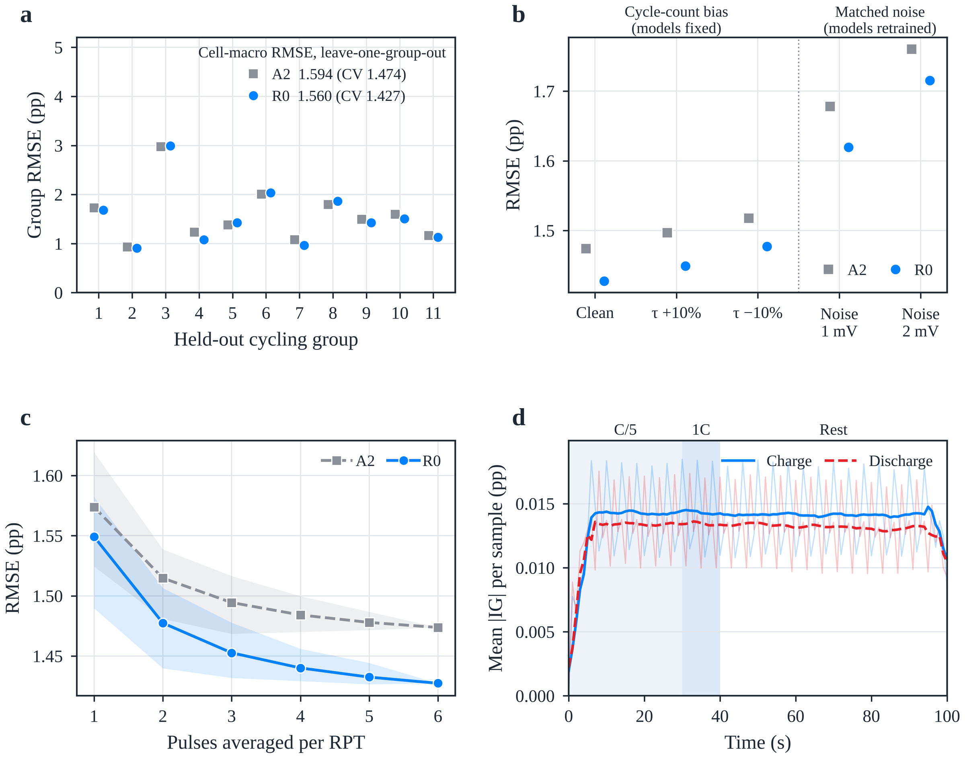
Fig. 7. Generalisation, robustness and attribution (re-implementation). (a) Group-mean RMSE when each cycling group is held out (leave-one-group-out); the legend gives the cell-macro RMSE under leave-one-group-out and, in parentheses, under five-fold cell-disjoint validation. (b) RMSE with a ±10% bias of the test cycle count (models fixed) and with matched Gaussian voltage noise in training and test data (models retrained). (c) RMSE versus the number of pulses averaged per RPT; lines show the mean over all condition combinations and bands their range. (d) Mean absolute integrated-gradient attribution of R0 per waveform sample for charge (solid) and discharge (dashed) pulses, averaged over test records, folds and seeds; shading marks the pulse segments.

4.7. Error characteristics and scope
The overall mean bias is close to zero but conceals SOH-dependent errors (Supplementary Fig. S3). Averaging the three initialisations of each record, R0 reaches a record-level RMSE of 1.461 pp, an MAE of 1.089 pp and a mean bias of −0.093 pp over the 16,938 records. The 630 records below 80% SOH are overestimated by 2.003 pp on average and the 5,682 records above 95% are underestimated by 0.574 pp. Individual cells differ markedly (Supplementary Fig. S4): cells 12, 6, 44 and 3, ranked 1st, 22nd, 43rd and 64th by R0 error, reach 0.526, 0.961, 1.519 and 3.568 pp (A2: 0.704, 1.066, 1.723 and 3.624 pp). Across the 11 cycling groups the cell-macro RMSE spans 0.878–2.333 pp (Supplementary Fig. S5), with positive biases in groups 3 and 6 and negative biases in group 8; the correlation between the per-cell fade rate and the mean bias is 0.59.
The analysis treats the 64 cells as the unit of inference on a fixed split; the low-SOH overestimation is reduced but not removed, and training data should come from the target sensor because difference- and spectrum-based features are sensitive to noise absent from training (Supplementary Note S4). Validation on field data with varying temperature and on target BMS hardware remains future work.

5. Conclusions
Using 16,938 short-pulse records from 64 public LFP/graphite cells, 15 encoder pairings were compared under one five-fold cell-disjoint protocol and training budget. The main conclusions are as follows.
- Encoders should be evaluated as pairings. The MLP primary branch with a PatchTST supplementary branch (R0) gives the lowest observed RMSE (1.377 pp), 8.7% below MLP + CNN, while PatchTST ranks last with the other two primary-branch encoders; the pairing term explains 11.8% of between-pairing variation (47.6% without FT-Transformer).
- The supplementary waveform branch improves a neural handcrafted primary branch. R0 is 0.123 pp (8.2%) below the primary-branch-only model in 58 of 64 cells, with the largest gain below 80% SOH (17.2%), consistent improvements in all six pulse conditions and a partial correction of the primary branch’s shrinkage bias.
- The waveform increment is reproduced on an independent NMC/graphite dataset (R0 − A2 = −0.163 pp, 7.6%, 39 of 44 cells) and originates from the dynamic response beyond the absolute voltage level. In a re-implementation, it also persists for held-out cycling conditions (−0.035 pp) and under matched sensor noise of 1–2 mV (−0.045 to −0.058 pp), while the error rises by only 9% for unseen cycling conditions and by at most 3.5% for a ±10% cycle-count bias.
- Among the ablated factors, the cumulative cycle count is the most influential input (+41% error without it), and the monotonicity penalty acts as a mild regulariser (−0.028 pp). The (9, 4) patch setting and the mean-pooling head (−0.062 pp and 55% fewer parameters than a flatten head) are the most effective design choices, and $K=50$ balances accuracy and input size.
- The model is light enough for embedded use, with 19,041 parameters (74 kB), 0.42 MFLOPs and sub-millisecond single-core inference per pulse; its attribution is spread over the whole transient, and the three charge pulses alone match the six-pulse protocol within 0.005 pp.
Nomenclature
Abbreviation | Definition | Symbol | Definition
BMS | Battery management system | $E_{h}$, $E_{v}$ | Primary- and supplementary-branch encoders
CNN | Convolutional neural network | $g$ | Regression head
DCIR | Direct-current internal resistance | $K$ | Number of selected handcrafted features
DOD | Depth of discharge | $L$, $P$, $S$ | Sequence length, patch length, patch stride
LFP | Lithium iron phosphate | $M$ | Number of patches
MAE | Mean absolute error | $Q_{ir}$ | Discharge capacity of cell $i$ at RPT $r$
MLP | Multilayer perceptron | $y_{ir}$ | Measured SOH (%)
NMC | Nickel–manganese–cobalt oxide | $\hat{y}$, ${\hat{y}}^{\text{*}}$ | Predicted SOH and its standardised value
PW-Trans. | Point-wise Transformer | $Δv_{t}$, ${\tilde{v}}_{t}$ | Referenced and standardised pulse voltage
RevIN | Reversible instance normalisation | $h$ | Primary-branch input vector
RMSE | Root-mean-square error | $n_{i,r}$, $τ$ | Cumulative cycle count and its standardised value
RPT | Reference performance test | $λ$ | Weight of the monotonicity penalty
SOC, SOH | State of charge, state of health | $ρ_{j}$ | Spearman correlation of feature $j$ with SOH
TCN | Temporal convolutional network | $σ_{noise}$ | Standard deviation of added voltage noise
 |  | R0 | Reference configuration (MLP + PatchTST)
 |  | A1–A4, D1–D3, P1–P3 | Ablation configurations (Section 3.5.1)
 |  | pp | Percentage points of SOH
Declaration of Competing Interest
The authors declare that they have no known competing financial interests or personal relationships that could have appeared to influence the work reported in this paper.
Data availability
The battery data are publicly available from the UConn-ISU-ILCC LFP and UConn-ILCC NMC ageing datasets [28,31]. Cleaning rules, input definitions, splits and metrics are specified in Sections 2 and 3 and Supplementary Notes S1–S4. [Repository, version and access details of the code and derived data to be added by the authors.]
Acknowledgments
[Funding sources and grant numbers to be added.]
Appendix A. Supplementary data
Supplementary data to this article (Supplementary Notes S1–S4, Tables S1–S6, Figs. S1–S5 and Algorithm S1) are provided in a separate file.
References
[1] Berecibar M, Gandiaga I, Villarreal I, Omar N, Van Mierlo J, Van den Bossche P. Critical review of state of health estimation methods of Li-ion batteries for real applications. Renew Sustain Energy Rev 2016;56:572–87.
[2] Xiong R, Li L, Tian J. Towards a smarter battery management system: a critical review on battery state of health monitoring methods. J Power Sources 2018;405:18–29. https://doi.org/10.1016/j.jpowsour.2018.10.019.
[3] Wang Y, Guo S, Cui Y, et al. A comprehensive review of machine learning-based state of health estimation for lithium-ion batteries: data, features, algorithms, and future challenges. Renew Sustain Energy Rev 2025;224:116125. https://doi.org/10.1016/j.rser.2025.116125.
[4] Zhu J, Wang Y, Huang Y, et al. Data-driven capacity estimation of commercial lithium-ion batteries from voltage relaxation. Nat Commun 2022;13:2261. https://doi.org/10.1038/s41467-022-29837-w.
[5] Figgener J, van Ouwerkerk J, Haberschusz D, et al. Multi-year field measurements of home storage systems and their use in capacity estimation. Nat Energy 2024;9:1438–47. https://doi.org/10.1038/s41560-024-01620-9.
[6] Pastor-Fernández C, Yu TF, Widanage WD, Marco J. Critical review of non-invasive diagnosis techniques for quantification of degradation modes in lithium-ion batteries. Renew Sustain Energy Rev 2019;109:138–59. https://doi.org/10.1016/j.rser.2019.03.060.
[7] Bilfinger P, Rosner P, Schreiber M, et al. Battery pack diagnostics for electric vehicles: transfer of differential voltage and incremental capacity analysis from cell to vehicle level. eTransportation 2024;22:100356. https://doi.org/10.1016/j.etran.2024.100356.
[8] Roman D, Saxena S, Robu V, Pecht M, Flynn D. Machine learning pipeline for battery state-of-health estimation. Nat Mach Intell 2021;3:447–56. https://doi.org/10.1038/s42256-021-00312-3.
[9] Zhang Y, Tang Q, Zhang Y, Wang J, Stimming U, Lee AA. Identifying degradation patterns of lithium ion batteries from impedance spectroscopy using machine learning. Nat Commun 2020;11:1706. https://doi.org/10.1038/s41467-020-15235-7.
[10] Luo Z, Gao Z, Cai Z, et al. A review of on-board electrochemical impedance spectroscopy for low-cost in situ characterization technology. J Energy Storage 2026;141:119153. https://doi.org/10.1016/j.est.2025.119153.
[11] Lin Y, Grosu C, Schreiber M, et al. Electrochemical impedance spectroscopy for onboard application: impact of the load conditions on the impedance relaxation behavior. J Power Sources 2025;654:237690. https://doi.org/10.1016/j.jpowsour.2025.237690.
[12] Barai A, Uddin K, Widanage WD, McGordon A, Jennings P. A study of the influence of measurement timescale on internal resistance characterisation methodologies for lithium-ion cells. Sci Rep 2018;8:21. https://doi.org/10.1038/s41598-017-18424-5.
[13] Li AG, Fahmy YA, Wu MM, et al. Fast time-domain impedance spectroscopy of lithium-ion batteries using pulse perturbation. In: 2022 IEEE Transportation Electrification Conference & Expo (ITEC); 2022, p. 155–60. https://doi.org/10.1109/ITEC53557.2022.9813868.
[14] Birkl CR, Roberts MR, McTurk E, Bruce PG, Howey DA. Degradation diagnostics for lithium ion cells. J Power Sources 2017;341:373–86.
[15] Barai A, Uddin K, Dubarry M, et al. A comparison of methodologies for the non-invasive characterisation of commercial Li-ion cells. Prog Energy Combust Sci 2019;72:1–31. https://doi.org/10.1016/j.pecs.2019.01.001.
[16] Li AG, Wang W, West AC, Preindl M. Health and performance diagnostics in Li-ion batteries with pulse-injection-aided machine learning. Appl Energy 2022;315:119005. https://doi.org/10.1016/j.apenergy.2022.119005.
[17] Tao S, Ma R, Zhao Z, et al. Generative learning assisted state-of-health estimation for sustainable battery recycling with random retirement conditions. Nat Commun 2024;15:10154. https://doi.org/10.1038/s41467-024-54454-0.
[18] Li M, Xu W, Zhang S, et al. State of health estimation and battery management: a review of health indicators, models and machine learning. Materials 2025;18(1):145. https://doi.org/10.3390/ma18010145.
[19] Kulkarni A, Teodorescu R. Computationally efficient machine-learning-based online battery state of health estimation. arXiv 2024. arXiv:2406.06151.
[20] Das K, Kumar R. Electric vehicle battery capacity degradation and health estimation using machine-learning techniques: a review. Clean Energy 2023;7(6):1268–81.
[21] Sylvestrin GR, Maciel JN, Ando Junior OH. Comprehensive feature extraction for battery health prognostics: identifying predictive indicators of state of health. J Power Sources 2026;668:239389. https://doi.org/10.1016/j.jpowsour.2026.239389.
[22] Fu P, Chu L, Hou Z, et al. Transfer learning and vision transformer based state-of-health prediction of lithium-ion batteries. arXiv 2022. arXiv:2209.05253.
[23] Li Y, Gao G, Chen K, et al. State-of-health prediction of lithium-ion batteries using feature fusion and a hybrid neural network model. Energy 2025;319:135163. https://doi.org/10.1016/j.energy.2025.135163.
[24] Zhao Y, Geng L, Meng W, et al. Cross-attention-based hybrid feature fusion network for state-of-health estimation of lithium-ion batteries. Sci Rep 2026;16:17800. https://doi.org/10.1038/s41598-026-48317-5.
[25] Jin P, Yang S, Xu X, et al. Multiview state-of-health estimation for lithium-ion batteries using time–frequency image fusion and attention-based deep learning. PLoS One 2025;20(11):e0335351. https://doi.org/10.1371/journal.pone.0335351.
[26] Pandit R, Ahlawat N. A standardized comparative framework for machine learning techniques in lithium-ion battery state of health estimation. Future Batteries 2025;7:100099. https://doi.org/10.1016/j.fub.2025.100099.
[27] Bairwa B, Pareek K, Jadoun VK. Cycle based state of health estimation of lithium ion cells using deep learning architectures. Sci Rep 2025;15:37078. https://doi.org/10.1038/s41598-025-20995-7.
[28] Nowacki B, Ramamurthy J, Thelen A, Tischer C, Pint CL, Hu C. Rapid estimation of lithium-ion battery capacity and resistances from short duration current pulses. J Power Sources 2025;628:235813. https://doi.org/10.1016/j.jpowsour.2024.235813.
[29] Tao S, Ma R, Chen Y, et al. Rapid and sustainable battery health diagnosis for recycling pretreatment using fast pulse test and random forest machine learning. J Power Sources 2024;597:234156. https://doi.org/10.1016/j.jpowsour.2024.234156.
[30] Ran A, Cheng M, Chen S, et al. Fast remaining capacity estimation for lithium-ion batteries based on short-time pulse test and Gaussian process regression. Energy Environ Mater 2023;6:e12386. https://doi.org/10.1002/eem2.12386.
[31] Nowacki B, Schmitt T, Aquino P, Hu C. Fine-tuning for rapid capacity estimation of lithium-ion batteries. Energy Storage Mater 2025;81:104425. https://doi.org/10.1016/j.ensm.2025.104425.
[32] Jones PK, Stimming U, Lee AA. Impedance-based forecasting of lithium-ion battery performance amid uneven usage. Nat Commun 2022;13:4806. https://doi.org/10.1038/s41467-022-32422-w.
[33] Lu J, Xiong R, Tian J, Wang C, Sun F. Deep learning to estimate lithium-ion battery state of health without additional degradation experiments. Nat Commun 2023;14:2760. https://doi.org/10.1038/s41467-023-38458-w.
[34] Che Y, Lam VN, Rhyu J, et al. Diagnostic-free onboard battery health assessment. Joule 2025;9:102010. https://doi.org/10.1016/j.joule.2025.102010.
[35] Sohail M, Tanveer M, Kim HS. Trustworthy machine learning and mathematical modelling for lithium-ion battery state-of-health estimation. Mathematics 2026;14(11):1879. https://doi.org/10.3390/math14111879.
[36] Barua N, Collins MD, Islam MS, et al. Predictor structure modulates validation inflation and cell-transfer reliability in battery state-of-health estimation. Batteries 2026;12(9):342. https://doi.org/10.3390/batteries12090342.
[37] Zhang H, Gui X, Zheng S, et al. BatteryML: an open-source platform for machine learning on battery degradation. In: International Conference on Learning Representations (ICLR); 2024.
[38] Bai S, Kolter JZ, Koltun V. An empirical evaluation of generic convolutional and recurrent networks for sequence modeling. arXiv 2018. arXiv:1803.01271.
[39] Vaswani A, Shazeer N, Parmar N, et al. Attention is all you need. In: Advances in Neural Information Processing Systems 30; 2017, p. 5998–6008.
[40] Nie Y, Nguyen NH, Sinthong P, Kalagnanam J. A time series is worth 64 words: long-term forecasting with transformers. In: International Conference on Learning Representations (ICLR); 2023. https://openreview.net/forum?id=Jbdc0vTOcol.
[41] Gorishniy Y, Rubachev I, Khrulkov V, Babenko A. Revisiting deep learning models for tabular data. In: Advances in Neural Information Processing Systems 34; 2021, p. 18932–43.
[42] Liu H, Li C, Hu X, et al. Multi-modal framework for battery state of health evaluation using open-source electric vehicle data. Nat Commun 2025;16:1137. https://doi.org/10.1038/s41467-025-56485-7.
[43] Huang X, Tao S, Liang C, et al. iMOE: prediction of second-life battery degradation trajectory using interpretable mixture of experts. Nat Commun 2026;17:2549. https://doi.org/10.1038/s41467-026-69369-1.
[44] Lu Z, Mo H, Wang Y. MSSformer: a model for accurate and stable state of health estimation of lithium-ion batteries. Electr Power Syst Res 2026;254:112661. https://doi.org/10.1016/j.epsr.2025.112661.
[45] Tang P, Qiu Z, Yao Z, et al. Lithium-ion battery RUL prediction based on optimized VMD-SSA-PatchTST algorithm. Sci Rep 2025;15:26824. https://doi.org/10.1038/s41598-025-11934-7.
[46] Labib KM, Rasool I, Ahmed S. Operator-theoretic and physics-guided sequence modeling of lithium-ion battery voltage dynamics. arXiv 2026. arXiv:2605.01693.
[47] Wang F, Zhai Z, Zhao Z, Di Y, Chen X. Physics-informed neural network for lithium-ion battery degradation stable modeling and prognosis. Nat Commun 2024;15:4332. https://doi.org/10.1038/s41467-024-48779-z.
[48] Che Y, Zheng Y, Rhyu J, et al. Mechanistically guided residual learning for battery state monitoring throughout life. Nat Commun 2026;17:855. https://doi.org/10.1038/s41467-025-67565-z.
[49] Guo W, Vilsen SB, Li Y, Verma A, Stroe DI, Brandell D. Uncovering the impact of battery design parameters on health and lifetime using short charging segments. Energy Environ Sci 2025;18:8462–74. https://doi.org/10.1039/D5EE03268G.
[50] Sundararajan M, Taly A, Yan Q. Axiomatic attribution for deep networks. In: Proceedings of the 34th International Conference on Machine Learning (ICML), PMLR 70; 2017, p. 3319–28.
CRediT authorship contribution statement
[Author 1]: Conceptualization, Methodology, Software, Formal analysis, Writing – original draft. [Author 2]: Validation, Visualization, Writing – review & editing. [Corresponding Author]: Supervision, Funding acquisition, Writing – review & editing.

