Supplementary material for “Fusing short-pulse voltage waveforms with handcrafted features for rapid state-of-health estimation of lithium iron phosphate batteries: a controlled comparison of encoder pairings”
[First Author]ª, [Second Author]ª, [Corresponding Author]^{a,}*
ª [Department, Institution, City Postcode, Country]
Contents
Supplementary Note S1. Handcrafted feature definitions
Supplementary Note S2. PatchTST encoder equations
Supplementary Note S3. Statistical test families
Supplementary Note S4. Re-implementation used for the generalisation, robustness and deployment experiments
Supplementary Algorithm S1; Supplementary Tables S1–S6; Supplementary Figs. S1–S5

Supplementary Note S1. Handcrafted feature definitions
This note defines the 143 waveform-derived features of Table 2; the seven context quantities are given in Eq. (3) of the main text. The segments follow the publisher’s pulse timing and are defined, together with the first and second differences, as
$S^{\left(1\right)}=\left(V_{1},…,V_{30}\right), S^{\left(2\right)}=\left(V_{31},…,V_{40}\right), S^{\left(3\right)}=\left(V_{41},…,V_{100}\right), d_{t}^{\left(1\right)}=V_{t+1}−V_{t}, d_{t}^{\left(2\right)}=d_{t+1}^{\left(1\right)}−d_{t}^{\left(1\right)}$ (S1)
Basic operators. For a window $x$ of length $n$,
$\overline{x}=\frac{1}{n}\sum_{i=1}^{n}{x_{i}}, σ\left(x\right)=\sqrt{\frac{1}{n}\sum_{i=1}^{n}{{\left(x_{i}−\overline{x}\right)}^{2}}}, RMS\left(x\right)=\sqrt{\frac{1}{n}\sum_{i=1}^{n}{x_{i}^{2}}}, E\left(x\right)=\sum_{i=1}^{n}{x_{i}^{2}}$ (S2)
$\begin{matrix} & R\left(x\right)=maxx−minx, IQR\left(x\right)=Q_{0.75}−Q_{0.25}, \\ & MAD\left(x\right)=median\left(\left|x−median\left(x\right)\right|\right), AUC\left(x\right)=\sum_{i=1}^{n−1}{\frac{x_{i}+x_{i+1}}{2}}\end{matrix}$ (S3)
The standard deviation uses the population form ($1/n$), except for the global voltage sequence, which follows the publisher’s supplementary definition with the sample form ($1/\left(n−1\right)$); both are labelled in the feature list.
Shape. Bias-corrected Fisher–Pearson skewness and excess kurtosis are used, with $m_{k}$ the $k$-th central moment:
$\begin{matrix} & m_{k}=\frac{1}{n}\sum_{i=1}^{n}{{\left(x_{i}−\overline{x}\right)}^{k}}, g_{1}=\frac{m_{3}}{m_{2}^{3/2}}, g_{2}=\frac{m_{4}}{m_{2}^{2}}−3, \\ & G_{1}=\frac{\sqrt{n\left(n−1\right)}}{n−2}g_{1}, G_{2}=\frac{n−1}{\left(n−2\right)\left(n−3\right)}\left[\left(n+1\right)g_{2}+6\right]\end{matrix}$ (S4)
Histogram entropy. The range of the window is divided into 16 equal bins and $p_{i}$ is the fraction of samples in bin $i$:
Hx=−1ln16pi>0​pilnpi (S5)
Linear trend. A least-squares line is fitted against the sample index $t_{i}$:
a=i​xi−xti−ti​ti−t2, b=x−at, R2=1−i​xi−b−ati2i​xi−x2 (S6)
Zero crossings and total variation. Zero crossings of a difference sequence are counted after removing exact zeros, giving $y$:
$Z\left(y\right)=\text{\#}\{i:y_{i}y_{i+1}<0\}, TV\left(x\right)=\sum_{i=1}^{n−1}{\left|x_{i+1}−x_{i}\right|}$ (S7)
The 15 operators of Eqs. (S2)–(S7) applied to $S^{\left(1\right)}$, $S^{\left(2\right)}$ and $S^{\left(3\right)}$ give the 45 segment statistics; applied to the full sequence and to $d^{\left(1\right)}$ and $d^{\left(2\right)}$, together with end points and quantiles, they give the 24 global and 22 difference-dynamics features.
Spectral features. The demeaned sequence is Hann-windowed and transformed by a real fast Fourier transform ($N=101$, frequency in cycles per sample):
$\begin{matrix} & w_{t}=0.5−0.5cos\left(\frac{2πt}{N−1}\right), x_{t}=\left(V_{t}−\overline{V}\right) w_{t}, \\ & X_{k}=\sum_{t=0}^{N−1}{x_{t}} e^{−j2πkt/N}, P_{k}={\left|X_{k}\right|}^{2}, f_{k}=\frac{k}{N}\end{matrix}$ (S8)
The amplitudes of the first eight non-DC lines and the energy shares of four bands are
Ak=2Xkt​wt k=1,…,8,B1=k=13Pkk=150Pk, B2=k=47Pkk=150Pk, B3=k=815Pkk=150Pk, B4=k=1650Pkk=150Pk (S9)
Spectral-shape features exclude the DC component: dominant frequency and amplitude, centroid, spread, flatness, entropy and 85% roll-off,
k⋆=argmaxk≥1Pk, fdom=fk⋆, Adom=Ak⋆,C=k​fkPkk​Pk, S=k​Pkfk−C2k​Pk, F=k​Pk1/K1Kk​Pk (S10)
Hf=−1ln50k​pklnpk, pk=Pkκ​Pκ, f85=minfk:κ≤k​Pκ≥0.85κ​Pκ (S11)
Wavelet features. A four-level db2 decomposition with symmetric extension gives coefficient sets $c$, and their energy fractions are
εc=i​ci2, EFc=εcc′​εc′, c∈{cA4,cD4,cD3,cD2,cD1} (S12)
Eqs. (S8)–(S12) yield 24 frequency and wavelet features (8 amplitudes, 4 band shares, 7 spectral-shape features and 5 wavelet energy fractions). The dominant frequency takes a single value in the whole dataset and the roll-off frequency takes two values and is constant in the training cells of fold 0; their rank correlations are undefined in the affected folds and they are skipped by the finiteness condition of Section 2.3.3, which is why the feature-count ladder ends at 144 rather than 146.
Nonlinear features. Lagged autocorrelation ($ℓ∈\{1,5,10\}$) and the three Hjorth parameters are
a=V0,…,V100−ℓ, b=Vℓ,…,V100, ρℓ=i​ai−abi−bi​ai−a2i​bi−b2,Act=σ2V, MobV=σ2d1σ2V, Com=Mobd1MobV (S13)
Approximate and sample entropy use embedding dimension $m=2$ (and $m+1=3$), tolerance $r=0.2σ\left(V\right)$ and the Chebyshev distance; approximate entropy counts self-matches, whereas sample entropy counts only pairs $i<j$:
Cimr=#{j:max0≤k<mVi+k−Vj+k≤r}N−m+1, Φmr=1N−m+1i​lnCimr,ApEn=Φ2r−Φ3r, SampEn=−lnAB (S14)
Permutation entropy uses order 3 and delay 1, and the Hurst exponent is the slope of a variogram regression over lags $ℓ∈\{1,2,4,8,16\}$:
PE=−1ln6π∈Π3​pπlnpπ, τℓ=1101−ℓi​Vi+ℓ−Vi2,H=OLS slope of lnτℓ on lnℓ (S15)
Transient-boundary features. Fifteen voltage differences between specified samples, including the steps at current changes ($V_{1}−V_{0}$, $V_{31}−V_{30}$, $V_{41}−V_{40}$) and the net changes within segments ($V_{30}−V_{1}$, $V_{40}−V_{31}$, $V_{100}−V_{41}$), describe the transitions between segments. Three response times are defined on the rest segment $S^{\left(3\right)}$, with linear interpolation between samples and $α∈\{0.10,0.50,0.90\}$:
$p_{t}=sgn\left(V_{100}−V_{41}\right) \left(V_{t}−V_{41}\right), t=41,…,100, t_{α}=min\left\{t:p_{t}≥α\left|V_{100}−V_{41}\right|\right\}$ (S16)

Supplementary Note S2. PatchTST encoder equations
Each patch $p_{m}$ of Eq. (12) is embedded by a shared linear map and a learnable positional embedding $e_{m}$, initialised from $N\left(0,{0.02}^{2}\right)$ and trained with the network:
$z_{m}^{\left(0\right)}=W_{p}p_{m}+b_{p}+e_{m}, W_{p}∈R^{D×P}, Z^{\left(0\right)}={\left[z_{1}^{\left(0\right)},…,z_{M}^{\left(0\right)}\right]}^{T}∈R^{M×D}$ (S17)
The $M$ tokens enter one Transformer encoder layer whose multi-head self-attention ($h=4$ heads, $d_{k}=D/h=8$) acts between patches:
$\begin{matrix} & Q_{i}=ZW_{i}^{Q}, K_{i}=ZW_{i}^{K}, V_{i}=ZW_{i}^{V}, \\ & {head}_{i}=softmax\left(\frac{Q_{i}K_{i}^{T}}{\sqrt{d_{k}}}\right)V_{i}, MHA\left(Z\right)=\left[{head}_{1};…;{head}_{h}\right]W^{O}\end{matrix}$ (S18)
The layer uses post-normalisation residual connections and a GELU feed-forward sublayer of width $2D=64$ with dropout 0.2:
$\begin{matrix} & Z′=LN\left(Z^{\left(0\right)}+MHA\left(Z^{\left(0\right)}\right)\right), Z^{\left(1\right)}=LN\left(Z′+FFN\left(Z′\right)\right), \\ & FFN\left(u\right)=W_{2} GELU\left(W_{1}u+b_{1}\right)+b_{2}\end{matrix}$ (S19)
Layer normalisation, mean pooling over tokens and a linear projection give the 32-dimensional waveform embedding:
$E_{v}\left(\tilde{v}\right)=Drop\left(ReLU\left(W_{o}⋅\frac{1}{M}\sum_{m=1}^{M}{LN}\left(z_{m}^{\left(1\right)}\right)+b_{o}\right)\right)∈R^{32}$ (S20)

Supplementary Note S3. Statistical test families
Holm correction was applied within the following prespecified families at α = 0.05: (1) the 14 encoder pairings versus MLP + CNN; (2) the five supplementary waveform branches versus A2; (3) the confirmatory ablations R0 − A1, R0 − A2, R0 − A3 and A3 − A4; (4) the three patch configurations versus R0; (5) the three adaptation ablations versus R0; (6) the six feature-count levels versus K = 50, separately for RMSE and MAE; and (7) the reproduced reference model versus A2 and versus R0 (an extended family whose adjusted p values are conservative). A1 − A2 was a single prespecified comparison without correction. Marginal effects, difference-in-differences, stratified increments, residual complementarity and low-SOH bias are descriptive. Confidence intervals are conditional on the fixed split and the trained models and do not cover the variability of new data collection or repartitioning.

Supplementary Note S4. Re-implementation used for the generalisation, robustness and deployment experiments
Apart from the main NMC/graphite results, the experiments of Section 4.6 were run with an independent re-implementation of the protocol written in Python (NumPy, scikit-learn 1.9 and PyTorch 2.14 on CPU, one thread per run), starting from the publisher’s processed pulse files [31]. Cleaning reproduced the record counts exactly: 17,130 records in 2,855 groups before cleaning, 192 records removed at the 42nd RPT, and 16,938 records in 2,823 complete groups (SOH 72.34–100%) after cleaning. The 143 waveform features were implemented from the definitions in Supplementary Note S1; details not fixed by those definitions, such as the quantile levels of the global family and the nine voltage differences not listed in Note S1, may differ from the original code, and the response-time levels were set to 0.5, 0.632 and 0.9. Feature selection was nonetheless similar: in fold 0 it selected 16 frequency and wavelet, 14 segment, 11 difference-dynamics, 6 global, 1 boundary and 1 nonlinear feature together with the DCIR, which ranked 13th; 44 features were selected in every fold and 57 in at least one. The split permutation used NumPy’s default generator with seed 42, which reproduces the fold sizes but not necessarily the fold membership of the original runs. Architectures, loss, optimiser, scheduler, early stopping and seeds follow Sections 3.2–3.4 of the main text, with positional embeddings initialised from U(−0.02, 0.02).
Under the original five-fold protocol the re-implementation gives R0 1.427 and A2 1.474 pp (reported: 1.377 and 1.500 pp). The waveform increment keeps its sign and significance (−0.046 pp, −0.070 to −0.023; p < 0.001; 42 of 64 cells), and cells 12 and 3 are again the best- and worst-estimated cells. Table S6 lists all re-implementation results.
NMC/graphite dataset. The UConn-ILCC NMC dataset [31] records the same 100-s pulses at nine nominal SOCs; the three SOCs used for LFP (20%, 50% and 90%) were retained, giving six conditions per RPT, 8,016 records in 1,336 cell–RPT groups of 44 cells and SOH from 41.2% to 100%. Because NMC cells have a higher resistance, the voltage-step and range limits of Eq. (2) were relaxed to 0.3 and 0.8 V; no record was removed. The main-text results come from the original implementation (five folds × three seeds, K = 50, λ = 0.1, as for LFP): R0 1.968 pp, A2 2.132 pp, R0 − A2 = −0.163 pp (Holm-adjusted p = 0.0004, 39/44) and A1 2.468 pp. The DCIR correlates strongly with SOH (ρ ≈ −0.82) but entered none of the 50 selected features because it is redundant with selected waveform features, so it was added to the A1 input separately, as the definition of A1 requires; R0 and A2 were run unchanged.
Difference between the re-implementation and the original implementation. The re-implementation found no waveform increment on NMC (R0 2.030 pp, A2 2.026 pp, R0 − A2 = +0.004 pp, p = 0.90). Diagnostics trace the difference to the primary branch features. The re-implementation computes its features on the absolute voltage and, on NMC, selects absolute-level features such as the pre-pulse and final voltages and voltage quantiles (six in fold 0, almost none on LFP). Because the NMC open-circuit voltage is sloped and capacity fade shifts the actual SOC of each pulse, the pre-pulse voltage tracks SOH (mean absolute Spearman correlation 0.93, LFP 0.36) and predicts the actual SOC deviation with R² = 0.964 (LFP 0.489). Once the primary branch holds this information, the dynamic information of the waveform branch partly overlaps with it: within each pulse condition the selected features explain 99.4% of the variance of the first ten principal components of ΔV (LFP 18.3%). With the 28 absolute-level features removed from the candidates, the re-implementation gives A2 2.098 pp, R0 1.940 pp and R0 − A2 = −0.158 pp (−0.205 to −0.112, p < 0.001, 36/44), consistent with the original implementation. Using all nine SOCs (24,048 records) does not change the re-implementation result (R0 − A2 = +0.017 pp, p = 0.67), so the difference is not a matter of data volume.
Noise not seen in training. When Gaussian noise is added only to the test voltages of models trained on clean data, both neural models deteriorate strongly (σ_{noise} = 0.5 mV: R0 4.37, A2 4.60 pp), because difference- and spectrum-based features computed on the smooth, 0.1-mV-resolution resampled records are sensitive to noise absent from training. Models should therefore be trained on data from the target sensor, or with matching noise augmentation, as in the matched-noise experiment of Section 4.6.

Supplementary Algorithm S1
Algorithm S1. Training and inference of the dual-branch SOH estimation model (handcrafted primary branch + supplementary pulse-waveform branch).
Input: cleaned record set D = {(V, x, y, cell, rpt, soc, pulse)} with 16,938 records of 64 cells; F = 5 folds, split seed 42, initialisation seeds {0, 1, 2}; K = 50, redundancy threshold 0.98, λ = 0.1.
Output: record-level test predictions and cell-macro errors for every fold and seed.
Offline training
1: Remove cumulative cycle count, RPT index, coulomb-counted SOC and SOC deviation from the 150 candidates → 146 selectable features (Section 2.3.2)
2: Permute the 64 cells with seed 42 and divide them into five disjoint test folds (13/13/13/13/12 cells)
3: In each fold, draw validation cells from the non-test cells with the fold index as offset and stride 5 (train/validation/test = 40/11/13, 41/10/13, 41/10/13, 41/10/13, 42/10/12)
4: for outer fold f = 0, …, 4 do
5: ⠀⠀Split D by cell into D_{tr}, D_{va}, D_{te}; all RPTs and condition records of a cell stay together
6: ⠀⠀Compute Spearman ρ_{j} of the 146 candidates with SOH on D_{tr} only ▷ Eq. (4)
7: ⠀⠀Select K features greedily by |ρ_{j}|, skipping rank correlation ≥ 0.98 with selected ones; fill to K if needed ▷ Eq. (5)
8: ⠀⠀Fit medians, feature means/s.d., per-position waveform means/s.d., cycle-count and label statistics on D_{tr} only
9: ⠀⠀Transform D_{tr}, D_{va}, D_{te} with these statistics ▷ Eqs. (6)–(10)
10: ⠀⠀for seed s ∈ {0, 1, 2} do
11: ⠀⠀⠀⠀Initialise E_{h}, E_{v} and g with seed s; AdamW (lr 10⁻³, weight decay 10⁻⁴), batch 256, ReduceLROnPlateau (patience 5, factor 0.5), gradient clipping 5, at most 100 epochs, early-stopping patience 15
12: ⠀⠀⠀⠀for each epoch and mini-batch do
13: ⠀⠀⠀⠀⠀⠀Enable gradients on τ; forward pass gives ŷ* ▷ Eq. (11)
14: ⠀⠀⠀⠀⠀⠀Compute ∂ŷ*/∂τ by automatic differentiation (create_graph = True)
15: ⠀⠀⠀⠀⠀⠀ℒ ← MSE(ŷ*, y*) + λ·⟨[∂ŷ*/∂τ]₊²⟩; back-propagate, clip, update ▷ Eq. (13)
16: ⠀⠀⠀⠀⠀⠀After each epoch, compute the cell-macro RMSE on D_{va}; keep the best weights; stop after 15 epochs without improvement
17: ⠀⠀⠀⠀Load the best-epoch weights and predict D_{te}
Online inference (one pulse record)
18: Reference the 101-point voltage to its first sample and standardise with the fold statistics → ṽ ▷ Eqs. (6), (7)
19: Compute the K selected features, impute and standardise, append standardised τ → h ▷ Eqs. (8), (9)
20: ŷ* ← g([E_{v}(ṽ); E_{h}(h)]); SOH ← 100(σ_{y}ŷ* + μ_{y}) ▷ Eqs. (11), (10)
Metrics and statistics
21: Average the six condition predictions of each cell–RPT, compute per-cell RMSE and the cell-macro mean ▷ Eq. (14)
22: Paired differences: 5,000 fold-stratified cell bootstrap intervals; 5,000 two-sided paired sign-flip tests; Holm correction within families

Supplementary Tables
Supplementary Table S1. Ageing protocols of the cycling-condition groups.
Group | CC–CV charge rate (C) | CC discharge rate (C) | DOD (%) | Cells (IDs)
1 | 2 | 1.5 | 60 | 6 (2–7)
2 | 2.42 | 1.5 | 60 | 6 (8–13)
3 | 2 | 2 | 60 | 6 (14–19)
4 | 2 | 1.5 | 80 | 6 (20–25)
5 | 2.83 | 1.5 | 60 | 6 (26–31)
6 | 2.42 | 2 | 60 | 6 (32–37)
7 | 2.42 | 1.5 | 80 | 6 (38–43)
8 | 3.25 | 1.5 | 60 | 6 (44–49)
9 | 2 | 1.5 | 100 | 6 (50–55)
10 | 2 | 2 | 80 | 6 (56–61)
11 | 2.83 | 1.5 | 80 | 4 (62–65)
From the cell test log in the publisher’s public repository [28]. Charging is CC–CV and discharging CC; rates refer to the nominal 1.2 Ah, so 2.42C, 2.83C and 3.25C correspond to 2.9 A, 3.4 A and 3.9 A.
Supplementary Table S2. Input information of the two branches.
Input | Dimension | Waveform branch | Primary branch | Source
First-sample-referenced voltage sequence | 101 | ✓ | — | Single pulse
Waveform-derived features (train-fold selected) | 49 | — | ✓ | Single pulse
Matched-condition DCIR (selected) | 1 | — | ✓ | Single pulse
Standardised cumulative cycle count τ | 1 | — | ✓ | Cycle record
Nominal SOC, pulse direction | — | — | Candidate, not selected | Test setting
Coulomb-counted SOC, SOC deviation | — | — | Excluded | Requires reference capacity
Other condition records, past capacities, cell identity | — | — | — | —
✓, input enters the branch; —, not used or not applicable.
Supplementary Table S3. Ablation configurations and reference models.
Category | Configuration | Handcrafted primary branch | Supplementary waveform branch | τ | λ | Trainings
Main | R0 | MLP, 50 features | PatchTST (9, 4) | ✓ | 0.1 | 15
Encoder matrix | 15 pairings | MLP / ResNet / FT-Transformer | CNN / MLP / TCN / PW-Trans. / PatchTST | ✓ | 0.1 | 225 (incl. R0)
Branch ablation | A2 | MLP | — | ✓ | 0.1 | 15
Branch ablation | A1 | DCIR only (concatenated) | PatchTST (9, 4) | ✓ | 0.1 | 15
Factor ablation | A3 | MLP | PatchTST (9, 4) | ✓ | 0 | 15
Factor ablation | A4 | MLP | PatchTST (9, 4) | — | 0 | 15
Patch parameters | P1, P2, P3 | MLP | PatchTST (5, 2), (5, 4), (9, 2) | ✓ | 0.1 | 45
Adaptation | D1, D2, D3 | MLP | Flatten head, + RevIN, raw voltage | ✓ | 0.1 | 45
Feature count | K = 10, 20, 30, 75, 100, 144 | MLP, K features | PatchTST (9, 4) | ✓ | 0.1 | 90 (K = 50 reuses R0)
Published model | Nowacki et al. [28], reproduced | — | Raw ΔV, 5 × 100 MLP | — | — | 30 models
Neural configurations use 5 folds × 3 seeds (465 trainings in total, plus 30 reproduced models).
Supplementary Table S4. Stratified waveform increment (R0 − A2, SOH pp).
Stratum | Level | A2 RMSE | R0 RMSE | ΔRMSE | 95% CI | Relative change | Improved cells
True SOH | <80% | 2.404 | 1.991 | −0.413 | −0.460 to −0.363 | −17.2% | 62/64
True SOH | 80–85% | 1.742 | 1.601 | −0.141 | −0.200 to −0.082 | −8.1% | 47/64
True SOH | 85–90% | 1.974 | 1.861 | −0.113 | −0.151 to −0.074 | −5.7% | 50/64
True SOH | 90–95% | 1.150 | 1.123 | −0.027 | −0.046 to −0.009 | −2.3% | 36/64
True SOH | ≥95% | 0.956 | 0.808 | −0.148 | −0.163 to −0.134 | −15.5% | 61/64
Nominal SOC | 20% | 1.546 | 1.452 | −0.094 | −0.116 to −0.072 | −6.1% | 55/64
Nominal SOC | 50% | 1.550 | 1.414 | −0.136 | −0.161 to −0.111 | −8.8% | 58/64
Nominal SOC | 90% | 1.579 | 1.474 | −0.104 | −0.127 to −0.080 | −6.6% | 56/64
Direction | Charge | 1.546 | 1.434 | −0.112 | −0.136 to −0.088 | −7.2% | 55/64
Direction | Discharge | 1.584 | 1.477 | −0.107 | −0.125 to −0.088 | −6.7% | 57/64
Condition | 20% charge | 1.533 | 1.431 | −0.102 | −0.128 to −0.076 | −6.7% | 47/64
Condition | 20% discharge | 1.556 | 1.471 | −0.085 | −0.109 to −0.061 | −5.5% | 49/64
Condition | 50% charge | 1.512 | 1.380 | −0.132 | −0.161 to −0.104 | −8.7% | 57/64
Condition | 50% discharge | 1.578 | 1.439 | −0.139 | −0.167 to −0.110 | −8.8% | 54/64
Condition | 90% charge | 1.567 | 1.458 | −0.109 | −0.141 to −0.078 | −7.0% | 52/64
Condition | 90% discharge | 1.584 | 1.483 | −0.101 | −0.124 to −0.077 | −6.4% | 54/64
True-SOH strata are formed at the cell–RPT level after averaging the six conditions, and each cell’s RMSE is computed within the stratum; SOC, direction and condition strata use single records. Predictions are averaged over the three seeds. Descriptive analysis without multiplicity correction.
Supplementary Table S5. Sensitivity to the number of handcrafted features (SOH pp).
K | Primary-branch input | Parameters | RMSE | MAE | ΔRMSE | 95% CI | Holm p | Improved / worse cells
10 | 11 | 16,481 | 1.516 | 1.249 | +0.139 | 0.089–0.188 | 0.001 | 16/48
20 | 21 | 17,121 | 1.499 | 1.226 | +0.122 | 0.077–0.169 | 0.001 | 14/50
30 | 31 | 17,761 | 1.468 | 1.210 | +0.091 | 0.057–0.125 | 0.001 | 14/50
50 (R0) | 51 | 19,041 | 1.377 | 1.141 | — | — | — | —
75 | 76 | 20,641 | 1.414 | 1.165 | +0.037 | 0.018–0.057 | 0.002 | 24/40
100 | 101 | 22,241 | 1.418 | 1.176 | +0.041 | 0.021–0.062 | 0.002 | 15/49
144 | 145 | 25,057 | 1.376 | 1.128 | −0.002 | −0.019 to 0.015 | 0.838 | 32/32
K excludes the separately appended cycle count, so the primary branch input has K + 1 dimensions. ΔRMSE is the level minus K = 50; Holm correction covers the six RMSE comparisons. Improved (worse) cells have lower (higher) error than K = 50.
Supplementary Table S6. Results of the supplementary experiments (cell-macro RMSE, SOH pp).
Scenario | Data | R0 | A2 | A1 | R0 − A2 | 95% CI | p | Improved cells
Five-fold, reported (main text) | LFP | 1.377 | 1.500 | 1.494 | −0.123 | −0.141 to −0.103 | <0.001 | 58/64
Five-fold, re-implementation | LFP | 1.427 | 1.474 | — | −0.046 | −0.070 to −0.023 | <0.001 | 42/64
Leave-one-group-out | LFP | 1.560 | 1.594 | — | −0.035 | −0.053 to −0.015 | 0.008 | 39/64
Cycle count +10% (test) | LFP | 1.449 | 1.497 | — | −0.048 | −0.072 to −0.024 | <0.001 | 43/64
Cycle count −10% (test) | LFP | 1.477 | 1.518 | — | −0.041 | −0.063 to −0.018 | 0.002 | 39/64
Matched noise, σ_{noise} = 1 mV | LFP | 1.620 | 1.678 | — | −0.058 | −0.077 to −0.040 | <0.001 | 50/64
Matched noise, σ_{noise} = 2 mV | LFP | 1.715 | 1.760 | — | −0.045 | −0.069 to −0.022 | 0.002 | 46/64
Test-only noise, σ_{noise} = 0.5 mVª | LFP | 4.374 | 4.595 | — | — | — | — | —
Five-fold, original implementation^{b} | NMC | 1.968 | 2.132 | 2.468 | −0.163 | to be added | 0.0004^{c} | 39/44
Five-fold, re-implementation | NMC | 2.030 | 2.026 | 2.317 | +0.004 | −0.042 to 0.047 | 0.90 | 21/44
Five-fold, re-implementation, primary branch without absolute-level features | NMC | 1.940 | 2.098 | — | −0.158 | −0.205 to −0.112 | <0.001 | 36/44
Paired comparisons use 5,000 fold- (or group-) stratified cell bootstraps and two-sided sign-flip tests, without multiplicity correction. ª Models trained on clean data with noise added to the test voltages only. ^{b} Original implementation; DCIR added to the A1 input (Supplementary Note S4). ^{c} Holm-adjusted. Group-level leave-one-group-out errors are shown in Fig. 7a of the main text.

Supplementary Figures
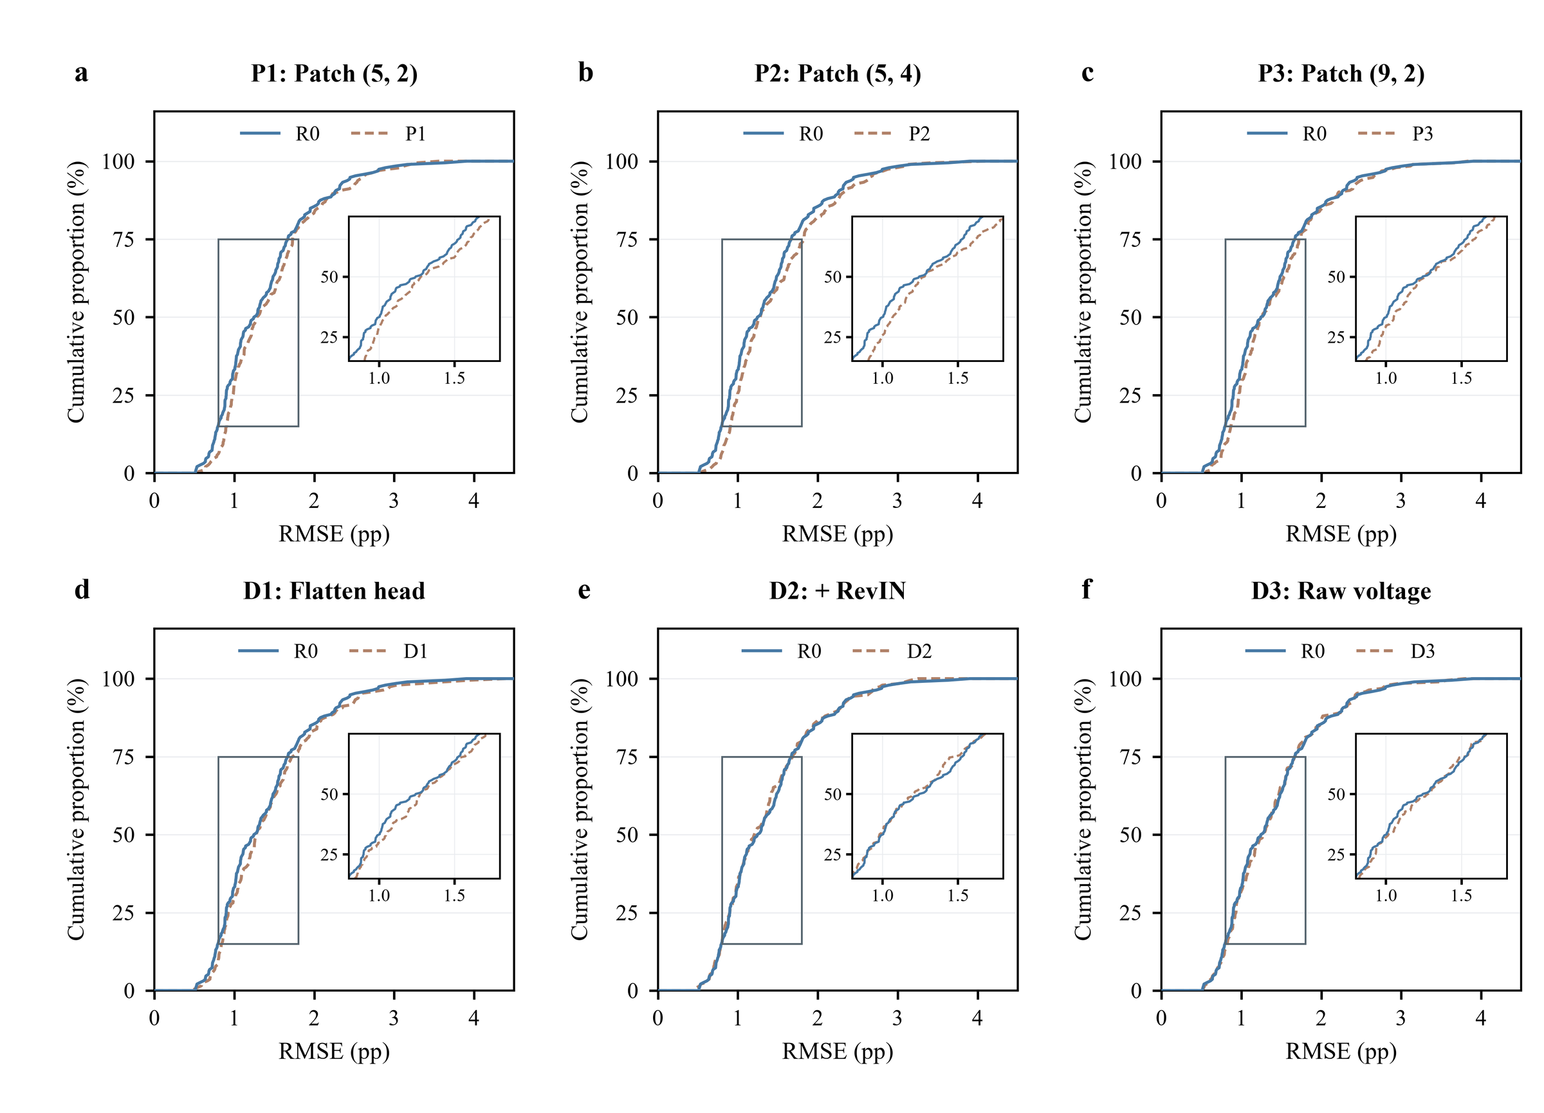
Fig. S1. Cumulative error distributions of the waveform-branch design variants. (a–c) Patch configurations P1 (5, 2), P2 (5, 4) and P3 (9, 2) versus R0 (9, 4); (d–f) adaptation ablations D1 (flatten head), D2 (with RevIN) and D3 (raw voltage). Solid blue, R0; dashed brown, variant. Each curve contains the 192 cell × seed RMSEs (not 192 independent cells); insets magnify RMSE 0.8–1.8 pp and cumulative proportion 15–75%. Cell-level tests are given in Table 8.
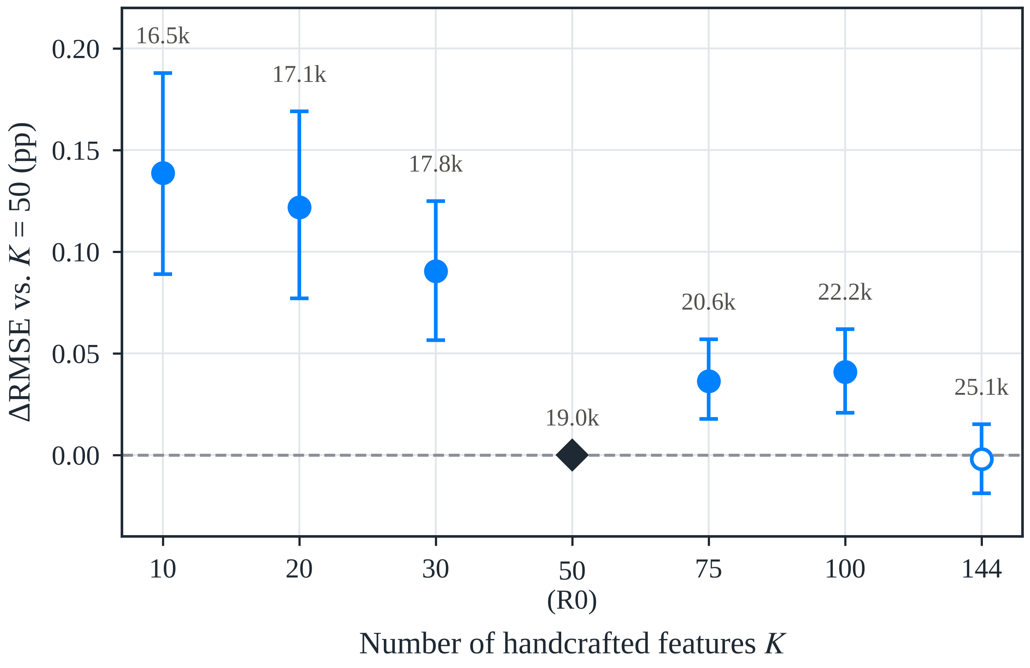
Fig. S2. Sensitivity to the number of handcrafted features K. Difference in cell-macro RMSE relative to K = 50 with 95% fold-stratified cell bootstrap intervals; labels give the total parameter count. Hollow markers denote intervals that include zero.
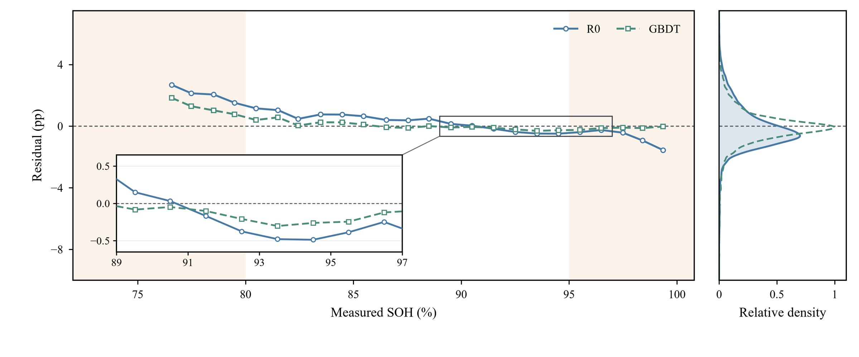
Fig. S3. SOH-dependent mean bias and overall residual distribution of R0 (blue, solid) and GBDT (teal, dashed). Residuals are the seed-averaged prediction minus the measured SOH of each record. Left: 1-pp bins of measured SOH with at least 20 records; shading marks SOH < 80% and ≥ 95%; the inset magnifies 89–97% SOH. Right: kernel density of all 16,938 residuals, normalised to the common maximum.
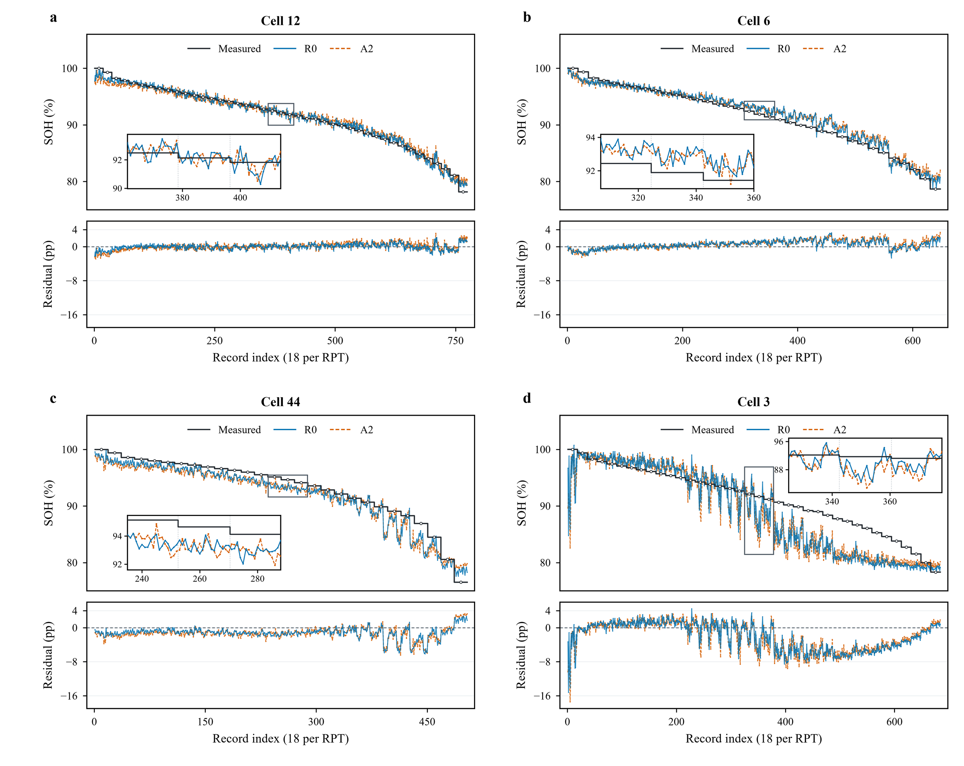
Fig. S4. Record-level predictions and residuals of representative cells 12, 6, 44 and 3 (ranks 1, 22, 43 and 64 by R0 error). Each RPT contributes 18 records (three SOCs × two directions × three seeds), so the horizontal axis is the record index rather than the cycle count; the grey staircase repeats the measured SOH of each RPT. Blue, R0; orange dashed, A2.
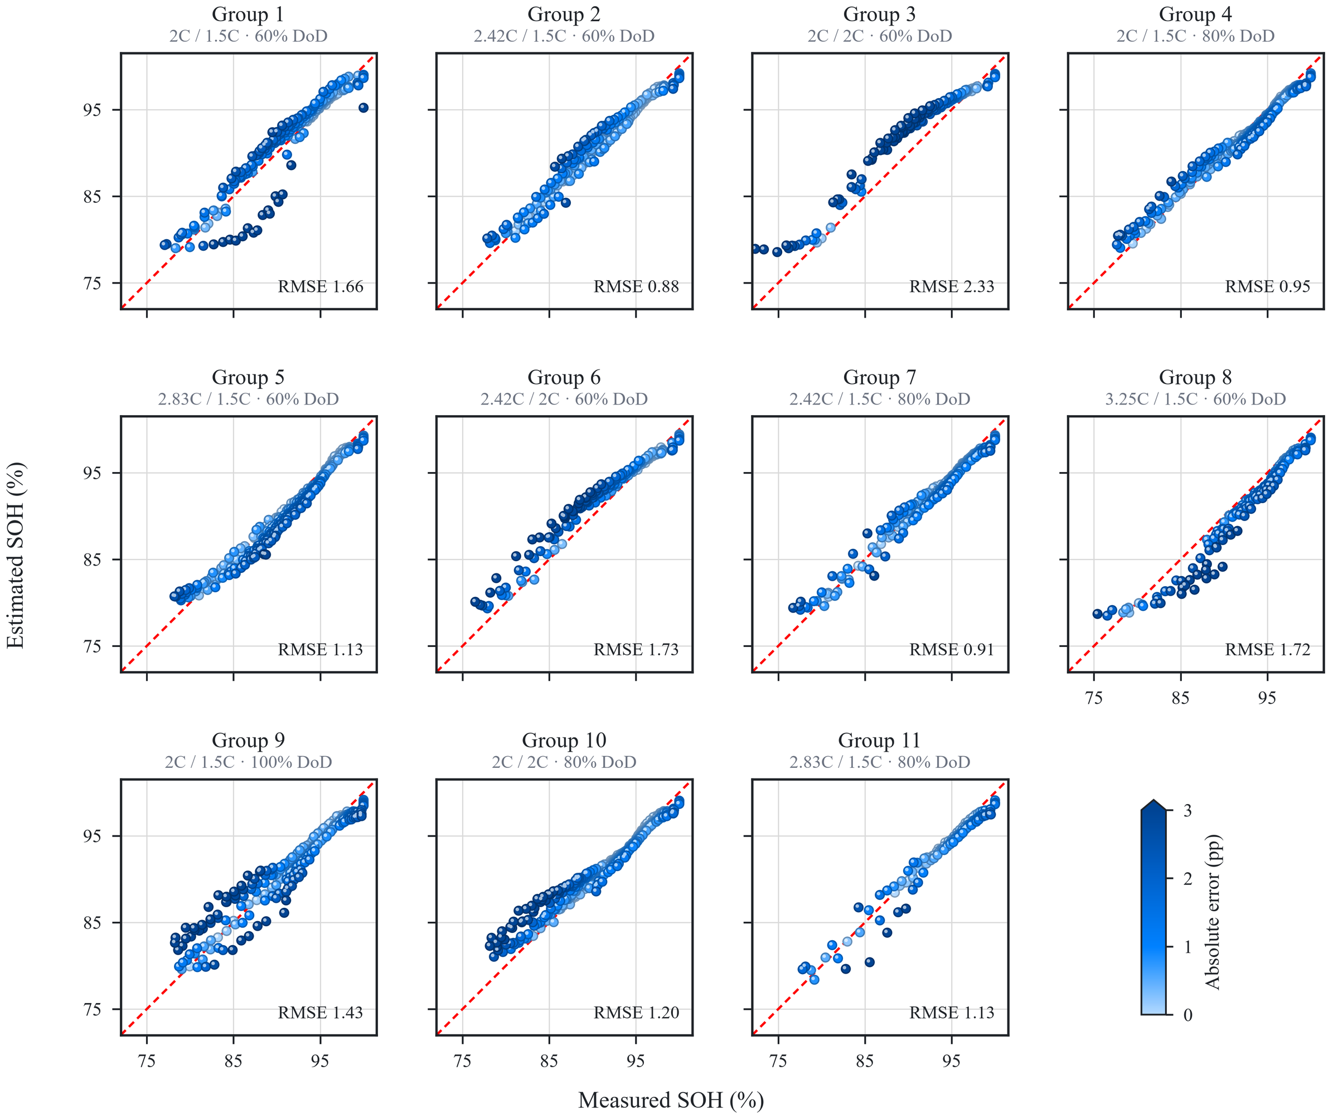
Fig. S5. SOH estimated by R0 versus measured SOH for the 11 cycling-condition groups. Each point is one cell–RPT (predictions averaged over seeds and conditions, all from the cell’s test fold); colour denotes absolute error (saturating at 3 pp) and the red dashed line is y = x. The number in each panel is the group’s cell-macro RMSE following Eq. (14).

