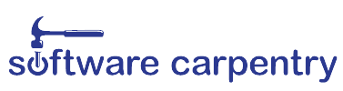
See http://software-carpentry.org/workshops to find a workshop near you.
we can help
Software Carpentry offers short workshops to teach researchers tools
and techniques that will help them use computers more productively.
topics Unix shell, version control, databases, Python, R
requirements
Varies depending on the workshop. No previous computing experience is required for our workshops for novices.
Web: http://software-carpentry.org
Email: admin@software-carpentry.org
Twitter: @swcarpentry
to learn more
C:\Users\scientist>_
Spending too much time
figuring out how to make your research more productive
using computers?

