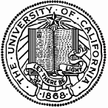UNIVERSITY OF CALIFORNIA, BERKELEY

BERKELEY • DAVIS • IRVINE • LOS ANGELES • MERCED • RIVERSIDE • SAN DIEGO • SAN FRANCISCO

SANTA BARBARA • SANTA CRUZ

Social Sciences Data Laboratory
350 Barrows Hall BERKELEY, CALIFORNIA 94720-3030
dlab@berkeley.edu
http://dlab.berkeley.edu/
25 January 2014

LETTER OF COMMITMENT

Dear Prof. Slaybaugh,

I am delighted offer to my support and commitment to your Assessing the Impact of Intensive Software Skills grant proposal, and look forward to providing space, outreach, and assistance in locating and supporting the assessment position. I am certain that D-Lab can be a strong partner as you carry out this project, and I look forward to continuing exchange with you and your team.

D-Lab’s mission is to create cross-disciplinary resources for high-level training and support services for social science researchers campus-wide. It does this by adaptively building new forms of shared infrastructure, including consulting and workshops in research tools and methods, and fostering discovery and connections with the pools of expertise and offerings of our departments and professional schools. As a new research unit at Berkeley, we have been actively involved in teaching software tools. We are ourselves engaged in evaluating students’ experiences with those trainings and adapting subsequent trainings in response to our evaluations, and we are enthusiastic supporters of campus efforts to broaden this approach to teaching.

You would be welcome to take advantage of D-Lab’s platform to recruit other partners, particularly in developing and implementing assessment strategies and tools, and to offer public presentations or trainings. I am confident that we can develop further concrete ways to support you in your trainings and assessments.

Yours truly,
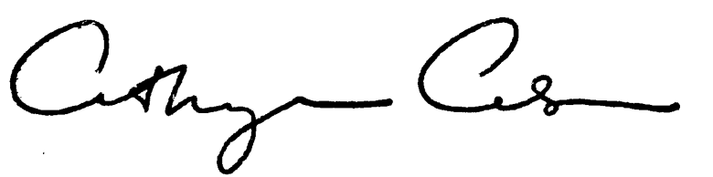
Cathryn Carson
Interim Director, D-Lab (Social Sciences Data Laboratory)
Associate Dean for Research, Division of Social Sciences

