

PROJECT REPORT
Report 3 – Software Requirement Specification

– Hanoi, OCT 2026 –
Table of Contents
Change Log 4
Definition and Acronyms 5
I. Overall Requirements 5
1. Context Diagram 5
2. Main Business Flow 7
3. Conceptual Data Model 7
3.1 Entity Relationship Diagram 7
3.2 Entity Descriptions 9
3.3 Data Business Rules 11
3.4 Data base design 12
4. User Requirements 16
4.1 Actors 16
4.2 Use Cases (UC) 16
4.3 Use Case Diagrams 18
4.4 Permission Matrix 19
5. System Functionalities 20
5.1 Screen Inventory 20
5.2 External API Inventory 20
5.3 Background Job Inventory 20
5.4 Sequence Diagrams 21
II. Use Case Specifications 21
1. Sales Staff 22
1.1 UC01 — Process Sale 22
1.2 UC02 — Process QR Payment 22
1.3 UC21 — Process Book Return 22
2. Inventory Staff 23
2.1 UC03 — Maintain Book Information 23
2.2 UC04 — Maintain Provider Information 23
2.3 UC05 — Prepare Purchase Order 24
2.4 UC06 — Record Goods Receipt 24
2.5 UC07 — Record Inventory Count 25
2.6 UC08 — Record Inventory Adjustment 25
2.7 UC09 — Perform Inventory Audit 26
3. Store Manager 26
3.1 UC10 — Update Price 26
3.2 UC11 — Update Discount/Promotion 26
3.3 UC12 — Update Staff Permissions 26
3.4 UC13 — Approve Purchase Order 26
3.5 UC14 — Approve Inventory Audit 27
3.6 UC15 — View Management Reports 27
Selected UC15 flow — Inventory report 27
4. System Admin 28
4.1 UC16 — Manage Accounts 28
4.2 UC17 — Configure System 28
4.3 UC18 — Review System Activity Logs 28
4.4 UC19 — Review Security Audit Logs 28
4.5 UC20 — Monitor System Alerts 28
III. Functional Requirements 28
2. User Authentication 28
3. System Administration 28
4. Other Functional Requirements 28
5. Background Job Inventory 28
6. External API Inventory 29
IV. Non-Functional Requirements 29
1. External Interfaces 29
2. Quality Attributes 29
2.1 Usability 29
2.2 Performance 29
2.3 Security 29
V. Requirement Appendix 29
1. Business Rules 29
2. System Messages 30
3. Other Requirements 30
Supporting implementation design 31
Traceability and review status 32

Change Log
Date | A*  M, D | In charge | Change Description
2026-10-22 | M | Review draft; acceptance pending | Controlled reconstruction from original template; source diagrams retained.
04 Nov 2026 |  |  | M: integrate UC21 decisions, UC15 report, 3NF relational design and implementation evidence; preserve source diagrams pending manual corrections.
*A - Added M - Modified D - Deleted

Definition and Acronyms
Acronym | Definition
SRS | Software Requirement Specification
UC | Use Case
BR | Business Rule
PO | Purchase Order in domain text; Requirements Approver where explicitly stated
3NF | Third normal form
Review labels | SOURCE FACT; USER-APPROVED REVIEW DECISION; INSTRUCTOR REQUIREMENT; PROPOSAL — NOT APPROVED; MISSING REQUIREMENT

I. Overall Requirements

1. Context Diagram
Book Sales Management System supports an internal offline bookstore. This revision consolidates confirmed decisions, the original unchanged diagrams, normalized relational design and selected implementation evidence. It is a review copy pending manual diagram corrections and unresolved requirements.
USER-APPROVED REVIEW DECISION: Review navigation: Context (I.1) → Chen (I.3.1) → Use Case diagrams (I.4.3) and specifications (II) → Database Design (I.3.4) → Screen Flow (I.5.1) → Sequence Diagrams (I.5.4). Physical template numbering is preserved.
SOURCE FACT: The following image is the user-authored Context Diagram JPEG. Labels and arrows are retained by embedding its original bytes; no reconstruction is substituted.
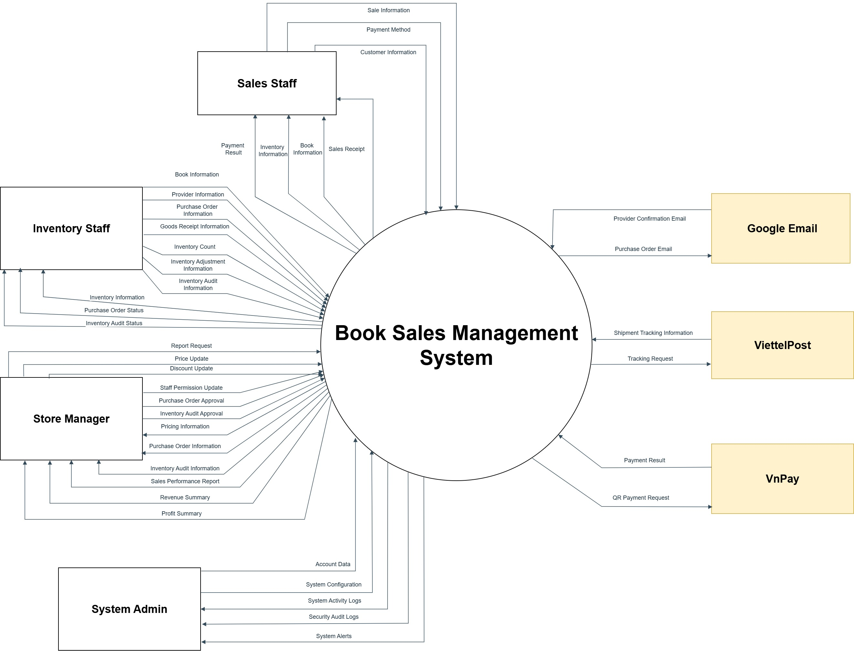

2. Main Business Flow
Selected implemented flows are cash sale (UC01), accepted book return (UC21), price update (UC10), and inventory reporting within UC15. The report flow is request → validate filters → read Book and BookStock → display → optional CSV export. Other procurement/approval scenarios retain explicit gaps below.
USER-APPROVED REVIEW DECISION: Supported flow constraints are documented in UC01, UC02, UC07, UC09 and UC14. These constraints do not establish a complete business flow.

3. Conceptual Data Model

3.1 Entity Relationship Diagram
USER-APPROVED REVIEW DECISION: Use the original Chen Diagram JPEG for this review, superseding the template sample instruction to use Crow-Foot notation.
The retained Chen image contains the original 14 conceptual entities. It predates Return/Count and Account refinements; review the required conceptual corrections before final submission. The relational schema in 3.4 must not be substituted for Chen.
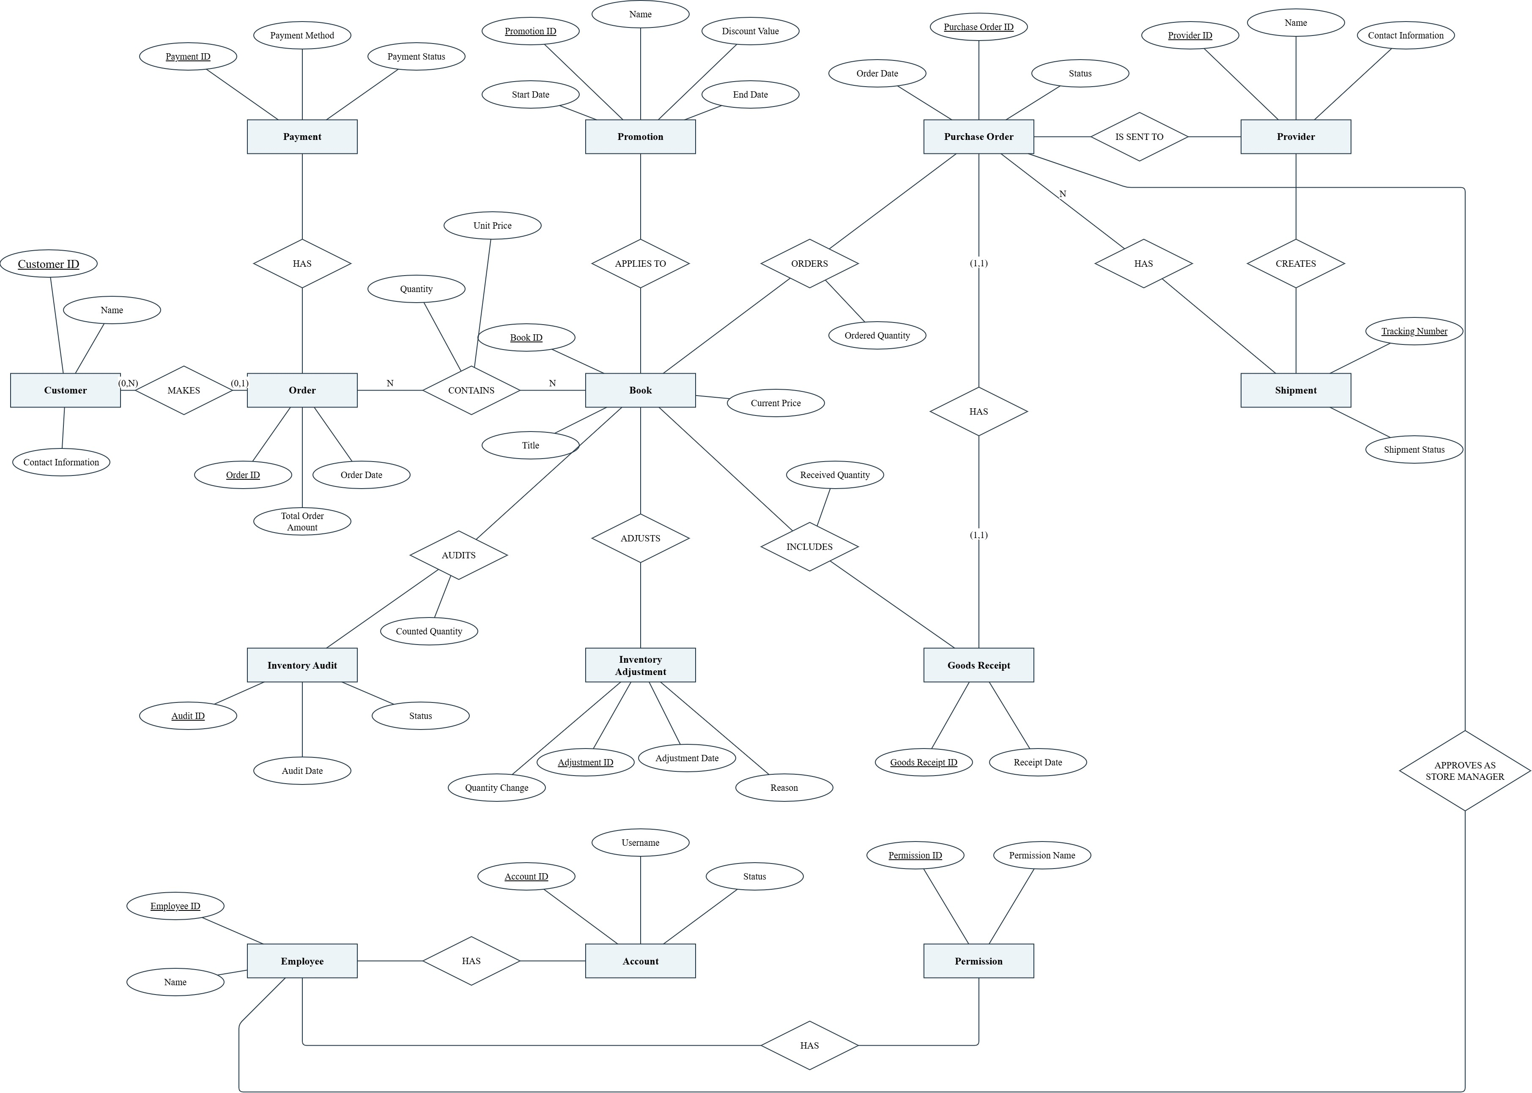

3.2 Entity Descriptions
Entity: Customer
Field | Value
Purpose | SOURCE FACT: Named conceptual entity in the original Chen page; business definition beyond its label is not inferred.
Key business attributes | SOURCE FACT: Customer ID, Name, Contact Information.
Identity | SOURCE FACT: Underlined: Customer ID. MISSING REQUIREMENT: Uniqueness scope and alternate determinants need validation.
Status / lifecycle | MISSING REQUIREMENT: Attribute labels do not establish allowed values or transitions.
Entity: Order
Field | Value
Purpose | SOURCE FACT: Named conceptual entity in the original Chen page; business definition beyond its label is not inferred.
Key business attributes | SOURCE FACT: Order ID, Order Date, Total Order Amount.
Identity | SOURCE FACT: Underlined: Order ID. MISSING REQUIREMENT: Uniqueness scope and alternate determinants need validation.
Status / lifecycle | MISSING REQUIREMENT: Attribute labels do not establish allowed values or transitions.
Entity: Payment
Field | Value
Purpose | SOURCE FACT: Named conceptual entity in the original Chen page; business definition beyond its label is not inferred.
Key business attributes | SOURCE FACT: Payment ID, Payment Method, Payment Status.
Identity | SOURCE FACT: Underlined: Payment ID. MISSING REQUIREMENT: Uniqueness scope and alternate determinants need validation.
Status / lifecycle | MISSING REQUIREMENT: Attribute labels do not establish allowed values or transitions.
Entity: Book
Field | Value
Purpose | SOURCE FACT: Named conceptual entity in the original Chen page; business definition beyond its label is not inferred.
Key business attributes | SOURCE FACT: Book ID, Title, Current Price.
Identity | SOURCE FACT: Underlined: Book ID. MISSING REQUIREMENT: Uniqueness scope and alternate determinants need validation.
Status / lifecycle | MISSING REQUIREMENT: Attribute labels do not establish allowed values or transitions.
Entity: Promotion
Field | Value
Purpose | SOURCE FACT: Named conceptual entity in the original Chen page; business definition beyond its label is not inferred.
Key business attributes | SOURCE FACT: Promotion ID, Name, Discount Value, Start Date, End Date.
Identity | SOURCE FACT: Underlined: Promotion ID. MISSING REQUIREMENT: Uniqueness scope and alternate determinants need validation.
Status / lifecycle | MISSING REQUIREMENT: Attribute labels do not establish allowed values or transitions.
Entity: Purchase Order
Field | Value
Purpose | SOURCE FACT: Named conceptual entity in the original Chen page; business definition beyond its label is not inferred.
Key business attributes | SOURCE FACT: Purchase Order ID, Order Date, Status.
Identity | SOURCE FACT: Underlined: Purchase Order ID. MISSING REQUIREMENT: Uniqueness scope and alternate determinants need validation.
Status / lifecycle | MISSING REQUIREMENT: Attribute labels do not establish allowed values or transitions.
Entity: Provider
Field | Value
Purpose | SOURCE FACT: Named conceptual entity in the original Chen page; business definition beyond its label is not inferred.
Key business attributes | SOURCE FACT: Provider ID, Name, Contact Information.
Identity | SOURCE FACT: Underlined: Provider ID. MISSING REQUIREMENT: Uniqueness scope and alternate determinants need validation.
Status / lifecycle | MISSING REQUIREMENT: Attribute labels do not establish allowed values or transitions.
Entity: Shipment
Field | Value
Purpose | SOURCE FACT: Named conceptual entity in the original Chen page; business definition beyond its label is not inferred.
Key business attributes | SOURCE FACT: Tracking Number, Shipment Status.
Identity | SOURCE FACT: Underlined: Tracking Number. MISSING REQUIREMENT: Uniqueness scope and alternate determinants need validation.
Status / lifecycle | MISSING REQUIREMENT: Attribute labels do not establish allowed values or transitions.
Entity: Goods Receipt
Field | Value
Purpose | SOURCE FACT: Named conceptual entity in the original Chen page; business definition beyond its label is not inferred.
Key business attributes | SOURCE FACT: Goods Receipt ID, Receipt Date.
Identity | SOURCE FACT: Underlined: Goods Receipt ID. MISSING REQUIREMENT: Uniqueness scope and alternate determinants need validation.
Status / lifecycle | MISSING REQUIREMENT: Attribute labels do not establish allowed values or transitions.
Entity: Inventory Adjustment
Field | Value
Purpose | SOURCE FACT: Named conceptual entity in the original Chen page; business definition beyond its label is not inferred.
Key business attributes | SOURCE FACT: Adjustment ID, Adjustment Date, Quantity Change, Reason.
Identity | SOURCE FACT: Underlined: Adjustment ID. MISSING REQUIREMENT: Uniqueness scope and alternate determinants need validation.
Status / lifecycle | MISSING REQUIREMENT: Attribute labels do not establish allowed values or transitions.
Entity: Inventory Audit
Field | Value
Purpose | SOURCE FACT: Named conceptual entity in the original Chen page; business definition beyond its label is not inferred.
Key business attributes | SOURCE FACT: Audit ID, Audit Date, Status.
Identity | SOURCE FACT: Underlined: Audit ID. MISSING REQUIREMENT: Uniqueness scope and alternate determinants need validation.
Status / lifecycle | MISSING REQUIREMENT: Attribute labels do not establish allowed values or transitions.
Entity: Employee
Field | Value
Purpose | SOURCE FACT: Named conceptual entity in the original Chen page; business definition beyond its label is not inferred.
Key business attributes | SOURCE FACT: Employee ID, Name.
Identity | SOURCE FACT: Underlined: Employee ID. MISSING REQUIREMENT: Uniqueness scope and alternate determinants need validation.
Status / lifecycle | MISSING REQUIREMENT: Attribute labels do not establish allowed values or transitions.
Entity: Account
Field | Value
Purpose | SOURCE FACT: Named conceptual entity in the original Chen page; business definition beyond its label is not inferred.
Key business attributes | Account ID, Username, Status; relational design also stores password_hash (not plaintext). One account per employee; role_code is stored once on Employee in the review schema.
Identity | SOURCE FACT: Underlined: Account ID. MISSING REQUIREMENT: Uniqueness scope and alternate determinants need validation.
Status / lifecycle | MISSING REQUIREMENT: Attribute labels do not establish allowed values or transitions.
Entity: Permission
Field | Value
Purpose | SOURCE FACT: Named conceptual entity in the original Chen page; business definition beyond its label is not inferred.
Key business attributes | SOURCE FACT: Permission ID, Permission Name.
Identity | SOURCE FACT: Underlined: Permission ID. MISSING REQUIREMENT: Uniqueness scope and alternate determinants need validation.
Status / lifecycle | MISSING REQUIREMENT: Attribute labels do not establish allowed values or transitions.

3.3 Data Business Rules
Rule | Description | Enforced On
BR-SALE-01 | USER-APPROVED REVIEW DECISION: Process Sale supports Cash and QR payment methods. | UC01, UC02
BR-SALE-02 | USER-APPROVED REVIEW DECISION: Process QR Payment only occurs as part of Process Sale; UC02 extends UC01 when Payment Method = QR. | UC01, UC02
BR-INV-01 | USER-APPROVED REVIEW DECISION: An Inventory Count may be performed independently of an Inventory Audit. | UC07, UC09
BR-INV-02 | USER-APPROVED REVIEW DECISION: An independent Count records results in history and updates current stock. | UC07
BR-INV-03 | USER-APPROVED REVIEW DECISION: A difference from recorded stock automatically creates an Inventory Adjustment; the same difference must not be posted twice. | UC07, UC08
BR-INV-04 | USER-APPROVED REVIEW DECISION: A Count occurrence covers one or multiple Books. | UC07
BR-INV-05 | USER-APPROVED REVIEW DECISION: Audit count results are recorded without updating stock before approval. | UC09
BR-INV-06 | USER-APPROVED REVIEW DECISION: Audit approval only confirms results; it does not create an Adjustment or update stock. | UC14

3.4 Data base design
Review schema: 38 business relations and 126 columns. SQL Server scripts, key/FK manifests and conditional FD proofs are retained under database/normalized-review-2026-10-27 in the repository. This is a physical relational design distinct from the conceptual Chen image. New password_hash storage is nullable for existing unprovisioned accounts; Login must reject NULL hashes. No JWT/refresh-token tables are required.
Normalization rationale: 1NF uses one value per contact and one row per grant/line/observation. 2NF separates Employee/Permission attributes from EmployeePermission and per-Book quantities from Adjustment headers. 3NF derives Book/PO from the exact PO line on receipt, and Book/original Order from the original sale line on Return. Source-to-candidate mapping covers all 27 source relations; new requirement-support tables are explicitly distinguished from decomposition.
Examples of dependencies: employee_id → name, role_code; account_id (and unique employee_id/username) → Account attributes; (employee_id, permission_id) is the grant key; receipt_line_id → purchase_order_line_id → purchase_order_id, book_id, so derived PO/Book are not repeated; return_line_id → original_order_line_id → Book, while return_id → original_order_id, returned_at_utc. Repeated Books retain independent occurrence keys. Recounts are observations with one selected result, not summed counts.
The FD closure and decomposition checks pass for the declared dependencies; this is conditional 3NF evidence, not proof that every possible business FD is known. Payment/provider/shipment cardinalities, contact/discount domains and migration of ambiguous legacy values remain review items. SQL trigger success is not proof of refund-calculation or concurrency correctness.
Relation and candidate key constraints | Columns and references
Employee  PK employee_id | employee_id nvarchar(200); name nvarchar(max) NULL; role_code nvarchar(32)
Account  PK account_id; UNIQUE employee_id; username | account_id nvarchar(200); employee_id nvarchar(200); username nvarchar(200); status nvarchar(max) NULL; password_hash nvarchar(512) NULL  FK employee_id → Employee(employee_id)
Permission  PK permission_id | permission_id nvarchar(200); permission_name nvarchar(max) NULL
EmployeePermission  PK employee_id, permission_id | employee_id nvarchar(200); permission_id nvarchar(200)  FK employee_id → Employee(employee_id); permission_id → Permission(permission_id)
UserAccessLog  PK access_log_id | access_log_id bigint; account_id nvarchar(200) NULL; occurred_at_utc datetime2(7); request_path nvarchar(2048); was_authorized bit; client_ip nvarchar(45)  FK account_id → Account(account_id)
ExternalServiceLog  PK service_log_id | service_log_id bigint; occurred_at_utc datetime2(7); service_name nvarchar(100); operation_name nvarchar(200); succeeded bit
Customer  PK customer_id | customer_id nvarchar(200); name nvarchar(max) NULL
CustomerContact  PK contact_id | contact_id bigint; customer_id nvarchar(200); contact_kind nvarchar(50); contact_value nvarchar(1000)  FK customer_id → Customer(customer_id)
Provider  PK provider_id | provider_id nvarchar(200); name nvarchar(max) NULL
ProviderContact  PK contact_id | contact_id bigint; provider_id nvarchar(200); contact_kind nvarchar(50); contact_value nvarchar(1000)  FK provider_id → Provider(provider_id)
Book  PK book_id | book_id nvarchar(200); title nvarchar(max) NULL; current_price decimal(19,4) NULL
Promotion  PK promotion_id | promotion_id nvarchar(200); name nvarchar(max) NULL; discount_kind nvarchar(50) NULL; discount_value decimal(19,4) NULL; start_date date NULL; end_date date NULL
PromotionBook  PK promotion_id, book_id | promotion_id nvarchar(200); book_id nvarchar(200)  FK promotion_id → Promotion(promotion_id); book_id → Book(book_id)
SalesOrder  PK order_id | order_id nvarchar(200); order_date date NULL; total_order_amount decimal(19,4) NULL; customer_id nvarchar(200) NULL  FK customer_id → Customer(customer_id)
SalesOrderLine  PK order_line_id | order_line_id bigint; order_id nvarchar(200); book_id nvarchar(200); quantity decimal(38,10); unit_price decimal(19,4) NULL  FK order_id → SalesOrder(order_id); book_id → Book(book_id)
Payment  PK payment_id | payment_id nvarchar(200); payment_method nvarchar(max) NULL; payment_status nvarchar(max) NULL
OrderPayment  PK order_id, payment_id | order_id nvarchar(200); payment_id nvarchar(200)  FK order_id → SalesOrder(order_id); payment_id → Payment(payment_id)
BookReturn  PK return_id | return_id nvarchar(200); original_order_id nvarchar(200); returned_at_utc datetime2(7)  FK original_order_id → SalesOrder(order_id)
BookReturnLine  PK return_line_id | return_line_id bigint; return_id nvarchar(200); original_order_line_id bigint; returned_quantity decimal(38,10); refund_amount decimal(19,4)  FK return_id → BookReturn(return_id); original_order_line_id → SalesOrderLine(order_line_id)
PurchaseOrder  PK purchase_order_id | purchase_order_id nvarchar(200); order_date date NULL; status nvarchar(max) NULL
PurchaseOrderLine  PK purchase_order_line_id | purchase_order_line_id bigint; purchase_order_id nvarchar(200); book_id nvarchar(200); ordered_quantity decimal(38,10)  FK purchase_order_id → PurchaseOrder(purchase_order_id); book_id → Book(book_id)
PurchaseOrderProvider  PK purchase_order_id, provider_id | purchase_order_id nvarchar(200); provider_id nvarchar(200)  FK purchase_order_id → PurchaseOrder(purchase_order_id); provider_id → Provider(provider_id)
GoodsReceipt  PK receipt_id | receipt_id nvarchar(200); receipt_date date NULL
GoodsReceiptLine  PK receipt_line_id | receipt_line_id bigint; receipt_id nvarchar(200); purchase_order_line_id bigint; received_quantity decimal(38,10)  FK receipt_id → GoodsReceipt(receipt_id); purchase_order_line_id → PurchaseOrderLine(purchase_order_line_id)
Shipment  PK shipment_id | shipment_id bigint; tracking_number nvarchar(200); shipment_status nvarchar(max) NULL
ProviderShipment  PK provider_id, shipment_id | provider_id nvarchar(200); shipment_id bigint  FK provider_id → Provider(provider_id); shipment_id → Shipment(shipment_id)
PurchaseOrderShipment  PK purchase_order_id, shipment_id | purchase_order_id nvarchar(200); shipment_id bigint  FK purchase_order_id → PurchaseOrder(purchase_order_id); shipment_id → Shipment(shipment_id)
PurchaseOrderApproval  PK employee_id, purchase_order_id | employee_id nvarchar(200); purchase_order_id nvarchar(200)  FK employee_id → Employee(employee_id); purchase_order_id → PurchaseOrder(purchase_order_id)
InventoryAudit  PK audit_id | audit_id nvarchar(200); audit_date date NULL; status nvarchar(max) NULL
InventoryAuditLine  PK audit_line_id | audit_line_id bigint; audit_id nvarchar(200); book_id nvarchar(200); counted_quantity decimal(38,10)  FK audit_id → InventoryAudit(audit_id); book_id → Book(book_id)
InventoryCount  PK count_id | count_id nvarchar(200); counted_at_utc datetime2(7); recorded_by_employee_id nvarchar(200)  FK recorded_by_employee_id → Employee(employee_id)
InventoryCountObservation  PK observation_id; UNIQUE observation_id,count_id,book_id | observation_id bigint; count_id nvarchar(200); book_id nvarchar(200); counted_quantity decimal(38,10); observed_at_utc datetime2(7)  FK count_id → InventoryCount(count_id); book_id → Book(book_id)
InventoryCountSelection  PK count_id, book_id; UNIQUE selected_observation_id | count_id nvarchar(200); book_id nvarchar(200); selected_observation_id bigint; recorded_quantity decimal(38,10)  FK selected_observation_id,count_id,book_id → InventoryCountObservation(observation_id,count_id,book_id)
InventoryAdjustment  PK adjustment_id | adjustment_id nvarchar(200); adjustment_date date NULL; reason nvarchar(max) NULL
AdjustmentBook  PK adjustment_id, book_id | adjustment_id nvarchar(200); book_id nvarchar(200); quantity_change decimal(38,10)  FK adjustment_id → InventoryAdjustment(adjustment_id); book_id → Book(book_id)
CountAdjustment  PK count_id; UNIQUE adjustment_id | count_id nvarchar(200); adjustment_id nvarchar(200)  FK count_id → InventoryCount(count_id); adjustment_id → InventoryAdjustment(adjustment_id)
BookStock  PK book_id | book_id nvarchar(200); current_quantity decimal(38,10)  FK book_id → Book(book_id)
InventoryMovement  PK movement_id; UNIQUE posting_key | movement_id bigint; posting_key nvarchar(200); book_id nvarchar(200); quantity_delta decimal(38,10); occurred_at_utc datetime2(7)  FK book_id → Book(book_id)
SQL integrity: FK/CHECK enforce existing references, positive return quantity and nonnegative refund. Three triggers enforce correct original-order membership and cumulative returned quantity, including protection against invalid source/header edits. Application transactions atomically save sale/Return, update current stock and append movement history. Audit approval does not itself change stock. Current stock and ledger are both retained.

4. User Requirements

4.1 Actors
# | Actor | Description
1 | Sales Staff | SOURCE FACT: Original human actor; associated business goals listed in I.4.2. No additional permission policy inferred.
2 | Inventory Staff | SOURCE FACT: Original human actor; associated business goals listed in I.4.2. No additional permission policy inferred.
3 | Store Manager | SOURCE FACT: Original human actor; associated business goals listed in I.4.2. No additional permission policy inferred.
4 | System Admin | SOURCE FACT: Original human actor; associated business goals listed in I.4.2. No additional permission policy inferred.

4.2 Use Cases (UC)
ID | Use Case | Feature | Use Case Description
UC01 | Process Sale | Sales Staff | SOURCE FACT: Source cell -iIRy7ccoKy4XHUG_YKf-2. See II for supported partial specification.
UC02 | Process QR Payment | Sales Staff | SOURCE FACT: Source cell -iIRy7ccoKy4XHUG_YKf-3. See II for supported partial specification.
UC03 | Maintain Book Information | Inventory Staff | SOURCE FACT: Source cell fME8TCTJ2Jw69tr8gcqI-2. See III for the source-supported scope; detailed behavior remains open.
UC04 | Maintain Provider Information | Inventory Staff | SOURCE FACT: Source cell fME8TCTJ2Jw69tr8gcqI-3. See III for the source-supported scope; detailed behavior remains open.
UC05 | Prepare Purchase Order | Inventory Staff | SOURCE FACT: Source cell fME8TCTJ2Jw69tr8gcqI-4. See II for supported partial specification.
UC06 | Record Goods Receipt | Inventory Staff | SOURCE FACT: Source cell fME8TCTJ2Jw69tr8gcqI-5. See II for supported partial specification.
UC07 | Record Inventory Count | Inventory Staff | SOURCE FACT: Source cell fME8TCTJ2Jw69tr8gcqI-6. See II for supported partial specification.
UC08 | Record Inventory Adjustment | Inventory Staff | SOURCE FACT: Source cell fME8TCTJ2Jw69tr8gcqI-7. See II for supported partial specification.
UC09 | Perform Inventory Audit | Inventory Staff | SOURCE FACT: Source cell fME8TCTJ2Jw69tr8gcqI-8. See II for supported partial specification.
UC10 | Update Price | Store Manager | SOURCE FACT: Source cell HkRzyqCWEv9dlyxQ2sEY-3. See III for the source-supported scope; detailed behavior remains open.
UC11 | Update Discount/Promotion | Store Manager | SOURCE FACT: Source cell HkRzyqCWEv9dlyxQ2sEY-4. See III for the source-supported scope; detailed behavior remains open.
UC12 | Update Staff Permissions | Store Manager | SOURCE FACT: Source cell HkRzyqCWEv9dlyxQ2sEY-5. See III for the source-supported scope; detailed behavior remains open.
UC13 | Approve Purchase Order | Store Manager | SOURCE FACT: Source cell HkRzyqCWEv9dlyxQ2sEY-6. See II for supported partial specification.
UC14 | Approve Inventory Audit | Store Manager | SOURCE FACT: Source cell HkRzyqCWEv9dlyxQ2sEY-7. See II for supported partial specification.
UC15 | View Management Reports | Store Manager | SOURCE FACT: Source cell -DCsxYDNAwu7hMHAQvoL-2. See III for the source-supported scope; detailed behavior remains open.
UC16 | Manage Accounts | System Admin | SOURCE FACT: Source cell uc-01. See III for the source-supported scope; detailed behavior remains open.
UC17 | Configure System | System Admin | SOURCE FACT: Source cell uc-02. See III for the source-supported scope; detailed behavior remains open.
UC18 | Review System Activity Logs | System Admin | SOURCE FACT: Source cell uc-03. See III for the source-supported scope; detailed behavior remains open.
UC19 | Review Security Audit Logs | System Admin | SOURCE FACT: Source cell uc-04. See III for the source-supported scope; detailed behavior remains open.
UC20 | Monitor System Alerts | System Admin | SOURCE FACT: Source cell uc-05. See III for the source-supported scope; detailed behavior remains open.
UC21 | Sales Staff | Process Book Return | Accept eligible returned Books against original sales lines, refund cash and restore stock.

4.3 Use Case Diagrams

4.3.1 UCs for Sales Staff
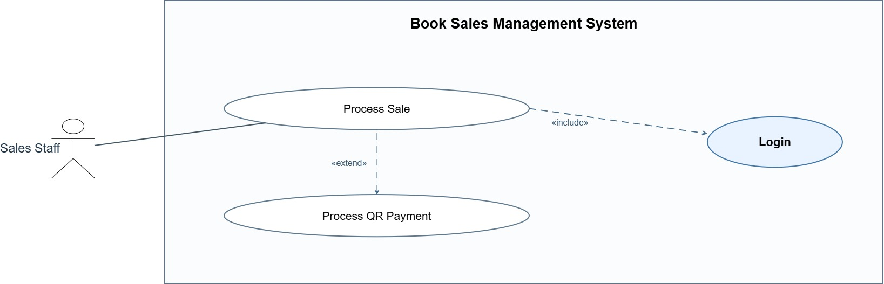

4.3.2 UCs for Inventory Staff
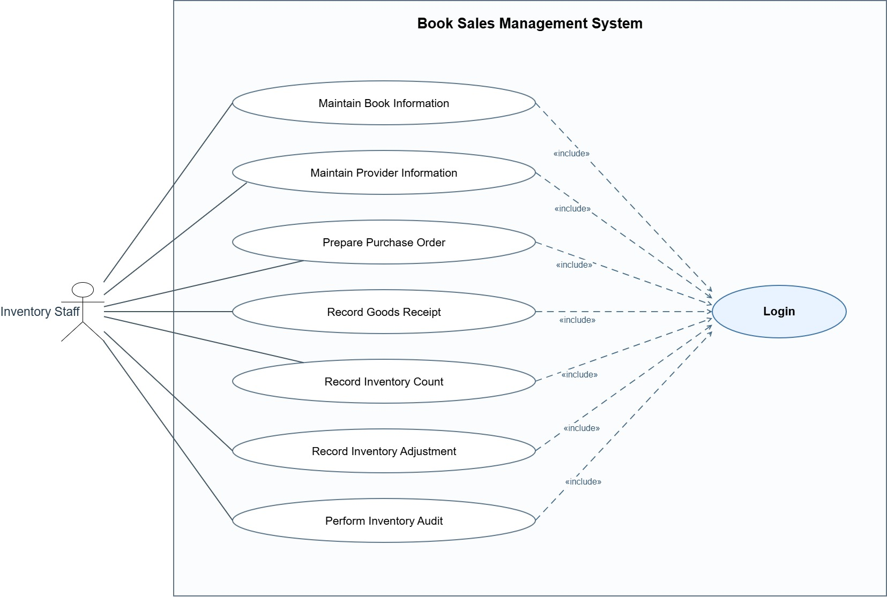

4.3.3 UCs for Store Manager
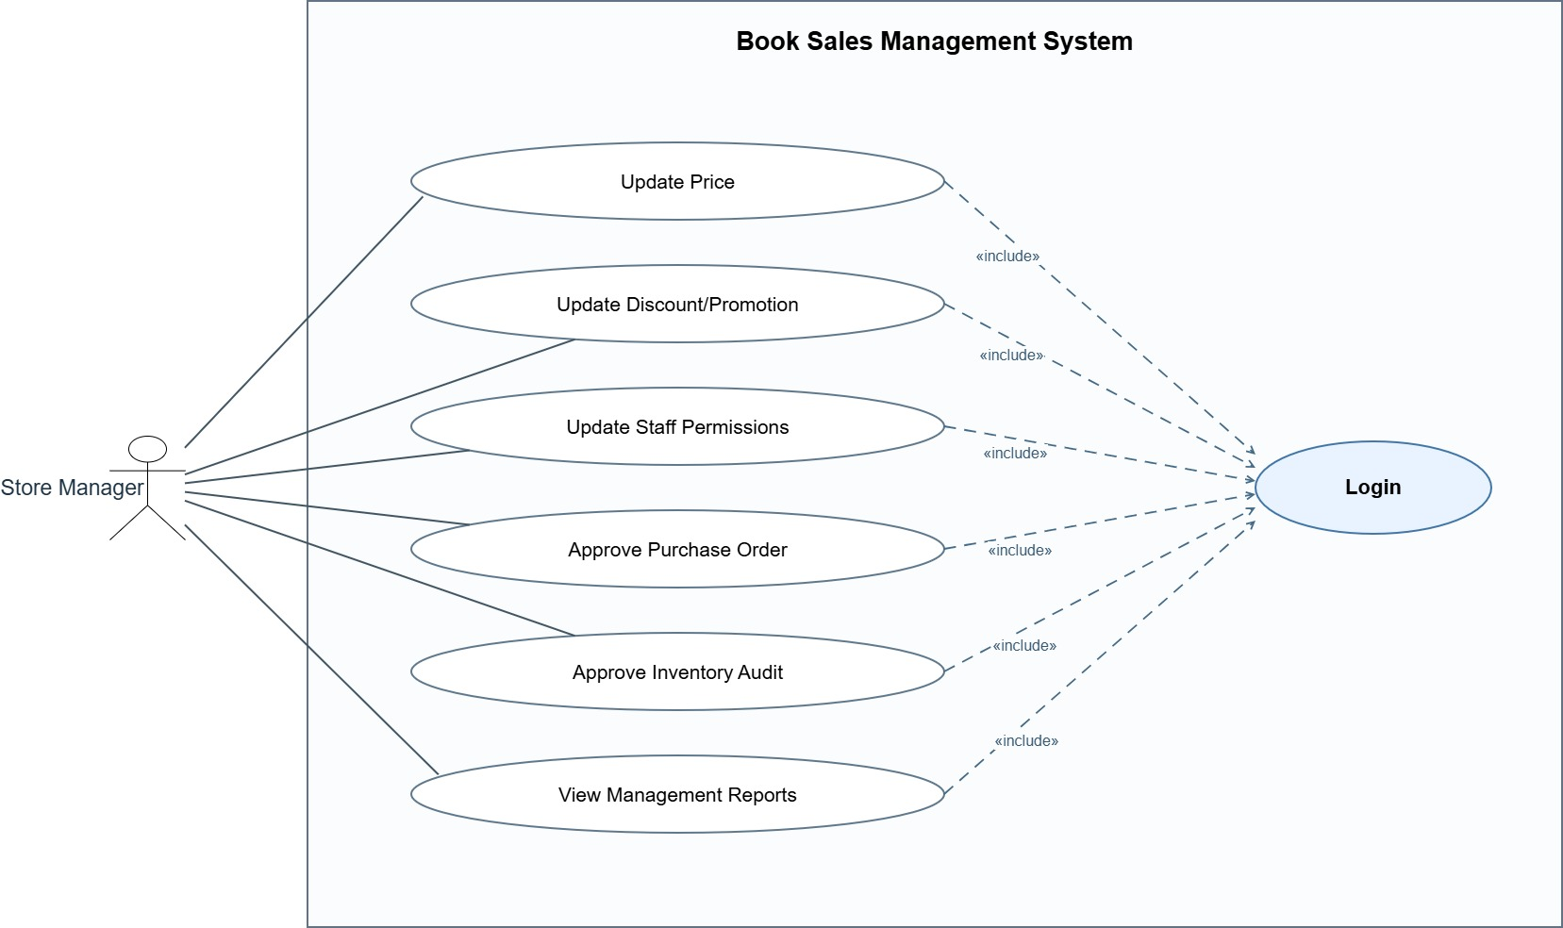

4.3.4 UCs for System Admin
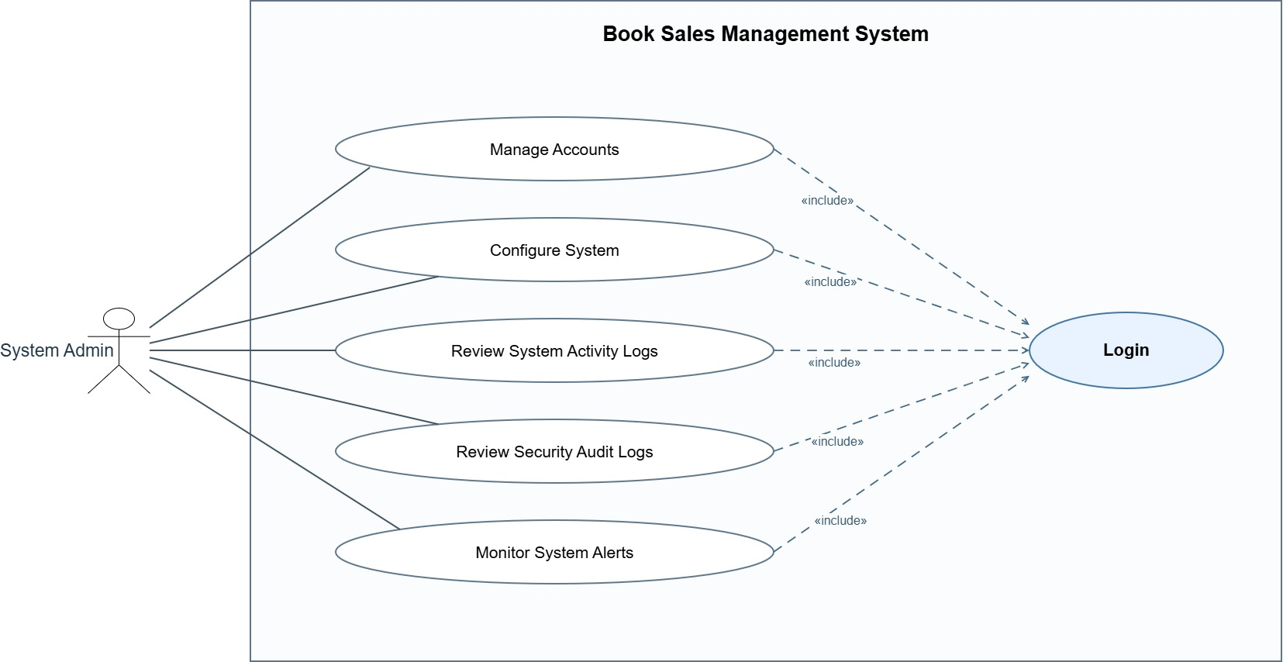

4.4 Permission Matrix
Confirmed access scope: Manager manages Business permissions; Admin manages all permissions. Manager may view staff logs; Admin may view all logs. The precise target/self-change rules and chosen Login implementation require the module owner to finalize. JWT is excluded. The integration currently restricts business demos to local Development; it does not claim production authorization.

5. System Functionalities
The system scope contains UC01–UC20 and UC21 Process Book Return. Each member implements one selected main flow; the system-wide use-case inventory is broader than the demonstration implementation.

5.1 Screen Inventory

a. Screen Flow
Implemented navigation: Home → Sales; Sales → cash receipt or Development-only simulated QR; Return search → eligible original order → confirm return → receipt/history; Inventory report → filter → table → CSV. Screens are local Development demos until the access module is integrated.

b. Screen List
Screen |  |  |  | Route and responsibility
Inventory report |  |  |  | GET /reports/inventory; filter/current data; GET /reports/inventory/export for CSV
Price update demo |  |  |  | GET/POST /Pricing; anti-forgery-protected form; commit then enqueue notification
Sale |  |  |  | GET/POST /sales; cash flow, Development-only simulated QR confirmation
Return |  |  |  | /returns/search, /returns/create/{orderId}, history/details/receipt routes; original sale-line identity
Access demo |  |  |  | Owned by the access module; not integrated in the reviewed two PRs. No claim of working Login on this integration.
# | Screen Name | Feature | Description
— | MISSING REQUIREMENT | — | Implementation inventory is listed above; formal screen approval remains pending.

5.2 External API Inventory
SOURCE FACT: Context contains Google Email, ViettelPost and VnPay exchanges. MISSING REQUIREMENT: These exchanges do not specify APIs, paths, authentication or confirmation mechanisms.
# | API Name | Calling Path | Description
— | MISSING REQUIREMENT | Not specified | No API contract adopted from template examples.

5.3 Background Job Inventory
Implemented demo worker: PriceDispatchWorker consumes PriceChangeQueue after price commit and sends BookPriceChanged through SignalR. This is an in-memory event-driven worker, not a scheduled durable job. No replay or delivery guarantee. Business stock posting remains synchronous within the transaction. Log retention and alert schedules remain unspecified.
# | Job Name | Group | Description
— | MISSING REQUIREMENT | Not specified | PriceDispatchWorker is event driven and in-memory. No scheduled cleanup/retention period is approved.

5.4 Sequence Diagrams
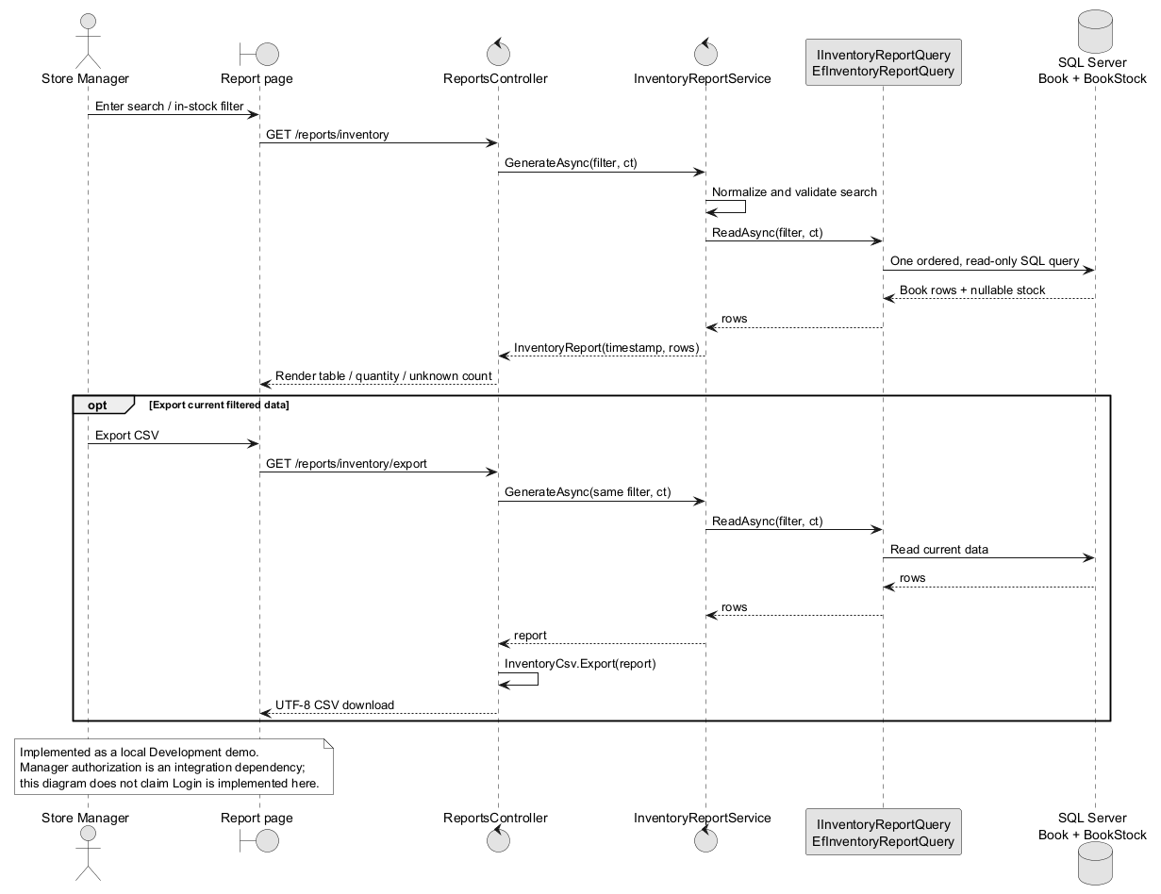
UC15 selected inventory report sequence — matches integrated code; local Development demo.
The inventory report sequence below realizes the selected UC15 flow and matches the integrated code. Older sequence fragments remain partial; they do not establish complete external payment/procurement protocols.

II. Use Case Specifications
INSTRUCTOR REQUIREMENT: Use the template fields for main/complex Use Cases; simple maintenance or viewing cases reference Functional Requirements. SOURCE FACT: The following specifications retain the original table structure. They are partial wherever required behavior is missing.

1. Sales Staff

1.1 UC01 — Process Sale
Primary Actors | SOURCE FACT: Sales Staff | Secondary Actors | MISSING REQUIREMENT: Direct secondary actor participation is not established.
Description | USER-APPROVED REVIEW DECISION: Sales Staff performs Process Sale with Cash or QR payment (BR-SALE-01).
Preconditions | SOURCE FACT: Login is included. MISSING REQUIREMENT: Other entry conditions are not defined; the include does not require reauthentication before each operation.
Normal Flow | USER-APPROVED REVIEW DECISION: At payment processing within Process Sale, payment method is Cash or QR. MISSING REQUIREMENT: The preceding interaction sequence, cash handling and sale completion response are not specified.
Alternative Flows | USER-APPROVED REVIEW DECISION: If Payment Method = QR, UC02 extends UC01 at payment processing. MISSING REQUIREMENT: QR failures, timeout, duplicate results and reconciliation are open (Q05).
Postconditions | MISSING REQUIREMENT: Successful completion, receipt issue timing and sale stock effects need approved requirements.

1.2 UC02 — Process QR Payment
Primary Actors | SOURCE FACT: Sales Staff via Process Sale; no independent QR actor association. | Secondary Actors | MISSING REQUIREMENT: Direct secondary actor participation is not established.
Description | USER-APPROVED REVIEW DECISION: Process QR Payment occurs only within Process Sale (BR-SALE-02).
Preconditions | USER-APPROVED REVIEW DECISION: Process Sale is in progress at payment processing and Payment Method = QR. SOURCE FACT: Login is included.
Normal Flow | USER-APPROVED REVIEW DECISION: Sales Staff performs the QR portion of Process Sale. MISSING REQUIREMENT: Confirmation interactions are not specified. Context QR exchanges do not establish their sequence.
Alternative Flows | MISSING REQUIREMENT: Confirmation, failure, timeout, duplicates and reconciliation need a decision; no callbacks, endpoints or states are assumed.
Postconditions | USER-APPROVED REVIEW DECISION: No independent sales workflow is created. MISSING REQUIREMENT: Payment success and completion effects remain unresolved.

1.3 UC21 — Process Book Return
Field | Specification
Primary actor | Sales Staff; Inventory Staff does not interact in this flow. The system updates stock automatically.
Trigger and preconditions | Staff has physically received and inspected the Book; original paid order exists; staff is authorized. Returned Books must be new, without writing, tears, missing pages or damage.
Main flow | 1. Inspect Books. 2. Find original order and select exact sales lines/quantities. 3. Validate date and remaining quantity. 4. Show cash refund based on original unit price for the no-discount flow. 5. Staff confirms completion and performs cash refund. 6. In one DB transaction save Return/lines, add stock and movement. 7. Show/print receipt; staff puts Books on shelf or in physical storage without another stock increment.
Rules | Within 7 calendar days after purchase; purchase day is day 0. Partial/multiple returns allowed; accumulated quantity per original sales line cannot exceed purchased quantity. Cash refund even for QR-paid sale. No return fee. Discounted-sale refund allocation is outside this minimal flow pending a rule.
Alternative and failure flows | Reject invalid/expired/excess quantity; staff may cancel before confirmation without saving a Return. Roll back all DB writes on failure and do not report success; physical cash and DB cannot be made atomic, so staff must check outcome before retrying.
Postconditions and history | Only completed accepted returns are stored in BookReturn/BookReturnLine; no lifecycle status is required. History and receipt reprint are available. Completed Return cannot be edited/cancelled in the minimal scope. Rejected/cancelled attempts are not persisted as Return records.
Stock meaning | BookStock is all saleable Books physically held by the store, including accepted returns at the sales counter. A separate Inventory Staff approval/location transfer is not modeled.

2. Inventory Staff

2.1 UC03 — Maintain Book Information
INSTRUCTOR REQUIREMENT: Refer to Functional Requirements, III.1, UC03. SOURCE FACT: The original name and actor participation are retained. MISSING REQUIREMENT: The name alone is not a complete behavior specification.

2.2 UC04 — Maintain Provider Information
INSTRUCTOR REQUIREMENT: Refer to Functional Requirements, III.1, UC04. SOURCE FACT: The original name and actor participation are retained. MISSING REQUIREMENT: The name alone is not a complete behavior specification.

2.3 UC05 — Prepare Purchase Order
Primary Actors | SOURCE FACT: Inventory Staff | Secondary Actors | MISSING REQUIREMENT: Direct secondary actor participation is not established.
Description | SOURCE FACT: Inventory Staff prepares a Purchase Order. USER-APPROVED REVIEW DECISION: It may exist before any Goods Receipt, may have multiple receipts and may repeat a Book (D-USER-01/02).
Preconditions | SOURCE FACT: Login is included. MISSING REQUIREMENT: Other prerequisites and provider selection constraints are open.
Normal Flow | MISSING REQUIREMENT: The source identifies the goal, not a complete actor–system sequence. Required fields, submission and approval entry conditions need requirements.
Alternative Flows | MISSING REQUIREMENT: Cancellation, validation and provider-response behavior are not specified.
Postconditions | MISSING REQUIREMENT: Exact saved/submitted outcome and status semantics are unresolved.

2.4 UC06 — Record Goods Receipt
Primary Actors | SOURCE FACT: Inventory Staff | Secondary Actors | MISSING REQUIREMENT: Direct secondary actor participation is not established.
Description | SOURCE FACT: Inventory Staff records Goods Receipt. USER-APPROVED REVIEW DECISION: A PO may have multiple receipts and a receipt may repeat a Book.
Preconditions | SOURCE FACT: Login is included. MISSING REQUIREMENT: Receipt-to-PO ownership, acceptance and quantity constraints are unresolved.
Normal Flow | MISSING REQUIREMENT: Recording interactions and checks are not supplied; source Received Quantity is a conceptual fact, not an approved validation algorithm.
Alternative Flows | MISSING REQUIREMENT: Partial/different quantities, rejection and correction behavior need decisions.
Postconditions | MISSING REQUIREMENT: Receipt completion and stock effects are not established by the approved count rules.

2.5 UC07 — Record Inventory Count
Primary Actors | SOURCE FACT: Inventory Staff | Secondary Actors | MISSING REQUIREMENT: Direct secondary actor participation is not established.
Description | USER-APPROVED REVIEW DECISION: Inventory Staff independently records an Inventory Count for one or multiple Books, including repeated Book occurrences (BR-INV-01/04; D-USER-02).
Preconditions | SOURCE FACT: Login is included. MISSING REQUIREMENT: Other entry conditions and repeated-occurrence meaning are open.
Normal Flow | USER-APPROVED REVIEW DECISION: 1. Inventory Staff supplies independent count results for the participating Books. 2. The system records the results in history and updates current stock. 3. If a difference from recorded stock is detected, the system automatically creates one Adjustment containing the differing Books, without posting the same difference twice. (BR-INV-02/03; D-USER-03.) MISSING REQUIREMENT: Input fields and intermediate confirmation interactions remain open.
Alternative Flows | USER-APPROVED REVIEW DECISION: If no difference exists, the conditional automatic adjustment rule does not apply. Audit counting follows UC09 and does not acquire this stock-update behavior. MISSING REQUIREMENT: Correction/recount/error responses are open.
Postconditions | USER-APPROVED REVIEW DECISION: Independent count results are retained and current stock is updated; any resulting adjustment represents the difference once. MISSING REQUIREMENT: Identity, recorded-stock reference and repeated-Book quantity meaning remain unresolved.

2.6 UC08 — Record Inventory Adjustment
Primary Actors | SOURCE FACT: Inventory Staff | Secondary Actors | MISSING REQUIREMENT: Direct secondary actor participation is not established.
Description | SOURCE FACT: Inventory Staff performs Record Inventory Adjustment as a separate actor-initiated Use Case.
Preconditions | SOURCE FACT: Login is included. MISSING REQUIREMENT: Manual adjustment prerequisites and permission conditions are unresolved.
Normal Flow | MISSING REQUIREMENT: The manual actor–system interaction sequence and its stock effects are not supplied. USER-APPROVED REVIEW DECISION: Automatic creation from UC07 does not invoke the complete UC08 workflow.
Alternative Flows | MISSING REQUIREMENT: Manual adjustment validation, cancellation and correction behavior are unresolved.
Postconditions | MISSING REQUIREMENT: Manual adjustment completion and stock effects need approval; they are not inferred from BR-INV-03.

2.7 UC09 — Perform Inventory Audit
Primary Actors | SOURCE FACT: Inventory Staff | Secondary Actors | MISSING REQUIREMENT: Direct secondary actor participation is not established.
Description | USER-APPROVED REVIEW DECISION: Inventory Staff records count results during Perform Inventory Audit separately from independent count behavior.
Preconditions | SOURCE FACT: Login is included. MISSING REQUIREMENT: Audit setup, selection and entry conditions are unresolved.
Normal Flow | USER-APPROVED REVIEW DECISION: Inventory Staff supplies audit count results; the system records those results without updating stock before approval (BR-INV-05). MISSING REQUIREMENT: The complete interaction sequence is not specified.
Alternative Flows | MISSING REQUIREMENT: Recount, correction, rejection and exception behavior are not approved.
Postconditions | USER-APPROVED REVIEW DECISION: Audit count results are recorded without a stock update before approval. UC14 approval only confirms results and also has no stock-update or automatic adjustment effect.

3. Store Manager

3.1 UC10 — Update Price
INSTRUCTOR REQUIREMENT: Refer to Functional Requirements, III.1, UC10. SOURCE FACT: The original name and actor participation are retained. MISSING REQUIREMENT: The name alone is not a complete behavior specification.

3.2 UC11 — Update Discount/Promotion
INSTRUCTOR REQUIREMENT: Refer to Functional Requirements, III.1, UC11. SOURCE FACT: The original name and actor participation are retained. MISSING REQUIREMENT: The name alone is not a complete behavior specification.

3.3 UC12 — Update Staff Permissions
INSTRUCTOR REQUIREMENT: Refer to Functional Requirements, III.1, UC12. SOURCE FACT: The original name and actor participation are retained. MISSING REQUIREMENT: The name alone is not a complete behavior specification.

3.4 UC13 — Approve Purchase Order
Primary Actors | SOURCE FACT: Store Manager | Secondary Actors | MISSING REQUIREMENT: Direct secondary actor participation is not established.
Description | SOURCE FACT: Store Manager performs Approve Purchase Order.
Preconditions | SOURCE FACT: Login is included. MISSING REQUIREMENT: Eligibility and approval prerequisites are unresolved.
Normal Flow | MISSING REQUIREMENT: Approval interaction, evidence and resulting status semantics are not supplied.
Alternative Flows | MISSING REQUIREMENT: Rejection, resubmission and reversal rules are not supplied.
Postconditions | MISSING REQUIREMENT: Approved outcome and effects on procurement require confirmation.

3.5 UC14 — Approve Inventory Audit
Primary Actors | SOURCE FACT: Store Manager | Secondary Actors | MISSING REQUIREMENT: Direct secondary actor participation is not established.
Description | USER-APPROVED REVIEW DECISION: Store Manager confirms audit results through Approve Inventory Audit (BR-INV-06).
Preconditions | SOURCE FACT: Login is included. MISSING REQUIREMENT: Eligibility and required evidence are unresolved.
Normal Flow | USER-APPROVED REVIEW DECISION: Store Manager confirms the audit results; the system records confirmation only. MISSING REQUIREMENT: Detailed review interactions and retained approval facts are open.
Alternative Flows | MISSING REQUIREMENT: Rejection, resubmission, reversal and failure behavior are not approved.
Postconditions | USER-APPROVED REVIEW DECISION: Approval does not create an Inventory Adjustment and does not update stock. No automatic reconciliation is inferred.

3.6 UC15 — View Management Reports

Selected UC15 flow — Inventory report
Field | Specification
Actor and scope | Store Manager; selected Tech Lead implementation. Report is a derived query result, not a Report database entity.
Main flow | Open inventory report; enter optional ID/title search and in-stock filter; validate search length ≤200; query Book with nullable BookStock in one ordered read; display rows, total known quantity and missing-stock count; optionally export current filtered rows to UTF-8 CSV.
Output | Book ID, title, current catalog price, current quantity; generated timestamp. Current price is not cost/profit. Missing stock is explicitly unknown, not zero.
Alternatives | No matches: empty table and headers-only export. Invalid filter: reject. Database unavailable: request fails; no fabricated report. Export queries current data again, so intervening changes may make it differ from the earlier screen.
Technical realization | ReportsController → InventoryReportService → IInventoryReportQuery/EfInventoryReportQuery → BookSalesDbContext → SQL Server. CSV export escapes text and guards spreadsheet formula injection. Manager authorization remains an integration dependency until access module is merged.
INSTRUCTOR REQUIREMENT: Refer to Functional Requirements, III.1, UC15. SOURCE FACT: The original name and actor participation are retained. MISSING REQUIREMENT: The name alone is not a complete behavior specification.

4. System Admin

4.1 UC16 — Manage Accounts
INSTRUCTOR REQUIREMENT: Refer to Functional Requirements, III.1, UC16. SOURCE FACT: The original name and actor participation are retained. MISSING REQUIREMENT: The name alone is not a complete behavior specification.

4.2 UC17 — Configure System
INSTRUCTOR REQUIREMENT: Refer to Functional Requirements, III.1, UC17. SOURCE FACT: The original name and actor participation are retained. MISSING REQUIREMENT: The name alone is not a complete behavior specification.

4.3 UC18 — Review System Activity Logs
INSTRUCTOR REQUIREMENT: Refer to Functional Requirements, III.1, UC18. SOURCE FACT: The original name and actor participation are retained. MISSING REQUIREMENT: The name alone is not a complete behavior specification.

4.4 UC19 — Review Security Audit Logs
INSTRUCTOR REQUIREMENT: Refer to Functional Requirements, III.1, UC19. SOURCE FACT: The original name and actor participation are retained. MISSING REQUIREMENT: The name alone is not a complete behavior specification.

4.5 UC20 — Monitor System Alerts
INSTRUCTOR REQUIREMENT: Refer to Functional Requirements, III.1, UC20. SOURCE FACT: The original name and actor participation are retained. MISSING REQUIREMENT: The name alone is not a complete behavior specification.

III. Functional Requirements

2. User Authentication
INSTRUCTOR REQUIREMENT: All 20 business Use Cases include Login. USER-APPROVED REVIEW DECISION: This does not require authentication again before every operation. MISSING REQUIREMENT: Session behavior, credential policies and failure responses are not specified.

3. System Administration
SOURCE FACT: UC16–UC20 retain Manage Accounts, Configure System, Review System Activity Logs, Review Security Audit Logs and Monitor System Alerts. MISSING REQUIREMENT: Configuration fields, account lifecycle, log contents, retention and alert thresholds are not supplied.

4. Other Functional Requirements
The selected UC15 implementation is an inventory report with ID/title search, in-stock filter, current-price reference, nullable stock and CSV export. Profit/cost basis, promotion rules, receiving validations and manual adjustment effects remain missing requirements.

5. Background Job Inventory
MISSING REQUIREMENT: No project job schedule, cleanup or automatic account-unlock policy is approved.

6. External API Inventory
MISSING REQUIREMENT: No callable API contract is approved. Source Context exchange labels remain evidence of boundary exchanges only. VnPay confirmation is Q05; no webhook or payment endpoint is inferred.

IV. Non-Functional Requirements

1. External Interfaces
SOURCE FACT: The original Context JPEG is the boundary reference for human and external-system exchanges. MISSING REQUIREMENT: Interface details and acceptance criteria remain open.

2. Quality Attributes

2.1 Usability
MISSING REQUIREMENT: Usability targets and acceptance measurements are not supplied.

2.2 Performance
Requirement | Target | Condition
MISSING REQUIREMENT | Not approved | Load, response-time and concurrency targets require decisions.

2.3 Security
Requirement | Description
INSTRUCTOR REQUIREMENT: Login relationship | INSTRUCTOR REQUIREMENT: All business Use Cases include Login; no repeated sign-in policy is inferred.
MISSING REQUIREMENT: Security policy | MISSING REQUIREMENT: Account has password_hash storage. User confirmed Manager business permissions, Admin all permissions and scoped log access; session, retention and detailed failure handling remain design work.

V. Requirement Appendix

1. Business Rules
GBR-ID | Rule Statement | Applies To | Rationale | Enforced By
BR-SALE-01 | USER-APPROVED REVIEW DECISION: Process Sale supports Cash and QR payment methods. | UC01, UC02 | Explicit user decision | System behavior; implementation undecided
BR-SALE-02 | USER-APPROVED REVIEW DECISION: Process QR Payment only occurs as part of Process Sale; UC02 extends UC01 when Payment Method = QR. | UC01, UC02 | Explicit user decision | System behavior; implementation undecided
BR-INV-01 | USER-APPROVED REVIEW DECISION: An Inventory Count may be performed independently of an Inventory Audit. | UC07, UC09 | Explicit user decision | System behavior; implementation undecided
BR-INV-02 | USER-APPROVED REVIEW DECISION: An independent Count records results in history and updates current stock. | UC07 | Explicit user decision | System behavior; implementation undecided
BR-INV-03 | USER-APPROVED REVIEW DECISION: A difference from recorded stock automatically creates an Inventory Adjustment; the same difference must not be posted twice. | UC07, UC08 | Explicit user decision | System behavior; implementation undecided
BR-INV-04 | USER-APPROVED REVIEW DECISION: A Count occurrence covers one or multiple Books. | UC07 | Explicit user decision | System behavior; implementation undecided
BR-INV-05 | USER-APPROVED REVIEW DECISION: Audit count results are recorded without updating stock before approval. | UC09 | Explicit user decision | System behavior; implementation undecided
BR-INV-06 | USER-APPROVED REVIEW DECISION: Audit approval only confirms results; it does not create an Adjustment or update stock. | UC14 | Explicit user decision | System behavior; implementation undecided

2. System Messages
# | Message code | Message Type | Context | Content
— | MISSING REQUIREMENT | Not specified | All pending scenarios | Message text and presentation require approved requirements.

3. Other Requirements
USER-APPROVED REVIEW DECISION: Review decisions D-USER-01–06 are recorded in I.3.3. Candidate conceptual changes G01–G08 and normalization limitations are recorded in I.3.3–I.3.4. None is promoted to an approved conceptual or physical database design.
SOURCE FACT: Use Case change log: source is the live original selected by the user, captured page by page without Apply. Source page IDs and all model cell IDs were preserved in the local derivative; the mxfile wrapper was newly packaged from these exact XML page captures. The local .drawio.xml was not used as its baseline.
USER-APPROVED REVIEW DECISION: Changed source edge fzx8sSwBRF-1hW_VwZmt-4 from a start arrow to an open target arrow: UC02 → UC01. Retained its source/target cell IDs. Added the QR guard to edge label -5. Added approved-review-include-UC02-login. No actor association was added; the other three page models are unchanged.

Supporting implementation design
The following diagrams document the selected report implementation and integration structure. They supplement requirements and do not establish new actor goals, external protocols or formal instructor acceptance.
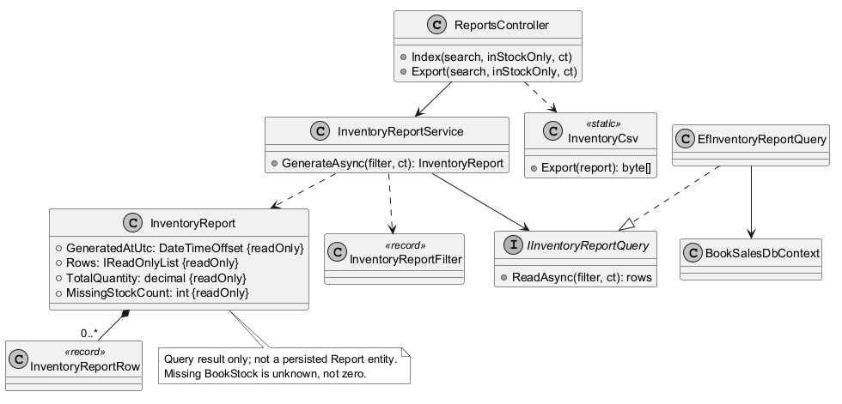
Design Class Diagram for the Tech Lead report flow
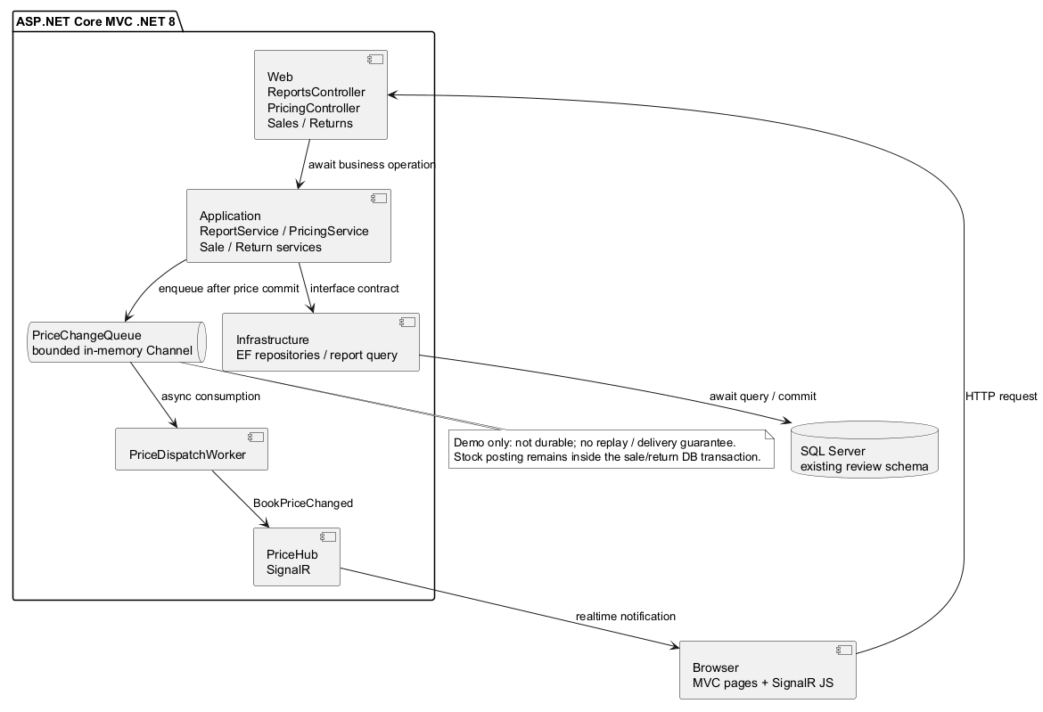
Implemented .NET 8 technical integration architecture

Traceability and review status
Artifact | Evidence and remaining work
Original Context / Chen / Use Case figures | Retained unchanged from the team v1. They require manual corrections listed in DIAGRAMS_REVIEW_CHECKLIST_2026-11-04.vi.md; embedding does not certify approval.
Return rules | User decisions in the current chat: completed-only Return, new Books, 7 days, staff confirmation, cash refund and immediate automatic stock increment.
3NF design | 38 relations/126 columns; schema-manifest, normalization-matrix, FD proof and source mapping. Conditional on declared FDs; unresolved domains remain marked.
Code | Reviewed PR heads #13 168e75b and #14 9c433cd; integration resolves Book/DbContext/SDK and queue differences. 44 local tests pass; HTTP/SQL report and two-client SignalR verified. No CI result is claimed.
Cloud sources | Drive folder 19Kv4nMac-cxRkLkAdF_uYk0MQqjL8Xvr; Use Case content inspected; Thống nhất nghiệp vụ read 04 Nov. Its older Admin-only technical framing conflicts with later user Admin-all policy; current chat governs that point.
Not ready for final sign-off | Correct original diagrams manually; finalize remaining UC scenarios, receiving/promotion/profit/external protocols. Access/inventory branches without the two reviewed PRs are not claimed integrated. Baseline definition remains open.

