Stephanie Richards

9 January 2009

Data Visualization and Analytics Boot Camp

Excel Challenge – Homework #1

Kickstarter is one of the largest and most important players when it comes to crowdfunding creative projects. An analysis of their provided data from 2009 to 2017 shows some interesting trends in who is using the platform and the kinds of projects that have the most success.

Theater is by far the largest category active on Kickstarter, with fundraising for plays making up the bulk of those campaigns.

All-in-all, theatrical campaigns account for 34% of all projects on the platform – twice the number of the next closest category, music, which comes in at 17%. The presence of theatrical data is so strong that it skews the annual project curve of all projects to resemble the typical seasonal schedule of the broader theater industry.

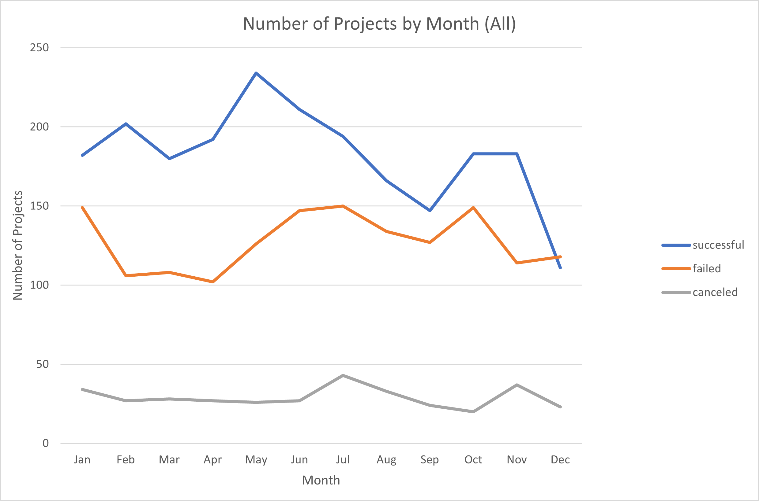

Note the pronounced peaks in May – the beginning of summer theater and lead-up to the world-wide fringe and festival season – and again in October, which could reflect the increase in programming leading up to the holiday season. By comparison, no other category matches the overall distribution.

Interestingly, while Theater holds the dominant and most influential spot in Kickstarter’s project roster, musical projects actually hold the top spot for success – boasting a 77% success rate, as contrasted with the 60% success rate of rivals Theater and Film/Video[1].

Regardless of category, Kickstarter projects seem to be successful inversely proportionate to their fundraising goal. The higher the goal, the more likely the campaign is to fail. While it’s not possible to say that campaigns fail *because* their goals are high, it makes logical sense given the limited time frames of campaigns and Kickstarter’s all-or-nothing approach to funding. It would make sense to break large projects into smaller component stages in order to set lower and more achievable goals for each, rather than try to raise a large sum all at once on the platform.

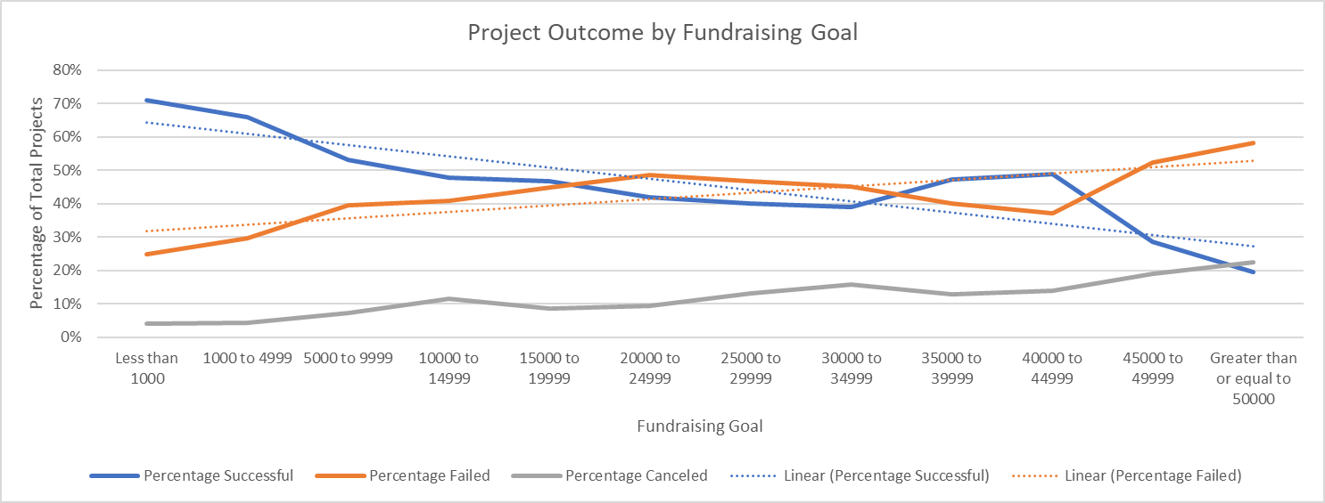

It also logically follows that successful campaigns tend to boast a larger cohort of supporters than unsuccessful campaigns, with many failed campaigns receiving no support at all. Again, however, it is difficult to use this measure to draw any kind of predictive conclusions about Kickstarter in general, as there are some significant outliers to this tendency. At least one successful campaign had only a single backer, and a failed campaign had over a thousand. [2]

There are some significant limitations to this dataset, the primary being that the set is incomplete. Several large and famous campaigns are not present, including 2013’s Veronica Mars movie, or the successful re-tooling of Reading Rainbow in 2016. If these well-known examples are not represented here, it is impossible to know what else might be missing. Without knowing what criteria led to *these* data being selected for this analysis, it is difficult to draw meaningful conclusions about Kickstarter as a whole entity. The dataset also ends in mid-2017; I believe a truly fascinating analysis could be done now to look at how the Covid-19 pandemic’s mass closures of the entertainment industry change how people interact with Kickstarter’s platform.

It would be interesting to try to use these data to dig further into possible factors in the success or failure of campaigns. Does being a “staff pick” tip your chance of success higher, or it is irrelevant? Do some countries have higher success rates overall than others? Is there information in the project titles and descriptions that influences success rates – for example, good grammar and clean writing, keywords, or the name-dropping of popular participants. There is still a lot of information here to look at.

1. Please see accompanying Excel workbook, sheet “Number v Category,” for success rates by category.
2. See Excel workbook, sheet “Summary Statistical Analysis.”