Hosting to Heroku

Overview
These instructions walk you through the process of hosting Homework 15 to Heroku. It’s certainly possible to host a different project instead (e.g., Project 2 or the Final Project), and you’ll simply have to adapt the instructions accordingly. Please follow all steps carefully!
Note that the Heroku or GitHub websites may change at any time, and these instructions may become obsolete.

Instructions
- You will need a Heroku account. If you opened one during the “prework” section of this bootcamp, please use that account. If not, please go to www.heroku.com and click Sign Up for Free. Enter your first name, last name, and email address; for Role, select Student; for Country, select United States; for Primary development language, select Python. Check your email inbox for a confirmation message, and follow the instructions provided. Be sure to remember your username and password!

- You will need to create a new conda environment. Please do so as follows:
  - Open a GitBash or Terminal window. (Exactly where you open it doesn’t matter for this step.)
  - conda create -n ForHeroku python=3.6
  - source activate ForHeroku
  - conda install pip
  - pip install gunicorn
  - pip install pandas
  - pip install flask
  - pip install flask-sqlalchemy
  - Close the GitBash or Terminal window.

- Create a new repository on GitHub. I’ve named mine newheroku, but you should name yours according to the homework instructions. Do this the same way you’ve done it for every other Python assignment. (Note: It’s possible to host a different project repo, provided the directory structure is similar to the one I show you here.)

- Use Git to clone the repository to your computer, similarly to the way you’ve done this on past assignments. This will create your working directory.

- Populate the working directory with the starter files for the assignment. To do this, copy the starter files from the class repo, the same way you’ve done this on past assignments. (If you’re using an existing project from a different repo, you can skip this step.)

- When you’ve finished populating your working directory, it should look like the following. (Note: I have my system configured to show hidden files, which is why you see .git. If your system is configured differently, you may not see this file. For more information on how to show hidden files, please use Google.)
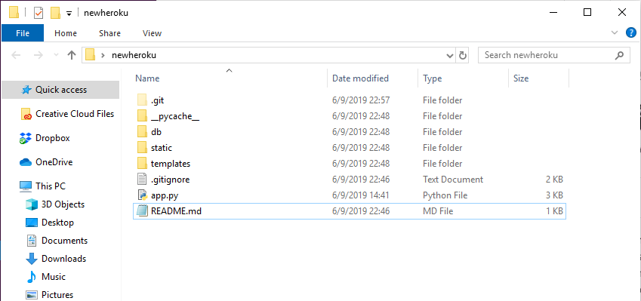

- Now your system is set up properly and you’re free to write and debug your code, just as you’ve done on previous assignments. While you do this, don’t worry about deploying your application to Heroku. That piece will happen later.

- During development, you will need to activate the ForHeroku environment you created earlier. Otherwise, your packages won’t be imported properly.

- During development, you will need to install any additional packages your application requires. We’ve started with a mostly empty environment because Heroku needs the environment to be as small as possible. Only install the packages you need and be sure the ForHeroku environment is active when you do so.

- During development, please use localhost to host your application, just like we’ve done in class. To do this, execute the following commands. Note that these must be run from your working directory.
  - export FLASK_APP=app.py
  - flask run

- Once your application is running on localhost, you can view it using Chrome. To do so, go to http://127.0.0.1:5000 or http://localhost:5000. These are two different addresses for the exact same server, which runs internally in your computer. This is how I’ve demonstrated the process in class, and this is how you may have done it on previous homework assignments.

- If Chrome doesn’t seem to update properly when you make changes to your code, you may be having cache issues. Tip: you can type CTRL-SHIFT-R (Windows) or CMD-SHIFT-R (Mac) to bypass the cache and force the page to reload. You can also clear the Chrome browsers’s cache completely by following the instructions you find on Google.

- When you’d like to test some changes to your code, you may need to restart the Flask server. To stop it first, type CTRL-C. (Note that you may have to type CTRL-C several times.) To restart it, use the commands above.

- Once your application is ready to host on Heroku, you’ll need to add two additional files to your working directory. These files tell Heroku how to create the server it needs to host your application properly.

Using a Git Bash or Terminal window in your project’s working directory, execute the following commands. Heroku is case-sensitive, so pay close attention to uppercase and lowercase letters.

  - pip freeze > requirements.txt

  - echo web: gunicorn app:app > Procfile

Note that you will have to repeat Step a and create a new requirements.txt file anytime you install a new package or update an existing package.

Note that Procfile begins with an uppercase letter and has no file extension.

- After these new files have been created, your working directory should be similar to mine, with Procfile and requirements.txt at the highest level (i.e., in the root directory of the project):
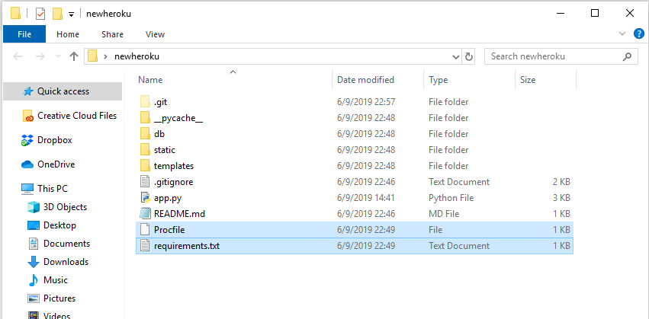

- Use Git to add, commit, and push your updated files to the repository. Now you’re ready to deploy your application to Heroku.

- Log in to Heroku.com, choose to create a “new app,” and give it a unique name.

- For Deployment method, select GitHub.

- Enter the name of the GitHub repository that contains the project you’d like to host, and connect to this repo.

- Click Enable Automatic Deploys.

- Click Deploy Branch and then wait patiently. This may take a few minutes. Once the deployment process is finished, click the button for View.

- You should now see your application running in Heroku.

