HEALTHCARE COST
OPTIMIZATION ANALYTICS
FINAL PROJECT REPORT
Synthea Synthetic Healthcare Dataset
Data Analytics | EDA | Statistical Modeling | Cost Optimization | Power BI
Submitted by

Swetha K
Data Analytics Trainee

Executive Summary

This project investigates where healthcare spending is concentrated, which utilization and cost patterns warrant further investigation, and what data-driven interventions could reduce avoidable expenditure without compromising patient outcomes. The project uses the Synthea synthetic healthcare dataset and follows an encounter-level analytical design.
The work progressed through data understanding, data cleaning and preparation, analytical dataset construction, exploratory data analysis, statistical/predictive modeling, cost-optimization analysis, and Power BI dashboard development. The final analytical dataset contains 61,459 healthcare encounters and 58 analytical features.
The analysis found strong cost concentration and substantial variation across encounter type, procedure intensity, utilization, patient characteristics, payer context, and provider context. The 99th-percentile encounter-cost threshold was $45,209.38, identifying 615 high-cost encounters. A 30-day repeat-encounter proxy identified 22,739 repeat encounters with $143.68M in associated spending. Twelve patients in the top 1% of patient-level spending accounted for $44.67M.
The strongest tested predictive approach was a log-transformed Random Forest with MAE of $1,557.67, RMSE of $6,741.13, and R² of 0.5559 on the held-out test set. The model supports prioritization and decision support; feature importance is not causation.
The final Power BI dashboard contains six pages: Healthcare Cost Overview, Cost Analysis, Utilization & Repeat Encounters, Patient Segmentation, Provider & Payer Analysis, and Cost Optimization Opportunities.

1. Introduction

1.1 Background
Healthcare organizations must control cost while maintaining appropriate care and patient outcomes. Healthcare expenditure can vary with encounter type, procedures, medication use, patient characteristics, payer context, provider patterns, and repeated utilization. Analytics can help identify concentrated spending and prioritize areas for deeper review.

1.2 Problem Statement
Where is healthcare spending being lost to inefficiency, and what data-driven interventions could reduce costs without compromising patient outcomes?

1.3 Objectives
- Identify major drivers of healthcare cost variation.
- Analyze spending across encounter types, demographics, providers, organizations, and payers.
- Identify high-cost patient and utilization segments.
- Investigate potentially avoidable patterns such as repeat encounters and high utilization.
- Develop a predictive model for encounter-level cost.
- Quantify cost-optimization opportunities where supported by the data.
- Build an interactive dashboard.
- Translate findings into practical recommendations.

1.4 Scope
The project is limited to the information available in the selected synthetic dataset. It does not diagnose patients, judge treatment appropriateness, or claim that high-cost care is waste. Identified patterns are screening signals requiring clinical and operational context.

2. Data Collection and Understanding

2.1 Dataset Selection
The Synthea synthetic healthcare dataset was selected because it provides linked healthcare data covering encounters, patients, conditions, procedures, medications, observations, imaging, care plans, providers, organizations, payers, claims, transactions, and other healthcare information.

2.2 Raw Dataset Inventory
Dataset | Records | Use
patients.csv | 1,163 | Patient demographics and expenses
encounters.csv | 61,459 | Encounters and costs
conditions.csv | 38,094 | Conditions
procedures.csv | 83,823 | Procedures and costs
medications.csv | 56,430 | Medication use/cost
imaging_studies.csv | 151,637 | Imaging
providers.csv | 5,056 | Providers
organizations.csv | 1,127 | Organizations
payers.csv | 10 | Payers
claims.csv | 117,889 | Claims
claims_transactions.csv | 711,238 | Transactions
observations.csv | 531,144 | Observations
careplans.csv | 3,931 | Care plans
immunizations.csv | 17,009 | Immunizations
allergies.csv | 794 | Allergies
devices.csv | 89 | Devices
supplies.csv | 1,573 | Supplies
payer_transitions.csv | 53,101 | Payer history

2.3 Analytical Design
- Primary table: encounters.csv.
- One row = one healthcare encounter.
- Primary cost measure: TOTAL_CLAIM_COST.
- One-to-many supporting datasets were aggregated to encounter level before merging.
- This prevented row multiplication and double-counting.
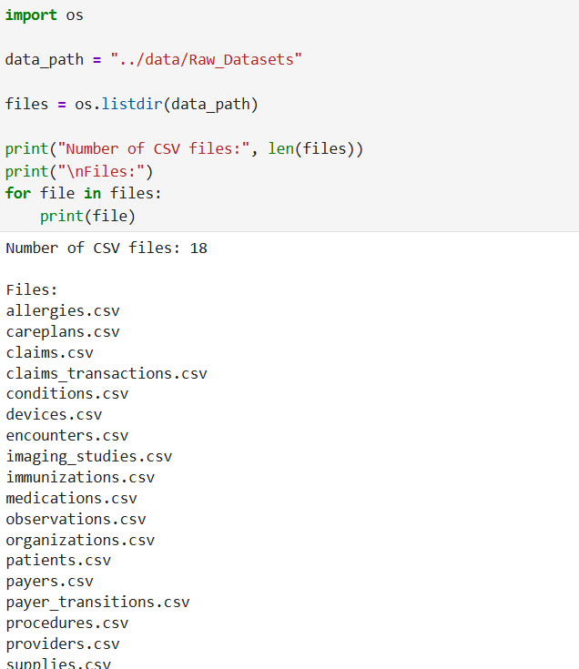
Suggested source: 01_Data_Understanding.ipynb / project data folder
Figure 1. Raw dataset inventory.

3. Data Cleaning and Preparation
Raw files were preserved for traceability. Cleaned files were stored separately. Cleaning included missing-value assessment, duplicate validation, date conversion, financial validation, reference checks, categorical checks, and final quality validation.

3.1 Major Data-Quality Findings
- observations.csv contained 249 exact duplicate rows; duplicates were handled.
- claims_transactions.csv contained 70,733 records with TODATE = 1970-01-01 used as an invalid placeholder; the placeholder was treated as missing/invalid while FROMDATE was retained.
- Repeated imaging Id and SERIES_UID values were not automatically treated as duplicates because they can represent study/series identifiers.
- organizations.csv contained all-zero REVENUE; revenue was excluded from financial analysis.
- Optional missing values were retained where they did not invalidate records.
- High healthcare costs were retained because they are central to the analysis.

3.2 Data Preservation Principle
Original raw files remain unchanged. Supporting datasets were aggregated to encounter level before integration. For encounter-level count/utilization features, absence of a supporting record was represented as zero; this means no matching record was found in the available source data.

4. Analytical Dataset Construction
The analytical master was built from the cleaned encounter dataset and enriched with encounter-level aggregates from supporting tables.
Validation | Result
Rows | 61,459
Columns | 58
Duplicate encounter IDs | 0
Missing encounter IDs | 0
Missing patient IDs | 0
Missing primary cost | 0
Negative primary cost | 0
Derived-feature missing values | 0
Final file | data/Analytical_Dataset/healthcare_analytical_dataset.csv

4.1 Feature Groups
- Encounter and cost information
- Patient demographics and age
- Clinical/utilization counts for conditions, procedures, medications, observations, allergies, care plans, devices, imaging and supplies
- Component costs
- Provider and organization information
- Payer information
- Claims/transaction-derived features
- Payer-transition summaries
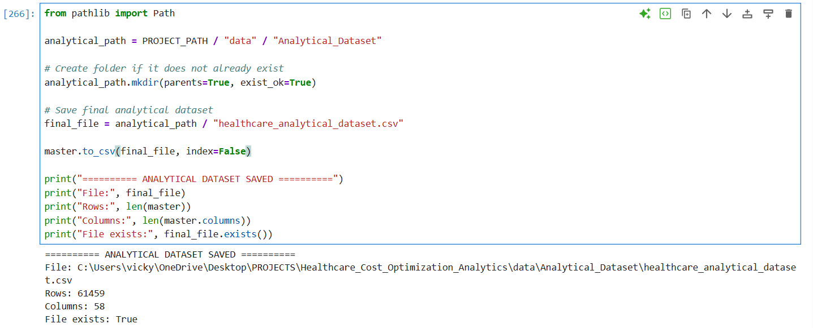
Suggested source: 03_Analytical_Dataset_Building.ipynb
Figure 3. Final analytical dataset validation.

5. Exploratory Data Analysis
EDA was structured around business questions relevant to healthcare cost optimization. Each question combined quantitative evidence, visualization, interpretation, and limitations.

5.1 Q1 — Overall Cost Profile
Metric | Finding
Mean | $4,149.66
Median | $786.33
Maximum | $873,646.19
99th percentile | $45,209.38
Top 1% spend share | ≈17.05%

The cost distribution was strongly right-skewed, indicating that a small number of encounters contribute disproportionately to total spending.
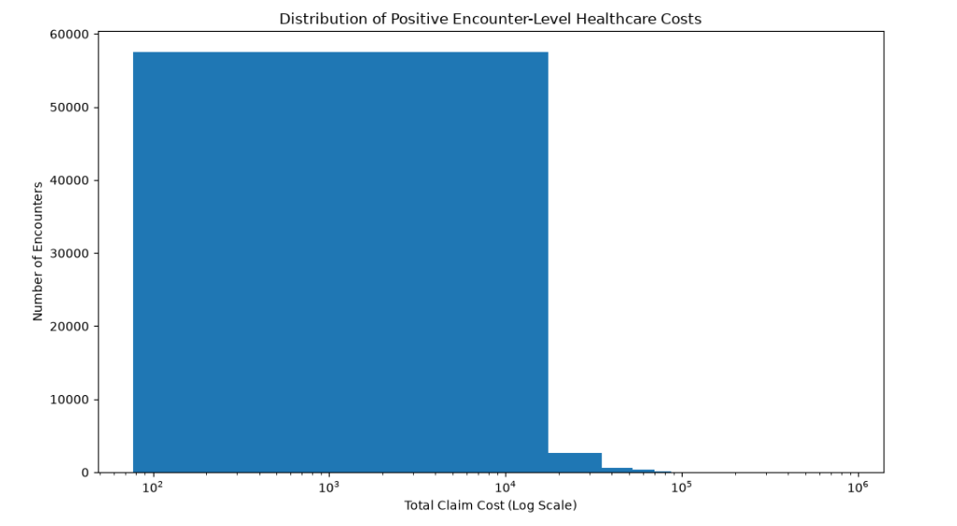
Suggested source: 04_Exploratory_Data_Analysis.ipynb — Q1
Figure 4. Overall healthcare cost distribution.

5.2 Q2 — Cost by Encounter Type
Type | Encounters | Average | Total
Ambulatory | 20,124 | $6,524.19 | $131.293M
Wellness | 24,038 | $1,909.49 | $45.900M
Outpatient | 10,837 | $2,827.51 | $30.642M
Emergency | 2,168 | $7,926.41 | $17.184M
Inpatient | 1,728 | $8,766.00 | $15.148M
Urgentcare | 2,564 | $5,798.27 | $14.867M

Ambulatory encounters represented approximately 51.48% of total recorded spending; inpatient encounters had the highest average recorded cost.
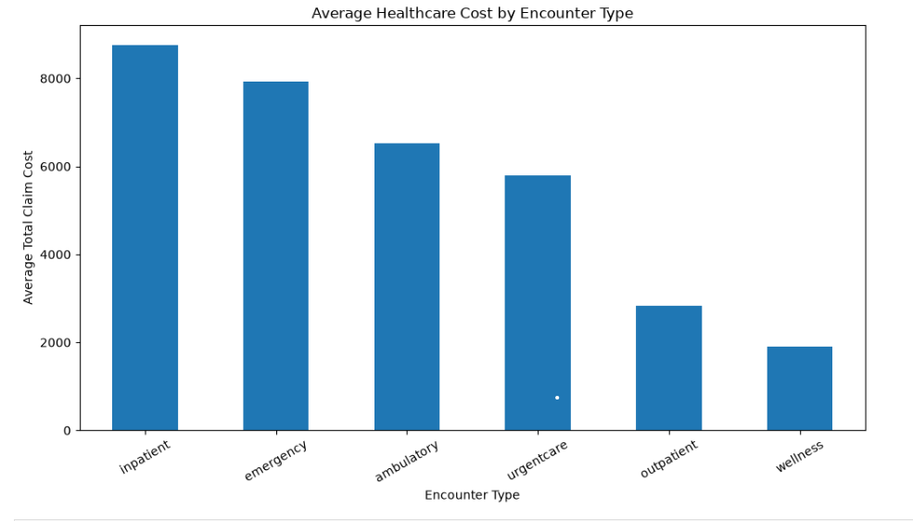
Suggested source: 04_Exploratory_Data_Analysis.ipynb — Q2
Figure 5. Cost by encounter type.

5.3 Q3 — Demographic Cost Variation
Dimension | Finding
Gender | Female $4,408.26; Male $3,795.23
Age | 81+ $7,495.30
Race | Black $6,214.92; White $3,902.87
Ethnicity | Non-Hispanic $4,155.90; Hispanic $4,065.92

These are descriptive associations and should not be interpreted as demographic causes of higher cost.
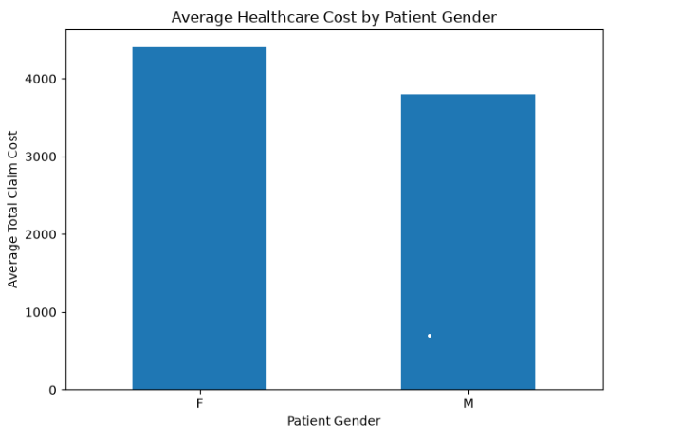

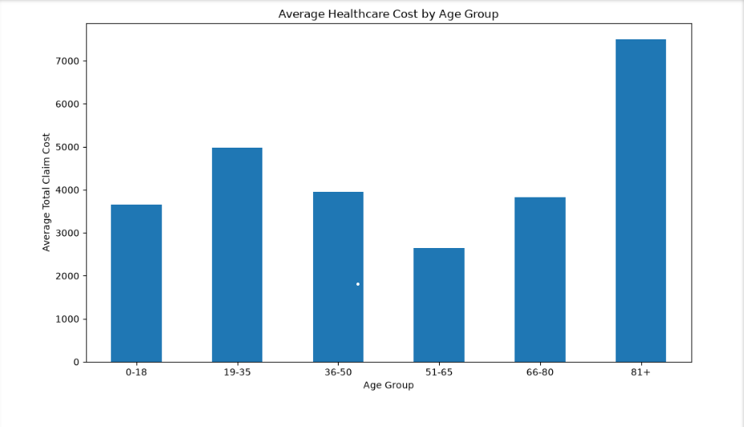
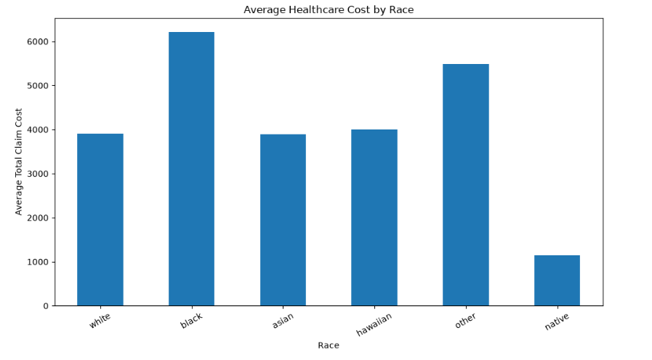
Suggested source: 04_Exploratory_Data_Analysis.ipynb — Q3
Figure 6. Demographic cost variation.

5.4 Q4 — Utilization vs Cost
Feature | Correlation
Procedure count | 0.3172
Careplan count | 0.1127
Device count | 0.1619
Imaging count | 0.0576
Supply count | 0.0525
Medication count | 0.0481
Observation count | -0.0042
Condition count | -0.0158
Immunization count | -0.0881

Procedure count had the strongest simple utilization correlation with total cost among the tested utilization measures.
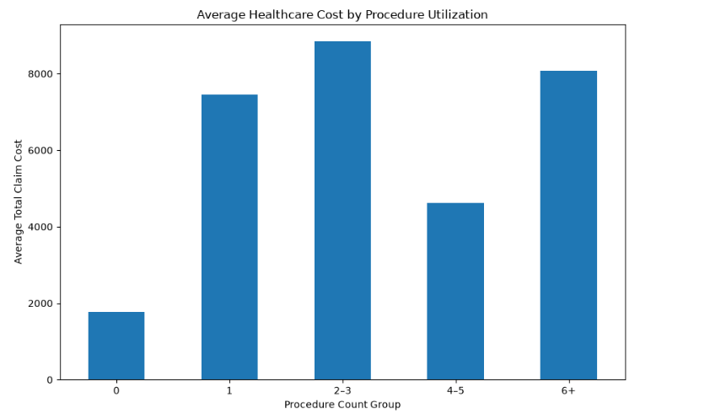
Suggested source: 04_Exploratory_Data_Analysis.ipynb — Q4
Figure 7. Utilization versus cost.

5.5 Q5 — Clinical Cost Components
Component | Finding
Procedure cost | Correlation 0.7366; ≈$210.20M
Medication cost | ≈$73.91M
Immunization cost | ≈$2.39M

Procedure cost showed the strongest observed association with total claim cost among the selected components.
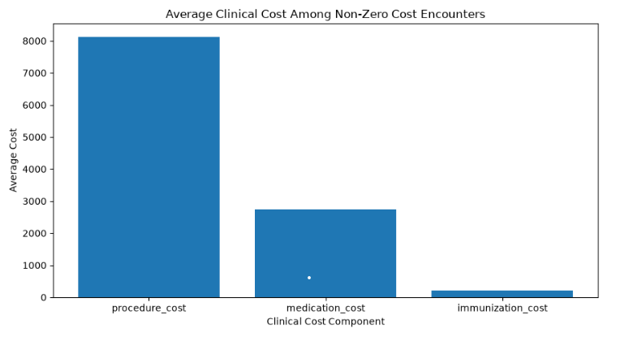
Suggested source: 04_Exploratory_Data_Analysis.ipynb — Q5
Figure 8. Clinical cost components.

5.6 Q6 — Provider and Organization Cost
Provider and organization comparisons were validated using a minimum 100-encounter threshold for the main comparison. The highest qualified provider average cost was $27,338.28 across 135 encounters.
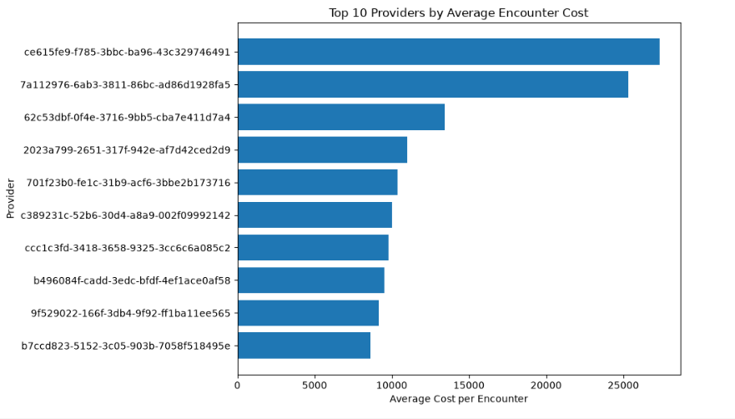
Suggested source: 04_Exploratory_Data_Analysis.ipynb — Q6
Figure 9. Provider and organization cost variation.

5.7 Q7 — Payer Cost Variation
Payer | Average Cost
NO_INSURANCE | $7,455.91
Medicaid | $4,915.02
Medicare | $3,812.77
BCBS | $2,994.74
Anthem | $2,954.56
Cigna | $2,882.31
Aetna | $2,777.26
UHC | $2,639.84
Humana | $2,558.69
Dual Eligible | $2,407.24

Uninsured encounters represented approximately 39.82% of total recorded spending. Payer differences require case-mix and utilization context.
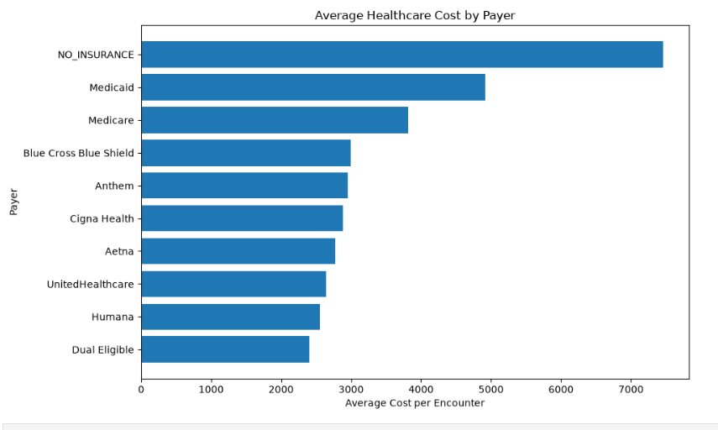
Suggested source: 04_Exploratory_Data_Analysis.ipynb — Q7
Figure 10. Average cost by payer.

5.8 Q8 — High-Cost Encounters
The 99th-percentile threshold was $45,209.38. There were 615 high-cost encounters with approximately $43.52M in associated spending and an average of approximately $70,766.12.
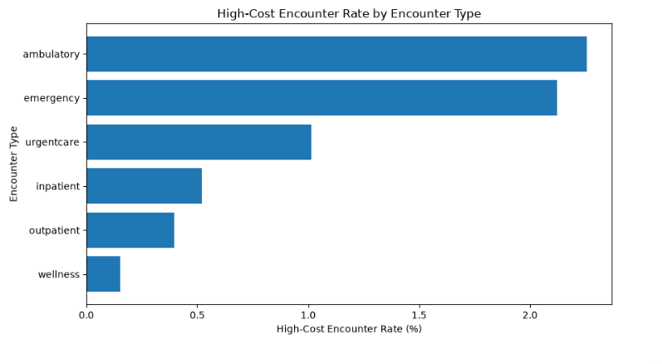
Suggested source: 04_Exploratory_Data_Analysis.ipynb — Q8
Figure 11. High-cost encounter analysis.

5.9 Q9 — 30-Day Repeat Encounter Proxy
A repeat encounter was defined as another encounter for the same patient occurring more than 0 days and within 30 days. There were 22,739 repeat encounters, approximately 36.99% of encounters. Repeat encounters averaged $6,318.59 versus $2,875.91 for non-repeat encounters.
This is a utilization proxy, not a clinically validated preventable-readmission measure.
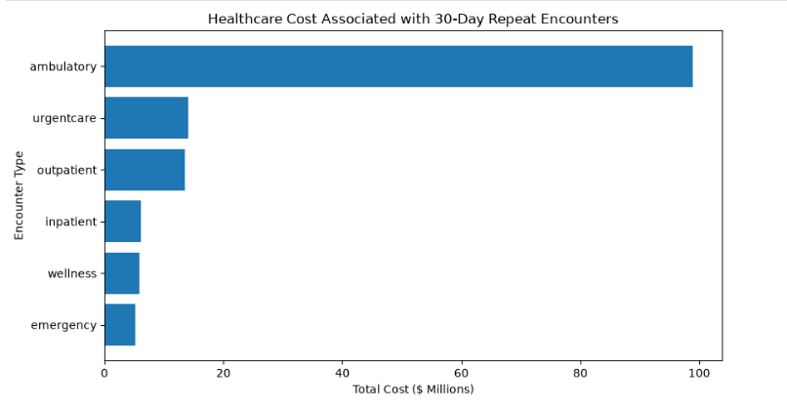
Suggested source: 04_Exploratory_Data_Analysis.ipynb — Q9
Figure 12. 30-day repeat encounter analysis.

5.10 Q10 — Inpatient Length of Stay
Mean inpatient length of stay was 4.47 days. The 8–30 day group had the highest average recorded cost at $31,491.49, but the sample was small. LOS was analyzed only for inpatient encounters.
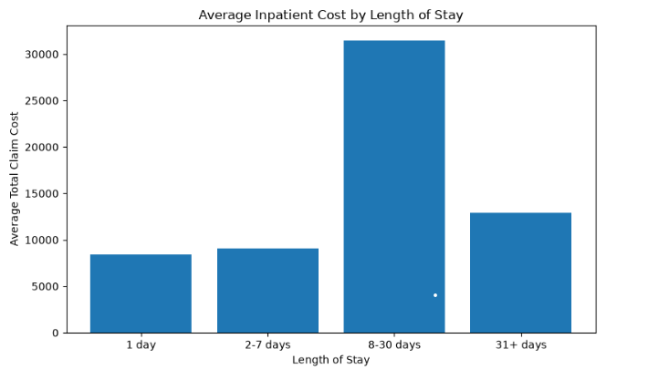
Suggested source: 04_Exploratory_Data_Analysis.ipynb — Q10
Figure 13. Inpatient length of stay.

5.11 Q11 — Cost-Inefficiency Screening Patterns
The EDA consolidated screening signals around extreme-cost encounters, repeat utilization, procedure-related spending, uninsured cost variation, and high-cost ambulatory care. These signals became the basis for the cost-optimization phase.
High cost, high utilization, or repeated care does not by itself establish inefficiency or avoidability.
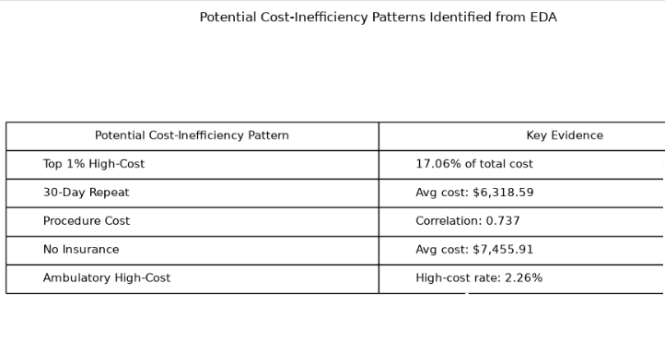
Suggested source: 04_Exploratory_Data_Analysis.ipynb — Q11
Figure 14. EDA cost-optimization screening summary.

6. Statistical and Predictive Modeling

6.1 Objective and Design
The target was TOTAL_CLAIM_COST at encounter level. The main model used non-leakage predictors covering encounter characteristics, demographics, clinical utilization, provider/organization context, and payer characteristics.
- 80% training and 20% held-out test data.
- Categorical variables one-hot encoded with unknown-category handling.
- Numerical variables standardized.
- Missing MARITAL represented as Unknown.
- Claims/payment transaction fields and directly associated financial fields excluded from the main model to reduce leakage.
- Main model used 22 predictors.

6.2 Model Comparison
Model | MAE | RMSE | R²
Mean-cost baseline | $5,515.74 | $10,115.98 | ~0.0000
Linear Regression | $4,390.25 | $8,475.29 | 0.2980
Standard Random Forest | $1,761.36 | $7,638.83 | 0.4298
Log-Transformed Random Forest | $1,557.67 | $6,741.13 | 0.5559

6.3 Best Tested Model
The log-transformed Random Forest was the strongest tested approach. The log1p transformation reduced the influence of the highly skewed cost target.
R² = 0.5559 means approximately 55.6% of held-out encounter-cost variation was explained by the model; it is not 55.6% prediction accuracy.

6.4 Feature Importance
Rank | Feature | Importance
1 | procedure_count | 25.31%
2 | AGE_AT_ENCOUNTER | 12.00%
3 | medication_count | 9.72%
4 | PAYER_NAME | 8.37%
5 | observation_count | 7.69%
6 | ENCOUNTERCLASS | 6.70%
7 | ORGANIZATION_UTILIZATION | 4.29%
8 | MARITAL | 4.28%
9 | PROVIDER_UTILIZATION | 3.83%
10 | condition_count | 3.66%

Feature importance is predictive contribution within the model, not causation or spending share.
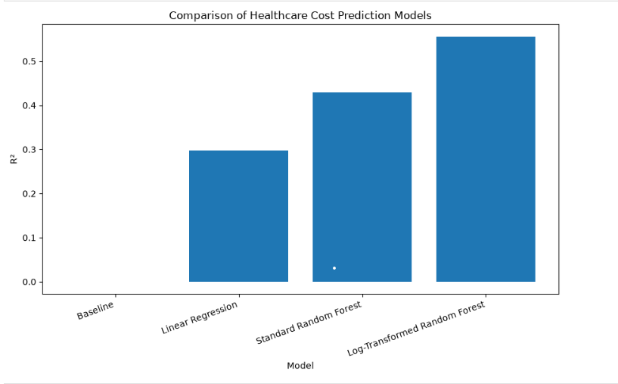
Suggested source: 05_Statistical_Modeling.ipynb
Figure 15. Model performance / feature importance.

6.5 Error Analysis
- Median absolute error: $257.76.
- Maximum absolute error: $364,225.08.
- Error distribution was strongly right-skewed.
- Extreme high-cost encounters were frequently underpredicted.
- Extreme-cost cases therefore warrant separate analytical attention.

7. Cost Optimization Analysis

7.1 High-Cost Segment
Metric | Finding
Threshold | $45,209.38
High-cost encounters | 615
Associated spend | $43.52M
Average high-cost encounter | $70,766.12
Procedure mean: high-cost | 10.95
Procedure mean: other | 1.27

7.2 High Procedure Intensity
There were 5,264 encounters with 6+ procedures, representing $42.54M in spending and an average cost of about $8,080.53. The high-cost rate was 6.52%, compared with 0.48% for encounters with fewer than six procedures.

7.3 30-Day Repeat Utilization
Type | Repeat | Rate | Avg Cost
Ambulatory | 11,945 | 59.36% | $8,278.64
Urgentcare | 2,214 | 86.35% | $6,343.58
Outpatient | 4,628 | 42.71% | $2,926.81
Inpatient | 825 | 47.74% | $7,418.32
Wellness | 2,264 | 9.42% | $2,582.07
Emergency | 863 | 39.81% | $6,065.12

7.4 Opportunity Screening Signal
A screening signal was defined as procedure count ≥6 OR imaging count ≥2 OR medication count ≥4 OR careplan count ≥2. It identified 7,501 encounters averaging $8,349.27, with 390 high-cost encounters. The non-signal group contained 53,958 encounters averaging $3,565.85.
This is a screening signal only and does not prove unnecessary care.

7.5 Patient Segmentation
Segment | Patients | Cost Share | Avg Encounters/Patient
Not High-Cost + Not Frequent | 1,043 | 64.58% | 39.07
Frequent + Not High-Cost | 108 | 17.91% | 153.56
High-Cost + Frequent | 11 | 17.03% | 366.82
High-Cost + Not Frequent | 1 | 0.49% | 88.00

There were 12 high-cost patients and 119 frequent users. Eleven belonged to both groups, meaning 91.67% of high-cost patients were also frequent users.

7.6 Opportunity Quantification
Opportunity | Volume | Associated Spend | 5% / 10% / 15% Scenarios
High procedure intensity | 5,264 encounters | $42.54M | $2.13M / $4.25M / $6.38M
30-day repeat encounters | 22,739 encounters | $143.68M | $7.18M / $14.37M / $21.55M
Top 1% high-cost patients | 12 patients | $44.67M | $2.23M / $4.47M / $6.70M
Unique opportunity-pattern pool | 27,330 encounters | $168.33M | $8.42M / $16.83M / $25.25M

The unique opportunity-pattern pool is a union of screening patterns and must not be added to the individual opportunity totals as independent populations.
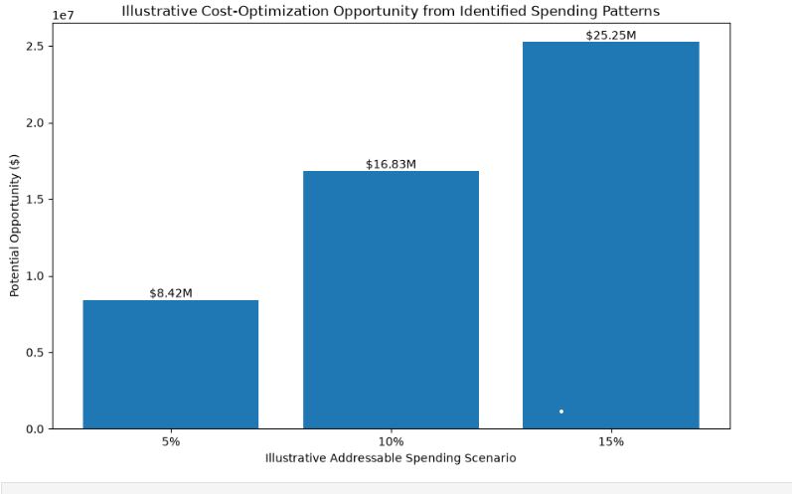
Suggested source: 06_Cost_Optimization_Analysis.ipynb
Figure 16. Cost-optimization opportunity analysis.

8. Power BI Dashboard
The final dashboard is the visualization and communication layer. It uses the validated encounter-level dataset and follows the storyline: Overview → Cost Drivers → Utilization → Patients → Providers/Payers → Optimization.
Configuration | Value
Tool | Microsoft Power BI
Canvas | 1920 × 1080; 16:9
Source | healthcare_analytical_dataset.csv
Grain | One row per encounter
Primary cost measure | TOTAL_CLAIM_COST
Pages | 6

8.1 Page 1 — Healthcare Cost Overview
KPI | Value
Total Healthcare Cost | $255.03M
Total Encounters | 61,459
Average Encounter Cost | $4,149.53
High-Cost Encounters | 615

Visuals: Total Cost by Encounter Type; Average Cost by Encounter Type; Cost Concentration; High-Cost Encounters by Encounter Type.
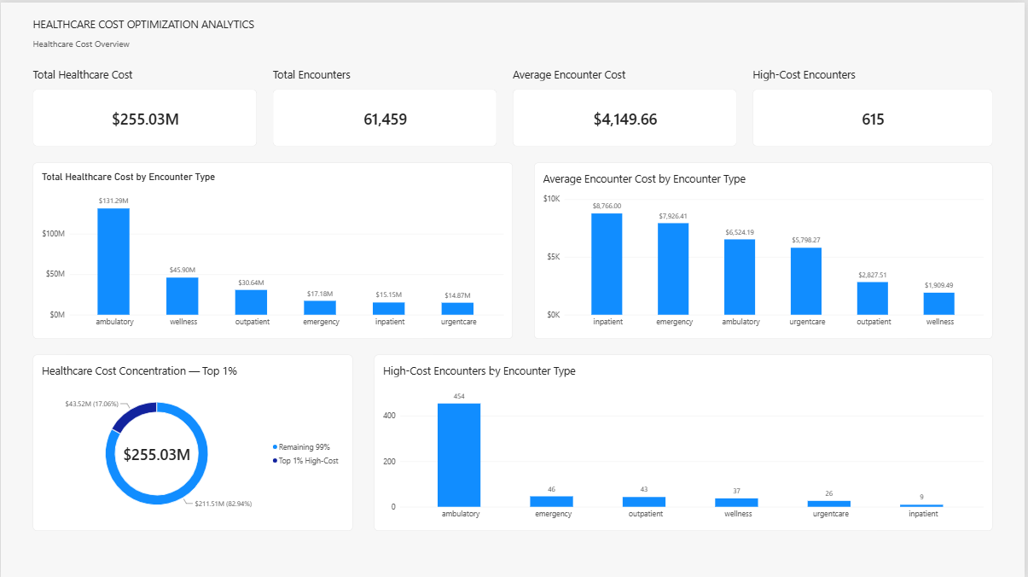
Figure 17. Dashboard Page 1 — Healthcare Cost Overview.

8.2 Page 2 — Cost Analysis
KPI | Value
Total Healthcare Cost | $255.03M
Average Encounter Cost | $4,149.53
Total Procedure Cost | $210.20M
High Procedure Encounters | 5,264

Visuals: Average Cost by Procedure Intensity; Procedure Utilization vs Average Encounter Cost; High-Cost Rate by Procedure Intensity; Cost Driver Analysis.
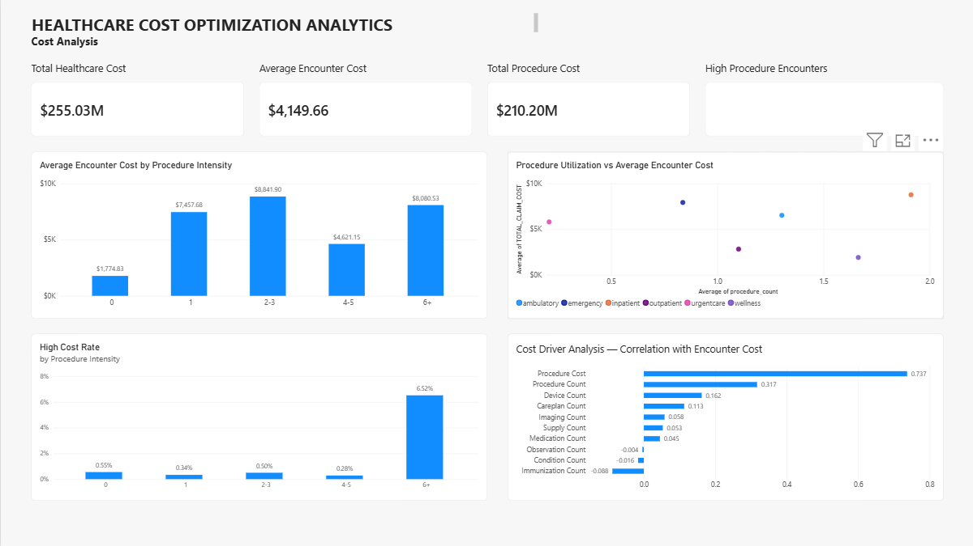
Figure 18. Dashboard Page 2 — Cost Analysis.

8.3 Page 3 — Utilization & Repeat Encounters
KPI | Value
Repeat Encounters | 22,739
Repeat Encounter Cost | $143.68M
High-Cost Patient Spend | $44.67M
High Procedure Encounters | 5,264

Visuals: Repeat Encounters by Encounter Type; High-Cost Encounters by Encounter Type; Patient Cost Concentration; High Procedure Encounters by Encounter Type.
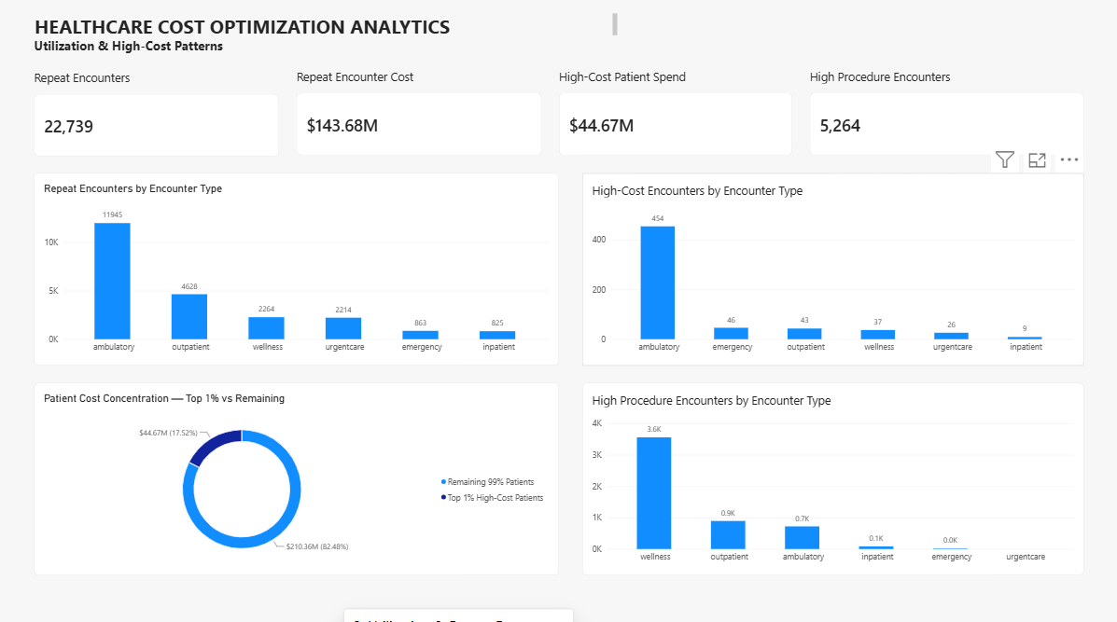

Figure 19. Dashboard Page 3 — Utilization & Repeat Encounters.

8.4 Page 4 — Patient Segmentation
KPI | Value
Total Patients | 1,163
High-Cost Patients | 12
Frequent Users | 119
High-Cost + Frequent Users | 11

The page classifies patients using the 99th-percentile patient-cost threshold and 90th-percentile encounter-count threshold.
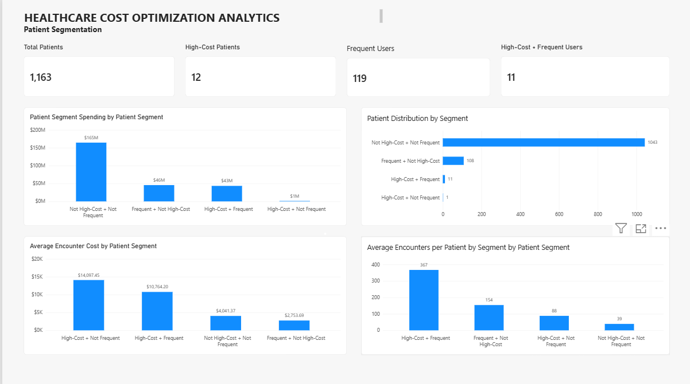

Figure 20. Dashboard Page 4 — Patient Segmentation.

8.5 Page 5 — Provider & Payer Analysis
KPI | Value
Total Providers | 1,123
Average Provider Cost | $4,149.53
Highest Provider Average Cost (≥100 encounters) | $27,338.28
Uninsured Cost Share | 39.82%

Visuals include Top 10 Providers by Average Encounter Cost, Average Encounter Cost by Payer, and High-Cost Encounters by Payer. The qualified provider comparison uses a minimum 100-encounter threshold. The final NO_INSURANCE average cost is $7,455.91.
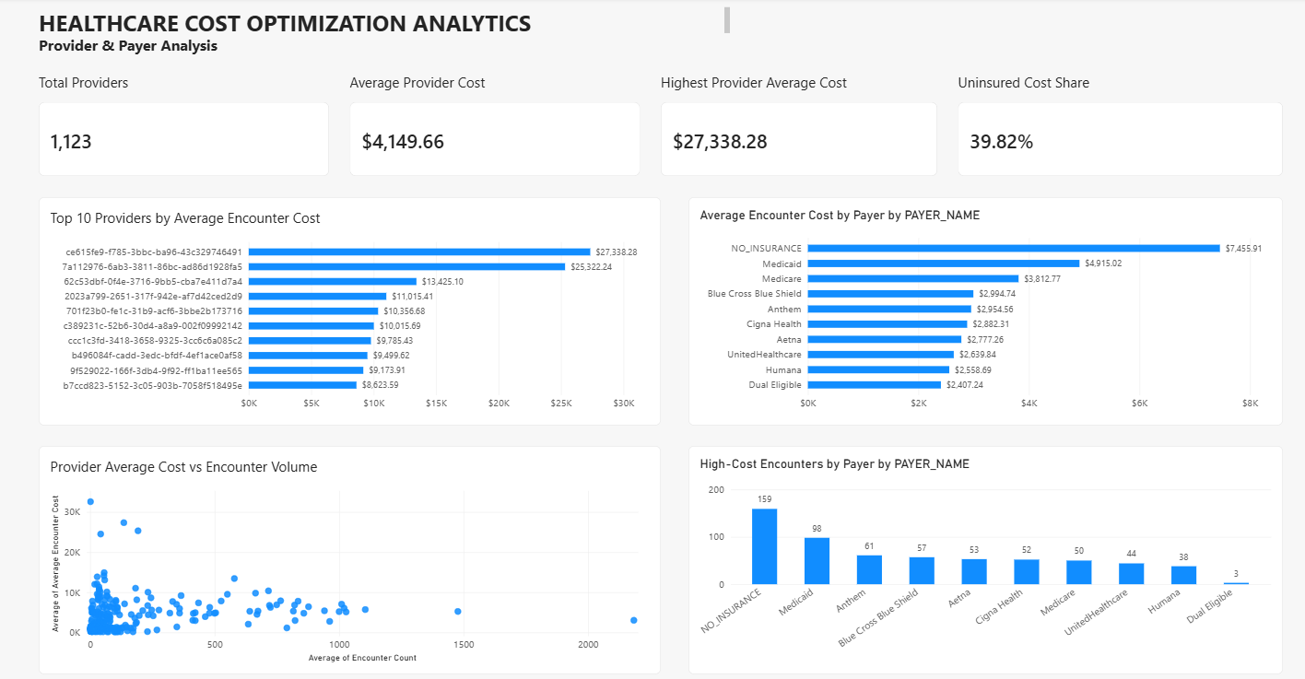

Figure 21. Dashboard Page 5 — Provider & Payer Analysis.

8.6 Page 6 — Cost Optimization Opportunities
KPI | Value
Opportunity Pattern Spend | $168.33M
Repeat Encounter Cost | $143.68M
High Procedure Cost | $42.54M
High-Cost Patient Spend | $44.67M

The page contains Opportunity Spend by Cost Area, Opportunity Pattern Spend vs Remaining Spend, Potential Savings Scenarios, and Cost Optimization Recommendations.
The opportunity-pattern pool is $168.33M (66%) versus $86.70M (34%) remaining recorded spend. Scenario estimates are $8.42M at 5%, $16.83M at 10%, and $25.25M at 15%.
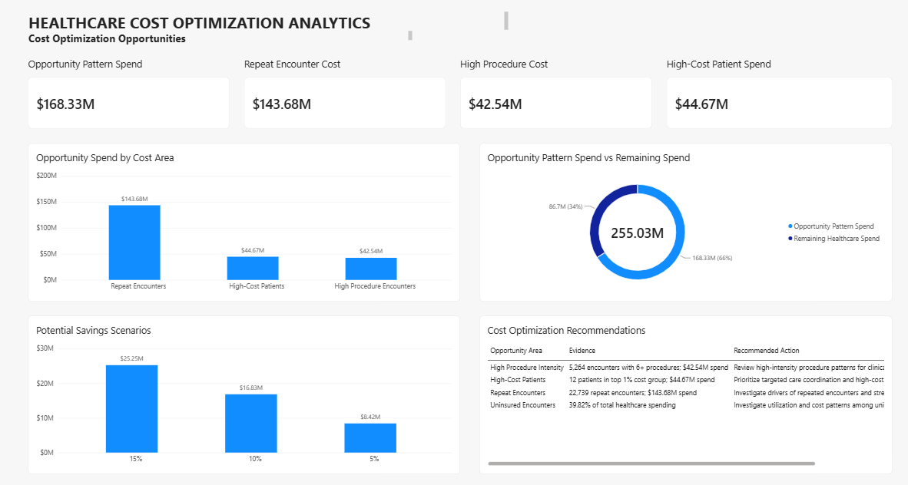

Figure 22. Dashboard Page 6 — Cost Optimization Opportunities.

9. Findings and Recommendations
Opportunity | Evidence | Recommended Action
Repeat encounters | 22,739; $143.68M | Investigate drivers and strengthen follow-up/care coordination where appropriate.
High procedure intensity | 5,264; $42.54M | Review clinical necessity, duplication, and pathway efficiency.
High-cost patients | 12; $44.67M | Prioritize targeted care coordination/case management.
Uninsured encounters | 39.82% of total spend | Investigate utilization, access, case mix and cost drivers.
Provider variation | Large variation among qualified providers | Review unusual patterns after considering case mix.
Predictive prioritization | Log-RF R² 0.5559 | Use predictions to prioritize review, not automate clinical decisions.

9.1 Illustrative Savings Scenarios
Optimization Rate | Potential Savings
5% | $8.42M
10% | $16.83M
15% | $25.25M

These are scenario estimates applied to the $168.33M screening pool. They are not guaranteed savings.

10. Limitations
- Synthea data are synthetic and do not represent actual patients or healthcare-system performance.
- High cost or utilization does not automatically mean waste.
- The 30-day repeat measure is not a validated preventable-readmission measure.
- The opportunity pool includes potentially necessary care.
- Scenario savings require clinical and operational validation.
- Payer differences are not causal without case-mix adjustment.
- Provider comparisons use minimum encounter-volume thresholds.
- Feature importance is predictive contribution, not causality or spending share.
- Some source fields have meaningful missingness.
- USD is retained because the dataset represents a U.S. healthcare context.

11. Conclusion
The Healthcare Cost Optimization Analytics project establishes a complete analytics workflow from raw synthetic healthcare data to a business-facing dashboard. The encounter-level analytical design enabled consistent cost measurement while preserving utilization, clinical, provider, organization, payer, and patient context.
The findings show concentrated spending and meaningful variation by encounter type, utilization, procedures, demographics, payer and provider context. The strongest predictive model confirms that utilization and encounter characteristics contain useful information for cost estimation, while the cost-optimization analysis identifies repeat encounters, high procedure intensity, high-cost patients, and uninsured patterns as important areas for further review.
The project deliberately distinguishes analytical opportunity from proven waste. The objective is to focus clinical and operational review on high-impact areas while preserving necessary care and patient outcomes.

12. Project Files and Reproducibility
Component | File / Location
Data understanding | notebooks/01_Data_Understanding.ipynb
Cleaning | notebooks/02_Data_Cleaning_Preparation.ipynb
Analytical dataset | notebooks/03_Analytical_Dataset_Building.ipynb
EDA | notebooks/04_Exploratory_Data_Analysis.ipynb
Statistical modeling | notebooks/05_Statistical_Modeling.ipynb
Cost optimization | notebooks/06_Cost_Optimization_Analysis.ipynb
Final analytical dataset | data/Analytical_Dataset/healthcare_analytical_dataset.csv
Raw data | data/Raw_Datasets
Cleaned data | data/Cleaned_Datasets
Dashboard | Microsoft Power BI — 6 pages

12.1 Screenshot Insertion Checklist
The reviewed source documents contained detailed textual specifications but did not contain the actual notebook or Power BI screenshots. Therefore, the report contains black-and-white placeholders rather than fabricated images. Replace the placeholders with screenshots from the completed project.
- Raw dataset inventory
- Cleaning validation
- Final analytical dataset validation
- EDA Q1–Q11 representative visuals
- Model comparison / feature importance
- Cost-optimization opportunity analysis
- Power BI Page 1
- Power BI Page 2
- Power BI Page 3
- Power BI Page 4
- Power BI Page 5
- Power BI Page 6

Appendix A — Key Definitions
Term | Definition
Encounter | One recorded healthcare interaction represented by one analytical row.
TOTAL_CLAIM_COST | Primary encounter-level cost measure.
High-cost encounter | TOTAL_CLAIM_COST ≥ $45,209.38.
Repeat encounter | Another same-patient encounter >0 and ≤30 days after the current encounter.
High-procedure encounter | procedure_count ≥ 6.
Frequent user | Patient at or above the 90th percentile of encounter count.
High-cost patient | Patient at or above the 99th percentile of patient-level total cost.
Opportunity-pattern pool | Unique encounters matching at least one predefined screening pattern.

Appendix B — Final Dashboard Storyline
- Healthcare Cost Overview — overall financial picture.
- Cost Analysis — cost drivers.
- Utilization & Repeat Encounters — repeated/high-cost utilization.
- Patient Segmentation — high-cost/frequent patient groups.
- Provider & Payer Analysis — provider/payer variation.
- Cost Optimization Opportunities — intervention areas and scenarios.

Appendix C — Final Status
Phase | Status
Phase 1 — Data Collection & Understanding | Completed
Phase 2 — Data Cleaning & Preparation | Completed
Phase 3 — Analytical Dataset Building | Completed
Phase 4 — EDA | Completed — Q1 to Q11
Phase 5 — Statistical & Predictive Modeling | Completed
Phase 6 — Power BI Dashboard | Completed — 6 pages
Final Project Report | Completed

Document Control
Item | Details
Project Title | Healthcare Cost Optimization Analytics
Report Type | Final Project Report
Dataset | Synthea Synthetic Healthcare Dataset
Analytical Grain | One row per healthcare encounter
Primary Cost Measure | TOTAL_CLAIM_COST
Final Analytical Dataset | 61,459 rows × 58 columns
Tools | Python, Pandas, Jupyter Notebook, Microsoft Power BI
Dashboard | 6-page interactive dashboard
Currency | USD; no INR conversion

