CAT Plug-in Project Documentation
SWE 574 - Fall 2016
CAT Plug-in Team

Table of Contents
1Introduction 4
2Requirements 4
2.1Authentication 4
2.1.1Sign in using credentials 4
2.1.2Sign up with e-mail, username, and password 4
2.1.3Maintain email uniqueness 4
2.1.4Have member and admin user types 4
2.1.5Change Password 4
2.1.6Make private and public annotations 4
2.1.7Annotate HTML pages and texts 5
2.1.8Don't include HTML tag in annotations 5
2.1.9Annotate images 5
2.1.10Only annotate the source of img tags 5
2.1.11Highlight annotated texts 5
2.1.12 Manage annotations 5
2.1.13Search and delete annotations as admin 5
2.1.14Delete other members' annotations 5
2.1.15View annotations of a page 5
2.1.16View annotations of a target 5
2.1.17Filter annotations 5
2.1.18Handle content changes 6
2.1.19Won't Have Requirements 6
3Mock-ups 6
3.1View for an Anonymous User 7
3.2Sign Up Screen 7
3.3Sign In Screen 8
3.4After Sign In 8
3.5Text Annotation 9
3.6Image Annotation 9
3.7Change Password Screen 10
3.8Manage Annotations 10
4Project Plan 11
5UML Design Diagrams 11
5.1Use Case Diagram 11
5.1.1Use Cases for Admin, User, and Non-User 12
5.2Activity Diagrams 12
5.2.1Create Annotation Activity Diagram 13
5.2.2View Annotation Activity Diagram 13
5.3Sequence Diagrams 14
5.3.1Create Annotation Sequence Diagram 14
5.3.2View Annotation Sequence Diagram 15
5.4Class Diagram 16

Introduction
This document provides information about our web annotation plug-in, CAT, for Mozilla Firefox web browser, as a SWE574 course project in Boğaziçi University. It provides details about the requirements, design diagrams, and project plan. It also includes a list of features and a user guide.
Using our plug-in, users shall be able to add annotations to web resources, delete, or modify them, and view a complete list of annotations about a particular web resource.
The plug-in adheres to the standards described by The World Wide Consortium (W3C); adopting their proposed protocol, data model, and vocabulary.

Requirements
This part describes the requirements of CAT Plug-in. The requirements are categorized in terms of functionality, and prioritized by MoSCoW prioritization standards.

Authentication

Sign in using credentials
An authorized user must be able to sign in to the system with his/her username and password. (MH)

Sign up with e-mail, username, and password
A non-member must be able to sign up by entering the following fields: e-mail, username, and password. (MH)

Maintain email uniqueness
A non-member must not be able to sign up with the same e-mail address which is recorded in the system. (MH)

Have member and admin user types
There should be two types of member: a regular member and an administrator. (SH)

Change Password
An authorized user should be able to edit her/his password. (SH)

Make private and public annotations
An authorized user must be able to make their annotations private or public on creation and can update later. (MH)

Annotate HTML pages and texts
An authorized user must be able to annotate any HTML web page or a specific text in the web page. (MH)

Don't include HTML tag in annotations
The html tag itself cannot be annotated. (MH)

Annotate images
An authorized user shall be able to annotate an image with coordinates of the origin, width and height, in a rectangular manner. (MH)

Only annotate the source of img tags
Only, the source of the "img" tags will be annotated. /(Ex.: <img src="image link" />)/ (MH)

Highlight annotated texts
An authorized user should be able to highlight an annotated text. (MH)

Manage annotations
An authorized user shall be able to create, edit or delete an annotation. The user can only delete and edit his/her own annotations. (MH)

Search and delete annotations as admin
An administrator should be able to search and delete any annotation, whenever they find the annotation is inappropriate. (MH)

Delete other members' annotations
In addition to all functions that the normal member do, the admin can also delete the other members' annotations. (MH)

View annotations of a page
Any user shall be able to view number of all annotations of a specific page on the right menu of the plugin. (MH)

View annotations of a target
Any user shall be able to view number of all annotations of a specific target on the right menu of the plugin. (MH)

Filter annotations
Any user shall be able to filter annotation by uniqueness. The bodies that are added to the target annotation will be shown when the annotation is selected. (SH)

Handle content changes
The annotated web pages' content may be changed, so the tool should take into account the current version of the web page. If a content change occurs, the tool should return a message that says "source might have changed". (SH)

Won't Have Requirements
- An authorized user won't be able to annotate pdf, video and audio files.
- The tool won't offer the ability to make a correction if the content of the annotation is wrong. An annotation can only be updated by its author.
- There won't be a rating system for the annotations.
- There won't be a report system for annotations.
- An authorized user won't be able to use his/her Facebook/Twitter/Google ID to sign-in.

Mock-ups
In manufacturing and design, a mockup, or mock-up, is a scale or full-size model of a design or device, used for teaching, demonstration, design evaluation, promotion, and other purposes. A mockup is a prototype if it provides at least part of the functionality of a system and enables testing of a design. (For more information, visit: Mockup)
This are more of a guideline than exact design models. This means that the actual design might include differences.

View for an Anonymous User
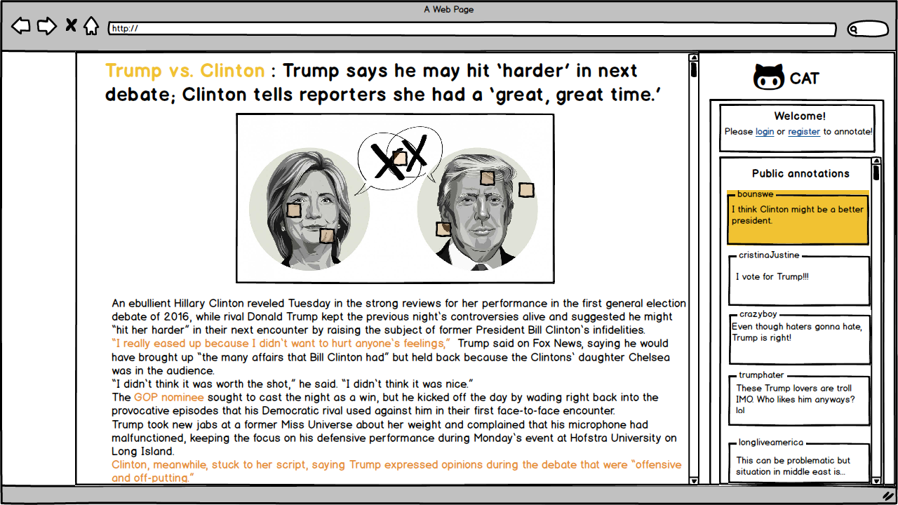

Sign Up Screen
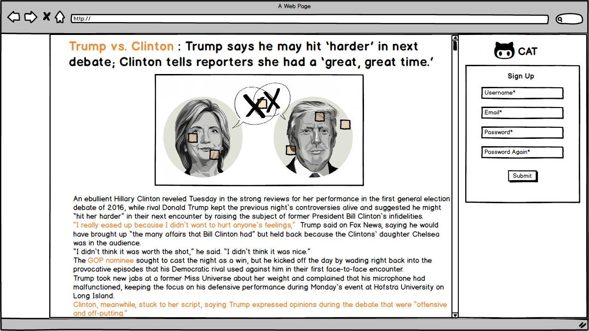

Sign In Screen
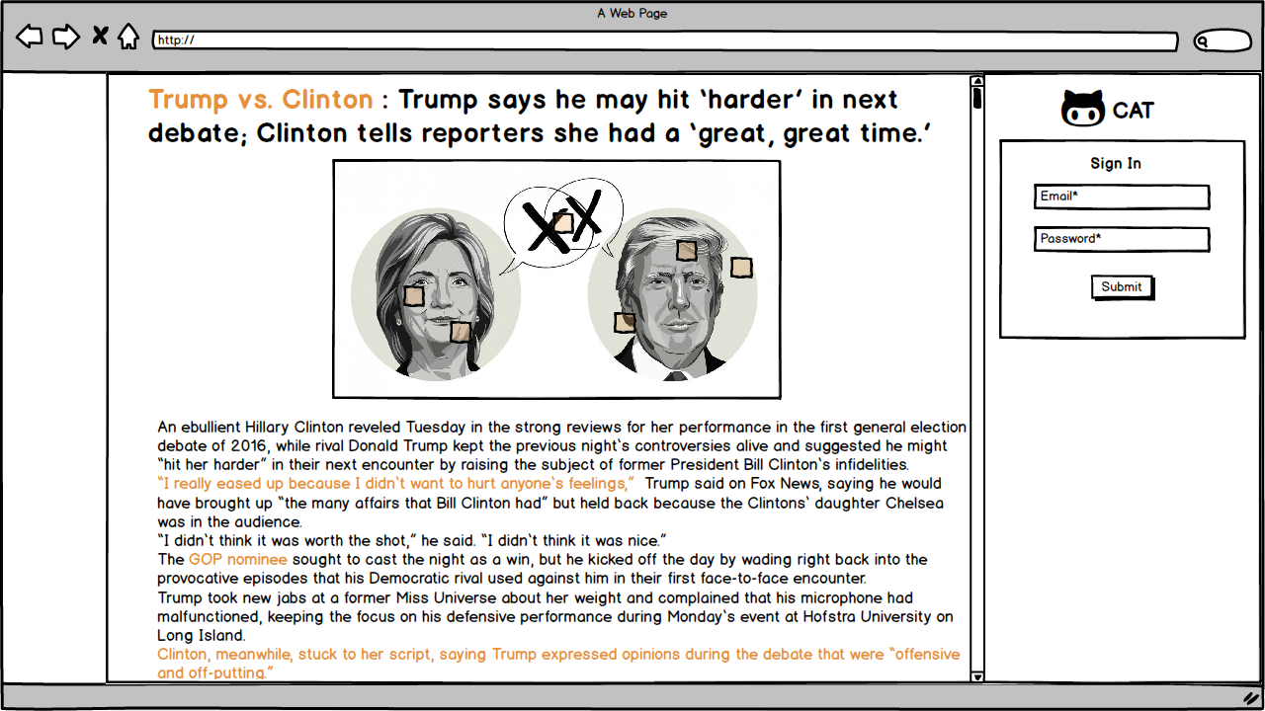

After Sign In
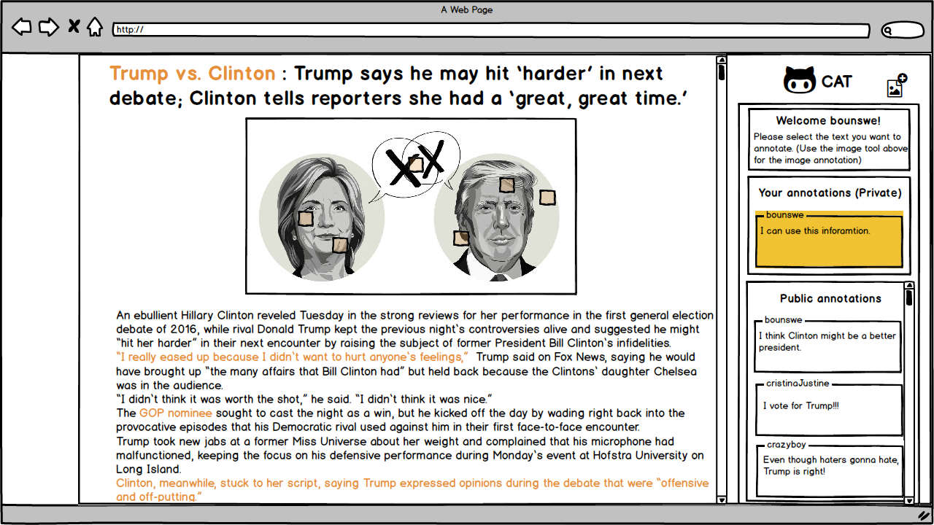

Text Annotation
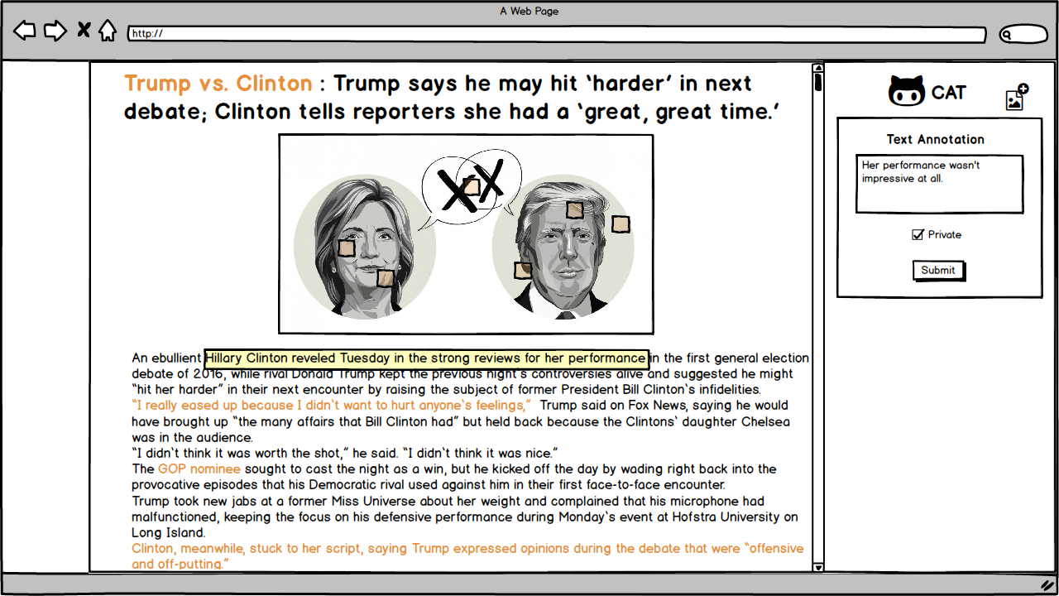

Image Annotation

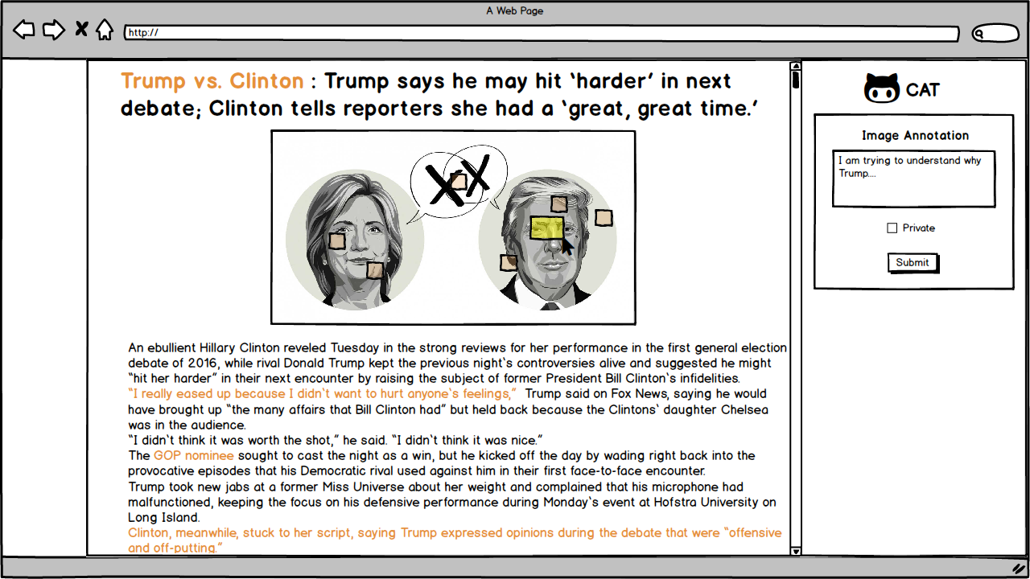

Change Password Screen
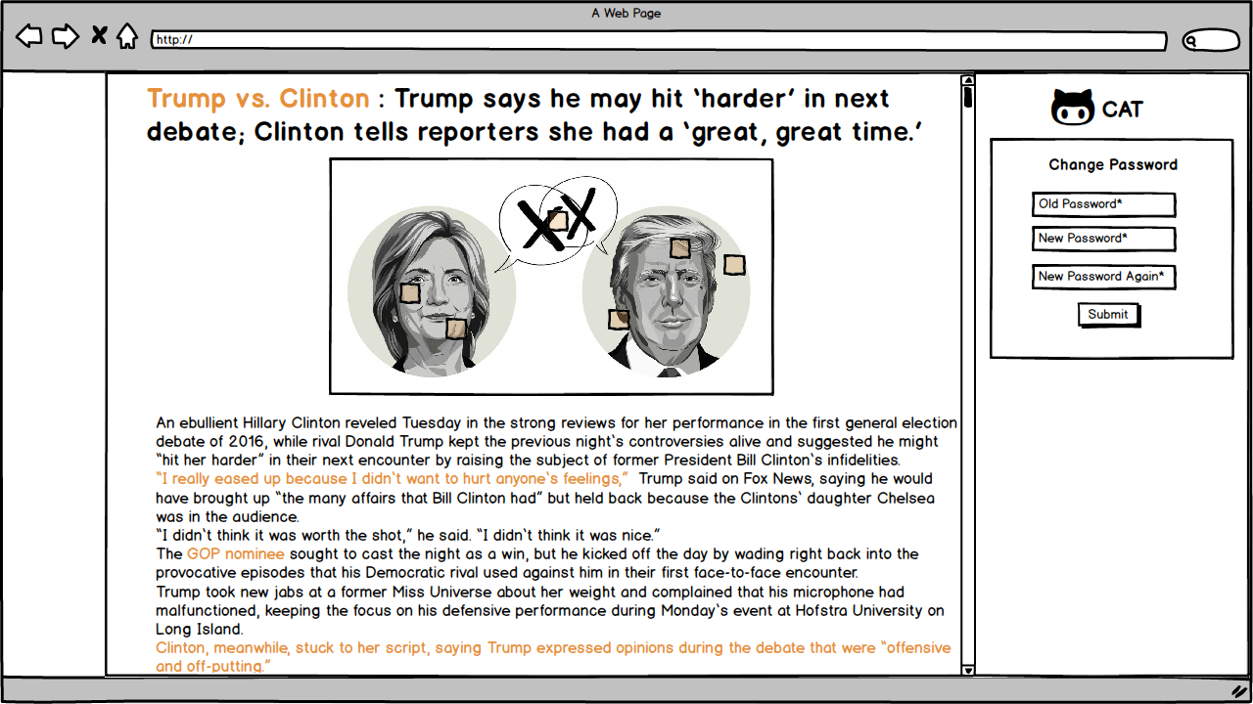

Manage Annotations
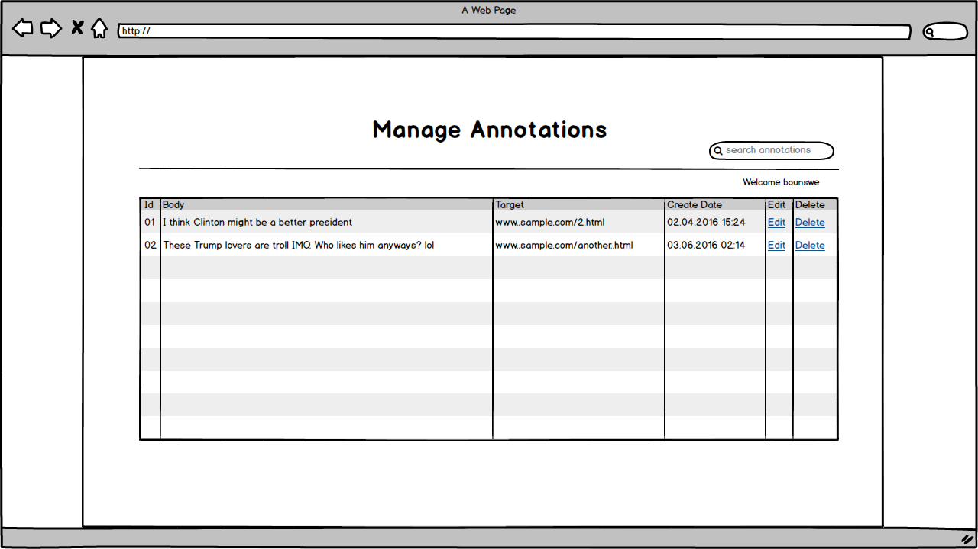

Project Plan
A project plan, according to the Project Management Body of Knowledge (PMBOK), is: "...a formal, approved document used to guide both project execution and project control. The primary uses of the project plan are to document planning assumptions and decisions, facilitate communication among project stakeholders, and document approved scope, cost, and schedule baselines. A project plan may be summarized or detailed." (For more information, visit: Project plan)
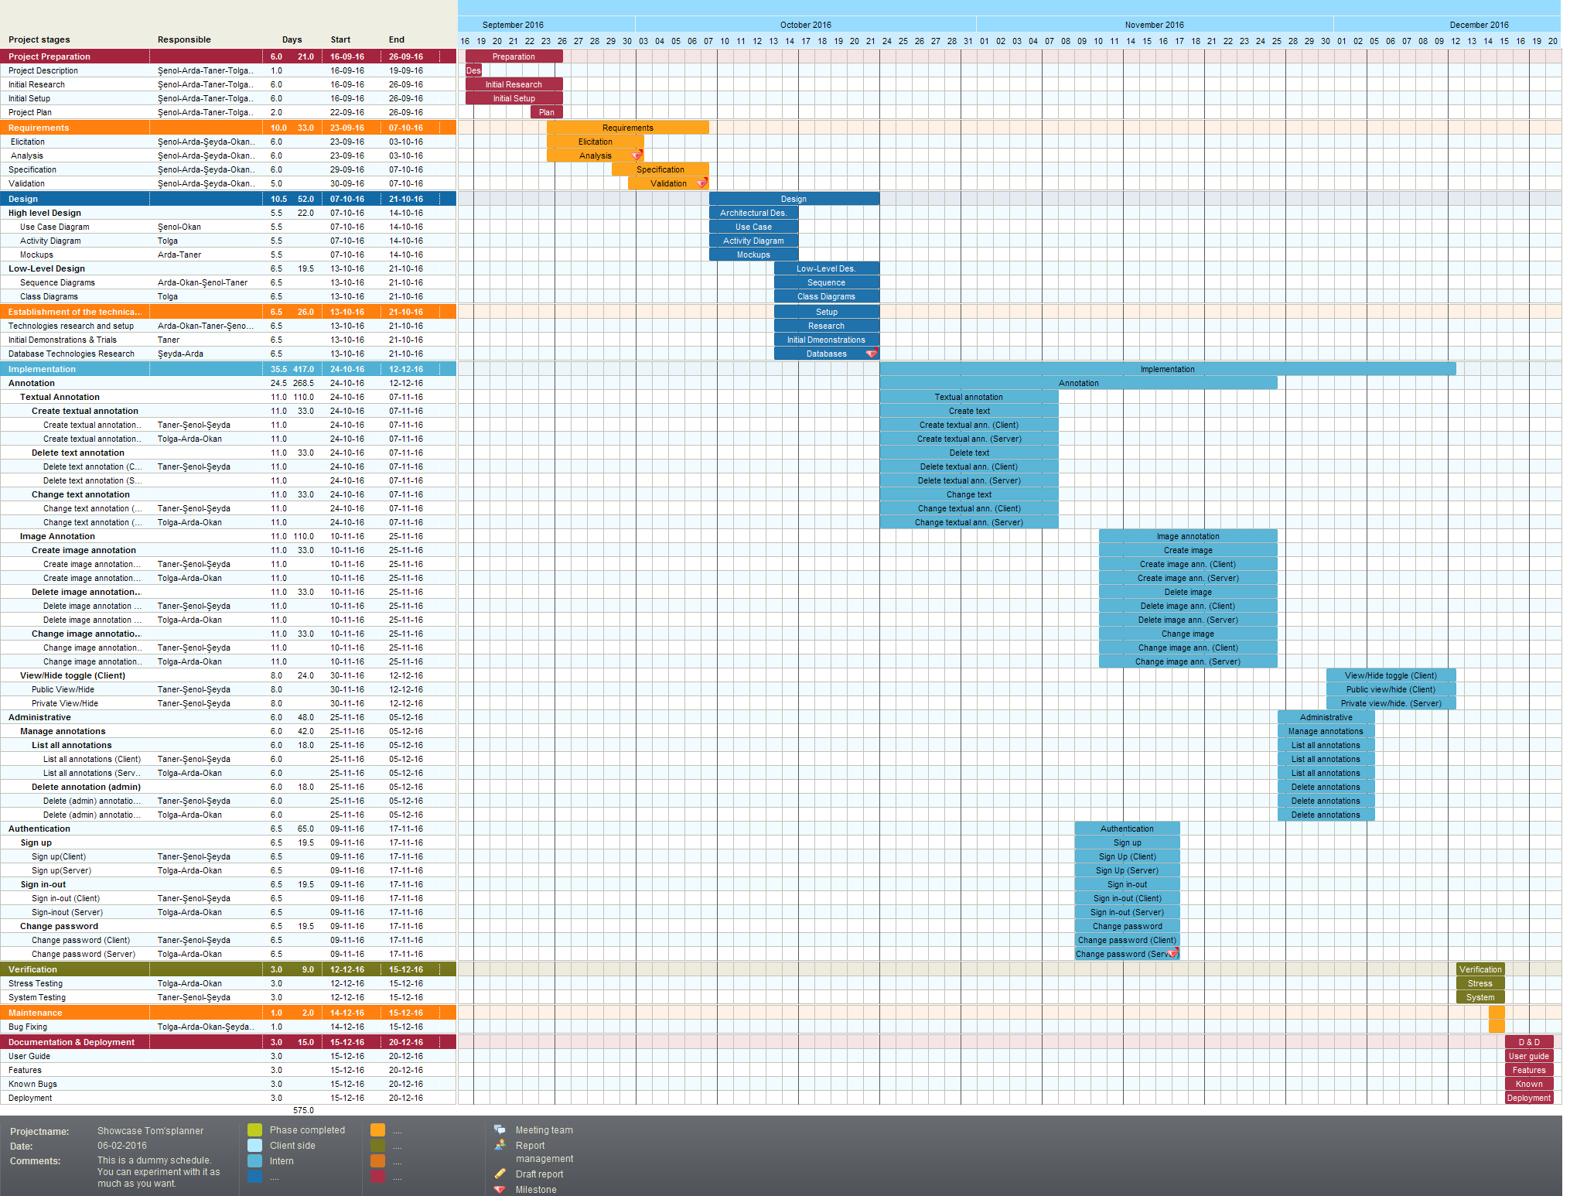

UML Design Diagrams

Use Case Diagram
Use case diagrams are consists of actors, use cases and their relationships. The diagram is used to model the system/subsystem of an application. A single use case diagram captures a particular functionality of a system.
So, to model the entire system, numbers of use case diagrams are used. (For more information, visit: UML - Use Case Diagrams)

Use Cases for Admin, User, and Non-User
The following use case diagram shows the actions available to users, admins, and non-users.

Activity Diagrams
Activity diagram is another important diagram in UML to describe dynamic aspects of the system. Activity diagram is basically a flow chart to represent the flow form one activity to another activity. The activity can be described as an operation of the system. So the control flow is drawn from one operation to another. This flow can be sequential, branched or concurrent. Activity diagrams deals with all type of flow control by using different elements like fork, join etc. (For more information, visit: Tutorials Point (UML - Activity Diagram)

Create Annotation Activity Diagram
The following diagram shows the logic of creating an annotation.

View Annotation Activity Diagram
The following diagram shows the logic of viewing an annotation.

Sequence Diagrams
The sequence diagram is part of the interaction diagram. Sequence diagram emphasizes on time sequence of messages and collaboration diagram emphasizes on the structural organization of the objects that send and receive messages. (For more information, visit: UML - Sequence Diagrams)

Create Annotation Sequence Diagram
The following sequence diagram shows the creation of an annotation.
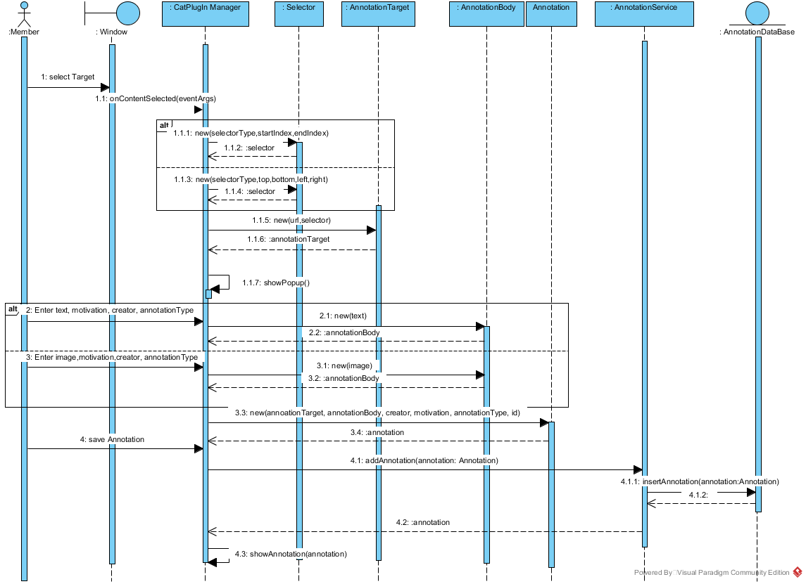

View Annotation Sequence Diagram
The following sequence diagram shows the displaying of an annotation.
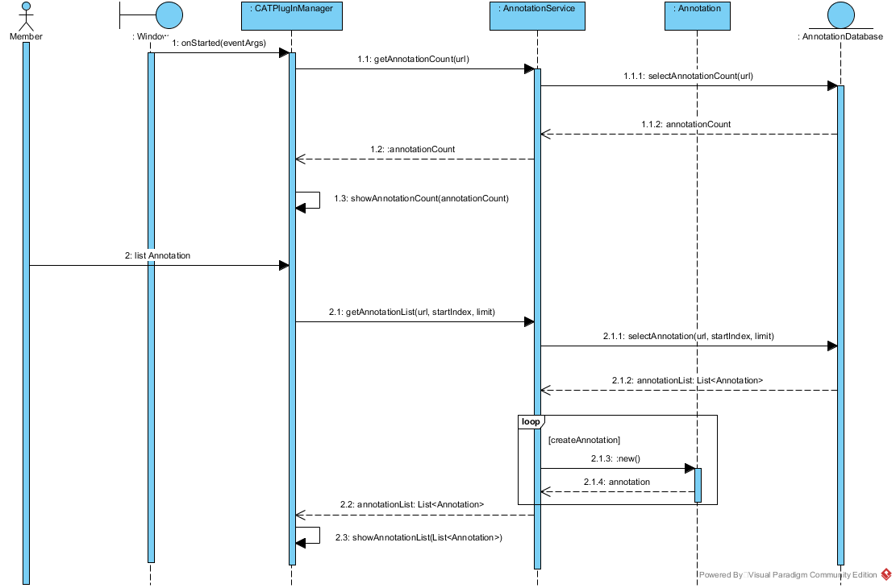

Class Diagram
The class diagram is a static diagram. It represents the static view of an application. Class diagram is not only used for visualizing, describing and documenting different aspects of a system but also for constructing executable code of the software application. The class diagram describes the attributes and operations of a class and also the constraints imposed on the system. The class diagrams are widely used in the modeling of object oriented systems because they are the only UML diagrams which can be mapped directly with object oriented languages. The class diagram shows a collection of classes, interfaces, associations, collaborations and constraints. It is also known as a structural diagram. (For more information, visit: UML - Class Diagram)
The following class diagram shows the models used in the project.
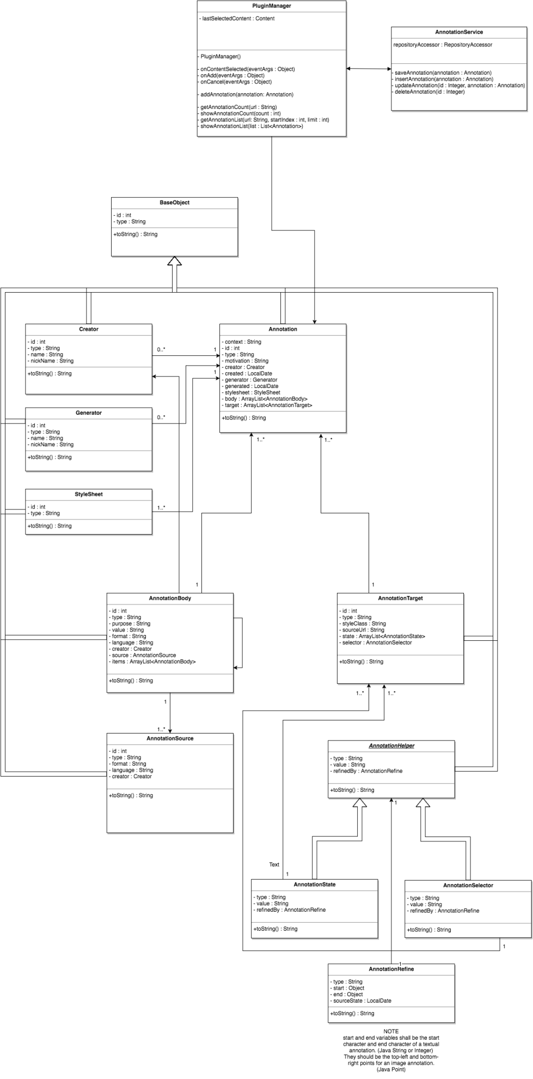

Features and User Guide

In order to launch Cat Annotation Tool, the user should download cat annotation plugin from firefox library. After set up, a cat icon will be appear on the browser and by clicking on this cat icon the pluging launches.
When the Cat Annotation tool is launced, login screen appears. If you do not have an account yet, you can create a new account by clicking on "Sign Up" button.
"Sign Up" page includes the required fields in order to register to the tool. the rquired fields are, "username", "email", "password".
In sign up page, there is control algorithm that checks the length of password, whether the passwords matches, if all required fields are filled. For the each case, there is a error message appears below the related field.
When the user, fills the form correctly and clicks on the register button, the register page redirects the user to the login page.
In the login page, username and password fields will be appeared.
The user have to enter his username and password. If the user doesn't enter his username or password, error messages appears again. If the user enters the username and password correctly and clicks to login button, the redirects the user to the manage page.
Manage page was created to manage annotations that created by other users and the annotations that created by the user who logined to the page. There are 2 tabs in this page that shows "Basic Search" and "Advanced Search".
In the basic search, the users can search the annotations by word and a given time interval. The user enters to the text box the word that he wants to search and determines a start date and end date. When the user clicks to serach button, the system displays all annotations that include the word that given by the user and created between start date and end date.
In the advanced search, the user can search the annotations by type of annotation,by the motivation of the annotation,by creator and by target.Besides, the user should can prefer to see his own annotations.
In order to list annotation that created by him, the user shoul check "show my annotations only" button.Moreover, the manage page asks to the user how many annotations should be displayed. There is count of annotation select box and the user can choose 1, 5, 10, 25, 50, 100. These numbers refer to the number of annotations that will be listed on the page. If the user wants to search by the annotations by type, he should select "image" or "text" options from the
option box named "selector" that locates at the top of the page. If the user wants to search by motivation type of the annotation, he should select an option from "motivation selection box".
This selection box includes "assesing", "book marking", " classifying", "commenting", "describing", "editing", "highlghting", "identifying","linking", "moderating", "questioning", "replying" and "tagging" options.
If the user prefers to search annotations by target, he should enter the target of the annotation to the text box named target.
In addition to target, the user can search annotations by the creator andin this case, he should write the creator to the creator text box.
After the user make all selections, he clicks to "search&show" button and the all annotations listed in pursuance of his selections.
There is no need to a page annotate an image or a text. When the use wants to annotate an image or a text, he should select the area or he should select the text and a small annotate button appears on the selected area. When the user clicks on this annotate message, the annotation page will be appeared on the right side of the browser.
The user should enter the motivation of the annotation that explained in the search section (assesing, book marking, classifying, commenting, describing, editing, highlighting, identifying, linking, moderating, questioning, replying and tagging) and click to annotate button.
The annotated image or text will be appeared on the right side of the browser and when the user clicks on the annote button, the system keeps his annotation and displays it on the top of the page.

