1. What is Github?
2. What all purposes would users of Github use it for?

Firstly, **GitHub contains powerful versioning software so that it can handle branching and merging easily**. This means multiple people can work on the same piece of code, online or offline, which will be saved in the same Git. Secondly, GitHub is great for remote collaboration

GitHub allows[software developers and engineers](https://blog.hubspot.com/website/software-developer-vs-software-engineer?hubs_content=blog.hubspot.com%252Fwebsite%252Fwhat-is-github-used-for&hubs_content-cta=What%2520is%2520GitHub%2520used%2520for%253F) to create remote, public-facing repositories on the cloud for free. A repository, or "repo" for short, is a coding project’s files and the revision history for each file.

Once you’ve set up a repository on GitHub, you can copy it to your device, add and modify files locally, then "push" your changes back to the repository where your changes display for the public.

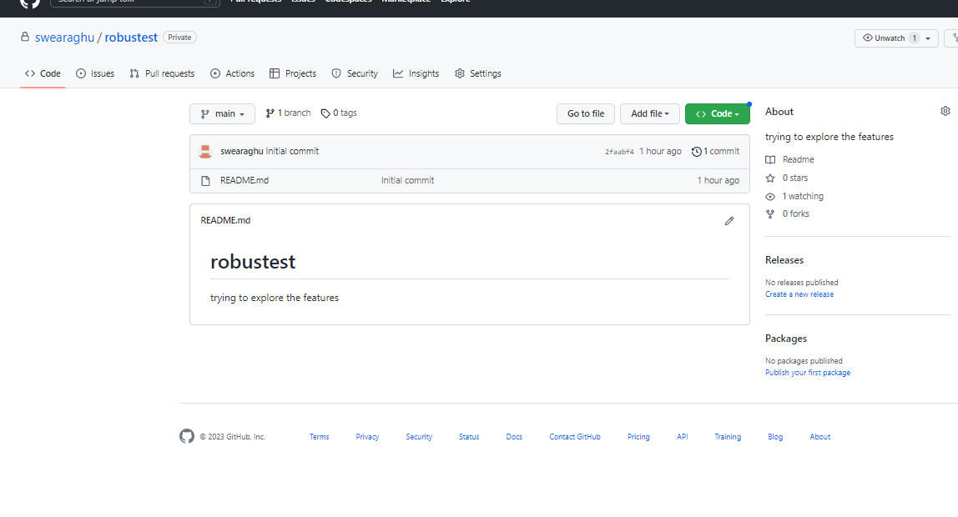

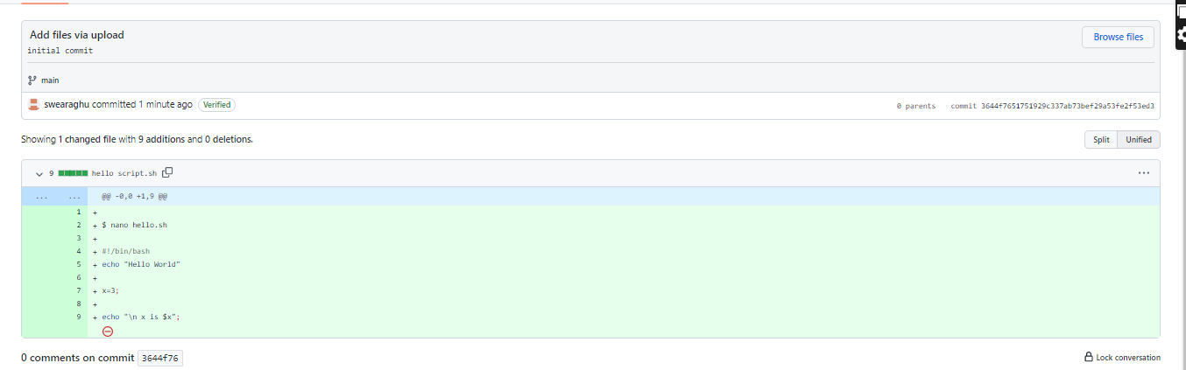

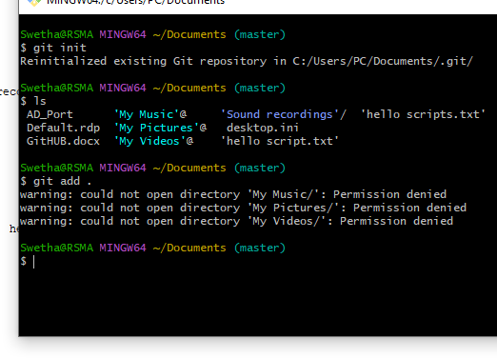

Tried the command line for adding a new file

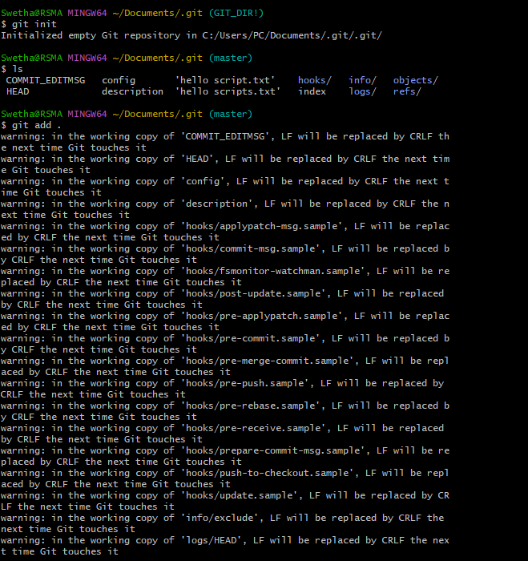

Creating a Repo

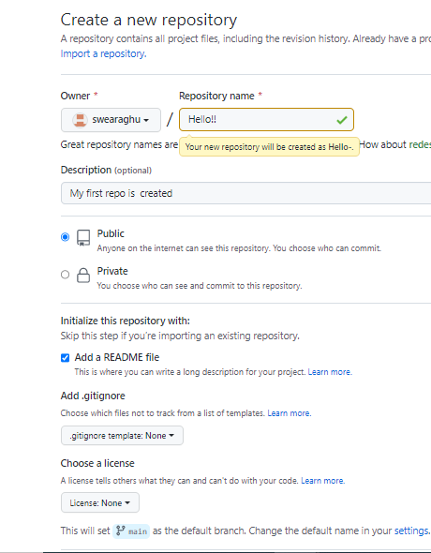

Add shell script using command line

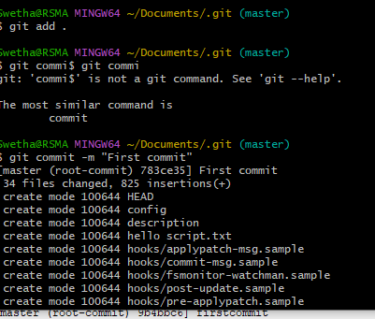

Added the origin and pushed the file using commands

