PROJECT DOCUMENTATION
Project Title: AI Weather API

Team ID | SWTID-2026-9130
Team Leader | Subha Shree.M  sac2427csc5476@ssacollegechennai.com
Team Members | Sweatha R  swetha.r1505@gmail.com  Tamilselvi S  sac2427csc5485@ssacollegechennai.com  Srividhya.M  sac2427csc5378@ssacollegechennai.com

1. Project Overview
AI Weather API is a server-side REST service that combines live weather readings with AI-written explanations. It is built on Node.js and Express.js, stores its data in MongoDB through the Mongoose library, and calls Google Gemini to turn raw figures such as temperature and humidity into plain-language summaries and practical suggestions.
Accounts are protected with JWT-based login and bcrypt-hashed passwords. Registered users can keep a personal list of favourite cities and query weather and AI advice for them. The service also has a fallback mode, so endpoints keep responding even when an external API key is missing, and it applies centralised error handling and input sanitisation on every request.

2. Case Study: Alex the Traveller
Alex travels between cities often and wants one place to check the weather and get sensible advice on what to do and what to wear. The table below shows the difficulties Alex faces and how the API answers each one.
Difficulty | How AI Weather API helps
Keeping track of many cities | Favourite locations can be added, viewed, updated and removed through CRUD endpoints.
No advice for outdoor plans or clothing | Gemini generates recommendations from the current conditions.
Raw numbers are hard to interpret | AI summaries describe the weather in everyday language.
Preferences are not saved securely | Authenticated accounts store data centrally, so it is available from any device.

Who Uses the System
- Registered user: manages saved cities, checks live weather, and asks for AI summaries and suggestions.
- Administrator / developer: watches service health, oversees user registrations and confirms the weather and AI integrations work.
- Public consumer: reads current weather from open endpoints without creating an account.
Result: people spend far less effort interpreting numbers, while Mongoose schemas keep the stored data consistent and Gemini supplies advice that fits the situation.

3. System Requirements

Software
Component | Purpose
Operating system | Windows 10/11, macOS or Linux
Node.js 16+ | Runs the server code and routing
npm 8+ | Installs and manages packages
Gemini AI SDK | Generates AI summaries and recommendations
MongoDB | Stores users, locations and related records
Postman | Sends test requests and checks responses
Visual Studio Code | Code editor (or any similar IDE)

Hardware
Resource | Minimum
Processor | Intel Core i5 (8th gen) / AMD Ryzen 5 or better
Memory | 8 GB (16 GB recommended when running MongoDB and the server together)
Disk space | 1 GB free

4. System Design

4.1 Architecture
The project follows the MVC pattern so that business logic stays separate from data handling. Controllers fetch weather from OpenWeatherMap and request AI text from Gemini; models describe the User and Location data.

Figure 1: Technical architecture of the AI Weather API

4.2 Main Components
Component | Role
API client | Tools such as Postman call the routes and receive JSON.
Express server | Listens on a port, maps GET/POST/PUT/DELETE routes, parses JSON and applies CORS.
Auth middleware | Reads the token from request headers, verifies it and checks the caller’s role before protected routes run.
Service modules | Hold the isolated business rules for each feature.
Mongoose layer | Converts application operations into MongoDB queries.
AI integration | Uses @google/generative-ai to write summaries and suggestions from live conditions.

4.3 MVC Layers

Figure 2: MVC structure
- Model: Mongoose schemas define each field, default values and indexes before anything is saved.
- Controller: receives the request, validates it, calls the models or services and returns a JSON response.
- View (routing): because this is a headless backend there are no page templates; the route files play the view role by linking each URL to its controller.

4.4 Data Model
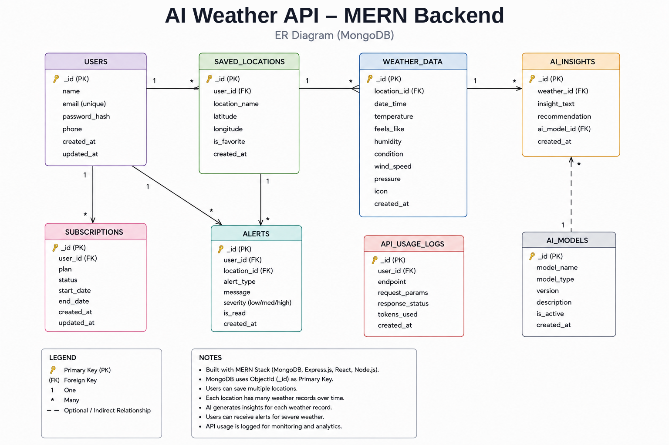
Figure 3: Entity-relationship diagram
One user can own many saved locations (one-to-many).
Entity | Field | Details
User | _id | Primary key (ObjectId)
 | name | String, required
 | email | String, required, unique
 | password | String, required, stored hashed
 | role | String, default "reader"
Location | _id | Primary key (ObjectId)
 | user | Reference to the User collection
 | city | String, required
 | country | String, required
 | createdAt | Date, defaults to now

5. Key Features
- Role-based access: token checks stop unauthorised users from changing protected data.
- Favourite-location management: full create, read, update and delete for saved cities.
- Live weather and AI insight: current conditions plus Gemini-written summaries and advice.
- Input sanitisation: cleans request data to block XSS and NoSQL injection attempts.
- Fallback mode: the API still answers when external keys are unavailable.

6. Roles and Workflow

Administrator
- Creates, removes or suspends user accounts.
- Monitors API health and logs.
- Keeps the database consistent.

Registered User
- Builds and maintains a list of favourite locations.
- Requests real-time weather data.
- Asks Gemini for personalised summaries and activity ideas.
- Manages own credentials and profile details.

Typical Request Flow
- The user registers or logs in.
- A favourite city is saved through the API.
- Current weather for that city is requested.
- AI insights (summary or recommendation) are requested from that data.
- The system checks the JWT and sends back the result.

Figure 4: User flow

7. Project Setup

7.1 Create and initialise the project
- Create a folder named AI Weather API and open it in Visual Studio Code.
- Open the integrated terminal and initialise Node.js:
npm init -y
- Install the runtime packages:
npm install express mongoose bcryptjs jsonwebtoken cors dotenv multer @google/genai
- Install Nodemon as a development tool:
npm install --save-dev nodemon

7.2 Files and folders
Create these files in the project root: index.js, .env, package.json and .gitignore. Then arrange the source folders as shown below.

Figure 5: Folder structure

7.3 Environment variables
Add the following to the .env file, replacing the placeholders with your own values:
PORT=5000
MONGO_URI=your_mongodb_connection_string
JWT_SECRET=your_jwt_secret
GEMINI_API_KEY=your_gemini_api_key

8. Backend Implementation
The backend is modular: routes, controllers, middleware, models and utilities live in separate folders, which keeps the code easy to maintain and extend. It exposes secured REST endpoints for authentication, saved locations, weather retrieval, AI recommendations and administration.

Figure 6: Backend file layout

Entry point: index.js
index.js starts the application. It loads environment variables, applies middleware, connects to MongoDB, registers the API routes and begins listening only after the database connection succeeds.

Figure 7: index.js

9. Database Configuration
Install Mongoose with npm install mongoose, create the connection module, then define the schemas and models. The connection must succeed before any request is handled.

Connection module
This module links the application to MongoDB through Mongoose so the server can talk to the database before serving clients.

Figure 8: Database connection

Location schema

Figure 9: Location schema

User schema

Figure 10: User schema

10. Running and Testing
Make sure MongoDB is running and the .env values are set. Install the dependencies and start the server:
npm install
npm start
Once started, the server connects to MongoDB and waits for requests. Endpoints can be tested with Postman or Thunder Client.

Register
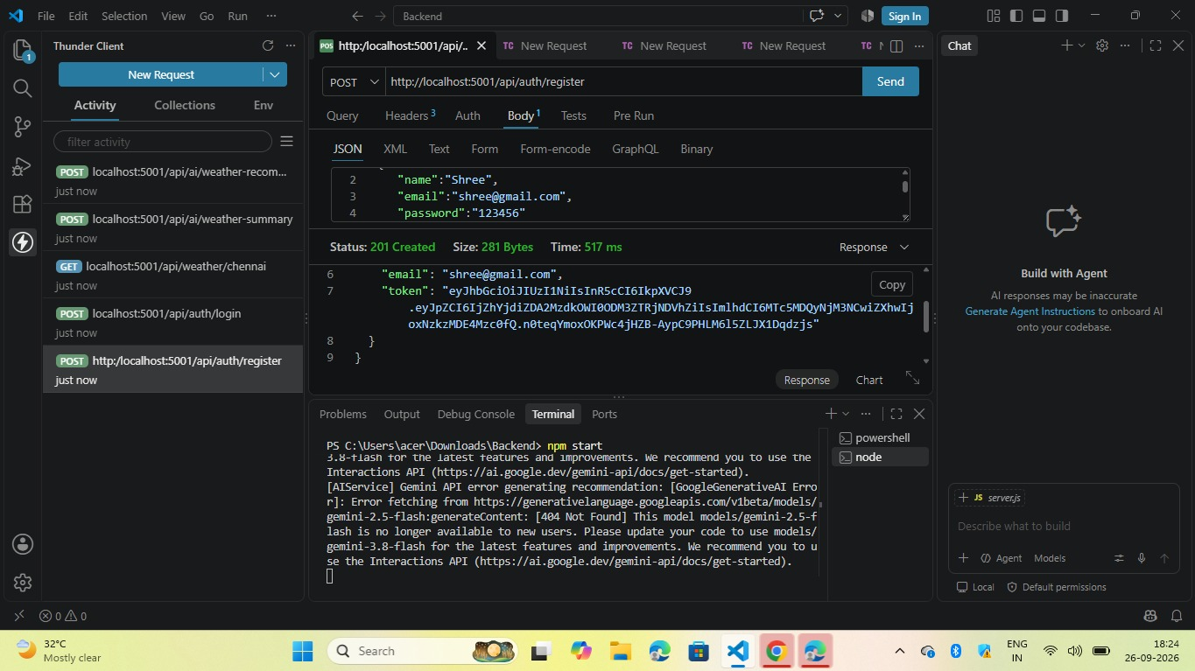
Figure 11: Register API test

Login
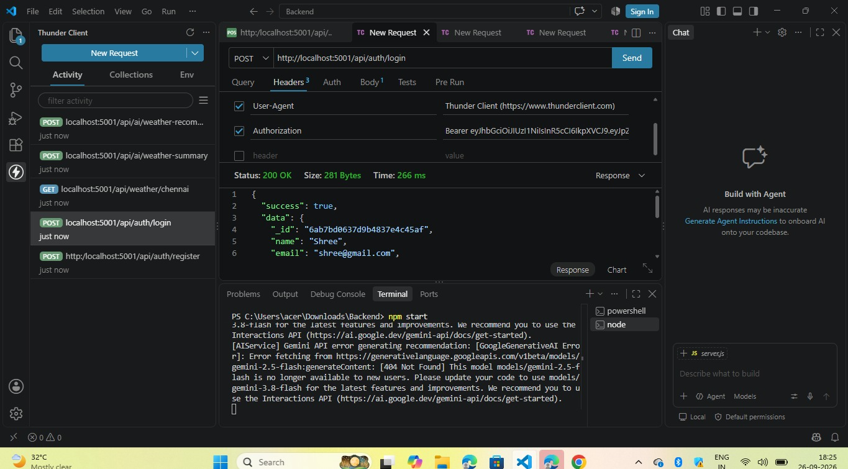
Figure 12: Login API test

Weather
Figure 13: Weather API test

Recommendation
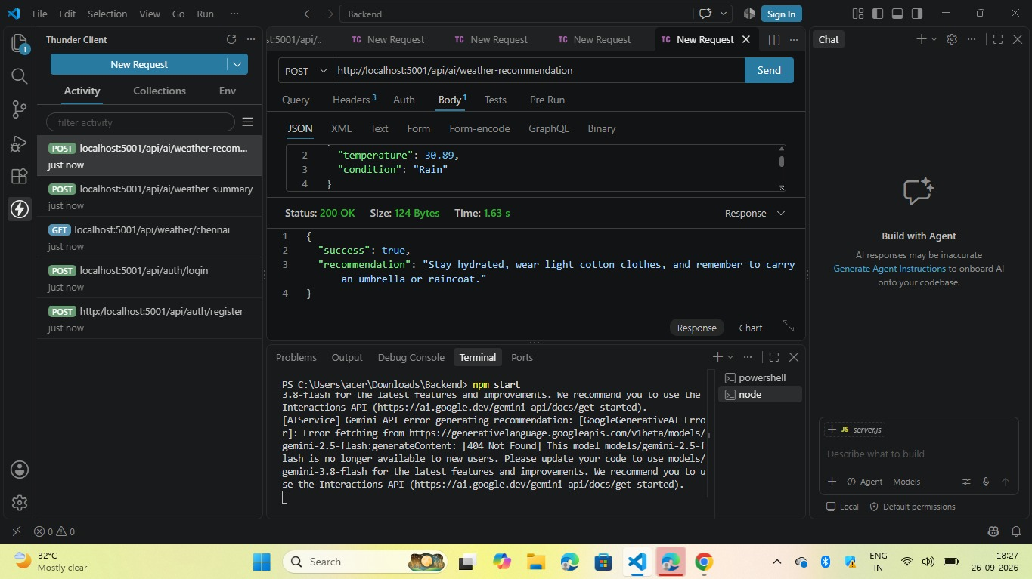
Figure 14: Recommendation API test

11. Resources
- Demo And API Testing Video: https://drive.google.com/file/d/1lvlOhIRx9OERFzCT1TV4y7yxUqsMfMk7/view?usp=drivesdk
- Source code:
https://drive.google.com/drive/folders/11OqDsQnAW3m6Ex3DBNCA1rdUYp_79nuH
- Github Link:
https://github.com/sweathar1505-jpg/AI-WEATHERWISE-API-.git

