This presentation has been set up for you in Word so you can easily edit content and import the information into PowerPoint. To import to PowerPoint, when in WORD, select 'File', then 'Send To' and finally 'Microsoft PowerPoint'. This will generate a PowerPoint file which may need a little cleaning up such as removing blank slides or slides with just 'Slide #'. You can then use the Living Smart template for this topic and copy and paste these slides into the template powerpoint file.

We recommend that you check the information as the slide contents will no doubt date.

HEALTH SMART HOME PRESENTATION

Slide 1

Health Smart Home

Creating a healthy chemical free home

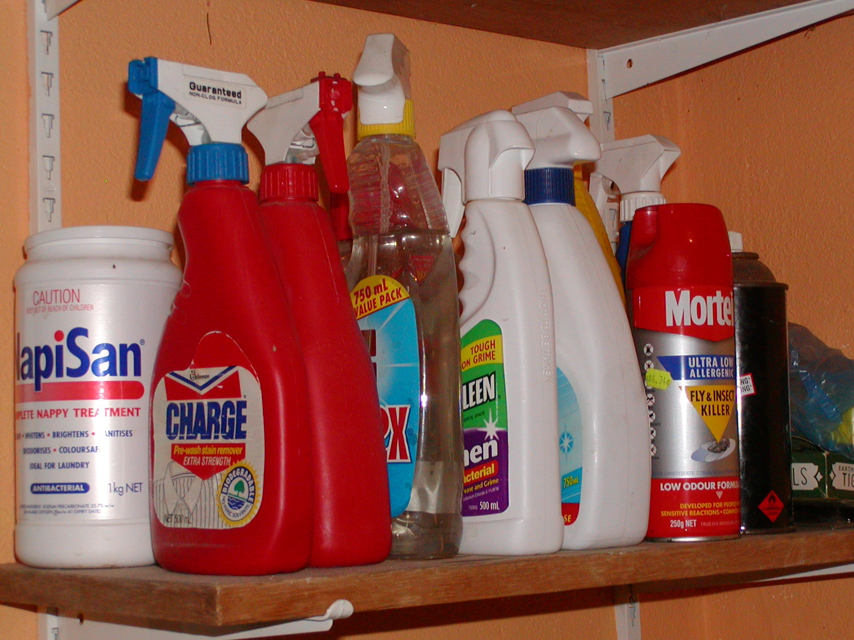
Slide 2

List of chemicals in my home…

Chemical 1

Chemical 2

etc

Notes:
It’s a good idea to do a chemical audit of your home for the presentation – it may surprise you how many chemicals you have, how many of these overlap in function and how many you don’t need! You may want to take a photo of your chemical shelf to get an idea of what’s there. This list may take up several slides.

Slide 3

Indoor air

The average Australian spends 80 to 90% of their time indoors

Indoor air is far dirtier than outdoor air – up to 10 times dirtier

Indoor contaminants include volatile organic compounds, dust and mould.

Notes
The average Australian spends 80 to 90% of their time indoors – which can be very unhealthy if the air quality indoors is poor.

Indoor air is far dirtier than outdoor air – up to 10 times dirtier, this is a concern to many of us. Most contaminants from outside come inside and stay there due to our modern homes being more snug and airtight. Many homes don’t get “aired out” regularly. Many indoor items will also be releasing toxins into the air eg carpets.

Indoor contaminants include volatile organic compounds, dust and mould.

So what can we do to reduce the amount of containments in indoor air?

Slide 4

What are volatile organic compounds (VOC’s)?

A class of carbon based chemicals, which evaporate easily at room temperatures, giving off vapours, which can be inhaled.

Slide 5

Where do we find VOC’s?

Houses

Offices

Trains

Planes

Cars

etc

Notes
VOC’s occur nearly anywhere where there are synthetically made products.

Slide 6

What contains VOC’s?

Plywood boards

Polystyrene insulation boards

Floor sealants

Paints

Lacquers

Varnishes & adhesives

Slide 7

What contains VOC’s? (continued)

Cleaning Products

Floor cleaners

Waxes

Deodorisers

Carpet cleaners

Furniture polish

Slide 8

What contains VOC’s? (continued)

Polyvinyl floor coverings

Polyvinyl coated wall papers

Carpet adhesives

Rubber backings for carpets

Furnishings

Slide 9

What contains VOC’s? (continued)

Personal care products

Dishwashing liquid

Clothes detergents

Pest baits and sprays

Hot water

New clothing/curtains/sheets

Slide 10

Health Consequences

Little is known about low level exposure

Can irritate the mucous membranes

Headaches

Impair thinking

Impair concentration

Respiratory irritants

Slide 11

Solutions for VOCs

Take less chemicals into your home!

Reduce cleaning and personal care products

Use non-toxic alternatives

Avoid using air fresheners, spray cans and poisonous baits

Air new furniture and soft furnishings outside

Notes
Many cleaning products can be replaced with natural alternatives such as bicarb soda and vinegar, lemon juice
Or you can purchase products based on vegetable oils rather than petroleum based products.
Micro fibre cloths are fantastic products, which will help you clean without chemicals.
Air new furniture and soft furnishings outside – this will allow chemicals to dissipate

Slide 12

Dust

On a normal day we breathe in one teaspoon of microscopic dust particles

Contributes to respiratory infection and disease.

Causes headaches, nausea and asthma

Notes
On a normal day we breathe in one teaspoon of microscopic dust particles
Dust contributes to respiratory infection and disease – many of the microscopic particles can be absorbed into our lungs.
Causes headaches, nausea and asthma

Slide 13

What Constitutes Dust?

Skin cells (animal and human)

House dust mites

Mould and fungal spores

Dead and living bacteria

Insect parts

Fibrous material

Left over food particles

Inorganic particles

Chemicals

Pesticides from gardens

Heavy metals from exhausts

Pet faeces

etc

Slide 14

Solutions for dust

Take off your shoes at the door!

Efficient vacuum cleaner – cyclonic or centrifugal action

Throw away the rag and use a micro fiber cloth

Notes
Take off your shoes! – This will reduce 50% of microscopic dust in the air simply by reducing the amount of dust that makes it inside.
Efficient vacuum cleaner – the best are vacuum cleaners have cyclonic action and HEPA filter. Bag vacuum cleaners are more like dust-distributors and will push the microscopic particles back up into the air, leaving them there for you to breath in. The small size of the particles mean they can take up to 140 days to drop down on the floor.
Throw away the rag and use a micro fiber cloth –Rags and dusters push dust back into the air where the micro fiber cloth holds onto the dust

Slide 15

Mould and Dust Mites

Dust mites are microscopic organisms that feed on dried human skin

Both love moist areas

Exposure to mould spores is serious especially for children

Dust mites are common trigger for asthma

Notes
Dust mites are microscopic organisms that feed on dried human skin
Both love moist areas- and dust mites need mould to survive.
Exposure to mould spores is serious especially for children. Mould can cause serious health consequences – any mould in a house is too much!
Both can cause asthma, chronic bronchitis, rhinitis, nasal congestion, coughs, wheezing and sore throats
Dust mites are common trigger for asthma

Slide 16

Solutions to Mould and Dust Mites

Prevent moisture

Treat the mould and dust mite problem

Notes
Prevent moisture – open bathroom window and install a fan. Open doors and windows to let in fresh air and take out moisture. Don’t keep you house at an even temperature – keeping your house at the same temperature all year creates perfect breeding ground for mould. Allow your house to cool down in winter and warm up in summer.
Treat mould and dust mite problem
- Kill mould with soapy detergent. The best solution is to use a 10% bleach solution in hot water.
- Take pillows and doona outside every couple of months for six hours, as mould and dust mites hate the sun and fresh air.
- In severe cases get in a professional!

Slide 17

Household Chemicals

More chemicals are used in our homes now than in laboratories at the turn of the century

No information is found for 79% of the 48,000 chemicals listed on the USA’s Environmental Protection Agency inventory of toxic substances

Chemicals in the home are the least regulated

Slide 18

Household Chemicals

Bad for your health and the environment

Think twice before buying chemicals

Use non-toxic alternatives

Make your own cleaning products

Notes
- Bad for your health – these chemicals can damage your health through long term exposure – chemicals can be useful, but most of the time they are not needed. When they are needed, be selective about how you use them. For example spot cleaning for cleaning up after pet accidents!
- Bad for the environment – chemicals from your home can end up in waterways contributing to algal growth and build up in food chains
- Think twice before buying chemicals – if you have to buy chemicals or cleaning products select ones that are made of only one chemical that is not very toxic. Avoid phosphates, nitrates and chlorine. Watch for marketing tricks, non-toxic and natural are often used with little or no meaning. Look for products, which say they are 100% biodegradable. Often it is only one ingredient, which is biodegradable.
- Use non-toxic alternatives –They are cost effective and safer for your family. You may already have these in your home. Microfibre cloths are a fantastic way to reduce the need for chemicals.
- Make your own cleaning products – check out some recipes on page 73 of the Action Guide

Slide 19

Storage and safe disposal of chemicals

Make sure chemicals are clearly labeled and out of reach from children

Only buy what you need

Do not incinerate aerosols

Do not pour chemicals down the drain

Do not put unwanted pesticides, fuels or solvents in the bin

Contact your local council for other tips

Notes
Make sure chemicals are clearly labeled and out of reach from children - and make sure containers sealed
Only buy what you need - avoid the disposal problem
Do not incinerate aerosols - dangerous
Do not pour chemicals down the drain –they end up in waterways
Do not put unwanted pesticides, fuels or solvents in the bin –these cause problems in landfill sites
Contact your local council for other tips

Slide 20

Top 5 tips for a healthy home

Replace your chemical cleaning products with non-toxic alternatives.

Take your shoes off before coming inside.

Open windows and ventilate your house regularly.

If you have to buy chemicals buy only what you need for the job.

Buy microfibre cloths and dusters and invest in a good vacuum cleaner.

