This presentation has been set up for you in Word so you can easily edit content and import the information into PowerPoint. To import to PowerPoint, when in WORD, select 'File', then 'Send To' and finally 'Microsoft PowerPoint'. This will generate a PowerPoint file which may need a little cleaning up such as removing blank slides or slides with just 'Slide #'. You can then use the Living Smart template for this topic and copy and paste these slides into the template powerpoint file.

We recommend that you check the information as the slide contents will no doubt date.

Power Smart PRESENTATION

Slide 1

Power Smart

Saving energy and greenhouse gases

Notes
We use energy everyday when we wash, cook, watch TV and indirectly when we purchase produce and services. It makes our lives comfortable. But the invisible nature of energy means that we don’t realise how much we are using, the impacts of using it or even that we are using it.

Slide 2

How do we produce power in WA?

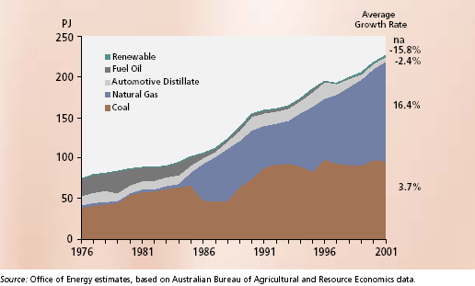
Coal

Oil

Gas

Hydroelectric

Landfills – gas

Wind

Solar

(Pic Source: Office of Energy, Energy in WA 2003)

Australia is one of only a few countries in the world highly dependent on coal (78%) for its electricity generation, after Poland and South Africa.

Source: Diesendorf, WWF, April 2003 Australia’s Polluting Power: Coal-fired electricity and its impact on global warming

http://www.wwf.org.au/News_and_information/Publications

Notes
For WA figures see Office of Energy at www.energy.wa.gov.au Energy in WA/Publications for Energy Western Australia 2003
Gas – this is both directly in our homes and indirectly through gas fired generators that produce electricity.
Landfills – as landfills decompose they produce a range of gases that are collected and then used to make power.
There are two types of energy resources here non-renewable (coal, oil, gas) and renewable (hydroelectric, wind, solar). The non- renewable gases are in limited supply, but the major source of energy in WA.

Slide 3

Why conserve energy?

Habitat destruction and land clearing

Soil and land degradation

Cost of rehabilitation

Depletion of a non-renewable resource

Greenhouse Gas Emissions -> Climate Change

Notes
The traditional sources of energy in WA are coal derived electricity and gas. They are extracted through mining and drilling and the impacts include:
- Habitat destruction and land clearing
- Soil and land degradation
- Cost of rehabilitation
- Depletion of non-renewable resource

As they are extracted, refined and distributed they create greenhouse gases which contribute to climate change.

While not feasible to do without energy altogether there is much we can do to use it more efficiently – not wasting it!

Slide 4

Greenhouse effect and Global Warming

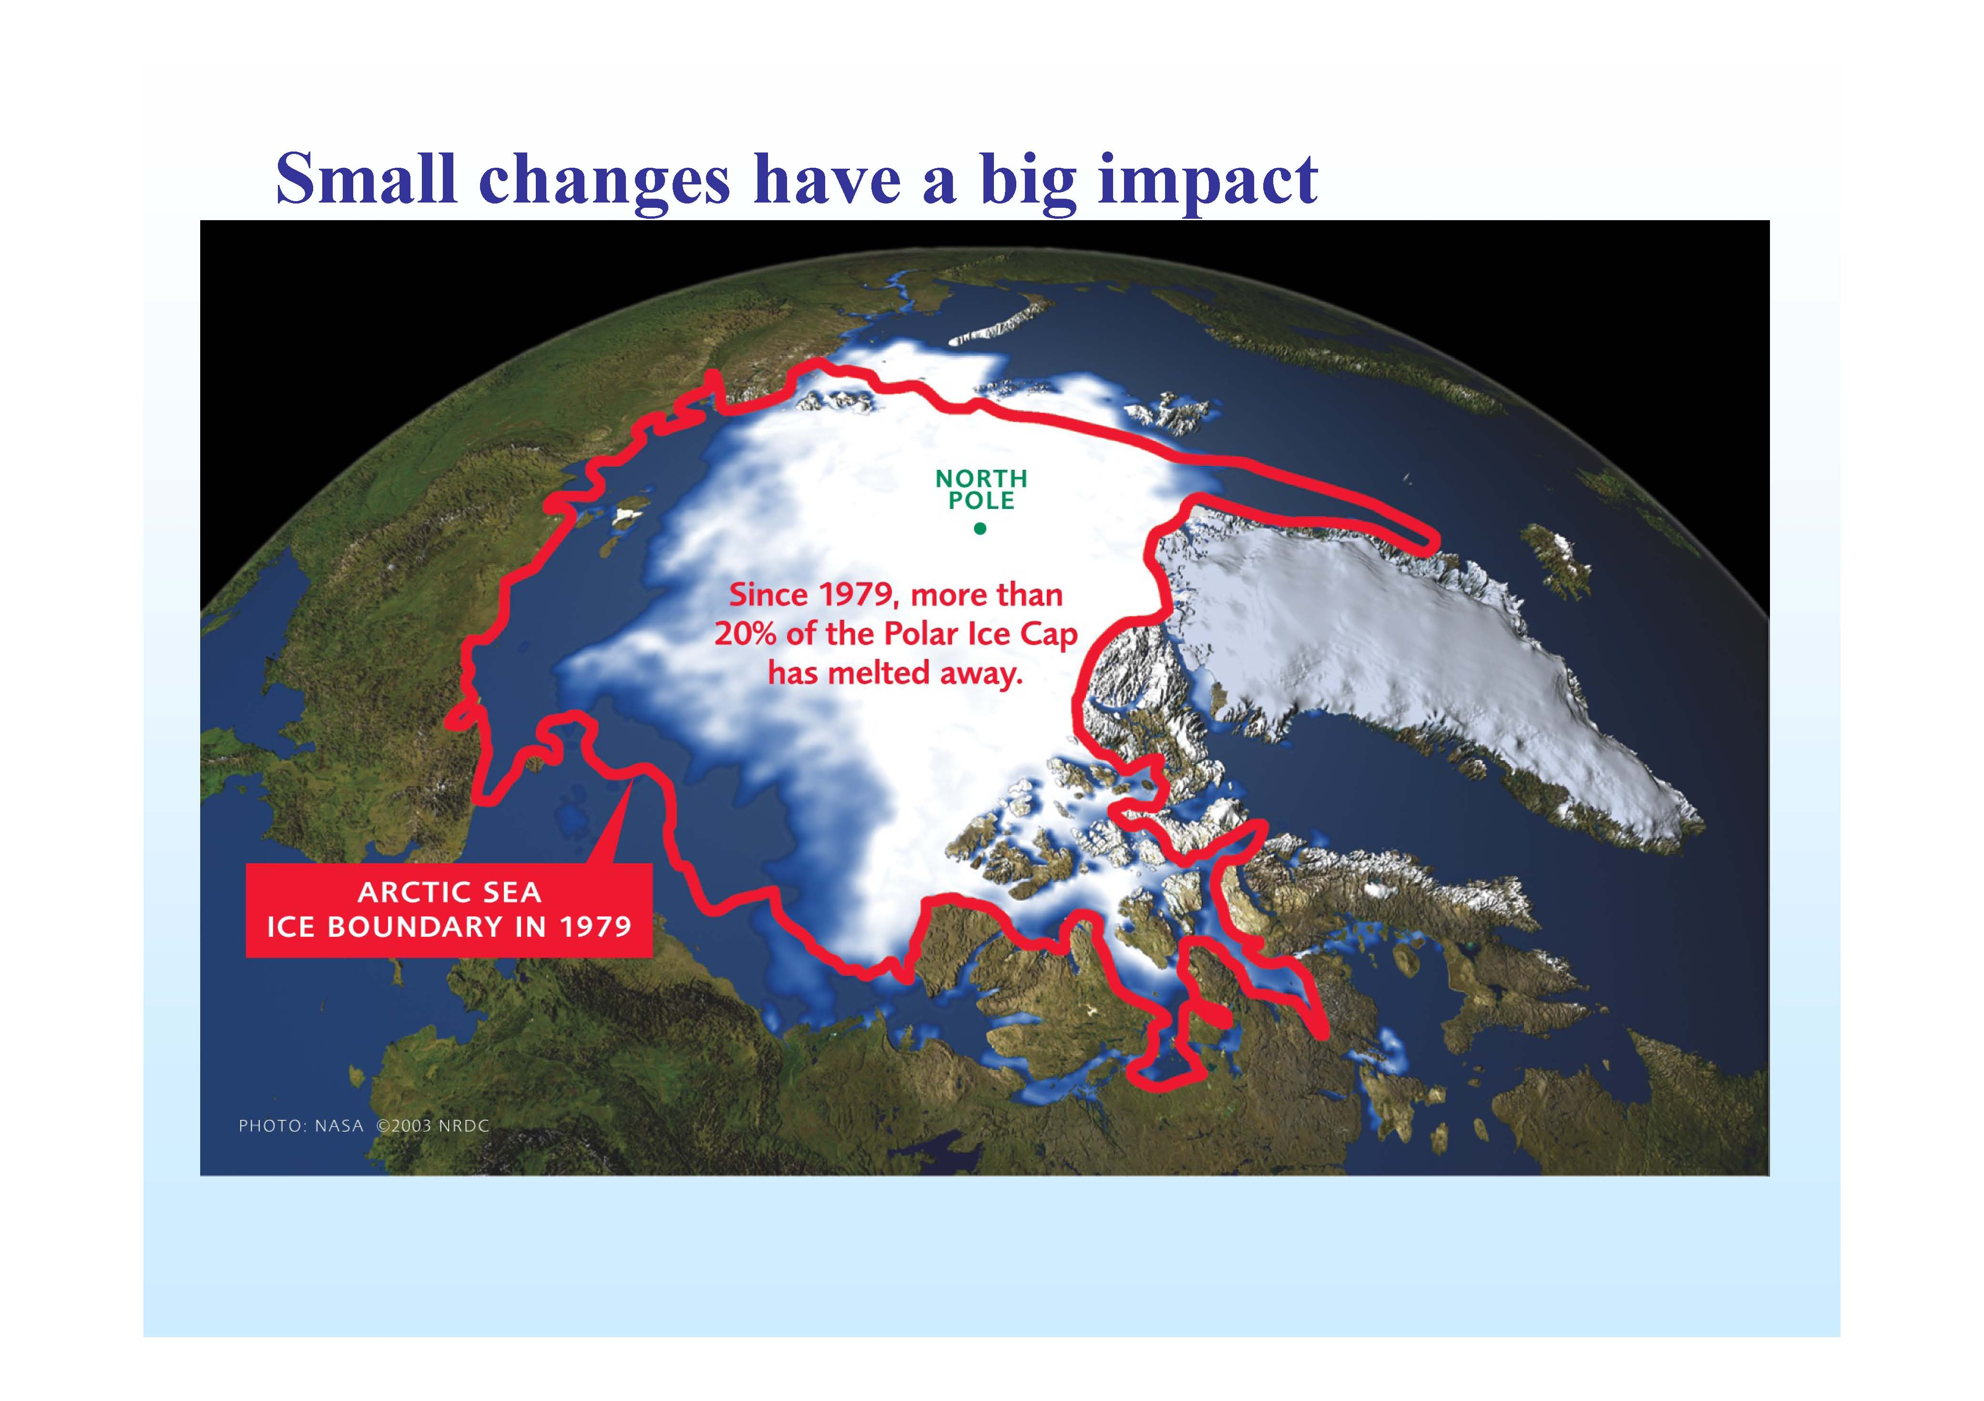
Greenhouse effect: A natural phenomenon which maintains earth’s temperature

Human activities principally the combustion of fossil fuels is causing a rise in greenhouse gas concentrations leading to global warming and climate change.

The Arctic is where the most rapid and severe climate change is already occurring, shrinking the extent of summer sea ice and thawing permafrost

Source: Arctic Climate Impact Assessment (http://www.amap.no/acia/index.html)

(Pic Source: Pearman, Australian Climate Group, 2004)

Notes
Greenhouse effect: A natural phenomenon which maintains earth’s temperature – at a level suitable for life to exist

Enhanced Greenhouse Effect = Global warming – human activities have led to an increase in concentration of green house gases trapping more heat at the Earth’s surface - 30% over the last 200 years from human activities (IPCC Third Assessment Report http://www.ipcc.ch/pub/un/syreng/spm.pdf )
The four warmest years ever recorded have occurred since 1998 and 19 of the warmest 20 years have occurred since 1980. (Source: New Scientist http://www.newscientist.com/channel/earth/climate-change)
This temperature rise has led to climate change already being witnessed around the globe.

This climate change has the potential to dramatically change both local and global weather patterns, creating widespread social, economic and environmental impacts.
See presentation by Graeme Pearman, Australian Climate Group for further info and figures http://www.ourwaterfuture.com.au/community/symposium2004/ws_2004_Pearman.pdf
Also Intergovernmental Panel on Climate Change IPCC reports http://www.ipcc.ch/pub/reports.htm

Slide 5

What it means for WA

Temperature rise

Winter rainfall (South West has already experienced 20% reduction over the last 30 years, Aust Gov 2005)

Increased evaporation rates

Increased bushfire risk

Cyclones more intense

In south-west of WA, a study (Pouliquen-Young & Newman 1999) on flora and fauna projected:

Extinction of 3 frog and 15 mammal species with just a 0.5°C temperature rise

Extinction of 119 Dryandra and Acacia species with 2°C rise

Notes
References:
Pouliquen-Young & Newman 1999 The Implications of Climate Change on Land Use Nature Conservation Strategies, Murdoch University
Federal Government’s Report Climate Change Risk and Vulnerability March 2005 page 87 for South-west of WA impacts http://www.greenhouse.gov.au/impacts/publications/pubs/risk-vulnerability.pdf
Australian Climate Group 2004 Climate Change: Solutions for Australia – Ch 3 & 4
http://www.iag.com.au/pub/iag/sustainability/publications/climate/media/overheating.pdf
http://www.iag.com.au/pub/iag/sustainability/publications/climate/media/smallchanges.pdf

Slide 6

Why act now?

Stabilising the concentration of greenhouse gases in the atmosphere will require a 60-70% global reduction in greenhouse emissions based on current levels.

UK Government have released a strategy to achieve 60% by 2050, German Government 40% by 2050

Australian Government have a target of 8% increase by 2010

Source: July 2004, Australian Climate Group, Climate Change: Solutions for Australia http://www.iag.com.au/pub/iag/sustainability/publications/climate/About_ACG.shtml

Greenhouse gas emissions in Australia have increased by 4.5% from 1990 to 2002 according to the Australian Greenhouse Office (2004). Australian has one of the highest emissions per person in the industrialised world.

Notes
A 60% reduction to stabilise atmospheric greenhouse emissions levels, will still mean a rise of temperature of 2.8 degrees as long-lived greenhouse gases continue to build up in the atmosphere before a 60% is reached. (Pearman, Australian Climate Group, 2004)
http://www.ourwaterfuture.com.au/community/symposium2004/ws_2004_Pearman.pdf

Australia has not ratified Kyoto protocol. Kyoto is an essential first step, but only a very small step in reducing emissions
Plus Australia has a poor record and it doesn't look to be changing.

Slide 7

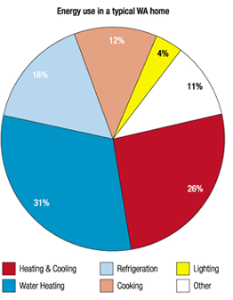
Your Household

Where does power go in your home?

In the typical WA household

The 3 big uses to focus on:

Water Heating

Heating & cooling

Refrigeration

Pic Ref: SEDO/energy smart homes

www.sedo.energy.wa.gov.au

Slide 8

Your choices make a difference

You can make a choice between whether you turn the fan or the air conditioner on.

A 2.5 star reverse cycle air conditioner will produce 2 kg of CO2 every hour it is used compared to a ceiling fan will produce 0.009 kg of CO2 every hour it is used.

Just turning the switch to cold water on your washing machine can save up to 567 kg of greenhouse gases every year.

Turning your television, video, microwave and stereos off at the power point can save up to 5% off your energy bill.

Notes
While the amount of energy you use in your house depends on how many people you have in your home and the structural characteristics (eg. insulation, orientation) of your home, a significant amount depends on the choices you make in how you use your appliances and live in your home. (See reference Saving Energy in the Home: Princeton's Experiments at Twin Rivers, editor. Ballinger Press, l978)

Focus on the 3 big uses, but small steps count too eg standby power

Slide 9

Technological Solutions

Energy Efficient Appliances

The more stars the better see www.energyrating.gov.au before buying whitegoods

Solar Heating

Passive solar house design, solar heaters and cookers

Solar Hot Water - Rebates available from SEDO for solar hot water systems

Low Greenhouse Energy

Your own grid-connected solar (photovoltaic) power system -$15,000-$30,000

Western Power’s Natural Power – few extra cents per unit to purchase renewable power produced by Western Power from power plants like the Albany Wind Farm

Western Power’s Earth-Friendly – pay a little extra to purchase electricity with greenhouse abatement

http://www.westernpower.com.au/home/green_energy/index.html

Notes
Energy Efficient Appliances – When you are buying new appliances for your home, check its energy rating. The greater the starts the more energy efficient the appliance is, which means less greenhouse gases and less costs for you.
Renewable Energy - The environmentally friendly alternative to electricity or gas. They utilise solar, wind or biomass energy and do not contribute to greenhouse gases or are greenhouse neutral in the case of sustainable harvested biomass.

Natural Power and Earth Friendly are tariffs offered to us by Western Power. You pay a little bit more for your electricity to have energy from renewable sources like the Albany Wind Farm or greenhouse abatement programs like the Waste Composter at RRRC, reducing methane emissions from landfill.

Slide 10:

Looking Ahead

“A solution that follows a single path or depends on a single technology will not be sufficient to reduce emissions to the extent required”

“All Australians need to take responsibility for their emissions …and do more with less”

Source: Australian Climate Group, July 2004

Notes
There is no single solution for climate change. We all have a role to play in addressing our use of energy, particularly coal-fired electricity, and beyond this as consumers we can choose less energy-intensive goods and services – local, less refined, less packaged and generally less

Slide 11

Top 5 Tips for living power smart

Turn down the thermostat setting on your hot water system.

Minimise the amount you heat and cool your home (take preventative measures) – focus on 1 or 2 rooms to heat and cool that you can seal off.

Turn off all standby power.

Purchase renewable energy for the household.

Wash your clothes in cold water.

