This presentation has been set up for you in Word so you can easily edit content and import the information into PowerPoint. To import to PowerPoint, when in WORD, select 'File', then 'Send To' and finally 'Microsoft PowerPoint'. This will generate a PowerPoint file which may need a little cleaning up such as removing blank slides or slides with just 'Slide #'. You can then use the Living Smart template for this topic and copy and paste these slides into the template powerpoint file.

We recommend that you check the information as the slide contents will no doubt date.

WASTE SMART PRESENTATION

Slide 1

Waste Smart

Managing waste better

Slide 2

The amount of waste I throw out each month fits in a one litre milk carton – David Suzuki

The average West Australian produces 117 kg of waste a month, or around 100 one litre milk cartons.

Slide 3

40 YEARS AGO

We consumed less

Ate more home grown or fresh produce with little/no packaging

Food scraps were feed to dogs/ chooks/ garden

Belongings repaired rather than thrown away

Slide 4

TODAY

We consume more

Products have lots of packaging

Disposable goods i.e. tissues rather than hankies

Easier to buy a new one than fix a broken one

Convenient service to take ‘rubbish’ away

Notes
In the last 100 years the amount of waste we produce has increased dramatically.
Waste used to be considered a resource, now we don’t give a second thought to what we throw in the bin.

Slide 5

Why be SMART about waste?

Landfills

It wastes valuable resources/ treasures

Rubbish is itself a resource.

It saves money

According to ABS, in 1996/97 it cost $1256 million to collect and dispose of Australian waste.

Notes
Landfills – 22 in WA. They contribute to disease, groundwater contamination, greenhouse gases, vermin etc.
It wastes valuable resources and treasures such as minerals, energy, forests, water, petroleum, and habitat.
Don’t look just at the product but what has gone into getting it to you – involves factory, shop, transport etc.
It saves you money, get more out of what you pay for and pay for less.
(This information was obtained from Waste Wise WA Fact Sheet, Department of Environmental Protection, Government of WA which sourced the information from the Australian Bureau of Statistics
http://www.wastewise.wa.gov.au/Pdfs/garbage.pdf ).

Slide 6

What we throw out in WA
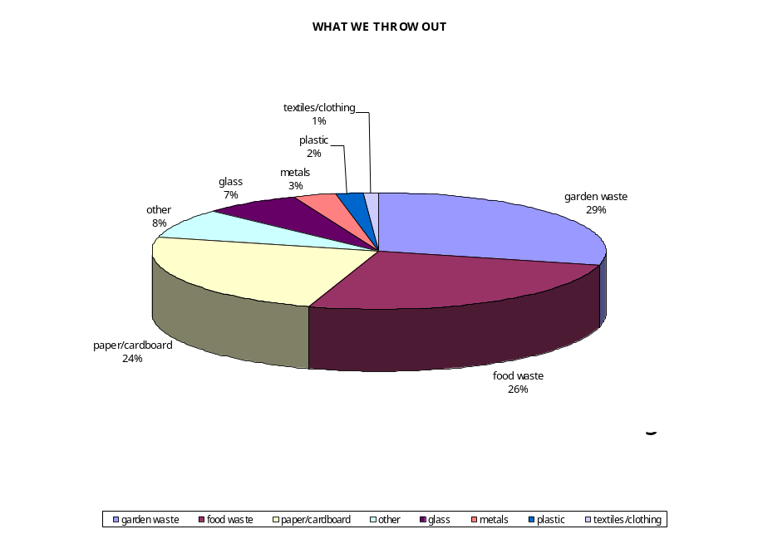

Pic Source: Waste Wise WA fact sheet, Department of Environmental Protection, Government of Western Australia.

Notes
As you can see in from this pie chart that over half of our waste is organic. Another large proportion of what we throw out is paper and cardboard.
Most of this pie chart can be reduced by composting or recycling.

Slide 7

The 3 R’s

Reduce

Reuse

Recycle

Notes
The 3R’s are a simple guide which can help us minimise our waste.
Recycle (good)> Reuse (better)>Reduce (best)
Remember first reduce, then reuse and then recycle or compost what is left, which makes sense when thinking about the diagram we were just viewing.
Suggest rethink as the first “R”. A lot of waste reduction comes down to rethinking things which we take for granted.

Slide 8

Reduce

There are over forty different plastics in use today

Each year Australia produces:

50,000 tonnes of soft drink bottles

30,000 tonnes of milk bottles, and

more than 10,000 tonnes of detergent and shampoo bottles.

Source: Waste Wise WA Fact Sheet Plastic

Notes
Each Australian consumes over 71kg of plastic every year – reducing this can be as simple as taking a bottle of water with you rather than buying.
(Statistics sourced from Waste Wise WA Fact Sheet Plastic – Department of Environmental Protection, Government of Western Australia http://www.wastewise.wa.gov.au/Pdfs/garbage.pdf ).

Slide 9

Reduce

Buy products with less packaging

Avoid takeaway & pre-packaged foods (lots of packaging) cook fresh foods or even grow your own

Repair rather than replace

Only buy what you need

Discourage junk mail

Avoid buying disposable products

Make gifts, cards etc rather than buying

Notes
Encourage people to call the toll free number to get a free no advertising material sticker – 1800 676 136 It’s the Distributions Standard Board, the regulatory arm of the Australian Catalogue Association, the company responsible for about 90% of junk mail.
To remove your name from the Australian Direct Marketing Association, go to http://www.planetark.com/mailing_preference_oz.cfm. The ADMA is responsible for direct marketing using your name and address.

Slide 10

Reuse

Reuse containers for storage (look out for reusable containers when shopping)

Buy second-hand or have a garage sale, reuse with others!

Take your own bag when shopping

Use back of leaflets/ envelopes for writing notes

By rechargeable batteries

Buy good quality reusable/ washable clothes

Notes
Use the same item more than once or preferably many times – saves resources, landfill space and money.

Slide 11

Be Creative

How many uses can you think of for an empty soft drink/water/juice bottle?



Notes
Allow time for people in small groups to discuss and brainstorm as many possibilities they can think of for an empty soft drink bottle. If running short on time, just ask the participants to give you ideas as a whole group discussion and leave out the discussion.

Slide 12

Recycle

Steel can be recycled again and again without reducing the quality of the end product

Every tonne of steel recycled saves 1.5 tonnes of iron ore, 0.5 tonnes of coal and 40% of the water and 75% of the energy it takes to make a tonne of new steel

In WA we used 5000 tonnes of steel cans in 1999, less than 20% were recycled –

That’s over 60 million steel cans going into our rubbish tips

Recycled aluminium uses 95% LESS energy than sourcing aluminium from bauxite mining

Recycling one aluminium can saves enough electricity to run a tv for 3 hours.
Notes
(These statistics were sourced from the Waste Wise WA Fact Sheets, Department of Environmental Protection, Government of Western Australia).

Slide 13

Recycling in your community

Local council – curbside recycling & verge collection

Recycle your car parts – The Autoparts Recyclers Assoc. of Aust. Will help you find a local dealer

Printer cartridges – participating Australian Post & Harvey Norman stores

Plastic bags – Coles supermarkets in the red wheelie bin

Mobile phones & accessories – contact Mobile Phone Industry Recycling Programme

What else?

Notes
These are general products that can be recycles in most councils, but check with your local council to ensure they can be recycled.
Curbside recycling - glass, paper, steel & aluminum cans, milk cartoons and juice cartoons
Verge collection - green waste & household goods

Slide 14:

When shopping:

Choose glass over plastic

Buy plastics with codes 1, 2 & 3.

Buy recycled products (close-the-loop)

Notes
Glass is a lot easier to recycle than plastics, so when possible, always buy glass.
Most councils cannot recycle plastics other than with codes 1, 2 & 3 so choose products which have easy to recycle plastics.
By buying recycled products, you are helping to create a market for recycling. There’s no point in recycling if people don’t buy the products.

Slide 15

TOP 5 Tips for living waste smart

Reduce the amount you buy, make do with less or make your own

Buy products with less packaging or packaging that can be recycled

Stick to your Council’s recycling guidelines

Create your own compost or worm farm

Give unwanted goods to charity

