This presentation has been set up for you in Word so you can easily edit content and import the information into PowerPoint. To import to PowerPoint, when in WORD, select 'File', then 'Send To' and finally 'Microsoft PowerPoint'. This will generate a PowerPoint file which may need a little cleaning up such as removing blank slides or slides with just 'Slide #'. You can then use the Living Smart template for this topic and copy and paste these slides into the template powerpoint file.

We recommend that you check the information as the slide contents will no doubt date.

SMART GARDENS FOR BIODIVERSITY PRESENTATION

Slide 1

Smart Gardens for Biodiversity

Create friendly and native gardens

Slide 2

What is biodiversity?

Biodiversity is the web of life. It is the many plants and creatures that live on Earth including humans, animals, fungi and microbes: from the smallest insect in the soil to the largest mammal in the ocean.

3 levels of diversity:

Genetic biodiversity

Species diversity

Ecosystem diversity

Notes
Biodiversity is variety in all life forms - a term coined in the 1980s
Genetic biodiversity: the variety of genetic information contained in all individual plants, animals and microorganisms that inhabit the Earth.
Species diversity: The very species on earth
Ecosystem diversity: the variety of habitats, biotic communities and ecological processes.

Source: National Strategy for the Conservation of Australia’s Biological Diversity (1998)

Slide 3

Why protect biodiversity?

Provides us with:

Clean water

Healthy soils

Medicines

Air

It also has spiritual & cultural value for us

It has intrinsic value – the web of life that links us all and warrants our respect.

Notes
See a full list of values in page 4 Box 2: Biodiversity is a means to an end and an end in itself - CALM, Towards a Biodiversity Conservation Strategy for WA 2004
http://www.calm.wa.gov.au/haveyoursay/pdf_files/biodiversity_draft_lores.pdf

Slide 4

What is the state of biodiversity?

Since European settlement, we have lost = EXTINCT

19 mammal species

10 marsupials

20 bird species

76 plant species

More than 100 mammal species are under threat

40% of Australian forest cleared

Source: National Strategy for the Conservation of Australia’s Biological Diversity (1998)

Notes
These are huge figures in such a short space of time considering Australia is billions of years old
Many are irreversible – EXTINCT/CLEARED
See further on http://www.deh.gov.au/biodiversity/publications/strategy/app1.html

Slide 5

On the SWAN COASTAL PLAIN, rare or likely to become EXTINCT fauna are:

4 mammal species

4 bird species

2 reptile species

1 crustacean species

2 native bee species

1 moth species

Rare flora

16 species – critically endangered

16 species – endangered

13 vulnerable species

(CALM, Towards a Biodiversity Conservation Strategy for WA 2004)

Notes
See further at http://www.calm.wa.gov.au/haveyoursay/pdf_files/biodiversity_draft_lores.pdf

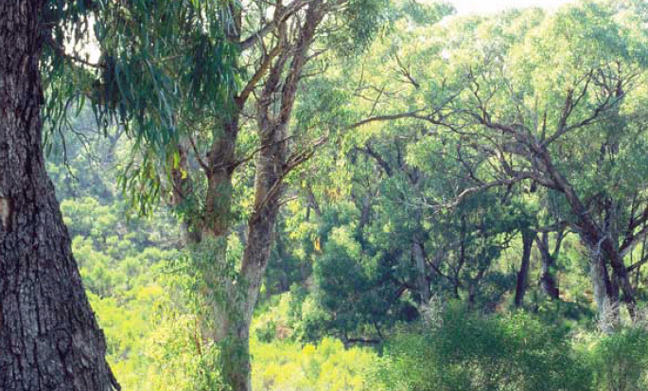
Slide 6

Are we supporting biodiversity?

260 000 hectares of remnant vegetation in Perth metro

Bush Forever Plan – 51 200 hectares identified as regionally significant

BUT still remnant vegetation being cleared

Across WA, 102 Threatened Ecological Communities – 21 of these critically endangered

Source: Bush Forever Plan 2000 & CALM 2004

Notes
Processes threatening these communities include:
- Declining groundwater levels
- Invasion of pests such as rabbits
- Invasion of weeds such as Watsonia
- Sand mining
- Increased nutrients in wetlands
- Physical disturbances from vehicles and recreation

But not all doom and gloom! There is hope!!
Perth's biodiversity is one of the highest recorded in any major city and the SW of WA is an internationally recognized biodiversity hot spot (referred to in Living Smart’s Sustainability topic overheads)

See Bush Forever Plan http://www.wapc.wa.gov.au/Publications/99.aspx
and CALM(2004) http://www.calm.wa.gov.au/plants_animals/watscu/pdf/tec/threatened_tec_threat_category%2003.pdf

Slide 7

What can you do?

Create a native garden for habitat for local animals and protect local plants species.

Even the odd backyard here and there can create ‘wildlife stepping stones’.

Get involved in protecting urban bushland areas in your local community – join your local friends group.

Notes
Don’t forget that other actions suggested in other topics in the course will also protect biodiversity
EG:
Better waste management will save resources and therefore prevent habitat destruction form mining and forestry.
Not putting chemicals down the drain will prevent groundwater and waterways pollution
See also State Government’s site http://www.sustainableliving.wa.gov.au/index.cfm?fuseaction=landscaping.intro#Local

Slide 8

Benefits of WA native gardens

Peaceful and tranquil area for you and your family to relax

Provides a much needed habitat and food source for local insects, lizards and birds

Needs less maintenance which gives you more time to enjoy them

Need much less maintenance, water and fertiliser

Notes
More cost effective, less time consuming and sustains the natural environment.
Don’t need to use sprays, which kill off bugs etc. which are important to natural ecosystem.
Fertilisers, which contribute to algal blooms, don’t end up in waterways.

Also see the Wildflower Society of WA:
Why plant WA plants? They’re beautiful, Australian (part of our heritage) waterwise, won’t become weeds and can be challenge to grow. (See more at http://members.ozemail.com.au/~wildflowers/)
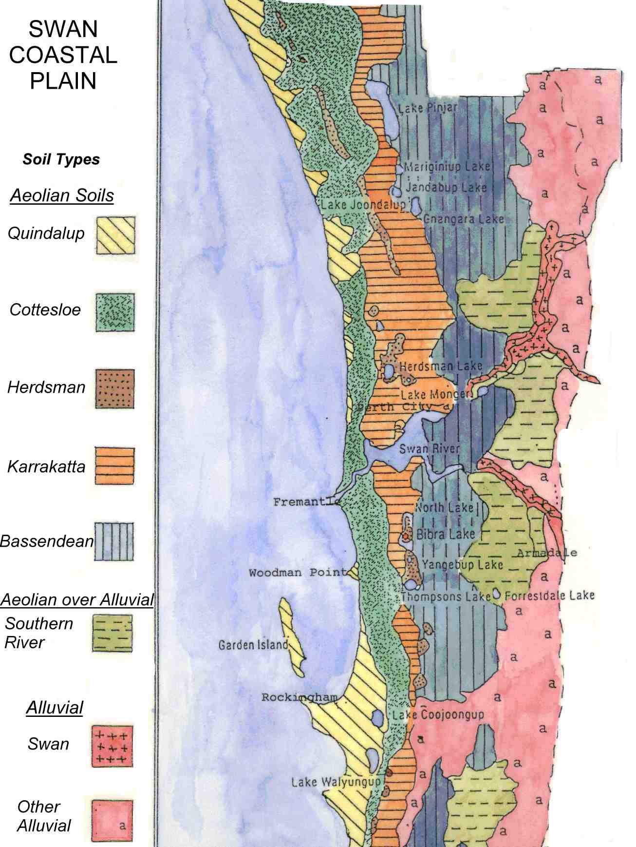
Slide 9

How to create a WA native garden

Find out the local plant species for your soil type

Plant a variety of species

Create habitats for animals

Water appropriately until established

Check out demonstration gardens

(Pic Source APACE, http://web.argo.net.au/apace/soiltypes.htm )

Notes
Find out the local plant species that suit your soil type
Plant a variety of species to create different layers like you see in natural areas
Create habitats for animals – build frog ponds, bird boxes, bird baths and sunny rocky areas for lizards
Water appropriately until established, especially the first summer until the roots reach the groundwater
Check out demonstration gardens for ideas, such as Kings Park
Keep dogs and cats in at dusk and make sure they are wearing bells

See 'Growing Locals' by Robert Powell and Jane Emberson and
'Perth plants for your garden' by Dorothy Redreau, Greening Western Australian

Slide 10

Alternatives to lawn

Native ground covers

Mulched areas

Paved areas

If you need a small grassed area chose a water tolerant, non-spreading variety.

Notes
Lawns are water thirsty and fertilisers leach into groundwater and contribute to algal blooms in waterways.
Most garden lawns are rarely used. Go to the local park to play cricket etc

Slide 11

Biodiversity

Get out and see it!

Slide 12

Top 5 Tips for living garden smart for biodiversity

Plant some native plants in your garden.

Replace some or all of your grass.

Replicate natural bushland by creating vegetation layers.

Create safe havens for wildlife.

Get out and enjoy the local bushland or participate in a local friends group.

