This presentation has been set up for you in Word so you can easily edit content and import the information into PowerPoint. To import to PowerPoint, when in WORD, select 'File', then 'Send To' and finally 'Microsoft PowerPoint'. This will generate a PowerPoint file which may need a little cleaning up such as removing blank slides or slides with just 'Slide #'. You can then use the Living Smart template for this topic and copy and paste these slides into the template powerpoint file.

We recommend that you check the information as the slide contents will no doubt date.

WATER SMART PRESENTATION

Slide 1

WATER SMART

Conserving water for the future

SLIDE 2

Artwork: Carolyn Gan
Activity: Display a glass/bottle of water and ask:
Q. How old is this water?
A. Essentially as old the Earth. Water is a closed system within the Earth. The same water is continuously cycling around the Earth in various forms.

Slide 3

Where Perth’s Water Comes From
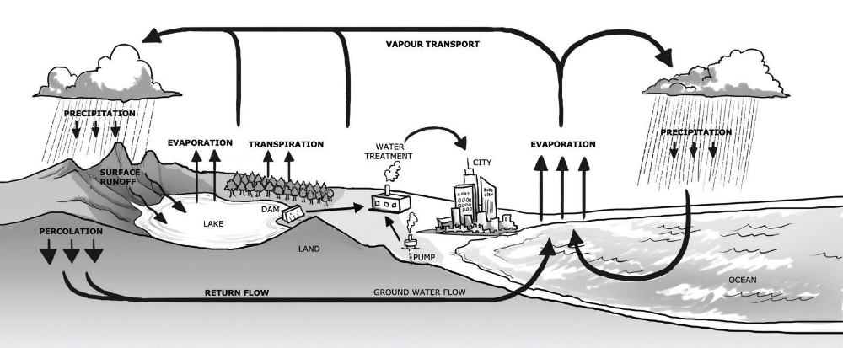

Artwork: Carolyn Gan, based on Water Corporation figure
Notes:
Approximately 75% of the Earths surface is water. Of that, only 3% is fresh and only 0.3% is available for humans.
Perth is the only city in Australia which accesses it’s scheme water from underground. In 2003 the maximum storage of Perths dams was 18.8%. 70% of the scheme water was accessed from groundwater.

Slide 4

Why conserve water?

Rainfall is decreasing

Rainfall in SW has been below average since 1975 – 15% reduction in rainfall

The average inflow into catchments has fallen by 64%

Slide 5

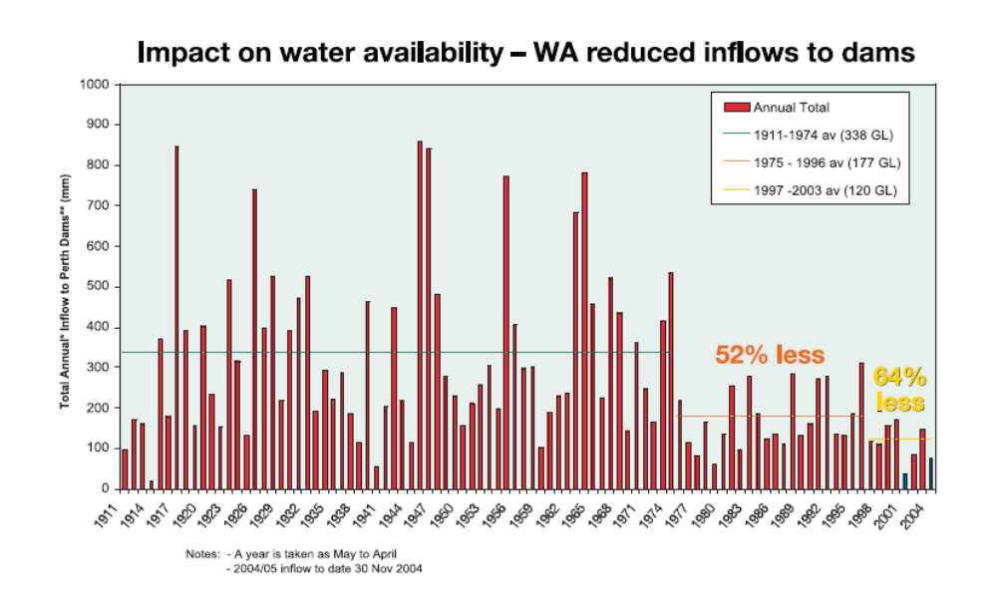

Water Corporation Waterwise Information Sheet #1

http://www.watercorporation.com.au/publications/3/WBI01.pdf

Slide 6

Water and climate change

Temperature rise by 1.3°C by 2030

Winter rainfall expected to decrease by a further 4-8% by 2030

Notes:
Climate change and water are strongly linked. Most inhabited areas within Australia are predicted to dry out with climate change. The southwest of WA is expected to be one of the most affected areas with climate change. Note the overlap with Living Smart topic – power and biodiversity.

Slide 7

Impacts on ecosystem health

76% of mean annual flow in the SW needs to be maintained to ensure ecosystem health. You can only take so much away before it starts to hurt the environment.

Cost to the community

The Stirling-Harvey Redevelopment Scheme cost over $275 million dollars
Notes:
New fresh water resources are costly.
Water conservation options are much more cost effective than creating new supplies.

Slide 8

Consumption is Increasing

Average household water use in 1981 was 815L per household per day

In 2000 it was 1259L, an increase of 55%

By the year 2031, it is estimated that Perth will need an extra 150 billion litres of water each year.

Sourced from: Water Corporations Domestic Water Use Study 2001

http://www.watercorporation.com.au/publications/12/Domestic_water_use_study.pdf

Slide 9

Where do we use our water?

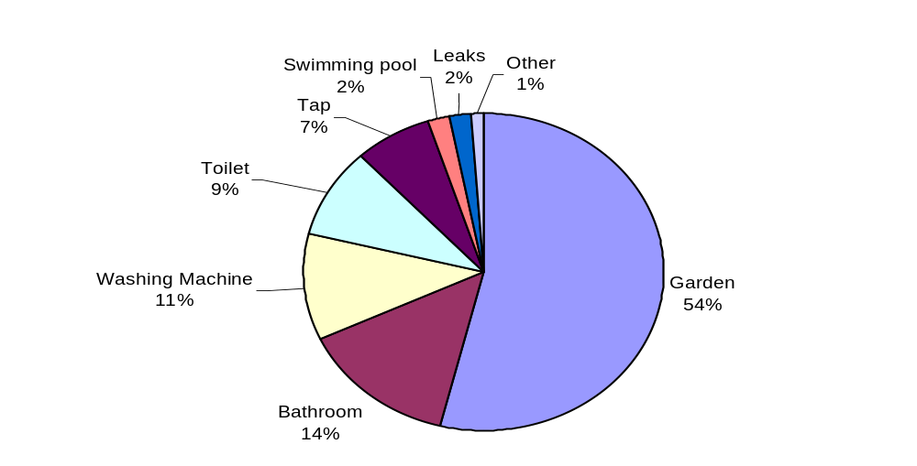

Adapted from http://www.watercorporation.com.au/publications/12/Domestic_water_use_study.pdf
Notes – it is a good idea for people to try and breakdown the water use for a household before they see this graph. This helps with retaining the information.

Slide 10

Why is water use increasing?

Mainly due to luxuries like reticulated watering systems and swimming pools.
Notes:
Although our knowledge of the importance of conserving water has increased, that knowledge has not impacted on our behaviour. Automated watering systems means it is easy for people to water, and part of the problem is that people no longer see how much water is used.

Slide 11

Perth’s water crisis

Accessing more water from groundwater and less from dams

Need to rethink our use of water

Creating new dams and bores have many environmental implications and are costly

Other alternatives are very costly eg Pipeline from the Kimberley

Notes:
In 2003, 70% of our water came from groundwater supplies. The maximum dam storage reached in 2003 was only 18.8% of total capacity.

Slide 12

The best solution?

Conserving water!

It’s a demand management problem.
Notes:
Changing some simple behaviours can save lots of water.

Slide 13

Water in the House

A running tap will use an average of twenty litres of water a minute – some use 24L/min

A water saving showerhead will use 9L per minute.

Turning off the tap while brushing your teeth or shaving can save up to 420 litres of water a year

Only run full loads in dishwasher and washing machine – washing machines use up to 250L per wash.

Old toilets use 11L for full flush, 4L for ½ flush. Modern toilets use 6L full flush and 3L for ½ flush.
Notes:
Before showing this slide, ask participants to guess how long it will take to fill up a 9L bucket of water using a water saving showerhead (1 minute). The variety of answers will surprise you and highlight that people don’t realize how much water is used per minute.

Slide 14

Water in the Garden

The average garden hose delivers 1000 litres of water an hour!
Notes:
Each year more than the entire contents of Mundaring Weir go on Perth gardens

Slide 15

Some Tips

Stick to the current water regulations

Mulch your garden

Keep the soil healthy

Water in early morning or at dusk

Plant natives

DON’T hose down bricks, buy a good outdoor broom instead.

Wash your car with a bucket and use your hose as little as possible
Notes
One half of a household’s water goes on the garden (with the exception of those who have native gardens or large paved areas) and this can increase up to 70%in summer.

Slide 16

Technological Solutions

Water Efficient Appliances

The more A’s the better

(Rebates available for front loading washing machines and shower heads)

Grey Water Reuse

Manual bucketing

Treatment systems – approvals needed from your local council.

Rainwater Tanks

For drinking or connect up to toilet

(Rebates available)
Notes
You can save water in your home by installing water efficient devices and appliances.
They may cost a little at the beginning but will save money (and water) in the end.

Grey water – is the name used for water that is discharged from household appliances and water using fixtures but not the toilet.
Manual bucketing – only method where you can reuse grey water without approval.
Follow tips in the action guide for safe use.

Rainwater Tanks - A good way of reducing amount of scheme water you use. Don’t use for drinking water if you live in a high traffic or industrial area, use in garden and toilet instead.

Slide 17

5 Top Tips for living water smart

Install a low flow shower head and have shorter showers.

Only run full loads in dishwasher and washing machine.

Minimise water use in the garden.

Install or make a dual flush toilet.

Reuse grey water in your garden.

